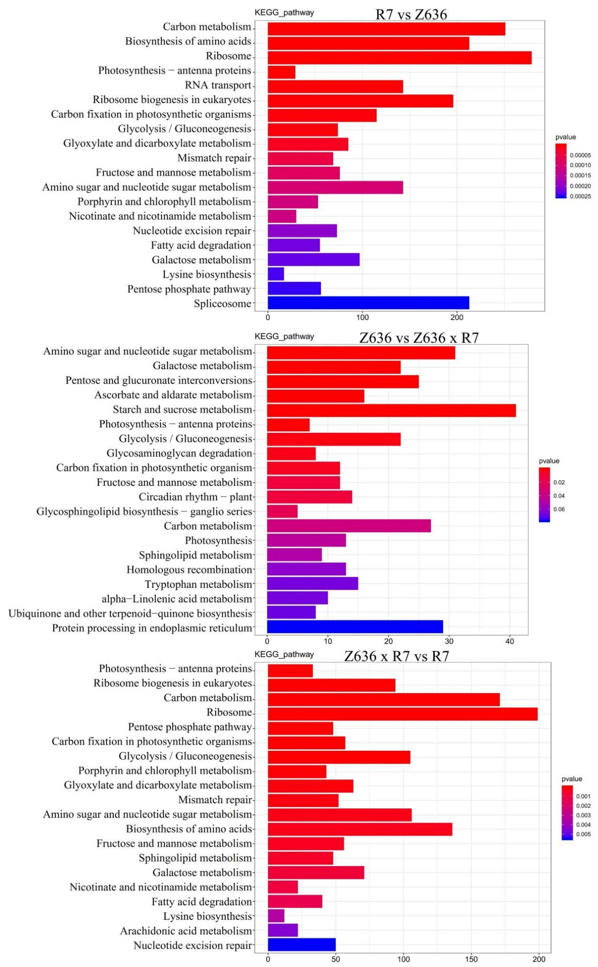
Supplementary 3. Histogram of KEGG enrichment of different expressed genes.

