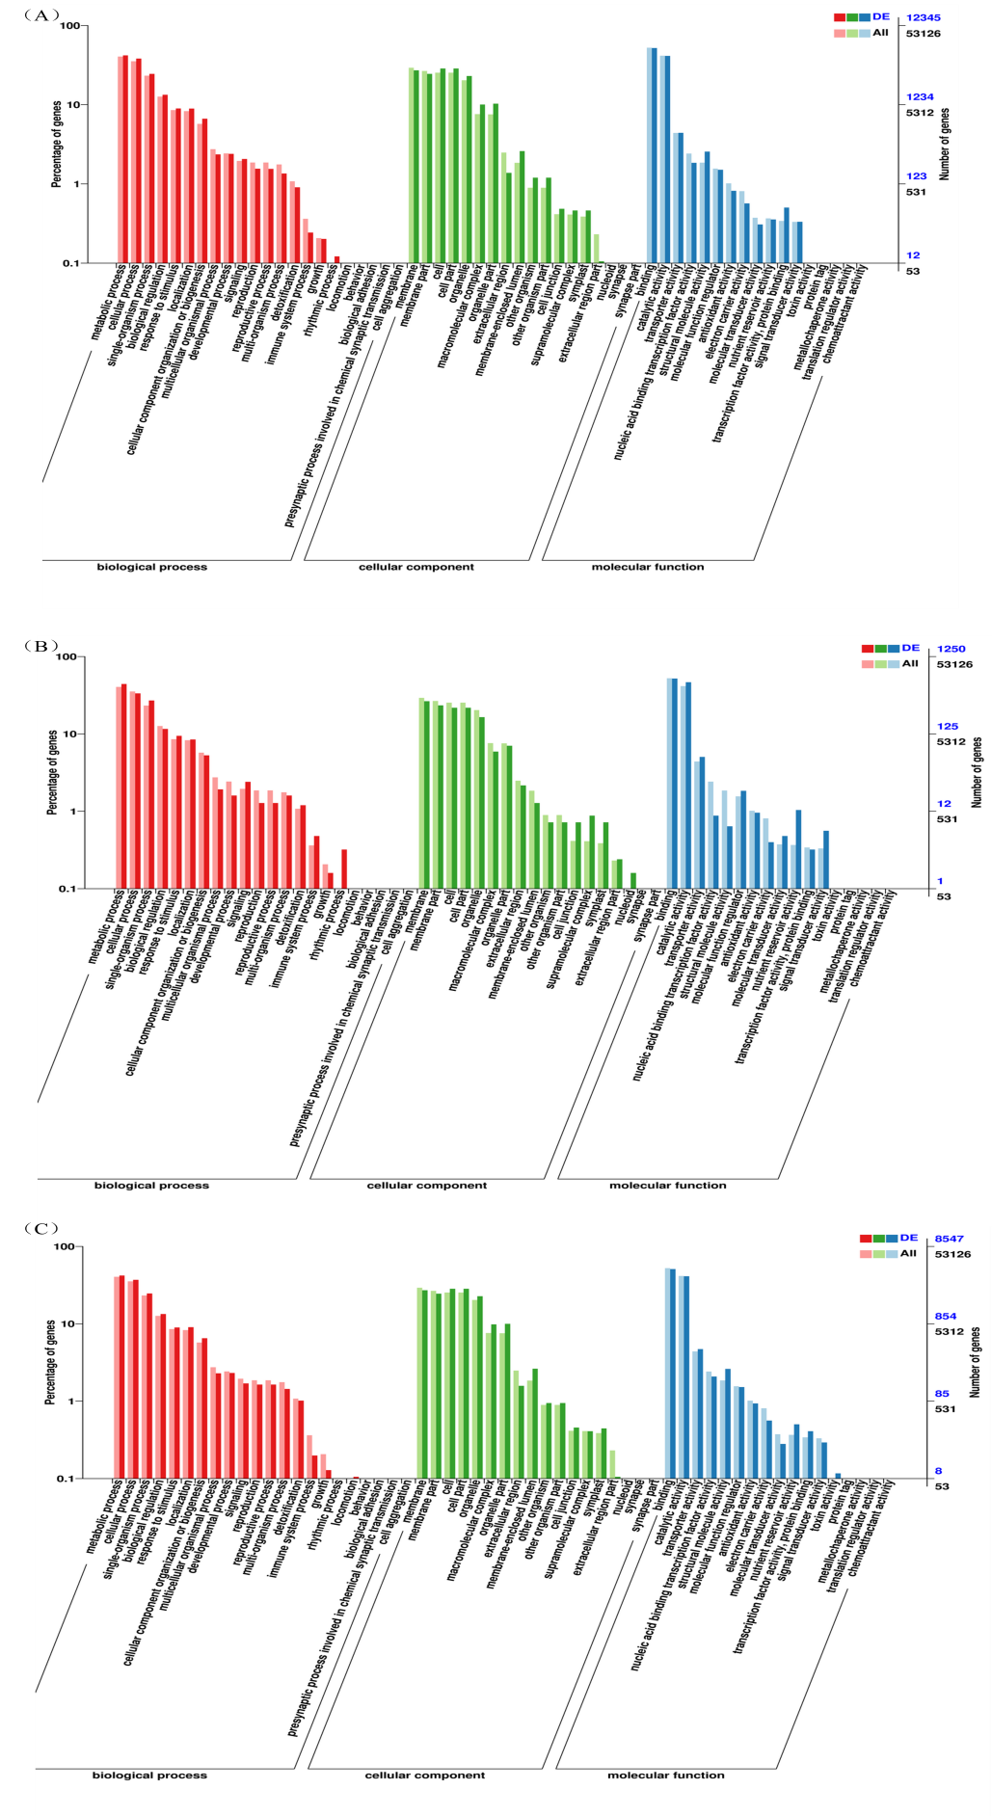
Supplementary 2. GO functional annotation of DEGs. A, GO functional annotation of R7 vs Z636. B, GO functional annotation of Z636 vs Z636×R7. C, GO functional annotation of Z636×R7 vs R7.

