Figure S1. The location map of experiment sites.
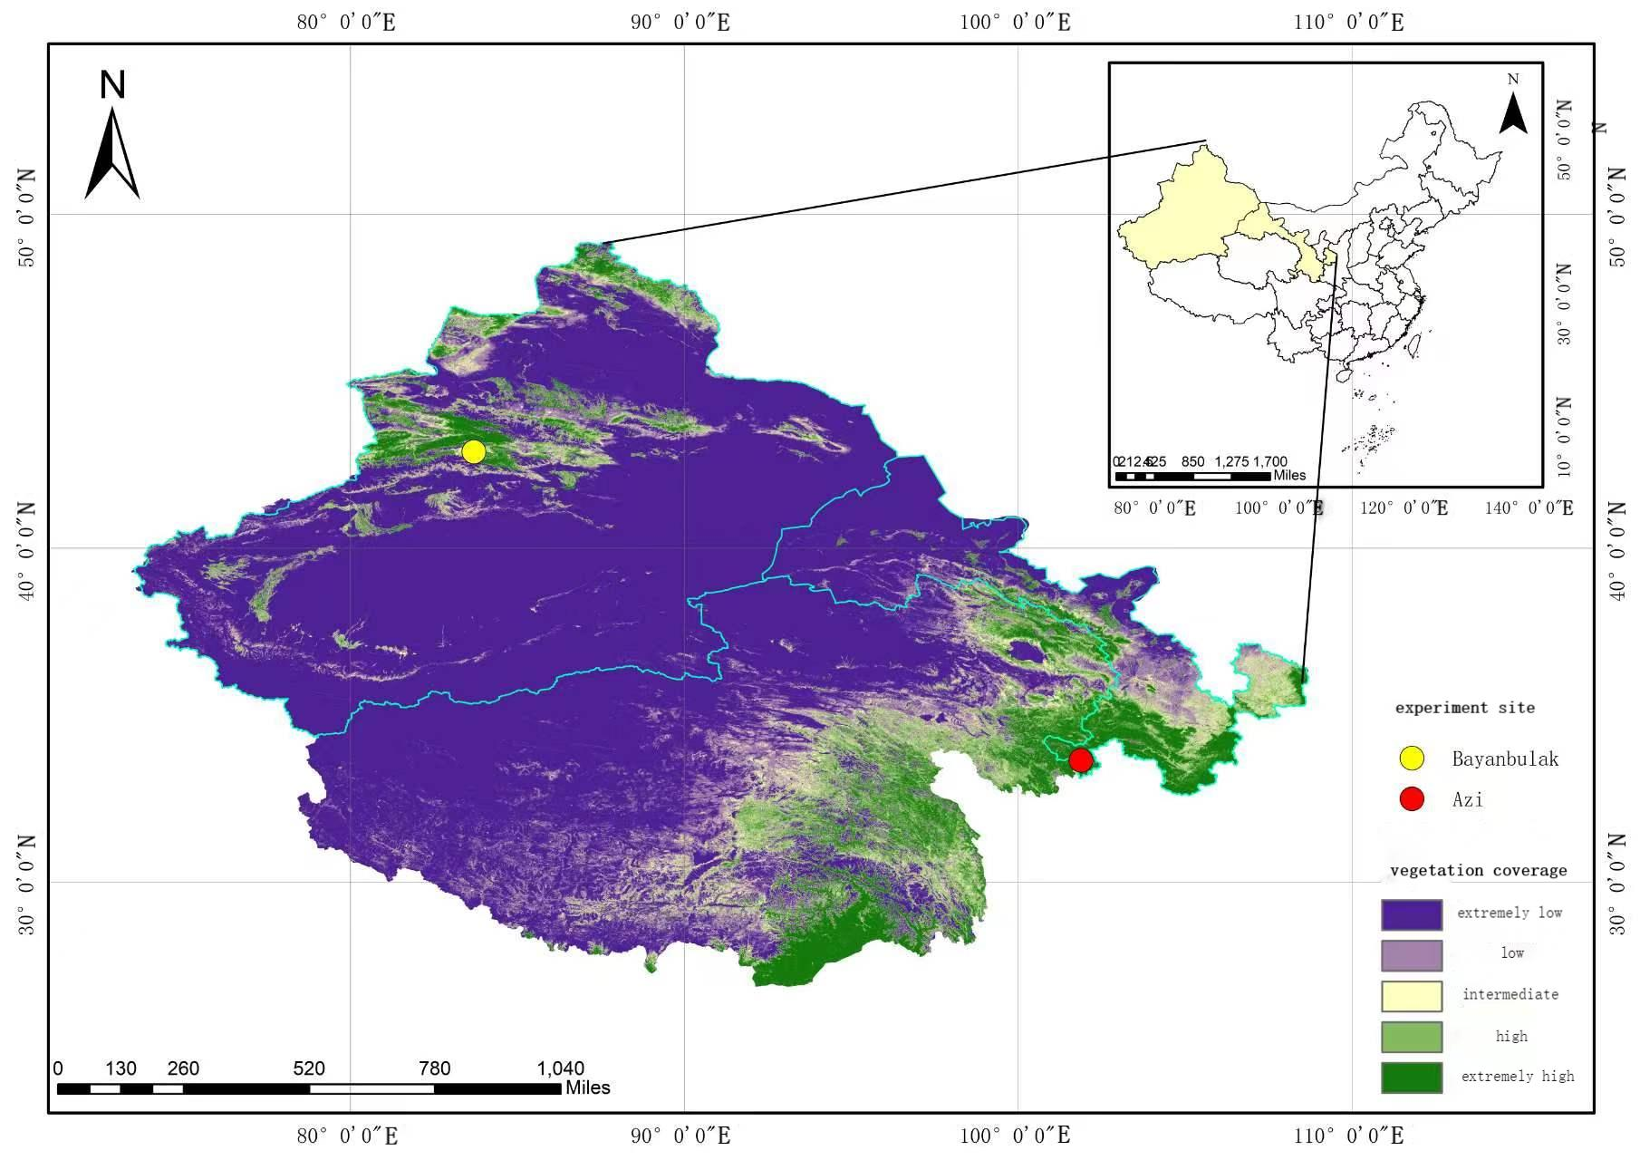

Table. S2 the mean value of species turnover and ITV in multiple and gradient nutrient addition experiment.

Trait category | Functional trait | treatment | Species  turnover | ITV | Log(species turn/ITV)
Whole-plant trait | Height | N | 0.594 | 0.03 | 1.645
Leaf morphological traits | SLA | N | 1.428 | 0.264 | 1.589
Leaf morphological traits | LDMC | N | 0.1905 | 1.955 | -1.01125
Leaf chemical  traits | leafC | N | 0.815 | 0.0001 | 3.883
Leaf chemical  traits | leafN | N | 0.373 | 1.309 | -0.197
Leaf chemical  traits | leafP | N | 0.888 | 0.931 | -0.019
Whole-plant trait | Height | P | 0.523 | 0.067 | 0.919
Leaf morphological traits | SLA | P | 0.637 | 1.002 | -0.044
Leaf morphological traits | LDMC | P | 2.982 | 0.326 | 0.96129
Leaf chemical  traits | leafC | P | 0.667 | 0.0001 | 2.667
Leaf chemical  traits | leafN | P | 0.6325 | 0.51 | -0.03
Leaf chemical  traits | leafP | P | 0.135 | 0.797 | -0.818
Whole-plant trait | Height | K | 1.168 | 0.237 | 1.114
Leaf morphological traits | SLA | K | 1.201 | 0.574 | 0.897
Leaf morphological traits | LDMC | K | 0.135 | 0.8673 | -0.80784
Leaf chemical  traits | leafC | K | 1 | 0.005 | 3.268
Leaf chemical  traits | leafN | K | 1.328 | 0.623 | -0.115
Leaf chemical  traits | leafP | K | 1.091 | 0.218 | 1.26
Whole-plant trait | Height | NP | 1.069 | 0.321 | 1.168
Leaf morphological traits | SLA | NP | 0.938 | 0.408 | 0.453
Leaf morphological traits | LDMC | NP | 1.42 | 2.17 | -0.18417
Leaf chemical  traits | leafC | NP | 0.75 | 0.007 | 2.538
Leaf chemical  traits | leafN | NP | 0.137 | 0.401 | -0.756
Leaf chemical  traits | leafP | NP | 0.053 | 0.549 | -1.212
Whole-plant trait | Height | NK | 1.157 | 0.219 | 0.547
Leaf morphological traits | SLA | NK | 0.516 | 2.463 | 0.588
Leaf morphological traits | LDMC | NK | 0.8898 | 0.1097 | 0.909086
Leaf chemical  traits | leafC | NK | 0.667 | 0.001 | 2.333
Leaf chemical  traits | leafN | NK | 0.069 | 0.613 | -1.69
Leaf chemical  traits | leafP | NK | 0.002 | 0.589 | -2.812
Whole-plant trait | Height | PK | 1.007 | 0.239 | 0.762
Leaf morphological traits | SLA | PK | 1.525 | 0.519 | -0.137
Leaf morphological traits | LDMC | PK | 0.09461 | 1.007 | -1.02709
Leaf chemical  traits | leafC | PK | 0.12 | 0.002 | 1.281
Leaf chemical  traits | leafN | PK | 0.394 | 0.896 | -0.228
Leaf chemical  traits | leafP | PK | 0.014 | 0.421 | -1.782
Whole-plant trait | Height | NPK | 0.869 | 0.571 | 0.217
Leaf morphological traits | SLA | NPK | 0.849 | 1.097 | 0.657
Leaf morphological traits | LDMC | NPK | 0.7479 | 0.2493 | 0.477121
Leaf chemical  traits | leafC | NPK | 0.5 | 0.001 | 1.566
Leaf chemical  traits | leafN | NPK | 0.192 | 0.479 | -0.658
Leaf chemical  traits | leafP | NPK | 0.118 | 0.644 | -1.781
Whole-plant trait | Height | N5 | 0.9607 | 0.001839 | 2.718006
Leaf morphological traits | SLA | N5 | 0.8589 | 0.08647 | 0.997077
Leaf morphological traits | LDMC | N5 | 0.5551 | 0.1727 | 0.507079
Leaf chemical  traits | leafN | N5 | 1.098 | 0.002268 | 2.684959
Leaf chemical  traits | leafP | N5 | 1 | 0.0001 | 4
Whole-plant trait | Height | N10 | 0.72747 | 0.031126 | 1.368698
Leaf morphological traits | SLA | N10 | 0.689569 | 0.080908 | 0.930586
Leaf morphological traits | LDMC | N10 | 0.383262 | 0.195911 | 0.291438
Leaf chemical  traits | leafN | N10 | 0.109447 | 0.509329 | -0.66779
Leaf chemical  traits | leafP | N10 | 0.060008 | 0.587679 | -0.99093
Whole-plant trait | Height | N15 | 1.27 | 0.02385 | 1.726315
Leaf morphological traits | SLA | N15 | 0.2598 | 0.2784 | -0.03003
Leaf morphological traits | LDMC | N15 | 0.4461 | 0.2055 | 0.33662
Leaf chemical  traits | leafN | N15 | 0.412 | 2.979 | -0.85917
Leaf chemical  traits | leafP | N15 | 0.1121 | 1.395 | -1.09497
Whole-plant trait | Height | P2 | 1.174 | 0.007262 | 2.208612
Leaf morphological traits | SLA | P2 | 0.7679 | 0.04772 | 1.206604
Leaf morphological traits | LDMC | P2 | 0.9172 | 0.01268 | 1.859345
Leaf chemical  traits | leafN | P2 | 0.923 | 0.739 | 0.096557
Leaf chemical  traits | leafP | P2 | 0.03635 | 1.019 | -1.44767
Whole-plant trait | Height | P4 | 1.047 | 0.003355 | 2.494254
Leaf morphological traits | SLA | P4 | 0.7397 | 0.08246 | 0.952812
Leaf morphological traits | LDMC | P4 | 1.089 | 0.01072 | 2.006833
Leaf chemical  traits | leafN | P4 | 0.506 | 2.508 | -0.69518
Leaf chemical  traits | leafP | P4 | 0.733 | 0.74 | -0.00413
Whole-plant trait | Height | P8 | 1.249 | 0.05173 | 1.38282
Leaf morphological traits | SLA | P8 | 0.4951 | 0.09843 | 0.701565
Leaf morphological traits | LDMC | P8 | 1.011 | 0.006088 | 2.220277
Leaf chemical  traits | leafN | P8 | 0.701 | 1.706 | -0.38626
Leaf chemical  traits | leafP | P8 | 0.1052 | 0.5869 | -0.74655

Table S3 the relationships between species relative abundance and different functional traits in nutrient addition treatments in Azi site and Bayanbulak site. The R² and P value from simple linear regression.

treatment | Functional trait | Azi site |  | Bayanbulak site
treatment | Functional trait | R² | P | R² | P
CK | height | 0.3143 | <0.001 | 0.00382 | 0.7742
CK | SLA | 0.1442 | <0.05 | 0.02878 | 0.4623
CK | LDMC | 0.01653 | 0.4616 | - | -
CK | LCC | - | - | 0.02978 | 0.4425
CK | LNC | 0.113 | 0.1726 | 0.03399 | 0.4365
CK | LPC | 0.007505 | 0.7325 | 0.0002799 | 0.9442
N | height | 0.7059 | <0.001 | 0.215 | <0.05
N | SLA | 0.01328 | 0.6006 | 0.003164 | 0.8036
N | LDMC | 0.008378 | 0.6779 | - | -
N | LCC | - | - | 0.01832 | 0.5283
N | LNC | 0.07254 | 0.2958 | 0.05051 | 0.3025
N | LPC | 0.03837 | 0.4512 | 0.04718 | 0.3194
P | height | 0.5316 | <0.001 | 0.002242 | 0.8261
P | SLA | 0.002469 | 0.8135 | 0.07165 | 0.2169
P | LDMC | 0.003789 | 0.7701 | - | -
P | LCC | - | - | 0.04397 | 0.3254
P | LNC | 0.2136 | 0.07147 | 0.0009087 | 0.8941
P | LPC | 0.02224 | 0.5815 | 0.07461 | 0.2187
K | height | 0.4296 | <0.001 | 0.06954 | 0.2357
K | SLA | 0.09095 | 0.1263 | 0.1833 | <0.05
K | LDMC | 0.0102 | 0.6162 | - | -
K | LCC | - | - | 0.01366 | 0.5954
K | LNC | 0.0249 | 0.5595 | 0.03364 | 0.4022
K | LPC | 0.151 | 0.1369 | 0.03932 | 0.3644
NP | height | 0.6533 | <0.001 | 0.0004997 | 0.9276
NP | SLA | 0.0006943 | 0.9147 | 0.004171 | 0.7928
NP | LDMC | 0.1911 | 0.06126 | - | -
NP | LCC | - | - | 0.1475 | 0.08567
NP | LNC | 0.04483 | 0.4874 | 0.05519 | 0.3481
NP | LPC | 0.1763 | 0.1532 | 0.01112 | 0.677
NK | height | 0.6468 | <0.001 | 0.0465 | 0.3006
NK | SLA | 0.03364 | 0.5129 | 0.05189 | 0.308
NK | LDMC | 0.01546 | 0.6588 | - | -
NK | LCC | - | - | 0.02925 | 0.4585
NK | LNC | 0.2296 | 0.115 | 0.02685 | 0.3311
NK | LPC | 0.1097 | 0.293 | 0.02831 | 0.2792
PK | height | 0.5178 | <0.001 | 0.073 | 0.2016
PK | SLA | 0.111 | 0.08316 | 0.2012 | <0.05
PK | LDMC | 0.03835 | 0.318 | - | -
PK | LCC | - | - | 0.1961 | <0.05
PK | LNC | 0.02078 | 0.5443 | 0.004642 | 0.7817
PK | LPC | 0.01334 | 0.6277 | 0.00661 | 0.7407
NPK | height | 0.4358 | <0.001 | 0.124 | 0.1392
NPK | SLA | 0.1002 | 0.2158 | 0.01051 | 0.6672
NPK | LDMC | 0.08433 | 0.2582 | - | -
NPK | LCC | - | - | 0.2316 | <0.05
NPK | LNC | 0.0313 | 0.5823 | 0.0003685 | 0.9307
NPK | LPC | 0.242 | 0.1042 | 0.006771 | 0.7089

Table S4 the relative abundance (%) of different nutrient addition treatments in Azi site. (F : forb, G : graminoid, L : legum)

species | Functional group | CK | N | P | K | NP | NK | PK | NPK
Agrostis stolonifera | G | 1.73 | 9.67 | 5.09 | 5.13 | 6.58 | - | 4.16 | 3.84
Allium chysanthum | F | 1.53 | 0.97 | - | - | 0.98 | 0.64 | 1.20 | -
Anaphalis hancockii | F | 0.19 | - | 0.54 | - | - | - | 0.49 | -
Anemone obtusiloba | F | 5.66 | 3.87 | 9.41 | 8.07 | 1.96 | 1.53 | 6.55 | 1.23
Anemone rivularis | F | 2.88 | 2.11 | 3.47 | 3.09 | 0.70 | 1.66 | 2.18 | 1.92
Anemone trullifolia | F | 1.53 | 2.02 | 5.02 | 3.92 | 0.56 |  | 3.24
Artemisia sieversiana | F | 0.48 | - | - | - | - | - | - | -
Astragalus polycladus | L | 1.05 | - | 0.31 | 1.13 | - | - | - | -
Cerastium arvense | F | 1.25 | - | 3.78 | 0.98 | - | - | 0.63 | -
Delphinium grandiflorum | F | 1.73 | 0.53 | 0.54 | 0.30 | - | - | 0.28 | -
Deschampsia caespitosa | G | - | - | - | 0.45 | 4.62 | - | - | -
Elymus nutans | G | 6.42 | 19.68 | 22.76 | 18.10 | 18.07 | 22.25 | 19.66 | 32.51
Euphorbia esula | F | 2.49 | 2.99 | - | - | 4.06 | 5.88 | 6.13 | 4.12
Euphrasia pectinata | F | 0.38 | - | - | - | - | - | - | -
Festuca coelestis | G | - | - | - | 0.53 | - | - | 0.92 | -
Festuca ovina | G | - | - | - | 1.36 | - | - | - | 2.33
Gentianopsis barbata | F | 2.49 | - | 0.77 | 1.66 | - | - | 0.99 | -
Geranium wilfordii | F | 2.40 | 2.11 | 3.70 | 3.32 | 5.04 | 2.56 | 3.74 | 1.92
Gueldenstaedtia verna | L | 2.59 | 0.53 | 0.62 | 0.90 | - | - | 1.13 | -
Halenia corniculata | F | 7.38 | - | 2.01 | 5.66 | - | - | 2.75 | -
Kobresia macrantha | G | 13.04 | 27.68 | 11.96 | 4.75 | 20.87 | 29.67 | 8.74 | 8.92
Kobresia setchwanensis | G | 6.14 | 4.83 | 8.33 | 10.71 | 10.50 | 12.66 | 8.53 | 13.58
Koeleria cristata | G | 1.63 | 7.21 | 3.78 | 1.51 | 9.10 | 7.54 | 4.30 | 8.50
Lamiophlomis rotata | F | 2.97 | - | - | - | - | 1.02 | 0.49 | -
Lancea tibetica | F | 1.53 | - | - | - | 2.52 | - | - | -
Oxytropis kansuensis | L | 0.77 | 0.35 | 1.39 | 2.56 | - | - | 0.70 | -
Pedicularis kansuensis | F | 2.78 | - | 1.47 | 3.54 | - | - | - | -
Pleurospermum camtschatium | F | 0.96 | 3.95 | - | 4.15 | - | 2.56 | 1.48 | 1.78
Poa crymophila | G | - | - | - | - | 4.48 | - | - | 1.37
Poa pratensis | G | 0.38 | 2.20 | - | - | 2.24 | 1.53 | 0.42 | 2.33
Polygonum viviparum | F | 2.11 | 0.62 | 1.93 |  | 2.38 | 2.56 | 5.71 | 2.61
Potentilla anserina | F | 1.15 | 1.67 | 1.00 | 2.04 | 1.68 | 5.50 | 5.36 | 10.29
Potentilla fragarioides | F | 6.81 | 2.81 | 2.93 | 7.54 | 1.82 | 1.53 | 6.41 | 1.78
Ranunculus reptans | F | 3.84 | 1.23 | - | - | 0.70 | - | - | -
Saussurea nigrescens | F | 11.03 | 1.05 | 2.39 | - | - | - | - | -
Taraxacum mongolicum | F | 1.05 | - | 0.77 | 1.06 | - | - | 1.27 | -
Thermopsis lanceolata | L | 0.19 | 0.79 | 1.08 | 2.26 | - | 0.90 | 1.69 | 0.96
Trollius farreri | F | 1.15 | 1.14 | 4.94 | 4.90 | 1.12 | - | 0.85 | -
Veronica didyma | F | 0.29 | - | - | 0.38 | - | - | - | -

Table S5 the relative abundance (%) of different nutrient addition treatments in Bayanbulak site. (F : forb, G : graminoid, L : legum)

species | Functional group | CK | N | P | K | NP | NK | PK | NPK
Agropyron cristatum | G | 1.69 | 3.34 | 3.98 | 5.80 | 8.27 | 34.13 | 6.06 | 24.16
Astragalus alpinus | L | 15.86 | 5.28 | 14.54 | 23.13 | 18.38 | 1.70 | 31.45 | 7.21
Carex stenocarpa | G | 0.15 | 0.60 | 0.17 | 0.54 | 0.13 | 0.61 | 0.50 | 1.25
Festuca ovina | G | 11.58 | 6.93 | 14.50 | 8.23 | 11.92 | 8.62 | 10.14 | 11.27
Festuca ovina | G | 27.68 | 22.11 | 28.38 | 27.06 | 33.11 | 13.30 | 29.35 | 20.45
Gentiana parvula | F | - | - | - | - | - | - | 0.37 | -
Leymus tianschanicus | G | 11.25 | 18.46 | 5.49 | 0.00 | 2.35 | 10.89 | 2.92 | -
Oxytropis glabra | L | - | - | 3.74 | 5.76 | - | 0.74 | 0.27 | 0.50
Poa pratensis | G | 8.39 | 17.22 | 16.05 | 7.22 | 5.91 | 11.27 | 5.81 | 17.09
Potentilla bifurca | F | 7.13 | 8.07 | 10.37 | 10.00 | 8.34 | 6.17 | 8.96 | 10.76
Potentilla fragarioides | F | 16.09 | 17.99 | 2.76 | 11.50 | 11.56 | 10.31 | 4.16 | 6.51
Potentilla multifida | F | - | - | - | 0.45 | 0.05 | - | - | -
Potentilla sp | F | - | - | - | - | - | 0.26 | - | 0.09
Saposhnikovia divaricata | F | - | - | 0.01 | 0.13 | - | 2.01 | - | 0.69
Stellaria media | F | - | - | - | 0.18 | - | - | - | -
Taraxacum tianschanicum | F | 0.20 | - | - | - | - | - | - | -
Thermopsis lanceolala | L | - | - | - | 0.12 | - | - | - | -

