Supplementary Materials
Appendix A. Climate change awareness (trend scepticism)

Table S1 Results of the multilevel models predicting climate change awareness.
 | Null Model | Model 1 (Fixed-effects only) | Model 2  (With interactions) | Model 3  (with random slope)
 | b (se) | b (se) | b (se) | b (se)
Intercept | 0.837 ***  (0.009) | 0.851 ***  (0.006) | 0.856 ***  (0.006) | 0.854 ***  (0.006)
Individual-level predictors
COVID-19 concerns |  | 0.078 ***  (0.005) | 0.055 ***  (0.006) | 0.039 **  (0.015)
Political orientation |  | -0.013 ***  (0.003) | -0.012 ***  (0.003) | -0.011 **  (0.003)
Attribution scepticism |  | 0.255 ***  (0.007) | 0.250 ***  (0.007) | 0.248 ***  (0.007)
Climate change concerns |  | 0.344 ***  (0.005) | 0.346 ***  (0.005) | 0.346 ***  (0.005)
Perceived impact of climate change |  | 0.088 ***  (0.005) | 0.098 ***  (0.006) | 0.094 ***  (0.006)
Gender (Female) |  | -0.015 ***  (0.003) | -0.016 ***  (0.003) | -0.017 ***  (0.003)
Age |  | 0.039 ***  (0.004) | 0.038 ***  (0.004) | 0.039 ***  (0.004)
Education |  | 0.022 ***  (0.004) | 0.024 ***  (0.004) | 0.024 ***  (0.004)
Country-level predictors
Total COVID-19 cases |  | -0.019  (0.036) | -0.018  (0.036) | -0.027  (0.035)
Total COVID-19 deathes |  | 0.047  (0.037) | 0.047  (0.037) | 0.044  (0.036)
Stringency index |  | -0.022  (0.041) | -0.020  (0.041) | -0.020  (0.040)
HDI |  | -0.028  (0.023) | -0.029  (0.023) | -0.029  (0.023)
CRI |  | 0.069 **  (0.025) | 0.066 **  (0.026) | 0.073 **  (0.025)
Green party support |  | 0.029  (0.026) | 0.032  (0.026) | 0.031  (0.026)
Right-wing party support |  | -0.061  (0.032) | -0.059  (0.032) | -0.054  (0.031)
Interactions
COVID-19 concerns*Attribution scepticism |  |  | -0.071 **  (0.024) | -0.046  (0.024)
COVID-19 concerns*Climate change concerns |  |  | -0.162 ***  (0.018) | -0.159 ***  (0.018)
COVID-19 concerns*Perceived impact of climate change |  |  | -0.111 ***  (0.021) | -0.110 ***  (0.021)
COVID-19 concerns*Education |  |  | -0.041 **  (0.013) | -0.034 *  (0.014)
Random Effects
Individual | 0.05 | 0.04 | 0.04 | 0.04
Country | 0.00 | 0.00 | 0.00 | 0.00
COVID-19 concerns |  |  |  | 0.00
ICC | 0.03 | 0.02 | 0.02 | 0.03
Observations | 27310 | 21890 | 21890 | 21890
Marginal R² / Conditional R² | 0.000 / 0.033 | 0.334 / 0.345 | 0.341 / 0.353 | 0.332 / 0.349
AIC | 36174.143 | 19081.805 | 18855.184 | 18747.539
log-Likelihood | -18084.072 | -9522.903 | -9405.592 | -9349.770
All independent variables are scaled between 0-1 and grand-mean centered, analysis weights were used, * p<0.05 ** p<0.01 *** p<0.001.

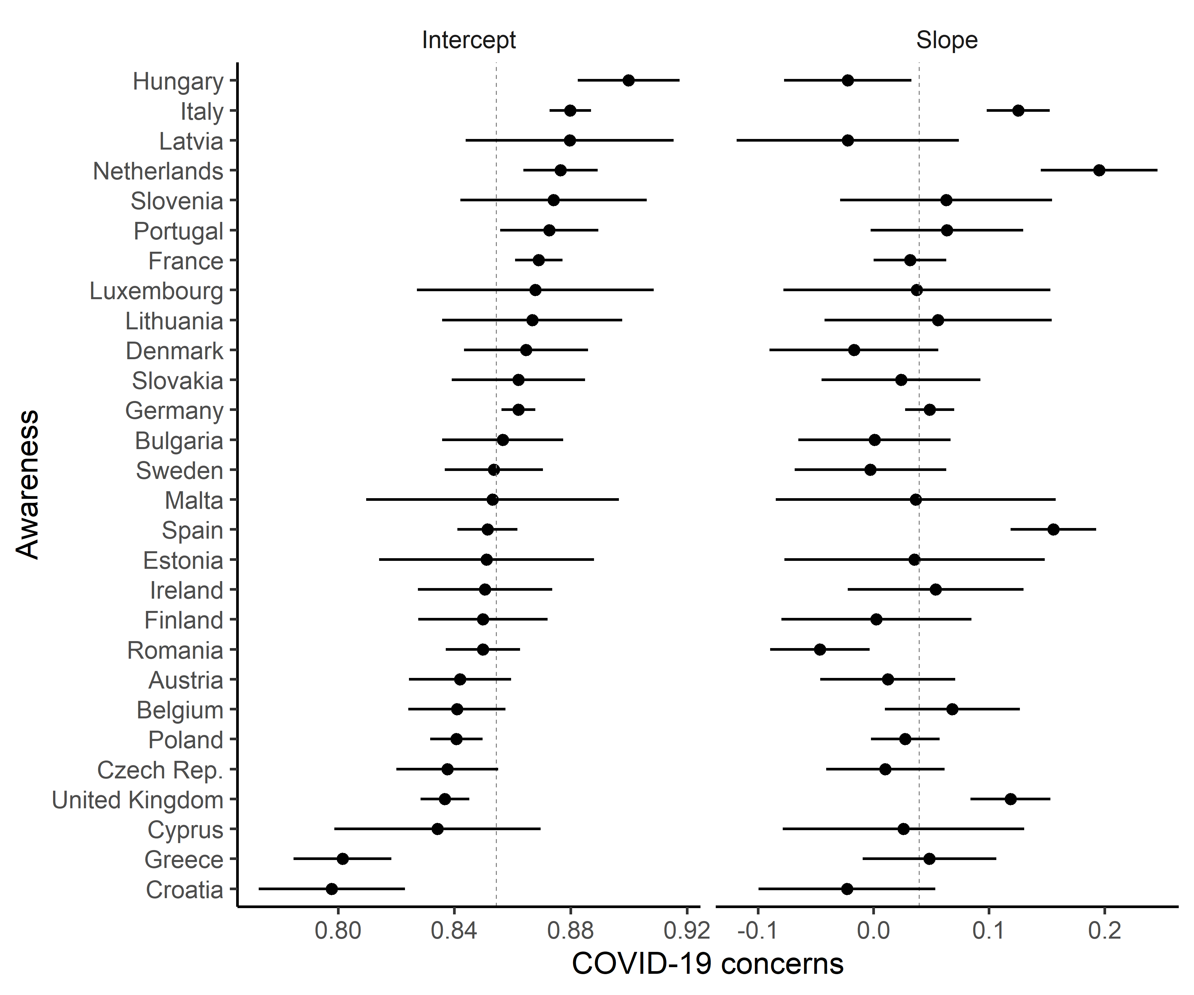

Fig. S1 Predicted per-country average intercepts and slopes (fixed+random effects) of COVID-19 concerns on climate change awareness. Whiskers represent 95% confidence intervals. The vertical intermittent line represents the mean of the total sample.

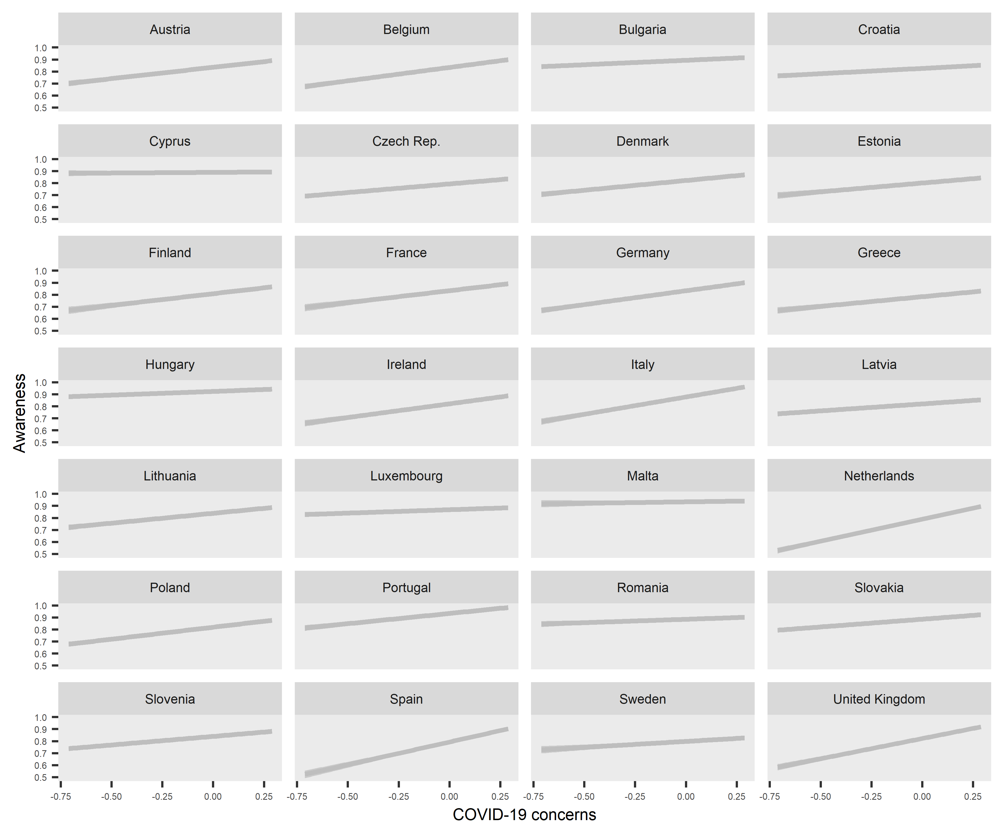
Fig. S2 Predicted per-country average slopes of COVID-19 concerns on climate change awareness with per-country random intercepts and 95% confidence intervals.

Table S2 Results of the final multilevel model predicting climate change awareness with standardized predictors.
 | Model 3 (with random slope)
 | B (SE)
Intercept | 0.846 ***  (0.005)
Individual-level predictors
COVID-19 concerns | 0.011 **  (0.004)
Political orientation | -0.004 **  (0.001)
Attribution scepticism | 0.048 ***  (0.001)
Climate change concerns | 0.091 ***  (0.001)
Perceived impact of climate change | 0.023 ***  (0.001)
Gender (Female) | -0.008 ***  (0.001)
Age | 0.012 ***  (0.001)
Education | 0.008 ***  (0.001)
Country-level predictors
Total COVID-19 cases | -0.007  (0.009)
Total COVID-19 deathes | 0.012  (0.010)
Stringency index | -0.005  (0.010)
HDI | -0.008  (0.007)
CRI | 0.019 **  (0.006)
Green party support | 0.008  (0.007)
Right-wing party support | -0.013  (0.007)
Interactions
COVID-19 concerns*Attribution scepticism | -0.003  (0.001)
COVID-19 concerns*Climate change concerns | -0.012 ***  (0.001)
COVID-19 concerns*Perceived impact of climate change | -0.008 ***  (0.001)
COVID-19 concerns*Education | -0.011 *  (0.005)
Random Effects
Individual | 0.04
Country | 0.00
COVID-19 concerns | 0.00
ICC | 0.03
Observations | 21890
Marginal R² / Conditional R² | 0.332 / 0.349
AIC | 18747.539
log-Likelihood | -9349.770
Analysis weights were used
* p<0.05 ** p<0.01 *** p<0.001.

Appendix B. Attribution scepticism

Table S3 Results of the multilevel models predicting attribution scepticism.
 | Null Model | Model 1 (Fixed-effects only) | Model 2  (With interactions) | Model 3  (with random slope)
 | b (se) | b (se) | b (se) | b (se)
Intercept | 0.680 ***  (0.007) | 0.680 ***  (0.004) | 0.683 ***  (0.004) | 0.682 ***  (0.004)
Individual-level predictors
COVID-19 concerns |  | -0.024 ***  (0.005) | -0.004  (0.006) | -0.003  (0.014)
Political orientation |  | -0.022 ***  (0.003) | -0.022 ***  (0.003) | -0.022 ***  (0.003)
Climate change awareness |  | 0.218 ***  (0.006) | 0.213 ***  (0.006) | 0.212 ***  (0.006)
Climate change concerns |  | 0.041 ***  (0.005) | 0.048 ***  (0.005) | 0.049 ***  (0.005)
Perceived impact of climate change |  | 0.253 ***  (0.005) | 0.255 ***  (0.005) | 0.259 ***  (0.005)
Gender (Female) |  | 0.019 ***  (0.002) | 0.018 ***  (0.002) | 0.018 ***  (0.002)
Age |  | 0.027 ***  (0.004) | 0.025 ***  (0.004) | 0.022 ***  (0.004)
Education |  | 0.039 ***  (0.003) | 0.031 ***  (0.003) | 0.026 ***  (0.003)
Country-level predictors
Total COVID-19 cases |  | 0.038  (0.027) | 0.039  (0.026) | -0.012  (0.018)
Total COVID-19 deathes |  | -0.033  (0.027) | -0.032  (0.026) | 0.001  (0.018)
Stringency index |  | 0.001  (0.031) | -0.001  (0.030) | 0.005  (0.023)
HDI |  | -0.038 *  (0.017) | -0.040 *  (0.016) | -0.026 *  (0.012)
CRI |  | -0.002  (0.019) | -0.003  (0.018) | 0.005  (0.013)
Green party support |  | -0.036  (0.019) | -0.034  (0.019) | -0.023  (0.013)
Right-wing party support |  | 0.043  (0.024) | 0.040  (0.023) | 0.019  (0.016)
Interactions
COVID-19 concerns*Climate change awareness |  |  | 0.056 **  (0.020) | 0.068 ***  (0.020)
COVID-19 concerns*Climate change concerns |  |  | -0.152 ***  (0.019) | -0.161 ***  (0.019)
COVID-19 concerns*Perceived impact of climate change |  |  | -0.046 *  (0.018) | -0.057 **  (0.018)
COVID-19 concerns*Education |  |  | 0.091 ***  (0.012) | 0.123 ***  (0.013)
Random Effects
Individual | 0.04 | 0.03 | 0.03 | 0.03
Country | 0.00 | 0.00 | 0.00 | 0.00
COVID-19 concerns |  |  |  | 0.00
ICC | 0.03 | 0.01 | 0.01 | 0.02
Observations | 27445 | 21890 | 21890 | 21890
Marginal R² / Conditional R² | 0.000 / 0.027 | 0.252 / 0.259 | 0.264 / 0.270 | 0.262 / 0.275
AIC | 28176.285 | 15633.537 | 15499.004 | 15358.949
log-Likelihood | -14085.142 | -7798.769 | -7727.502 | -7655.474
All independent variables are scaled between 0-1 and grand-mean centered, analysis weights were used, * p<0.05 ** p<0.01 *** p<0.001.

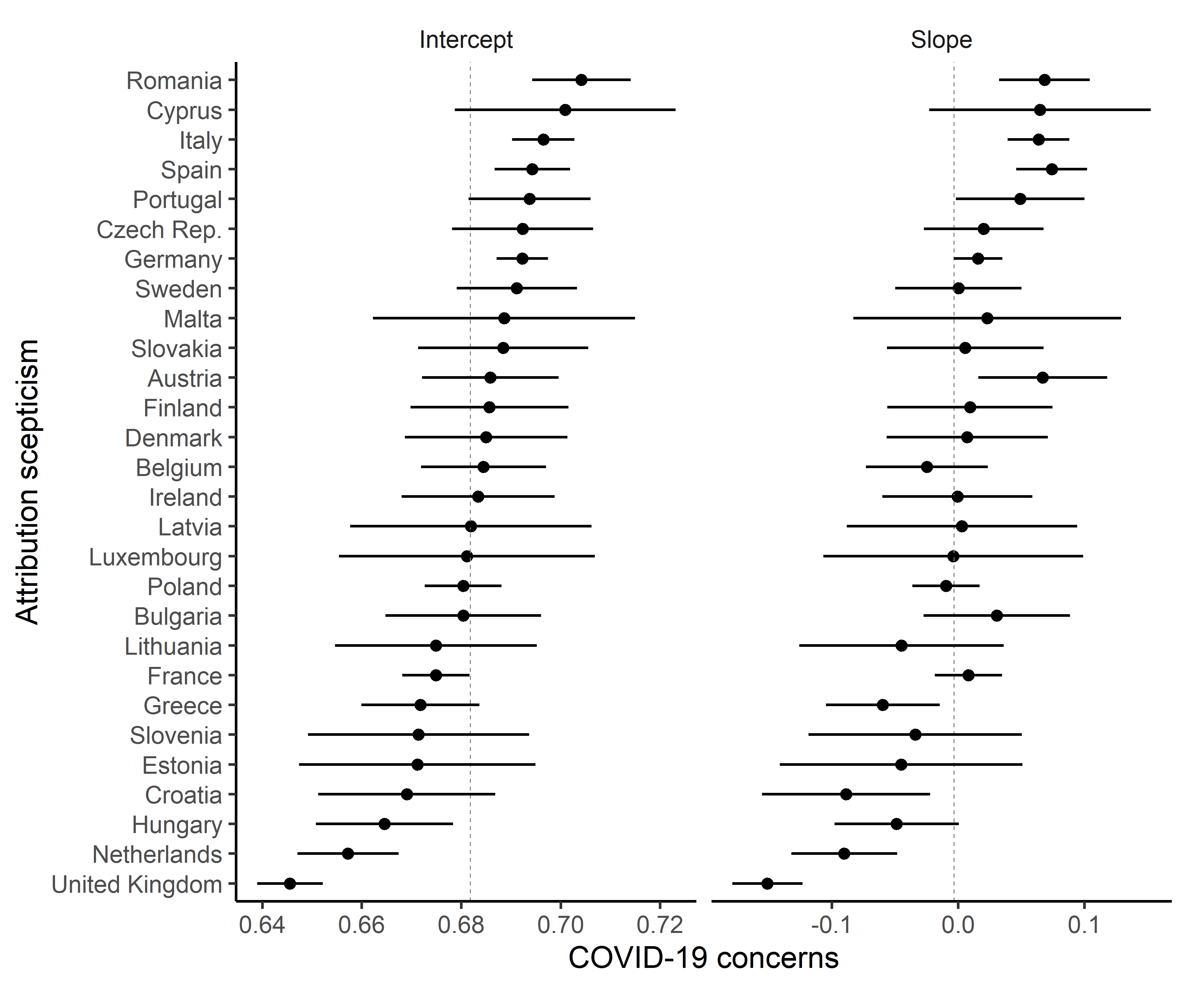
Fig. S3 Predicted per-country average intercepts and slopes (fixed+random effects) of COVID-19 concerns on attribution scepticism. Whiskers represent 95% confidence intervals. The vertical intermittent line represents the mean of the total sample.

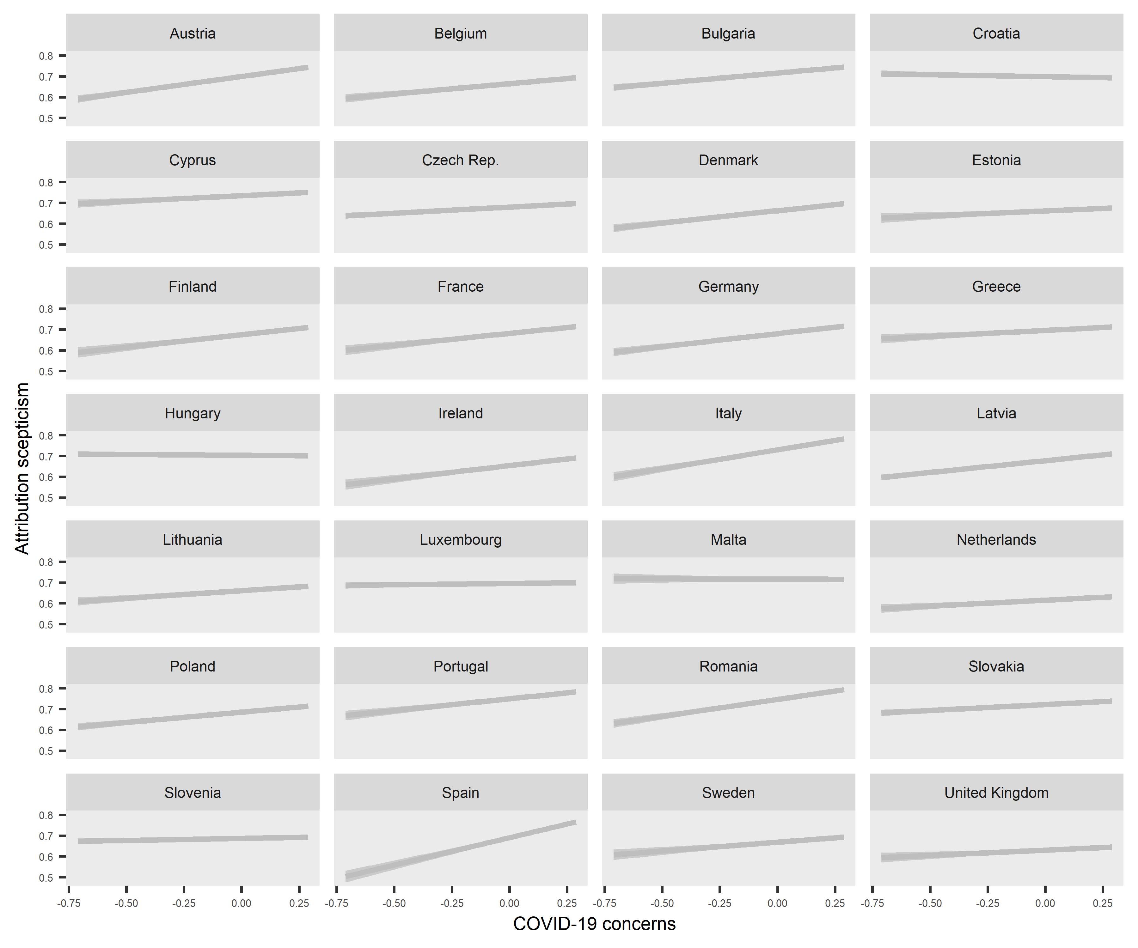
Fig. S4 Predicted per-country average slopes of COVID-19 concerns on attribution scepticism with per-country random intercepts and 95% confidence intervals.

Table S4 Results of the final multilevel model predicting attribution scepticism with standardized predictors.
 | Model 3 (with random slope)
 | B (SE)
Intercept | 0.691 ***  (0.004)
Individual-level predictors
COVID-19 concerns | -0.001  (0.004)
Political orientation | -0.009 ***  (0.001)
Climate change awareness | 0.048 ***  (0.001)
Climate change concerns | 0.013 ***  (0.001)
Perceived impact of climate change | 0.064 ***  (0.001)
Gender (Female) | 0.009 ***  (0.001)
Age | 0.007 ***  (0.001)
Education | 0.009 ***  (0.001)
Country-level predictors
Total COVID-19 cases | -0.003  (0.004)
Total COVID-19 deathes | 0.000  (0.005)
Stringency index | 0.001  (0.006)
HDI | -0.008 *  (0.004)
CRI | 0.001  (0.003)
Green party support | -0.006  (0.003)
Right-wing party support | 0.005  (0.004)
Interactions
COVID-19 concerns*Climate change awareness | 0.004 ***  (0.001)
COVID-19 concerns*Climate change concerns | -0.012 ***  (0.001)
COVID-19 concerns*Perceived impact of climate change | -0.004 **  (0.001)
COVID-19 concerns*Education | 0.041 ***  (0.004)
Random Effects
Individual | 0.03
Country | 0.00
COVID-19 concerns | 0.00
ICC | 0.02
Observations | 21890
Marginal R² / Conditional R² | 0.262 / 0.275
AIC | 15358.949
log-Likelihood | -7655.474
Analysis weights were used, * p<0.05 ** p<0.01 *** p<0.001.

Appendix C. Climate change concern

Table S5 Results of the multilevel models predicting climate change concerns.
 | Null Model | Model 1 (Fixed-effects only) | Model 2  (With interactions) | Model 3  (with random slope)
 | b (se) | b (se) | b (se) | b (se)
Intercept | 0.585 ***  (0.015) | 0.581 ***  (0.008) | 0.581 ***  (0.008) | 0.580 ***  (0.008)
Individual-level predictors
COVID-19 concerns |  | 0.215 ***  (0.006) | 0.200 ***  (0.007) | 0.180 ***  (0.013)
Political orientation |  | -0.078 ***  (0.004) | -0.077 ***  (0.004) | -0.077 ***  (0.004)
Climate change awareness |  | 0.452 ***  (0.007) | 0.451 ***  (0.007) | 0.453 ***  (0.007)
Attribution scepticism |  | 0.063 ***  (0.008) | 0.069 ***  (0.008) | 0.070 ***  (0.008)
Perceived impact of climate change |  | 0.085 ***  (0.006) | 0.090 ***  (0.006) | 0.089 ***  (0.006)
Gender (Female) |  | 0.016 ***  (0.003) | 0.016 ***  (0.003) | 0.017 ***  (0.003)
Age |  | -0.094 ***  (0.005) | -0.092 ***  (0.005) | -0.091 ***  (0.005)
Education |  | -0.023 ***  (0.004) | -0.017 ***  (0.004) | -0.014 **  (0.004)
Country-level predictors
Total COVID-19 cases |  | 0.013  (0.050) | 0.013  (0.049) | 0.015  (0.045)
Total COVID-19 deathes |  | -0.087  (0.051) | -0.088  (0.051) | -0.091 *  (0.046)
Stringency index |  | 0.159 **  (0.057) | 0.160 **  (0.057) | 0.160 **  (0.053)
HDI |  | -0.116 ***  (0.033) | -0.115 ***  (0.032) | -0.103 ***  (0.029)
CRI |  | -0.096 **  (0.036) | -0.096 **  (0.035) | -0.100 **  (0.032)
Green party support |  | 0.016  (0.037) | 0.016  (0.037) | -0.002  (0.033)
Right-wing party support |  | 0.061  (0.046) | 0.063  (0.045) | 0.083 *  (0.041)
Interactions
COVID-19 concerns*Climate change awareness |  |  | 0.155 ***  (0.023) | 0.144 ***  (0.023)
COVID-19 concerns*Attribution scepticism |  |  | -0.142 ***  (0.028) | -0.141 ***  (0.028)
COVID-19 concerns*Perceived impact of climate change |  |  | -0.078 **  (0.024) | -0.078 **  (0.024)
COVID-19 concerns*Education |  |  | -0.071 ***  (0.015) | -0.086 ***  (0.016)
Random Effects
Individual | 0.07 | 0.05 | 0.05 | 0.05
Country | 0.01 | 0.00 | 0.00 | 0.00
COVID-19 concerns |  |  |  | 0.00
ICC | 0.08 | 0.03 | 0.03 | 0.03
Observations | 27679 | 21890 | 21890 | 21890
Marginal R² / Conditional R² | 0.000 / 0.079 | 0.347 / 0.365 | 0.340 / 0.359 | 0.335 / 0.355
AIC | 43919.194 | 25080.506 | 25005.251 | 24947.334
log-Likelihood | -21956.597 | -12522.253 | -12480.625 | -12449.667
All independent variables are scaled between 0-1 and grand-mean centered, analysis weights were used, * p<0.05 ** p<0.01 *** p<0.001.

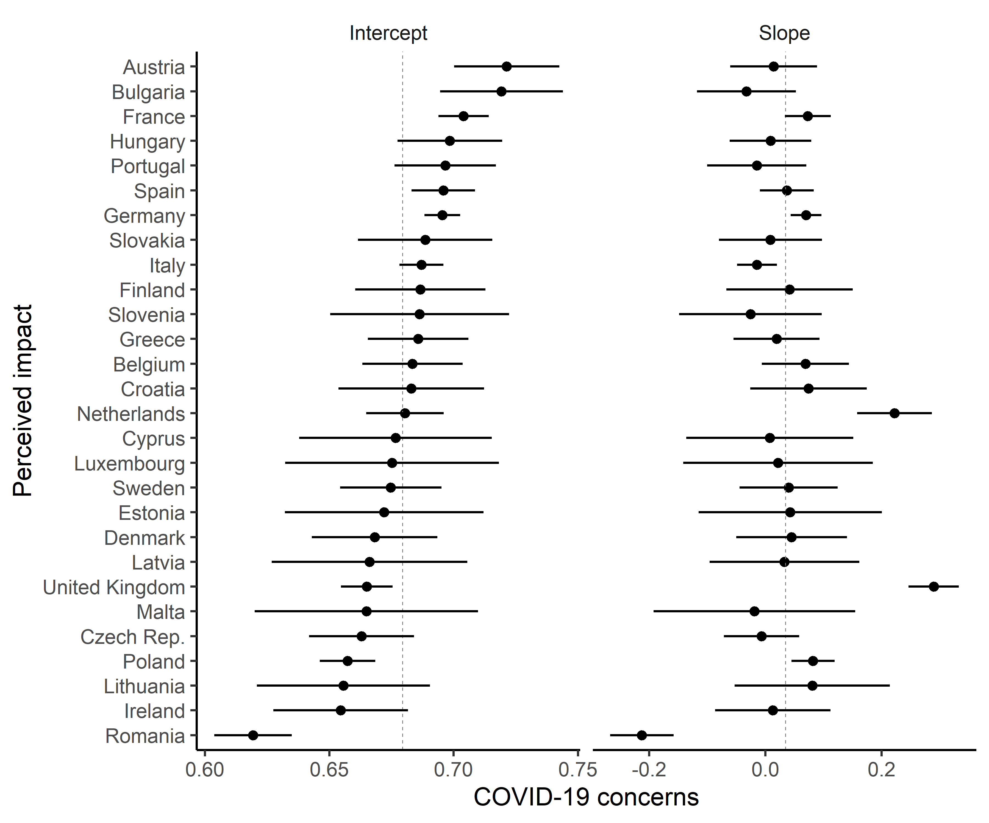
Fig. S5 Predicted per-country average intercepts and slopes (fixed+random effects) of COVID-19 concerns on climate change concerns. Whiskers represent 95% confidence intervals. The vertical intermittent line represents the mean of the total sample.

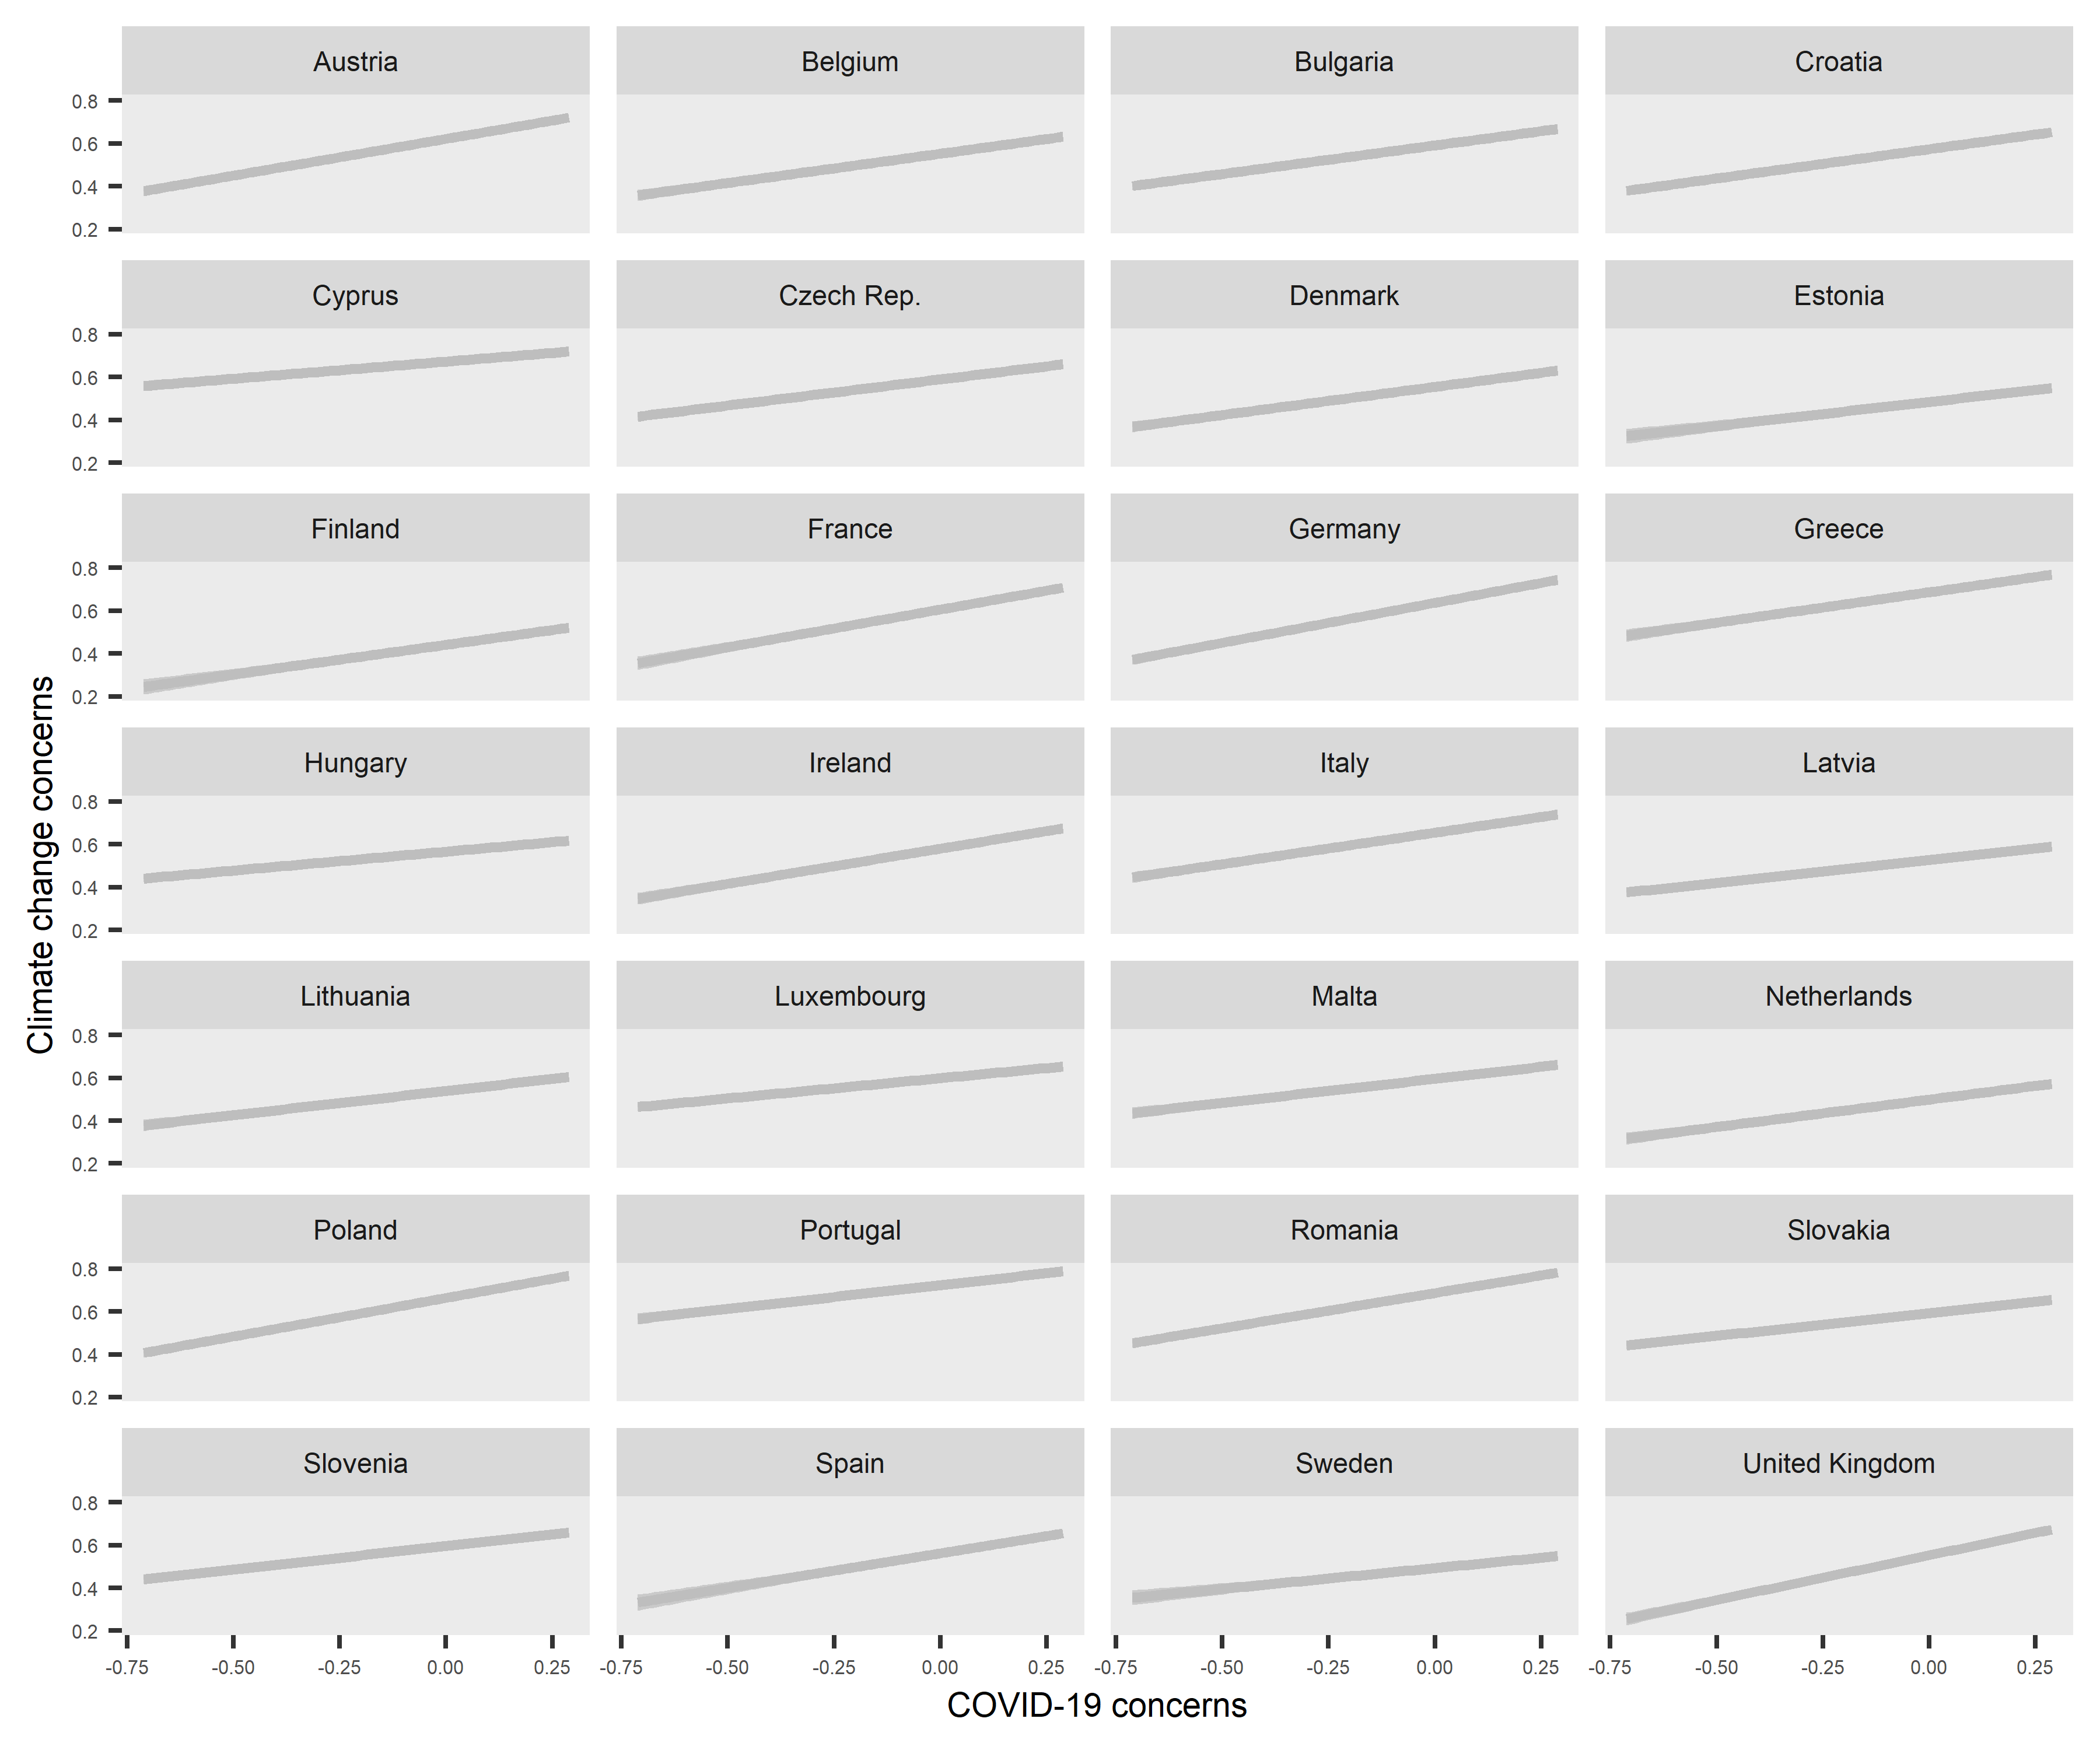
Fig. S6 Predicted per-country average slopes of COVID-19 concerns on climate change concerns with per-country random intercepts and 95% confidence intervals.

Table S6 Results of the final multilevel model predicting climate change concerns with standardized predictors.
 | Model 3 (with random slope)
 | B (SE)
Intercept | 0.589 ***  (0.008)
Individual-level predictors
COVID-19 concerns | 0.051 ***  (0.004)
Political orientation | -0.031 ***  (0.001)
Climate change awareness | 0.103 ***  (0.002)
Attribution scepticism | 0.014 ***  (0.002)
Perceived impact of climate change | 0.022 ***  (0.002)
Gender (Female) | 0.008 ***  (0.001)
Age | -0.029 ***  (0.001)
Education | -0.005 **  (0.001)
Country-level predictors
Total COVID-19 cases | 0.004  (0.011)
Total COVID-19 deathes | -0.025 *  (0.013)
Stringency index | 0.041 **  (0.014)
HDI | -0.030 ***  (0.009)
CRI | -0.026 **  (0.008)
Green party support | -0.001  (0.009)
Right-wing party support | 0.019 *  (0.010)
Interactions
COVID-19 concerns*Climate change awareness | 0.009 ***  (0.002)
COVID-19 concerns*Attribution scepticism | -0.008 ***  (0.002)
COVID-19 concerns*Perceived impact of climate change | -0.005 **  (0.002)
COVID-19 concerns*Education | -0.029 ***  (0.005)
Random Effects
Individual | 0.05
Country | 0.00
COVID-19 concerns | 0.00
ICC | 0.03
Observations | 21890
Marginal R² / Conditional R² | 0.335 / 0.355
AIC | 24947.334
log-Likelihood | -12449.667
Analysis weights were used.
* p<0.05 ** p<0.01 *** p<0.001.

Appendix D. Perceived impact of climate change

Table S7 Results of the multilevel models predicting perceived impact of climate change.
 | Null Model | Model 1 (Fixed-effects only) | Model 2  (With interactions) | Model 3  (with random slope)
 | b (se) | b (se) | b (se) | b (se)
Intercept | 0.670 ***  (0.007) | 0.681 ***  (0.006) | 0.680 ***  (0.006) | 0.679 ***  (0.006)
Individual-level predictors
COVID-19 concerns |  | 0.058 ***  (0.007) | 0.061 ***  (0.008) | 0.034  (0.022)
Political orientation |  | -0.022 ***  (0.004) | -0.023 ***  (0.004) | -0.021 ***  (0.004)
Climate change awareness |  | 0.136 ***  (0.008) | 0.140 ***  (0.008) | 0.133 ***  (0.008)
Attribution scepticism |  | 0.456 ***  (0.009) | 0.454 ***  (0.009) | 0.457 ***  (0.009)
Climate change concerns |  | 0.099 ***  (0.007) | 0.099 ***  (0.007) | 0.097 ***  (0.007)
Gender (Female) |  | -0.007 *  (0.003) | -0.006 *  (0.003) | -0.006  (0.003)
Age |  | 0.029 ***  (0.005) | 0.028 ***  (0.005) | 0.031 ***  (0.005)
Education |  | -0.007  (0.005) | -0.007  (0.005) | 0.000  (0.005)
Country-level predictors
Total COVID-19 cases |  | 0.038  (0.039) | 0.035  (0.039) | 0.057  (0.037)
Total COVID-19 deathes |  | -0.033  (0.040) | -0.032  (0.039) | -0.054  (0.037)
Stringency index |  | -0.054  (0.045) | -0.056  (0.045) | -0.055  (0.043)
HDI |  | 0.053 *  (0.025) | 0.053 *  (0.025) | 0.040  (0.023)
CRI |  | 0.005  (0.027) | 0.006  (0.027) | 0.005  (0.026)
Green party support |  | 0.007  (0.028) | 0.006  (0.028) | 0.002  (0.027)
Right-wing party support |  | -0.005  (0.035) | -0.006  (0.035) | 0.008  (0.033)
Interactions
COVID-19 concerns*Climate change awareness |  |  | 0.066 *  (0.028) | 0.065 *  (0.028)
COVID-19 concerns*Attribution scepticism |  |  | 0.078 **  (0.030) | 0.131 ***  (0.030)
COVID-19 concerns*Climate change concerns |  |  | -0.007  (0.025) | -0.003  (0.026)
COVID-19 concerns*Education |  |  | -0.017  (0.017) | -0.062 ***  (0.017)
Random Effects
Individual | 0.07 | 0.06 | 0.06 | 0.05
Country | 0.00 | 0.00 | 0.00 | 0.00
COVID-19 concerns |  |  |  | 0.01
ICC | 0.02 | 0.01 | 0.01 | 0.02
Observations | 27981 | 21890 | 21890 | 21890
Marginal R² / Conditional R² | 0.000 / 0.018 | 0.211 / 0.221 | 0.210 / 0.219 | 0.203 / 0.221
AIC | 44016.662 | 28554.462 | 28537.424 | 28328.440
log-Likelihood | -22005.331 | -14259.231 | -14246.712 | -14140.220
All independent variables are scaled between 0-1 and grand-mean centered, analysis weights were used, * p<0.05 ** p<0.01 *** p<0.001.

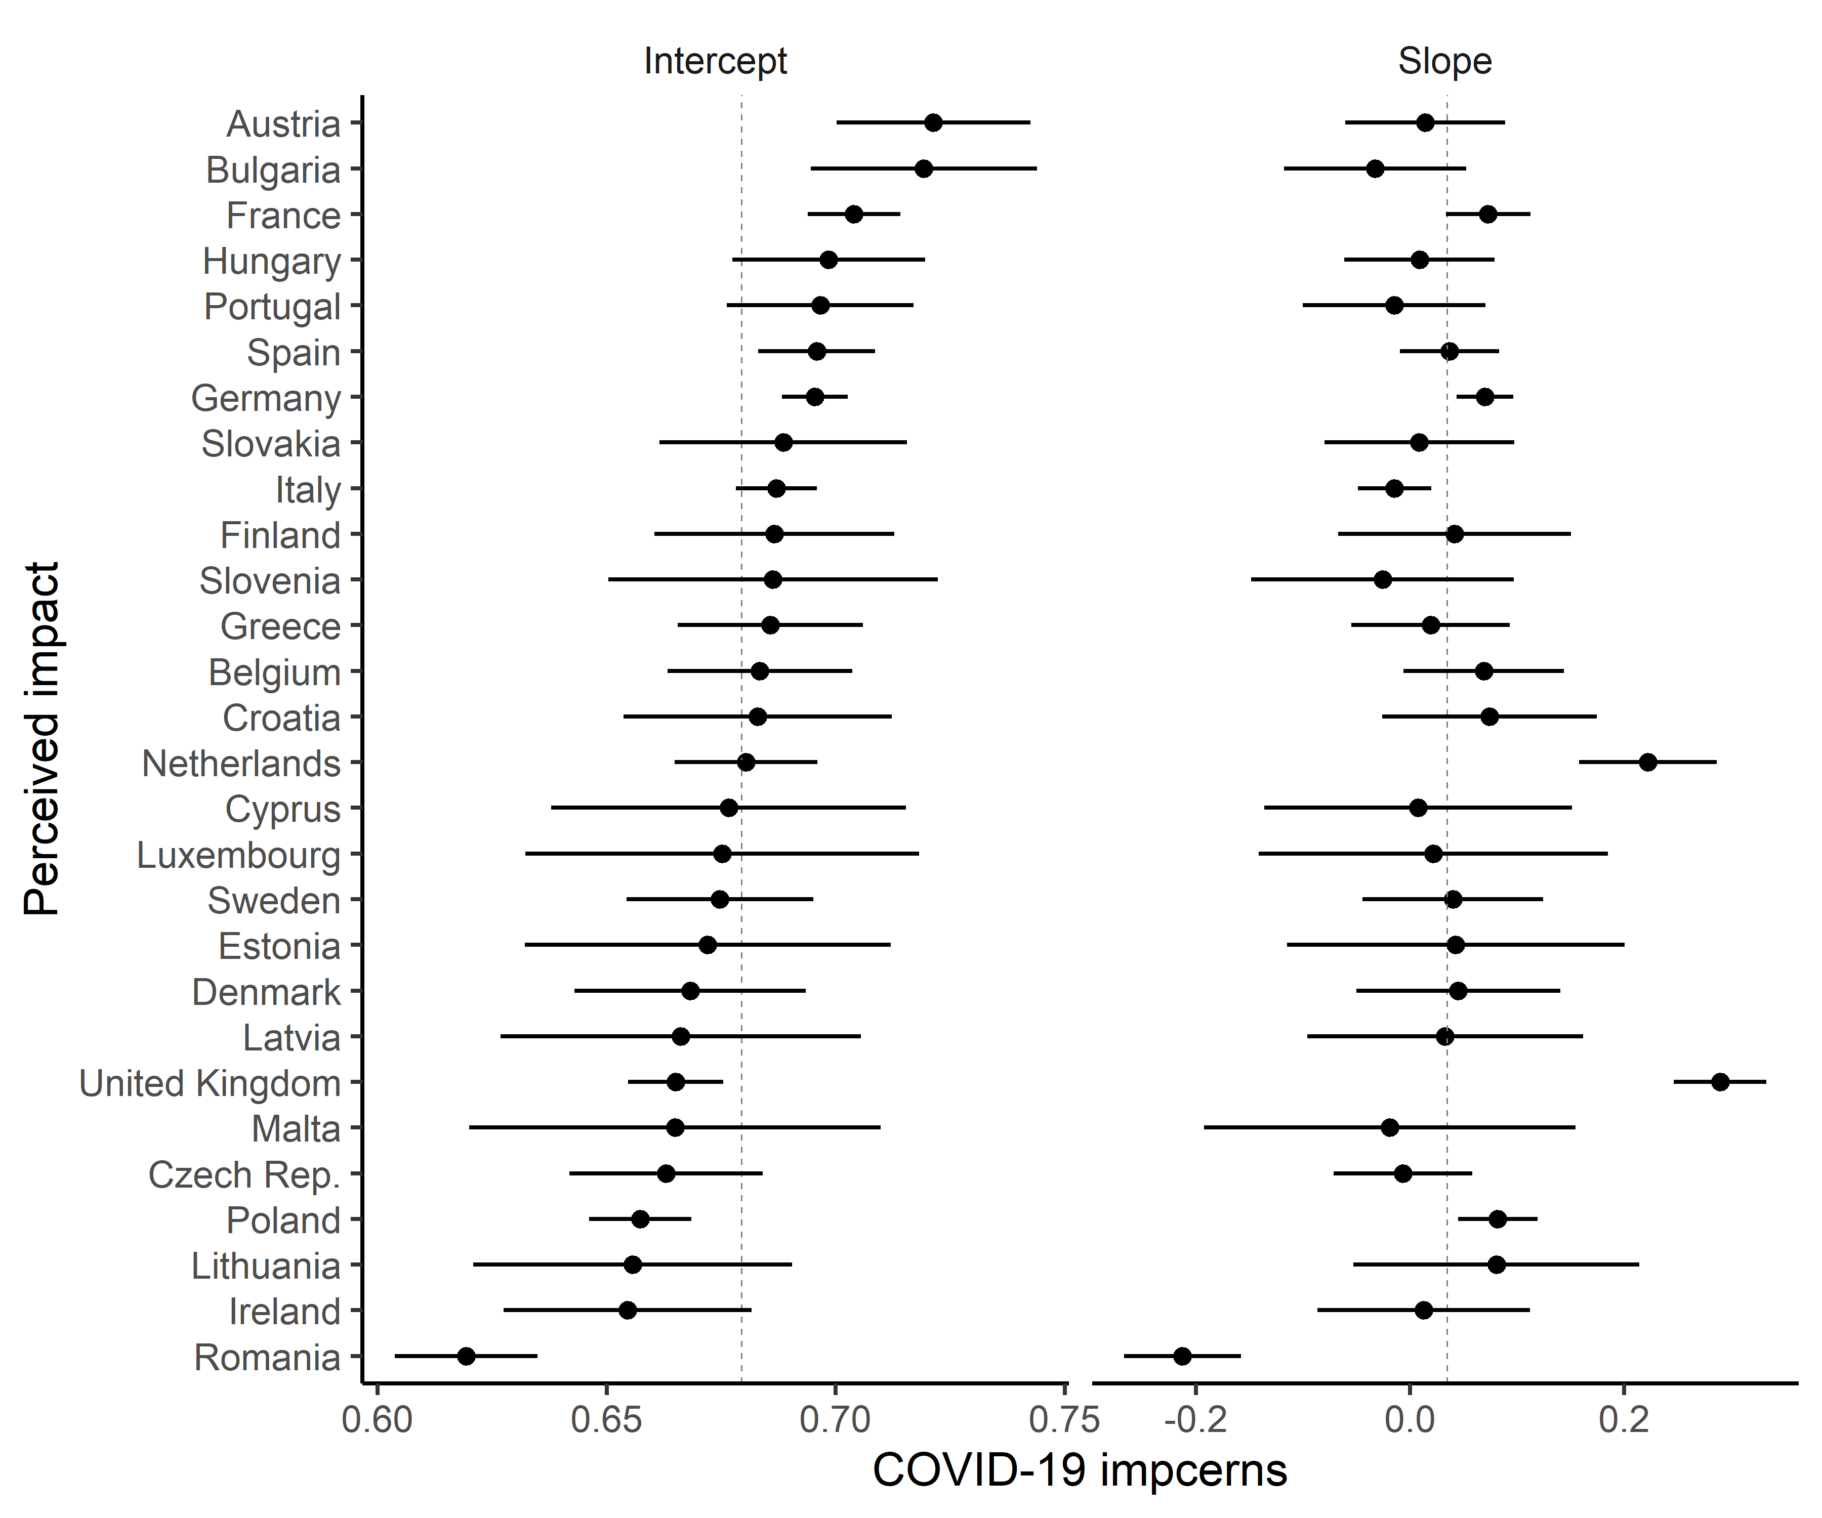
Fig. S7 Predicted per-country average intercepts and slopes (fixed+random effects) of COVID-19 concerns on perceived impact of climate change. Whiskers represent 95% confidence intervals. The vertical intermittent line represents the mean of the total sample.

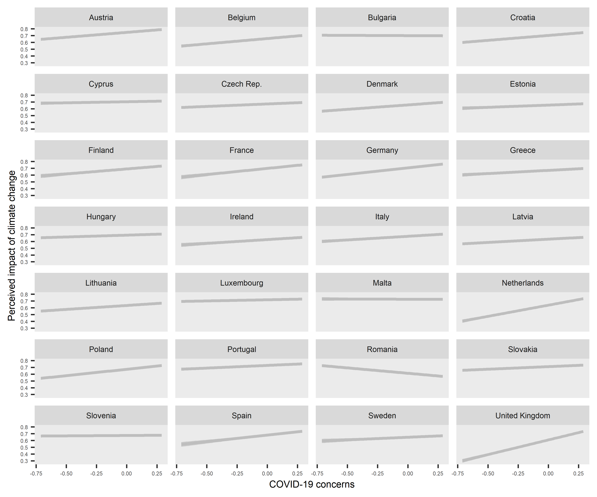
Fig. S8 Predicted per-country average slopes of COVID-19 concerns on perceived impact of climate change with per-country random intercepts and 95% confidence intervals.

Table S8 Results of the final multilevel model predicting perceived impact of climate change with standardized predictors.
 | Model 3 (with random slope)
 | B (SE)
Intercept | 0.677 ***  (0.006)
Individual-level predictors
COVID-19 concerns | 0.010  (0.006)
Political orientation | -0.009 ***  (0.002)
Climate change awareness | 0.030 ***  (0.002)
Attribution scepticism | 0.088 ***  (0.002)
Climate change concerns | 0.025 ***  (0.002)
Gender (Female) | -0.003  (0.002)
Age | 0.010 ***  (0.002)
Education | 0.000  (0.002)
Country-level predictors
Total COVID-19 cases | 0.014  (0.009)
Total COVID-19 deathes | -0.015  (0.010)
Stringency index | -0.014  (0.011)
HDI | 0.012  (0.007)
CRI | 0.001  (0.007)
Green party support | 0.000  (0.007)
Right-wing party support | 0.002  (0.008)
Interactions
COVID-19 concerns*Climate change awareness | 0.004 *  (0.002)
COVID-19 concerns*Attribution scepticism | 0.007 ***  (0.002)
COVID-19 concerns*Climate change concerns | -0.000  (0.002)
COVID-19 concerns*Education | -0.021 ***  (0.006)
Random Effects
Individual | 0.05
Country | 0.00
COVID-19 concerns | 0.00
ICC | 0.02
Observations | 21890
Marginal R² / Conditional R² | 0.203 / 0.221
AIC | 28328.440
log-Likelihood | -14140.220
Analysis weights were used.
* p<0.05 ** p<0.01 *** p<0.001.

Appendix E. Descriptive statistics of the variables

Table S9 Descriptive statistics of the demographic variables.
 | Gender | Age | Education | Political orientation
Country | % Female | Mean (SD) | Mean (SD) | Valid N | Mean (SD)
Austria (N=1000) | 51,90 | 0.566 (0.309) | 0.526 (0.334) | 864 | 0.465 (0.362)
Belgium (N=1000) | 50,80 | 0.557 (0.321) | 0.536 (0.397) | 789 | 0.528 (0.371)
Bulgaria (N=1000) | 52,10 | 0.595 (0.319) | 0.503 (0.343) | 735 | 0.636 (0.404)
Croatia (N=1000) | 52,20 | 0.565 (0.326) | 0.453 (0.316) | 798 | 0.343 (0.397)
Cyprus (N=1000) | 50,80 | 0.527 (0.314) | 0.543 (0.369) | 799 | 0.578 (0.401)
Czech Republic (N=1000) | 51,00 | 0.545 (0.320) | 0.522 (0.274) | 863 | 0.539 (0.322)
Denmark (N=1000) | 50,30 | 0.571 (0.328) | 0.508 (0.357) | 891 | 0.518 (0.427)
Estonia (N=1000) | 54,20 | 0.566 (0.318) | 0.604 (0.328) | 650 | 0.661 (0.379)
Finland (N=1000) | 51,00 | 0.583 (0.329) | 0.533 (0.346) | 771 | 0.479 (0.454)
France (N=1000) | 52,60 | 0.575 (0.320) | 0.460 (0.337) | 718 | 0.522 (0.440)
Germany (N=1000) | 51,20 | 0.582 (0.323) | 0.501 (0.299) | 913 | 0.443 (0.352)
Greece (N=1000) | 52,00 | 0.587 (0.319) | 0.498 (0.373) | 826 | 0.500 (0.382)
Hungary (N=1004) | 52,90 | 0.570 (0.319) | 0.484 (0.323) | 855 | 0.609 (0.337)
Ireland (N=1000) | 51,10 | 0.512 (0.320) | 0.532 (0.362) | 849 | 0.489 (0.354)
Italy (N=1000) | 51,90 | 0.592 (0.321) | 0.326 (0.350) | 848 | 0.498 (0.444)
Latvia (N=1000) | 55,30 | 0.580 (0.314) | 0.566 (0.306) | 661 | 0.628 (0.345)
Lithuania (N=1000) | 55,00 | 0.566 (0.309) | 0.552 (0.301) | 646 | 0.511 (0.391)
Luxembourg (N=1000) | 50,00 | 0.517 (0.305) | 0.593 (0.394) | 816 | 0.494 (0.401)
Malta (N=1000) | 50,00 | 0.534 (0.321) | 0.391 (0.410) | 668 | 0.467 (0.395)
Netherlands (N=1000) | 51,00 | 0.560 (0.322) | 0.493 (0.378) | 897 | 0.520 (0.374)
Poland (N=1000) | 52,30 | 0.557 (0.316) | 0.438 (0.392) | 869 | 0.542 (0.402)
Portugal (N=1000) | 53,90 | 0.590 (0.312) | 0.309 (0.392) | 824 | 0.421 (0.444)
Romania (N=1000) | 51,60 | 0.559 (0.314) | 0.450 (0.318) | 791 | 0.678 (0.353)
Slovakia (N=1000) | 51,70 | 0.542 (0.312) | 0.531 (0.289) | 787 | 0.556 (0.348)
Slovenia (N=1000) | 50,40 | 0.581 (0.312) | 0.512 (0.308) | 769 | 0.404 (0.394)
Spain (N=1000) | 51,80 | 0.567 (0.304) | 0.396 (0.417) | 938 | 0.408 (0.382)
Sweden (N=1000) | 49,50 | 0.522 (0.322) | 0.553 (0.346) | 908 | 0.535 (0.432)
United Kingdom (N=1000) | 48,30 | 0.547 (0.321) | 0.601 (0.348) | 900 | 0.385 (0.417)

Table S10 Descriptive statistics of the climate change perceptions variables.
 | Climate change awareness |  | Attribution scepticism |  | Climate change concerns |  | Perceived impact of climate change
Country | Valid N | Mean (SD) | Valid N | Mean (SD) | Valid N | Mean (SD) | Valid N | Mean (SD)
Austria (N=1000) | 976 | 0.820 (0.260) | 983 | 0.676 (0.188) | 983 | 0.598 (0.284) | 1000 | 0.738 (0.211)
Belgium (N=1000) | 968 | 0.818 (0.241) | 968 | 0.649 (0.220) | 983 | 0.547 (0.256) | 1000 | 0.634 (0.269)
Bulgaria (N=1000) | 984 | 0.902 (0.188) | 990 | 0.697 (0.164) | 993 | 0.579 (0.257) | 1000 | 0.735 (0.222)
Croatia (N=1000) | 988 | 0.799 (0.229) | 987 | 0.693 (0.198) | 993 | 0.546 (0.240) | 1000 | 0.683 (0.242)
Cyprus (N=1000) | 988 | 0.865 (0.228) | 990 | 0.766 (0.225) | 989 | 0.697 (0.263) | 1000 | 0.705 (0.260)
Czech Republic (N=1000) | 948 | 0.768 (0.239) | 973 | 0.683 (0.197) | 985 | 0.551 (0.252) | 1000 | 0.652 (0.219)
Denmark (N=1000) | 960 | 0.811 (0.219) | 966 | 0.669 (0.182) | 987 | 0.549 (0.241) | 1000 | 0.649 (0.238)
Estonia (N=1000) | 981 | 0.793 (0.247) | 987 | 0.645 (0.189) | 990 | 0.470 (0.246) | 1000 | 0.631 (0.227)
Finland (N=1000) | 973 | 0.801 (0.246) | 984 | 0.676 (0.201) | 988 | 0.426 (0.257) | 1000 | 0.687 (0.228)
France (N=1000) | 954 | 0.826 (0.247) | 952 | 0.678 (0.219) | 985 | 0.620 (0.271) | 1000 | 0.702 (0.249)
Germany (N=1000) | 976 | 0.819 (0.258) | 982 | 0.675 (0.203) | 991 | 0.632 (0.279) | 1000 | 0.694 (0.236)
Greece (N=1000) | 985 | 0.774 (0.258) | 989 | 0.657 (0.204) | 997 | 0.677 (0.287) | 1000 | 0.652 (0.275)
Hungary (N=1004) | 992 | 0.925 (0.167) | 998 | 0.691 (0.151) | 997 | 0.559 (0.255) | 981 | 0.691 (0.228)
Ireland (N=1000) | 969 | 0.822 (0.225) | 984 | 0.667 (0.214) | 989 | 0.607 (0.267) | 1000 | 0.625 (0.271)
Italy (N=1000) | 971 | 0.859 (0.210) | 981 | 0.705 (0.192) | 985 | 0.661 (0.252) | 1000 | 0.656 (0.287)
Latvia (N=1000) | 984 | 0.799 (0.242) | 991 | 0.638 (0.186) | 993 | 0.417 (0.234) | 1000 | 0.584 (0.210)
Lithuania (N=1000) | 977 | 0.842 (0.217) | 979 | 0.652 (0.177) | 985 | 0.496 (0.240) | 1000 | 0.626 (0.241)
Luxembourg (N=1000) | 978 | 0.879 (0.231) | 973 | 0.693 (0.188) | 987 | 0.620 (0.259) | 1000 | 0.703 (0.256)
Malta (N=1000) | 978 | 0.926 (0.142) | 989 | 0.741 (0.152) | 990 | 0.703 (0.235) | 1000 | 0.666 (0.273)
Netherlands (N=1000) | 974 | 0.796 (0.271) | 976 | 0.621 (0.228) | 983 | 0.501 (0.296) | 1000 | 0.638 (0.267)
Poland (N=1000) | 958 | 0.819 (0.225) | 967 | 0.673 (0.186) | 984 | 0.650 (0.250) | 1000 | 0.677 (0.235)
Portugal (N=1000) | 994 | 0.943 (0.158) | 992 | 0.751 (0.145) | 997 | 0.739 (0.192) | 1000 | 0.731 (0.269)
Romania (N=1000) | 980 | 0.890 (0.196) | 974 | 0.719 (0.215) | 992 | 0.692 (0.251) | 1000 | 0.622 (0.338)
Slovakia (N=1000) | 980 | 0.877 (0.200) | 981 | 0.728 (0.171) | 981 | 0.566 (0.213) | 1000 | 0.704 (0.231)
Slovenia (N=1000) | 980 | 0.836 (0.232) | 986 | 0.664 (0.177) | 991 | 0.553 (0.232) | 1000 | 0.674 (0.225)
Spain (N=1000) | 985 | 0.848 (0.232) | 987 | 0.712 (0.197) | 993 | 0.620 (0.238) | 1000 | 0.717 (0.263)
Sweden (N=1000) | 966 | 0.793 (0.237) | 960 | 0.678 (0.203) | 979 | 0.500 (0.265) | 1000 | 0.648 (0.254)
United Kingdom (N=1000) | 963 | 0.838 (0.238) | 976 | 0.600 (0.217) | 989 | 0.612 (0.315) | 1000 | 0.631 (0.322)

Table S11 Descriptive statistics of the COVID-19 related variables.
 | COVID-19 concerns |  | Total COVID-19 cases | Total COVID-19 deathes | Stringency index
Country | Valid N | Mean (SD) | Per million | Per million | Score
Austria (N=1000) | 977 | 0.666 (0.286) | 4761,574 | 88,142 | 38,735
Belgium (N=1000) | 977 | 0.739 (0.273) | 10323,954 | 864,797 | 50,167
Bulgaria (N=1000) | 986 | 0.635 (0.306) | 2967,486 | 115,363 | 35,949
Croatia (N=1000) | 986 | 0.670 (0.325) | 3972,757 | 65,432 | 28,700
Cyprus (N=1000) | 990 | 0.767 (0.295) | 1981,144 | 25,878 | 53,227
Czech Republic (N=1000) | 983 | 0.567 (0.310) | 6491,390 | 61,928 | 41,431
Denmark (N=1000) | 986 | 0.651 (0.267) | 4543,920 | 111,866 | 48,675
Estonia (N=1000) | 990 | 0.748 (0.256) | 2423,948 | 49,193 | 25,431
Finland (N=1000) | 994 | 0.735 (0.245) | 1792,034 | 61,790 | 32,943
France (N=1000) | 980 | 0.792 (0.255) | 8790,072 | 486,660 | 48,042
Germany (N=1000) | 990 | 0.700 (0.269) | 3458,102 | 113,089 | 49,777
Greece (N=1000) | 988 | 0.781 (0.281) | 1667,585 | 35,725 | 55,649
Hungary (N=1004) | 988 | 0.638 (0.305) | 2454,498 | 79,099 | 41,690
Ireland (N=1000) | 987 | 0.792 (0.268) | 7233,680 | 364,826 | 59,031
Italy (N=1000) | 986 | 0.713 (0.259) | 5194,786 | 593,004 | 50,403
Latvia (N=1000) | 985 | 0.551 (0.331) | 996,821 | 19,698 | 36,921
Lithuania (N=1000) | 980 | 0.681 (0.297) | 1647,980 | 34,030 | 32,844
Luxembourg (N=1000) | 980 | 0.708 (0.296) | 13257,984 | 201,245 | 46,293
Malta (N=1000) | 997 | 0.845 (0.240) | 6747,088 | 65,041 | 43,659
Netherlands (N=1000) | 983 | 0.729 (0.246) | 7208,770 | 375,499 | 55,131
Poland (N=1000) | 989 | 0.700 (0.306) | 2460,352 | 66,280 | 28,942
Portugal (N=1000) | 996 | 0.777 (0.224) | 7233,894 | 192,056 | 57,751
Romania (N=1000) | 989 | 0.749 (0.303) | 6484,581 | 244,948 | 44,112
Slovakia (N=1000) | 972 | 0.614 (0.310) | 1928,768 | 8,590 | 36,751
Slovenia (N=1000) | 983 | 0.596 (0.317) | 2706,308 | 71,647 | 49,002
Spain (N=1000) | 994 | 0.892 (0.206) | 15382,780 | 670,143 | 61,504
Sweden (N=1000) | 987 | 0.781 (0.230) | 9096,651 | 581,758 | 55,560
United Kingdom (N=1000) | 993 | 0.836 (0.216) | 6781,527 | 621,632 | 65,775

Table S11 Descriptive statistics of the country-level variables.
 | HDI | CRI | Green party support | Right-wing party support
Country | Score | Score | % | %
Austria (N=1000) | 0,908 | 56,000 | 14 | 12
Belgium (N=1000) | 0,916 | 81,830 | 19 | 25
Bulgaria (N=1000) | 0,813 | 101,000 | 9 | 1
Croatia (N=1000) | 0,831 | 108,330 | 10 | 9
Cyprus (N=1000) | 0,869 | 73,500 | 6 | 6
Czech Republic (N=1000) | 0,888 | 46,830 | 1 | 8
Denmark (N=1000) | 0,929 | 61,330 | 8 | 6
Estonia (N=1000) | 0,871 | 90,500 | 3 | 16
Finland (N=1000) | 0,920 | 125,000 | 11 | 19
France (N=1000) | 0,901 | 46,170 | 8 | 25
Germany (N=1000) | 0,936 | 13,830 | 19 | 10
Greece (N=1000) | 0,870 | 23,670 | 0 | 5
Hungary (N=1004) | 0,838 | 107,170 | 2 | 2
Ireland (N=1000) | 0,938 | 76,500 | 5 | 2
Italy (N=1000) | 0,880 | 33,670 | 2 | 25
Latvia (N=1000) | 0,847 | 50,000 | 13 | 14
Lithuania (N=1000) | 0,858 | 29,330 | 18 | 0
Luxembourg (N=1000) | 0,904 | 84,330 | 12 | 10
Malta (N=1000) | 0,878 | 125,000 | 2 | 0
Netherlands (N=1000) | 0,931 | 67,170 | 12 | 22
Poland (N=1000) | 0,865 | 49,000 | 25 | 42
Portugal (N=1000) | 0,847 | 70,670 | 6 | 6
Romania (N=1000) | 0,811 | 81,670 | 1 | 9
Slovakia (N=1000) | 0,855 | 88,330 | 0 | 2
Slovenia (N=1000) | 0,896 | 57,830 | 2 | 7
Spain (N=1000) | 0,891 | 47,670 | 1 | 16
Sweden (N=1000) | 0,933 | 89,000 | 4 | 20
United Kingdom (N=1000) | 0,922 | 73,830 | 4 | 1

Table S12 List of green and right-wing parties [38].
Country | Green party | Right-wing party
Austria | The Greens – The Green Alternative | Freedom Party of Austria
Belgium | Green+ECOLO | Flemish Interest
Bulgaria | Green Party of Bulgaria/The Green Movement) | Attack
Croatia | We Can! – Political Platform | Miroslav Škoro Homeland Movement
Cyprus | Movement of Ecologists – Citizens’ Cooperation | Ethniko Laiko Metopo (ELAM)
Czech Republic | Green Party (SZ) | Freedom and Direct Democracy
Denmark | Socialist People’s Party (SF) | Danish People's Party
Estonia | Estonian Greens | Conservative People’s Party of Estonia
Finland | Green League | Finns Party/True Finns
France | Europe Ecology – The Greens | National Rally
Germany | Alliance ‘90/The Greens | Alternative for Germany
Greece | Ecologist Greens | Greek Solution
Hungary | Politics can be different (LMP) | Our Home Movement
Ireland | Green Party – Comhaontas Glas | Renua Ireland
Italy | Green Europe | League
Latvia | Union of Greens and Farmers | National Alliance+Who Owns the State?
Lithuania | Lithuanian Farmers and Greens Union
Luxembourg | The Greens | Alternativ Demokratesch Reformpartei
Malta | Alternative Democracy | Maltese Patriots Movement
Netherlands | Green Left | Party for Freedom
Poland | Green Party | Law and Justice/United Right
Portugal | Unitary Democratic Coalition (Ecologist Party ’The Greens’ (PEV) + Portuguese Communist Party) | Enough (Chega)
Romania | Romanian Ecologist Party | Alliance for the Unity of Romanians
Slovakia |  | Slovak National Party
Slovenia | Andrej Čuš and Greens of Slovenia | New Slovenia
Spain | Animalist Party Against Mistreatment of Animals | Vox
Sweden | Green Party | Sweden Democrats
United Kingdom | Green Party of England and Wales (GPEW) | UK Independence Party

