SUPPLEMENTARY MATERIAL

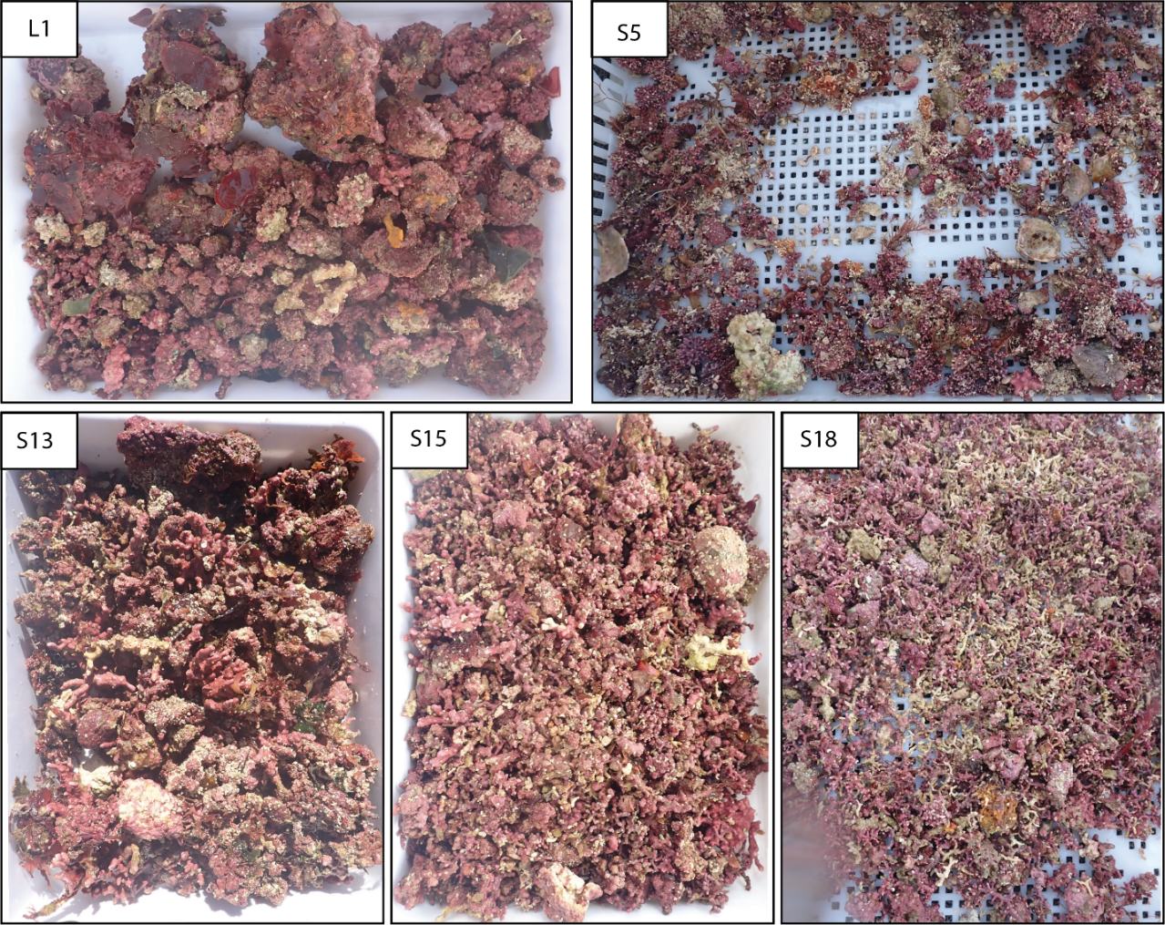
Fig. S1: Example of a dredge for each station.
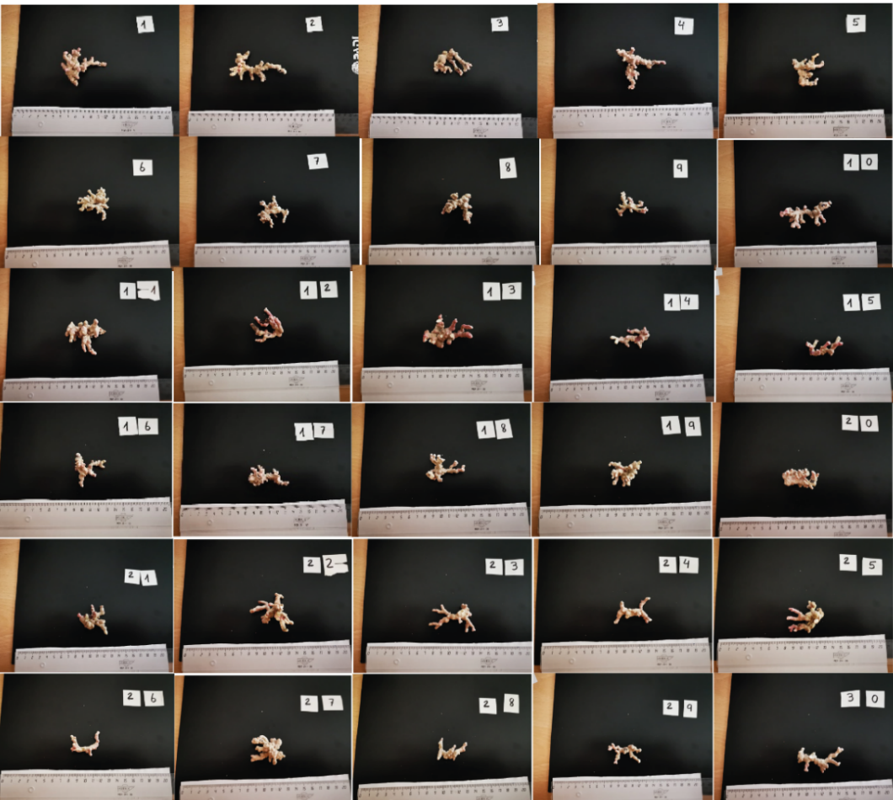
Fig. S2: Images of the 30 individual rhodoliths selected for the 2D/3D study.
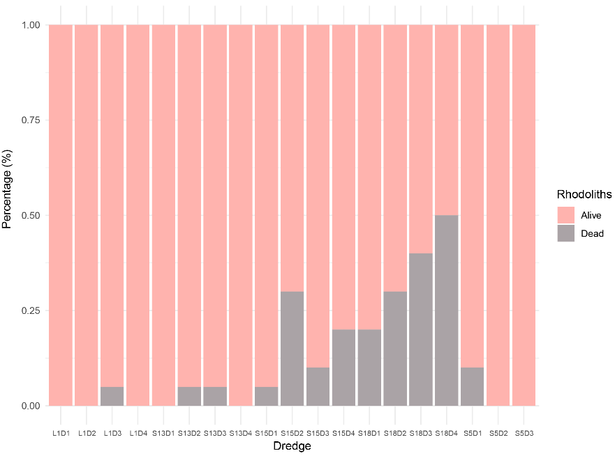
Fig. S3: Proportions of dead rhodoliths found in each dredge.

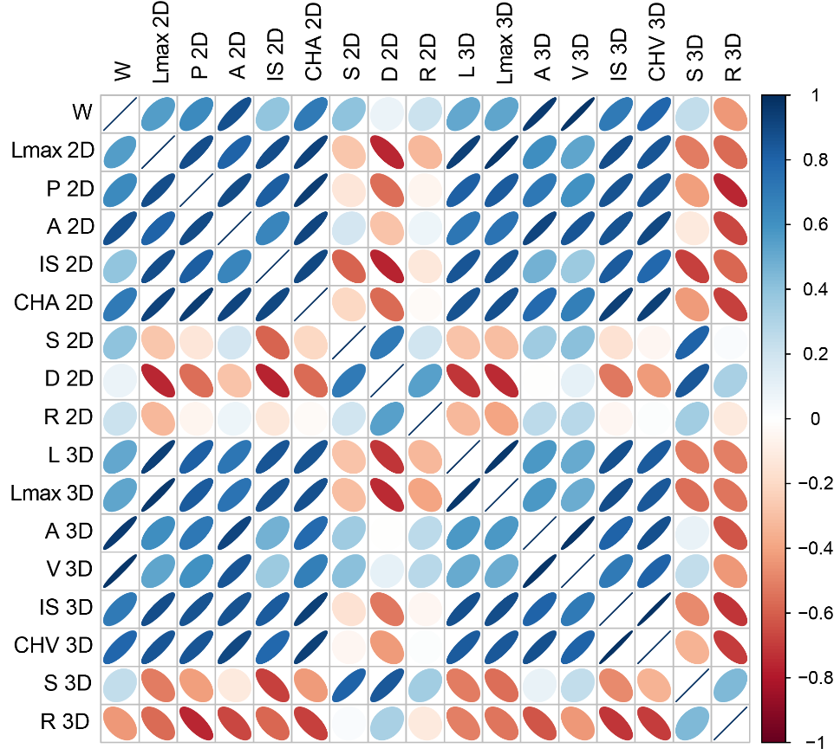
Fig. S4: Pearson correlations between 2D and 3D measurements.

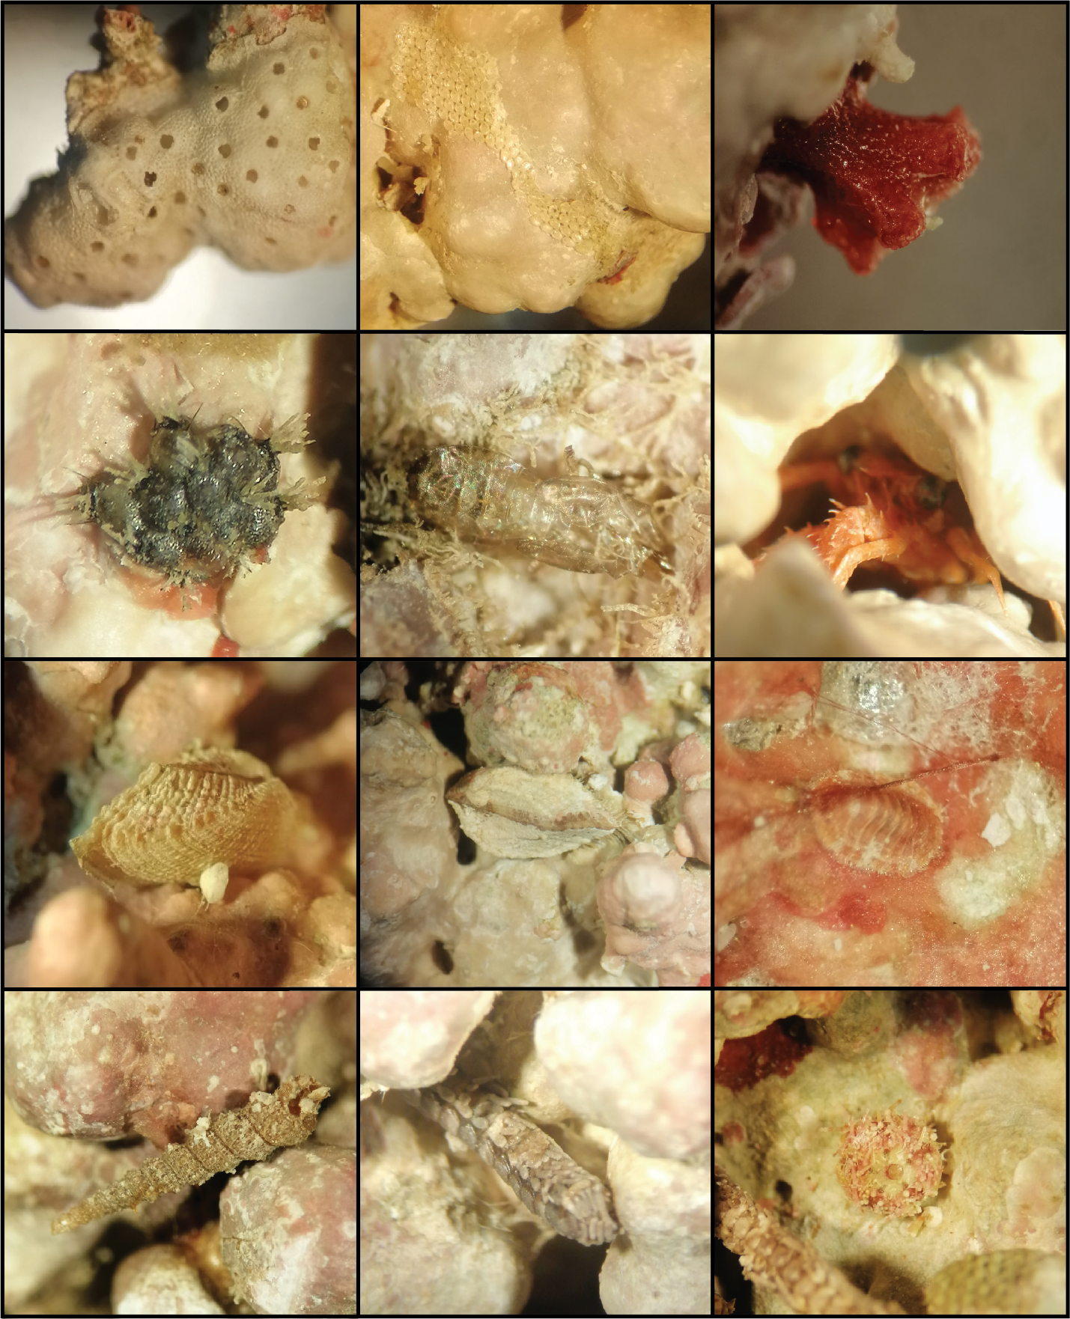
Fig.S5: Example of cryptofauna found between interstitial spaces in branched forms.
Table S1: Proportions of morphologies and growth forms in the study area.

 | Station | S05 |  |  | S13 |  |  |  | S15 |  |  |  | S18 |  |  |  | L1
 | Dredge | D1 | D2 | D3 | D1 | D2 | D3 | D4 | D1 | D2 | D3 | D4 | D1 | D2 | D3 | D4 | D1 | D2 | D3 | D4 | TOTAL
Branched | A | 1 | 0 | 2 | 42 | 41 | 34 | 56 | 40 | 47 | 76 | 33 | 2 | 4 | 0 | 0 | 8 | 1 | 6 | 0 | 393
Branched | B | 0 | 0 | 0 | 29 | 15 | 20 | 34 | 108 | 33 | 60 | 0 | 84 | 0 | 73 | 41 | 47 | 5 | 17 | 4 | 570
Branched | C | 0 | 0 | 0 | 0 | 16 | 18 | 22 | 134 | 67 | 95 | 110 | 169 | 322 | 255 | 153 | 45 | 45 | 4 | 0 | 1455
Branched | D | 116 | 33 | 86 | 0 | 0 | 0 | 0 | 3 | 0 | 0 | 0 | 0 | 0 | 0 | 22 | 0 | 0 | 0 | 3 | 263
Praline | E | 0 | 0 | 0 | 15 | 32 | 0 | 13 | 37 | 76 | 24 | 116 | 76 | 57 | 39 | 0 | 36 | 17 | 14 | 0 | 552
Praline | F | 30 | 1 | 42 | 0 | 0 | 0 | 0 | 0 | 0 | 0 | 0 | 0 | 19 | 0 | 2 | 0 | 0 | 29 | 0 | 123
Praline | G | 2 | 0 | 0 | 0 | 0 | 26 | 0 | 0 | 2 | 0 | 15 | 0 | 0 | 18 | 1 | 0 | 0 | 0 | 0 | 64
Boxwork | H | 0 | 1 | 0 | 6 | 11 | 7 | 19 | 67 | 24 | 4 | 29 | 0 | 28 | 23 | 13 | 12 | 10 | 43 | 16 | 313
Boxwork | I | 2 | 0 | 0 | 15 | 8 | 0 | 5 | 0 | 0 | 7 | 0 | 36 | 0 | 0 | 0 | 44 | 5 | 9 | 13 | 144
 | TOTAL | 151 | 35 | 130 | 107 | 123 | 105 | 149 | 389 | 249 | 266 | 303 | 367 | 430 | 408 | 232 | 192 | 83 | 122 | 36 | 3877
Table S2. Random selected, measured and weighted rhodoliths.
 | S05 | S13 | S15 | S18 | L1 | Total
A | 1 | 5 | 5 | 5 | 5 | 21
B | 0 | 5 | 5 | 5 | 5 | 20
C | 2 | 5 | 5 | 5 | 5 | 22
D | 12 | 1 | 2 | 5 | 0 | 20
E | 0 | 6 | 6 | 6 | 4 | 22
F | 7 | 1 | 4 | 3 | 5 | 20
G | 1 | 6 | 5 | 6 | 3 | 21
H | 1 | 5 | 4 | 5 | 6 | 21
I | 3 | 5 | 4 | 5 | 5 | 22
Total | 27 | 39 | 41 | 44 | 38 | 189

Table S3: 2D-3D measurements in 30 rhodoliths from morphotype A
Site | Code | W (gr) | Feret-2D  (mm) | P-2D  (mm) | A-2D  (mm²) | IS-2D  (mm²) | CHA-2D  (mm²) | S-2D | D-2D | R-2D | L-3D  (mm) | Feret-3D (mm) | A-3D  (mm²) | Vol-3D  (mm³) | IS-3D  (mm³) | CHV-3D  (mm³) | S-3D | R-3D
S13 | rod01 | 14.48 | 65.98 | 318.40 | 1291.55 | 898.38 | 2189.93 | 0.58 | 0.26 | 0.82 | 39.21 | 64.23 | 5362.23 | 8517.53 | 30439.48 | 38957.02 | 0.22 | 0.39
S13 | rod02 | 11.82 | 85.68 | 375.42 | 1313.61 | 1330.69 | 2644.31 | 0.49 | 0.19 | 0.43 | 46.35 | 75.35 | 4556.28 | 6685.52 | 38091.05 | 44776.57 | 0.15 | 0.39
S13 | rod03 | 11.22 | 54.81 | 287.14 | 970.07 | 452.20 | 1422.27 | 0.68 | 0.29 | 0.63 | 30.38 | 53.46 | 3629.24 | 6168.41 | 15235.34 | 21403.75 | 0.29 | 0.46
S13 | rod04 | 13.75 | 68.89 | 297.11 | 1030.79 | 1102.16 | 2132.94 | 0.48 | 0.25 | 0.93 | 37.03 | 61.55 | 4982.04 | 7660.13 | 31915.26 | 39575.40 | 0.19 | 0.39
S13 | rod05 | 9.21 | 47.85 | 242.19 | 837.74 | 504.85 | 1342.60 | 0.62 | 0.31 | 0.87 | 28.32 | 50.88 | 3827.79 | 5243.44 | 17289.84 | 22533.28 | 0.23 | 0.40
S15 | rod06 | 11.49 | 44.39 | 220.36 | 853.75 | 417.87 | 1271.62 | 0.67 | 0.36 | 0.82 | 25.64 | 46.13 | 4261.93 | 6098.49 | 16324.61 | 22423.10 | 0.27 | 0.40
S15 | rod07 | 8.36 | 46.12 | 248.73 | 785.75 | 606.85 | 1392.60 | 0.56 | 0.32 | 0.88 | 22.39 | 42.15 | 3300.43 | 4398.77 | 13171.78 | 17570.55 | 0.25 | 0.42
S15 | rod08 | 10.10 | 45.96 | 203.07 | 747.60 | 435.87 | 1183.47 | 0.63 | 0.34 | 0.81 | 24.48 | 43.54 | 3322.90 | 4731.14 | 11364.73 | 16095.87 | 0.29 | 0.44
S15 | rod09 | 4.98 | 42.81 | 222.32 | 523.92 | 379.54 | 903.46 | 0.57 | 0.29 | 0.61 | 23.89 | 42.56 | 2360.24 | 2476.70 | 11607.10 | 14083.81 | 0.18 | 0.39
S15 | rod10 | 13.88 | 85.61 | 380.15 | 1528.93 | 1050.45 | 2579.38 | 0.59 | 0.20 | 0.42 | 39.84 | 72.12 | 5388.93 | 7557.70 | 34894.76 | 42452.47 | 0.18 | 0.36
S13 | rod11 | 18.26 | 59.41 | 291.93 | 1359.23 | 734.74 | 2093.98 | 0.64 | 0.32 | 0.81 | 31.75 | 56.26 | 6381.20 | 11454.98 | 31195.98 | 42650.96 | 0.27 | 0.41
S13 | rod12 | 8.32 | 47.58 | 282.65 | 888.68 | 533.66 | 1422.34 | 0.62 | 0.31 | 0.90 | 26.20 | 47.27 | 3308.97 | 4315.26 | 13703.31 | 18018.57 | 0.24 | 0.40
S13 | rod13 | 16.93 | 73.70 | 330.34 | 1412.67 | 828.70 | 2241.37 | 0.63 | 0.25 | 0.50 | 36.49 | 63.92 | 5050.74 | 8240.61 | 27294.15 | 35534.75 | 0.23 | 0.41
S13 | rod14 | 8.54 | 55.60 | 221.15 | 704.95 | 420.12 | 1125.08 | 0.62 | 0.26 | 0.42 | 31.69 | 54.71 | 3128.58 | 4825.84 | 14516.96 | 19342.81 | 0.25 | 0.46
S13 | rod15 | 5.86 | 48.50 | 203.03 | 533.86 | 367.30 | 901.16 | 0.59 | 0.27 | 0.41 | 26.18 | 49.85 | 2533.43 | 3171.41 | 10895.90 | 14067.31 | 0.23 | 0.43
S15 | rod16 | 6.26 | 44.30 | 203.00 | 568.84 | 458.09 | 1026.93 | 0.55 | 0.30 | 0.87 | 25.25 | 42.53 | 2507.08 | 3545.70 | 11018.06 | 14563.76 | 0.24 | 0.47
S15 | rod17 | 7.78 | 47.21 | 178.39 | 546.52 | 298.72 | 845.23 | 0.64 | 0.30 | 0.44 | 31.02 | 50.81 | 2946.33 | 4184.77 | 11937.66 | 16122.42 | 0.26 | 0.45
S15 | rod18 | 8.67 | 52.05 | 245.87 | 713.04 | 543.70 | 1256.74 | 0.57 | 0.28 | 0.69 | 28.21 | 49.84 | 3398.97 | 4649.62 | 15813.34 | 20462.96 | 0.23 | 0.41
S15 | rod19 | 9.12 | 43.99 | 197.08 | 659.83 | 251.40 | 911.23 | 0.72 | 0.34 | 0.74 | 24.20 | 41.88 | 3402.35 | 5118.06 | 10543.34 | 15661.40 | 0.33 | 0.45
S15 | rod20 | 12.07 | 45.84 | 184.33 | 765.59 | 158.68 | 924.27 | 0.82 | 0.36 | 0.49 | 25.08 | 47.01 | 3810.96 | 6169.83 | 11321.29 | 17491.12 | 0.35 | 0.46
S13 | rod21 | 10.71 | 46.74 | 189.75 | 664.34 | 369.54 | 1033.88 | 0.64 | 0.34 | 0.82 | 27.92 | 48.18 | 3703.62 | 6469.84 | 14736.22 | 21206.06 | 0.31 | 0.48
S13 | rod22 | 10.22 | 55.30 | 261.95 | 858.93 | 657.28 | 1516.21 | 0.56 | 0.28 | 0.71 | 30.60 | 57.21 | 4248.30 | 5738.78 | 26830.28 | 32569.05 | 0.18 | 0.38
S13 | rod23 | 8.94 | 59.40 | 278.44 | 716.49 | 928.86 | 1645.35 | 0.43 | 0.25 | 0.53 | 34.81 | 60.51 | 3002.25 | 4144.11 | 15150.06 | 19294.16 | 0.21 | 0.43
S13 | rod24 | 7.27 | 55.85 | 200.01 | 569.77 | 726.81 | 1296.59 | 0.44 | 0.25 | 0.54 | 28.78 | 55.79 | 2392.32 | 3418.93 | 15756.04 | 19174.98 | 0.18 | 0.48
S13 | rod25 | 11.29 | 46.67 | 241.64 | 813.90 | 444.85 | 1258.76 | 0.64 | 0.34 | 0.67 | 26.62 | 48.28 | 3913.45 | 6119.77 | 16384.02 | 22503.80 | 0.27 | 0.44
S15 | rod26 | 4.17 | 42.59 | 158.68 | 391.49 | 495.10 | 886.59 | 0.44 | 0.27 | 0.58 | 26.01 | 43.84 | 1625.88 | 1921.33 | 8427.76 | 10349.09 | 0.19 | 0.48
S15 | rod27 | 14.66 | 45.58 | 231.62 | 881.00 | 358.72 | 1239.72 | 0.71 | 0.39 | 0.82 | 25.63 | 46.04 | 4383.88 | 7699.53 | 13725.90 | 21425.43 | 0.36 | 0.45
S15 | rod28 | 5.37 | 42.95 | 164.10 | 437.77 | 377.45 | 815.22 | 0.53 | 0.29 | 0.57 | 25.00 | 45.88 | 1971.54 | 2734.67 | 8223.53 | 10958.20 | 0.25 | 0.51
S15 | rod29 | 5.58 | 51.04 | 224.26 | 540.06 | 625.47 | 1165.53 | 0.46 | 0.25 | 0.51 | 25.77 | 48.89 | 2111.20 | 2631.18 | 9565.64 | 12196.81 | 0.22 | 0.45
S15 | rod30 | 9.39 | 60.06 | 278.27 | 789.62 | 825.14 | 1614.77 | 0.49 | 0.25 | 0.40 | 34.15 | 61.23 | 3294.93 | 4388.91 | 26907.68 | 31296.59 | 0.14 | 0.41

Table S4: CaCo3 content of each dredge. Showing the weight (g) of the carbonates, their volume and the percentage they represent.
Dredge | Weight (g) | Volume (mm³) | Percentage (%)
L1D1 | 0.2504 | 56.5 | 95.69
L1D2 | 0.2503 | 56 | 94.88
L1D3 | 0.2501 | 53.5 | 90.71
L1D4 | 0.2504 | 56.5 | 95.69
S5D1 | 0.2506 | 56 | 94.76
S5D2 | 0.2500 | 56.5 | 95.84
S5D3 | 0.2504 | 55.5 | 93.99
S13D1 | 0.2503 | 56 | 95.65
S13D2 | 0.2500 | 56 | 95.76
S13D3 | 0.2505 | 57 | 97.28
S13D4 | 0.2500 | 56.5 | 96.62
S15D1 | 0.2502 | 57 | 97.40
S15D2 | 0.2503 | 56.7 | 96.50
S15D3 | 0.2506 | 57.5 | 98.09
S15D4 | 0.2506 | 55 | 96.34
S18D1 | 0.2502 | 56 | 98.25
S18D2 | 0.2501 | 55.5 | 97.41
S18D3 | 0.2505 | 56 | 98.13
S18D4 | 0.2505 | 56.5 | 99.00

