ABA-responsive small RNAs contribute to drought stress memory by regulating antioxidant activity and lignification

Parisa Khoshniat¹, Muhammad Suhail Rafudeen², Alireza Seifi¹

- Department of Biotechnology and Plant Breeding, Faculty of Agriculture, Ferdowsi University of Mashhad, Iran
- Department of Molecular and Cell Biology, Plant Stress Laboratory, University of Cape Town, South Africa

Corresponding author:
Alireza Seifi
Department of Biotechnology and Plant Breeding,
Faculty of Agriculture,
Ferdowsi University of Mashhad,
E-mail: arseifi@um.ac.ir
ORCID number: 0000000258070568

Fig S1. (a) Relative abundance of small RNAs in the length of (a) lower than 21 nt, (b) 21 nt, (c) 22 nt, (d) 23 nt, (e) larger than 24 nt and the (f) ratio of 21 nt to 24 nt in Arabidopsis plants subjected to the ABA and Water foliar treatment at two timepoints; T₁ (4 hours after spraying), and T₂ (14 days after spraying). Different letters indicate statistically significant differences (p < 0.05; one-way ANOVA followed by Tukey HSD test).

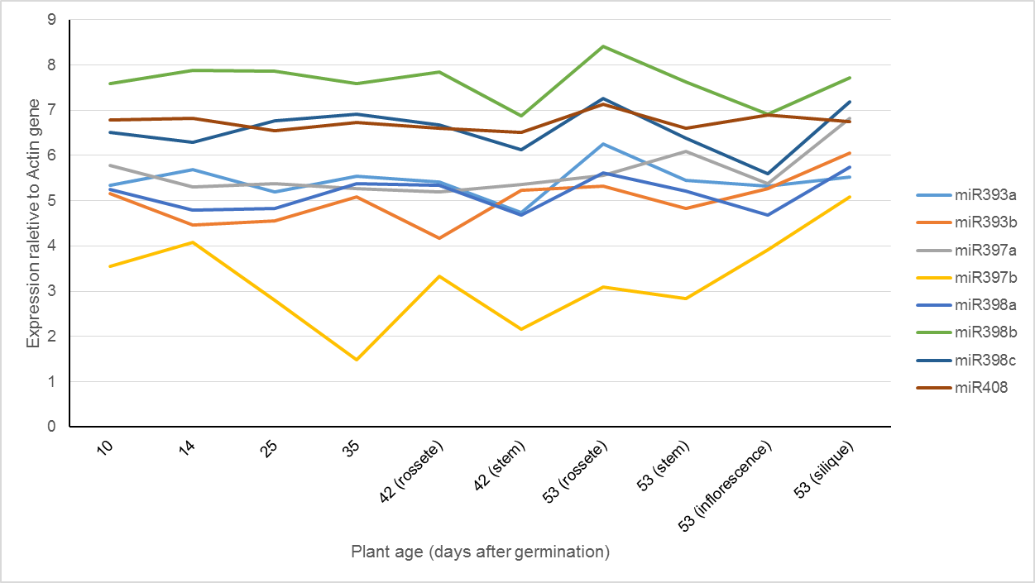

Fig. S2. Expression pattern of the seven miRNAs at different developmental stages. The expression of the miRNAs is reported as relative expression to the Actin housekeeping gene. The expression data is retrieved from the mirEX database.

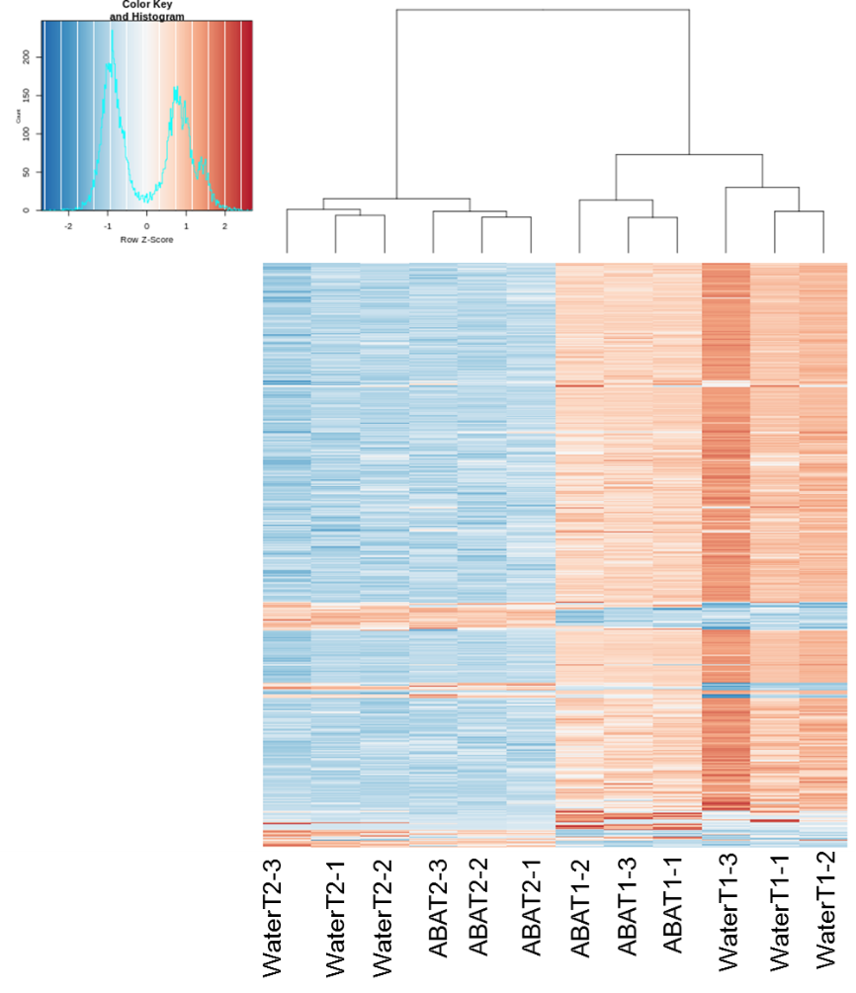
Fig. S3. Heatmap represents differentially expressed siRNA loci. The heatmap shows the top 1000 siRNA loci that were differentially expressed at least in two conditions. Most of the siRNAs were regulated developmentally.

