  - Benford’s Law
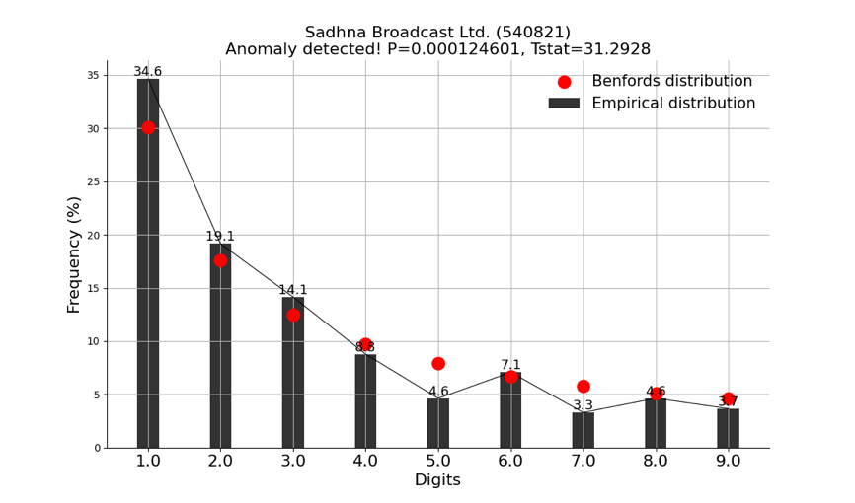
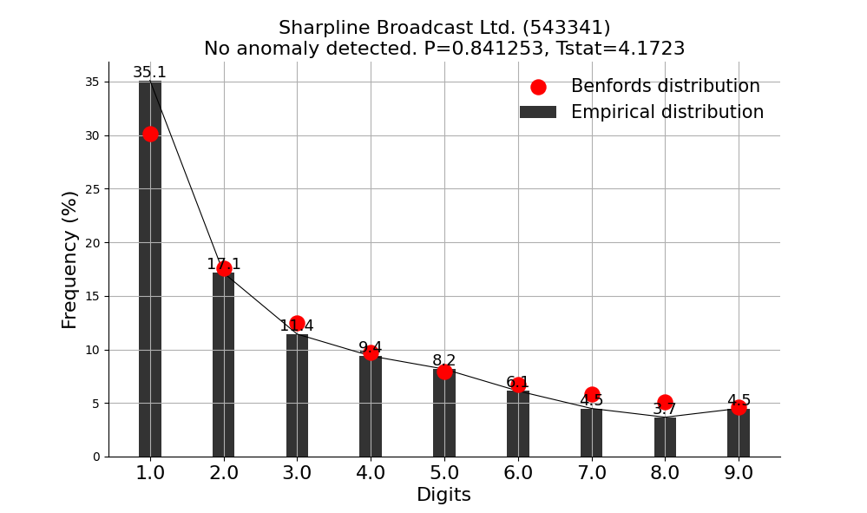

  - LSTM Autoencoder
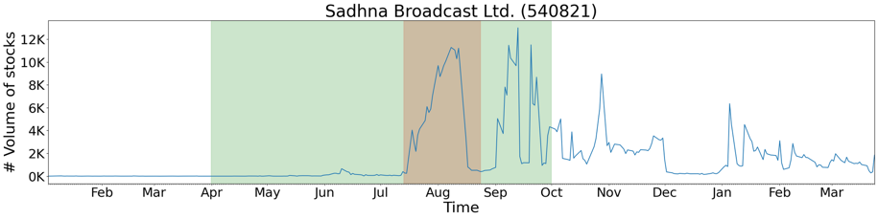
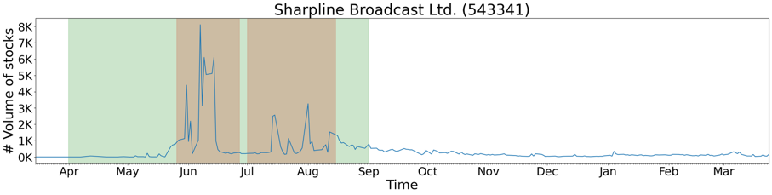

Name | F1 Score | Recall
Sadhna Broadcast Ltd. | 0.367893 | 0.225410
Sharpline Broadcast Ltd. | 0.669565 | 0.503268

Table 2

  - LSTM with Dynamic Thresholding
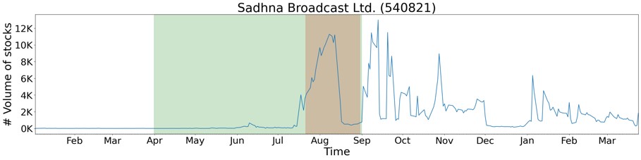
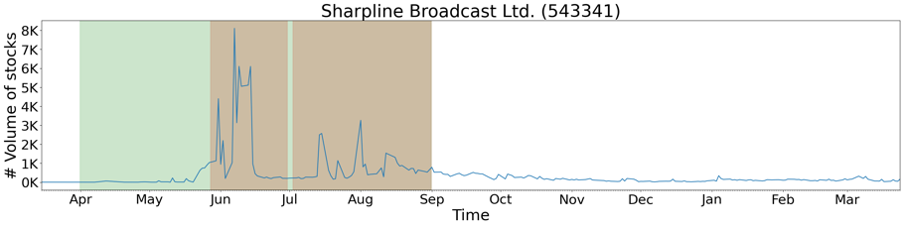

Name | F1 Score | Recall
Sadhna Broadcast Ltd. | 0.362695 | 0.348175
Sharpline Broadcast Ltd. | 0.759879 | 0.612745

  - TadGAN
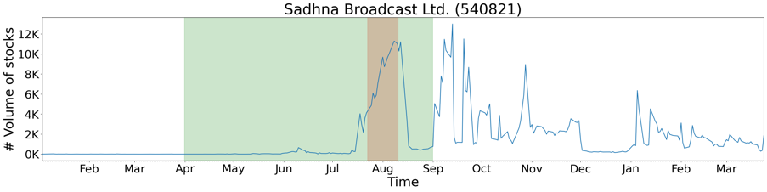

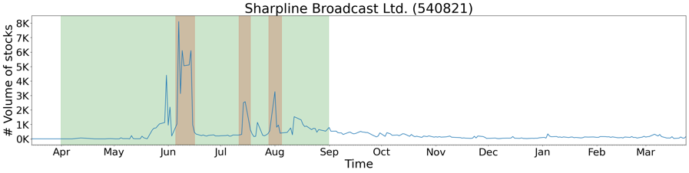

Name | F1 Score | Recall
Sadhna Broadcast Ltd. | 0.218773 | 0.122821
Sharpline Broadcast Ltd. | 0.278078 | 0.161493

Table 3

- Auto-Encoder with Regression
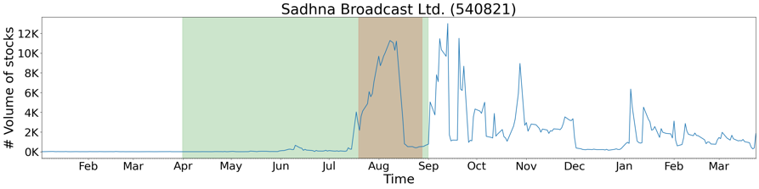
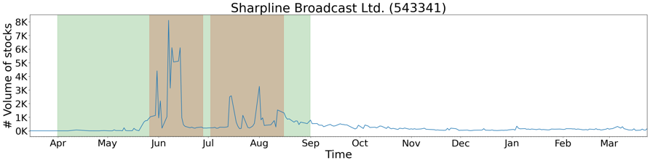

Name | F1 Score | Recall
Sadhna Broadcast Ltd. | 0.410390 | 0.258170
Sharpline Broadcast Ltd. | 0.660832 | 0.493464

