Annexe 1. Distribution of organ compromise per patient.
Patient | sex | Country | Cornea verticillata | stroke | Proteinuria | Dialysis | HF or LVH | Pacemaker | NSVT/VT
1 |  | 
2 |  |  |  |  | 
3 |  |  |  |  |  |  | 
4
5 | 
6
7
8
9 |  |  |  |  |  |  |  |  | 
10
11
12 |  |  |  | 
13
14
15
16
17
18
19
20
21 |  |  |  |  |  |  |  | 
22
23 |  |  |  |  |  | 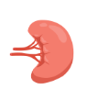
24
25
26
27
28
29
30
31
32
33 |  |  | 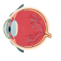
34
35
36
37 |  | 
38
39
40
41
42
43 |  | 
44
45
46
47
48
49

Family Pedigree
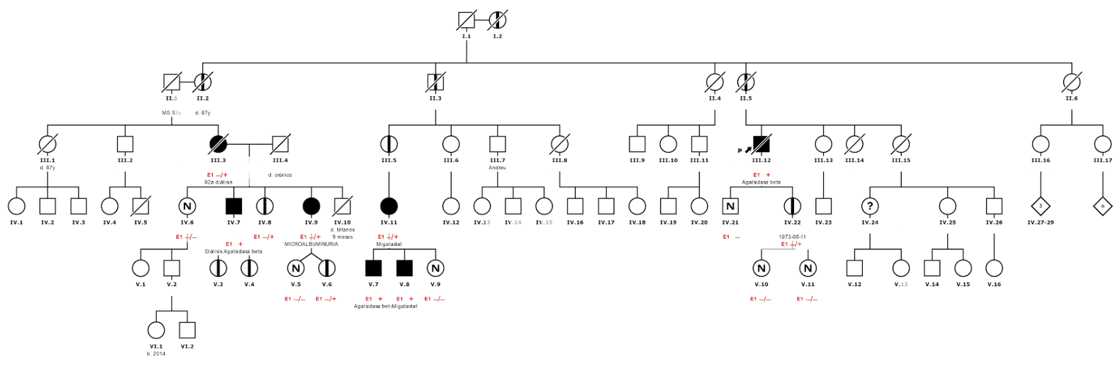
FD affected, Carrier. FD not affected, Unknown, Not carrier.

