e-Figure 1. 21 cities in Guangdong Province.
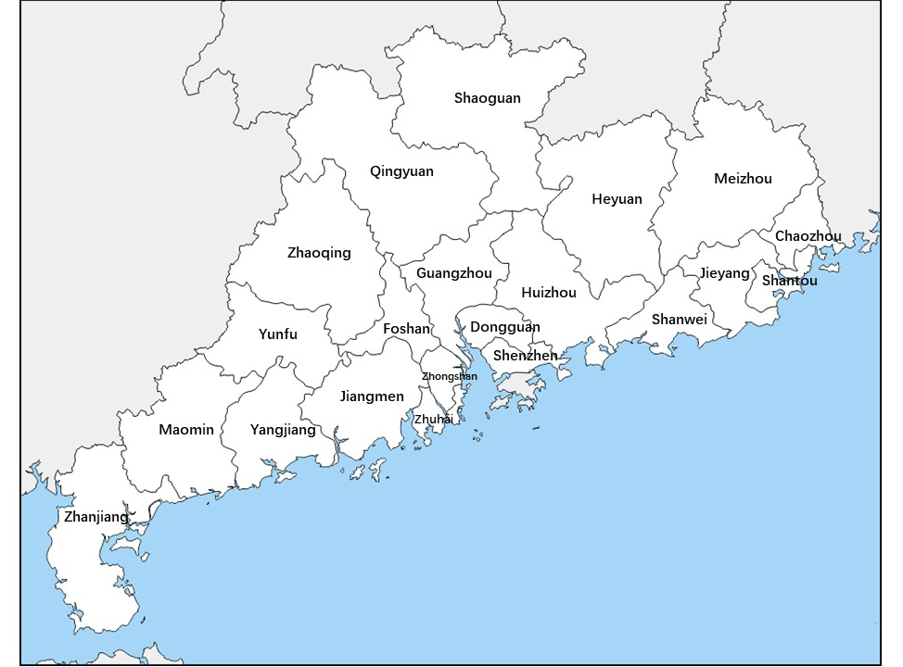

e-Table 1. Sensitivity analysis: relative risks (95% CI) of hospitalizations for exacerbations of chronic respiratory disease per IQR increase of diurnal temperature range.
Variables | relative risks (95% CI)
Numbers of moving average for diurnal temperature range
1 (lag 0) | 1.02 (1.01 to 1.02)
3 (lag 0-2) | 1.04 (1.03 to 1.06)
5 (lag 0-4) | 1.07 (1.06 to 1.09)
7 (lag 0-6) | 1.09 (1.07 to 1.10)
14 (lag 0-13) | 1.09 (1.07 to 1.11)
21 (lag 0-20) | 1.09 (1.06 to 1.12)
Degree of freedom for time per years
6 | 1.07 (1.06 to 1.09)
7 | 1.07 (1.05 to 1.08)
8 | 1.09 (1.07 to 1.10)
9 | 1.08 (1.07 to 1.10)
10 | 1.09 (1.08 to 1.10)
Degree of freedom for meteorological measures
3 | 1.09 (1.07 to 1.10)
6 | 1.09 (1.07 to 1.10)
Spline function
natural cubic spline function | 1.09 (1.07 to 1.10)
penalized splines function | 1.08 (1.07 to 1.10)
Dataset
cities with > 5 hosiptals data | 1.08 (1.07 to 1.10)
21 cities | 1.09 (1.07 to 1.10)

