Supplementary materials
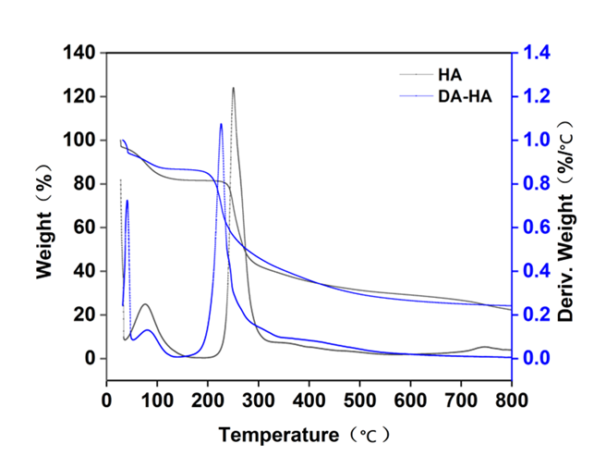
Figure S1 Thermogravimetric curves of DA-HA and HA
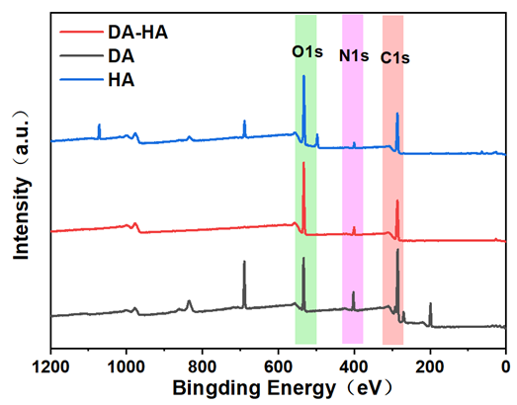
Figure S2 DA-HA and HA photoelectron spectra
Table S1 The heat loss rate of HA and DA-HA
Sample |  | Initial temperature /℃ | Weight loss /%
HA | First heat loss | 56.74 | 15.52
HA | Second heat loss | 241.74 | 59.36
DA-HA | First heat loss | 67.93 | 7.629
DA-HA | Second heat loss | 212.18 | 62.52

Table S2 Oil-water interfacial tension at different concentrations of DA-HA
C（mg/mL） | γ_{DA-HA-white oil}（mN/m） | γ_{water-white oil}（mN/m）
10 | 36.59±1.63 | 45.70±1.09
5 | 39.09±1.55 | 45.70±1.09
2.5 | 39.81±2.31 | 45.70±1.09
1 | 42.05±1.41 | 45.70±1.09

