1. Synthetic scheme for broad-spectrum antibacterial small molecule compounds based on structural hybridization strategy

Scheme S1. Synthetic scheme for F1.
Reagents and conditions: florfenicol, 3-oxocyclobutanecarboxylic acid, EDC, DMAP, 25℃, 24 h, 46%.

Scheme S2. Synthetic scheme for F2.
Reagents and conditions: florfenicol, folcisteine, EDC, DMAP, 25℃, 24 h, 62%.

Scheme S3. Synthetic scheme for F3.
Reagents and conditions: florfenicol, cyclopropanecarboxylic acid, EDC, DMAP, 25℃, 24 h, 51%.

Scheme S4. Synthetic scheme for F4.
Reagents and conditions: florfenicol, cyclo-butyl formic acid, EDC, DMAP, 25℃, 24 h, 42%.

Scheme S5. Synthetic scheme for F6.
Reagents and conditions: florfenicol, 2-(1-pyrrolidyl)acetic acid, EDC, DMAP, 25℃, 24 h, 39%.

Scheme S6. Synthetic scheme for F7.
Reagents and conditions: florfenicol, 3,3-difluorocyclobutanecarboxylic acid, EDC, DMAP, 25℃, 24 h, 39%.

Scheme S7. Synthetic scheme for F8.
Reagents and conditions: florfenicol, 3-(1-piperidinyl)propanoic acid, EDC, DMAP, 25℃, 24 h, 41%.

Scheme S8. Synthetic scheme for F11.
Reagents and conditions: florfenicol, 6-quinolinecarboxylic acid, EDC, DMAP, 25℃, 24 h, 45%.

Scheme S9. Synthetic scheme for F13.
Reagents and conditions: florfenicol, morpholin-4-yl-acetic acid, EDC, DMAP, 25℃, 24 h, 41%.

Scheme S10. Synthetic scheme for F14.
Reagents and conditions: florfenicol, 3-phthalimidopropionic acid, EDC, DMAP, 25℃, 24 h, 52%.

Scheme S11. Synthetic scheme for F15.
Reagents and conditions: florfenicol, 3,3-difluorocyclobutanecarboxylic acid, EDC, DMAP, 25℃, 24 h, 42%.

2. MS data of the final compounds
High-resolution mass analysis was performed on the liquid chromatograph mass spectrometry–ion trap–time of flight (LCMS–IT–TOF) from Shimadzu (Kyoto, Japan).

F1, m/z calculated for C₁₇H₁₈Cl₂FNO₆S [M+H]⁺: 453.0216, found: 452.0009

F2, m/z calculated for C₁₈H₂₁Cl₂FN₂O₆S₂ [M+H]⁺: 514.0202, found: 514.9950

F3, m/z calculated for C₁₆H₁₈Cl₂FNO₅S [M+H]⁺: 425.0267, found: 424.0068

F4, m/z calculated for C₁₇H₂₀Cl₂FNO₅S [M+H]⁺: 440.3138, found: 440.0529

F6, m/z calculated for C₁₈H₂₃Cl₂FN₂O₅S [M+H]⁺: 468.0689, found: 467.0515

F7, m/z calculated for C₁₇H₁₈Cl₂F₃N₁O₅S [M+H]⁺: 475.0235, found: 475.3320

F8, m/z calculated for C₂₀H₂₇Cl₂FN₂O₅S [M+H]⁺: 497.4082, found: 497.0945

F11, m/z calculated for C₂₂H₁₉Cl₂FN₂O₅S [M+H]⁺: 513.3661, found: 513.0349

F13, m/z calculated for C₁₈H₂₃Cl₂FN₂O₆S [M+H]⁺: 485.3544, found: 485.0699

F14, m/z calculated for C₂₃H₂₁Cl₂FN₂O₇S [M+H]⁺: 559.3914, found: 559.0531

F15, m/z calculated for C₂₆H₂₉Cl₂FN₂O₇S [M+H]⁺: 603.4871, found: 6603.1110

3. NMR spectra of synthetic compounds
The ¹H- and ¹³C-NMR spectra were recorded on a Bruker Avance 400 spectrometer at 25℃ using DMSO-α₆ as the solvent. Chemical shifts (δ) are reported in ppm relative to Me₄Si (internal standard), coupling constants (J) are reported in hertz, and peak multiplicity is reported as s (singlet), d (doublet), t (triplet), q (quartet), m (multiplet), or br s (broad singlet).

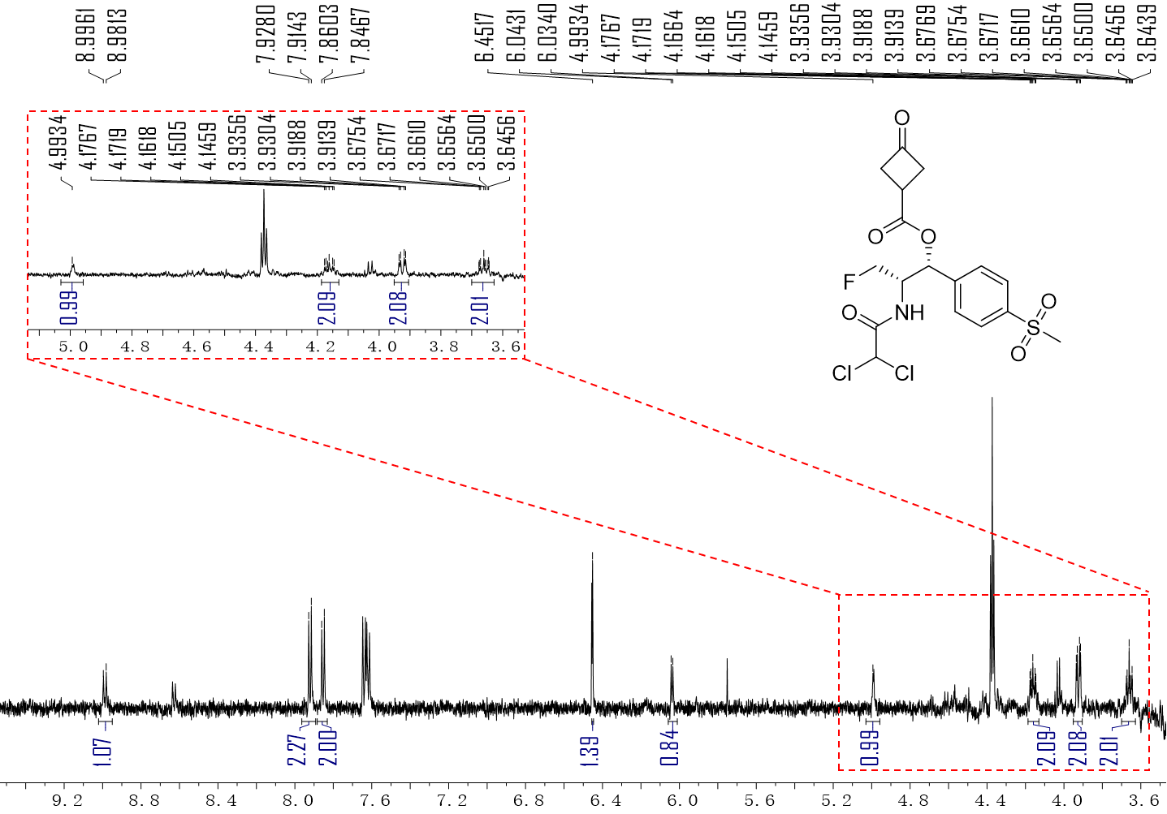
¹H-NMR spectrum of compound F1 (600 MHz, DMSO).
¹H NMR (600 MHz, DMSO-d₆) δ 8.99 (m, 1H), 7.92 (d, J = 8.3 Hz, 2H), 7.85 (d, J = 8.2 Hz, 2H), 6.45 (s, 1H), 6.04 (m, 1H), 4.99 (m, 1H), 4.19 – 4.13 (m, 2H), 3.92 (m, 2H), 3.70 – 3.63 (m, 2H).

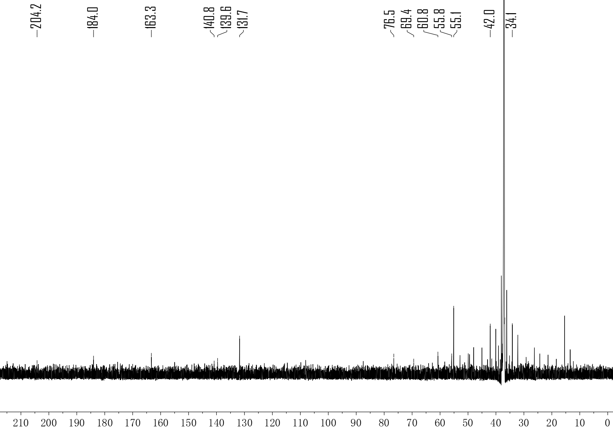
¹³C-NMR spectrum of compound F1 (150 MHz, DMSO).
¹³C NMR (150 MHz, DMSO) δ 204.22, 184.01, 163.31, 140.84, 139.61, 131.75, 76.55, 69.42, 60.77, 55.83, 55.13, 42.03, 34.15.

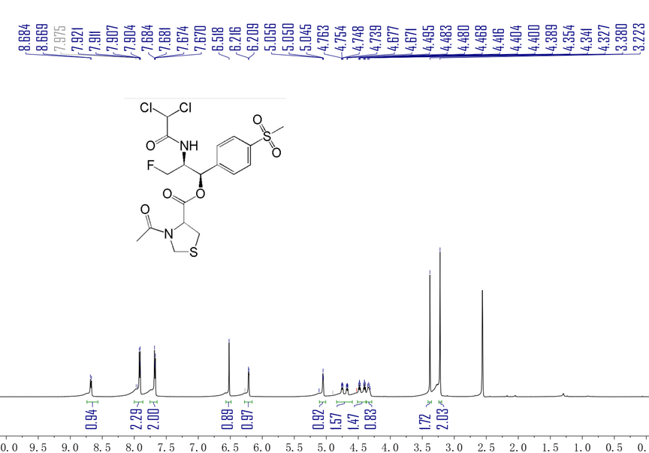
¹H-NMR spectrum of compound F2 (600 MHz, DMSO).
¹H NMR (600 MHz, DMSO-d₆) δ 8.68 (d, J = 9.0 Hz, 1H), 8.00 – 7.87 (m, 2H), 7.76 – 7.64 (m, 2H), 6.52 (s, 1H), 6.21 (d, J = 4.2 Hz, 1H), 5.05 (t, J = 3.5 Hz, 1H), 4.71 (ddd, J = 46.3, 9.2, 5.5 Hz, 2H), 4.44 (ddd, J = 47.5, 9.3, 7.2 Hz, 1H), 4.33 (q, J = 7.4, 7.0 Hz, 1H), 3.38 (s, 2H), 3.22 (s, 2H).

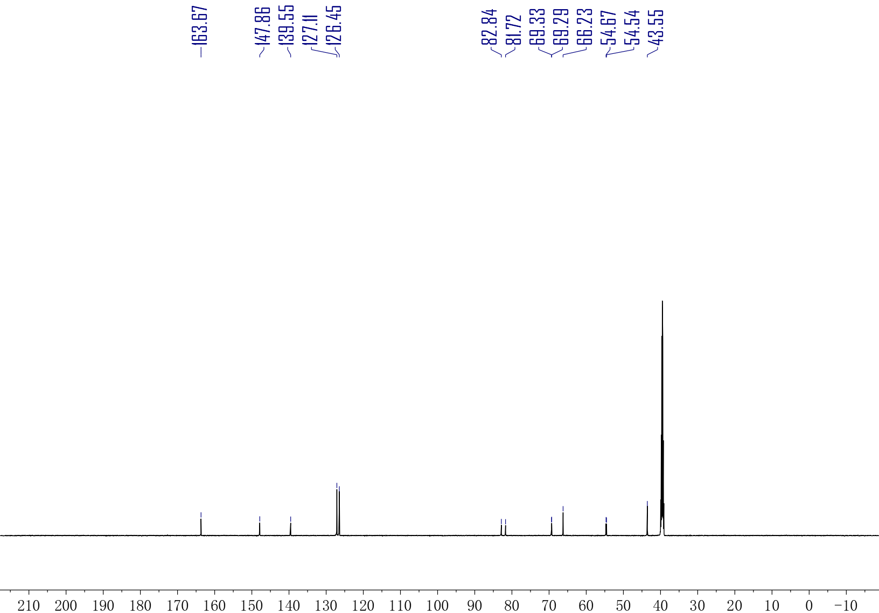
¹³C-NMR spectrum of compound F2 (150 MHz, DMSO).
¹³C NMR (150 MHz, DMSO) δ 163.67, 147.86, 139.55, 127.11, 126.45, 82.84, 81.72, 69.33, 69.29, 66.23, 54.67, 54.54, 43.55.

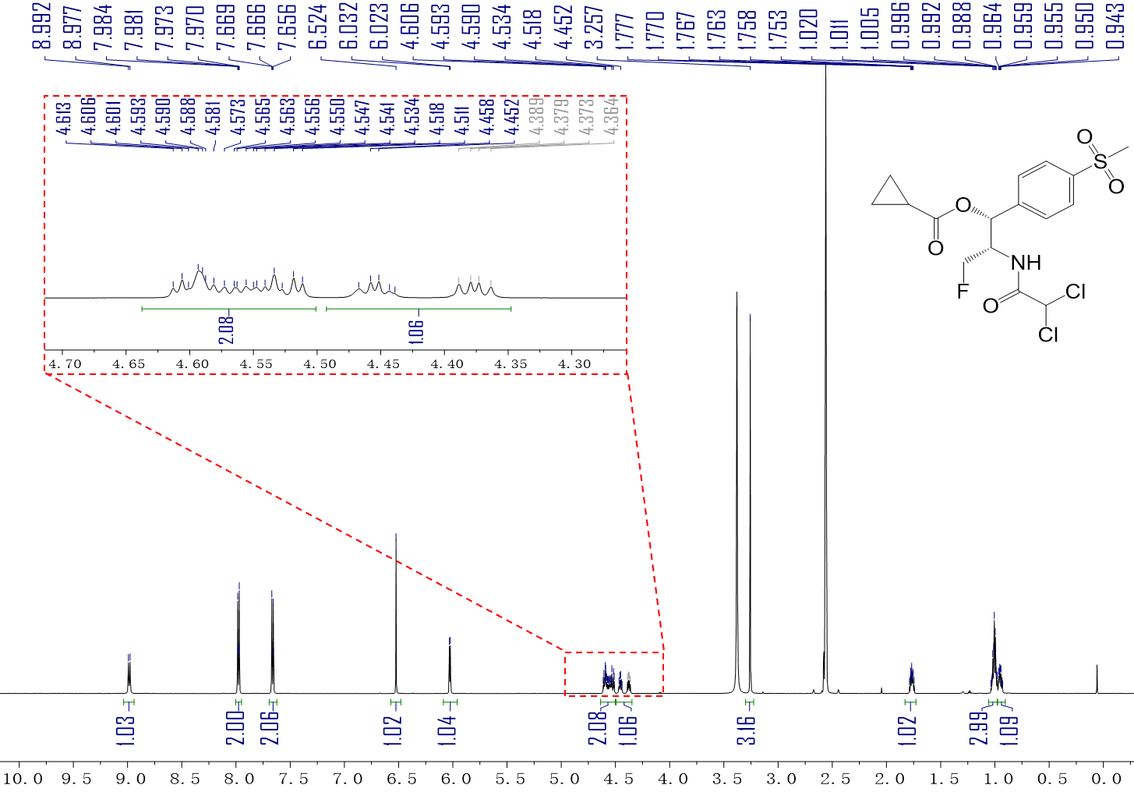
¹H-NMR spectrum of compound F3 (600 MHz, DMSO).
¹H NMR (600 MHz, DMSO-d₆) δ 8.98 (d, J = 8.8 Hz, 1H), 8.00 – 7.95 (m, 2H), 7.66 (d, J = 8.2 Hz, 2H), 6.52 (s, 1H), 6.03 (d, J = 5.3 Hz, 1H), 4.64 – 4.50 (m, 2H), 4.45 (dt, J = 7.6, 4.1 Hz, 1H), 3.26 (s, 3H), 1.77 (tt, J = 7.8, 4.7 Hz, 1H), 1.00 (td, J = 9.7, 9.2, 6.1 Hz, 3H), 0.97 – 0.90 (m, 1H).

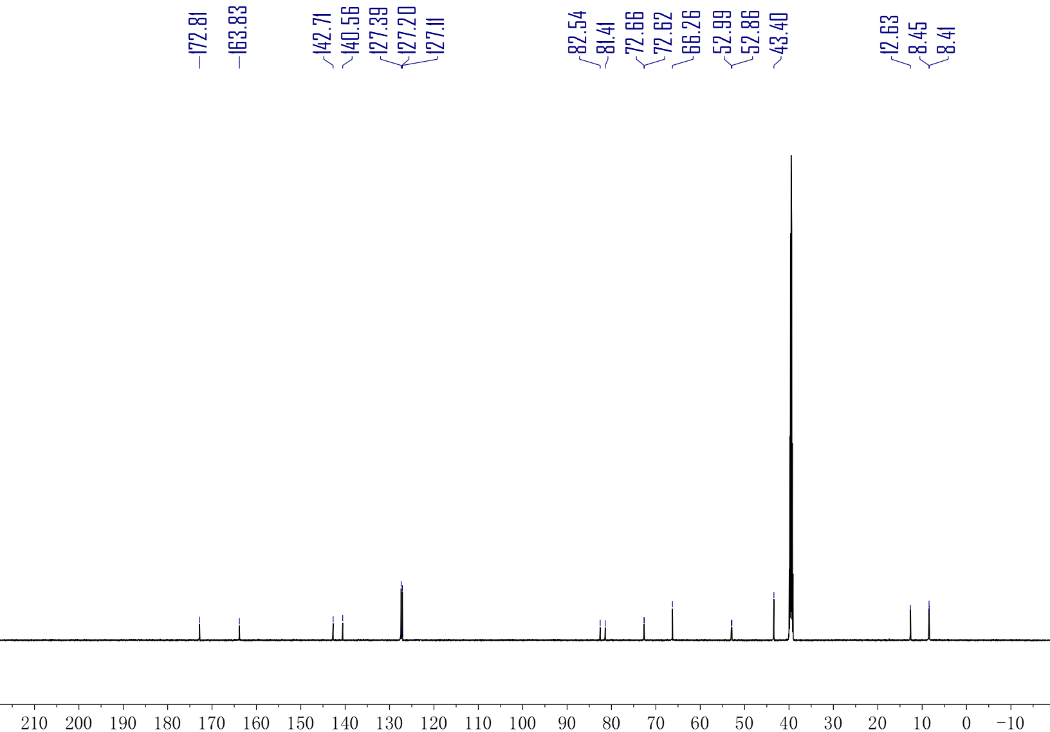
¹³C-NMR spectrum of compound F3 (150 MHz, DMSO).
¹³C NMR (150 MHz, DMSO) δ 172.81, 163.83, 142.71, 140.56, 127.39, 127.20, 127.11, 82.54, 81.41, 72.66, 72.62, 66.26, 52.99, 52.86, 43.40, 12.63, 8.45, 8.41.

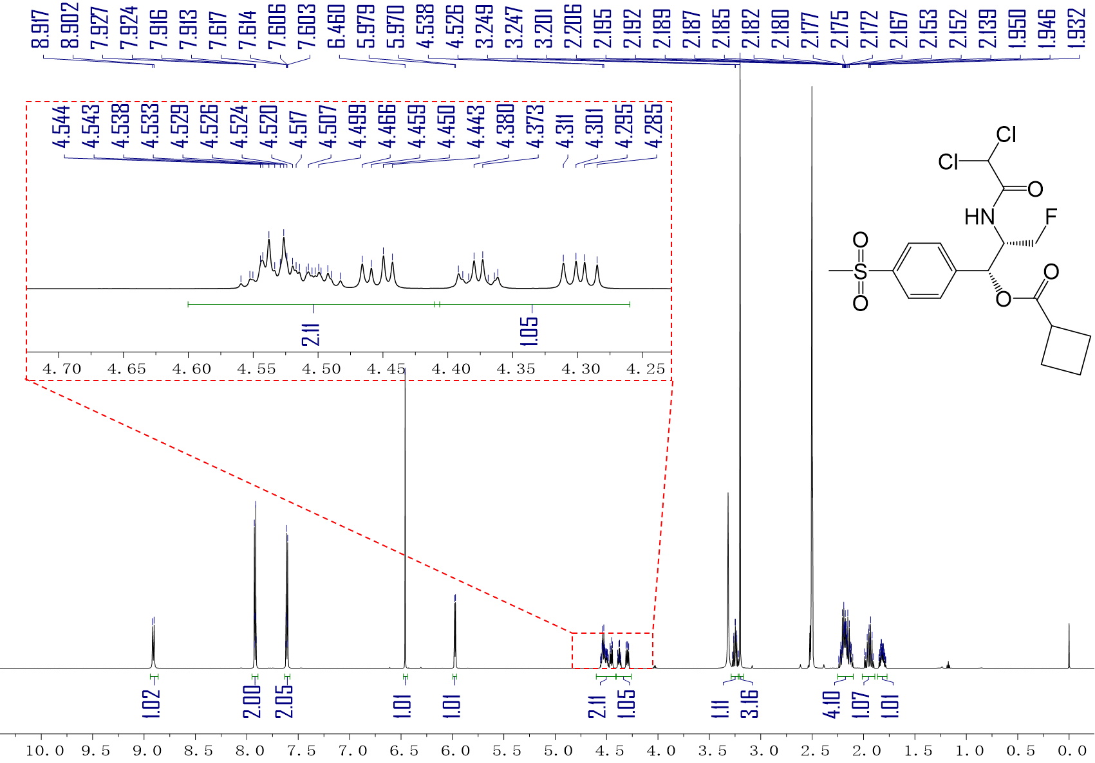
¹H-NMR spectrum of compound F4 (600 MHz, DMSO).
¹H NMR (600 MHz, DMSO-d₆) δ 8.91 (d, J = 8.8 Hz, 1H), 7.95 – 7.89 (m, 2H), 7.63 – 7.58 (m, 2H), 6.46 (s, 1H), 5.97 (d, J = 5.7 Hz, 1H), 4.60 – 4.41 (m, 2H), 4.41 – 4.26 (m, 1H), 3.29 – 3.21 (m, 1H), 3.20 (s, 3H), 2.25 – 2.10 (m, 4H), 2.01 – 1.89 (m, 1H), 1.82 (ddddd, J = 10.1, 9.0, 6.5, 4.5, 1.1 Hz, 1H).

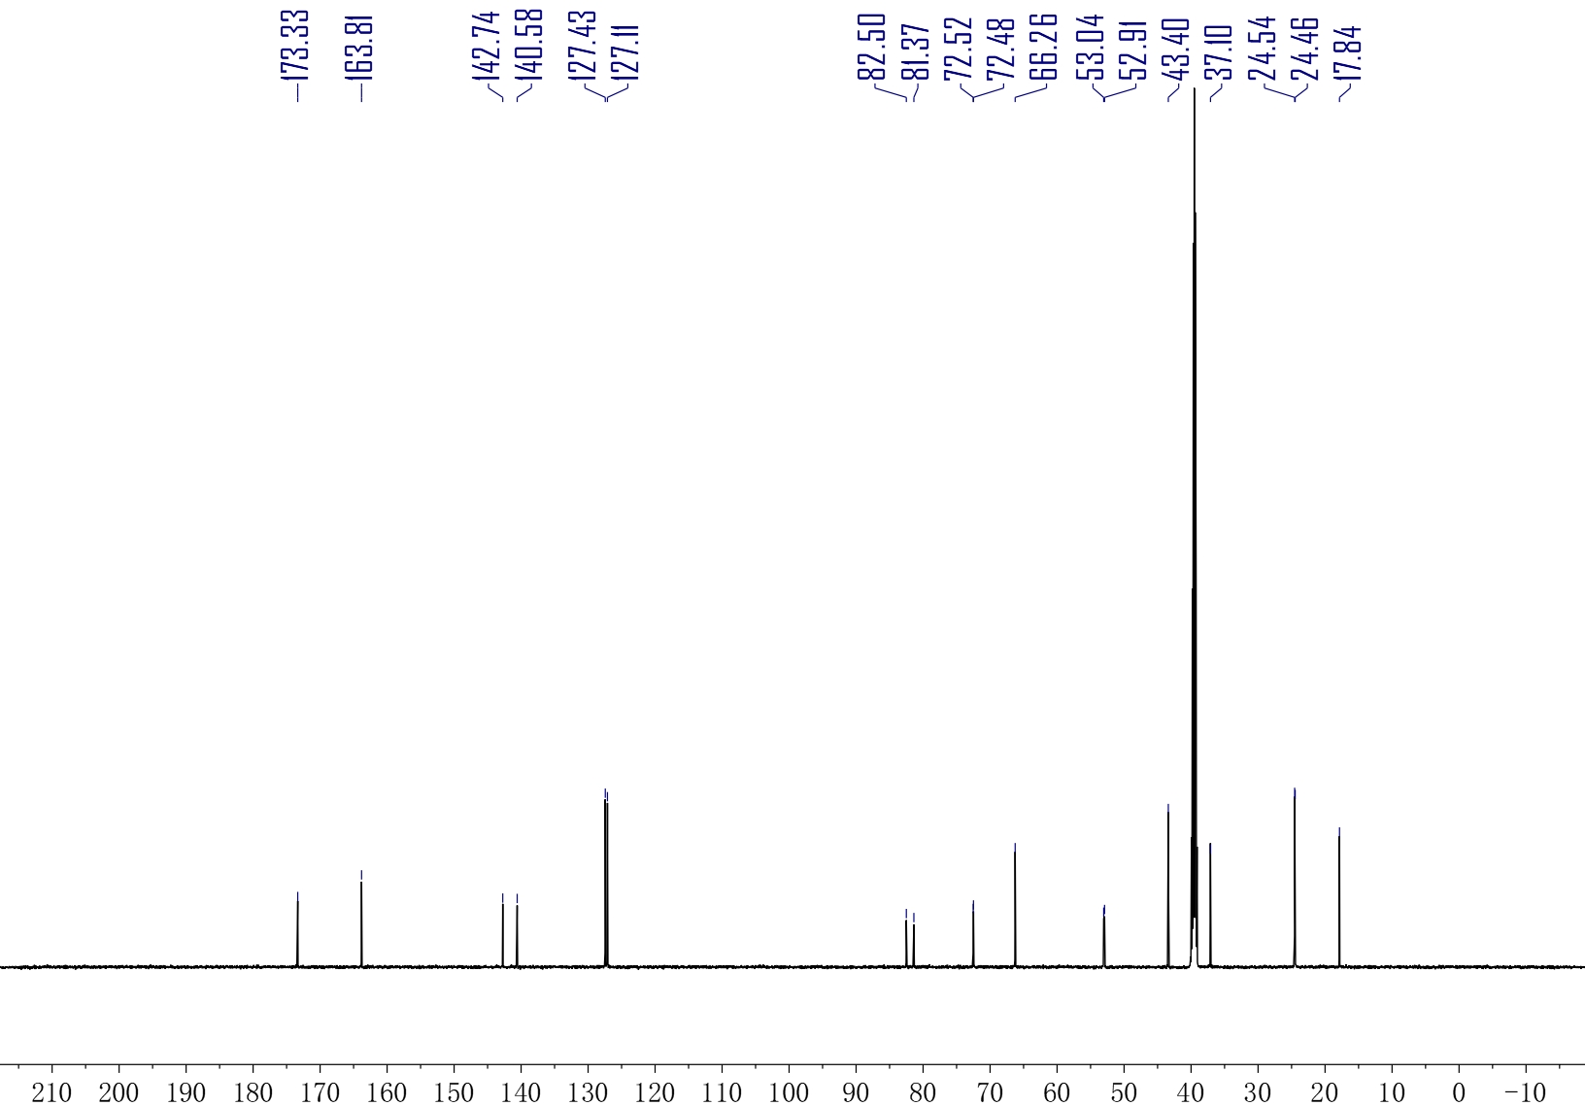
¹³C-NMR spectrum of compound F4 (150 MHz, DMSO).
¹³C NMR (150 MHz, DMSO) δ 173.33, 163.81, 142.74, 140.58, 127.43, 127.11, 82.50, 81.37, 72.52, 72.48, 66.26, 53.04, 52.91, 43.40, 37.10, 24.54, 24.46, 17.84.

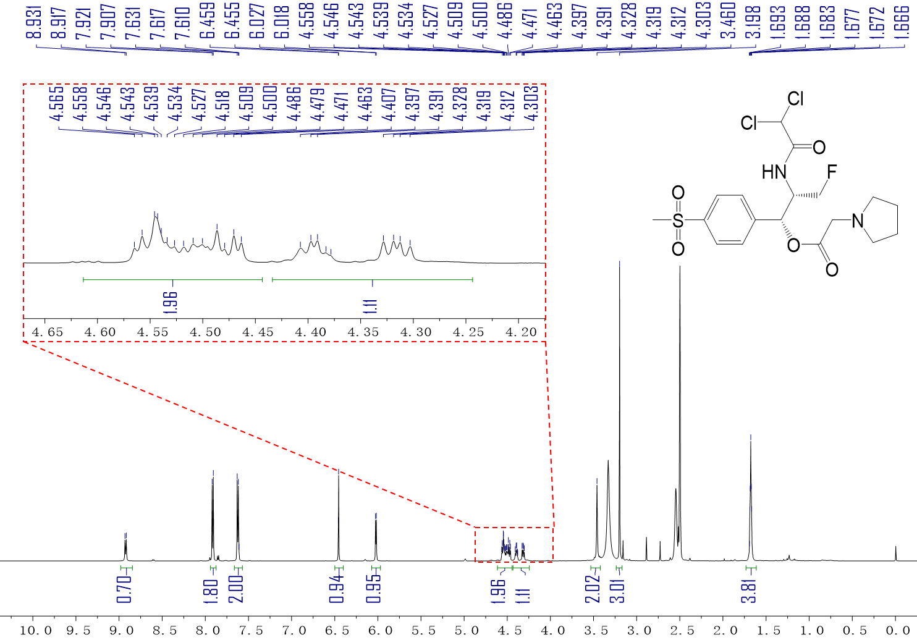
¹H-NMR spectrum of compound F6 (600 MHz, DMSO).
¹H NMR (600 MHz, DMSO-d₆) δ 8.92 (d, J = 8.8 Hz, 1H), 7.91 (d, J = 8.2 Hz, 2H), 7.62 (d, J = 8.2 Hz, 2H), 6.46 (d, J = 2.4 Hz, 1H), 6.02 (d, J = 5.1 Hz, 1H), 4.61 – 4.44 (m, 2H), 4.36 (ddd, J = 48.0, 9.6, 5.8 Hz, 1H), 3.46 (s, 2H), 3.20 (s, 3H), 2.55 (s, 4H), 1.68 (h, J = 3.2 Hz, 4H).

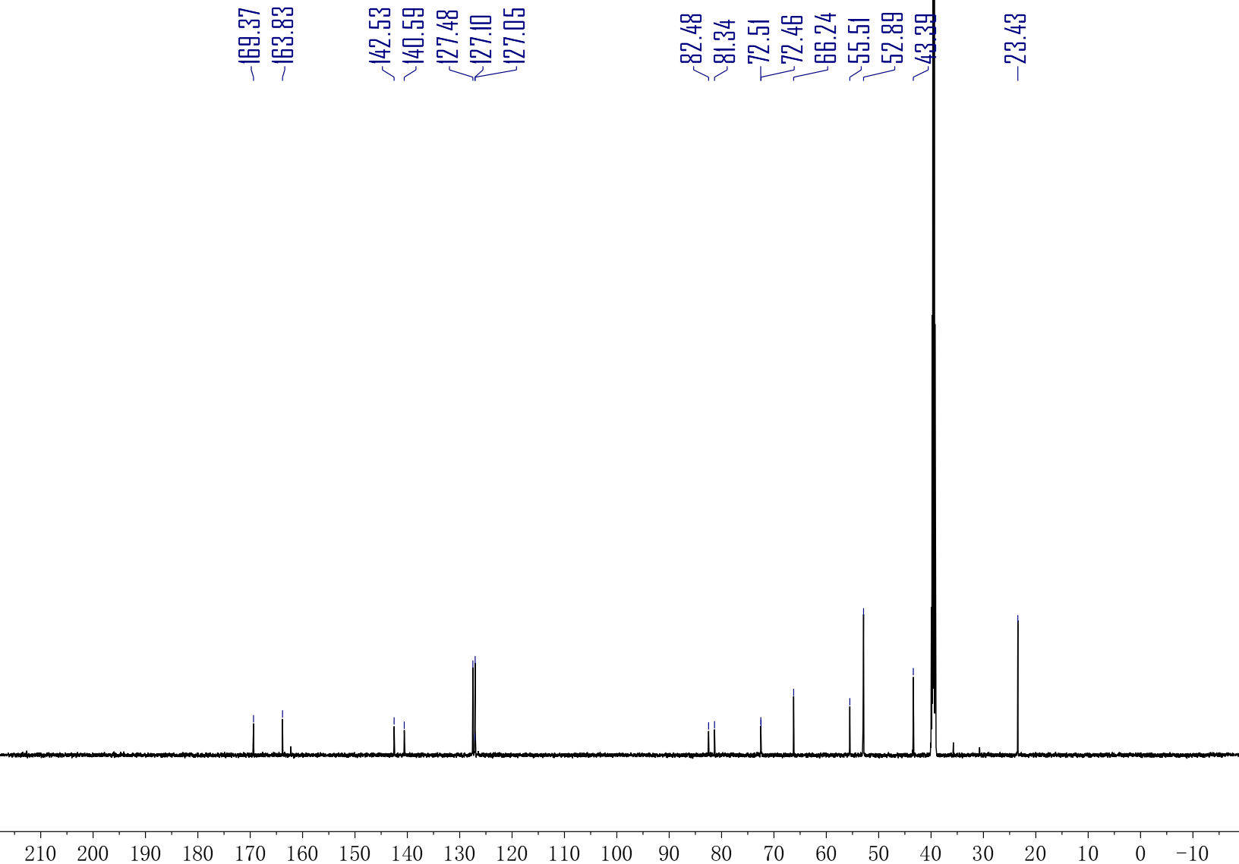
¹³C-NMR spectrum of compound F6 (150 MHz, DMSO).
¹³C NMR (150 MHz, DMSO) δ 169.37, 163.83, 142.53, 140.59, 127.48, 127.10, 127.05, 82.48, 81.34, 72.51, 72.46, 66.24, 55.51, 52.89, 43.39, 23.43.

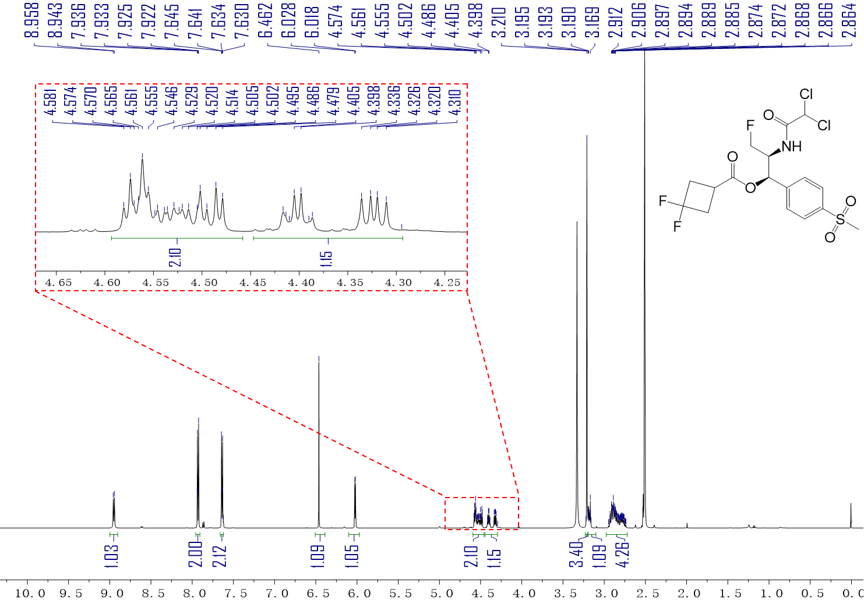
¹H-NMR spectrum of compound F7 (600 MHz, DMSO).
¹H NMR (600 MHz, DMSO-d₆) δ 8.95 (d, J = 8.7 Hz, 1H), 7.96 – 7.91 (m, 2H), 7.66 – 7.62 (m, 2H), 6.46 (s, 1H), 6.02 (d, J = 5.6 Hz, 1H), 4.59 – 4.46 (m, 2H), 4.45 – 4.29 (m, 1H), 3.21 (s, 3H), 3.20 – 3.10 (m, 1H), 2.98 – 2.72 (m, 4H).

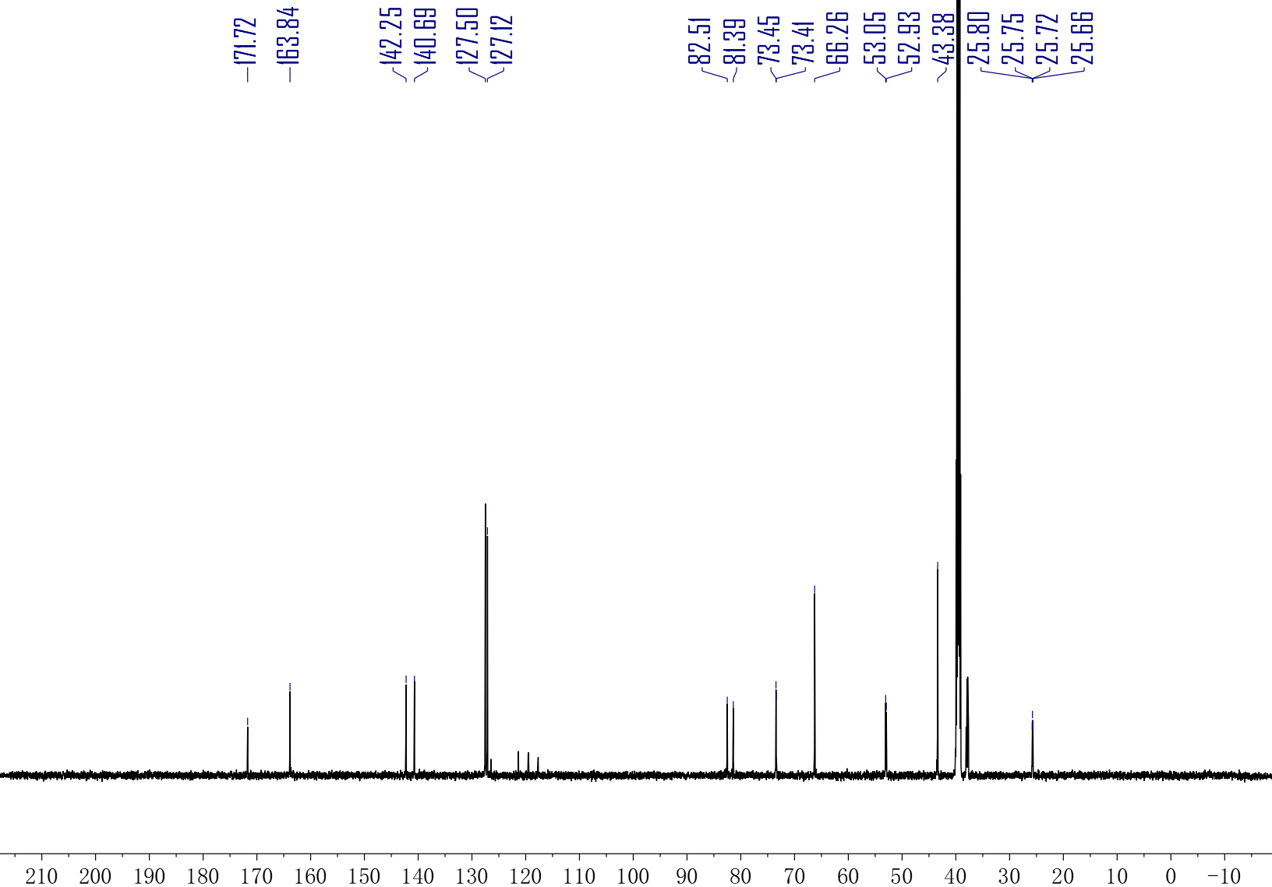
¹³C-NMR spectrum of compound F7 (150 MHz, DMSO).
¹³C NMR (150 MHz, DMSO) δ 171.72, 163.84, 142.25, 140.69, 127.50, 127.12, 82.51, 81.39, 73.45, 73.41, 66.26, 53.05, 52.93, 43.38, 25.80, 25.75, 25.72, 25.66.

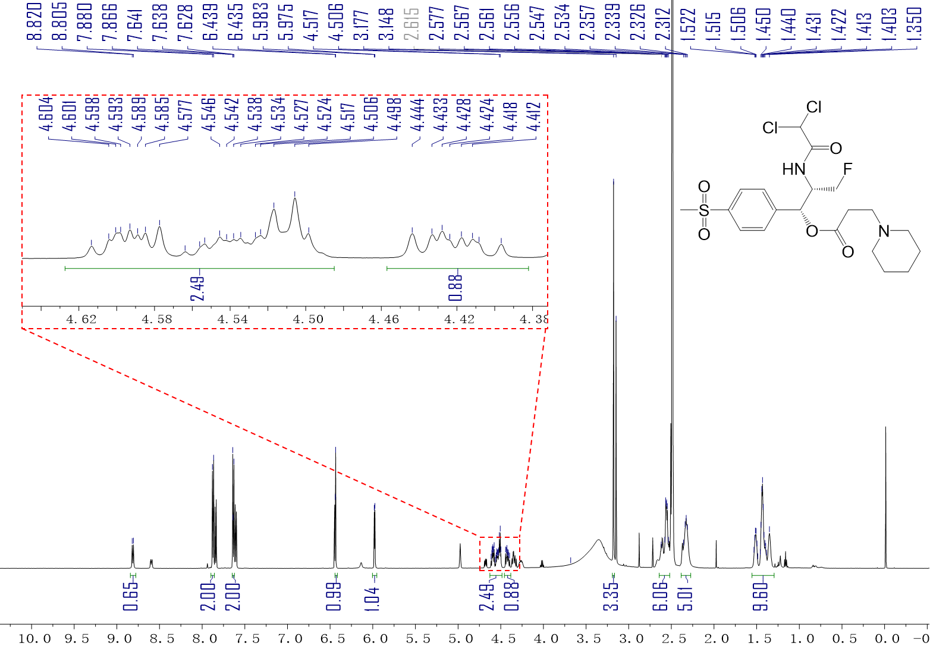
¹H-NMR spectrum of compound F8 (600 MHz, DMSO).
¹H NMR (600 MHz, DMSO-d₆) δ 8.81 (d, J = 8.7 Hz, 1H), 7.87 (d, J = 8.1 Hz, 2H), 7.63 (d, J = 8.3 Hz, 2H), 6.44 (d, J = 2.4 Hz, 1H), 5.98 (d, J = 4.5 Hz, 1H), 4.63 – 4.48 (m, 2H), 4.42 (ddd, J = 12.6, 9.3, 6.7 Hz, 1H), 3.18 (s, 3H), 2.64 – 2.52 (m, 6H), 2.33 (dd, J = 17.4, 9.1 Hz, 5H), 1.55 – 1.30 (m, 6H).

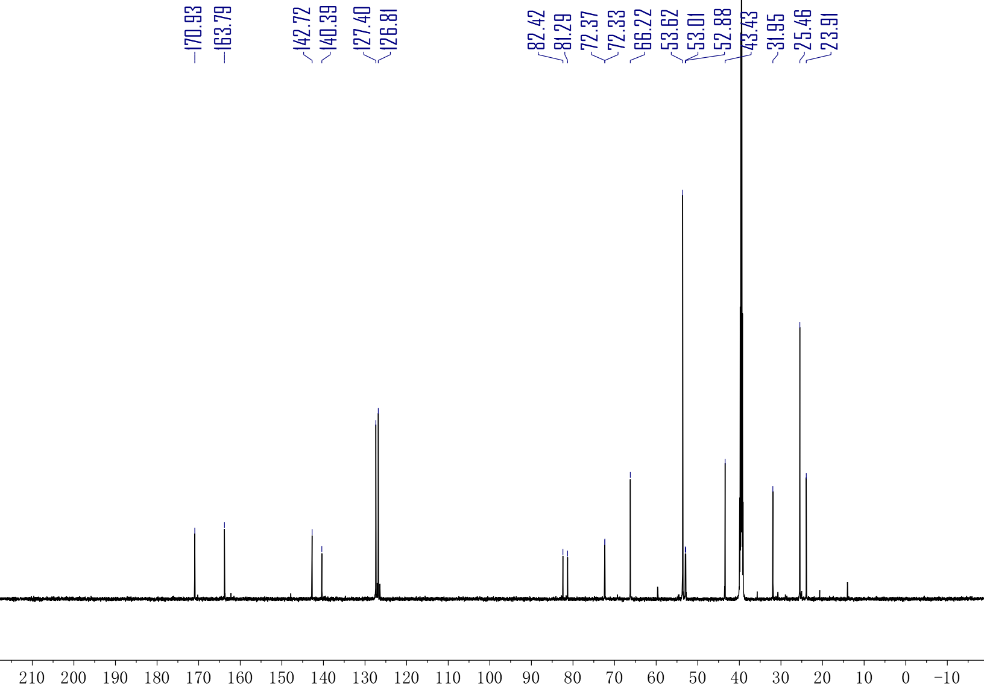
¹³C-NMR spectrum of compound F8 (150 MHz, DMSO).
¹³C NMR (150 MHz, DMSO) δ 170.93, 163.79, 142.72, 140.39, 127.40, 126.81, 82.42, 81.29, 72.37, 72.33, 66.22, 53.62, 53.01, 52.88, 43.43, 31.95, 25.46, 23.91.

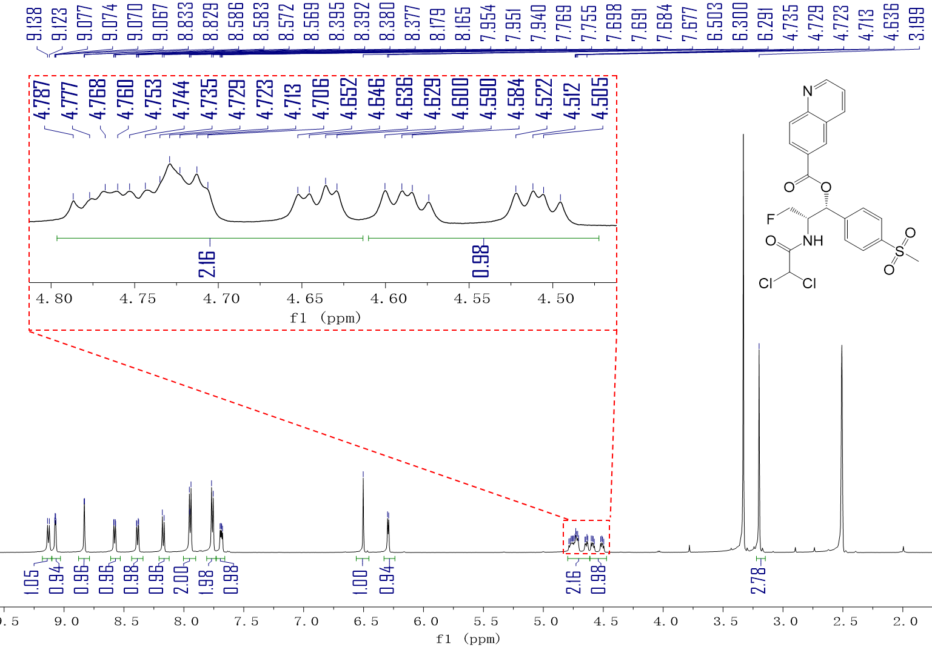
¹H-NMR spectrum of compound F11 (600 MHz, DMSO).
¹H NMR (600 MHz, DMSO-d₆) δ 9.13 (d, J = 9.1 Hz, 1H), 9.07 (dd, J = 4.3, 1.9 Hz, 1H), 8.83 (d, J = 2.0 Hz, 1H), 8.58 (dd, J = 8.4, 1.7 Hz, 1H), 8.39 (dd, J = 8.8, 2.0 Hz, 1H), 8.17 (d, J = 8.8 Hz, 1H), 7.95 (d, J = 8.2 Hz, 2H), 7.76 (d, J = 8.2 Hz, 2H), 7.69 (dd, J = 8.3, 4.2 Hz, 1H), 6.50 (s, 1H), 6.30 (d, J = 5.6 Hz, 1H), 4.80 – 4.61 (m, 2H), 4.55 (ddd, J = 47.3, 9.9, 6.1 Hz, 1H), 3.20 (s, 3H).

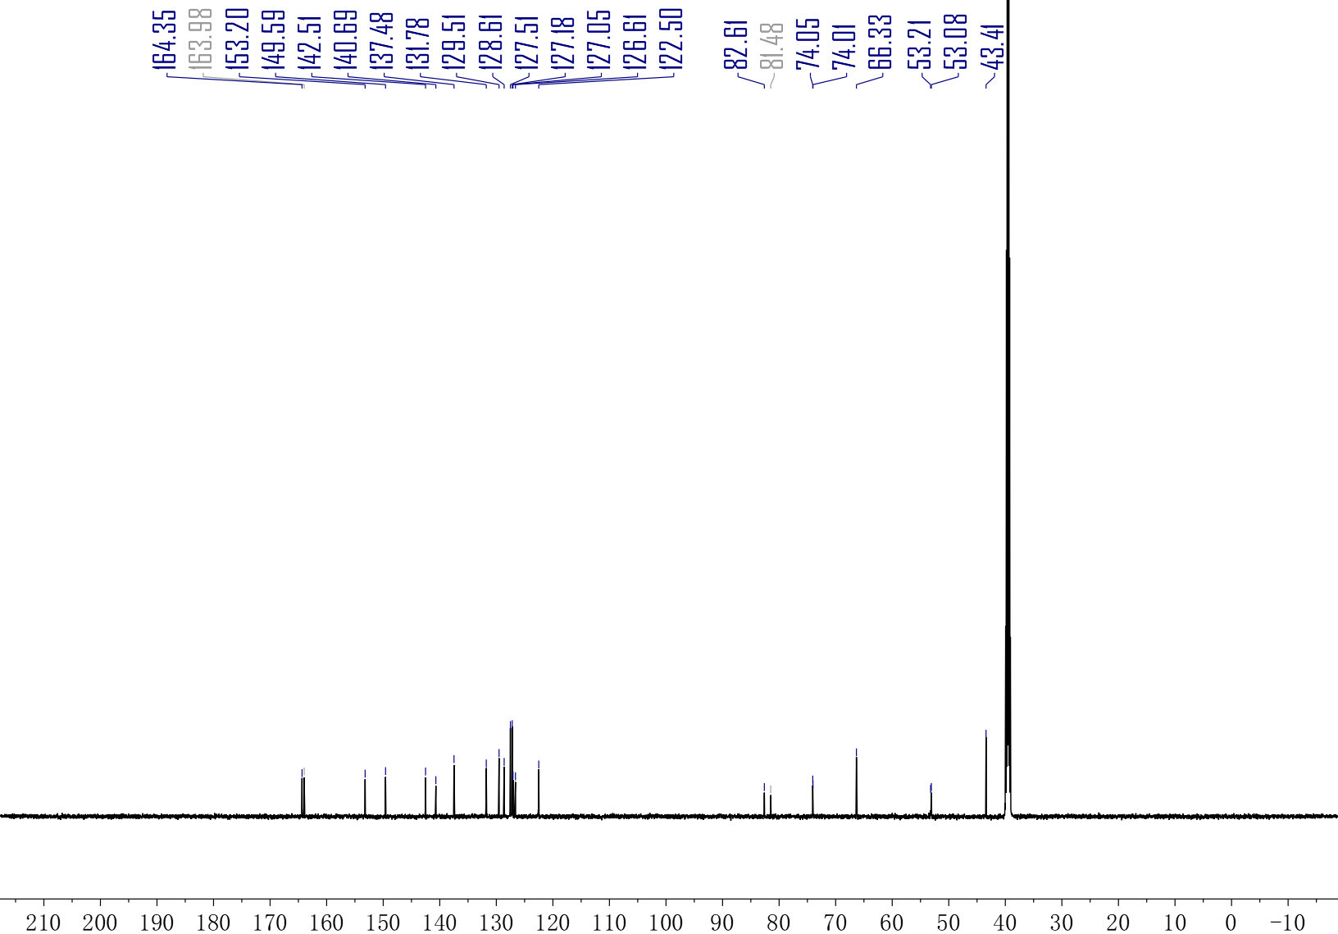
¹³C-NMR spectrum of compound F11 (150 MHz, DMSO).
¹³C NMR (150 MHz, DMSO) δ 164.35, 163.98, 153.20, 149.59, 142.51, 140.69, 137.48, 131.78, 129.51, 128.61, 127.51, 127.18, 127.05, 126.61, 122.50, 82.61, 81.48, 74.05, 74.01, 66.33, 53.21, 53.08, 43.41.

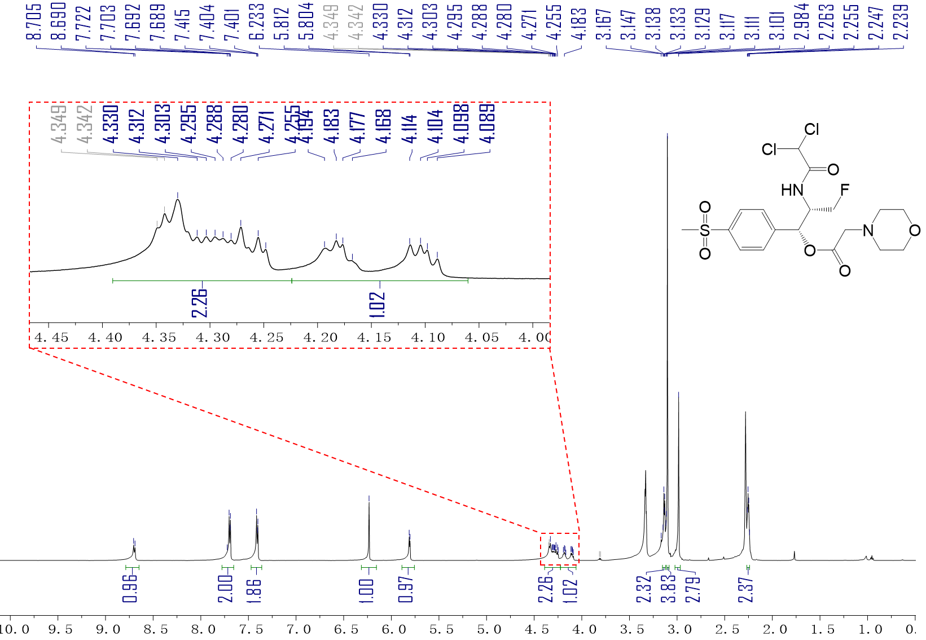
¹H-NMR spectrum of compound F13 (600 MHz, DMSO).
¹H NMR (600 MHz, DMSO-d₆) δ 8.70 (d, J = 8.9 Hz, 1H), 7.70 (dd, J = 13.2, 6.6 Hz, 2H), 7.41 (d, J = 8.5 Hz, 2H), 6.23 (s, 1H), 5.81 (d, J = 5.2 Hz, 1H), 4.39 – 4.22 (m, 2H), 4.14 (ddd, J = 47.4, 9.8, 6.1 Hz, 1H), 3.15 – 3.12 (m, 2H), 3.10 (s, 4H), 2.98 (s, 3H), 2.27 – 2.24 (m, 2H).

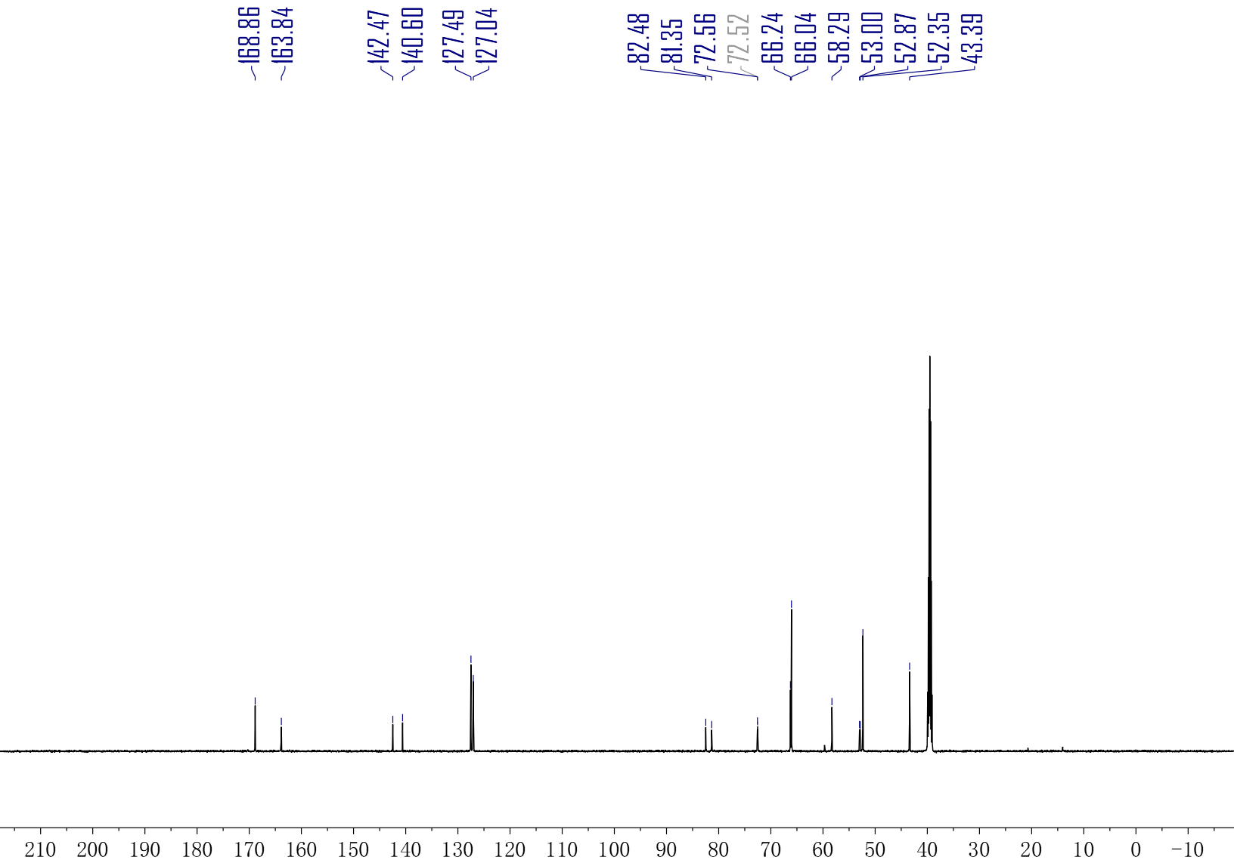
¹³C-NMR spectrum of compound F13 (150 MHz, DMSO).
¹³C NMR (150 MHz, DMSO) δ 168.86, 163.84, 142.47, 140.60, 127.49, 127.04, 82.48, 81.35, 72.56, 72.52, 66.24, 66.04, 58.29, 53.00, 52.87, 52.35, 43.39.

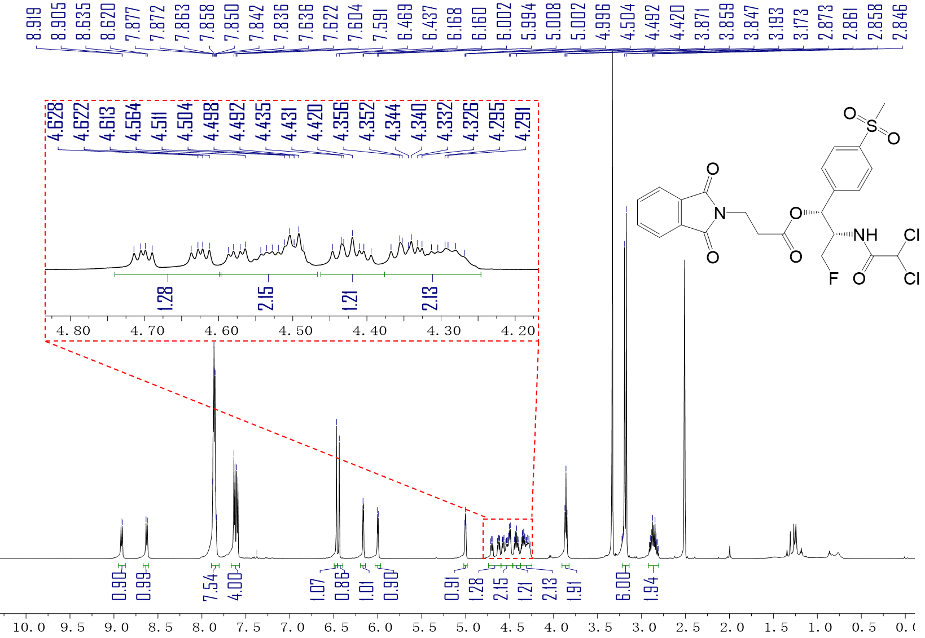
¹H-NMR spectrum of compound F14 (600 MHz, DMSO).
¹H NMR (600 MHz, DMSO-d₆) δ 8.91 (d, J = 8.7 Hz, 1H), 8.63 (d, J = 9.0 Hz, 1H), 7.86 (dt, J = 9.5, 5.0 Hz, 8H), 7.61 (dd, J = 19.0, 8.1 Hz, 4H), 6.47 (s, 1H), 6.44 (s, 1H), 6.16 (d, J = 4.2 Hz, 1H), 6.00 (d, J = 5.0 Hz, 1H), 5.00 (t, J = 3.6 Hz, 1H), 4.66 (ddd, J = 46.3, 9.2, 5.5 Hz, 1H), 4.60 – 4.47 (m, 2H), 4.42 (ddd, J = 15.2, 9.3, 6.5 Hz, 1H), 4.38 – 4.25 (m, 2H), 3.86 (t, J = 7.1 Hz, 2H), 3.18 (d, J = 11.8 Hz, 6H), 2.86 (qt, J = 16.5, 7.2 Hz, 2H).

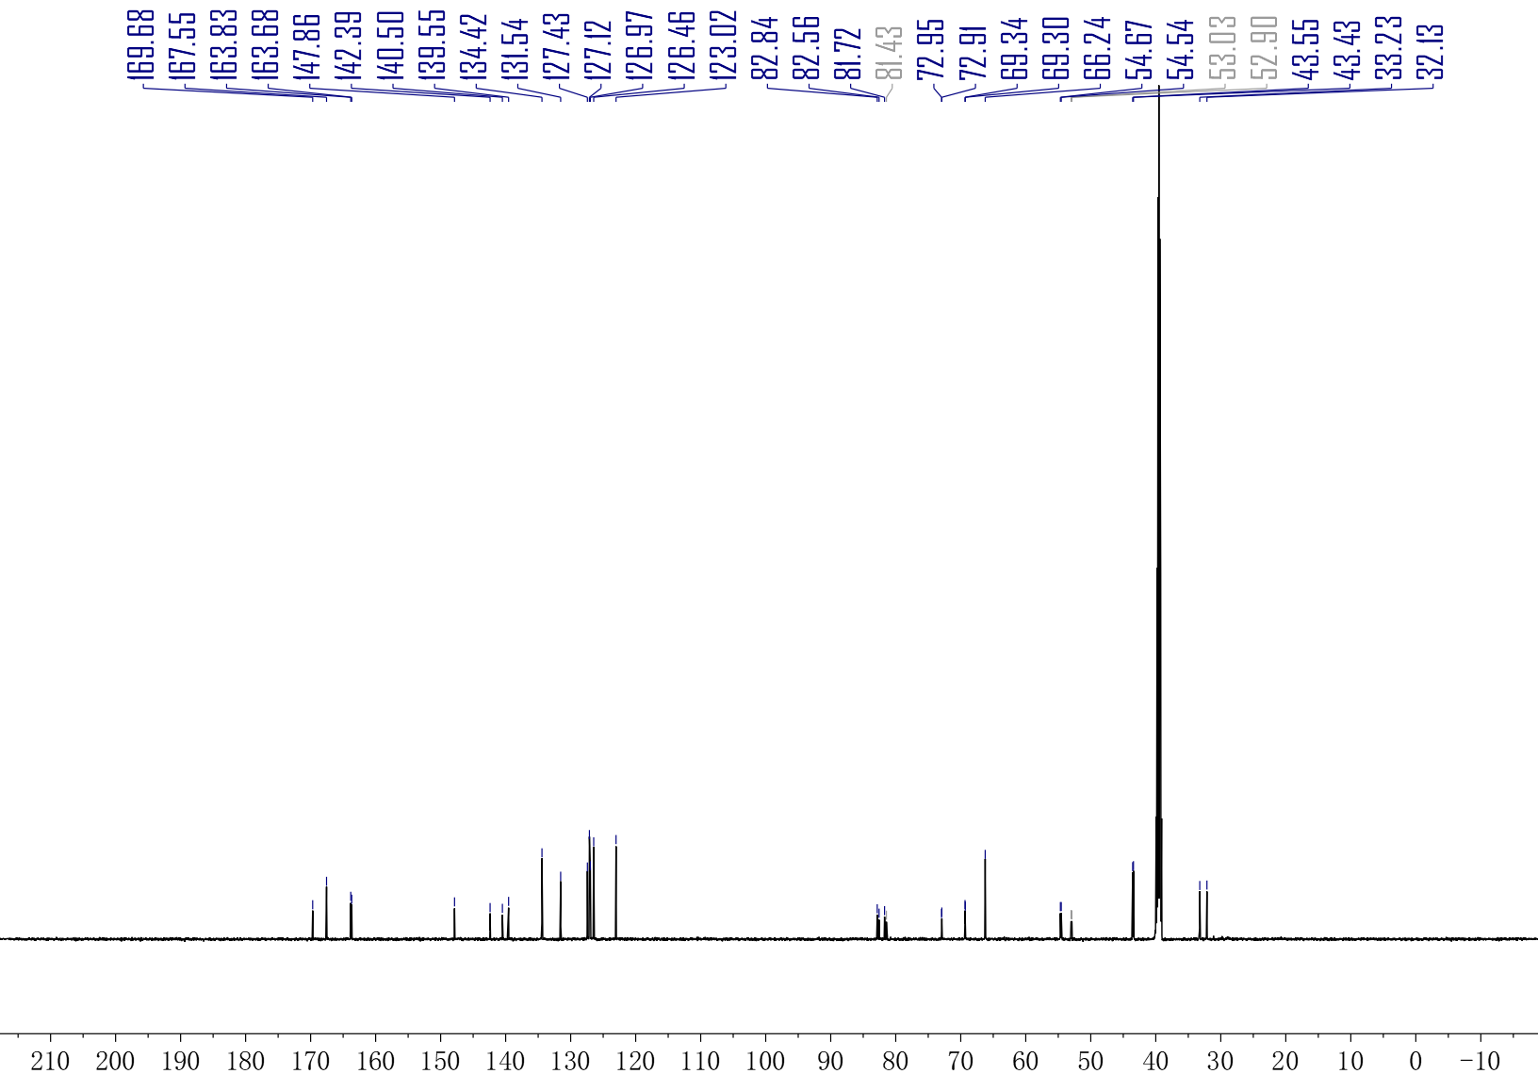
¹³C-NMR spectrum of compound F14 (150 MHz, DMSO).
¹³C NMR (150 MHz, DMSO) δ 169.68, 167.55, 163.83, 163.68, 147.86, 142.39, 140.50, 139.55, 134.42, 131.54, 127.43, 127.12, 126.97, 126.46, 123.02, 82.84, 82.56, 81.72, 81.43, 72.95, 72.91, 69.34, 69.30, 66.24, 54.67, 54.54, 53.03, 52.90, 43.55, 43.43, 33.23, 32.13.

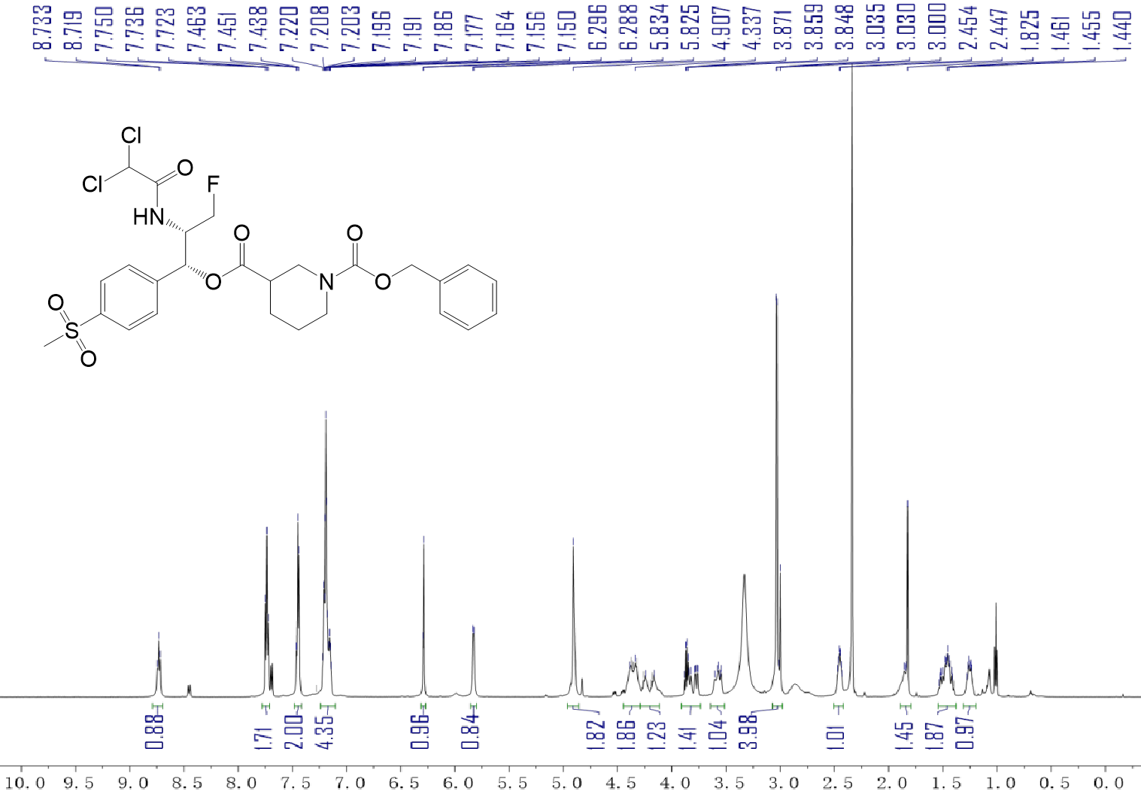
¹H-NMR spectrum of compound F15 (600 MHz, DMSO).
¹H NMR (600 MHz, DMSO-d₆) δ 8.73 (t, J = 8.0 Hz, 1H), 7.74 (t, J = 8.2 Hz, 2H), 7.44 (d, J = 7.8 Hz, 2H), 7.24 – 7.10 (m, 4H), 6.29 (d, J = 5.1 Hz, 1H), 5.83 (d, J = 5.3 Hz, 1H), 4.91 (s, 2H), 4.36 (d, J = 31.4 Hz, 2H), 4.20 (d, J = 46.6 Hz, 1H), 3.91 – 3.74 (m, 1H), 3.64 – 3.51 (m, 1H), 3.07 – 2.98 (m, 4H), 2.45 (dq, J = 9.8, 4.6, 4.2 Hz, 1H), 1.84 (d, J = 19.4 Hz, 1H), 1.47 (tdd, J = 25.3, 12.1, 5.5 Hz, 2H), 1.31 – 1.20 (m, 1H).

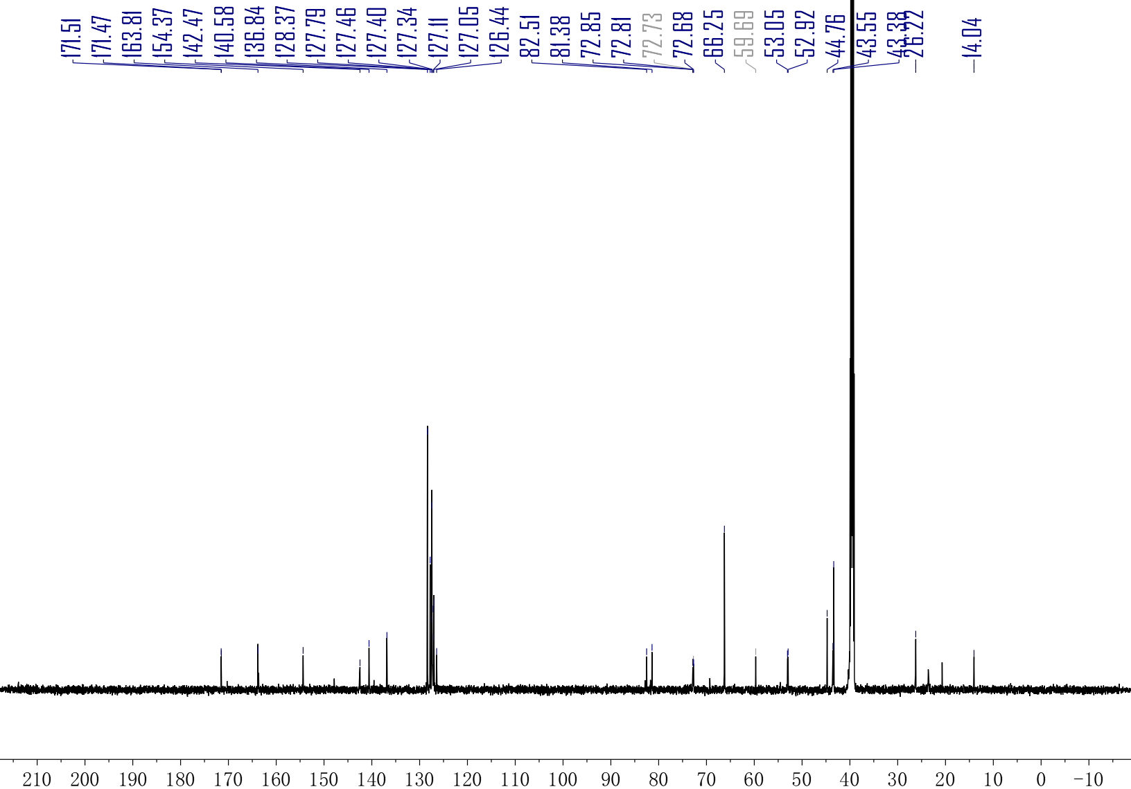
¹³C-NMR spectrum of compound F15 (150 MHz, DMSO).
¹³C NMR (150 MHz, DMSO) δ 171.51, 171.47, 163.81, 154.37, 142.47, 140.58, 136.84, 128.37, 127.79, 127.46, 127.40, 127.34, 127.11, 127.05, 126.44, 82.51, 81.38, 72.85, 72.81, 72.73, 72.68, 66.25, 59.69, 53.05, 52.92, 44.76, 43.55, 43.38, 26.22, 14.04.

