Results
Animals and Physiological Parameters
During the experiment, physiological parameters were maintained within normal ranges. The median peripheral capillary oxygen saturation (SpO₂) was 99.4% (interquartile range [IQR], 0.2), the arterial partial pressure of carbon dioxide (pCO₂) was 39.75 mmHg (IQR, 3.00), and the mean arterial pressure (MAP) was 73 mmHg (IQR, 8). The median rectal temperature was 36.7°C (IQR, 0.7), the heart rate was 102 beats per minute (IQR, 6), and the glucose level was 74 mg/dL (IQR, 30). These physiological variables, alongside other relevant measures, are detailed in Supplementary Table S1.
Incidence, Duration, Amplitude, and Expansion of the r_{c}SO₂% Responses in PAI
Utilizing photoacoustic imaging (PAI), we identified regional cerebral oxygen saturation (r_{c}SO₂%) fluctuations coupled with spreading depolarization (SD) waves identified by electrocorticography (ECoG) data (refer to Online Resource 3). A total of 12 events and 74 measurements within the regions of interest (ROIs) were detected. Each experiment typically exhibited one response (median), with an average reach of 6.5 ROIs per response (IQRs of 0.25 and 2.00, respectively). The median duration of the responses was 15.24 minutes (IQR, 14.34). An estimated median r_{c}SO₂% increase of +10.29% (IQR, 7.21) and a median decrease of -10.09% (IQR, 6.96) from the baseline level (median, 66.28; IQR, 17.41) were observed. Notably, in 53% (39/74) of the ROIs reached within these experiments, baseline r_{c}SO₂% was not restored due to the initiation of a subsequent response or the conclusion of the recording period.
Observed components in the r_{c}SO₂% SD-Responses
Our observations revealed several components associated with hemodynamic responses to SDs, namely brief hyperoxia, initial hypoxia, peak hyperoxia, late hyperoxia, post-SD hypoxia, and peak hypoxia. The most frequently observed components were peak hyperoxia, late hyperoxia, and post-SD hypoxia. Moreover, 8 r_{c}SO₂% alterations (10.8% of events) were categorized as nonspecific. These components are depicted in Supplementary Figure 1d (see Online Resource 4). Out of the total observed components, we delineated 12 distinct morphologies of r_{c}SO₂% responses, accounting for 86.6% of the responses. Morphologies that occurred only once (10 responses) were not included in the analysis. Supplementary Figure 2 illustrates the documented morphologies (available in Online Resource 5).

Supplementary Material. Table S1.

Physiological Parameters of the Animals.

Variables | Total  med (IQR)
SpO₂ (%) § | 99.4 (0.2)
EtCO₂ (mmHg) | 45.5 (6.5)
Heart rate | 102 (6)
MAP (mmHg) | 73 (8)
Rectal T°C | 36.7 (0.7)
Arterial pH § | 7.38 (0.05)
Arterial pCO₂ (mmHg) § | 39.75 (3.00)
Arterial pO₂ (mmHg) § | 141.70 (17.85)
HCO₃ (mmol/L) § | 22.9 (4.0)
Hematocrit (%) § | 29.0 (1.5)
Hemoglobin (g/dL) § | 9.9 (0.6)
Sodium (mEq/L) § | 132.1 (3.1)
Potassium (mmol/L) § | 4.1 (0.1)
Calcium (mmol/L) § | 1.17 (0.19)
Chlorine (mEq/L) § | 106 (4)
Glucose (mg/dL) § | 74 (30)
Lactate (mmol/L) § | 0.98 (0.43)
§ Values obtained between 34 and 153 minutes after the experiment under the same physiological conditions. Abbreviations: peripheral capillary oxygen saturation, SpO₂; end-tidal CO₂, EtCO₂; mean arterial pressure, MAP; partial pressure of carbon dioxide, pCO₂; partial pressure of oxygen, pO₂; median, med; interquartile range, IQR.

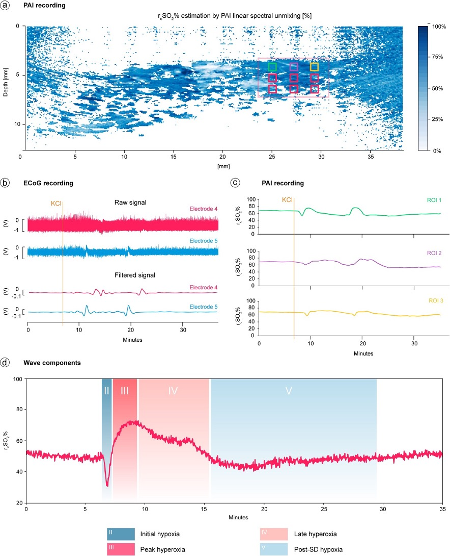
Supplementary Figure 1. (a) Photoacoustic imaging (PAI) linear spectral unmixing estimation of regional cerebral oxygen saturation (r_{c}SO₂%) at different depths within the gray matter of cerebral pig cortex. (b) & (c) Electrocorticographic (ECoG) (raw data and filtered signal) and PAI recordings were obtained to provide representative data of spreading depolarization (SD) development after the direct application of KCl. PAI signals correspond to ROIs in respective colors in (a) (d) SD wave components were identified through PAI, which measures the changes in r_{c}SO₂% over time. Component II, also referred to as initial hypoxia, exhibits a baseline reduction preceding any hyperoxic phase or a decrease that occurs during a peak hyperoxia. Subsequently, Component III (peak hyperoxia) displays a predominant baseline elevation lasting under 3 minutes. Component IV (late hyperoxia) represents a sustained baseline elevation extending beyond 3 or a slowing of the descent phase following peak hyperoxia. Lastly, Component V (post SD hypoxia) features a baseline decline persisting for over 3 minutes.

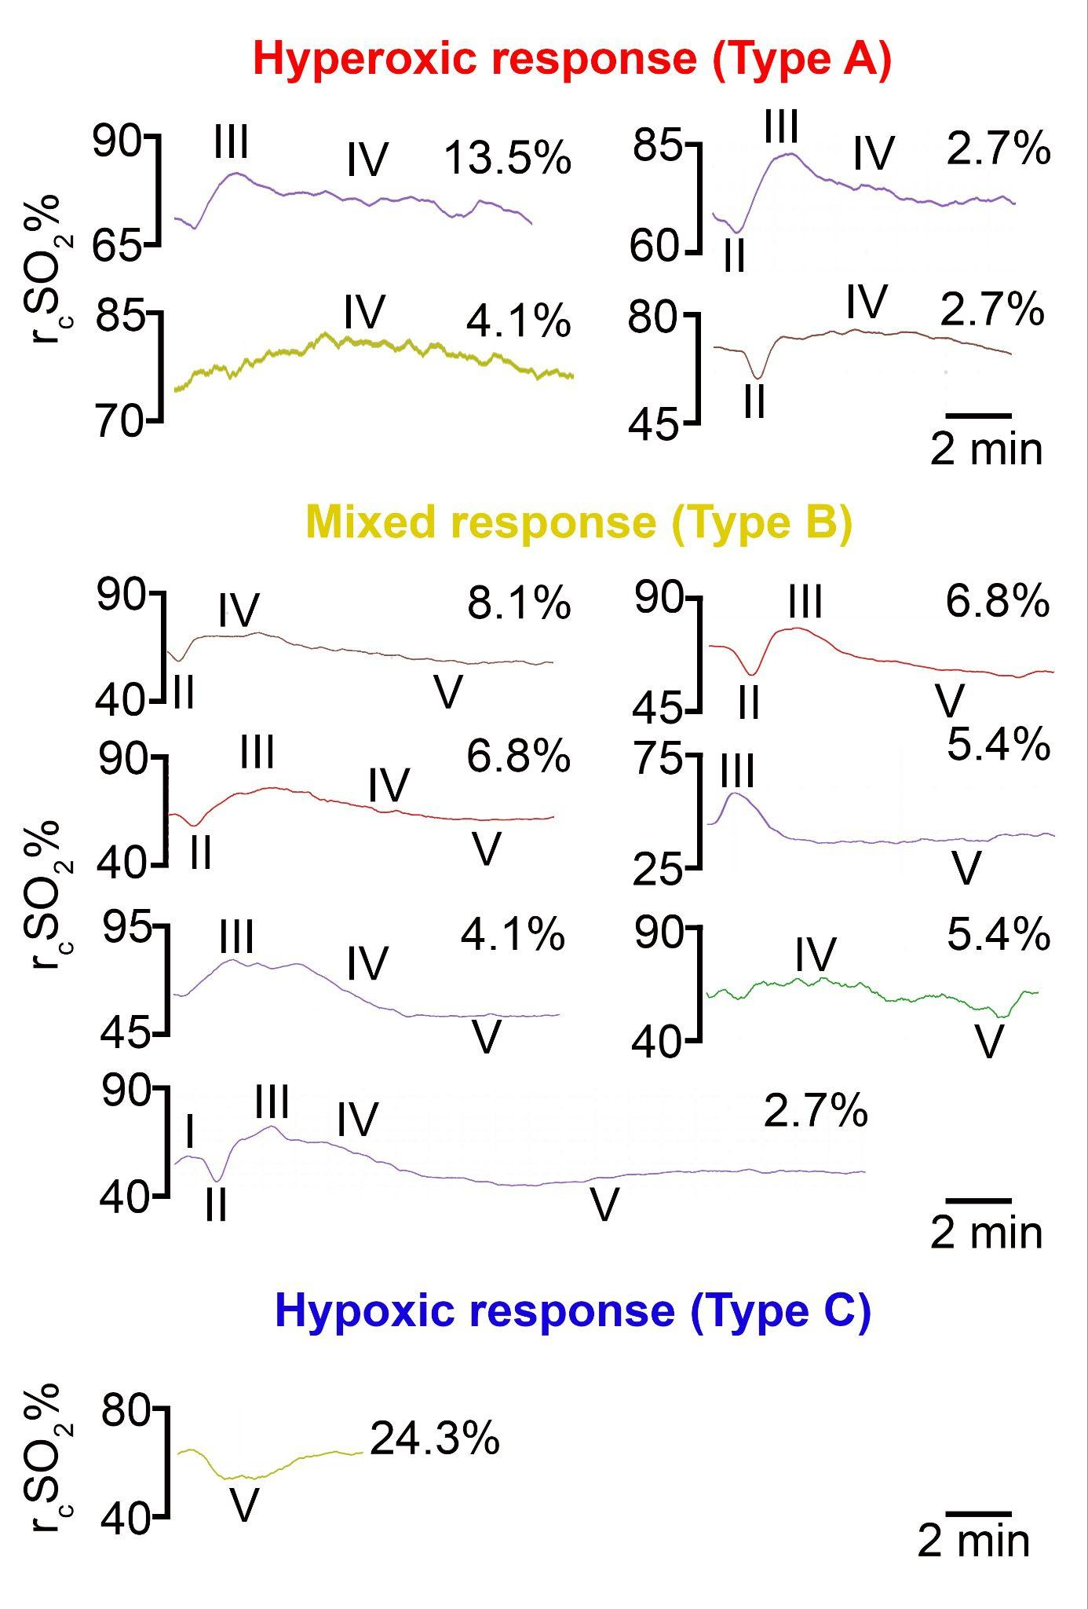
Supplementary Figure 2. This figure displays the 12 most commonly observed r_{c}SO₂% responses. The morphologies are categorized by response type and segmented into components: I (brief hyperoxia), II (initial hypoxia), III (peak hyperoxia), IV (late hyperoxia), and V (post-SD hypoxia). The color-coding differentiates between hyperoxic responses (Type A, red), mixed responses (Type B, yellow) and hypoxic responses (Type C, blue). The percentage displayed to the right of each plot indicates the proportion of total responses in which the respective morphology was observed.

Supplementary Video 1. This video provides a dynamic visualization of raw data capturing a spreading depolarization (SD) wave as observed through Photoacoustic Imaging (PAI). It displays temporal changes in regional cerebral oxygen saturation (r_{c}SO₂%) across nine selected Regions of Interest (ROIs) within the cerebral cortex. Each ROI is depicted as a separate graph line, demonstrating its unique baseline r_{c}SO₂% value on the y-axis against the progression of time on the x-axis. This visualization allows for the examination of the heterogeneity and temporal dynamics of the SD wave impact on cerebral oxygenation at various cortical depths.

