Materials and Methods
Premedication and Anesthesia Protocol
We administered Azaperone (Stresnil®, 4 mg/kg) and Midazolam (Dormicum®, 0.5-0.7 mg/kg) intramuscularly as premedication. Venous access was established, followed by induction of anesthesia with an intravenous bolus of Propofol (Disoprivan®, 5-7 mg/kg). Intubation was performed, and the animals were ventilated mechanically. Ventilation parameters were set to a flow rate of 2.5 l/min, a respiratory rate of 18 breaths/min, a fraction of inspired oxygen (FiO₂) of 35%, and a tidal volume of 8-12 ml/kg. Anesthesia was maintained with Isoflurane (Isothesia®, 0.6–1.0% vol) and a continuous infusion of Midazolam at 0.5 mg/kg/h. Bolus doses of Propofol were administered as required to maintain an adequate depth of anesthesia.
Physiological Monitoring
Physiological parameters were continuously monitored to maintain homeostasis. Heart rate was kept at 60-120 beats per minute, mean arterial pressure (MAP) was maintained within a range of 60-90 mmHg, peripheral capillary oxygen saturation (SpO₂) was sustained at levels >90%, arterial partial pressure of carbon dioxide (pCO₂) was regulated between 35-45 mmHg, blood glucose levels were kept >60 mg/dL, and rectal temperature was controlled within the range of 36.0-37.5°C.
Operative Procedure
A custom frame was utilized to position the pig heads securely in a prone orientation. A craniotomy was executed, followed by excision of the dura mater, to reveal the cerebral hemispheres. Subsequently, the brains were subject to a preconditioning high-potassium Ringer's lactate solution (11 mmol/L) for one hour. To enhance imaging quality and prevent cortical reflection and dehydration, a paraffin pool was applied and replenished bihourly. Electrocorticography (ECoG) strips (Ad-tech, Racine, Wisconsin, USA) were positioned subdurally in contact with the parietal cortex. For photoacoustic imaging (PAI), after placing an Aquaflex Ultrasound Gel Pad and interposing a submicron gold leaf, the PAI transducer was aligned 1 cm from the sagittal midline over the hemisphere of interest. Post-experiment, euthanasia was induced via an intravenous injection of 20 ml of 7.45% KCl under maintained anesthesia.
ECoG and PAI Monitoring
ECoG recordings were conducted using two strips of platinum electrodes, each with five contacts. Signals were digitized at a sampling rate of 1000 Hz across ten active channels using Octal Bio Amp amplifiers and a PowerLab 16/SP analog-to-digital converter (ADInstruments Inc., Dunedin, New Zealand). An Ag/AgCl reference electrode was positioned subcutaneously below the malar bone.
The PAI setup comprised a 128-channel ultrasound system (DiPhAs, Fraunhofer IBMT, St. Ingbert, Germany) with a linear 128-element transducer (L7-Xtech, Vermon, Tours, France) operating at a central frequency of 7.5 MHz, and a NIR fast-tuning optical parametric oscillator laser (Phocus Mobile, Opotek, Carlsbad, USA). The interposed gold leaf minimized artifacts from light absorption by the ultrasound transducer.
Spreading Depolarizations (SD) Induction
SDs were elicited by the topical application of 1-2 μl of 1 M KCl to the cerebral cortex. If an SD was not observed within 10-20 minutes, a second application was performed. Visualization during the experiment was facilitated by the Medical Imaging Interaction Toolkit (MITK) software [1], which was used to guide the placement of the KCl. Monitoring via both ECoG and PAI commenced, with a median recording duration of 36 minutes post-stimulation.
Data analysis
ECoG-Based Identification of SD
SDs were verified through analysis of ECoG data utilizing the Labchart-7 platform (ADInstruments Inc., New Zealand), as per the guidelines prescribed by the Co-operative Studies on Brain Injury Depolarizations (COSBID) [2]. This process ensured the identification of SD events was consistent with recognized standards in the field.
PAI data analysis
Estimation of Oxygen Saturation
The quantification of oxyhemoglobin (HbO₂) and deoxyhemoglobin (Hb) concentrations via PAI leverages the technique of linear spectral unmixing to resolve regional cerebral oxygen saturation (r_{c}SO₂%). The r_{c}SO₂% is calculated using the equation r_{c}SO₂% = CHbO₂ / (CHbO₂ + CHb), with C representing the concentration of each hemoglobin form.
Nine regions of interest (ROIs) within the cerebral cortex were systematically chosen for analysis, organized into a 3x3 grid with dimensions of 4.00 mm x 5.25 mm across varying cortical depths delineated as 0.80 mm to 1.70 mm for depth 1, 1.95 mm to 2.85 mm for depth 2, and 3.10 mm to 4.00 mm for depth 3. The arrangement of ROIs is visualized in Supplementary Figure 1a (Online Resource 4). PAI data were corrected for inter-frame motion artifacts attributable to physiological movements such as respiration and pulsatile brain swelling, thus ensuring spatial accuracy over time [3]. Subsequent temporal plotting of r_{c}SO₂% facilitated detailed analysis across different cortical depths.
Characterization of r_{c}SO₂% Fluctuations Associated with SD
r_{c}SO₂% fluctuations were temporally correlated with ECoG-detected SD events, as exemplified in Supplementary Figures 1b and 1c (Online Resource 4). An r_{c}SO₂% response was initiated upon deviation from baseline levels and concluded upon return to these levels. The baseline was established differently for the initial r_{c}SO₂% response (preceding period average) versus subsequent responses (preceding 5-minute interval average). The incidence, duration (min), and amplitude (Δ) of these responses were quantified using Image J 1.53k software.
Pathways and kinetics of initial r_{c}SO₂% responses were extrapolated from sequential observations within ROIs, with the initial response's propagation speed being a particular focus, calculated using inter-ROI central distances. Analysis only included initial responses to preclude data confounding.
Components of the r_{c}SO₂% response
Each response was dissected into distinct 'components' reflecting either an increase or decrease in r_{c}SO₂% relative to the baseline. We analyzed the following characteristics of these components using the Image J 1.53k Software program: occurrence, duration (min), and amplitude (Δ r_{c}SO₂%).
In reminiscence of the principal hemodynamic components described by Ayata et al. [4] in response to an SD, we categorized four distinct components based on their r_{c}SO₂% levels and duration. Components were classified as hyperoxic if r_{c}SO₂% was above the baseline level and hypoxic below the baseline level. Peak and long-lasting components were distinguished with a 3-minute cut-off point according to the usual duration of peak hyperemia (up to 3 min) and late hyperemia (4 to 8 min) described within the hemodynamic response to SDs. Thus, we defined the following components (refer to Supplementary Figure 1d within the Online Resource 4):
• Initial hypoxia (Component II): a baseline reduction preceding any hyperoxic phase or a decrease that occurs during a peak hyperoxia.
• Peak hyperoxia (Component III): a predominant baseline elevation lasting under 3 minutes.
• Late hyperoxia (Component IV): a sustained baseline elevation extending beyond 3 or a slowing of the descent phase following peak hyperoxia.
• Post-SD hypoxia (Component V): a baseline decline persisting for over 3 minutes.
Furthermore, we identified other components to a lesser extent. Brief hyperoxia (Component I) was characterized as an increase occurring before peak or late hyperoxia. Peak hypoxia was defined as a predominant decrease below the baseline level lasting less than 3 min and not followed by hyperoxia (peak or late). Finally, nonspecific variations encompassed changes that did not meet the criteria for the components mentioned above. As an additional analysis, we identified the different morphologies of the rcSO2% responses considering the combination of all the aforementioned components.
Classification of r_{c}SO₂% Response Types
The aggregate of the predominant components (III, IV, V, and peak hypoxia) yielded three distinct response classifications:
- Hyperoxic (type A): Isolated or combined occurrences of Components III and IV.
- Mixed (type B): Any hyperoxic component (III or/and IV) preceding a hypoxic phase (V or peak hypoxia).
- Hypoxic (type C): Isolated instances of Component V or peak hypoxia.
Quantitative features of these responses, including incidence, duration (min), and amplitude extremes (Δr_{c}SO₂%), were documented using the Image J 1.53k platform.
Histological analysis
Serial sections (3 µm thickness) were cut and stained with hematoxylin and eosin. The histological sections were scanned and evaluated using specific software (Aperio, Imagescope). The neuronal layers were assessed quantitatively and qualitatively to classify the histological layers of the cerebral gray matter and white matter, considering the orientation of the cerebral convolutions. Brain sections were conducted on 6 animals, distinct from the subjects under investigation in this study but matching in terms of race, gender, and age. We identified a heterogeneity of neuronal cells across the layers at various depths.
Statistical analysis
The normality of data distributions was ascertained via the Kolmogorov–Smirnov test. Descriptive statistics for normally distributed variables were presented as mean (m) ± standard deviation (Std), while those not normally distributed were presented as median (med) and interquartile ranges (IQR). Comparative analysis of non-normally distributed quantitative variables was performed using the Kruskal-Wallis test with Dunn-Bonferroni post hoc adjustments or the Mann-Whitney U test for two independent samples. Categorical variables underwent Chi-square evaluation. Statistical processes were executed using IBM SPSS Statistics 28.0.0.0 (SPSS Inc., Chicago, Illinois, USA), with a p-value threshold of <0.05 demarcating statistical significance. All statistical tests were two-sided.
References
- Nolden M, Zelzer S, Seitel A, Wald D, Müller M, Franz AM, et al. The Medical Imaging Interaction Toolkit: challenges and advances: 10 Years of open-source development. Int J Comput Assist Radiol Surg [Internet]. 2013;8(4):607–20. Disponible en: doi:10.1007/s11548-013-0840-8
- Dreier JP, Fabricius M, Ayata C, et al. Recording, analysis, and interpretation of spreading depolarizations in neurointensive care: Review and recommendations of the COSBID research group. Journal of Cerebral Blood Flow and Metabolism. 2017;37(5):1595-1625. doi:10.1177/0271678X16654496
- Kirchner T, Gröhl J, Herrera MA, et al. Photoacoustics can image spreading depolarization deep in gyrencephalic brain. Sci Rep. 2019;9(1). doi:10.1038/s41598-019-44935-4
- Ayata C, Lauritzen M. SPREADING DEPRESSION, SPREADING DEPOLARIZATIONS, AND THE CEREBRAL VASCULATURE. Physiol Rev. 2015;95:953-993. doi:10.1152/physrev.00027.2014.-Spreading

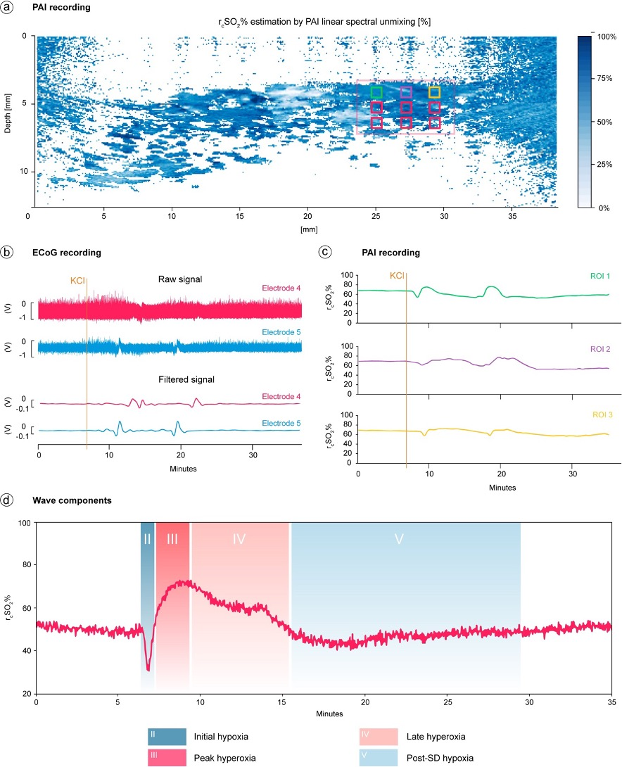

Supplementary Figure 1. (a) Photoacoustic imaging (PAI) linear spectral unmixing estimation of regional cerebral oxygen saturation (r_{c}SO₂%) at different depths within the gray matter of cerebral pig cortex. (b) & (c) Electrocorticographic (ECoG) (raw data and filtered signal) and PAI recordings were obtained to provide representative data of spreading depolarization (SD) development after the direct application of KCl. PAI signals correspond to ROIs in respective colors in (a) (d) SD wave components were identified through PAI, which measures the changes in r_{c}SO₂% over time. Component II, also referred to as initial hypoxia, exhibits a baseline reduction preceding any hyperoxic phase or a decrease that occurs during a peak hyperoxia. Subsequently, Component III (peak hyperoxia) displays a predominant baseline elevation lasting under 3 minutes. Component IV (late hyperoxia) represents a sustained baseline elevation extending beyond 3 or a slowing of the descent phase following peak hyperoxia. Lastly, Component V (post SD hypoxia) features a baseline decline persisting for over 3 minutes.

