Supplementary Information

In situ photocatalytic strain evolution of a single Au nanoparticle in Au/TiO₂ heterostructures
Sunghyun Park¹, Sukyoung Kim^{2,6}, JaeWhan Park³, Seunghee Kim^{2,6}, Wonsuk Cha⁴, Joonseok Lee^{2,5,6}*

¹Department of HY-KIST Bio-Convergence, Hanyang University, Seoul 04763, Republic of Korea
²Department of Chemistry, Hanyang University, Seoul 04763, Republic of Korea
³Center for Artificial Low Dimensional Electronic Systems, Institute for Basic Science, Pohang 37673, Republic of Korea
⁴X-ray Science Division, Advanced Photon Source, Argonne National Laboratory, Argonne, IL 60439, USA
⁵Research Institute for Convergence of Basic Sciences, Hanyang University, Seoul 04763, Republic of Korea
⁶Research Institute for Natural Sciences, Hanyang University, Seoul, 04763, Republic of Korea

†Corresponding authors
E-mail address: joonseoklee@hanyang.ac.kr
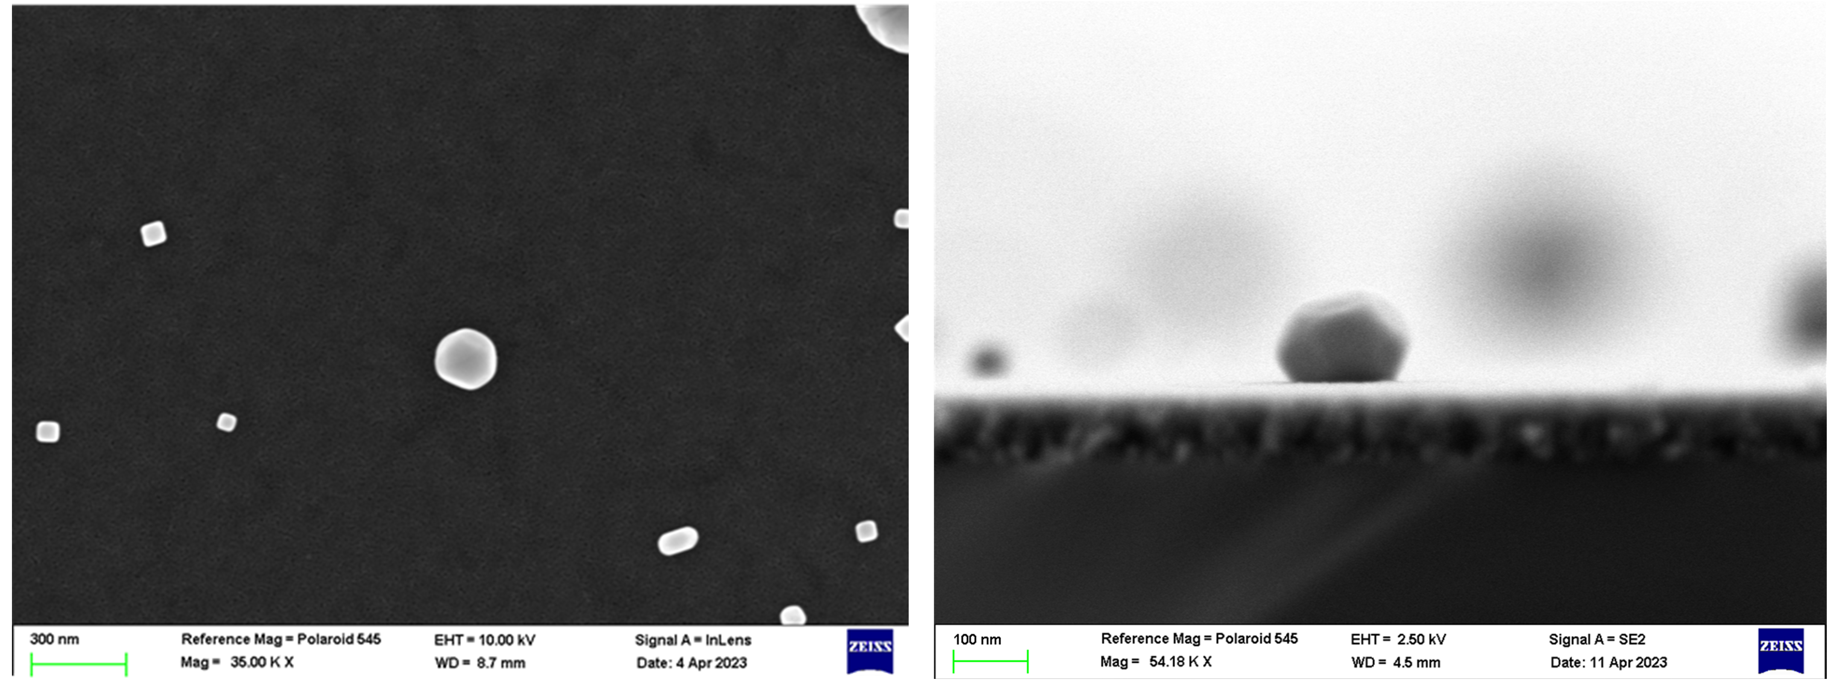
Supplementary Fig. 1. SEM images of top and cross-sectional views of AuNPs on TiO₂ substrate. The focused X-ray beam was illuminated to an isolated AuNP in BCDI measurements.

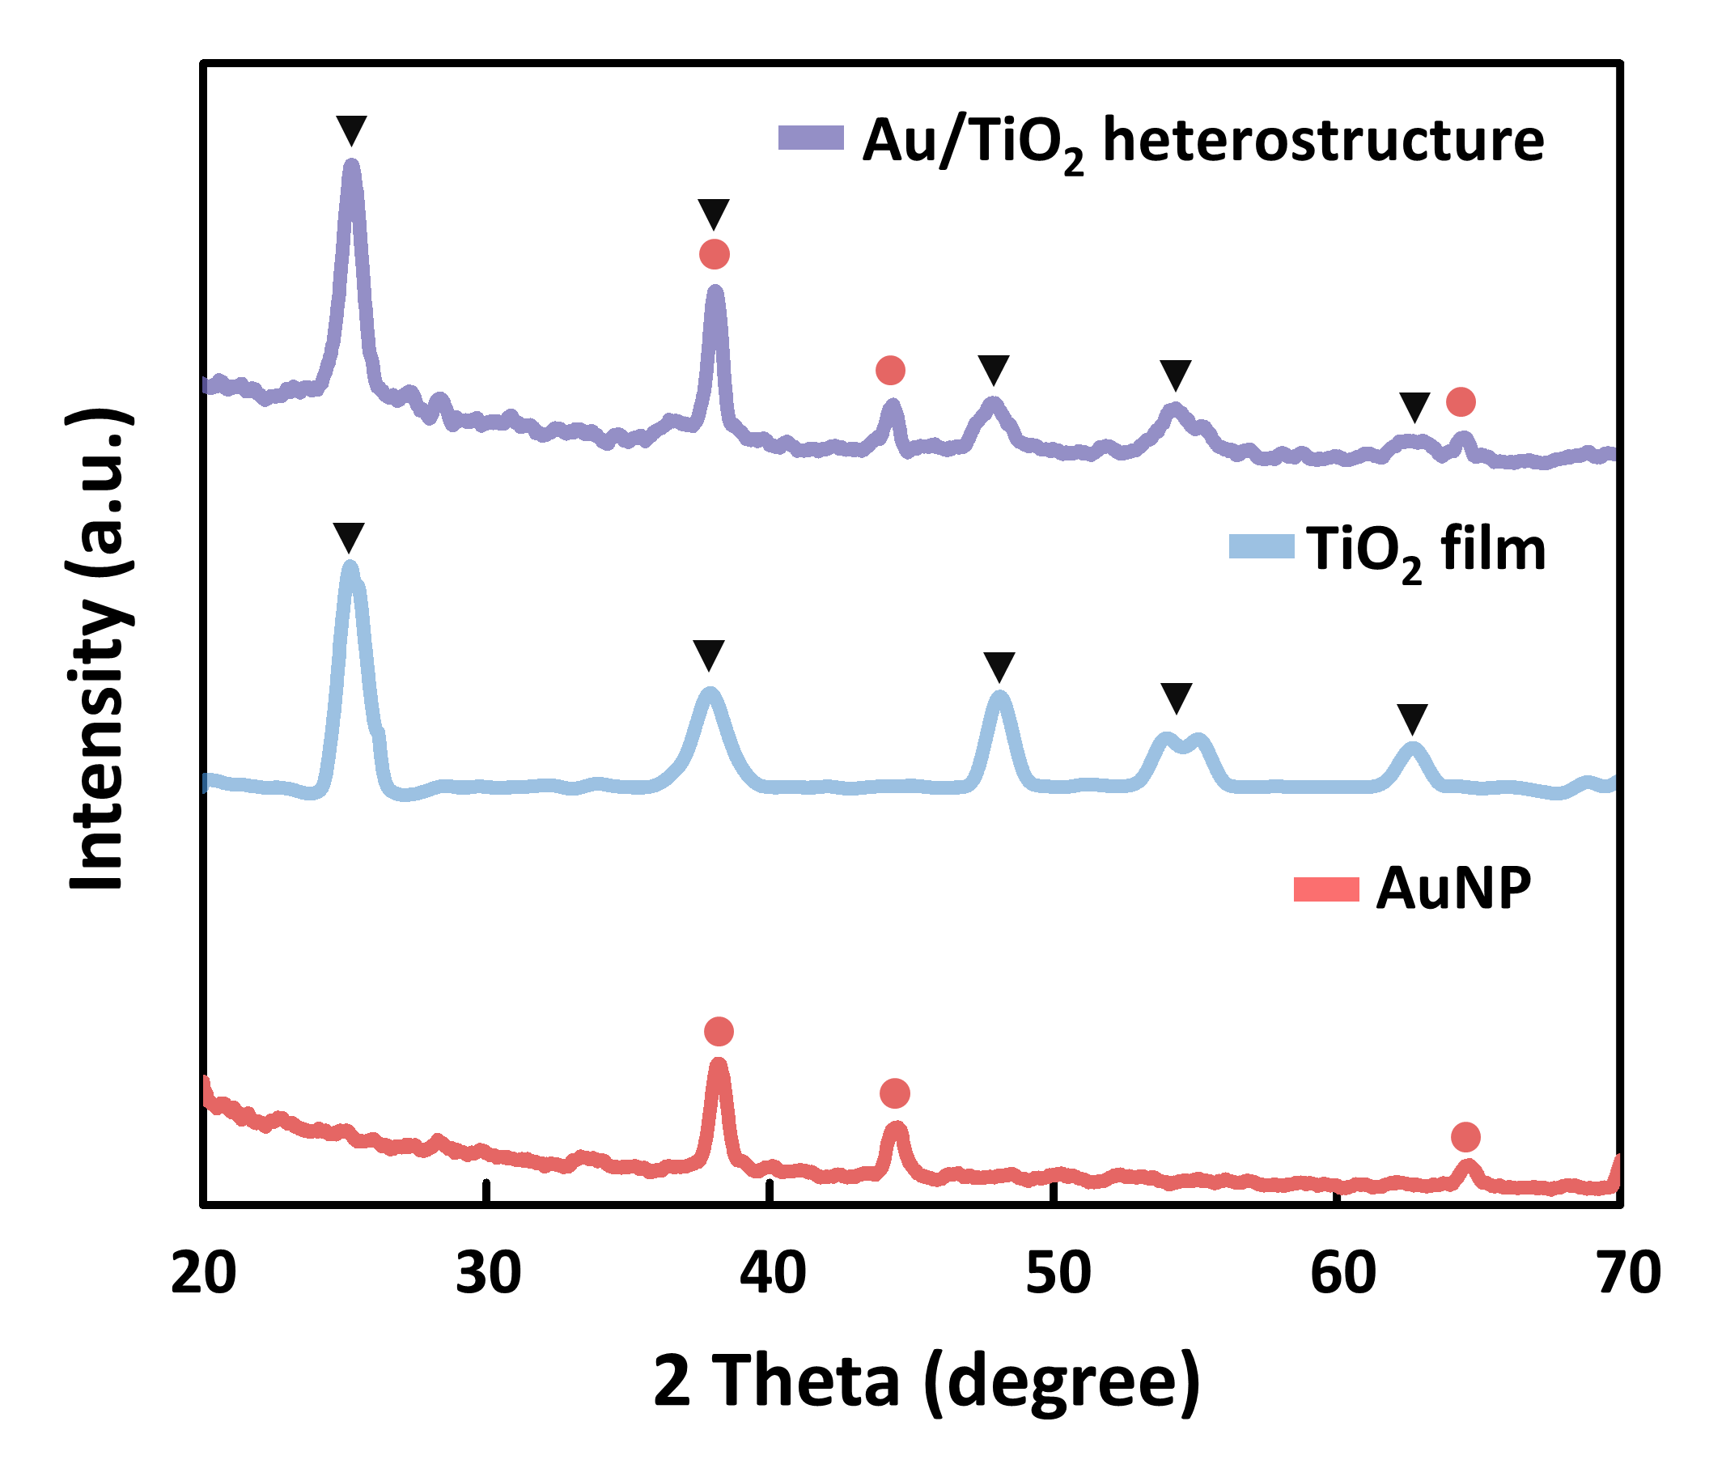
Supplementary Fig. 2. XRD patterns of AuNP, TiO₂, and Au/TiO₂ heterostructure with peaks labeled based on the standard pattern of the pure phase of Au and TiO₂.

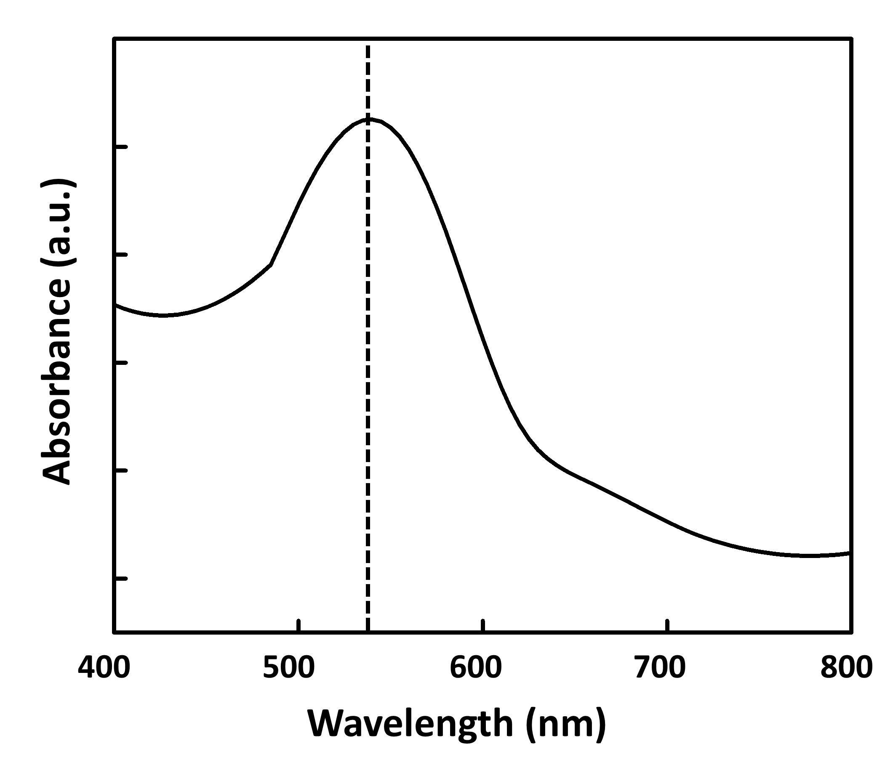
Supplementary Fig. 3. UV/Visible spectra of AuNPs. The observed peak of 532 nm indicates the maximum absorbance wavelength of the AuNPs.

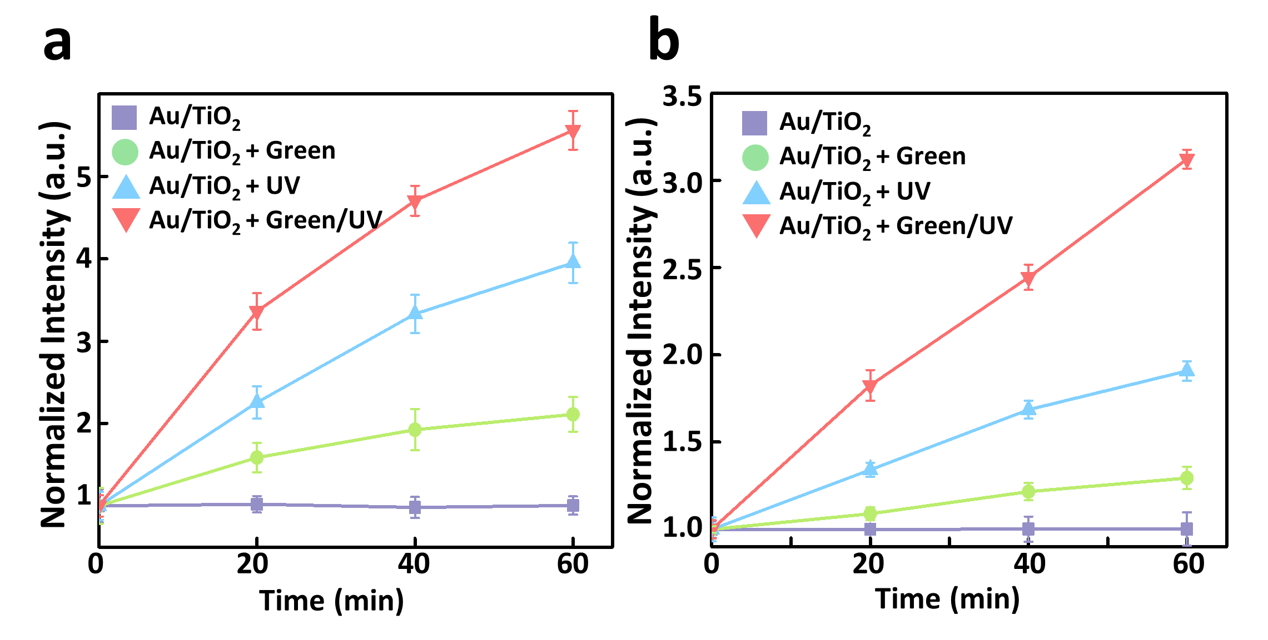
Supplementary Fig. 4. a Time-dependent fluorescence intensity of 7-OH-coumarin for detecting the •OH generation of the Au/TiO₂ heterostructure irradiated by green, UV, and green/UV. b Time-dependent fluorescence intensity of DHE for detecting the O₂^{-•} generation of the Au/TiO₂ heterostructure irradiated by green, UV, and green/UV.

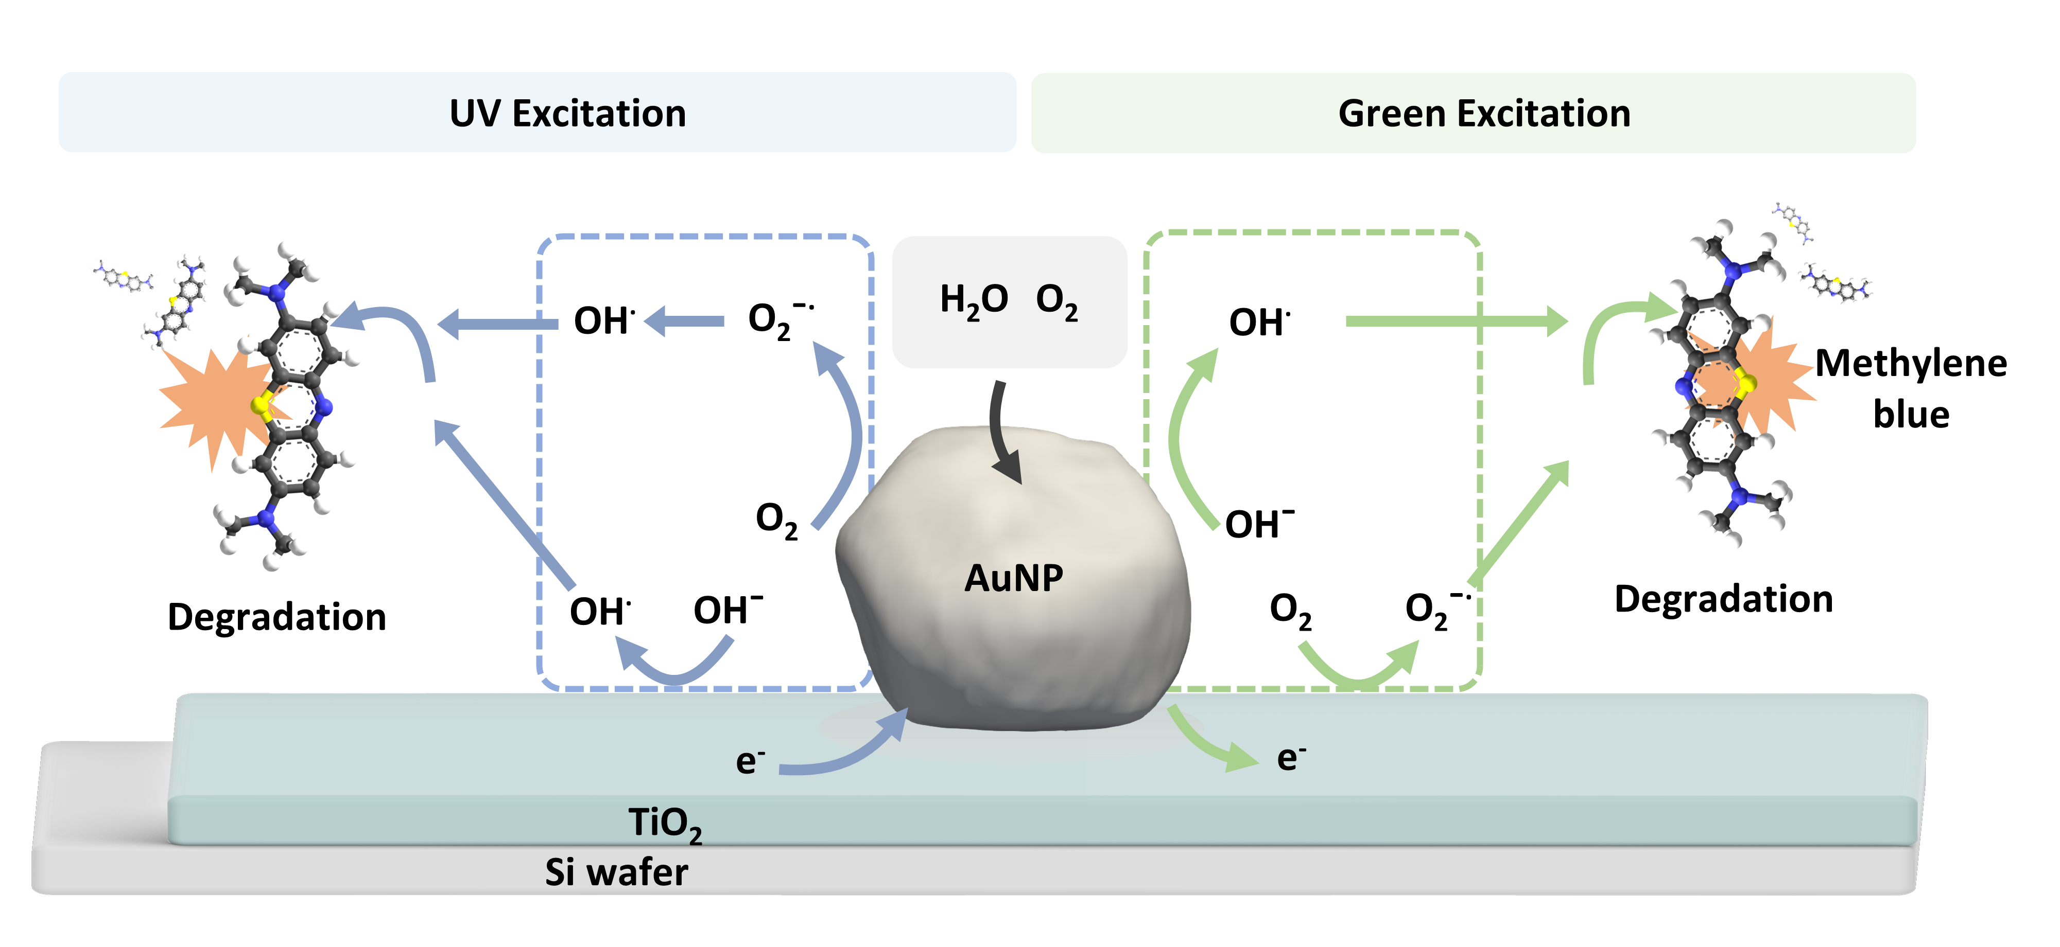
Supplementary Fig. 5. Schematic illustration of the photocatalytic degradation mechanism of MB by Au/TiO₂ heterostructure.

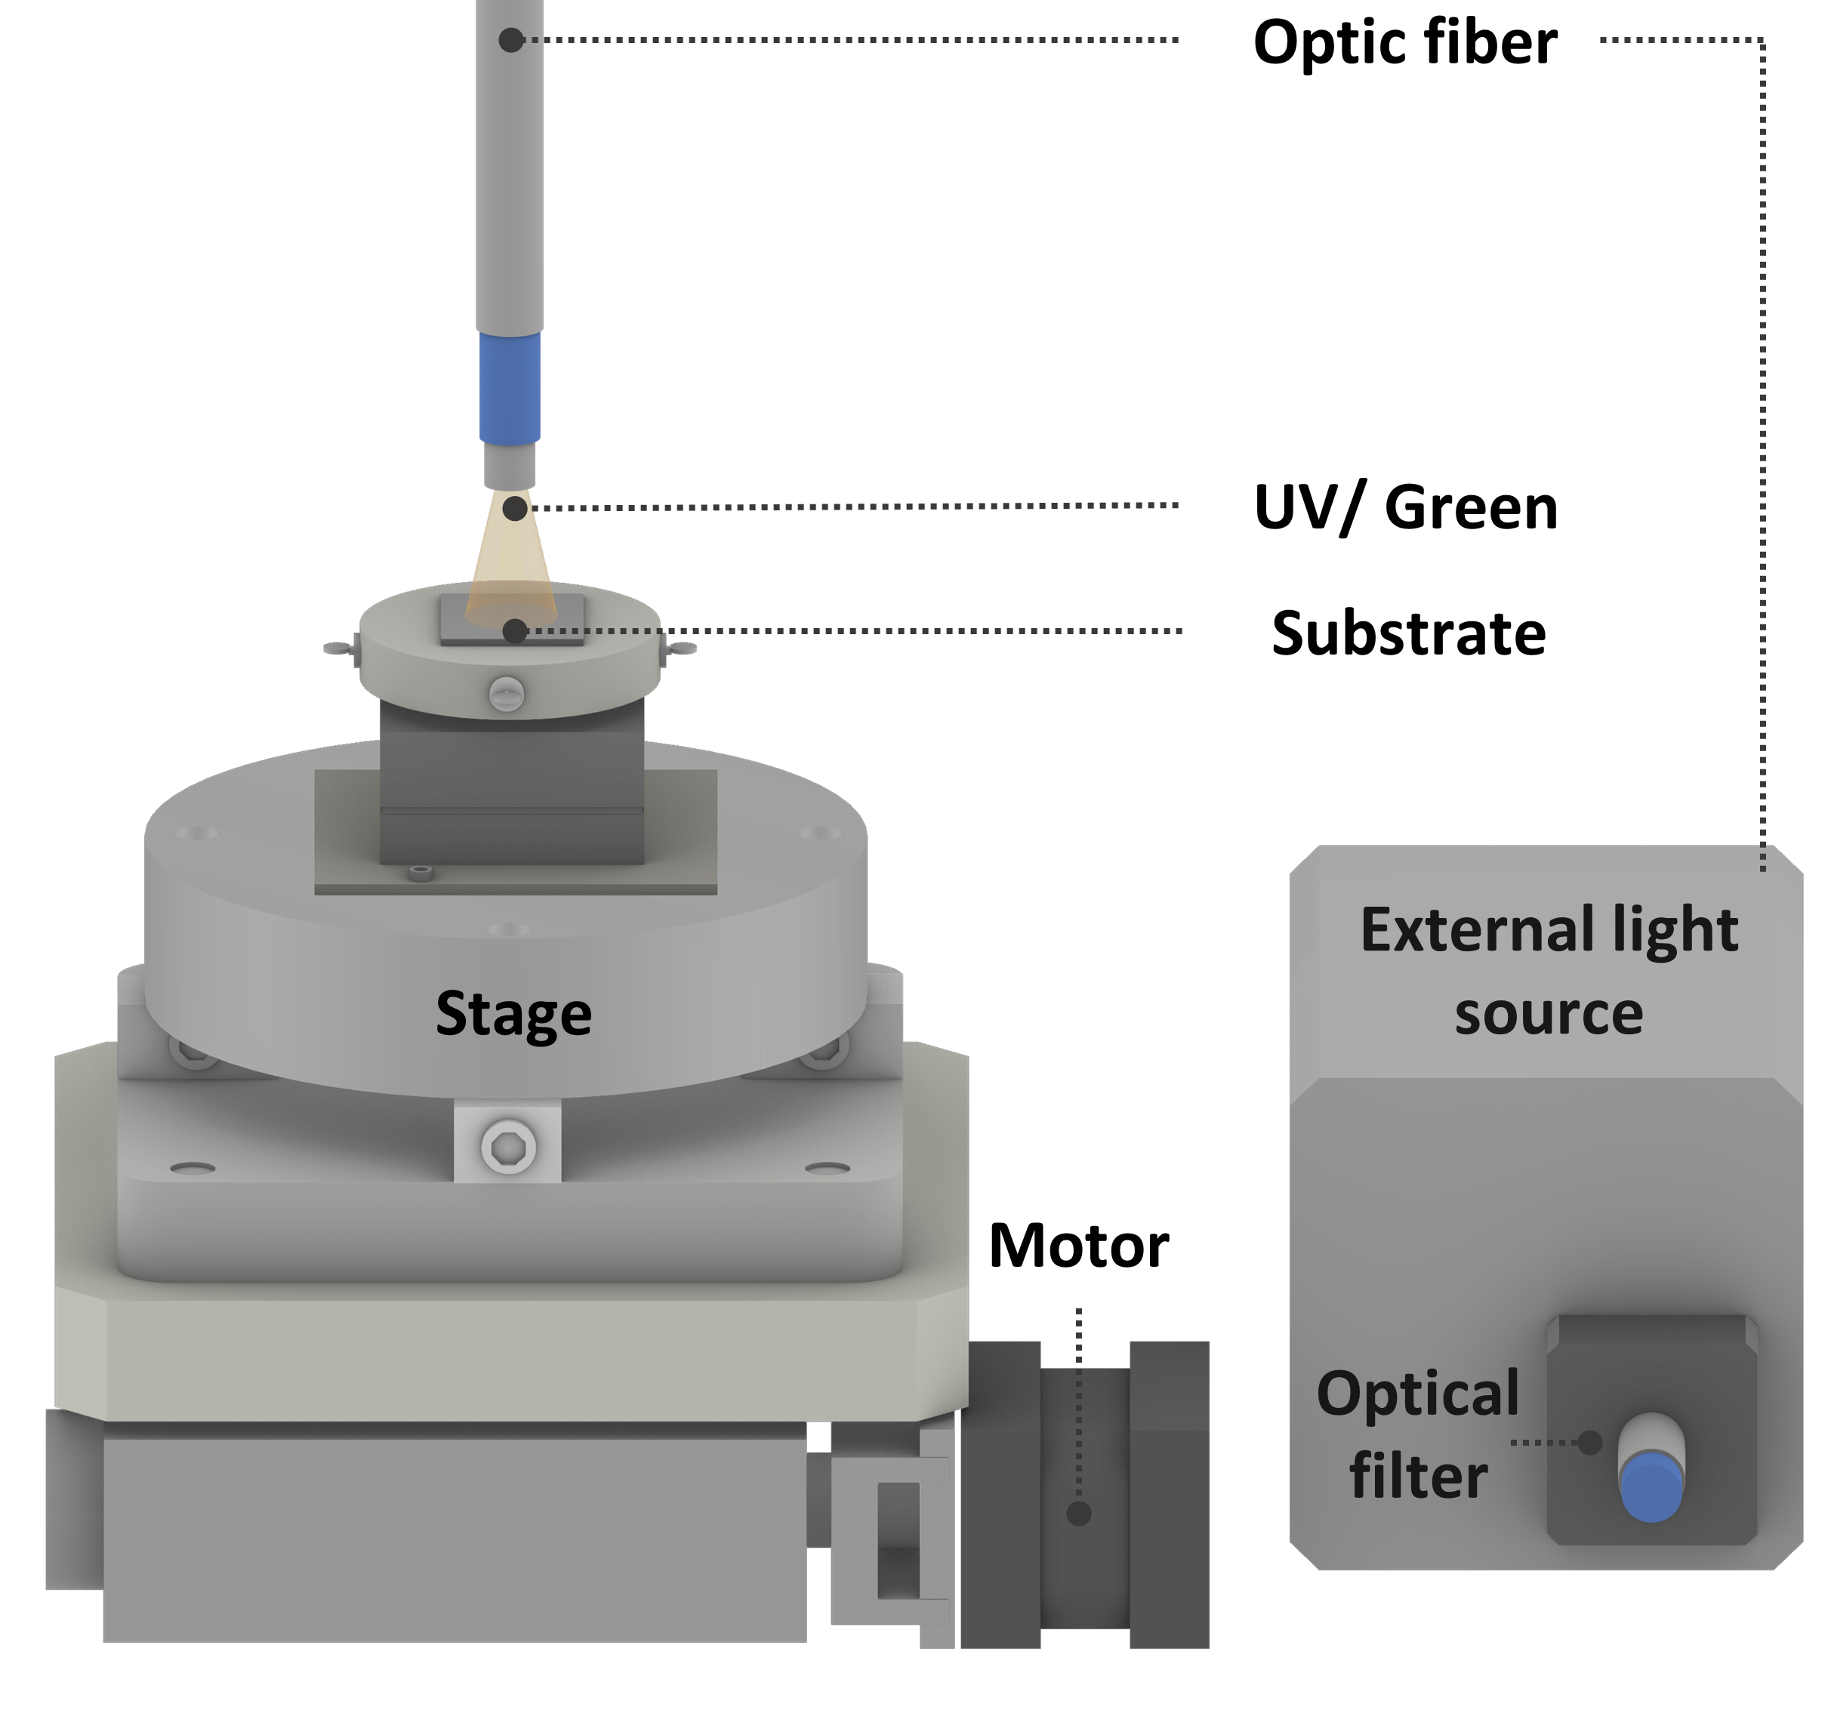
Supplementary Fig. 6. Experimental setup for imaging strain evolution of individual AuNP.

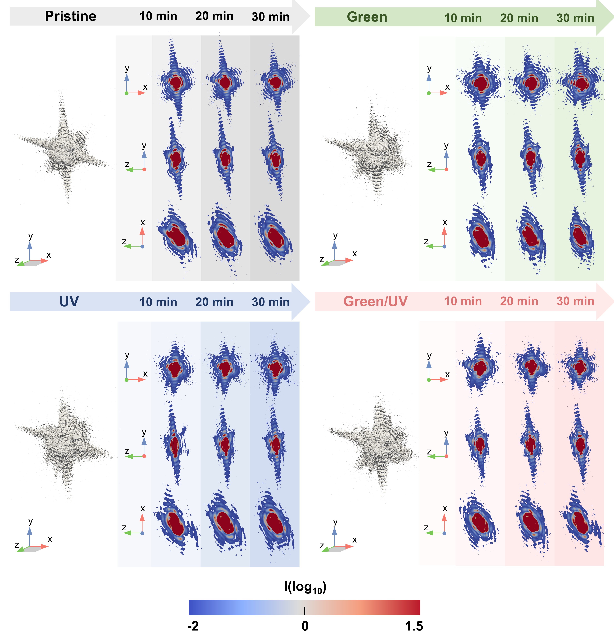Supplementary Fig. 7. Coherent x-ray diffraction patterns of a single AuNP on TiO₂ film at the (111) Bragg peak as a function of the x, y, and z coordinates of the scattering vector Q₁₁₁. The intensity has been normalized by its maximum value. The illumination conditions are indicated in the figures.
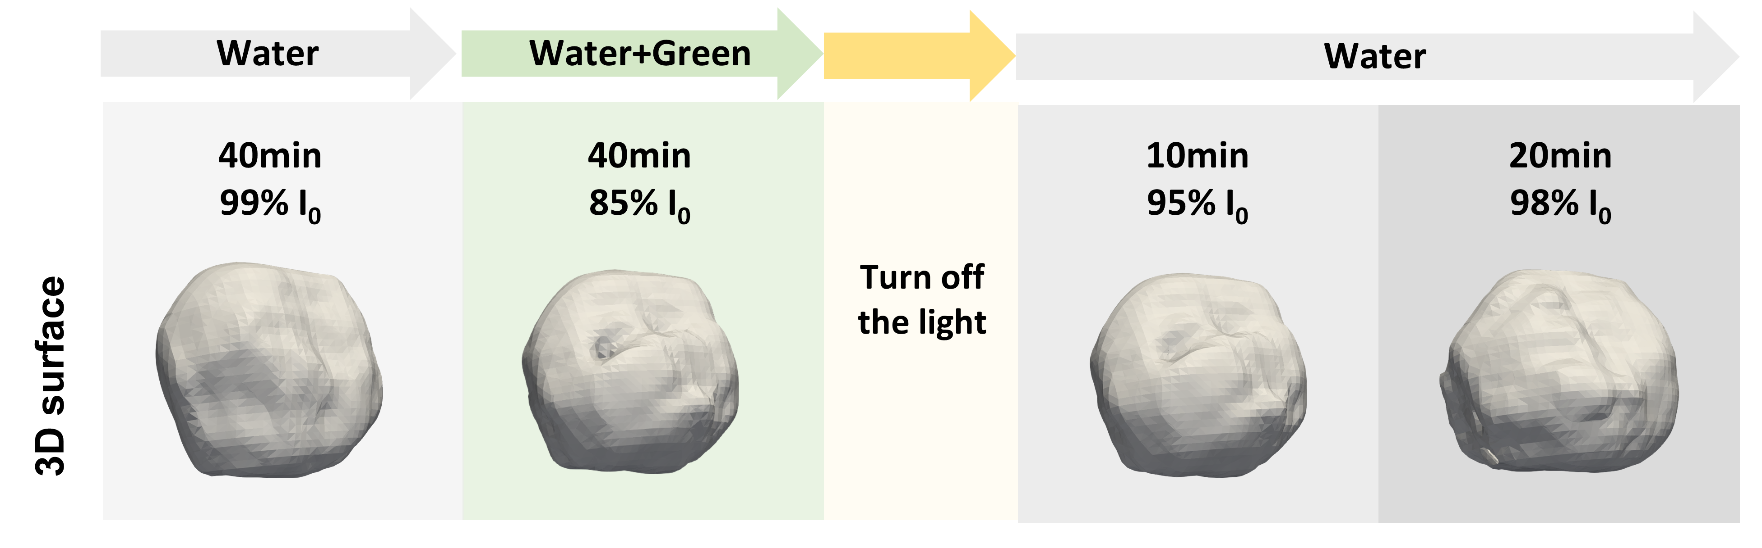
Supplementary Fig. 8. Structural deformation of a single AuNP as a function of light irradiation. As the irradiation time increased, the integrated intensity of Bragg peak decreased to 85%, and voids were observed inside the AuNP. After turning off the light, the intensity recovered up to 98%. The illumination conditions are indicated in the figures. 3D volume viewed at a 30% amplitude threshold.

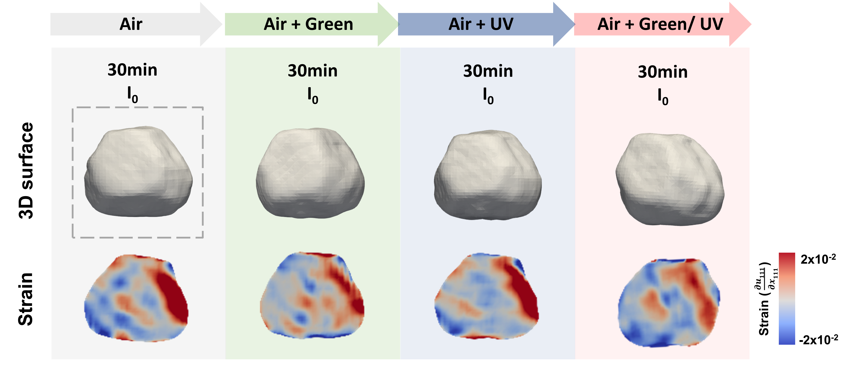
Supplementary Fig. 9. Morphology and strain distribution changes of a single AuNP in air. 3D volume viewed at a 30% amplitude threshold. The illumination conditions are indicated in the figures.

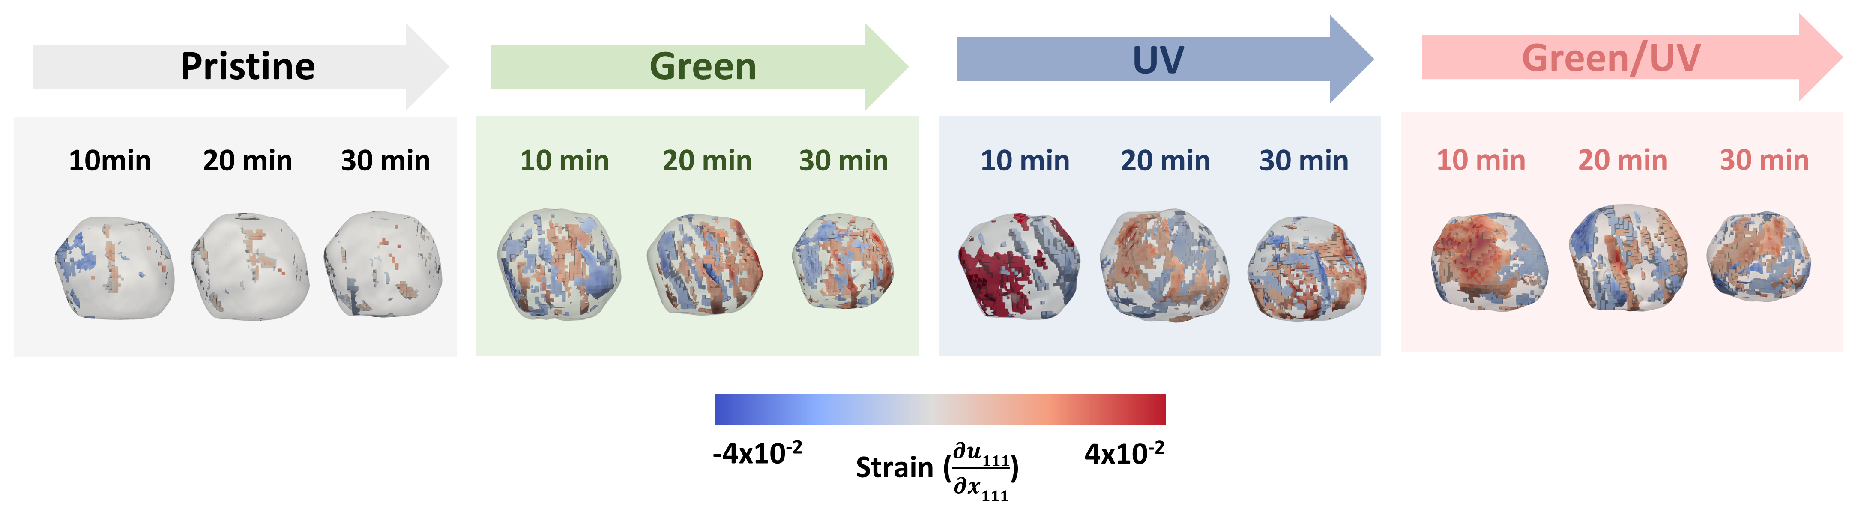
Supplementary Fig. 10. 3D strain structure associated with compressive (blue, strain < −0.002 shown in Fig. 3b) and tensile (red, strain > 0.002 shown in Fig. 3b) strains. The illumination conditions at which the measurements have been performed are indicated in the figures.

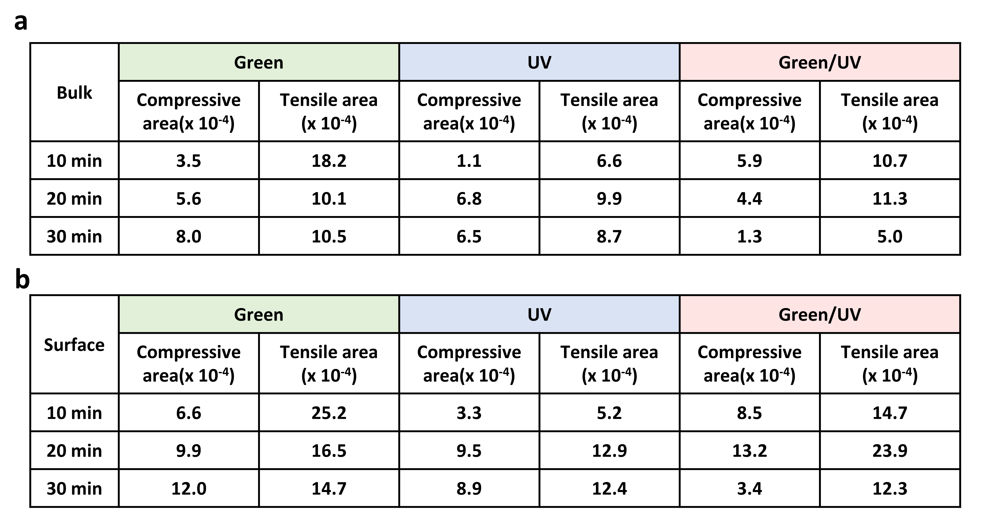
Supplementary table 1. Integration of the high strain region. The high strain region of the tensile and compressive areas was integrated from the strain distribution. a Integration results for the bulk state of the compressive and tensile areas as a function of the irradiated wavelength. b Integration results for the surface state of the compressive and tensile areas as a function of the irradiated wavelength.

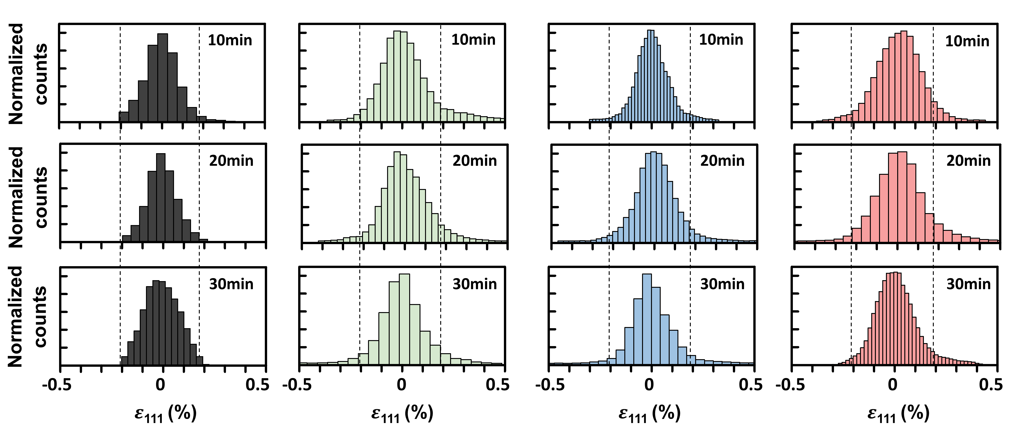
Supplementary Fig. 11. Statistical distribution of surface strain of a single AuNP from Fig. 2. Lines on the strain plots indicate the threshold values (−0.2% and 0.2%) used for plotting the 3D high strain structures shown in Fig 2c.
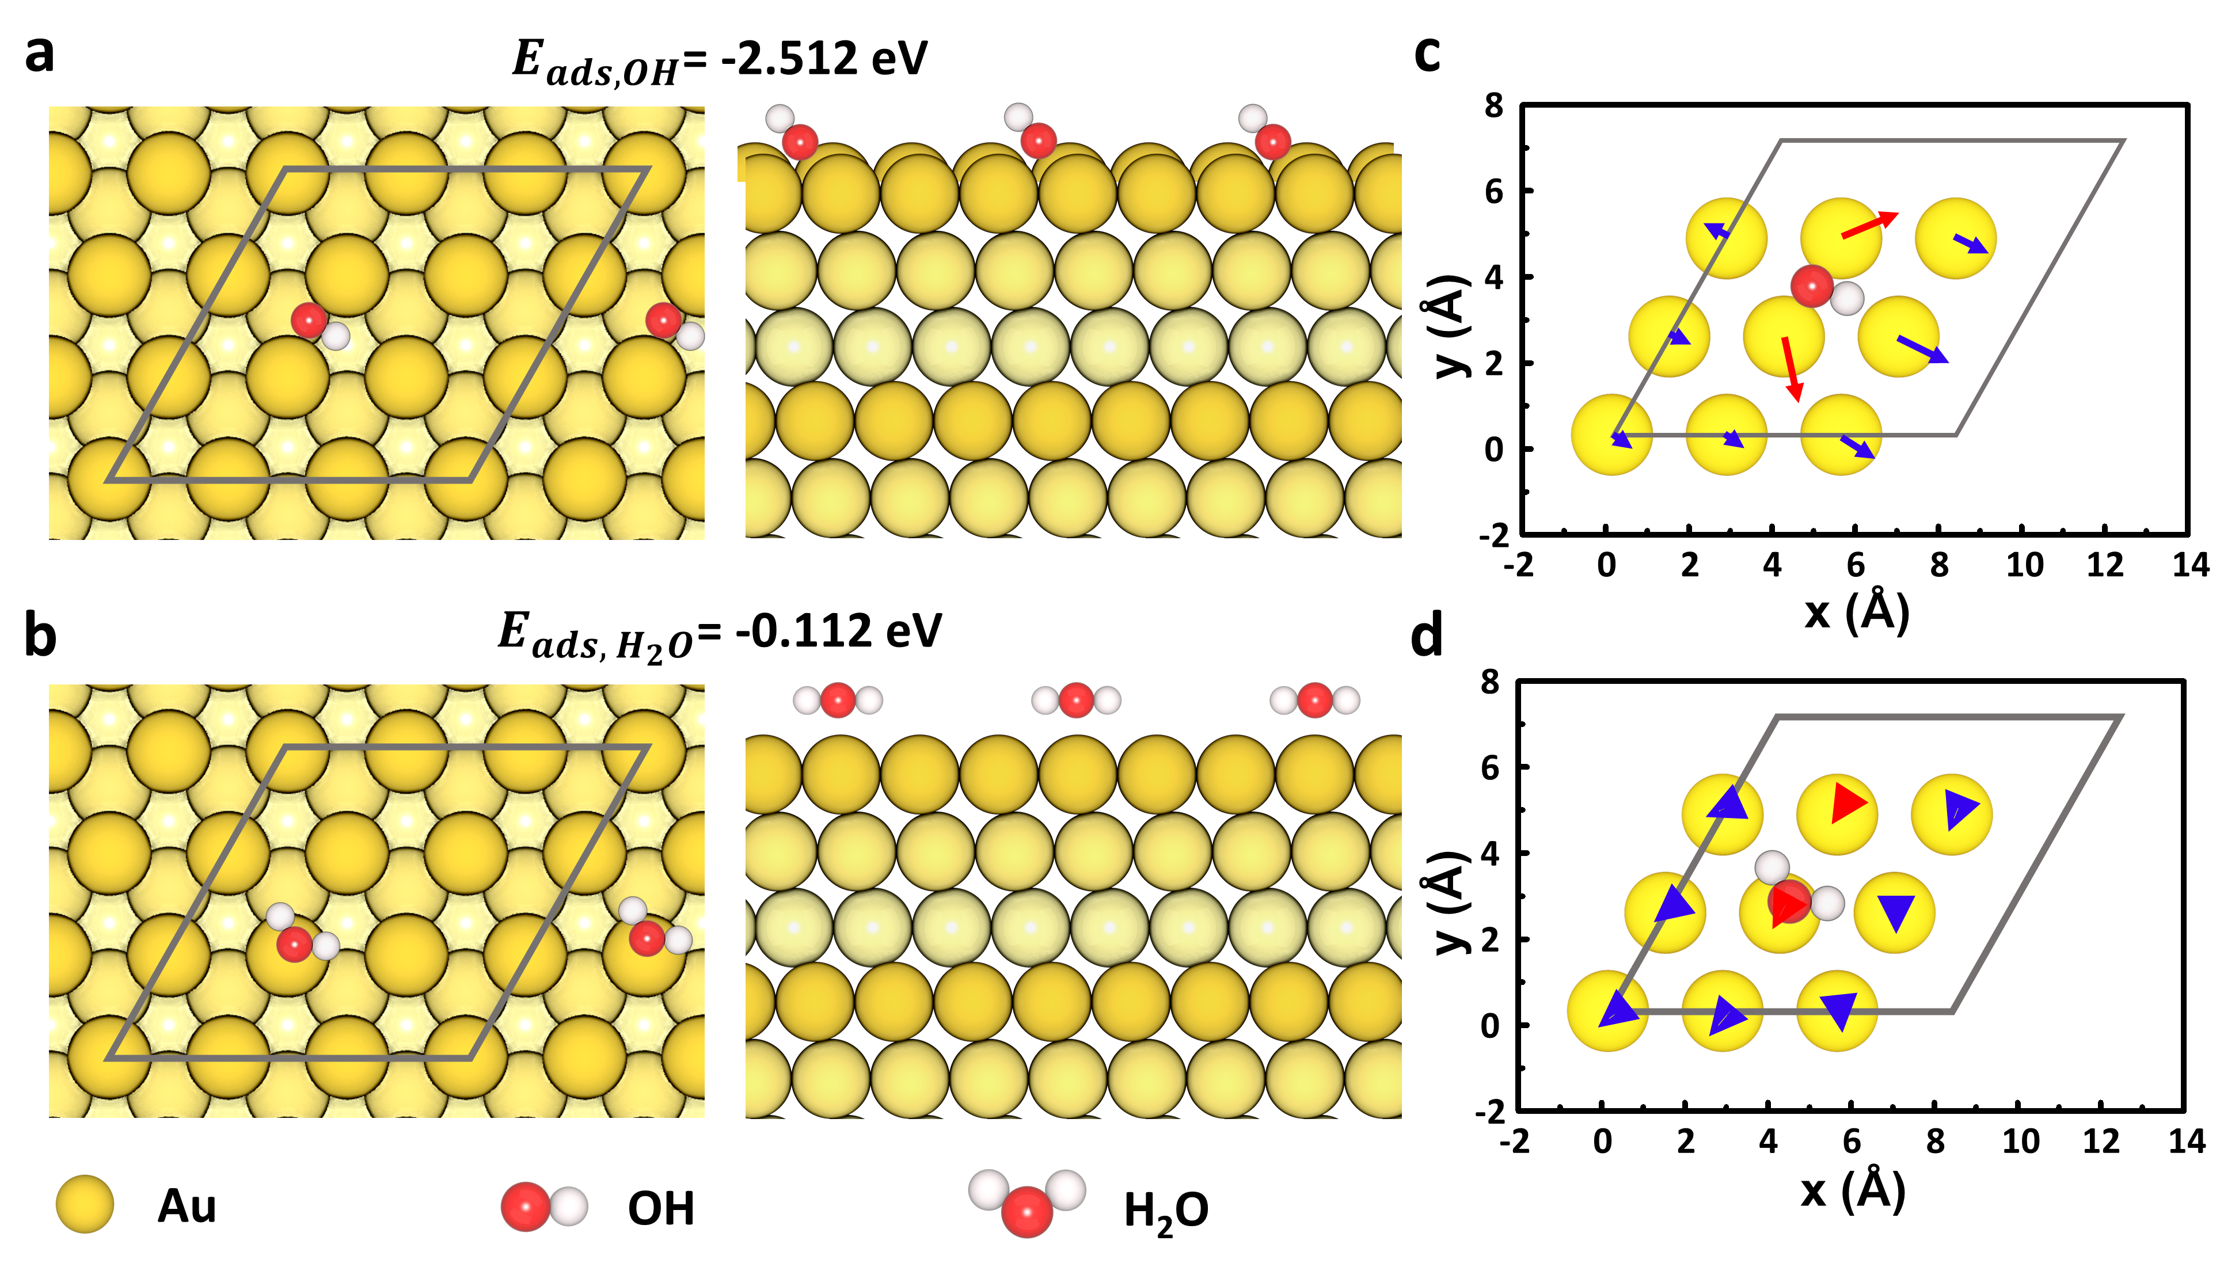
Supplementary Fig. 12. Adsorption configurations of OH and H₂O on AuNP and their associated displacement response. a, b Optimized adsorption configurations of OH and H₂O on the Au (111) surface: (left) top view and (right) side view of the most stable structure. c, d In-plane distortion of the top-layer Au atoms for the adsorption of OH and H₂O. The in-plane distortion of the top-layer Au surface determined from the top 9 Au atoms. The red and blue colors represent the out-of-plane directions: red indicates the upward direction from the center of mass, while blue indicates the downward direction toward the surface.

