Table S1. Phytocompounds from Paeonia species and their classification.
 | Organism name |  | NCBI_Taxonomy_ID | Organism ID
 | Paeonia officinalis | 69717 |  | NPO13118
Pubchem CID | Natural Product ID |  | Prefer name | IUPAC name | Smiles | Chemical Classification
10154 | NPC306843 |  | Boldine | (6aS)-1,10-dimethoxy-6-methyl-5,6,6a,7-tetrahydro-4H-dibenzo[de,g]quinoline-2,9-diol | C[NH+]1CCc2cc(c(c3-c4cc(c(cc4C[C@H]1c23)O)OC)OC)O | Aporphines
442194 | NPC229166 |  | Cassythicine | n.a. | COc1cc2c(cc1O)C[C@H]1c3c2c2OCOc2cc3CCN1C | Aporphines
31415 | NPC69712 |  | Laurotetanine | (6aS)-1,2,10-trimethoxy-5,6,6a,7-tetrahydro-4H-dibenzo[de,g]quinoline-9-ol | COc1c(OC)cc2c3c1c1cc(OC)c(cc1C[C@@H]3NCC2)O | Aporphines
41169 | NPC170503 |  | (S)-1,2-Dimethoxy-5,6,6A,7-Tetrahydro-4H-Dibenzo[De,G]Quinoline | (6aS)-1,2-dimethoxy-5,6,6a,7-tetrahydro-4H-dibenzo[de,g]quinoline | COc1cc2CCN[C@H]3Cc4ccccc4-c(c23)c1OC | Aporphines
12313923 | NPC213788 |  | na | n.a. | CN1CC[C@]23C=C(C(=O)C=C3[C@@H]1Cc1cc(c(cc21)OC)O)OC | Phenanthrenes and derivatives
72196849 | NPC101908 |  | na | n.a. | CCN=C(/C=C/C=C/[C@@H](Cc1ccc(c(c1)OC)OC)O)O | Dimethoxybenzenes

 | Organism name | NCBI_Taxonomy_ID | Organism ID
 | Paeonia rockii | 62886 | NPO15265
Pubchem CID | Natural Product ID | Prefer name | IUPAC name | Smiles | Chemical Classification
445154 | NPC161571 | Resveratrol | 5-[(E)-2-(4-hydroxyphenyl)ethenyl]benzene-1,3-diol | C(=Cc1cc(cc(c1)O)O)/c1ccc(cc1)O | Stilbenes
5280443 | NPC50898 | Apigenin | 5,7-dihydroxy-2-(4-hydroxyphenyl)chromen-4-one | Oc1ccc(cc1)c1cc(=O)c2c(o1)cc(cc2O)O | Flavones
5280445 | NPC279121 | Luteolin | 2-(3,4-dihydroxyphenyl)-5,7-dihydroxychromen-4-one | Oc1cc(O)c2c(c1)oc(cc2=O)c1ccc(c(c1)O)O | Flavones
5280863 | NPC116775 | Kaempferol | 3,5,7-trihydroxy-2-(4-hydroxyphenyl)chromen-4-one | Oc1ccc(cc1)c1oc2cc(O)cc(c2c(=O)c1O)O | Flavones
9064 | NPC219876 | Cianidanol | (2R,3S)-2-(3,4-dihydroxyphenyl)-3,4-dihydro-2H-chromene-3,5,7-triol | c1cc(c(cc1[C@@H]1[C@H](Cc2c(cc(cc2O1)O)O)O)O)O | Flavones
439533 | NPC246162 | (+)-Taxifolin | (2R,3R)-2-(3,4-dihydroxyphenyl)-3,5,7-trihydroxy-2,3-dihydrochromen-4-one | c1cc(c(cc1[C@@H]1[C@H](C(=O)c2c(cc(cc2O1)O)O)O)O)O | Flavones
1794427 | NPC302857 | Chlorogenic Acid | (1S,3R,4R,5R)-3-[(E)-3-(3,4-dihydroxyphenyl)prop-2-enoyl]oxy-1,4,5-trihydroxycyclohexane-1-carboxylic acid | c1cc(c(cc1/C=C/C(=O)O[C@@H]1C[C@@](C[C@H]([C@H]1O)O)(C(=O)O)O)O)O | Quinic acids and derivatives
5281654 | NPC125062 | Isorhamnetin | 3,5,7-trihydroxy-2-(4-hydroxy-3-methoxyphenyl)chromen-4-one | COc1cc(ccc1O)c1c(c(=O)c2c(cc(cc2o1)O)O)O | Flavones
440735 | NPC294852 | Eriodictyol | (2S)-2-(3,4-dihydroxyphenyl)-5,7-dihydroxy-2,3-dihydrochromen-4-one | Oc1cc2O[C@@H](CC(=O)c2c(c1)O)c1ccc(c(c1)O)O | Flavones
5281717 | NPC292452 | Oxyresveratrol | 4-[(E)-2-(3,5-dihydroxyphenyl)ethenyl]benzene-1,3-diol | Oc1ccc(c(c1)O)/C=C/c1cc(O)cc(c1)O | Stilbenes
637775 | NPC300326 | Sinapinate | (E)-3-(4-hydroxy-3,5-dimethoxyphenyl)prop-2-enoic acid | COc1cc(/C=C/C(=O)O)cc(c1O)OC | Hydroxycinnamic acids
932 | NPC79943 | na | 5,7-Dihydroxy-2-(4-Hydroxyphenyl)-2,3-Dihydrochromen-4-One | Oc1ccc(cc1)C1CC(=O)c2c(O1)cc(cc2O)O | Flavones
11092 | NPC186098 | Paeonol | 1-(2-hydroxy-4-methoxyphenyl)ethanone | COc1ccc(c(c1)O)C(=O)C | Alkyl-phenylketones
2214 | NPC32163 | Apocynin | 1-(4-hydroxy-3-methoxyphenyl)ethanone | CC(=O)c1ccc(c(c1)OC)O | Alkyl-phenylketones
133475 | NPC77493 | Paeoniflorigenone | na | O=C(c1ccccc1)OC[C@H]1[C@H]2O[C@]3([C@@](O2)(C[C@@H]1C(=O)C3)O)C | Benzoic acids and derivatives
9841735 | NPC280725 | Palbinone | (3S,5R,8R,9R,10S,14S)-3,17-dihydroxy-4,4,8,10,14-pentamethyl-2,3,5,6,7,9-hexahydro-1H-cyclopenta[a]phenanthrene-15,16-dione | CC1(C)[C@@H]2CC[C@]3(C)[C@H](C=CC4=C(C(=O)C(=O)[C@@]34C)O)[C@@]2(C)CC[C@@H]1O | Oxosteroids
56677066 | NPC477616 | na | (2R,3R)-3-(hydroxymethyl)-2-[4-(3-hydroxypropyl)-3-methoxyphenyl]-6-methoxy-2,3-dihydro-1-benzofuran-5-ol | COC1=C(C=CC(=C1)[C@H]2[C@H](C3=CC(=C(C=C3O2)OC)O)CO)CCCO | Phenylpropanoids and polyketides
21631105 | NPC161626 | na | na | C[C@]12C[C@@]3([C@@H]4C[C@]1([C@]4(COC(=O)c1ccc(cc1)O)[C@H](O2)O3)O[C@H]1[C@@H]([C@H]([C@@H]([C@@H](CO)O1)O)O)O)O | Terpene glycosides
70698092 | NPC225280 | na | na | COc1cc(ccc1CCCO)[C@@H]1[C@@H](CO)c2cc(c(cc2O1)OC)O | Phenylpropanoids and polyketides
16112794 | NPC280652 | na | na | C[C@H](CCCC(C)(C)O)[C@H]1[C@@H](C[C@@]2(C)[C@@H]3CC[C@H]4C(C)(C)[C@H](CC[C@]54C[C@@]35CC[C@]12C)O)OC(=O)C | Cycloartanols and derivatives
10592506 | NPC273769 | na | na | COc1cc(ccc1O)C(=O)OC[C@@H]1[C@H]([C@@H]([C@H](C(O)O1)O)O)O | Hydrolyzable tannins

 | Organism name | NCBI_Taxonomy_ID | Organism ID
 | Paeonia emodi | 40708 | NPO16999
Pubchem CID | Natural Product ID | Prefer name | IUPAC name | Smiles | Chemical Classification
154417 | NPC213126 | Hyoscyamine | na | OC[C@H](c1ccccc1)C(=O)O[C@@H]1C[C@@H]2CC[C@H](C1)N2C | Tropane alkaloids
21770005 | NPC109862 | na | na | C/C=C(C)/C(=O)O[C@H]1[C@@H]2C[C@@H](C[C@H]([C@H]1O)N2C)O | Tropane alkaloids
44233425 | NPC21330 | na | na | CC1=CC(=O)[C@@H]2C[C@]1(OC(C2=C)OC)O[C@H]1[C@@H]([C@H]([C@@H]([C@@H](CO)O1)O)O)O | Carbohydrates and carbohydrate conjugates

 | Organism name | NCBI_Taxonomy_ID | Organism ID
 | Paeonia delavayi | 40707 | NPO21850
Pubchem CID | Natural Product ID | Prefer name | IUPAC name | Smiles | Chemical Classification
11746695 | NPC2728 | 5-Epi-Eudesm-4(15)-Ene-1Beta,6Beta-Diol | (1R,2R,4aR,5R,8aR)-4a-methyl-8-methylidene-2-propan-2-yl-1,2,3,4,5,6,7,8a-octahydronaphthalene-1,5-diol | C=C1CC[C@H]([C@]2([C@@H]1[C@H](O)[C@H](CC2)C(C)C)C)O | Prenol lipids
636618 | NPC283316 | 4(15)-Eudesmene-1Beta,5Alpha-Diol | (1R,4aR,6R,8aS)-8a-methyl-4-methylidene-6-propan-2-yl-2,3,5,6,7,8-hexahydro-1H-naphthalene-1,4a-diol | CC([C@@H]1CC[C@@]2([C@](C1)(O)C(=C)CC[C@H]2O)C)C | Prenol lipids
15599878 | NPC249078 | (1S,4R,5R,8S,9S)-Clovane-5,9-Diol | (3S,3aS,6R,7R,9aS)-1,1,7-trimethyl-3,4,5,6,8,9,9a,10-octahydro-2H-tricyclo[6.3.1.0^{1,5}]dodecane-3,6-diol | CC1(C)C[C@@H]([C@@]23CC[C@H]([C@](C)(CC[C@@H]13)C2)O)O | Prenol lipids
11542987 | NPC54339 | na | na | CC(C)[C@H]1C[C@@H]([C@](C)([C@H]([C@@H]1O)O)O)O | Monoterpenoids
10448571 | NPC107183 | na | na | CC(=O)C[C@@]12[C@H](CC(=O)O2)[C@@H](COC(=O)c2ccccc2)CO1 | Benzoic acids and derivatives
185847 | NPC179897 | na | na | CC(C)[C@]([C@@H](C)O)(C(=O)OCC1=CCN2CC[C@@H]([C@@H]12)OC(=O)C)O | Alkaloids and derivatives

 | Organism name | NCBI_Taxonomy_ID | Organism ID
 | Paeonia veitchii | 40722 | NPO242667
Pubchem CID | Natural Product ID | Prefer name | IUPAC name | Smiles | Chemical Classification
636822 | NPC52464 | Trans-Asarone | 1,2,4-trimethoxy-5-[(E)-prop-1-enyl]benzene | C/C=C/c1cc(OC)c(cc1OC)OC | Phenol ethers
5315911 | NPC96224 | N-(4-Hydroxyphenethyl)Cinnamamide | (E)-N-[2-(4-hydroxyphenyl)ethyl]-3-phenylprop-2-enamide | c1ccc(cc1)/C=C/C(=NCCc1ccc(cc1)O)O | Cinnamic acids and derivatives
21631108 | NPC151516 | Moudanpioside F | (1R,5S,6R)-6-(hydroxymethyl)-4,6-dimethyl-5-[(2S,3R,4S,5S,6R)-3,4,5-trihydroxy-6-(hydroxymethyl)oxan-2-yl]oxybicyclo[3.1.1]hept-3-en-2-one | CC1=CC(=O)[C@@H]2C[C@]1([C@@]2(C)CO)O[C@H]1[C@@H]([C@H]([C@@H]([C@@H](CO)O1)O)O)O | Prenol lipids
7576924 | NPC48645 | na | na | c1cc(ccc1O)O[C@H]1[C@@H]([C@@H]([C@@H]([C@@H](CO)O1)O)O)O | Phenolic glycosides
11107141 | NPC214153 | na | na | c1cc(c(cc1Cl)NCC(=O)O)C(=O)O | Benzoic acids and derivatives
12134774 | NPC155926 | na | na | C=C1CC[C@@]2(CC[C@]3(C)C(=CC[C@@H]4[C@@]5(C)CC[C@@H](C(=C)[C@@H]5CC[C@@]34C)O)[C@@H]2C1)C(=O)O | Cyclic alcohols and derivatives
6931410 | NPC261084 | na | na | c1ccc(c(c1)CO)O[C@H]1[C@@H]([C@@H]([C@@H]([C@H](CO)O1)O)O)O | Phenolic glycosides
5280960 | NPC73532 | 4,2',4',6'-Tetrahydroxychalcone | (E)-3-(4-hydroxyphenyl)-1-(2,4,6-trihydroxyphenyl)prop-2-en-1-one | Oc1ccc(cc1)/C=C/C(=O)c1c(O)cc(cc1O)O | Chalcones and dihydrochalcones

 | Organism name | NCBI_Taxonomy_ID |  | Organism ID
 | Paeonia albiflora | 35924 |  | NPO30226
Pubchem CID | Natural Product ID | Prefer name |  | IUPAC name | Smiles | Chemical Classification
73160 | NPC15658 | (-)-Catechin | (2S,3R)-2-(3,4-dihydroxyphenyl)-3,4-dihydro-2H-chromene-3,5,7-triol |  | c1cc(c(cc1[C@H]1[C@@H](Cc2c(cc(cc2O1)O)O)O)O)O | Flavonoids
46883516 | NPC221249 | Paeoniflorone | [(1S,4R,5R,6S)-5-hydroxy-4,6-dimethyl-2-oxo-6-bicyclo[3.1.1]heptanyl]methyl 3,4,5-trihydroxybenzoate |  | C[C@@H]1CC(=O)[C@H]2C[C@@]1([C@]2(C)COC(=O)c1cc(c(c(c1)O)O)O)O | Gallic acid and derivatives
46883511 | NPC469513 | Paeonidangenin | na |  | CC12CC(=O)C3CC1(C3(C(O2)OC)COC(=O)C4=CC=CC=C4)O | Monoterpenoids
46883519 | NPC268633 | na | na |  | OC[C@H]1O[C@@H](O[C@]23C[C@H]4[C@@]3(CO)[C@@H]3O[C@@]2(C)C[C@]4(O3)OC)[C@@H]([C@H]([C@@H]1O)O)O | Prenol lipids
10425234 | NPC42760 | (2S,3S)-2-(3,4,5-Trihydroxy-Phenyl)-Chroman-3,5,7-Triol | (2S,3S)-2-(3,4,5-trihydroxyphenyl)-3,4-dihydro-2H-chromene-3,5,7-triol |  | c1c(cc(c(c1O)O)O)[C@H]1[C@H](Cc2c(cc(cc2O1)O)O)O | Flavonoids
44445800 | NPC238254 | na | na |  | C[C@H]1Cc2c(cc(cc2O[C@@H]1c1ccc(c(c1)O)O)O)O | Flavonoids
12309543 | NPC17308 | na | na |  | c1c(cc(c(c1O)O)O)[C@@H]1C(Cc2c(cc(cc2O1)O)O)O | Flavonoids
10426003 | NPC318613 | na | na |  | CC12CC(=O)C3CC1(OC(C3COC(=O)C4=CC=CC=C4)O2)O
5320378 | NPC319486 | na | na |  | CC1C2CC(=O)C(CC2OC1=O)(C)O | Benzofurans

 | Organism name | NCBI_Taxonomy_ID |  |  | Organism ID
 | Paeonia lactiflora |  | 35924 | NPO9798
Pubchem CID | Natural Product ID |  | Prefer name | IUPAC name |  |  | Smiles |  | Chemical Classification
5280681 | NPC286342 |  | 3-O-Methylquercetin | 2-(3,4-dihydroxyphenyl)-5,7-dihydroxy-3-methoxychromen-4-one |  |  | COc1c(oc2c(c1=O)c(O)cc(c2)O)c1ccc(c(c1)O)O |  | Flavonoids
160521 | NPC307050 |  | Isolariciresinol | (6R,7R,8S)-8-(4-hydroxy-3-methoxyphenyl)-6,7-bis(hydroxymethyl)-3-methoxy-5,6,7,8-tetrahydronaphthalen-2-ol |  |  | OC[C@@H]1Cc2cc(OC)c(cc2[C@@H]([C@H]1CO)c1ccc(c(c1)OC)O)O |  | Aryltetralin lignans
182232 | NPC261619 |  | (+)-Epicatechin | (2S,3S)-2-(3,4-dihydroxyphenyl)-3,4-dihydro-2H-chromene-3,5,7-triol |  |  | Oc1cc2O[C@@H](c3ccc(c(c3)O)O)[C@H](Cc2c(c1)O)O |  | Flavonoids
124021 | NPC108455 |  | Beta-Glucogallin[(2S,3R,4S,5S,6R)-3,4,5-trihydroxy-6-(hydroxymethyl)oxan-2-yl] 3,4,5-trihydroxybenzoate | na |  |  | OC[C@H]1O[C@@H](OC(=O)c2cc(O)c(c(c2)O)O)[C@@H]([C@H]([C@@H]1O)O)O |  | Phenylpropanoids and polyketides
475263 | NPC114242 |  | na | na |  |  | O[C@@H]1C[C@@](O)(C[C@H]([C@H]1OC(=O)c1cc(O)c(c(c1)O)O)O)C(=O)O |  | Quinic acids and derivatives
5316900 | NPC279989 |  | 3,3'-O-Dimethylquercetin | 5,7-dihydroxy-2-(4-hydroxy-3-methoxyphenyl)-3-methoxychromen-4-one |  |  | COc1cc(ccc1O)c1c(c(=O)c2c(cc(cc2o1)O)O)OC |  | Flavonoids
442988 | NPC50221 |  | 3-O-Galloyl-Quinic Acid | (1S,3R,4R,5R)-1,3,4-trihydroxy-5-(3,4,5-trihydroxybenzoyl)oxycyclohexane-1-carboxylic acid |  |  | O[C@@H]1C[C@](O)(C[C@H]([C@@H]1O)OC(=O)c1cc(O)c(c(c1)O)O)C(=O)O |  | Quinic acids and derivatives
10471123 | NPC182580 |  | na | na |  |  | C[C@@]1(C[C@@H]2[C@H](CC1=O)[C@@H](COC(=O)c1ccccc1)C(=O)O2)O |  | Benzoic acids and derivatives
45268216 | NPC476298 |  | na | na |  |  | C[C@]12CC(=O)[C@@H]3C[C@@]1([C@]3(CO)C(OC)O2)O[C@H]1[C@@H]([C@H]([C@@H]([C@@H](CO)O1)O)O)O |  | Prenol lipids
44233202 | NPC305095 |  | na | na |  |  | CC1=CC(=O)[C@@H]2C[C@]1(OC=C2CO)O[C@H]1[C@@H]([C@H]([C@@H]([C@@H](CO)O1)O)O)O |  | Glycosyl compounds
51136471 | NPC159200 |  | na | na |  |  | C[C@]12CC(=O)C3C[C@@]1(O)OC([C@H]3COC(=O)c1ccccc1)O2 |  | Benzoic acids and derivatives
14336593 | NPC235175 |  | na | na |  |  | C[C@@H]1[C@H]2C[C@@H]([C@](C)(C[C@H]2OC1=O)O)O |  | Benzofurans
70698143 | NPC250447 |  | na | na |  |  | C[C@]12CC(=O)[C@@H]3C[C@@]1(O)O[C@@H]([C@@H]3COC(=O)c1ccccc1)O2 |  | Benzoic acids and derivatives
101997224 | NPC67337 |  | na | na |  |  | C[C@@H]1[C@H]2C[C@@]3([C@](C)(CC2=O)O[C@H]1O3)O |  | Organoheterocyclic compounds
11538453 | NPC287319 |  | na | na |  |  | C=C(C)C(=O)O[C@H]1C[C@](C)([C@@]2(CC[C@](C)(/C=C/3C1=C(COC)C(=O)O3)O2)O)O |  | Furanones
44233203 | NPC67698 |  | na | na |  |  | CC1=CC(=O)[C@@H]2C[C@]1(OC=C2COC)O[C@H]1[C@@H]([C@H]([C@@H]([C@@H](CO)O1)O)O)O |  | Glycosyl compounds
102417832 | NPC53763 |  | na | na |  |  | CC12CC3(C4CC1(C4(CO)C(O2)O3)O[C@H]1[C@@H]([C@H]([C@@H]([C@@H](CO)O1)O)O)O)OC |  | Terpene glycosides
475263 | NPC85202 |  | na | na |  |  | c1c(cc(c(c1[O-])O)O)C(=O)OC1[C@@H](CC(C[C@H]1O)(C(=O)O)O)O |  | Quinic acids and derivatives
100945853 | NPC242528 |  | na | na |  |  | CC1=CC(=O)[C@@H]2C[C@]1([C@@]2(C)CO[C@H]1[C@@H]([C@H]([C@@H]([C@@H](CO)O1)O)O)O)O |  | Terpene glycosides

Table S2. List of the natural products having favorable docking scores.
Name | Pubchem CID | Natural product ID | IUPAC name | Smiles | Organism name
(-)-Catechin | 73160 | NPC15658 | (2S,3R)-2-(3,4-dihydroxyphenyl)-3,4-dihydro-2H-chromene-3,5,7-triol | c1cc(c(cc1[C@H]1[C@@H](Cc2c(cc(cc2O1)O)O)O)O)O | Paeonia albiflora
Apigenin | 5280443 | NPC50898 | 5,7-dihydroxy-2-(4-hydroxyphenyl)chromen-4-one | Oc1ccc(cc1)c1cc(=O)c2c(o1)cc(cc2O)O | Paeonia rockii
Palbinone | 9841735 | NPC280725 | (3S,5R,8R,9R,10S,14S)-3,17-dihydroxy-4,4,8,10,14-pentamethyl-2,3,5,6,7,9-hexahydro-1H-cyclopenta[a]phenanthrene-15,16-dione | CC1(C)[C@@H]2CC[C@]3(C)[C@H](C=CC4=C(C(=O)C(=O)[C@@]34C)O)[C@@]2(C)CC[C@@H]1O | Paeonia rockii
Kaempferol | 5280863 | NPC116775 | 3,5,7-trihydroxy-2-(4-hydroxyphenyl)chromen-4-one | Oc1ccc(cc1)c1oc2cc(O)cc(c2c(=O)c1O)O | Paeonia rockii
Paeoniflorigenone | 70698143 | NPC250447 | [(1S,3S,6R,8R,10S)-8-hydroxy-3-methyl-5-oxo-2,9-dioxatricyclo[4.3.1.03,8]decan-10-yl]methyl benzoate | C[C@]12CC(=O)[C@@H]3C[C@@]1(O)O[C@@H]([C@@H]3COC(=O)c1ccccc1)O2 | Paeonia lactiflora
Eriodictyol | 440735 | NPC294852 | (2S)-2-(3,4-dihydroxyphenyl)-5,7-dihydroxy-2,3-dihydrochromen-4-one | Oc1cc2O[C@@H](CC(=O)c2c(c1)O)c1ccc(c(c1)O)O | Paeonia rockii
Paeonilactone C | 10471123 | NPC182580 | [(3S,3aR,6S,7aR)-6-hydroxy-6-methyl-2,5-dioxo-3a,4,7,7a-tetrahydro-3H-1-benzofuran-3-yl]methyl benzoate | C[C@@]1(C[C@@H]2[C@H](CC1=O)[C@@H](COC(=O)c1ccccc1)C(=O)O2)O | Paeonia lactiflora
Cassythicine | 442194 | NPC229166 | (12S)-17-methoxy-11-methyl-3,5-dioxa-11-azapentacyclo[10.7.1.02,6.08,20.014,19]icosa-1(20),2(6),7,14,16,18-hexaen-16-ol | COc1cc2c(cc1O)C[C@H]1c3c2c2OCOc2cc3CCN1C | Paeonia officinalis
3-o-methylquercetin | 5280681 | NPC286342 | 2-(3,4-dihydroxyphenyl)-5,7-dihydroxy-3-methoxychromen-4-one | COc1c(oc2c(c1=O)c(O)cc(c2)O)c1ccc(c(c1)O)O | Paeonia albiflora

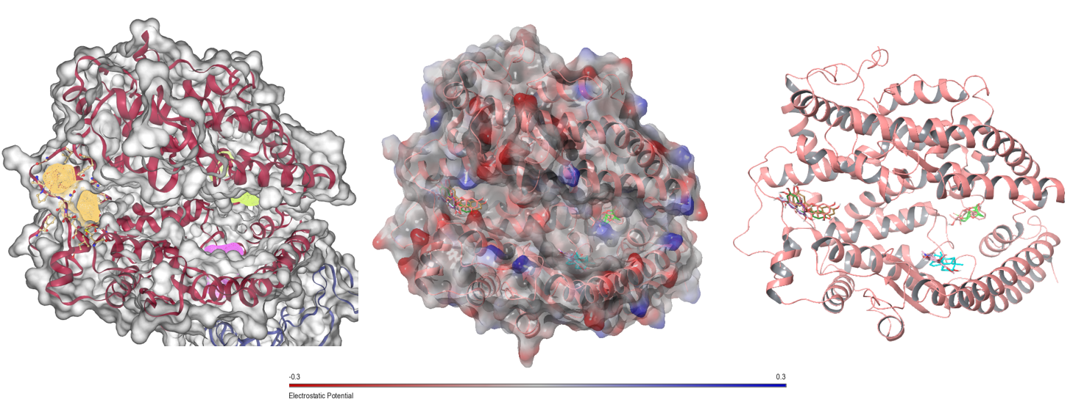
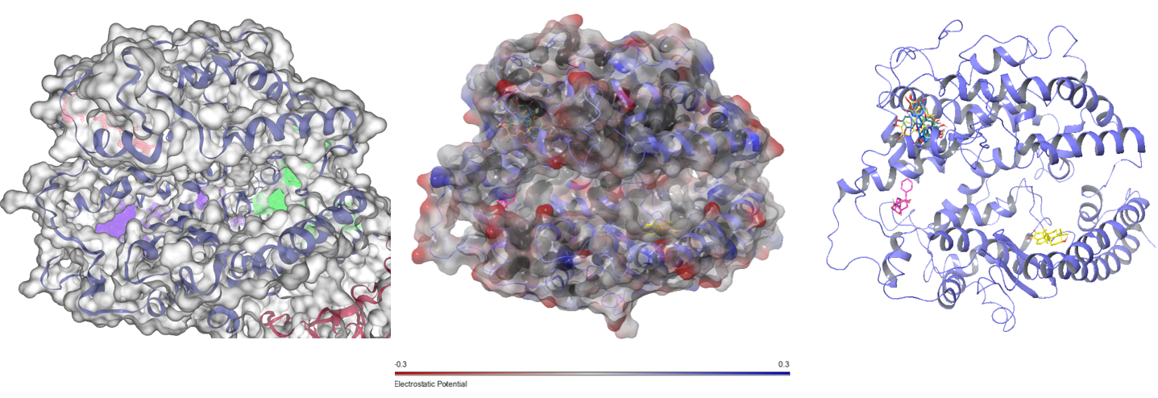
Figure S1. Top 6LZG, Bottom 7WPA: DoGSiteScorer Left, Electrostatic Potential Middle, Docked Ligands Right

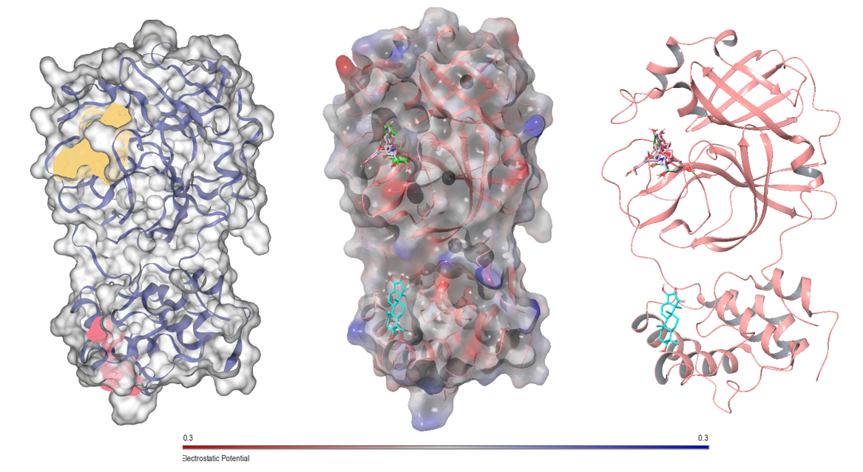
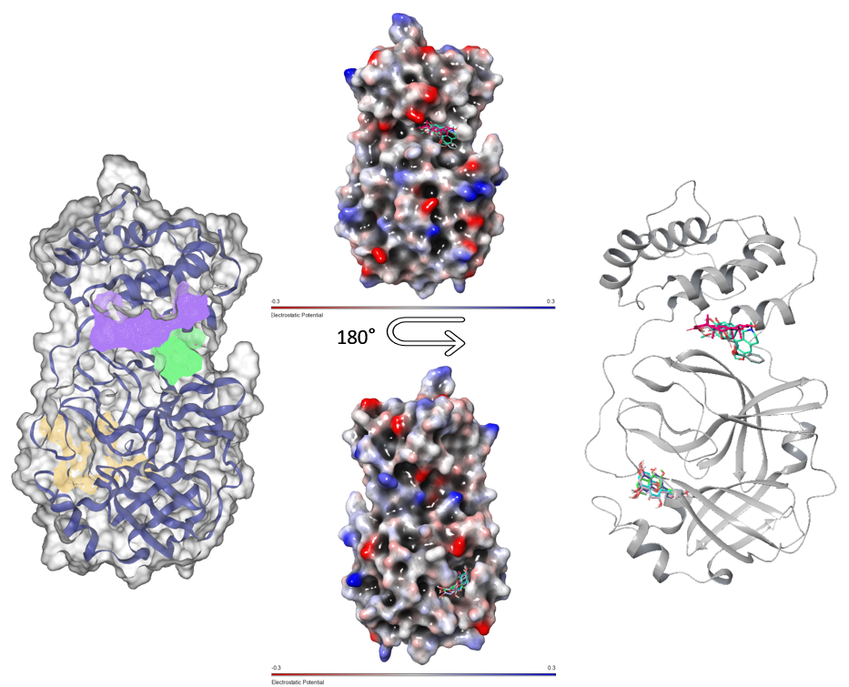
Figure S2. Top 6LU7, Bottom 6M2N: Left DoGSiteScorer, Middle Electrostatic Potential, Right Ligands docked regions

