SUPPLEMENTARY INFORMATION

A decadal Twin Dipole mode in the Southern Atlantic and Indian Oceans

Xing Gao^{1,2,3}, Yuanlong Li^{1,2,3*}, Pengfei Lin^{2,4}, Lei Zhang⁵, Ying Lu^{1,2}, Qiuping Ren¹, Fan Wang^{1,2,3}

¹CAS Key Laboratory of Ocean Circulation and Waves, Institute of Oceanology, Chinese Academy of Sciences, Qingdao, China,

²University of Chinese Academy of Sciences, Beijing, China,

³Laoshan Laboratory, Qingdao, China,

⁴State Key Laboratory of Numerical Modeling for Atmospheric Sciences and Geophysical Fluid Dynamics, Institute of Atmospheric Physics, Beijing, China,

⁵State Key Laboratory of Tropical Oceanography, South China Sea Institute of Oceanology, Chinese Academy of Sciences, Guangzhou, China

*Corresponding author: Yuanlong Li (liyuanlong@qdio.ac.cn)

Supplementary Figures

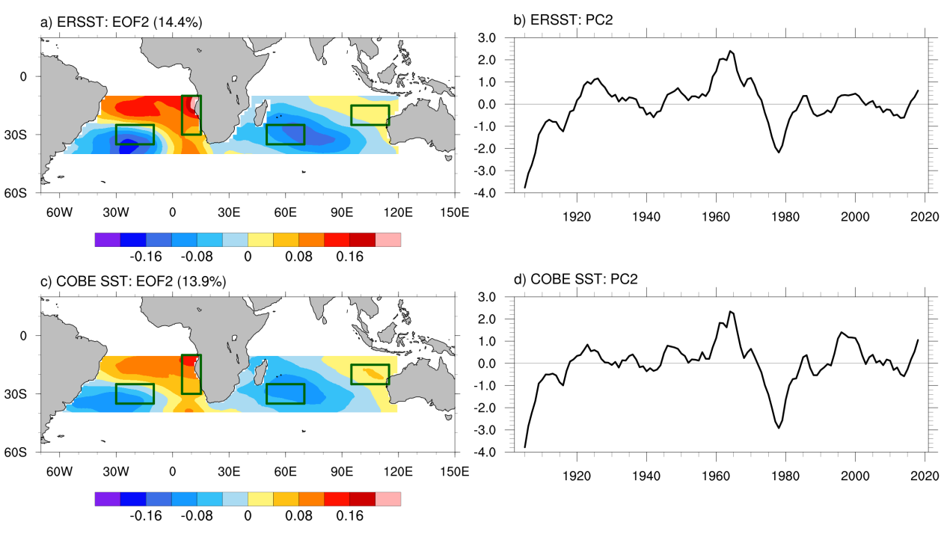
Supplementary Fig. S1 | Observed AITDs. (a) The second mode (EOF2) of the yearly SST anomaly in the SAIOs within the 10°-40°S band obtained from the EOF analysis and (b) its principle component (PC2) after 7-yr running average based on ERSST. The explained variance is 14.4%. The external components were removed (see Methods) prior to the EOF analysis. (c, d) Same as (a, b), but the results are based on the COBE SST. The explained variance is 13.9%. All PC2s are normalized. Rectangles denote regions of the southwestern Atlantic Ocean (SWAO; 25°-35°S, 30°-10°W), the southeastern Atlantic Ocean (SEAO; 10°-30°S, 5°-15°E), the southwestern Indian Ocean (SWIO; 25°-35°S, 50°-70°E), and the southeastern Indian Ocean (SEIO; 15°-25°S, 95°-115°E) that are used for the calculation of the AITD index.

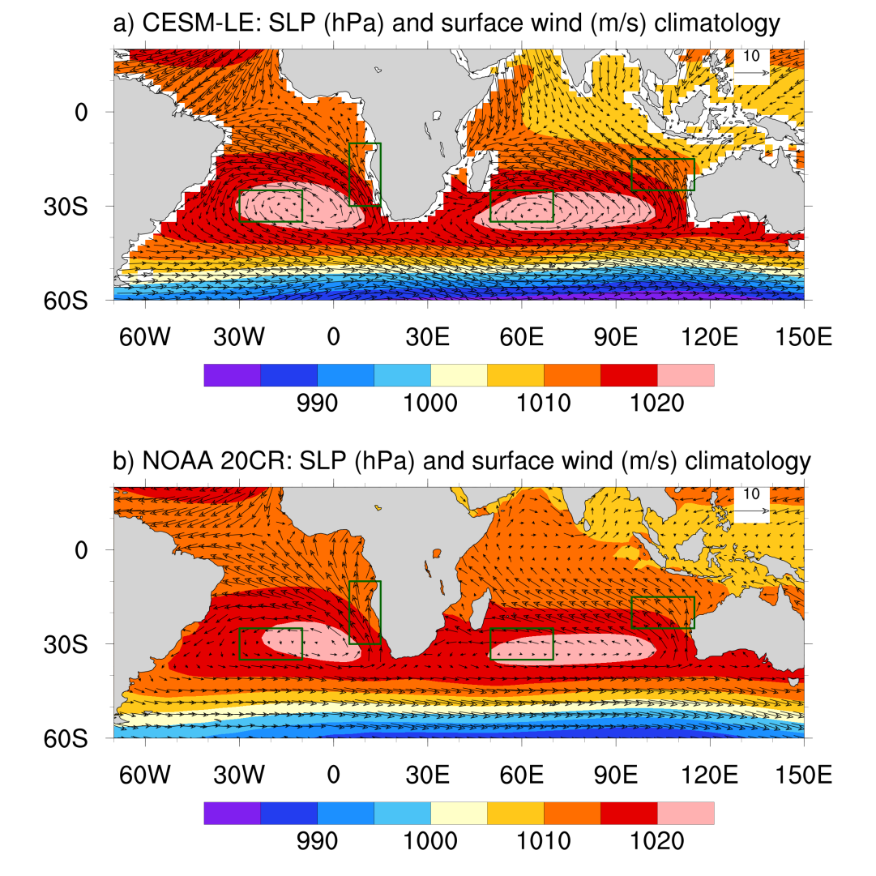
Supplementary Fig. S2 | SLP and surface wind climatology. (a) 1920-2005 climatology derived from the CESM-LE ensemble mean. (b) 1902-2012 climatology derived from the reanalysis product NOAA 20CR.
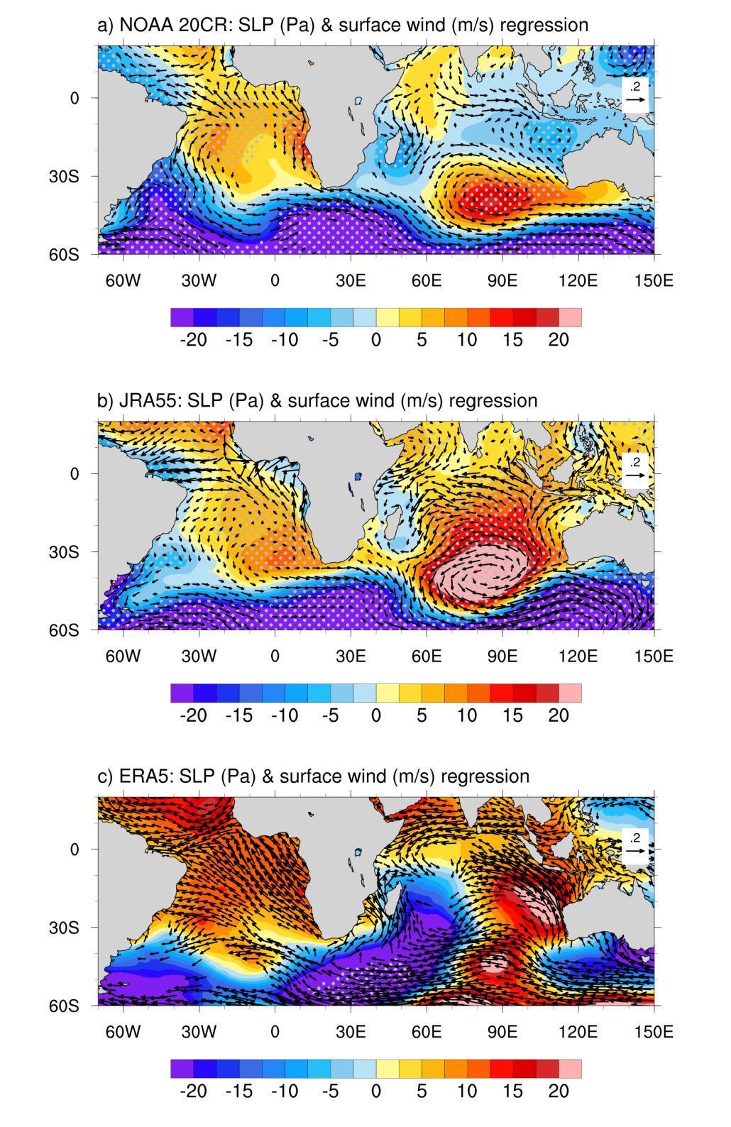
Supplementary Fig. S3 | The AITD-related atmospheric variations derived from reanalysis products. Sea level pressure (SLP; shading) and surface wind (vectors) anomalies regressed onto the AITD index derived from (a) NOAA 20CR, (b) JRA55 and (c) ERA5. Vectors denote the surface winds that are significant at 95% confidence level. Stippling indicates significant values at 95% confidence level based on the Student’s t test.
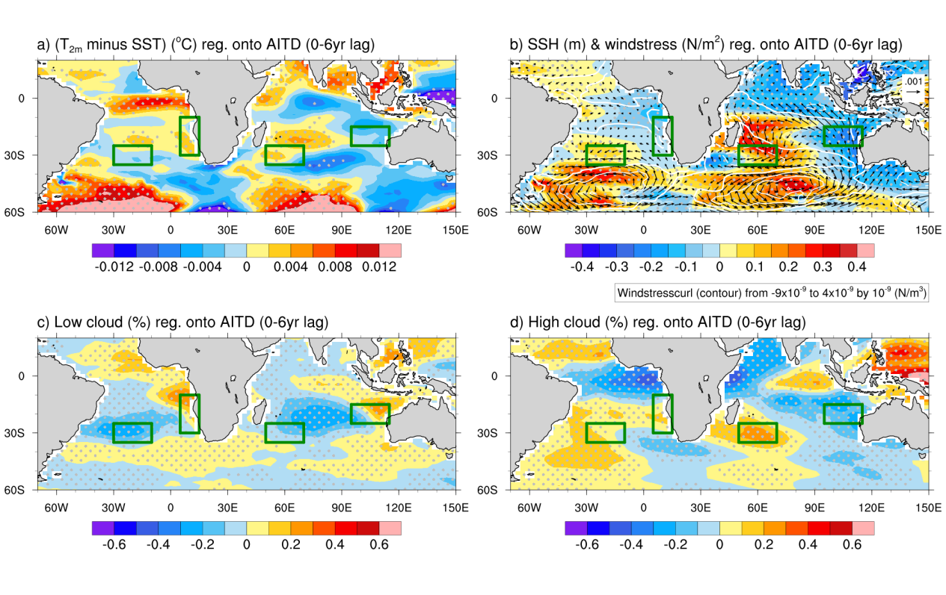
Supplementary Fig. S4 | Surface atmospheric and oceanic conditions associated with the AITDs. Composites of (a) the differences between the 2 m-height air temperatures and SSTs, (b) the sea surface height (SSH; shading) and wind stress (vectors), (c) the low-level cloud covers (shading), and (d) the high-level cloud covers (shading) regressed onto the AITD index with the leading time of 0-6 years (AITD index lags). The white contours in (b) denote the wind stress curl. The results are derived from CESM-LE.
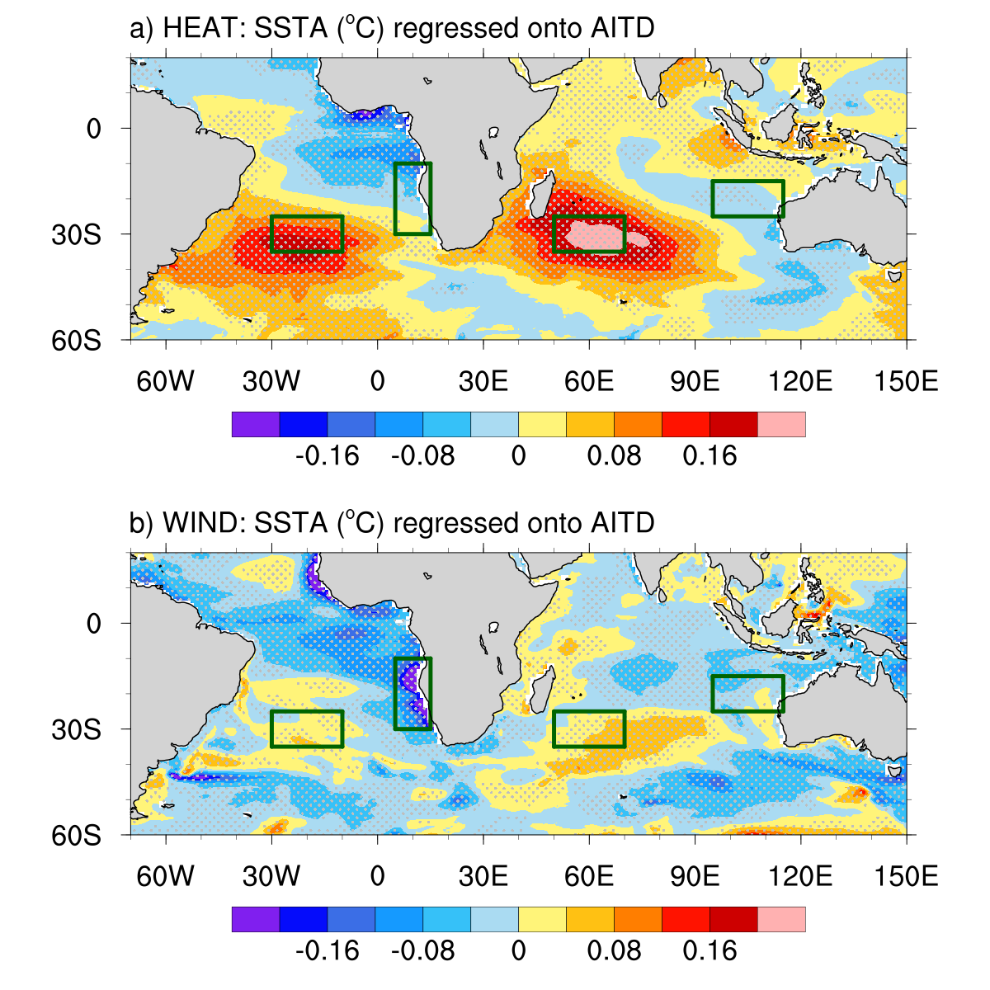
Supplementary Fig. S5 | AITD-related SST anomalies revealed by LICOM3 experiments. SST anomalies regressed onto the AITD index derived from the (a) heat fluxes forcing run (HEAT) and (b) wind forcing run (WIND).
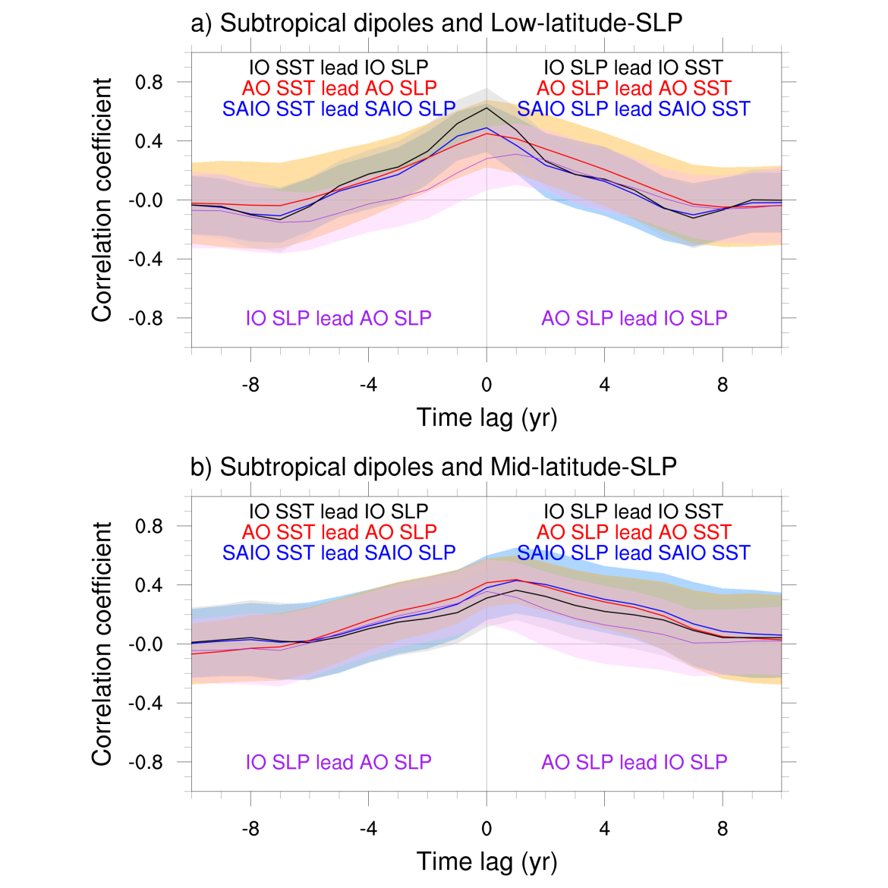
Supplementary Fig. S6 | The connection between the AITDs and the subtropical highs in the SAIOs. (a) Lead-lagged correlations between the subtropical SST dipoles and the low-latitude SLPs (10°-25°S) in the southern Indian Ocean (black line) and in the South Atlantic (red line), respectively. The blue line denotes the lead-lagged correlation between the AITDs and the low-latitude SLPs in the SAIOs. The purple line denotes the lead-lagged correlation between the low-latitude SLPs in the southern Indian Ocean and in the South Atlantic. The colors of the curves, shading and texts are in correspondence. The curves represent the average correlation coefficients, while the shading denotes one standard deviation. (b) Same as (a), but for the mid-latitude SLPs (30°-50°S). All the results are derived from the CESM-LE.
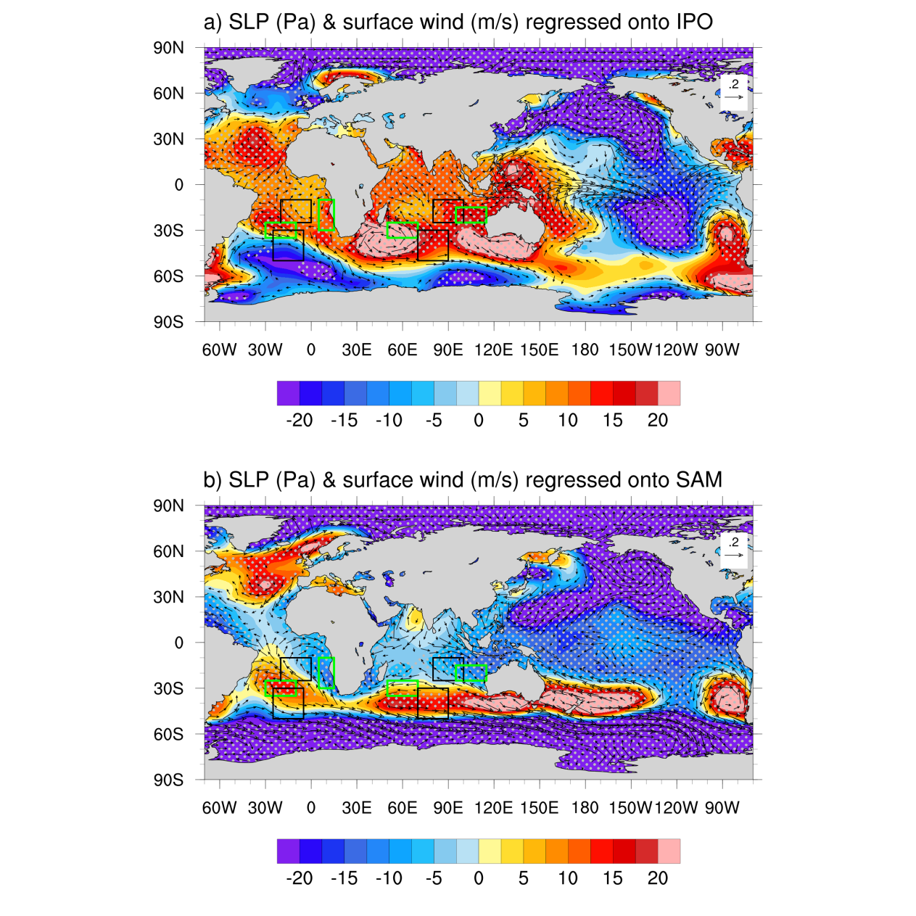
Supplementary Fig. S7 | The IPO and SAM-related atmospheric circulations. The SLPs (shading) and surface winds (vectors) regressed onto (a) the IPO index and (b) the SAM index. The black boxes denote the low- and mid-latitude SLP anomalies in the SAIOs, respectively, covering the regions of low-latitude South Atlantic (10-25°S, 20°W-0°), the mid-latitude South Atlantic (30°-50°S, 25°-5°W), the low-latitude southern Indian Ocean (10°-25°S, 80°-100°E), and the mid-latitude southern Indian Ocean (30°-50°S, 70°-90°E). The results are derived from NOAA 20CR.
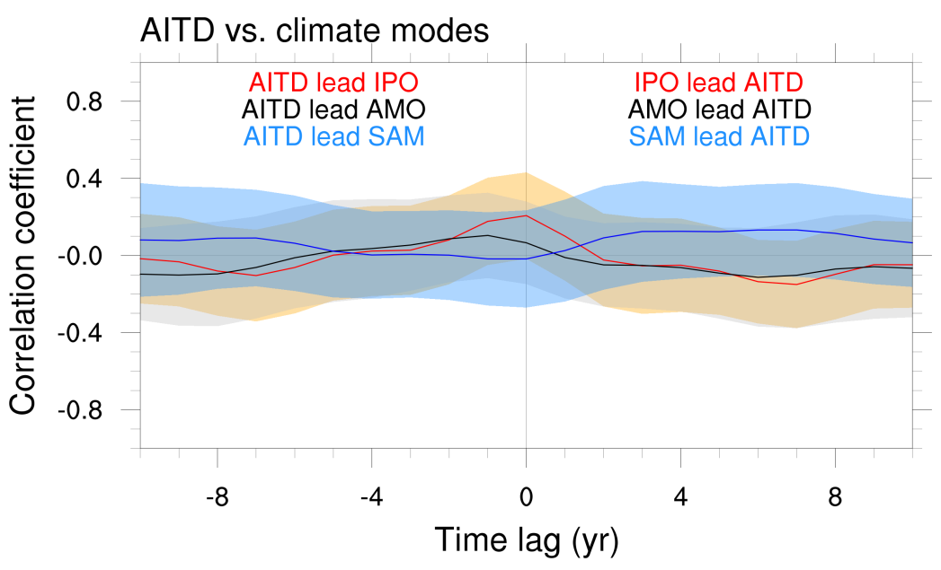
Supplementary Fig. S8 | The relationship of the AITDs with the IPO, AMO and SAM. Lead-lagged correlations of the AITDs with the IPO (red line), AMO (black line) and SAM (blue line) indices, respectively. The results are derived from the CESM-LE.

