Supplementary information
Table S1 The date of growth period and irrigation index during rice planting
 |  | Regreening Period | Early tillering Period | Late tillering Period | Jointing Period | Heading Period | Yellow-ripening Period
Date | 2016 | 01/07-07/07 | 08/07-05/08 | 06/08-11/08 | 12/08-05/09 | 06/09-25/09 | 26/09-02/11
Date | 2017 | 25/06-01/07 | 02/07-30/07 | 31/07-05/08 | 06/08-30/08 | 31/08-19/09 | 20/09-27/10
Date | 2018 | 27/06-03/07 | 04/07-01/08 | 02/08-07/08 | 08/08-01/09 | 02/09-21/09 | 22/09-30/10
Irrigation index | Upper limit of irrigation (mm) | 30 | 30 | 0 | 40 | 40 | 0
Irrigation index | Lower limit of irrigation (mm) | 10 | 10 | 60% | 10 | 10 | Natural drying
Note: ‘mm’ represents the depth of water int the field; ‘%’ represents the percentage of 30 cm surface soil moisture content to saturated moisture content.

Table S2 Timing (day/month) of fertilization and sampling
 |  | 2016 | 2017 | 2018
Fertilization | Base fertilizer | 30/06 | 24/06 | 26/06
Fertilization | Tillering fertilizer | 10/07 | 05/07 | 09/07
Fertilization | Panicle fertilizer | 10/08 | 07/08 | 10/08
Sampling | Tillering Period |  | 06/07 | 10/07
Sampling | Jointing Period |  | 08/08 | 11/08
Sampling | Heading Period |  | 06/09 | 08/09
Sampling | Yellow-ripening Period |  | 15/10

Table S3 Significance test for the effects of biochar and PAM application on denitrification rates
Factors | df | F | Sig.
Biochar | 2 | 18.068 | 0.000
PAM | 2 | 4.513 | 0.012
Biochar×PAM | 4 | 0.399 | 0.809
Dependent variable: denitrification rate

Table S4 Significance test for the effects of biochar and PAM application on NH₃ volatilization
Factors | df | F | Sig.
Biochar | 2 | 8.287 | 0.000
PAM | 2 | 7.193 | 0.001
Biochar×PAM | 4 | 0.096 | 0.984
Dependent variable: NH₃ volatilization rate

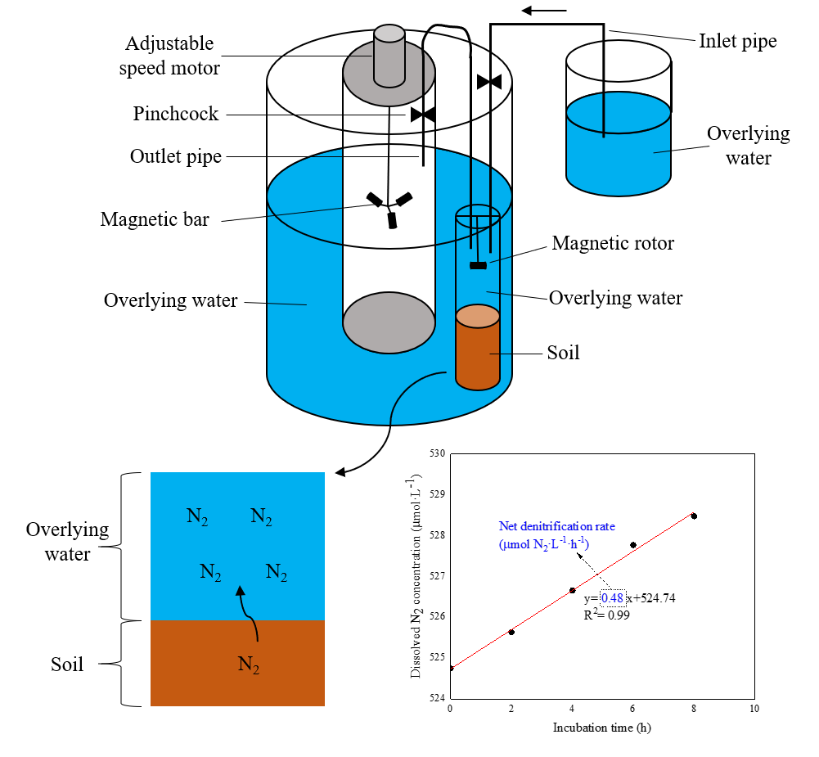
Figure S1 Conceptual diagram of in-situ flow-through incubation device and calculation diagram of net denitrification rate in the water-soil interface.
Generally, undisturbed soil samplers (PVC, inner diameter 8 cm, outer diameter 9 cm, height 30 cm) were gently immersed in the samples to collect soil cores from the incubators, and then, the bottoms were sealed with rubber stoppers. The overlying water solutions of each corresponding treatment were collected and slowly added into the soil cores and flow-through incubation device. The soil cores were placed vertically in the incubation device simulating the in-situ flooding environment and the water level was approximately 4-5 cm above the samplers, and then equilibrated overnight with gentle aeration from an aquarium air pump. After 8-12 h of immersion to achieve a stable state, the covers of the soil samplers were gently screwed on and adjusted until there were no bubbles in the samplers, and then the samplers were connected to inlet and outlet pipes. The inlet pipe was connected to replenishment liquid above the incubator. When a sample was taken, the replenishment liquid automatically replenished the water sample flowing out of the incubator to ensure that there were no bubbles throughout the experiment. Initial samples were taken corresponding to 0 h, and then, samples were taken at 2, 4, 6, and 8 h.

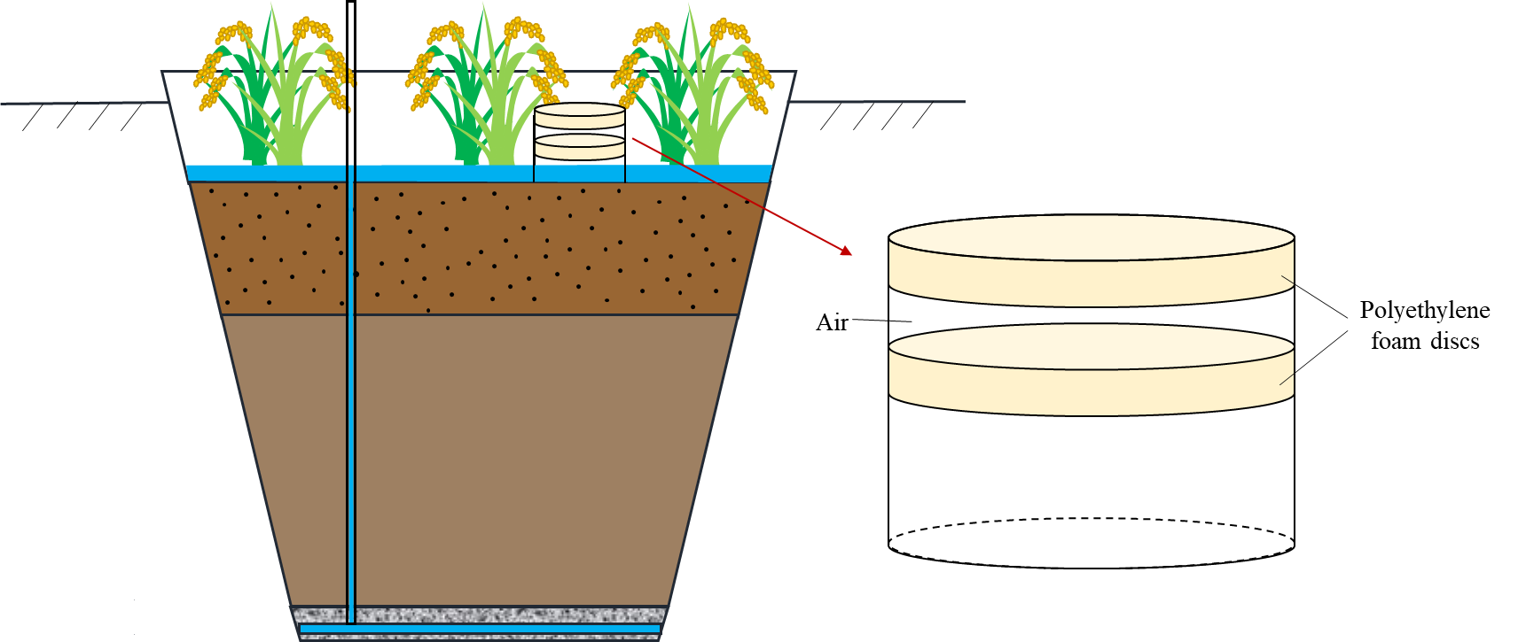
Figure S2 Schematic diagram of device for measuring ammonia volatilization by static semi-opened chamber technique.

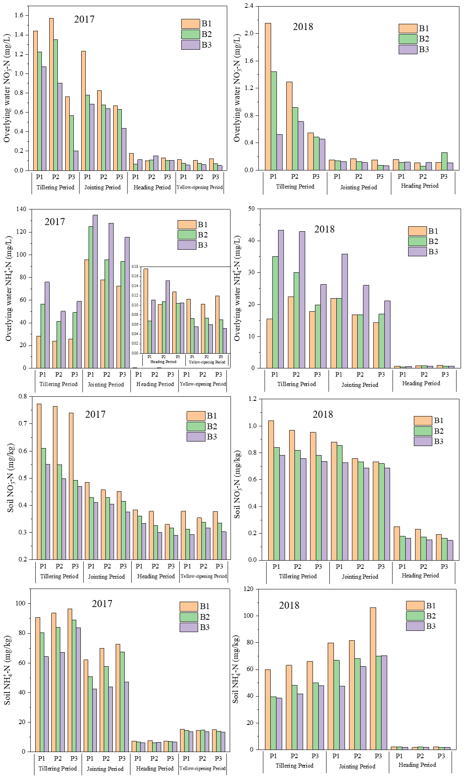
Figure S3 Concentrations of NO₃⁻-N and NH₄⁺-N in the overlying water and soil in each growth period of rice in 2017 and 2018.
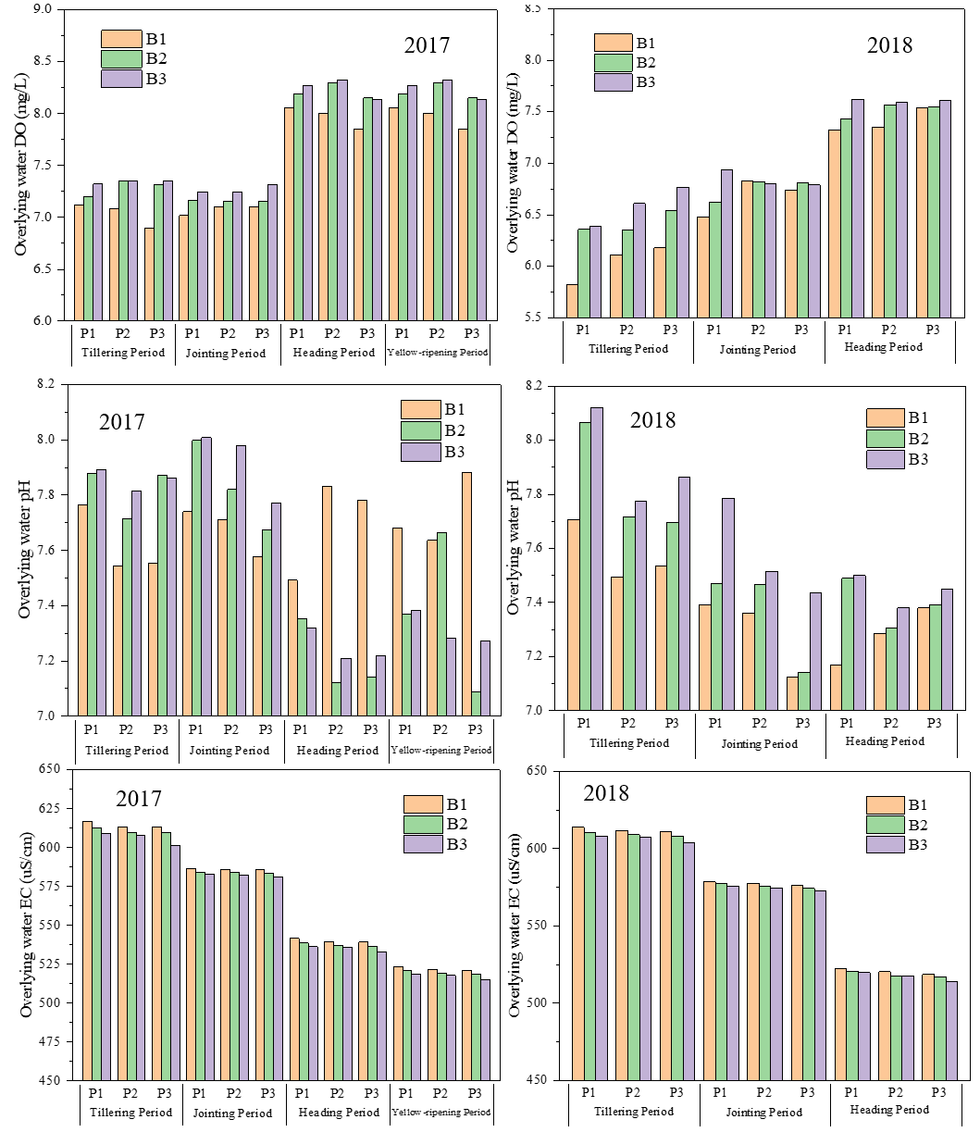
Figure S4 Environmental factors of overlying water in each growth period of rice in 2017 and 2018.

