Supporting Information
Figure
Fig. S1. (A) Predicted OsJAZ5 protein transmembrane region and (B) the secretory signal peptide Fig. S2. Bioinformatics analysis
Fig. S3. Predicted OsJAZ5 interaction in the protein regulatory network
Table
Table. S1 Gene expression analysis primers for the validation data.

Fig. S1. (A) Prediction of OsJAZ5 protein transmembrane region and (B) secretory signal peptide
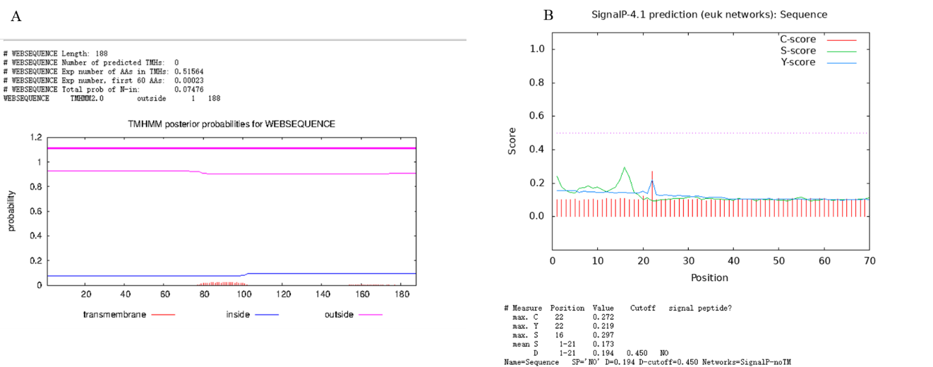

Fig. S2. Bioinformatics analysis. (A) Prediction of tertiary structure of OsJAZ5 encoded protein. (B) Subcellular localization prediction for OsJAZ5 protein. (C) Secondary domain analysis of the OsJAZ5 protein
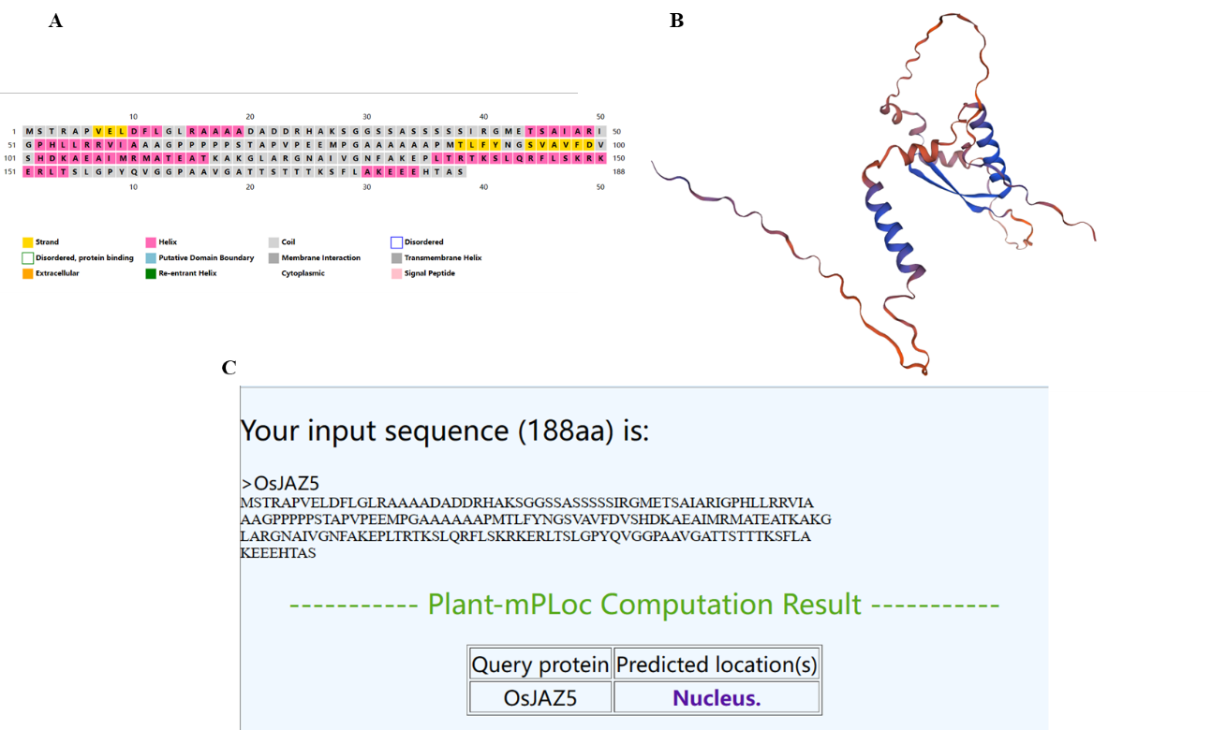
Fig. S3. Predicted OsJAZ5 protein regulatory network interactions
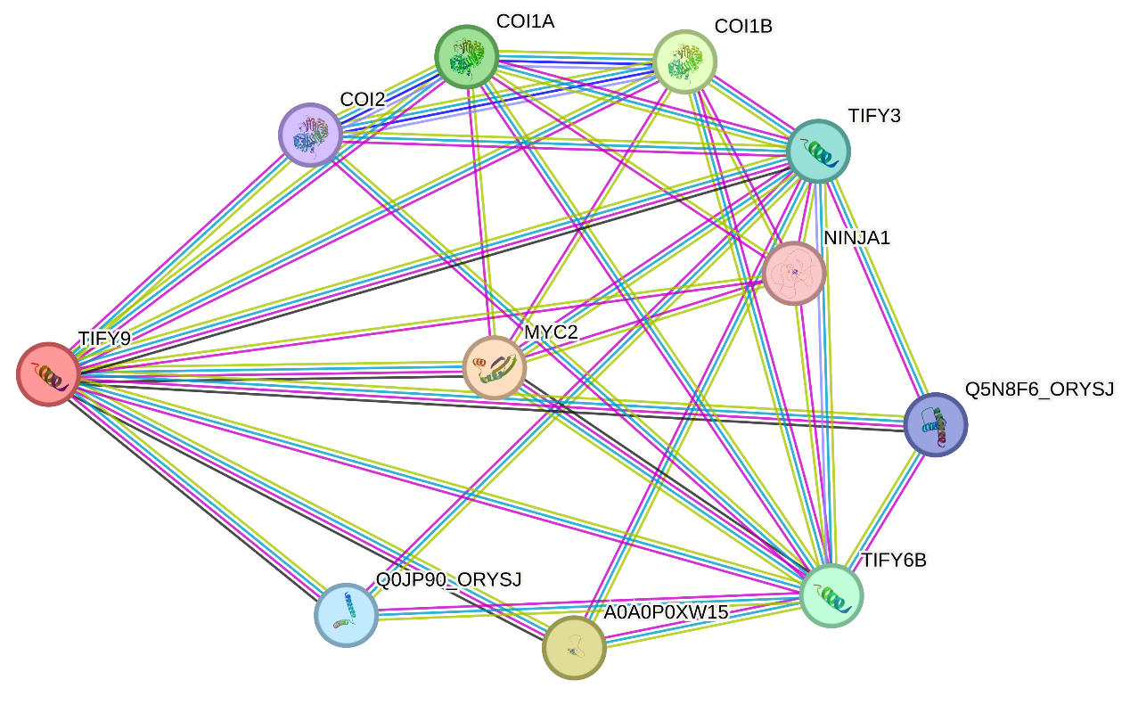
Table S1
Gene expression analysis primers for the validation data
Description | Gene name | Primer sequence | Product size (bp)
OsJAZ5 | LOC_Os04g32480 | F: CTCCGATGACGCTCTTCTAC | 163
OsJAZ5 | LOC_Os04g32480 | R: GTTCTTGTGAGTGGCTCTTTG | 163
OsDhn1 | LOC_Os02g44870 | F: GCAGGAAGAAGGACGATCAG | 204
OsDhn1 | LOC_Os02g44870 | R: TGTCATCGATCACCTCCTCT | 204
OsbZIP23 | LOC_Os02g52780 | F: GAAGGTTGTCGAGAGAAGA | 166
OsbZIP23 | LOC_Os02g52780 | R: CTGCTCCAACATTTCATCC | 166
Oshox22 | LOC_Os04g45810 | F: CTAGGATCGCCATGGATCG | 216
Oshox22 | LOC_Os04g45810 | R: GTATCTGCTCCTCCGTGAAC | 216
OsAMTR1 | LOC_Os05g39770 | F: TACAGGGAGTGGGTGGAATA | 201
OsAMTR1 | LOC_Os05g39770 | R: TGCCATTGCCTATACCCTTT | 201
OsOPR1 | LOC_Os06g11290 | F: GGCCATAATCGAAGGACGAA | 205
OsOPR1 | LOC_Os06g11290 | R: TGGTGCGTCAAGCTCAAA | 205
OsPP108 | LOC_Os09g15670 | F: GCTATCCTCCGACCACAAG | 205
OsPP108 | LOC_Os09g15670 | R: GAGGCACTCGTCGAAGTC | 205

