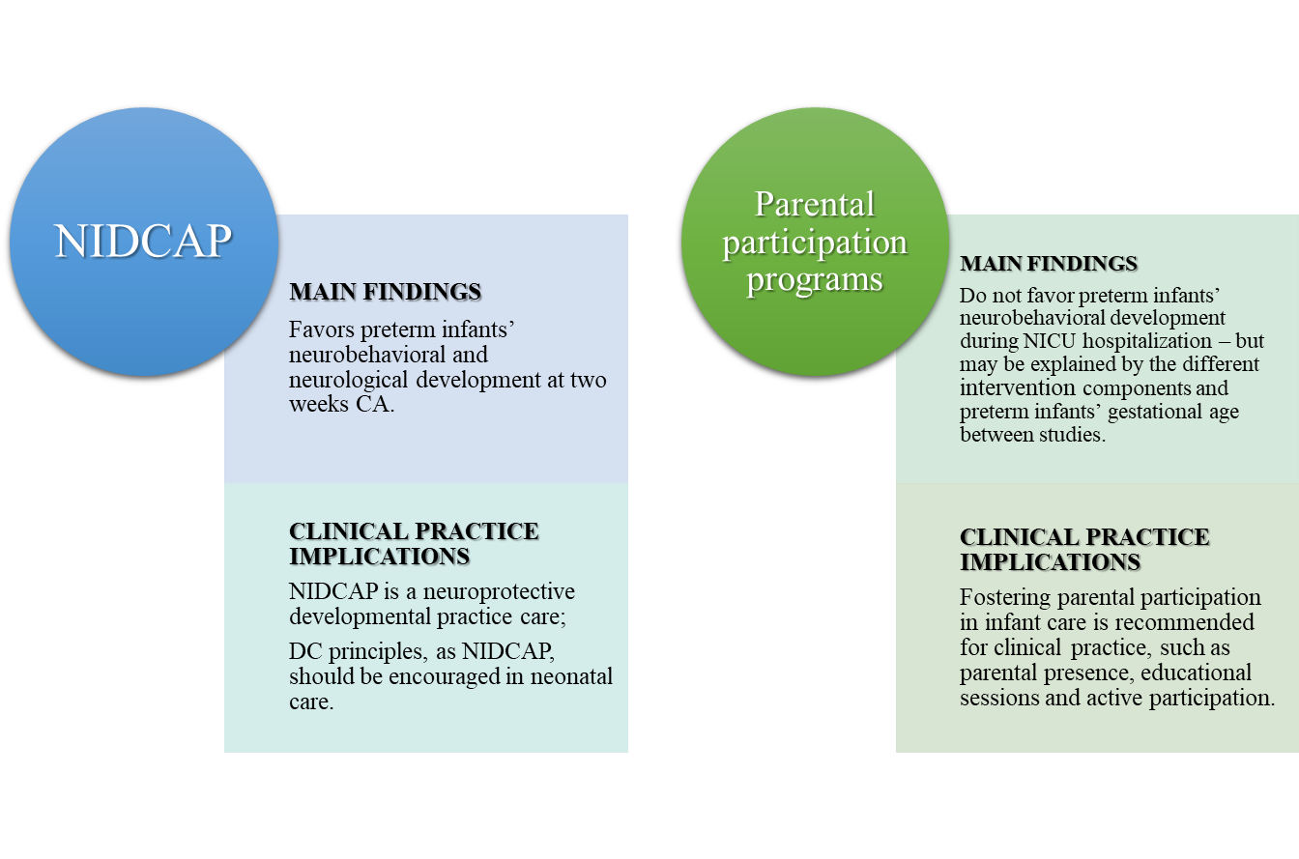
Figure 6S. Summary of meta-analysis main findings and clinical implications.

