Diel and seasonal mixing patterns and water quality dynamics in a multipurpose tropical semiarid reservoir

Maria Aparecida Melo Rochaª; Mário U G Barros^{b}; Francisco de Assis de Souza Filhoª; Iran Eduardo Lima Neto^{a*}
ª Department of Hydraulic and Environmental Engineering, Federal University of Ceará, bl. 713, 60.451-970 Fortaleza, Brazil
^{b} Water Resources Company of the State of Ceará COGERH, Rua Adualdo Batista, 1550, 60.824.140 Fortaleza, Brazil
*Corresponding Author: iran@deha.ufc.br

Supplementary material

1 Hydrodynamics of the Castanhão reservoir
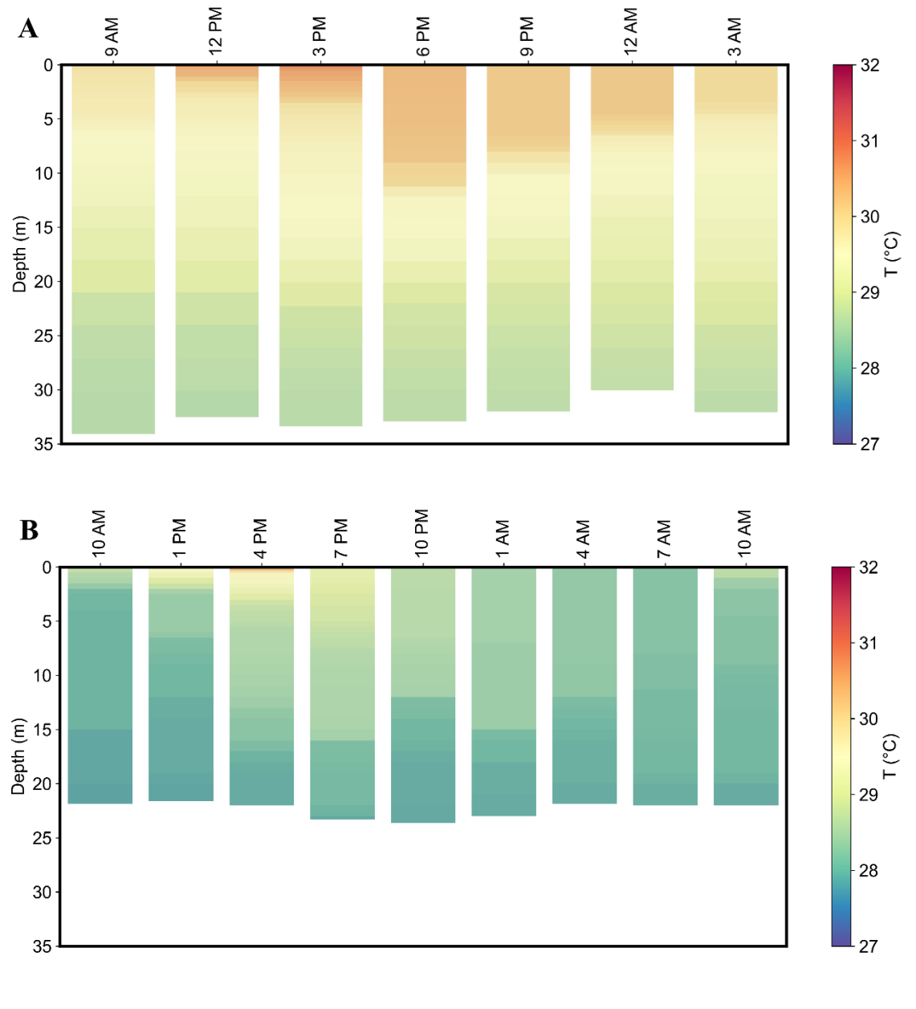
Figure S1 - Water temperature profiles at P6 with data collected in A) May 2023 (rainy season) and B) October 2021 (dry season).
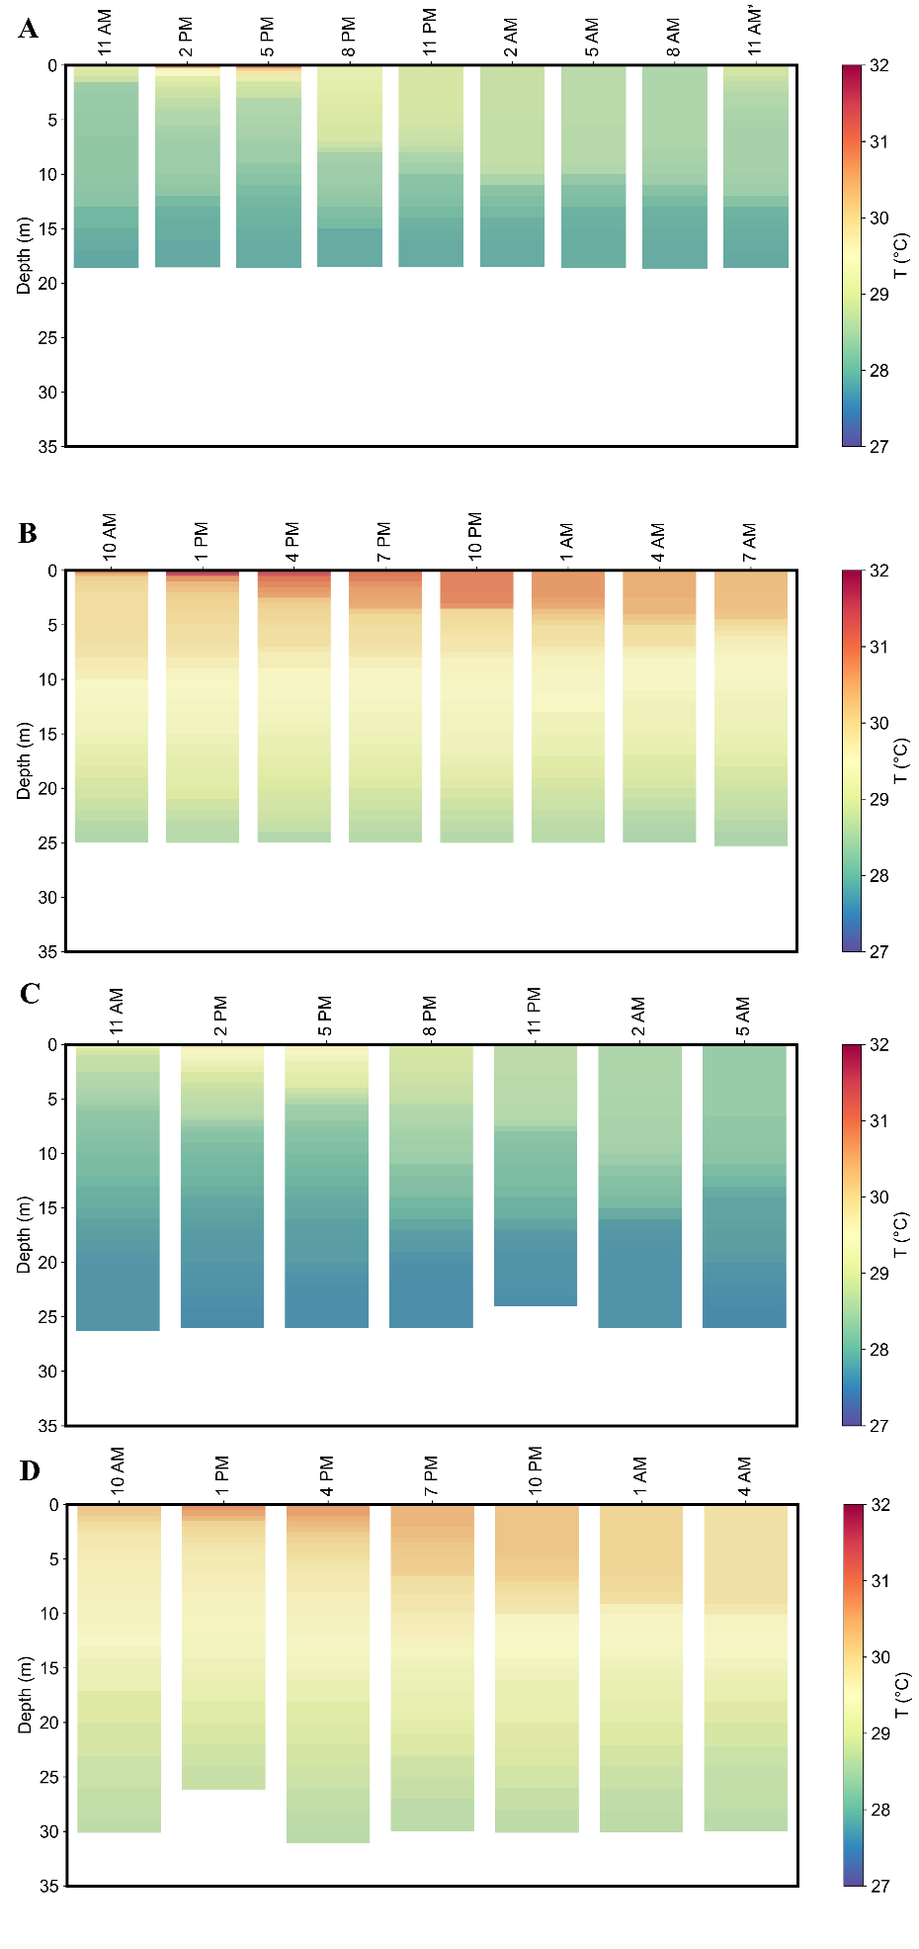
Figure S2 - Water temperature profiles at P7 with data collected in A) October 2021 (dry season), B) March 2022 (rainy season), C) November 2022 (dry season), and D) May 2023 (rainy season).
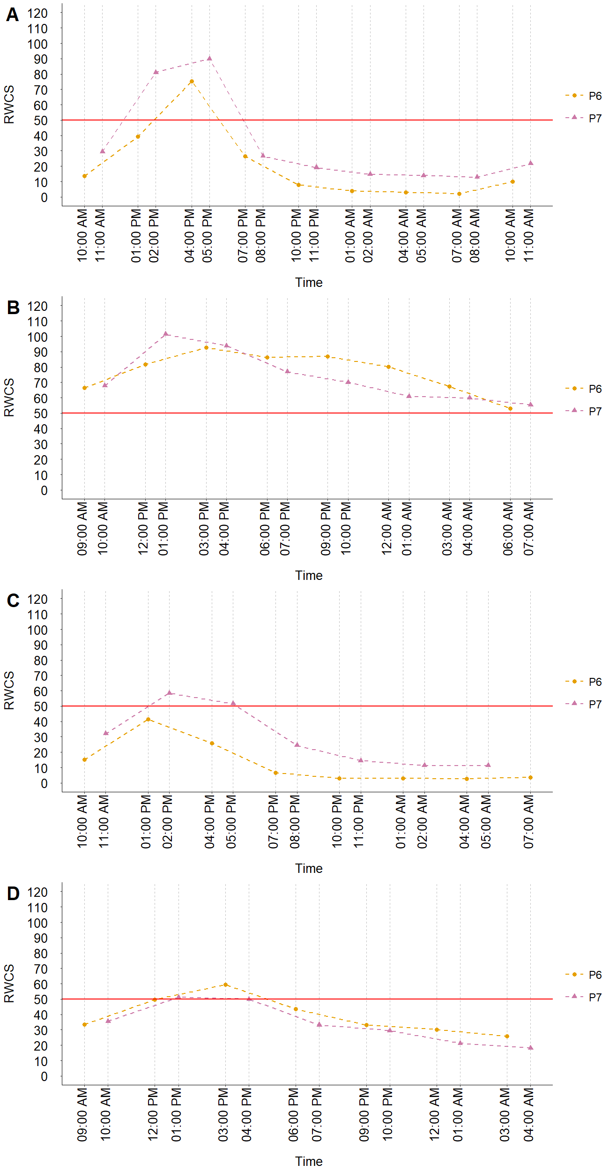
Figure S3 - RWCS index at P6 and P7 calculated for A) October 2021 (dry season), B) March 2022 (rainy season), C) November 2022 (dry season), and D) May 2023 (rainy season). The horizontal line represents the limit where above 50 it characterizes thermal stratification in the water column.
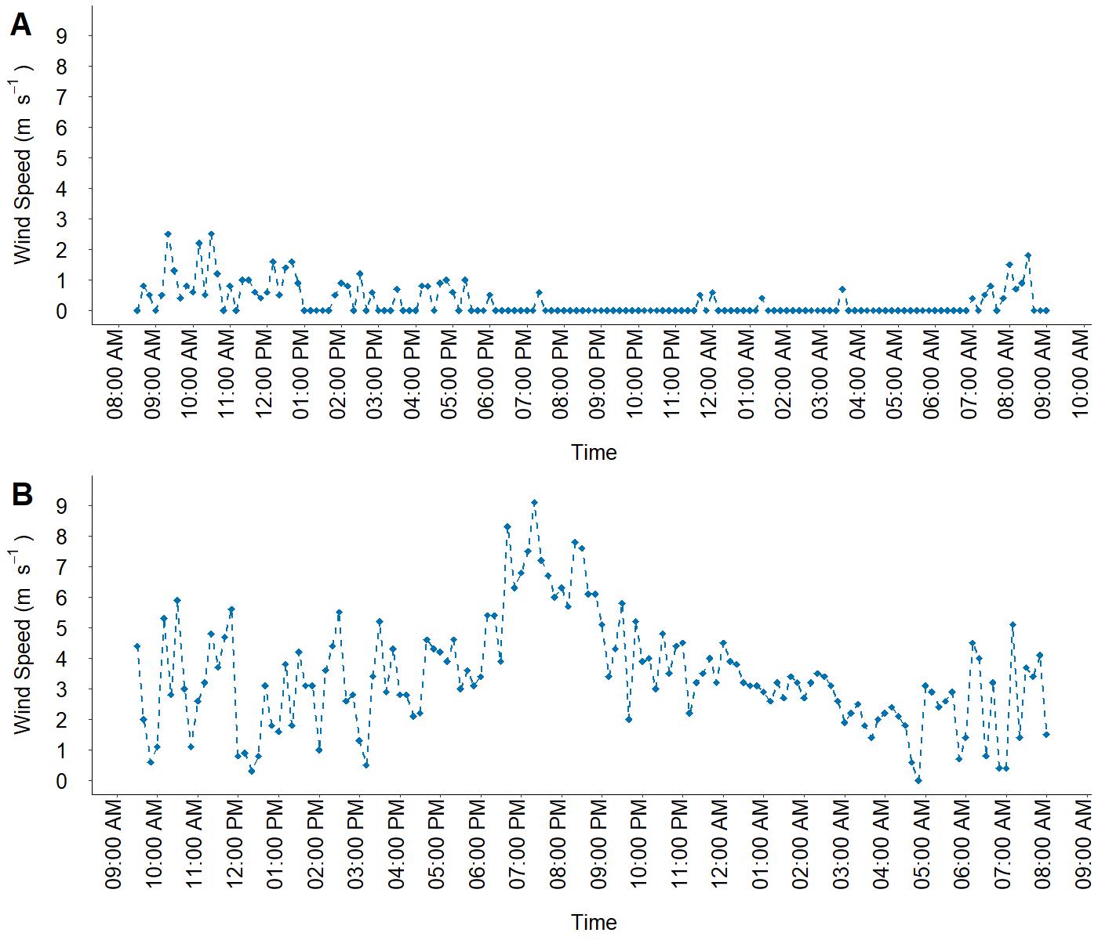
Figure S4 - Wind speed at the water dam of Castanhão reservoir in A) March 2022 (rainy season) and B) November 2022 (dry season).
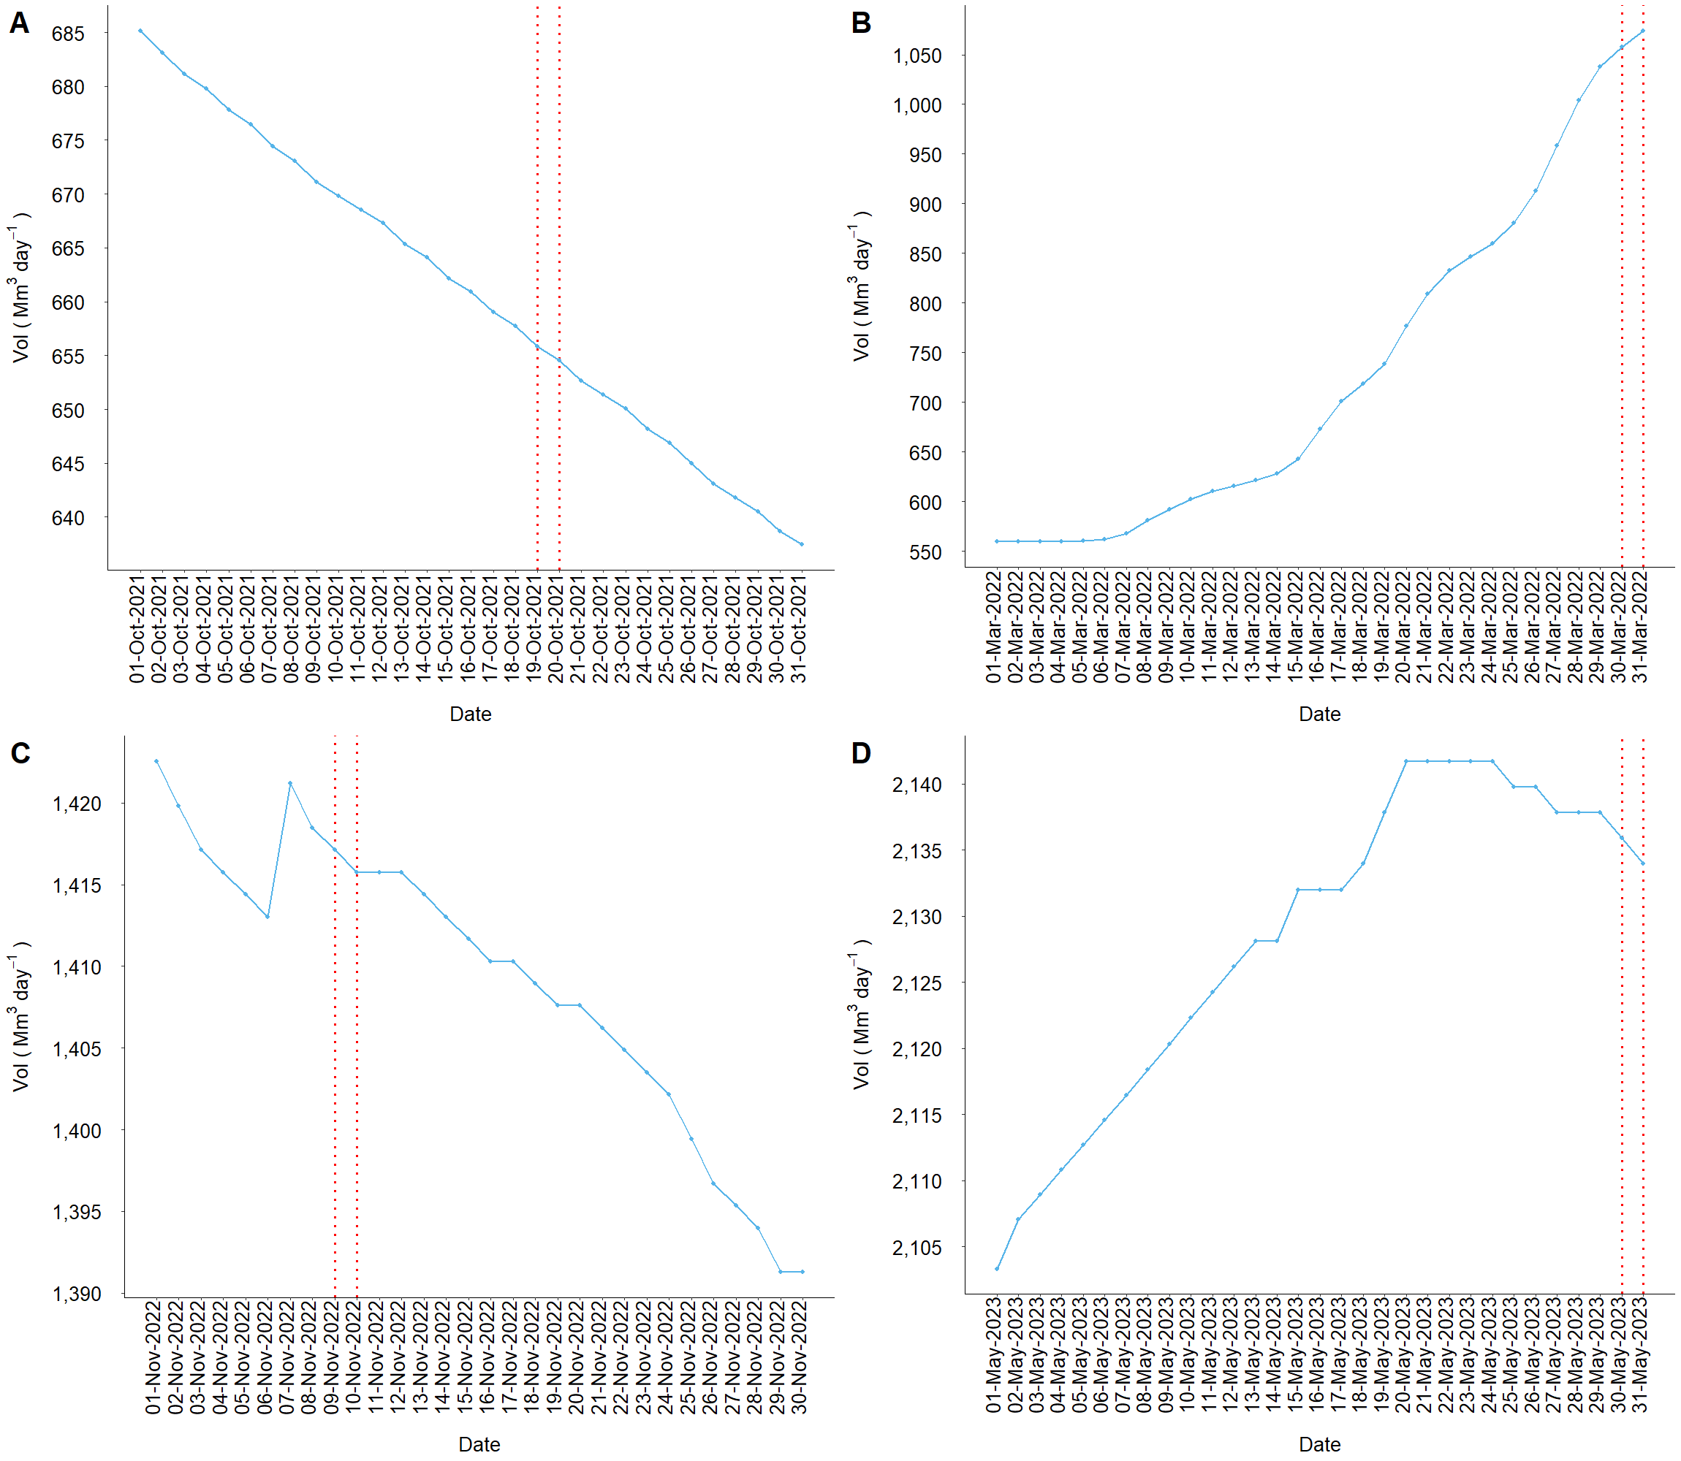
Figure S5 - Daily reservoir volume from A) October 2021 (dry season), B) March 2022 (rainy season), C) November 2022 (dry season), and D) May 2023 (rainy season). The dashed red dotted lines represent the dates where the diel analyses were performed.
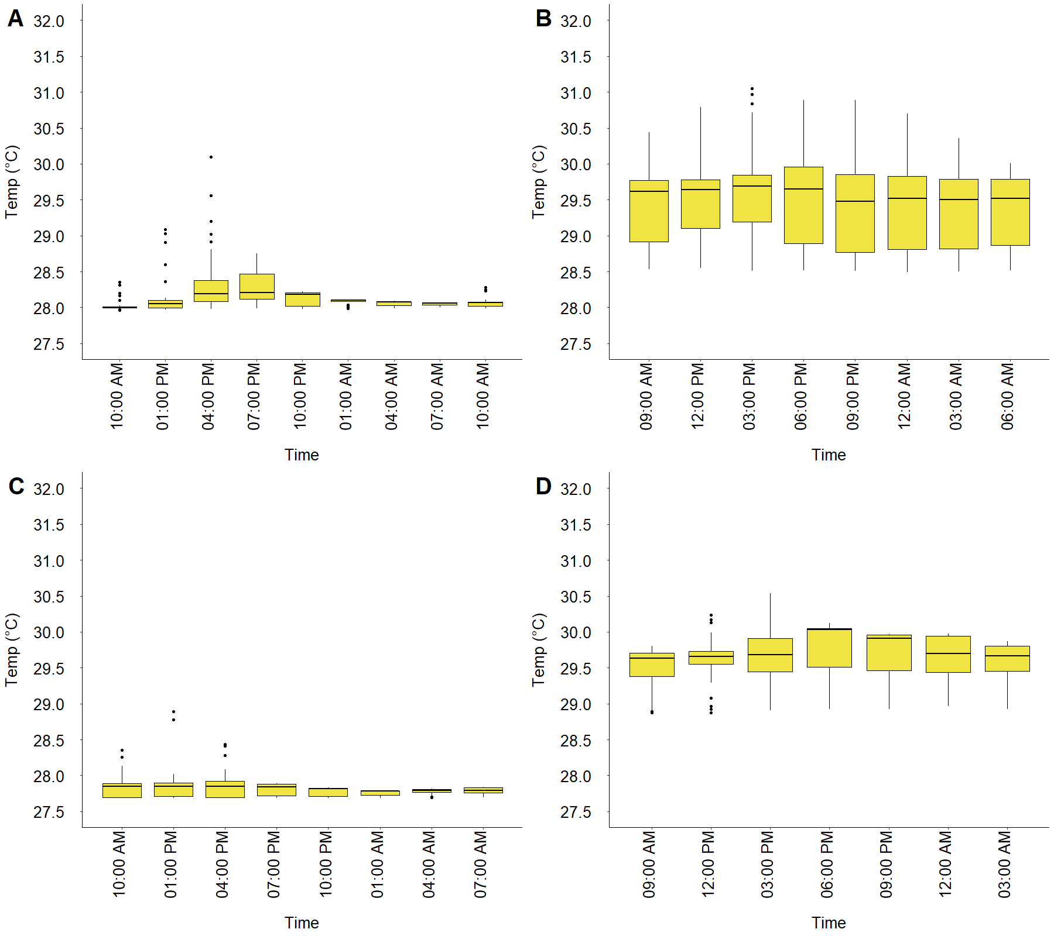
Figure S6 - Boxplots presenting the Temperature variations throughout the day at each measurement time at P6 in A) October 2021 (dry season), B) March 2022 (rainy season), C) November 2022 (dry season), D) May 2023 (rainy season). The horizontal line at each boxplot represents the median values within the water column.

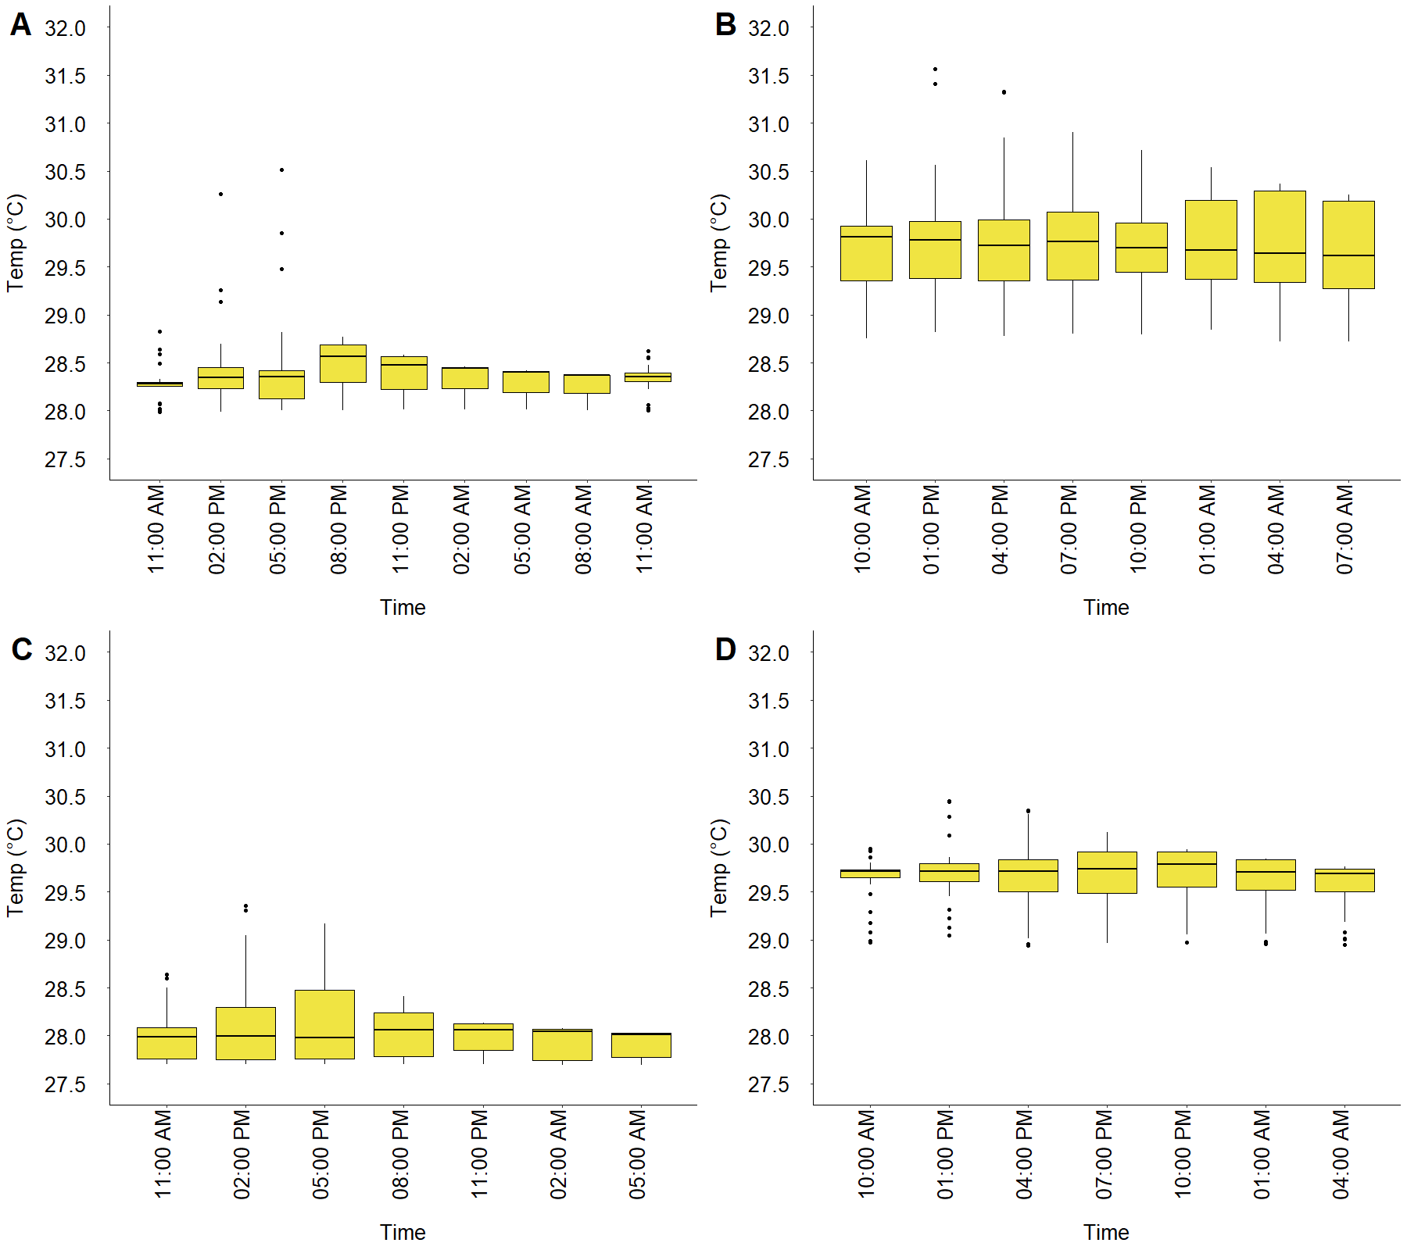
Figure S7 - Boxplots presenting the Temperature variations throughout the day at each measurement time in an analysis at P7 in A) October 2021 (dry season), B) March 2022 (rainy season), C) November 2022 (dry season), D) May 2023 (rainy season). The horizontal line at each boxplot represents the median values within the water column.
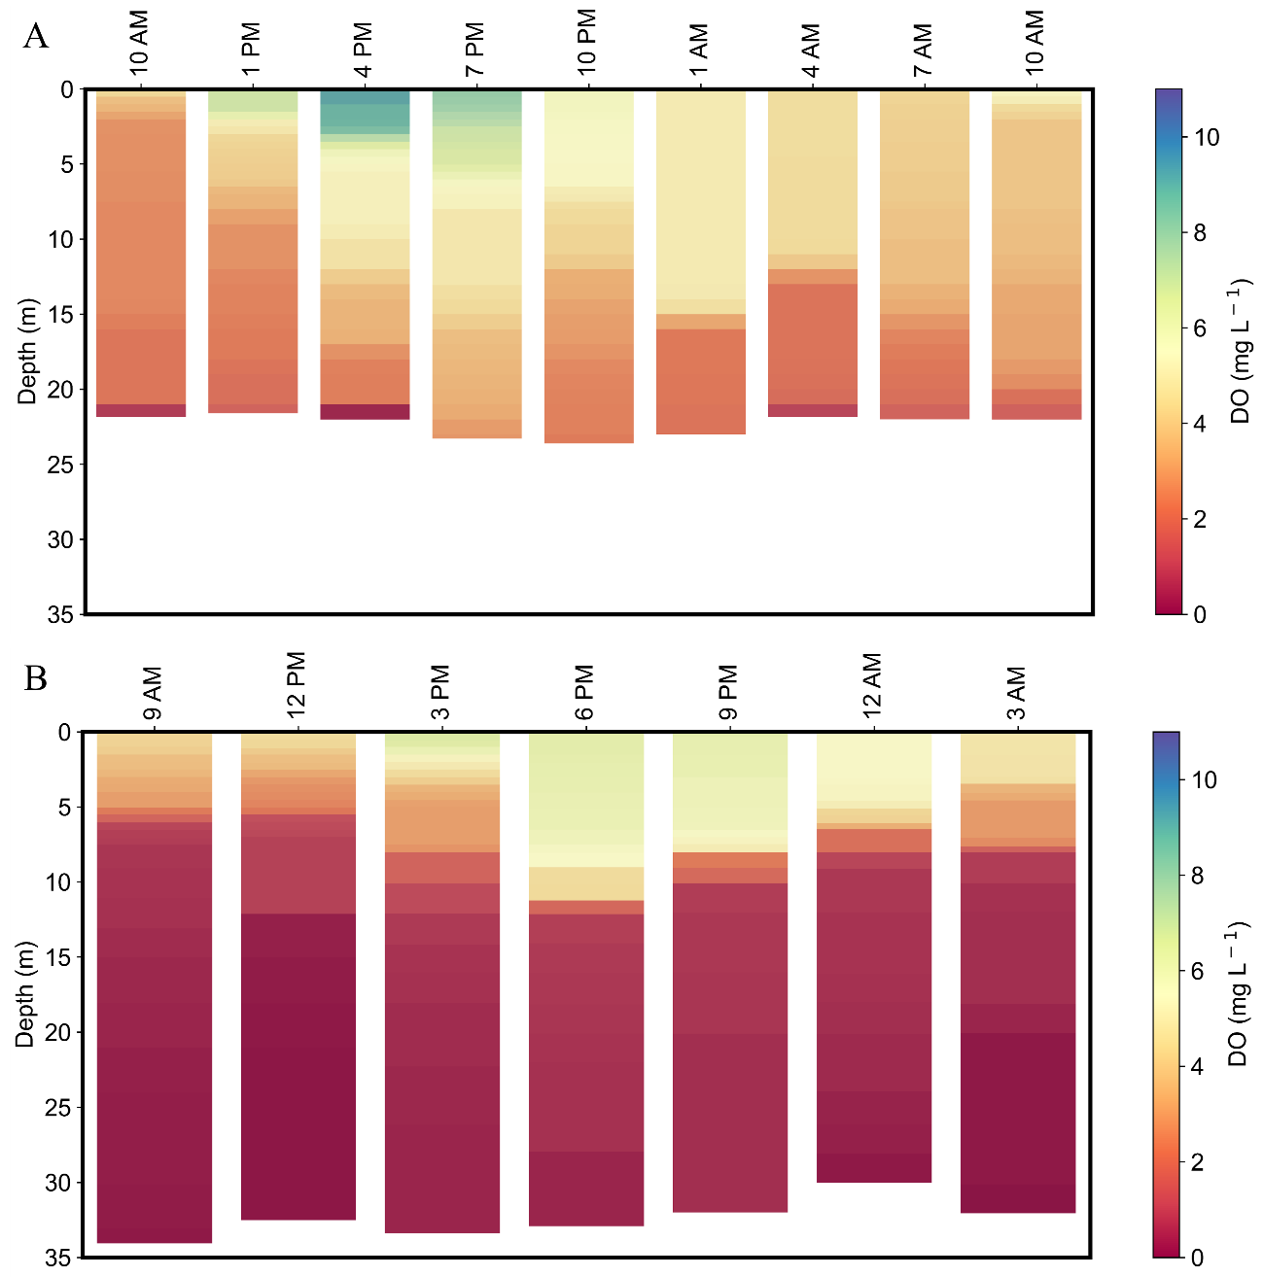
Figure S8 – Dissolved oxygen profiles at the sampling P6 in A) October 2021 (dry season), B) May 2023 (rainy season).

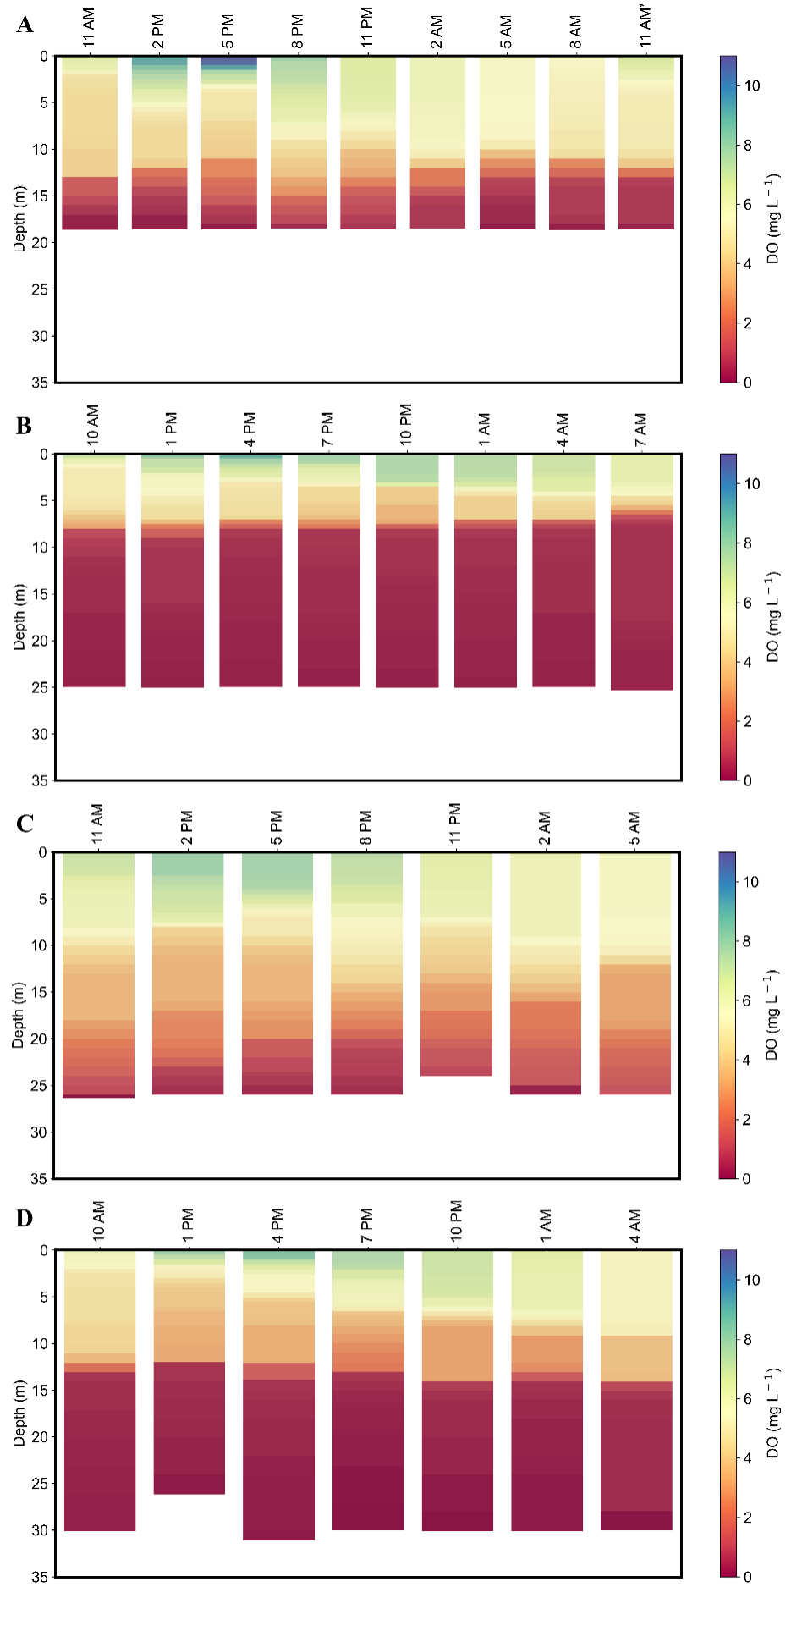
Figure S9 - Dissolved oxygen profiles at the P7 in A) October 2021 (dry season), B) March 2022 (rainy season), C) November 2022 (dry season), D) May 2023 (rainy season).

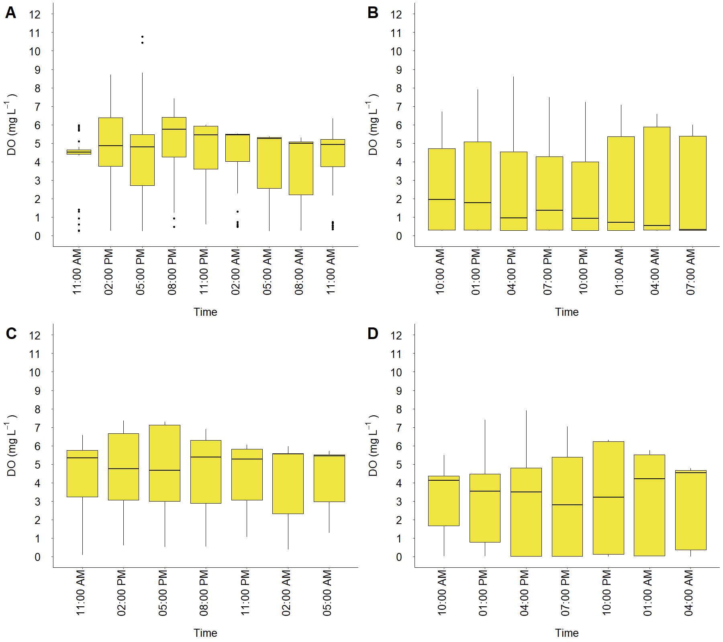
Figure S10 - Boxplots presenting the dissolved oxygen variations throughout the day at the P7 in A) October 2021 (dry season), B) March 2022 (rainy season), C) November 2022 (dry season), D) May 2023 (rainy season). The horizontal line at each boxplot represents the median values within the water column.

2 Seasonal diel nutrient variation
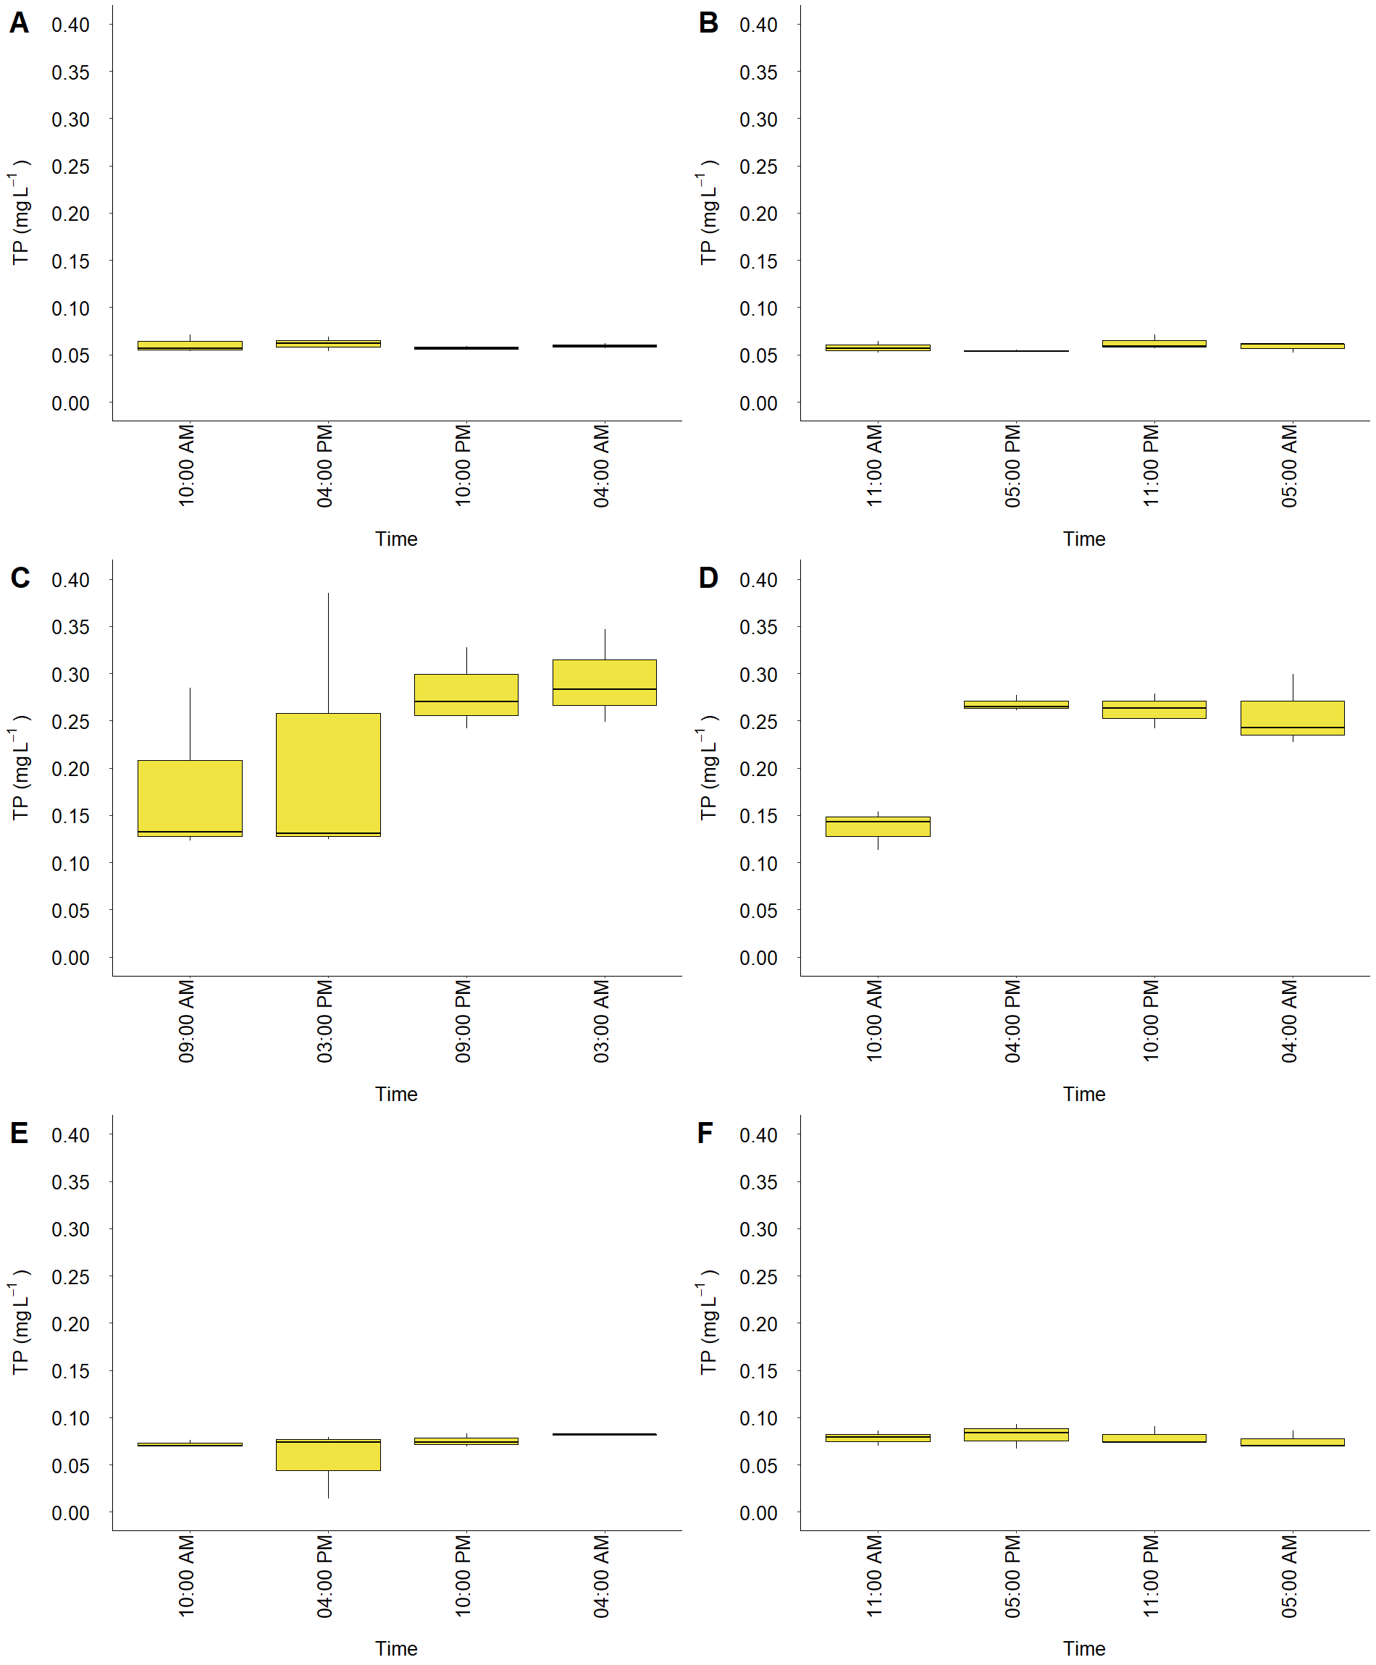
Figure S11 – Variation of TP concentration in the water through time in A) October 2021 at P6, B) October 2021 at P7, C) March 2022 at P6, D) March 2022 at P7, E) November 2022 at P6 and F) November 2022 at P7. The horizontal line at each boxplot represents the median values within the water column.

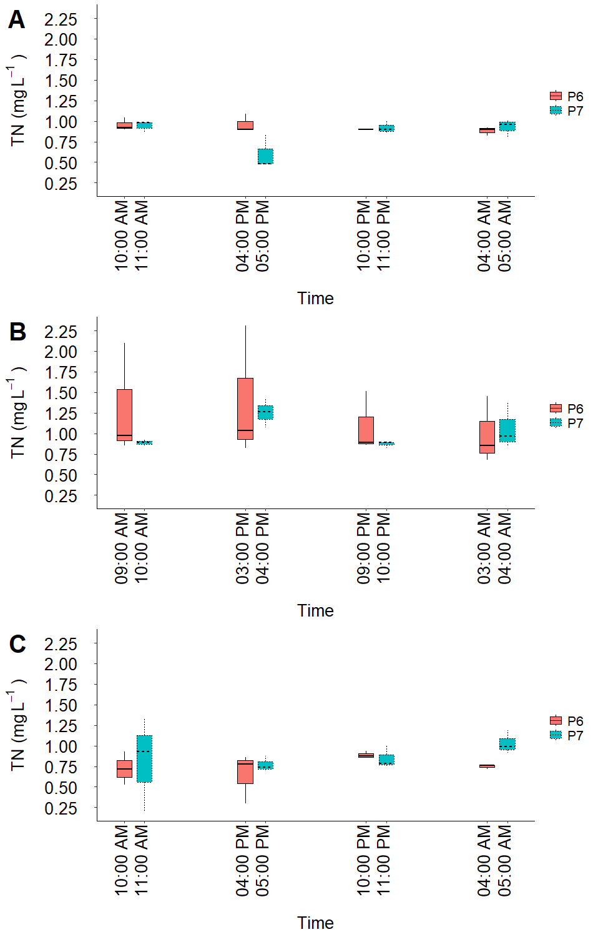
Figure S12 - TN concentration variation throughout the day in A) October 2021 (dry season), B) March 2022 (rainy season), C) November 2022 (dry season). The horizontal line at each boxplot represents the median values within the water column.
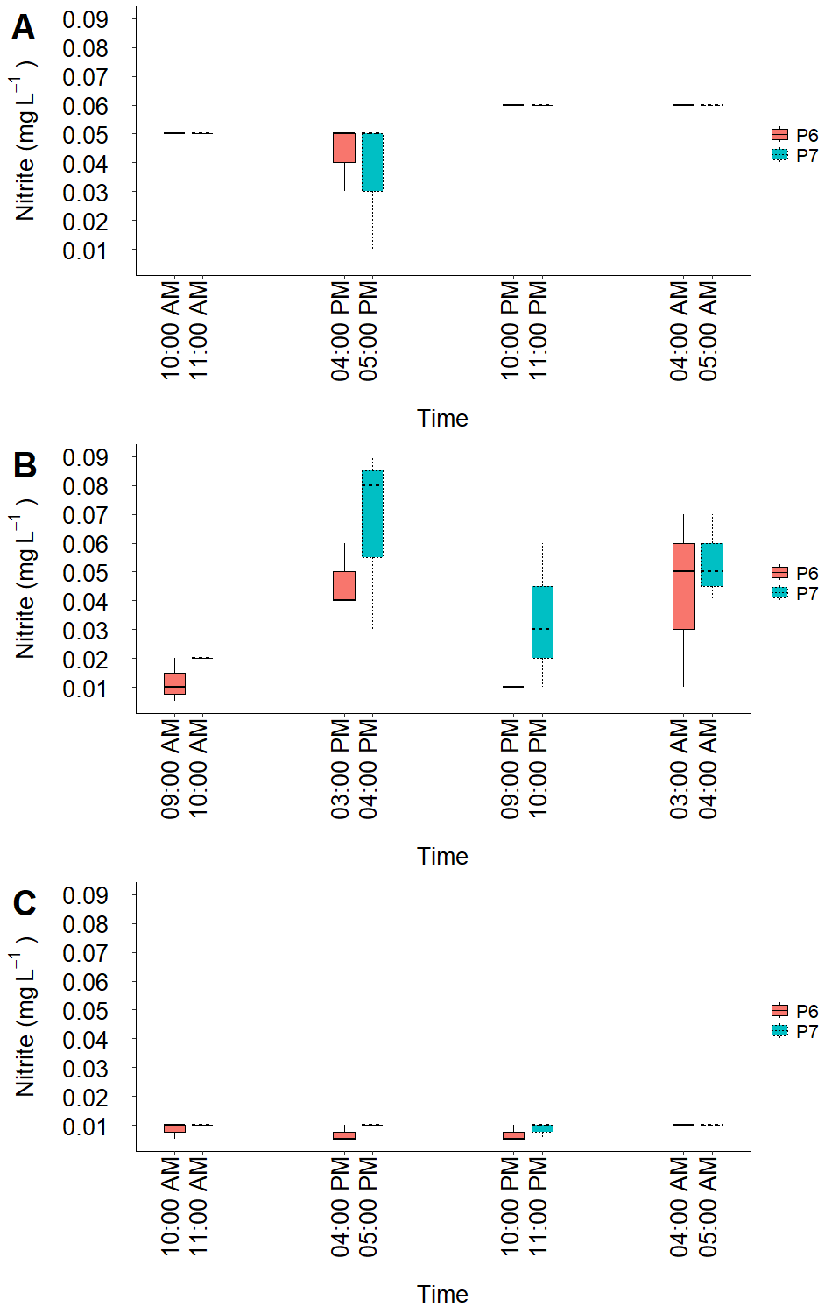
Figure S13 - Nitrite concentration variation throughout the day in A) October 2021 (dry season), B) March 2022 (rainy season), C) November 2022 (dry season). The horizontal line at each boxplot represents the median values within the water column.

3 Phytoplankton diel variation
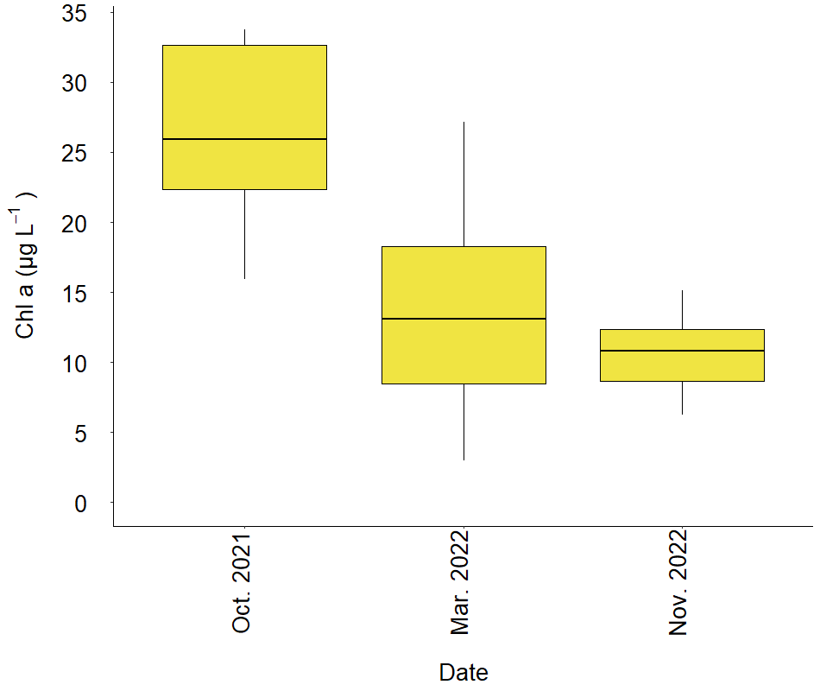
Figure S14 - Difference in chlorophyll a concentration between the measurements at each month. The horizontal line at each boxplot represents the median values within the water column.

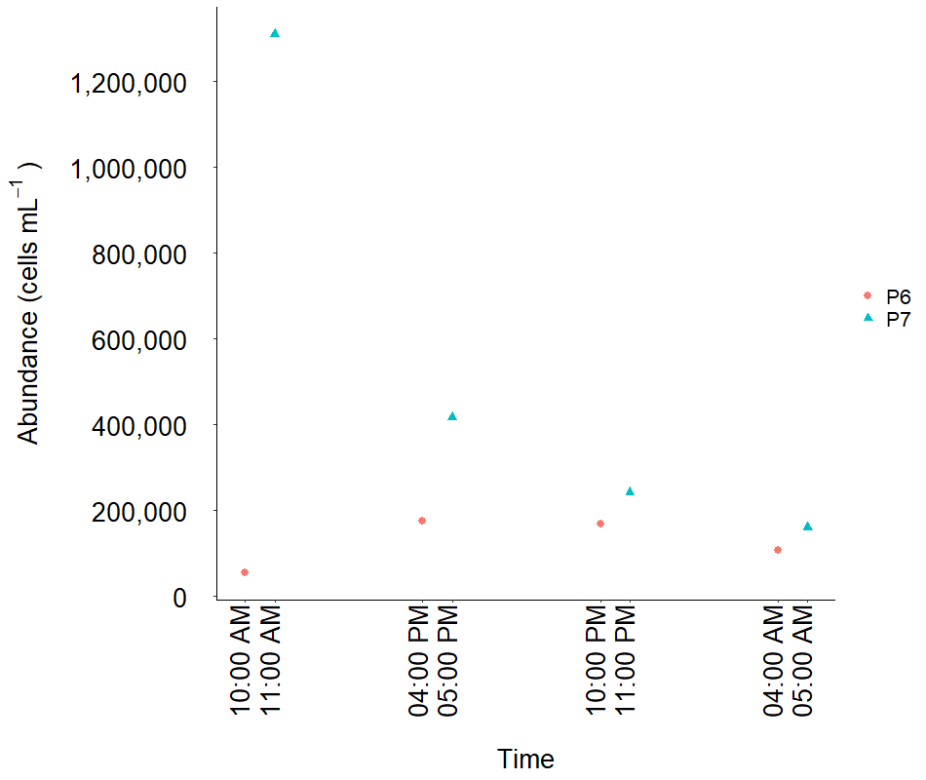
Figure S15 – Cyanobacteria abundance in October 2021 at a 0.3 m depth.

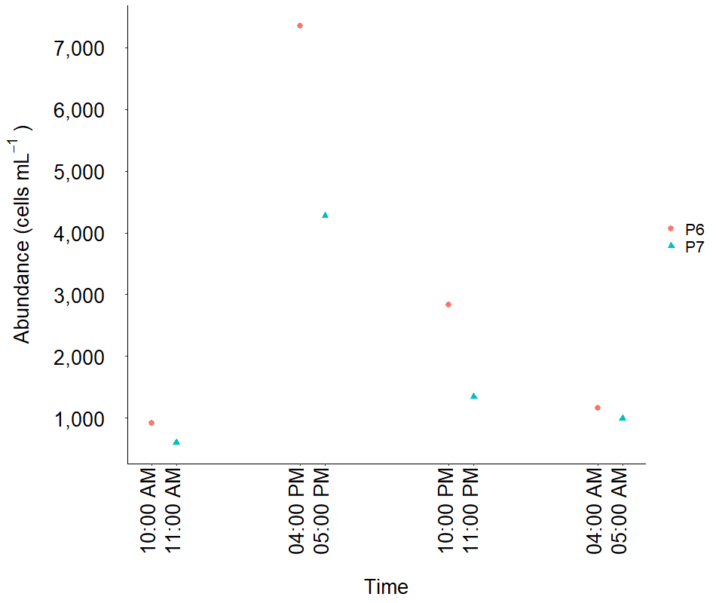
Figure S16 – Other organisms of the phytoplankton community in October 2021 at a 0.3 m depth.

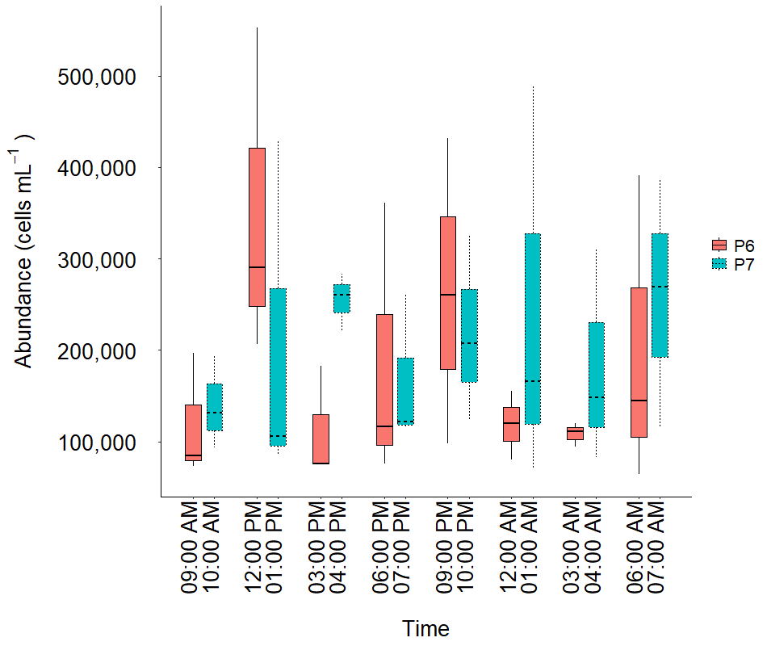
Figure S17 – Comparison of cyanobacteria abundance in March 2022 between the sampling points. The horizontal line at each boxplot represents the median values within the water column.
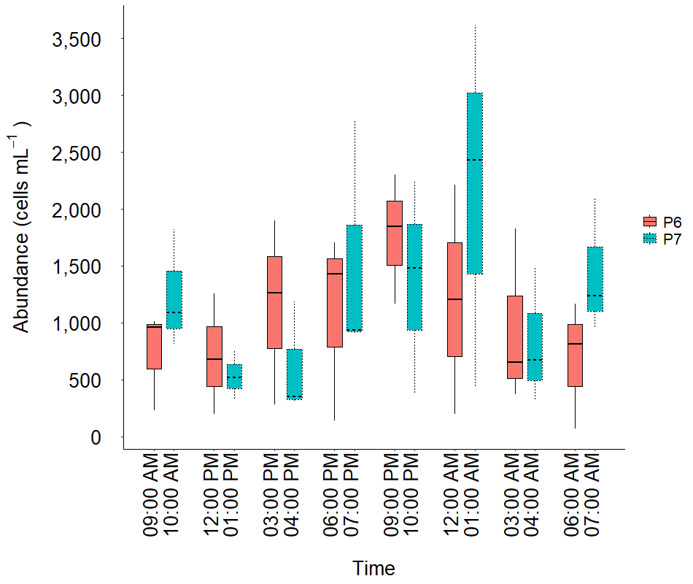
Figure S18 – Comparison of the abundance of other organisms of the phytoplankton community in March 2022 between the sampling points. The horizontal line at each boxplot represents the median values within the water column.

4 Nutrient variation with depth
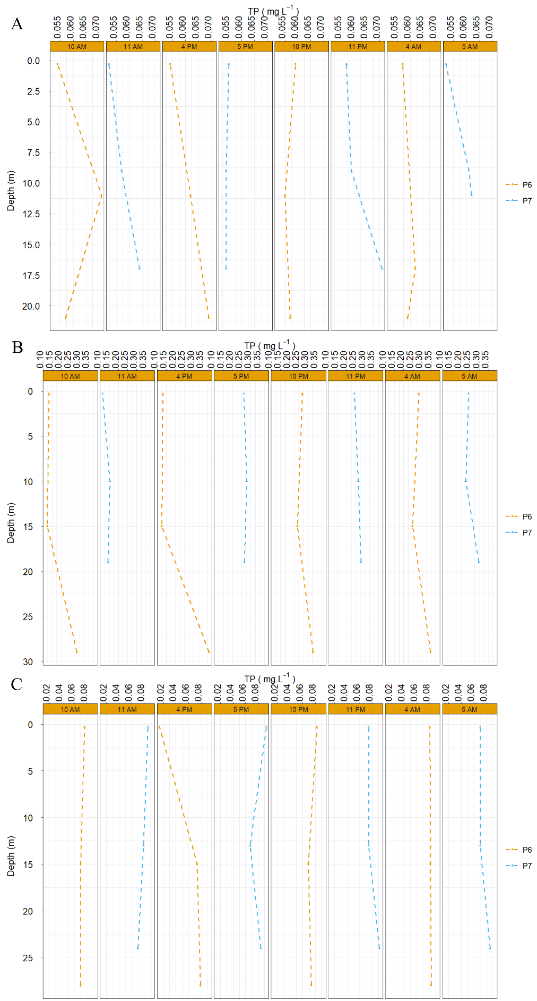
Figure S19 – Variation of TP concentration with depth at P6 and P7 in A) October 2021 (dry season), B) March 2022 (rainy season), C) November 2022 (dry season).
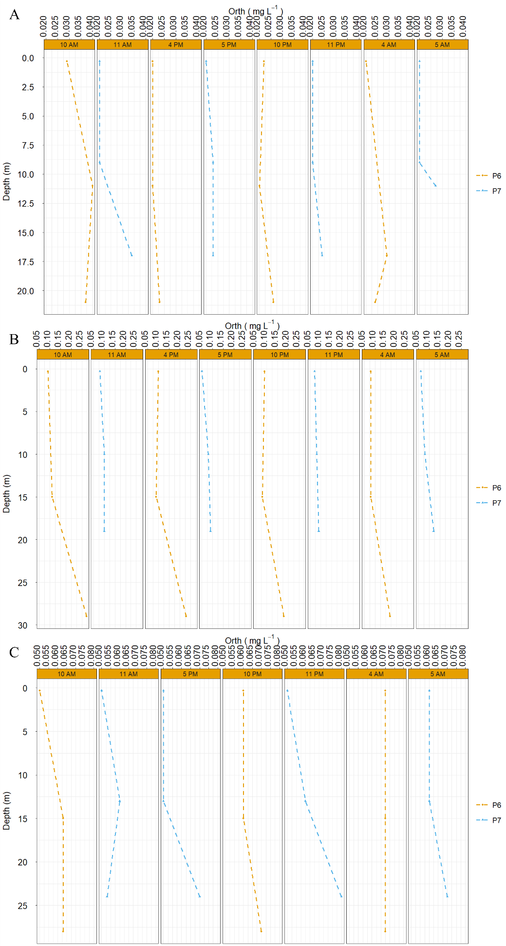
Figure S20 – Variation of orthophosphate concentration with depth at P6 and P7 in A) October 2021 (dry season), B) March 2022 (rainy season), C) November 2022 (dry season).
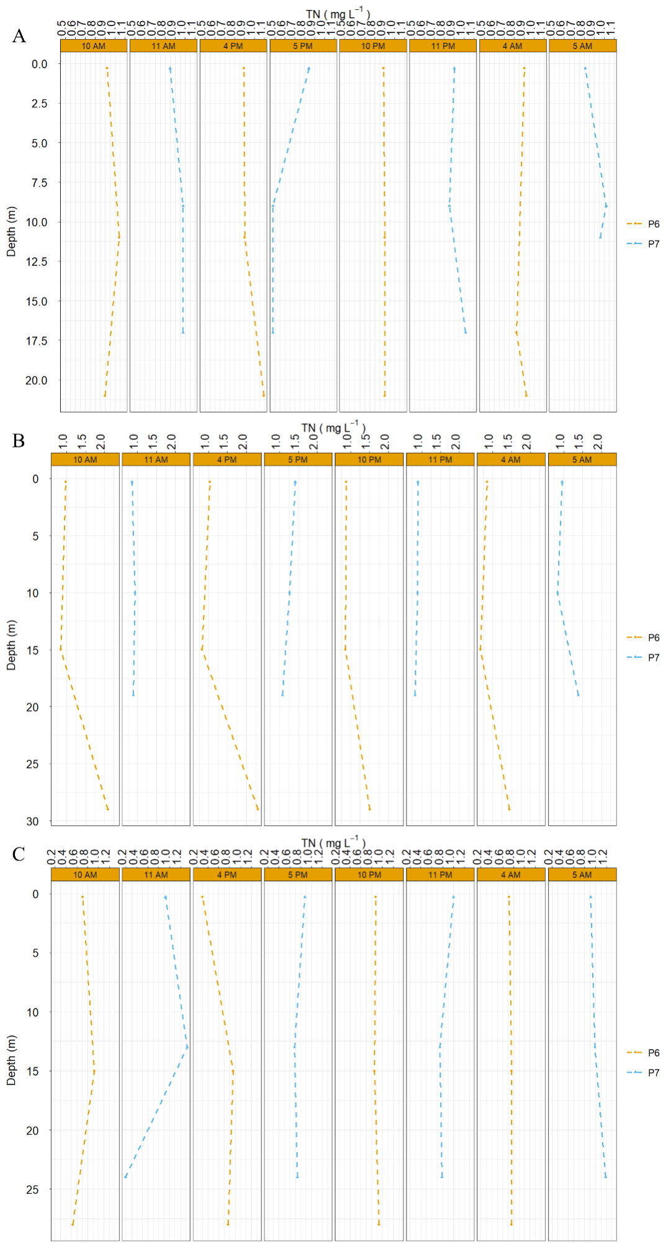
Figure S21 – Variation of TN concentration with depth at P6 and P7 in A) October 2021 (dry season), B) March 2022 (rainy season), C) November 2022 (dry season).

