SUPPLEMENTAL DATA

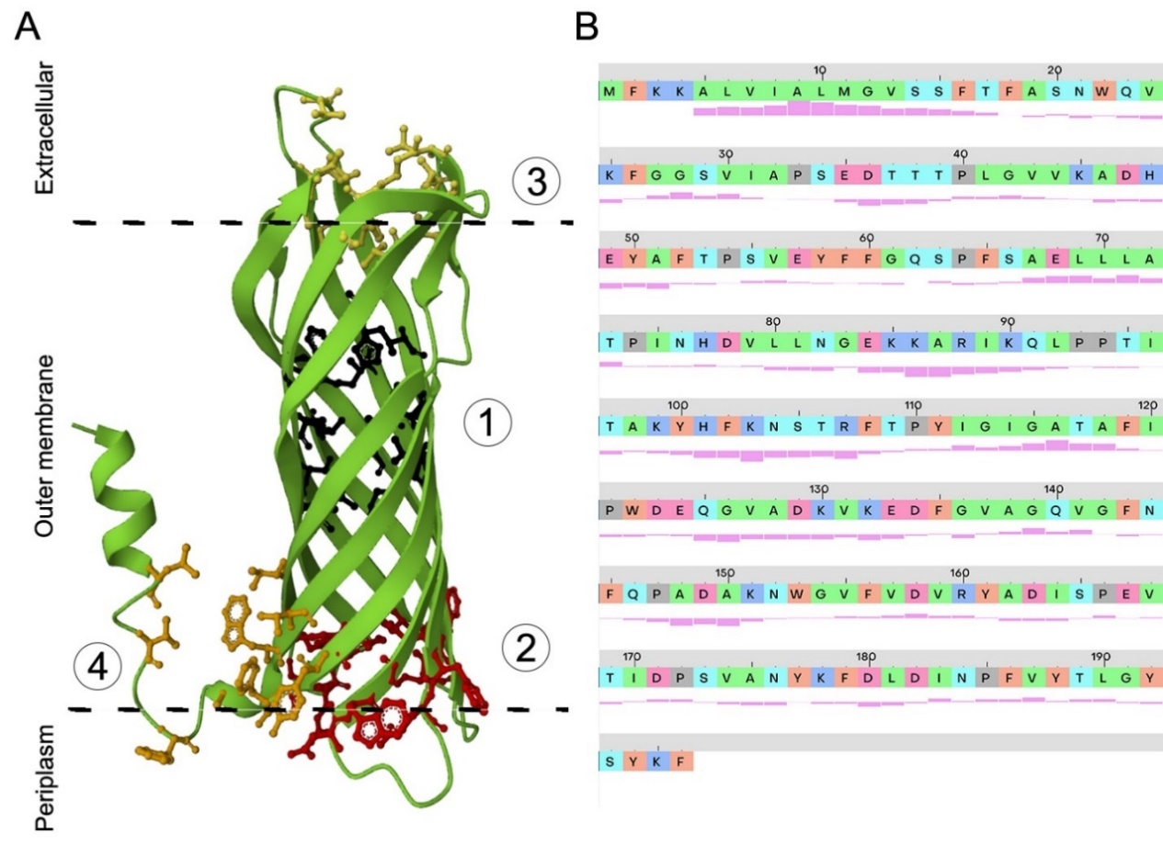

Figure S1. 3D structure of OmpW with each predicted binding pocket (A). Protein sequence of OmpW with the hydrophobicity level of each amino acid (B).

Table S1. Predicted binding pockets for OmpW.
Name | Score | Probability | Center_x | Center_y | Center_z | Residue_ids
pocket1 | 12.87 | 0.627 | -2.82 | -0.55 | 1.61 | A_117 A_119 A_138 A_160 A_162 A_164 A_183 A_185 A_187 A_31 A_53 A_70 A_77 A_91 A_93 A_95
pocket2 | 8.69 | 0.443 | 10.39 | -0.52 | -17.85 | A_101 A_102 A_103 A_104 A_106 A_109 A_144 A_145 A_146 A_152 A_153 A_154 A_193 A_195 A_23 A_59 A_61 A_63 A_64
pocket3 | 6.36 | 0.287 | -15.81 | -3.1 | 17.51 | A_127 A_128 A_168 A_170 A_174 A_179 A_39 A_41 A_44 A_79 A_81 A_86 A_87
pocket4 | 2.41 | 0.052 | 6.91 | 15.69 | -15.66 | A_10 A_13 A_19 A_196 A_22 A_24

