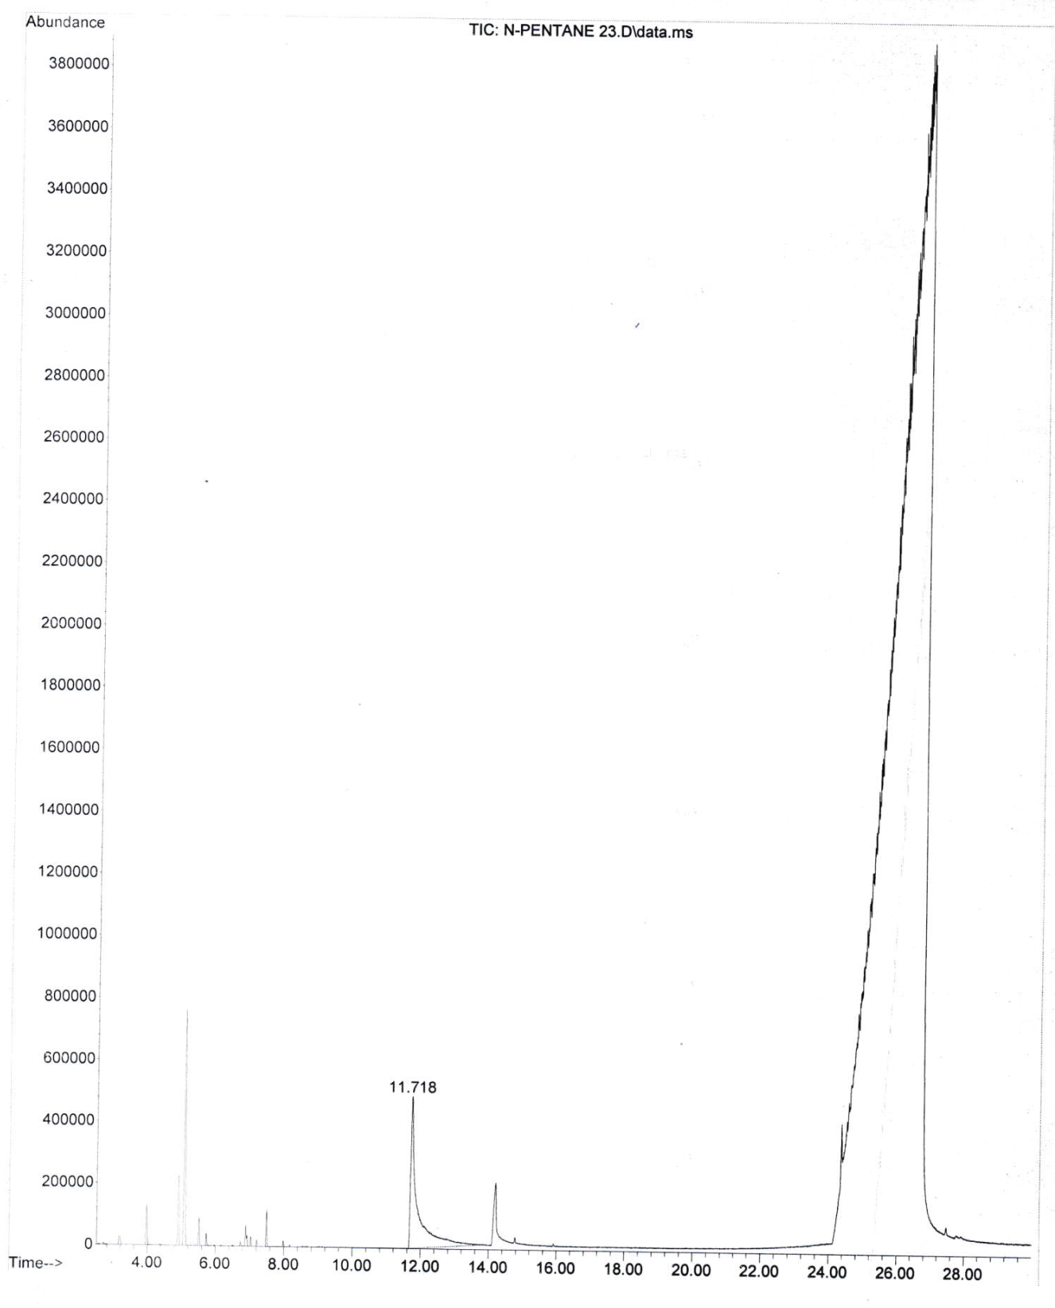

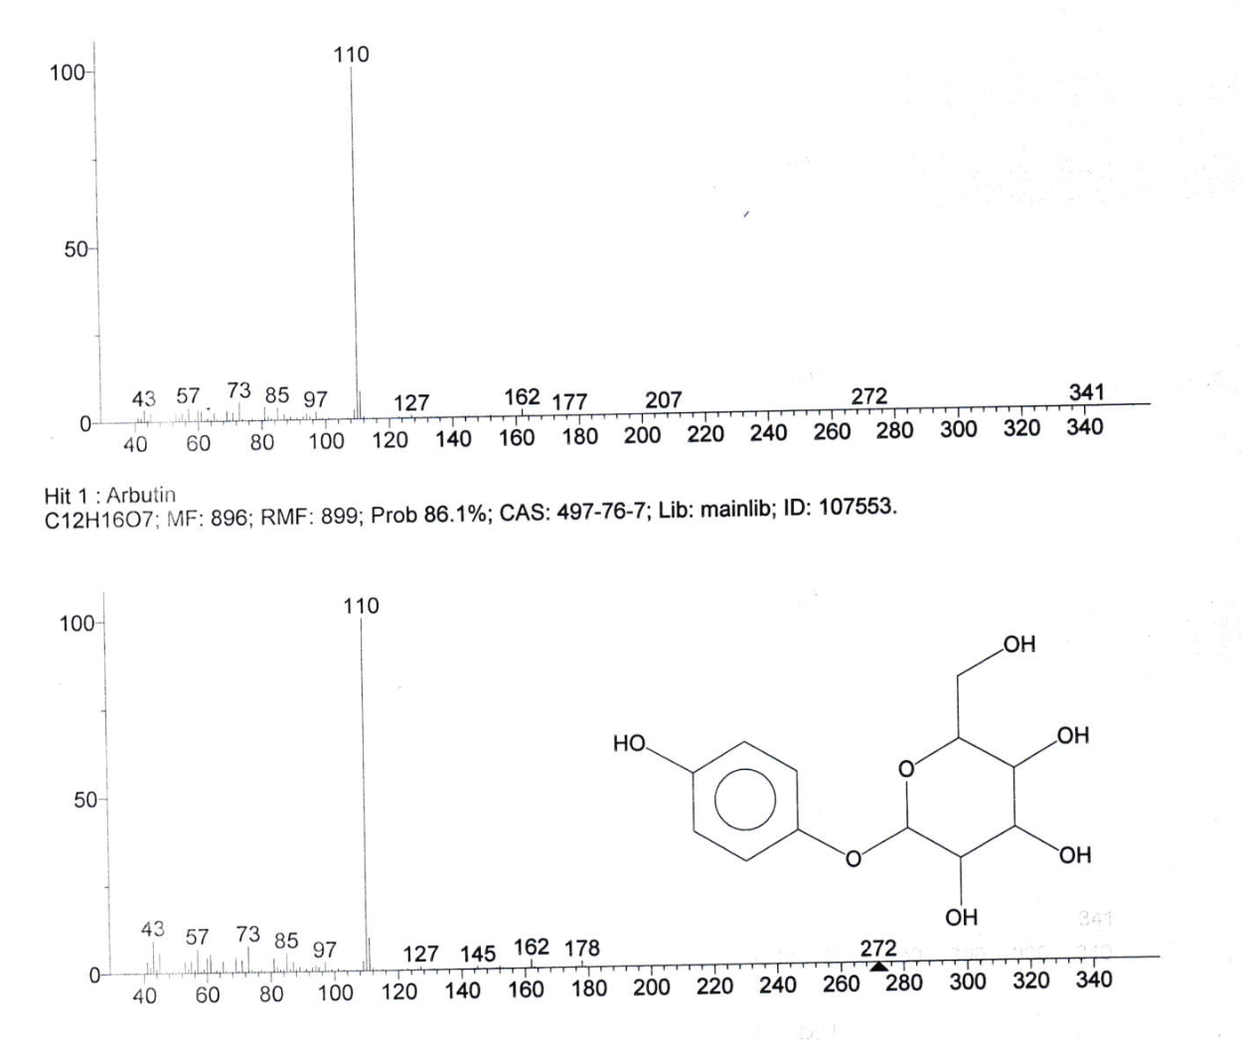

Figure S1: GC-MS identification of the arbutin compound purchased from Macklin, China

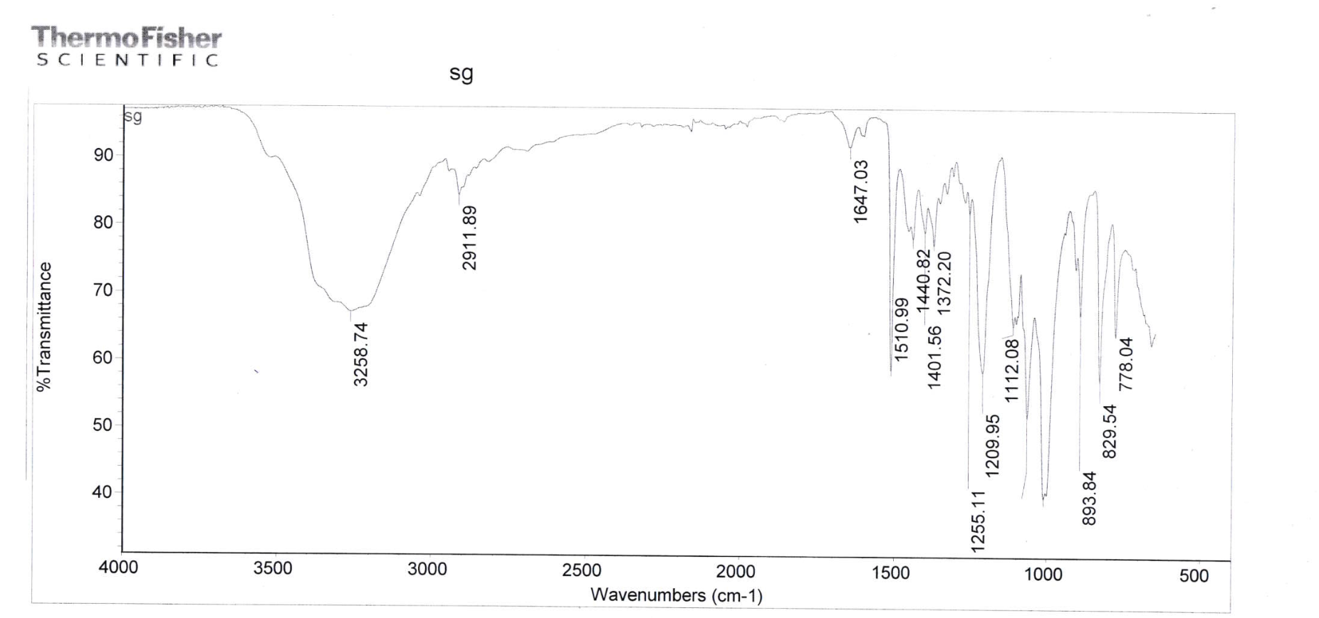

Figure S2: FTIR analysis of the arbutin compound purchased from Macklin, China

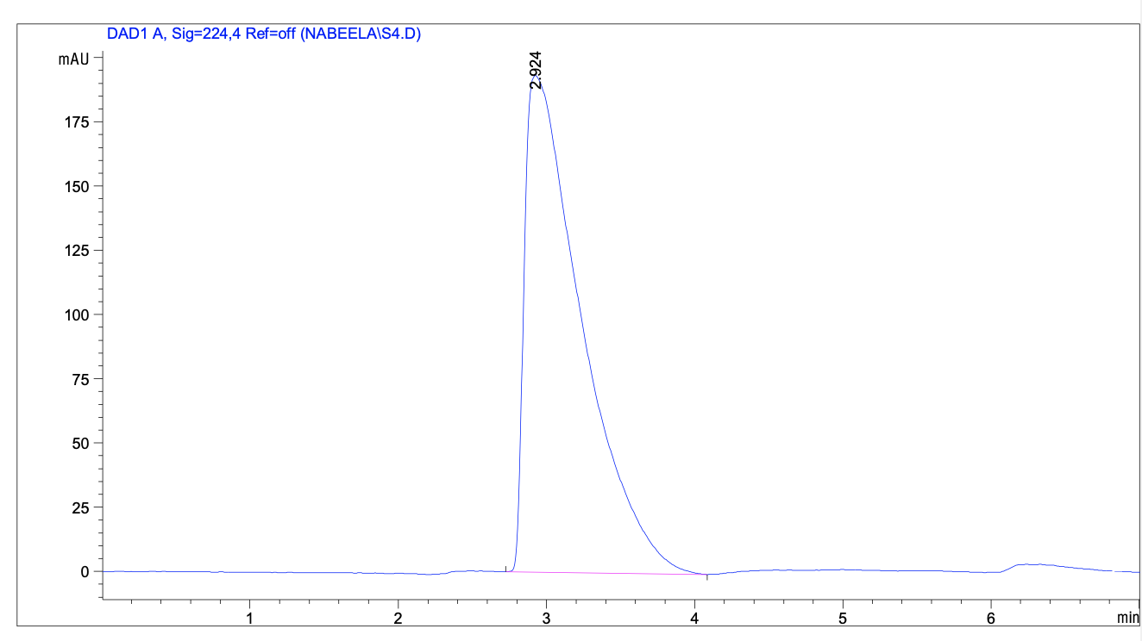
Figure S3: Purity analysis of the arbutin compound by HPLC purchased from Macklin, China

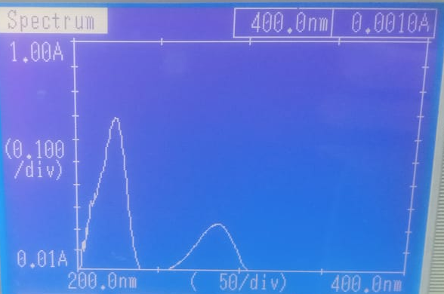

Figure S4: UV analysis of the arbutin compound by purchased from Macklin, China

