Table S1. Material used in molecular phylogenetic analyses and species delimitation tests, with GenBank accession numbers and relevant references. Outgroup specimens marked with asterisk (*). Newly generated sequences marked in bold.

Species | Voucher num. | Locality | COI | 16S | 18S | 28S | H3 | References
Aldisa  sanguinea* | CASIZ182031 | USA: Marin Co., California | MF958435 | MF958311 | MF958350 | MF958394 | - | Hallas J et al. 2017
Aldisa  fragaria* | MB28–004393 | Zavora Bay, Inhambane Province, Mozambique | MF288003 | MF288006 | - | - | MF327389 | Tibiriçá Y et al. 2019
Ardeadoris  egretta | CASIZ191166 | Papua New Guinea | KT600680 | KT595610 | - | KT698764 | - | Matsuda et al. 2018
Ardeadoris  egretta | SAMD19257 | Indonesia: Sulawesi | EF535140 | EF534068 | EF534022 | - | - | Turner et al. 2008
Ardeadoris  scottjohnsoni | CASIZ120939 | USA: Hawaii, Oahu Island, Pupukea | EU982714 | EU982763 | - | KT698766 | - | Johnson et al. 2011
Cadlina aff.  luteomarginata | CASIZ 188599A | Parksville, Vancouver Island, British Columbia | KM219678 | KJ653679 | KP340317 | KP340350 | KM225828 | Hallas J et al. 2015
Cadlinella  ornatissima | CASIZ177420 | Philippines: Maricaban Island, Luzon | MF958415 | MF958284 | MF958325 | MF958371 | - | Hallas et al. 2017
Cadlinella  subornatissima | ZMMU:Op-693 | Japan | - | MN224097 | MN224106 | MN224131 | - | Korshunova et al. 2020
Chromodoris  ambiguus | SAMD19260 | Australia: Port Phillip Bay, VIC | EF535119 | - | EF534038 | - | - | Turner et al. 2008
Chromodoris  celinae | MB28-005098 | Mozambique | MK994116 | MK994178 | - | - | MK994146 | Tibiriçá et al. 2020
Chromodoris  magnifica | SAMD19290 | Australia: Whitsundays, QLD | EF535110 | EF534042 | EF534028 | - | - | Turner et al. 2008
Chromodoris  magnifica | WAMS96183 | Australia: Western Australia Montebello Islands | MG883314 | MG883007 | - | - | MG873292 | Layton et al. 2018  Donohoo et al. 2020
Dendrodoris  atromaculata* | CASIZ181231 | Janao Bay, Luzon, Philippines | MF958434 | MF958307 | MF958348 | MF958392 | MN720315 | Hallas et al. 2017
Doriprismatica atromarginata | CASIZ177237 | Philippines: Batangas, Caban Island | JQ727864 | JQ727746 | - | KT698770 | - | Johnson et al. 2012
Doriprismatica atromarginata | - | Australia, Great Barrier Reef | AF249789 | - | AF249211 | - | - | WollscheidLengeling et al. 2001
Doriprismatica  balut | CASIZ186096 | Philippines | KT600688 | KT595648 | - | KT698822 | - | Matsuda et al. 2018
Doriprismatica  stellata | CASIZ167963 | Papua New Guinea: Nabwageta Island | JQ727880 | JQ727761 | - | KT698781 | - | Johnson et al. 2012
Felimare  bayeri | HP104 | Mexico | KT833257 | KT820520 | - | - | - | Almada et al. 2016
Felimare  tema | CASIZ179384 | Sao Tome and Principe: Principe Island | HM162685 | HM162594 | MF958346 | MF958389 | HM162500 | Pola et al. 2010
Felimare  tricolor | CASIZ175443 | Portugal: Algarve, Islotes do Martinha | JQ727898 | JQ727789 | - | KT698783 | - | Johnson et al. 2012
Felimare  tricolor | CASIZ179386 | Sao Tome and Principe: Principe Island | MK474118 | MK468886 | - | - | MK474154 | Ortigosa et al. 2017
Felimida  binza | MZUCR8352 | Costa Rica | KX262398 | KX262431 | - | KX279323 | - | Padula et al. 2016
Felimida  krohni | MNCN15.05/70697 | Guetaria Bay, Basque Country, Spain (EA) | KJ911277 | KJ911257 | AJ224774 | AY427445 | KJ911237 | Ortigosa et al. 2014  Wollscheid et al. 1999
Felimida  sphoni | MZUCR8146 | Costa Rica | KX279342 | KX279345 | - | KX354952 | KX290856 | Padula V et al. 2016
Gymnodoris  brunnea | CASIZ185968 | Philippines: Luzon: Batangas Province: Balayan Bay, Anilao Pier | KJ396780 | MZ409259 | - | MZ409086 | MZ399401 | Knutson et al. 2022
Gymnodoris  ceylonica | - | UQ, Lizard Island | KY806818 | KY806790 | KY806800 | KY806809 | - | Wilson et al. 2017
Gymnodoris  okinawae | CASIZ189440 | USA: Hawaii: Maui | MZ382655 | MZ409298 | - | MZ409121 | MZ399438 | Knutson et al. 2022
Gymnodoris  striata | CASIZ192277 | Saudi Arabia: Red Sea: Marka Islands | MZ382770 | MZ409418 | - | MZ409230 | MZ399560 | Knutson et al. 2022
Hexabranchus  sanguineus | CASIZ193381 | Papua New Guinea | MF958433 | MF958305 | MF958344 | MF958388 | - | Hallas et al. 2017
Hexabranchus  sanguineus | CPIC00336 | N/A | KP871644 | KP871692 | - | - | KP871668 | Mahguib et al. 2015
Kalinga  ornata | ZMMU:Op-83 | Vietnam | MN224072 | MN224103 | - | MN224136 | - | Korshunova et al. 2020
Kalinga  ornata | CASMB-NB001 | India: Southeast coast | KJ643912 | - | - | - | - | Mohanraj M et al. 2014
Kaloplocamus  ramosus | MNCN:15.05/55473 | Australia: New South Wales, Nelson Bay | JX274104 | JX274066 | - | - | - | Palomar et al. 2014
Kaloplocamus  sp.1 JH-2017 | CASIZ194412 | Madagascar: South Madagascar | MF958429 | MF958299 | MF958337 | MF958383 | - | Hallas et al. 2017
Lecithophorus  capensis | CASIZ 176173 | South Africa: Western Cape Province: False Bay | MZ382782 | MZ409431 | - | MZ409242 | MZ399572 | Knutson et al. 2022
Limacia  mcdonaldi | SCBUCN4608 | Carpinteria, California, USA | KX673494 | KX673500 | - | - | - | Uribe et al. 2018
Limacia  sp.1 MP2010 | CASIZ 176312 | South Africa: Western Cape Province, False Bay | HM162692 | HM162602 | KP340320 | KP340353 | HM162508 | Hallas et al. 2015
Mexichromis  antonii | CASIZ175432 | Costa Rica: Playa Real | EU982748 | EU982800 | - | - | MG645548 | Johnson et al. 2011
Mexichromis  macropus | WAMS12634 | Australia: Dampier, WA | EF535123 | EF534050 | EF534016 | - | - | Turner et al. 2008
Mexichromis  porterae | SIO-BICM11642 | USA: Palos Verdes, CA | EF535139 | EF534067 | EF534014 | - | - | Turner et al. 2008
Nembrotha  cristata | CASIZ191428 | Papua New Guinea: Madang Province | MF958431 | MF958301 | MF958339 | MF958385 | - | Hallas et al. 2017
Nembrotha  kubaryana | CASIZ158256 | Philippines | DQ231007 | - | - | - | - | Pola et al. 2006
Nembrotha  purpureolineata | CASIZ177006 | Mozambique: Inhambane Province | MZ382785 | MZ409434 | - | MZ409245 | MZ399575 | Knutson et al. 2022
Palio  dubia | CASIZ 182030 | USA: Maine: Portland | MZ382786 | MZ409435 | - | MZ409246 | MZ399576 | Knutson et al. 2022
Phyllidia  coelestis* | - | Australia, Great Barrier Reef | - | - | AF249209 | - | - | Wollscheid Lengeling E et al. 2001
Phyllidia  coelestis* | CASIZ 190982 | Kranket Island, Madang Province, Papua New Guinea | MF958412 | MF958279 | - | MF958366 | - | Hallas et al. 2017
Plocamopherus  ceylonicus | CASIZ185147 | USA: Hawaii, Maui, Maalaea Bay | MZ382787 | MZ409436 | - | MZ409247 | MZ399577 | Knutson et al. 2022
Plocamopherus  maderae | MNCN15.05/46735 | Cape Verde Archipelago, Sal Island | EF142905 | EF142951 | - | - | - | Palomar et al. 2014
Plocamopherus  pecoso | CASIZ191587 | Papua New Guinea: Madang Prov. | MF958430 | MF958300 | MF958338 | MF958384 | - | Hallas et al. 2017
Polycera  abei | CAS:IZ 180290 | USA: Hawaii, Maui, Maalaea Bay | MZ382788 | MZ409437 | - | - | MZ399578 | Knutson et al. 2022
Polycera  picta | CAS IZ 190951 | Australia: Queensland, Mooloolaba | MZ382790 | MZ409440 | - | MZ409250 | MZ399581 | Knutson et al. 2022
Polycera  quadrilineata | MNCN:15.05/55463 | Sweden: Gothenborg,  Tjarno | JX274074 | JX274045 | AJ224777 | - | - | Wollscheid et al. 1999  Palomar et al. 2014
Polycera  capensis | CAS:IZ 176206 | South Africa: Western Cape Province, False Bay | MZ382789 | MZ409439 | - | MZ409249 | MZ399580 | Knutson et al. 2022
Polycerella  emertoni | RM3 2285 | Italy: Liguria, La spezia | OP218058 | OP218055 | - | - | OP251346 | Mioni E et al. 2022
Polycerella  emertoni | MNCN150555480 | Spain, Cádiz, Santi Petri | JX274095 | JX274060 | - | - | - | Palomar et al. 2014
Showajidaiidae  segamiensis | ZMMUOp690 | Japan | MN224069 | MN224100 | MN224107 | - | - | Korshunova et al. 2020
Showajidaiidae  segamiensis | ZMMUOp691 | Japan | MN224070 | MN224101 | MN224108 | MN224134 | - | Korshunova et al. 2020
Tambja  stegosauriformis | CASIZ180370 | Brazil: Rio de Janeiro, Ilha do Papagaio | KJ999226 | KJ999206 | - | - | KJ999246 | Pola et al. 2014
Tambja  verconis | MNCN 15.05/46653 | Tasmania: Spring Beach | EF142869 | EF142919 | - | - | - | Pola et al. 2007
Tambja  zulu | CASIZ181519 | South Africa: Kwazulu-Natal | KJ999230 | KJ999210 | - | - | KJ999249 | Pola et al. 2014
Thecacera  pennigera | CASIZ176285 | South Africa, Cape province, Atlantic coast, Oudekraal | JX274094 | JX274059 | - | - | - | Palomar et al. 2014
Thecacera  picta | CASIZ 182281 | N/A | KP871652 | KP871701 | - | - | KP871676 | Mahguib J et al. 2015
Thecacera sp. | CASIZ 182906 | Philippines: Luzon: Batangas Province: Balayan Bay | MZ382795 | MZ409445 | - | MZ409255 | MZ399586 | Knutson et al. 2022
Triopha  catalinae | CASIZ170648 | California: San Francisco, San Francisco Yacht Harbor | HM162690 | HM162600 | KP340321 | KP340354 | HM162506 | Hallas et al. 2015
Triopha  maculata | CASIZ181556 | USA: California, Marin County, Duxbury Reef | HM162691 | HM162601 | - | - | HM162507 | Pola et al. 2010
Triopha  modesta | CASIZ172971 | Sanak Island, Aleutian Islands, AK, USA | MT367420 | MT367447 | - | - | MT458633 | Jung Dae Wui et al. 2020
Tyrinna  delicata | ZSMM20050508 | Chile: Region de Los Lagos | EF535127 | EF534054.2 | EF534035 | - | - | Turner et al. 2008
Tyrinna  evelinae | CASIZ175440 | Costa Rica: Playa Ventana | EU982757 | EU982811 | - | MF958391 | - | Johnson et al. 2011
Vayssierea sp. | CASIZ190731 | Australia: Queensland, Sunshine Coast | MZ382796 | MZ409446 | MF958362 | MF958408 | MZ399587 | Knutson et al. 2022  Hallas et al. 2017
Vayssierea sp. | ZSM Mol 20071333 | Russia: Far Eastern: Primorsky Krai: Vostok Bay, Srednaya Bay | - | KY806799 | KY806808 | KY806817 | - | Wilson et al. 2017
Vayssierea sp. | MCZ 385477 | Australia | X | - | X | X | X | This study
Vayssierea sp. | MCZ 386352 | Japan | X | - | X | X | X | This study
Vayssierea sp. | This study | Aquari de Murcia | X | - | - | - | - | This study
Vayssierea sp. | This study | Confital Beach, North Gran Canaria, Canary Islands, Spain | X | - | X | X | X | This study
Vayssierea sp. | This study | El Faro Beach, South Gran Canaria, Canary Islands, Spain | X | X | X | X | X | This study

Table S2. PCR primers and conditions used for all sequenced genes.
Name | 5’ → 3’ | References | PCR conditions
LCO1490 | GGTCAACAAATCATAAAGATATTGG | Folmer et al. 1994 | 94°C 5min, 40× (94°C 30s, 46-50°C 15s, 72°C 30s), 72°C 5min
HCO2198 | TAAACTTCAGGGTGACCAAAAAATCA | Folmer et al. 1994 | 94°C 5min, 40× (94°C 30s, 46-50°C 15s, 72°C 30s), 72°C 5min
16S ar-L | CGCCTGTTTAACAAAAACAT | Palumbi et al. 2002 | 95°C 15min, 40× (94°C 30s, 50°C 90s, 72°C 90s), 72°C 10min
16S R | CCGRTYTGAACTCAGCTCACG | Puslednik and Serb, 2008 | 95°C 15min, 40× (94°C 30s, 50°C 90s, 72°C 90s), 72°C 10min
H3AD5’3’ | ATGGCTCGTACCAAGCAGAC(ACG)GC | Colgan et al. 1998 | 94°C 3min, 35× (94°C 35s, 52°C 60s, 72°C 15s), 72°C 2min
H3BD5’3’ | ATATCCTT(AG)GGCAT(AG)AT(AG)GTGAC | Colgan et al. 1998 | 94°C 3min, 35× (94°C 35s, 52°C 60s, 72°C 15s), 72°C 2min
28S C1 | ACCCGCTGAATTTAAGCAT | Dayrat et al. 2001 | 94°C 5min, 35× (94°C 45s, 52°C 45s, 72°C 2min), 72°C 10min
28S C2 | TGAACTCTCTCTTCAAAGTTCTTTTC | Lê et al. 1993 | 94°C 5min, 35× (94°C 45s, 52°C 45s, 72°C 2min), 72°C 10min
18S 1F | TACCTGGTTGATCCTGCCAGTAG | Giribet et al. 1996 | 95°C 2min, 35× (95°C 30s, 47°C 30s, 72°C 3min), 72°C 5min
18S 4R | GAATTACCGCGGCTGCTGG | Giribet et al. 1996 | 95°C 2min, 35× (95°C 30s, 47°C 30s, 72°C 3min), 72°C 5min
18S 3F | GTTCGATTCCGGAGAGGGA | Okuzu et al. 2003 | 95°C 2min, 35× (95°C 30s, 54°C 30s, 72°C 3min), 72°C 5min
18S bi | GAGTCTCGTTCGTTATCGGA | Okuzu et al. 2003 | 95°C 2min, 35× (95°C 30s, 54°C 30s, 72°C 3min), 72°C 5min
18S a2.0 | ATGGTTGCAAAGCTGAAAC | Giribet et al. 1996 | 95°C 2min, 35× (95°C 30s, 47°C 30s, 72°C 3min), 72°C 5min
18S 9R | GATCCTTCCGCAGGTTCACCTAC | Giribet et al. 1996 | 95°C 2min, 35× (95°C 30s, 47°C 30s, 72°C 3min), 72°C 5min

Figure S1. Results from Species Delimitation Test (ASAP) for both COI and 16S genes of the alignment of the species of Vayssierea genus based on the results of the phylogenetic tree.
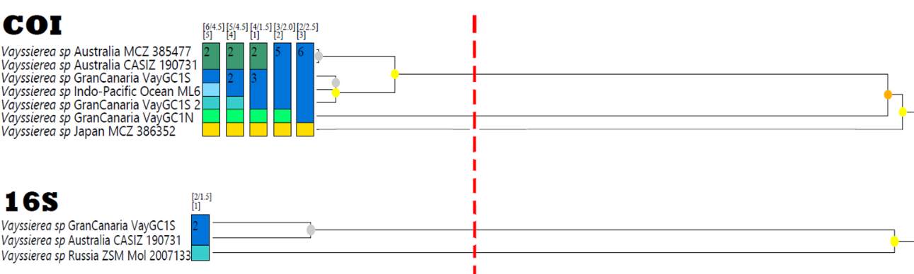
Figure S2. Distribution map of the genus Vayssierea including the locality of all sequenced individuals represented in the phylogenetic tree. Dots indicate individuals and colors indicate different species according to the ASAP analysis: green for the first species, blue for the second species, orange for the third and red for the fourth. The pink dots represent the individuals from La Palma and Lanzarote. Type species location represented with yellow stars (1. Vayssierea caledonica 2. Vayssierea cinnabarea 3. Vayssierea elegans 4. Vayssierea felis). Generated with https://www.simplemappr.net and edited in Adobe Photoshop.
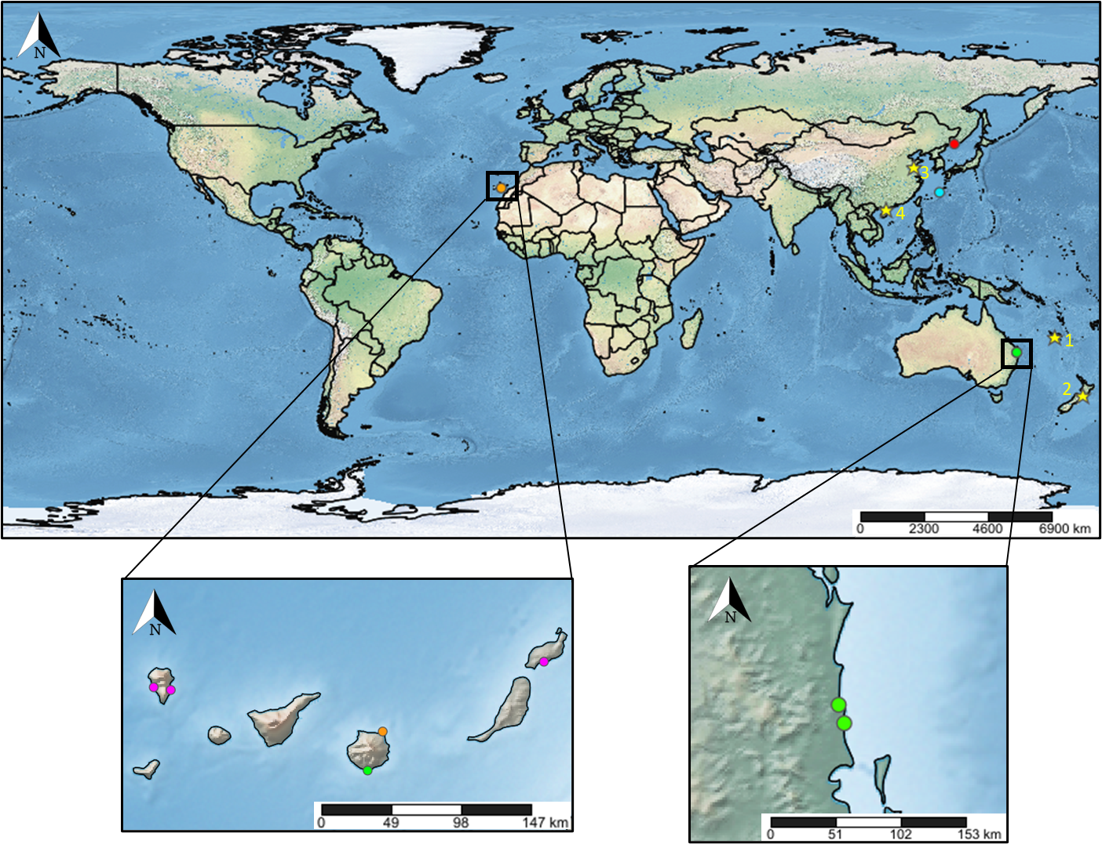

Figure S3. Maximum likelihood tree for Polyceridae based on the COI marker (658 bp). Bootstrap support values are shown on branches. The outgroups used to root the tree were Dendrodorididae and Phyllidiidae. Scale bar indicates substations per site.
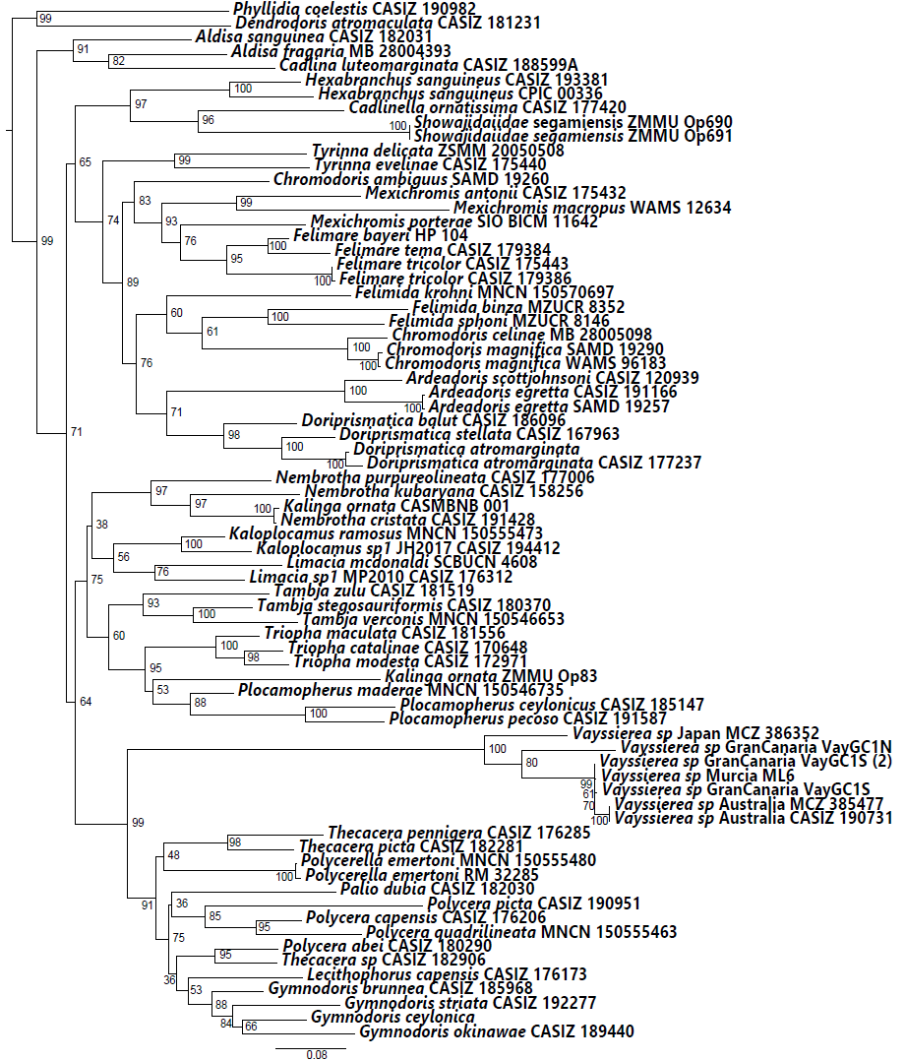

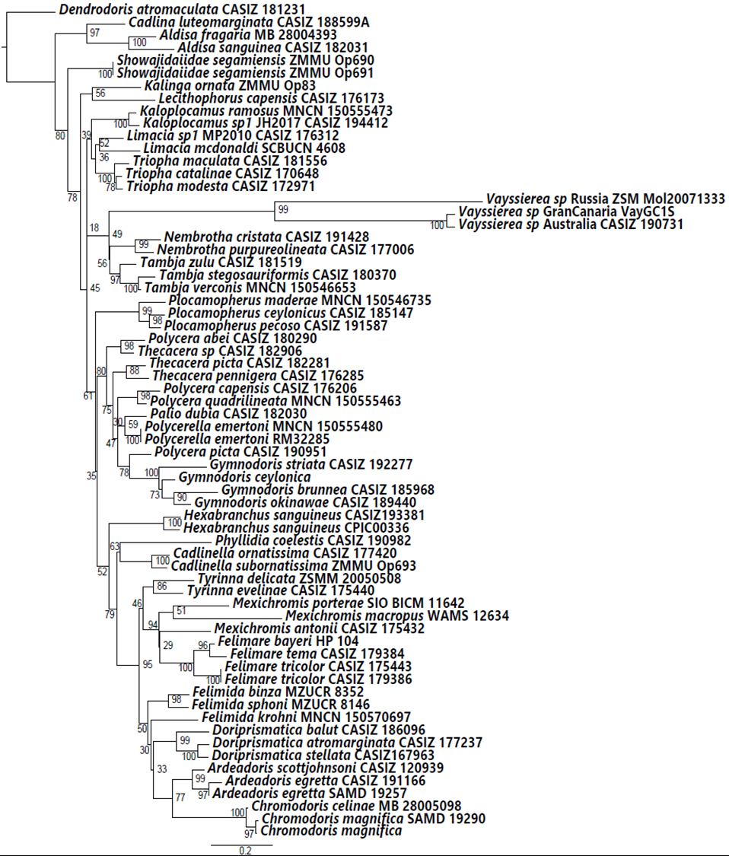
Figure S4. Maximum likelihood tree for Polyceridae based on the 16S marker (507 bp). Bootstrap support values are shown on branches. The outgroup used to root the tree was Dendrodorididae. Scale bar indicates substations per site.

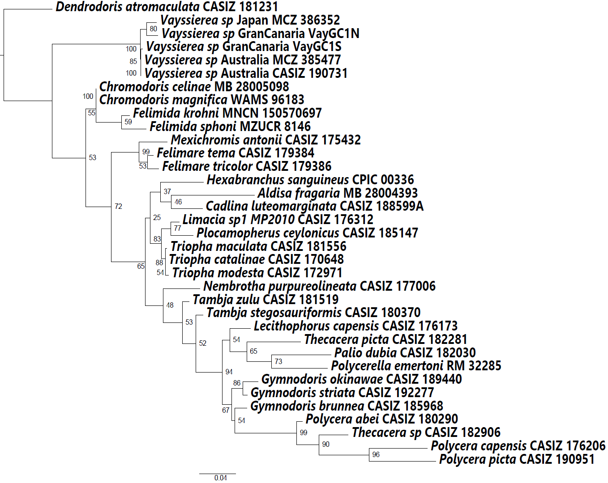
Figure S5. Maximum likelihood tree for Polyceridae based on the H3 marker (328 bp). Bootstrap support values are shown on branches. The outgroup used to root the tree was Dendrodorididae. Scale bar indicates substations per site.

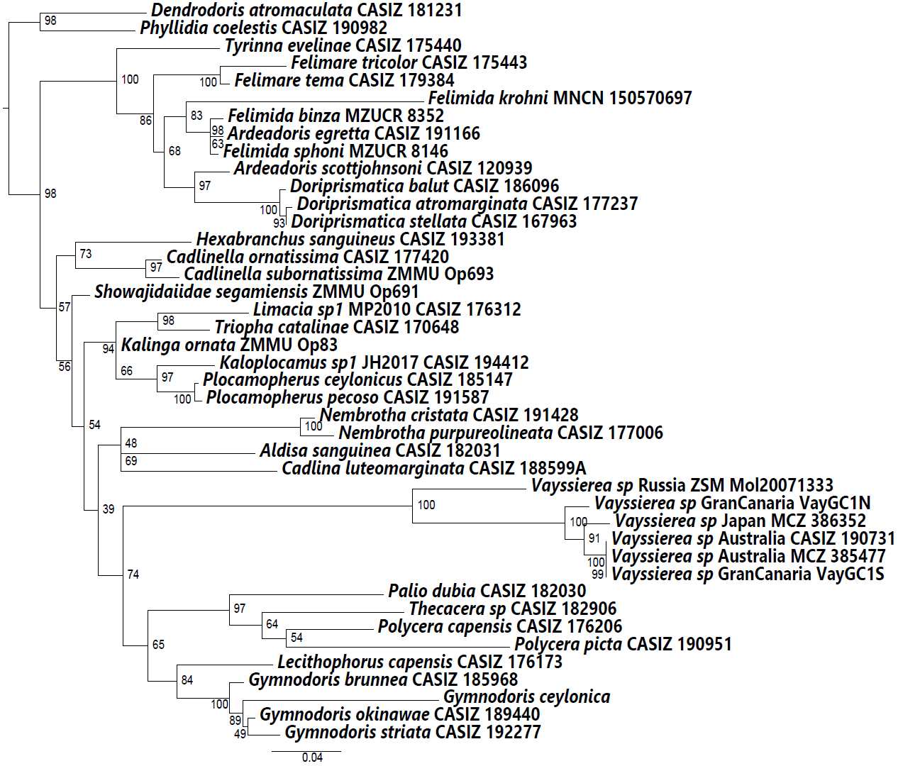
Figure S6. Maximum likelihood tree for Polyceridae based on the 28S marker (1082 bp). Bootstrap support values are shown on branches. The outgroups used to root the tree were Dendrodorididae and Phyllidiidae. Scale bar indicates substations per site.

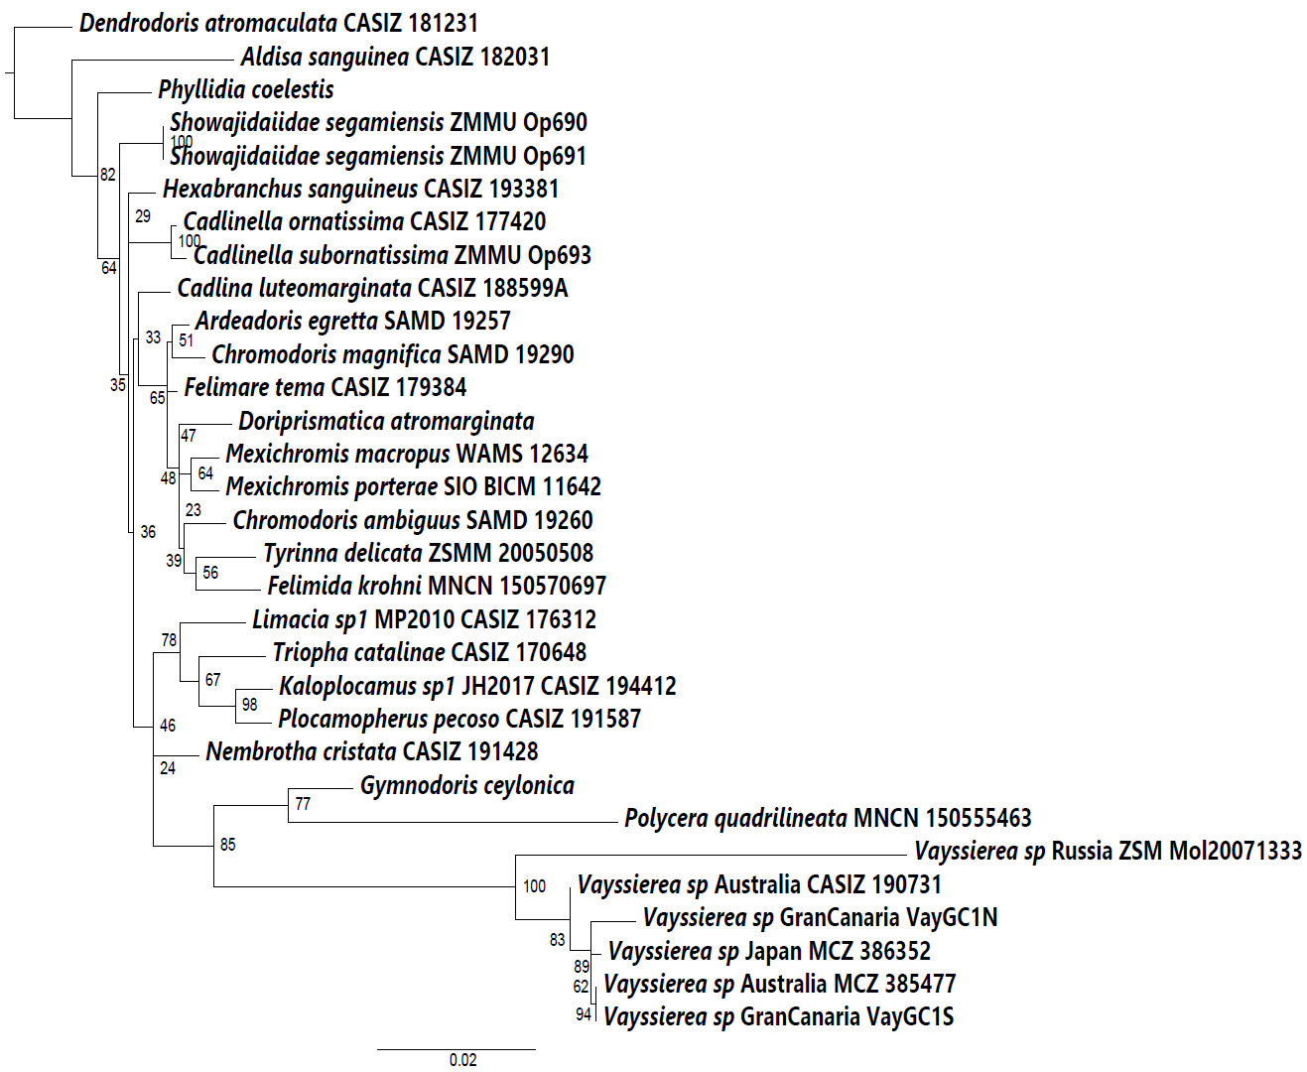
Figure S7. Maximum likelihood tree for Polyceridae based on the 18S marker (1941 bp). Bootstrap support values are shown on branches. The outgroup used to root the tree was Dendrodorididae. Scale bar indicates substations per site.

