Additional figures and tables

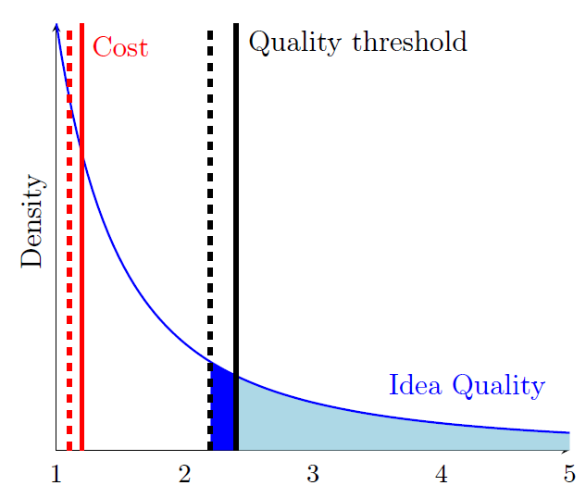

Fig. S1.
Visual representation of innovation production. Innovators draw ideas from a Pareto idea quality distribution (the blue line). The idea quality provides a signal about the value of the innovation that might result from the idea. To pursue an idea, the innovator incurs a cost (red vertical line). Only ideas for which the quality is high enough are pursued (solid black line). Prior to the subsidy, all ideas in the light-blue-shaded area are pursued. The subsidy pushes down the cost, and therefore the idea quality threshold (now the dotted black line), resulting in additional ideas being pursued into innovations (ideas in the the dark-blue-shaded area). The returns to the subsidy are determined by the total cost of the subsidy (which scales with the cost threshold of the field), the mass of ideas present below the quality threshold (which depends on the shape parameter of the Pareto distribution), and the expected spillover value those ideas generate (which is approximated by the spillovers created by observed innovations of relatively small private value).

(A) Semiconductors (B) Organic fine chemistry

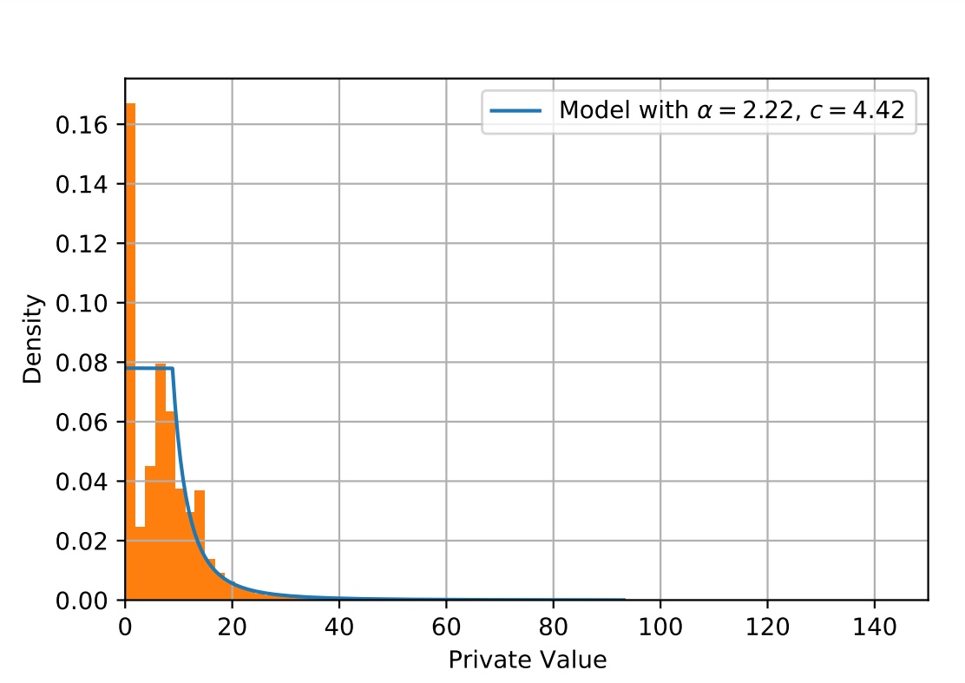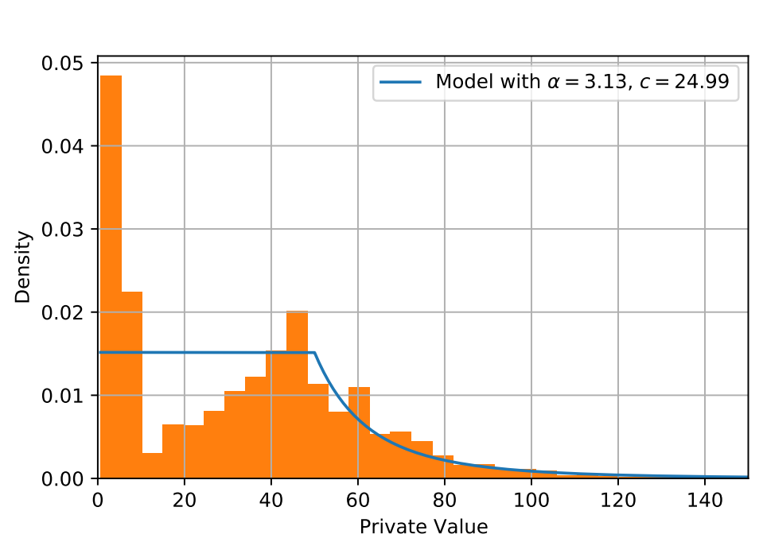

Fig. S2.
Comparison of actual and modeled private value distributions for the two fields with the lowest (A) and highest (B) estimated cost. The histogram plots the actual private value distribution in the field, and the blue line shows the modeled density. Cost ($c$) and alpha ($α$) are estimated for each field (41) and year (10) combination. Plotted examples are based on the year 2010.

(A) Global SV
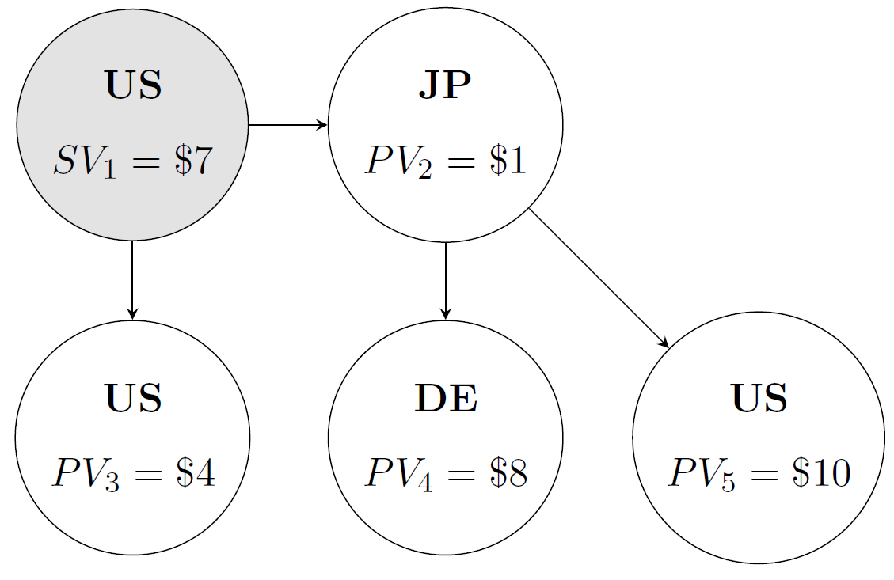
(B) Local SV
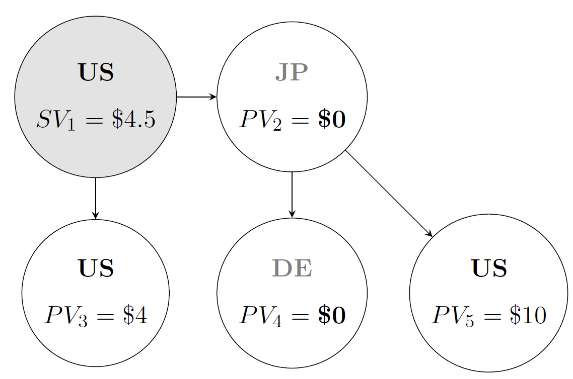

Fig. S3.
Illustration of the calculation of knowledge spillovers. Circles represent patented innovations, country codes indicate the country of the patent's inventors. Lines represent citations between patent families. The global spillover value of a particular innovation (upper figure) is calculated by summing its private value and the value of the spillovers it creates (see also equation (2)). Let us calculate $SV_{1}=PV_{1}+SV_{1}$. We need to consider the innovations that cite 1, which are innovations 2 (from Japan) and 3 (from the US). As per equation (2), $SV_{1}=σ\left(V_{2}+V_{3}\right)$, because $N_{2}=N_{3}=1$ (each citing innovation only cites innovation 1). As innovation 3 is not cited, we have $V_{3}=PV_{3}=\$4$. Innovation 2 is cited by innovations 4 and 5, so $V_{2}=σ\left(V_{4}+V_{5}\right)$, recognizing again that $N_{4}=N_{5}=1$. As both innovations 4 and 5 are not cited, we have that $V_{4}=PV_{4}=\$8$ and $V_{5}=PV_{5}=\$10$. Now we see that $SV_{1}=σ\left(PV_{3}+PV_{2}\right)+σ^{2}\left(PV_{4}+PV_{5}\right)=0.5\left(4+1\right)+{0.5}^{2}\left(8+10\right)=\$7$. To calculate local $SV_{1}$, we simply set all private values of innovations from foreign countries (non-US in this case) to zero, and repeat this calculation to see that $SV_{1}=σ\left(PV_{3}+PV_{2}\right)+σ^{2}\left(PV_{4}+PV_{5}\right)=0.5\left(4+0\right)+{0.5}^{2}\left(0+10\right)=\$4.5$.

(A) SV to Japan
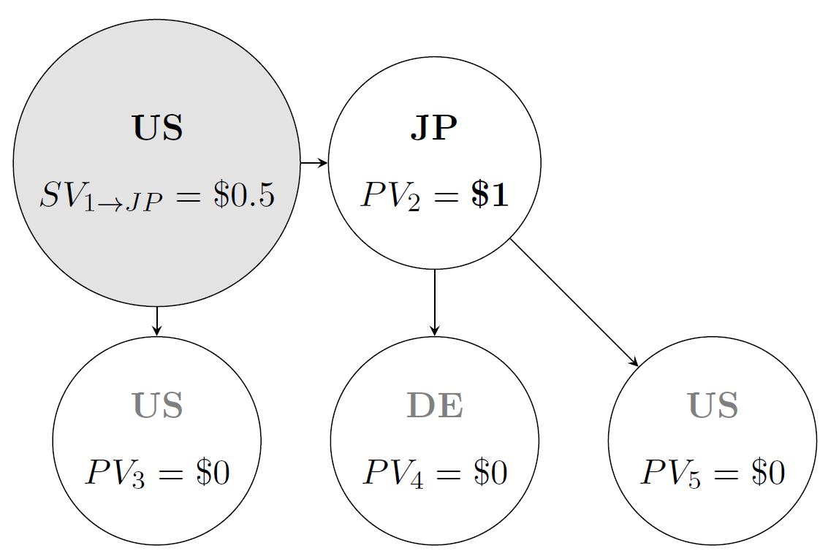
(B) SV to Germany
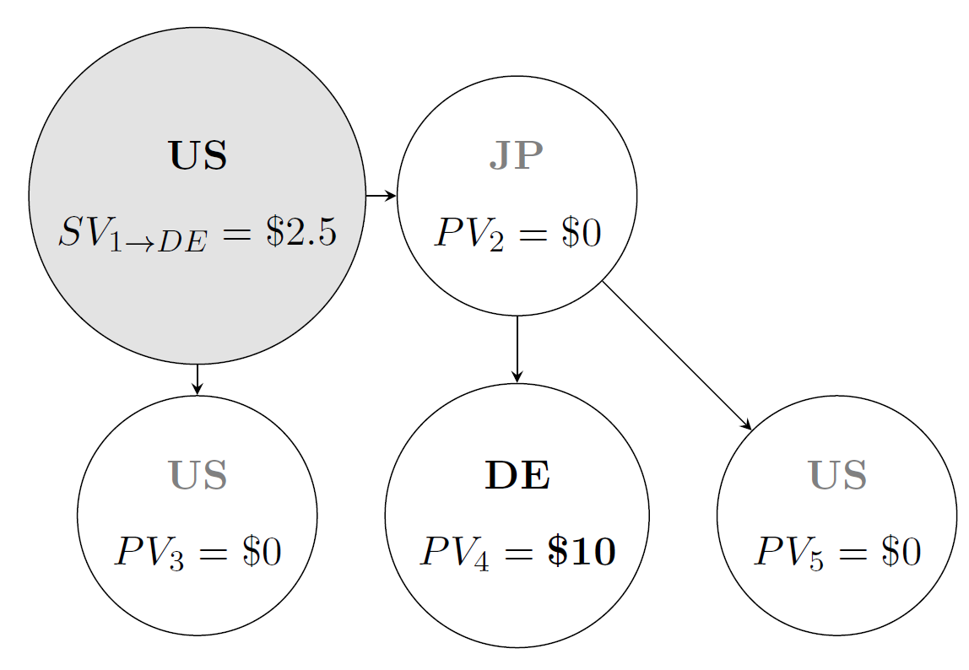

Fig. S4.
Illustration of the calculation of between-country knowledge spillovers. The spillover network is identical to the one in Figure S3. Circles represent patented innovations, country codes indicate the country of the patent's inventors. Lines represent citations between patent families. To calculate the spillover of innovation 1 to Japan, we simply set all private values of innovations that are not from Japan to zero (upper panel), and repeat our spillover value calculation. We see that $SV_{1→JP}=σ\left(PV_{3}+PV_{2}\right)+σ^{2}\left(PV_{4}+PV_{5}\right)=0.5\left(0+1\right)+{0.5}^{2}\left(0+0\right)=\$0.5$. Similarly, to calculate the spillover of innovation 1 to Germany, we set all private values of non-German innovations to zero, and adapt our calculation accordingly: $SV_{1→DE}=σ\left(PV_{3}+PV_{2}\right)+σ^{2}\left(PV_{4}+PV_{5}\right)=0.5\left(0+0\right)+{0.5}^{2}\left(10+0\right)=\$2.5$. Once we have calculated the spillover flows to a given country for all innovations in the sample, we can sum up over the relevant innovations to calculate total spillover value flows between the countries of interest.

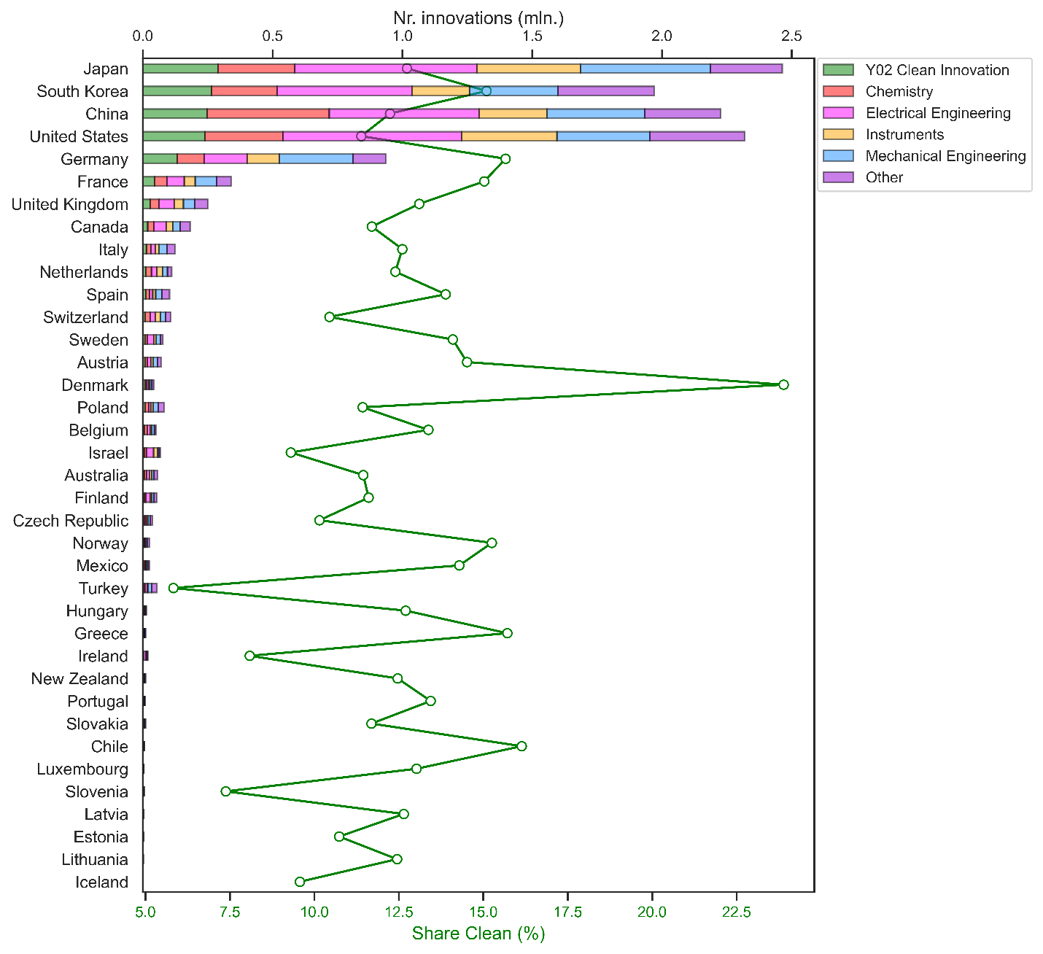

Fig. S5.
Innovation counts by country across six technology sectors (ordered by the number of Clean innovations). Stacked bars, matching the upper x-axis, display counts in millions, using 'full counting' for multi-sector or multi-country innovations. Green circles, aligning with the lower x-axis, represent each country's share of clean innovations.

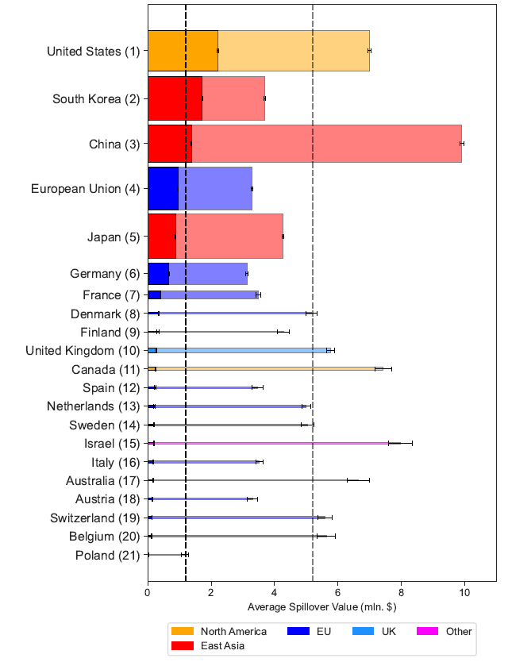

Fig. S6.
Average spillover value by country (y-axis) along with 95\% confidence bands. The (vertical) width of a bar scales with the number of clean innovations in the country. The x-axis displays the average local (dark-shaded bars) and global (light-shaded bars) spillover value of clean innovations in the country. It is the average $SV_{i}$ over all clean innovation in a country (expressed in millions of 2015 US dollars) as calculated in Figure S3.

Fig. S7. Clean Subsidy Advantage (CSA) by country – Global returns. Clean Subsidy Advantage by country (y-axis). The (vertical) width of a bar scales with the number of clean innovations in the country. All countries in our sample with at least 2000 clean innovations are included. The Clean Subsidy Advantage for a country (on the x-axis) is calculated by dividing the global return rate from an extra subsidy in Clean by the weighted average global return rate across all country innovations. We then subtract one and multiply by 100% (it corresponds, for each country, to the height of the green bar, divided by the dotted line in Figure 1).

 | Obs. | Mean | S.D. | Min. | 25th pct. | 50th pct. | 75th pct. | Max.
Innovations
PV | 7017805 | 17.44 | 20.24 | 0 | 2.62 | 12.83 | 23.57 | 590.05
SV | 7017805 | 5.09 | 13.94 | 0 | 0 | 0.64 | 4.9 | 3236.8
Fields
PV | 39 | 19.6 | 6.76 | 9.86 | 14.7 | 18.59 | 22.2 | 40.41
SV | 39 | 5.62 | 2.11 | 2.39 | 3.74 | 5.48 | 7.26 | 10.24
α | 39 | 2.9 | 0.53 | 2.11 | 2.52 | 2.79 | 3.23 | 4.52
c | 39 | 13.61 | 2.36 | 8.85 | 11.84 | 13.32 | 14.71 | 20.17
Field-years
PV | 390 | 20.34 | 8.84 | 6.15 | 14.16 | 18.6 | 24.21 | 56.55
SV | 390 | 5.34 | 4.6 | 0.04 | 1.61 | 4.32 | 8.08 | 25.6
α | 390 | 2.93 | 0.96 | 1.48 | 2.4 | 2.71 | 3.17 | 8.5
c | 390 | 14.05 | 4.52 | 5.54 | 10.7 | 13.14 | 17 | 29.33

Table S1. Summary Statistics
Descriptive statistics of key parameters that determine subsidy return rates. The upper panel is at the level of the innovation, the middle panel at the level of the technology fields used for the estimation of $c$ and $α$, the lower panel at the level of field-year combinations. $PV$, $SV$, and $c$ are expressed in millions of 2015 US dollars.

Sub-technology | Patent Codes | Confidence
Component  • Scale-up  • Deployment  • Link to CCUS  • Renewable hydrogen | Y02E 50/00: Technologies for the production of fuel of nonfossil origin Biofuels, e.g. bio-diesel; Fuel from waste, e.g. synthetic alcohol or diesel | High
Gasifier  • Feedstock  • Gasifier  • Syngas cleanup | C10J2300/0916: Details of gasification process, Biomass | High
BioH2 and Bio-SNG  • Water-Gas Shift (WGS) Reaction | C12M21/04: Bioreactors or fermenters for producing gas, e.g. biogas. | Medium
Fischer-Tropsch Synthesis  • FT Catalyst  • FT reactor  • Upgrading | C10G2300/1022: Aspects relating to hydrocarbon processing covered by groups: Feedstock Materials → Fischer-Tropsch products  C01B2203/062: Integrated processes for the production of hydrogen or synthesis gas (Hydrocarbon production e.g. Fischer-Tropsch process) | High
Syngas to Methanol  • Overall Process | C01B2203/061: Integrated processes for the production of hydrogen or synthesis gas (Methanol production) | High
Woody & Grassy Energy Crops -SRC &  Miscanthus  • Breeding & Crop R&D  • Growing and harvesting, improving  agronomics | A01C7/00: Sowing Seeds  A01C 15/00: Fertiliser Distribution  A01C 17/00: Fertisliser or seeders with centrifugal wheels  A01C 19/00: Arrangements for driving working parts of fertilisers or seeders  A01C 21/00: Methods of fertilising  A01D45/30: Harvesting of standing crops (of grass-seeds or like seeds).  A01H1/12: Processes for modifying genotypes → Processes for modifying agronomic input traits, (e.g. crop yield, drought, cold, pest resistence)  Y02A 40/10 | Medium
Novel Oil Crops  • Breeding & Crop R&D  • Growing and harvesting, improving  agronomics | C11B1/00: Production of fats or fatty oils from raw materials (under head of vegitable oils). | High
Lignocellulosic feedstock pre-treatment &  hydrolysis  • Pre-treatment  • Hydrolysis | C12P2201/00: Pretreatment of cellulosic or lignocellulosic material for subsequent enzymatic treatment or hydrolysis  C08H8/00: Macromolecular compounds derived from lignocellulosic materials | High
Lignocellulosic ethanol  • Overall process | C12P7/10: Preparation of Ethanol substrate containing cellulosic material | High
Syngas fermentation  • Pre-treatment  • Reactor  • Bacteria | C12M21/04: Bioreactors or fermenters specially adapted or producing gas, e.g. biogas  C10L3/08: Production of synthetic natural gas  C10L3/10: Working-up natural gas or synthetic natural gas | High
Feedstock Pre-treatment  • Pre-treatment | C10G2300/10: Feedstock materials (covers: waste, vegetal biomass, animal biomass, natural gas, gas hydrates, hydrocarbon fractions, Fischer-Tropsch etc)  Y02P20/145: Feedstock of biological origin | Medium
Digestion | C12M21/04: Bioreactors or fermenters specially adapted or producing gas, e.g. biogas | Medium

Table S2. Biomass & Bioenergy Patent Codes
Academic benchmark used for this subfield: Johnstone et al. (44)
Sub-technology | Patent Codes | Confidence
Pre-Construction and Design  • New Build and Existing  • New Build | Y02B10/00: Integration of renewable energy sources in buildings. | High
Materials and Components  • New Build  • (Some retrofits)  • New Build and Existing | F24S: Solar Heat Collectors  E06B3/24: Double Glazing  E06B3/20: Vinyl wind frame  E06B1/325: Thermal Break between Frames  E04B1/74: Insulation materials  E04B1/76: Heat insulation only  E04F15/18: Floor Insulation  E04D13/16: Roof Insulation  F16L59/00: Thermal insulation of pipes  F21Y2115/10: LEDs | High
Build Process  • New Build and Existing | Y02B80/00: Architectural or constructional elements improving the thermal performance of buildings | High
Building Operation  • New Build and Existing | Y02B90/00: Enabling technologies or technologies with a potential or indirect contribution to GHG emissions mitigation (Fuel cells in buildings & Smart Grids for buildings) | High
All  • New Build and Existing | Y02B: climate change mitigation technologies related to buildings, e.g. housing, house appliances or related enduser applications | High

Table S3. Building Fabric Patent Codes
Academic benchmark used for this subfield: Noailly (45)

Sub-technology | Patent Codes | Confidence
Power  • Gas post-combustion capture  • Gas pre-combustion capture  • Gas Oxy-combustion capture  • Solid fuel Post- combustion capture  • Solid fuel Pre-combustion capture  • Solid fuel Oxy-combustion  • CO2 Storage: Infrastructure & injection  wells | Y02C20/00: Capture or disposal of greenhouse gases  B01D53/00: Separation of gases or vapours; Recovering vapours of volatile solvents from gases; Chemical or biological purification of waste gases, e.g. engine exhaust gases, smoke, fumes, flue gases, aerosols  Y02E20/18: Integrated gasification combined cycle [IGCC], e.g. combined with carbon capture and storage [CCS] Covered by Y02C20/00  Y02P90/70: Combining sequestration of CO2 and exploitation of hydrocarbons by injecting CO2 or carbonated water in oil wells | High
Industry  • Cement  • Chemicals  • Iron & steel  • Refining  • Cross-cutting | Y02P40/18: Production of cement - Carbon capture and storage  Y02P20/151: Technologies relating to chemical industry - Reduction of GHG emissions e.g. CO2  Y02P10/122: Technologies relating to metal processing – by capturing or storing CO2  B01D53/00: Separation of gases or vapours; Recovering vapours of volatile solvents from gases; Chemical or biological purification of waste gases, e.g. engine exhaust gases, smoke, fumes, flue gases, aerosols,  Y02P70/10: Final consumer goods - Greenhouse gas capture. | High

Table S4. Carbon Capture, Use & Storage Patent Codes
Academic benchmark used for this subfield: Sharifzadeh et al. (46)

Sub-technology | Patent Codes | Confidence
Heat pumps  • Heat source  • System  • Installation  • Integration  • O&M  • Installation | F25B30/00: Heat Pumps | High
Heat networks  • Design  • Installation  • Connection to heat user  • Interface with heat user | Y02B30/00: Energy efficient heating, ventilation or air conditioning [HVAC]  Y02A30/27: Relating to heating, ventilation or air conditioning [HVAC] technologies  C09K5/00: Heat-transfer, heat-exchange or heat-storage materials, e.g. refrigerants; Materials for the production of heat or cold by chemical reactions other than by combustion | High
Heat storage  • Heat source & sink  • Heat store | F24S: Solar Heat Collectors  Y02E60/14: Thermal energy storage  F24H7/00: Storage heaters, i.e. heaters in which energy is  stored as heat in masses for subsequent release | High
Cooling  • Main Unit  • System  • Design  • Control  • O&M  • Storage | F24F: air-conditioning; air-humidification; ventilation; use of air currents for screening  F25B: refrigeration machines, plants or systems; combined heating and refrigeration systems; heat-pump systems | High

Table S5. Heating & Cooling Patent Codes
Academic benchmark used for this subfield: Renaldi et al. (47)

Sub-technology | Patent Codes | Confidence
Natural Gas Reforming  • Integration with CCS  • Reformer  • Water-gas shift reactor  • Reformer | Y02E60/30: Hydrogen Technology, Storage & Distribution  C01B2203/02: Processes for making hydrogen or synthesis gas (reforming & partial oxidation)  C01B3/00: Hydrogen; Gaseous mixtures containing hydrogen; Separation of hydrogen from mixtures containing it | High
Coal Gasification  • Integration with CCS  • Gasifier + Gas Purification Unit  • Gasifier  • Air Separation Unit (ASU) | C10J3/00: Production of combustible gases containing carbon monoxide from solid carbonaceous fuels | High
Electrolysis  • Manufacturing  • Cell  • Cell  • Purification Equipment  • Purification Equipment  • System Integration  • Other Routes  • Other Applications  • Modelling | C25B1/02: Electrolytic production of inorganic compounds or non-metals > Hydrogen or oxygen > by electrolysis of water  Y02E60/36 (Covered by Y02E60/30): Hydrogen production from non-carbon containing sources, e.g. by water electrolysis  C25B11/00: Electrodes; Manufacture thereof not otherwise provided for | High
Delivery  • Pressure Levels  • Safety  • Pipelines  • Tube Trailers  • Compression  • Liquefaction Process  • Alternative Carriers  • Odorants  • Sensors | F25J1/00: Processes or apparatus for liquefying or solidifying gases or gaseous mixtures  Y02E60/34 (covered by Y02E60/30): Hydrogen Distribution  F17C5/02: Methods or apparatus for filling containers with liquefied, solidified, or compressed gases under pressures > for filling with liquefied gases e.g. helium or hydrogen | High
Storage  • Alternative Hydrogen Storage  • Alternative Hydrogen Storage  • Cavern Topside Facility  • Underground Storage | Y02E60/32 (Covered by Y02E60/30): Hydrogen Storage | High
Refuelling Stations  • Purification  • Unloading Equipment  • Verification  • Design  • Standardisation | C01B3/50: Separation of hydrogen or hydrogen containing gases from gaseous mixtures, e.g. purification | High
Fuel cells  • Manufacturing  • Manufacturing  • SOFC  • SOFC  • PEMFC  • PEMFC  • Design  • Grid Services | H01M8/00: Fuel cells; Manufacture thereof  Y02E60/50 (Covered by Y02E60/30): Fuel cells | High

Table S6. Hydrogen Patent Codes
Academic benchmark used for this subfield: Baumann et al. (48)

Sub-technology | Patent Codes | Confidence
Chemicals  • Efficiency improvements  • Low-carbon substitutes  • Heat recovery and reuse  • Recovery and recycling  • Energy systems  • Alternative process technologies  • Clustering | Y02P20/00: Chemical Industry, includes: Process Efficiency,  Feedstocks, Reduction of GHG emissions, Energy Recovery, Recycling catalysts/materials | High
Food & drink  • Efficiency improvements  • Low-carbon substitutes  • Heat recovery and reuse  • Recovery and recycling  • Energy systems  • Alternative process technologies  • Clustering | Y02P80/00: Climate change mitigation technologies for sector-wide applications (note: not specific to food & Drink, but relevant for all sectors hence included) | High
Iron & steel  • Efficiency improvements  • Low-carbon substitutes  • Heat recovery and reuse  • Recovery and recycling  • Energy systems  • Alternative process technologies  • Clustering | Y02P10/00: Technologies related to metal processing: Reduction in GHGs, using alternative fuels, using renewables, recycling, process efficiency | High
Cement  • Efficiency improvements  • Low-carbon substitutes  • Heat recovery and reuse  • Recovery and recycling  • Energy systems  • Alternative process technologies  • Clustering | Y02P40/10: Production of Cement: energy efficiency, Fuels from renewables, CCS, Optimizing production methods | High
Pulp & paper  • Efficiency improvements  • Low-carbon substitutes  • Heat recovery and reuse  • Recovery and recycling  • Energy systems  • Alternative process technologies  • Clustering | D21: paper-making; production of cellulose | Medium
Glass  • Efficiency improvements  • Low-carbon substitutes  • Heat recovery and reuse  • Recovery and recycling  • Energy systems  • Alternative process technologies  • Clustering | Y02P40/50: Glass production, e.g. reusing waste heat during processing or shaping; improving yield and rejection rates | High
Ceramics  • Efficiency improvements  • Low-carbon substitutes  • Heat recovery and reuse  • Recovery and recycling  • Energy systems  • Alternative process technologies  • Clustering | Y02P40/60: Production of ceramic materials or ceramic elements, e.g. substitution of clay or shale by alternative raw materials, e.g. ashes | High

Table S7. Industrial Clean Innovation Patent Codes
No academic benchmark was found for this sub-field.

Sub-technology | Patent Codes | Confidence
Mining, Processing, Enriching, Fabricating | Y02E30/00: Energy Generation of Nuclear Origin, G21: NUCLEAR PHYSICS; NUCLEAR ENGINEERING | High
CAPEX – Components and systems | Covered by G21: Additive manufacturing technology, B33Y | High
CAPEX – Construction and materials | Covered by G21 | High
CAPEX – Construction installation and  commissioning | Covered by G21 | Medium
Operations and Maintenance | Covered by G21 | Medium
Decommissioning | Covered by G21 | Medium
Waste Management | Covered by G21 | High
Regulatory | Covered by G21 | Medium

Table S8. Nuclear Fission Patent Codes
No academic benchmark was found for this sub-field.

Sub-technology | Patent Codes | Confidence
Floating wind  • Moorings  • Floating Foundations  • Dynamic Cables | B63B 21/00: Tying-up; Shifting, towing, or pushing equipment; Anchoring  B63B 2035/446: Floating structures carrying electric power plants for converting wind energy into electric energy  H01B7/12: Floating cables  H01B7/045: Flexible cables, conductors, or cords, e.g. trailing cables attached to marine objects e.g. buoys, diving equipment, aquatic probes, marine towline | High
Turbines | Y02E10/70: Energy generation through renewable Energy sources (wind)  F03D: Wind motors, control and rotation axis. . . etc  F05B 2240/21: Components for wind turbines | High
Foundations  • Foundation Optimisation  • New Foundation Design | E02D27/00: Foundations as substructures  E02D27/425 | High
Advanced Wind Modelling | G06F 30/00: Computer Aided Design | Medium
Balance of Plant (Transmission)  • Longer Distance Transmission  • Grid Integration  • Grid Layout  • Array Cables  • HVDC Substations  • Substation Co-location | Y04S10/00: System supporting electrical power generation, transmission or distribution  Y02E60/60: Arrangements for transfer of electric power between AC networks or generators via a high voltage DC  link (HVDC)  H02J 3/36: Arrangements for transfer of electric power between ac networks via a high-tension dc link  H02J 2003/365: Equipment being or involving an electric power substation  H02J 13/00034 | Medium
Operations & Maintenance  • Remote Access  • Remote O&M  • O&M Optimisation | F03D 17: Monitoring or testing of wind motors, e.g. diagnostics  Y02P 80/00: Climate change mitigation technologies for sector-wide applications  H02J 13/365: Adaptive control systems, systems automatically adjusting themselves to have a performance which is optimum according to some preassigned criterion  G05B 13/00 | High
Installation (and logistics)  • Advanced Lifting  • Innovative Installation Techniques  • Assembly | F03D 9/00: Vessels or similar floating structures specially adapted for specific purposes and not otherwise provided  B63B 2035: Wind motors specially adapted for installation in particular locations  E03D 27 | High
Energy storage  • Offshore Wind Energy Storage  • Alternative Energy Storage | Y02E 70/30: Systems combining energy storage with energy generation of non-fossil origin  F03D 9/10 | Medium
Decommissioning & End of Life  • Decommissioning  • Repowering  • Life Extension | F05B 2240: Component | Medium

Table S9. Offshore Wind Patent Codes
Academic benchmark used for this subfield: Johnstone et al. (44)

Sub-technology | Patent Codes | Confidence
Smarter markets  • Market platforms and aggregation | Y04S50/00: Market activities related to the operation of systems integrating technologies related to power network operation and communication or information technologies  Y04S: systems integrating technologies related to power network operation, communication or information technologies for improving the electrical power generation, transmission, distribution, management or usage, i.e. smart  grids | High
Demand side response  • DSR – Homes/ buildings  • DSR – EV integration | Covered by Y04S | High
Electricity storage  • Bulk storage  • Distributed storage  • Distributed storage  • Fast response storage | Y04S10/14: Energy Storage Units  Y02E70/30: Systems combining energy storage with energy generation of non-fossil origin  Y02E60/10: Energy Storage Using Batteries  Y02E60/16: Mechanical energy storage, e.g. flywheels or pressurised fluids  Y02E60/13: Energy storage using capacitors | High
Vector coupling  • Power-to-gas | C25B1/02: Electrolytic production of inorganic compounds or non-metals > Hydrogen or oxygen > by electrolysis of water  Y02E60/36: Hydrogen production from non-carbon containing sources, e.g. by water electrolysis  C01C1/00: Ammonia; Compounds thereof | Medium
Networks  • Networks | H02H9/00: Emergency protective circuit arrangements for limiting excess current or voltage without disconnection  Y02E40/00: Technologies for an efficient electrical power generation, transmission or distribution | High
Applications of HPC, AI and ML in datarich energy systems | G06F30/27: using machine learning, e.g. artificial intelligence, neural networks, support vector machines [SVM] or training a model  G06F21/00: Security arrangements for protecting computers, components thereof, programs or data against unauthorized activity | Medium

Table S10. Smart Systems Patent Codes
No academic benchmark was found for this subfield.

Sub-technology | Patent Codes | Confidence
N/A | Y02E10/50: Photovoltaic [PV] energy  H01L31/00: Semiconductor devices sensitive to infrared radiation, light, electromagnetic radiation of shorter wavelength or corpuscular radiation and specially adapted either for the conversion of the energy of such radiation into electrical energy or for the control of electrical energy by such radiation; Processes or apparatus specially adapted for the manufacture or treatment thereof or of parts thereof  H02S: Generation of electric power by conversion of infrared radiation, visible light or ultraviolet light, e.g. using photovoltaic [pv] modules  F24S: Solar Heat Collectors  F03G6/00: Devices for producing mechanical power from solar energy | High

Table S11. Solar Patent Codes
Academic benchmark used for this subfield: Johnstone et al. (44)

Sub-technology | Patent Codes | Confidence
Structure & Prime Mover | Y02E10/20: Hydro energy  Y02E10/30: Energy from the sea, e.g. using wave energy or salinity gradient  F03B3/00: machines or engines for liquids | High
Power Take Off & Control | F03B15/00: Controlling Machines or Engines for Liquids  E02B9/08: Tide or wave power plants | High
Foundations & Moorings | B63B2035/4466: Floating Structures carrying electric power plants (for converting water energy into electrical energy)  E02D27/52: Submerged foundations  B63B21/00: Tying-up; Shifting, towing, or pushing equipment; Anchoring | High
Connection | H01B7/12: Floating cables, Flexible cables, conductors, or cords, e.g. trailing cables attached to marine objects e.g. buoys  H01B7/045: diving equipment, aquatic probes, marine towline | Medium

Table S12. Tidal Stream Patent Codes
Academic benchmark used for this subfield: Johnstone et al. (44)

