Appendix 1

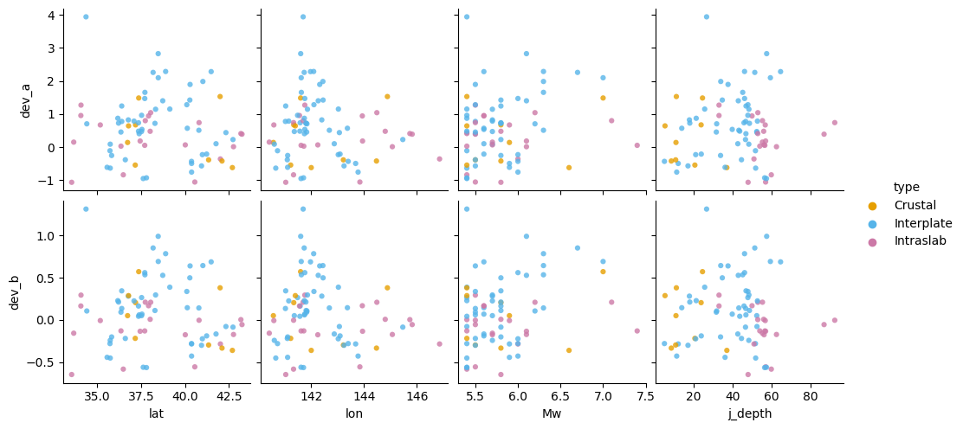
Figure S1. Difference in distance coefficient and intercept between the buried and unburied stations for each event. Comparison of these values with earthquake magnitude, focal depth, and epicenter coordinates.

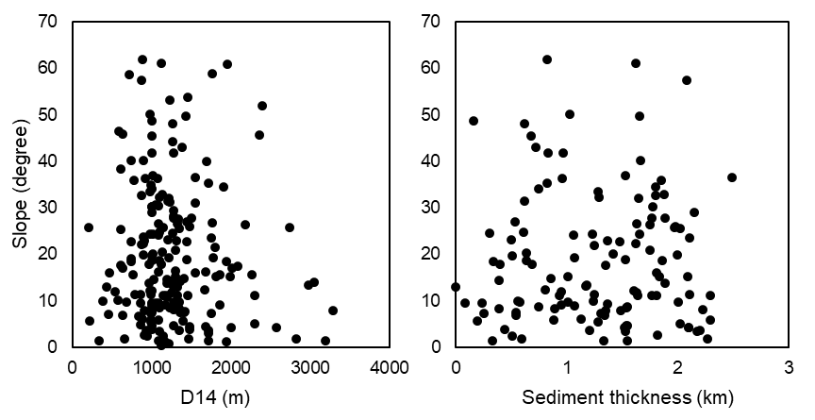
Figure S2. Comparison of slope angle with D14 and sediment thickness (Nishizawa et al. 2022).

