Supplementary Material

Table S1. Receiver operating characteristics -curve picked cut-offs of M1- and M2-like macrophage densities and M1:M2 polarisation ratios.
 | Epith TC | Epith IM | Strom TC | Strom IM
M1-like macrophages | 16.636 | 52.789 | 132.122 | 198.29
M2-like macrophages | 28.57 | 33.56 | 181.48 | 278.64
M1:M2 ratio | 2.412 | 2.674 | 0.616 | 0.858
Epith=intraepithelial; IM=invasive margin; Strom=stromal; TC=tumour centre
Table S2. Macrophage densities and polarisation according to the order of the pulmonary metastasectomies.
 | Order of pulmonary metastasectomy
 | First | Later
 | MD (IQR) | MD (IQR) | p
Tumour centre
Stromal macrophages
M1-like | 153.7 (102.6-309.8) | 132.8 (73.9-272.9) | 0.297
M2-like | 229.7 (113.0-379.9) | 208.2 (113.5-308.9) | 0.707
M1:M2 ratio | 0.6 (0.3-2.3) | 0.7 (0.3-1.4) | 0.964
Overall (CD68) | 977.9 (714.4-1359.2) | 1003.6 (570.0-1254.5) | 0.400
Intraepithelial macrophages
M1-like | 117.2 (44.9-218.0) | 102.3 (39.5-200.8) | 0.317
M2-like | 75.1 (17.3-200.4) | 62.0 (13.6-176.6) | 0.272
M1:M2 ratio | 1.5 (0.5-5.5) | 1.8 (0.6-5.6) | 0.651
Overall (CD68) | 137.3 (65.0-352.8) | 74.8 (34.8-148.9) | 0.022*
Overall (stromal + intraepithelial) macrophages
M1-like | 106.1 (48.6-179.7) | 55.6 (31.6-117.2) | 0.059
M2-like | 94.2 (53.4-164.8) | 81.8 (36.4-167.5) | 0.311
M1:M2 ratio | 0.78 (0.35-2.38) | 0.8 (0.3-1.7) | 0.610
Overall (CD68) | 504.9 (307.1-813.4) | 324.7 (196.3-604.5) | 0.050*
Invasive margin
Stromal macrophages
M1-like | 191.7 (125.0-248.2) | 196.5 (154.1-321.5) | 0.611
M2-like | 285.2 (170.3-425.0) | 255.1 (95.5-483.8) | 0.403
M1:M2 ratio | 0.6 (0.3-1.5) | 0.7 (0.3-1.8) | 0.420
Overall (CD68) | 1181.1 (935.3-1803.5) | 1130.6 (869.3-1474.5) | 0.386
Intraepithelial macrophages
M1-like | 81.9 (31.0-167.3) | 56.9 (34.9-171.1) | 0.788
M2-like | 39.4 (15.3-125.2) | 29.9 (6.3-77.7) | 0.455
M1:M2 ratio | 1.7 (0.6-4.6) | 2.4 (0.9-7.0) | 0.339
Overall (CD68) | 370.3 (105.4-535.2) | 309.8 (115.4-498.8) | 0.698
Overall (stromal + intraepithelial) macrophages
M1 | 145.2 (72.5-196.6) | 117.8 (76.5-190.3) | 0.543
M2 | 160.1 (77.1-291.6) | 100.0 (46.9-268.7) | 0.169
M1:M2 ratio | 0.8 (0.3-1.9) | 0.8 (0.4-2.7) | 0.408
Overall (CD68) | 757.6 (528.7-1169.7) | 645.5 (382.7-791.2) | 0.127
*statistically significant at the level p<0.05

Table S3. Spearman correlation coefficients of M1- and M2-like macrophages in the first resected pulmonary metastases of colorectal carcinoma
 |  |  | M1-like macrophages |  |  |  | M2-like macrophages
 |  |  | Epith TC | Epith IM | Strom TC | Strom IM | Epith TC | Epith IM | Strom TC | Strom IM
M1-like macrophages | Epith TC | r_{s} | 1.000 | 0.348** | 0.666** | 0.288* | 0.340** | 0.099 | -0.038 | -0.114
M1-like macrophages | Epith TC | p |  | <0.001 | <0.001 | 0.035 | <0.001 | 0.478 | 0.775 | 0.411
M1-like macrophages | Epith TC | N | 636 | 54 | 60 | 54 | 636 | 54 | 60 | 54
M1-like macrophages | Epith IM | r_{s} | 0.348** | 1.000 | 0.296* | 0.532** | 0.221 | 0.478** | 0.123 | 0.010
M1-like macrophages | Epith IM | p | <0.001 |  | <0.001 | <0.001 | 0.108 | <0.001 | 0.376 | 0.464
M1-like macrophages | Epith IM | N | 54 | 56 | 54 | 56 | 54 | 56 | 54 | 56
M1-like macrophages | Strom TC | r_{s} | 0.666** | 0.296* | 1.000 | 0.297* | -0.123 | -0.010 | -0.291* | -0.169
M1-like macrophages | Strom TC | p | <0.001 | 0.030 |  | 0.029 | 0.348 | 0.942 | 0.024 | 0.223
M1-like macrophages | Strom TC | N | 60 | 54 | 60 | 54 | 60 | 54 | 60 | 54
M1-like macrophages | Strom IM | r_{s} | 0.288* | 0.532** | 0.297* | 1.000 | -0.039 | -0.002 | -0.291* | -0.324*
M1-like macrophages | Strom IM | p | 0.035 | <0.001 | 0.029 |  | 0.777 | 0.987 | 0.033 | 0.015
M1-like macrophages | Strom IM | N | 54 | 56 | 54 | 56 | 54 | 56 | 54 | 56
M2-like macrophages | Epith TC | r_{s} | 0.340** | 0.221 | -0.123 | -0.039 | 1.000 | 0.480** | 0.511** | 0.399**
M2-like macrophages | Epith TC | p | <0.001 | 0.108 | 0.348 | 0.777 |  | <0.001 | <0.001 | 0.003
M2-like macrophages | Epith TC | N | 636 | 54 | 60 | 54 | 636 | 54 | 60 | 54
M2-like macrophages | Epith IM | r_{s} | 0.099 | 0.478** | -0.010 | -0.002 | 0.480** | 1.000 | 0.365** | 0.642**
M2-like macrophages | Epith IM | p | 0.478 | <0.001 | 0.942 | 0.987 | <0.001 |  | 0.007 | <0.001
M2-like macrophages | Epith IM | N | 54 | 56 | 54 | 56 | 54 | 56 | 54 | 56
M2-like macrophages | Strom TC | r_{s} | -0.038 | 0.123 | -0.291* | -0.291* | 0.511** | 0.365** | 1.000 | 0.554**
M2-like macrophages | Strom TC | p | 0.775 | 0.376 | 0.024 | 0.033 | <0.001 | 0.007 |  | <0.001
M2-like macrophages | Strom TC | N | 60 | 54 | 60 | 54 | 60 | 54 | 60 | 54
M2-like macrophages | Strom IM | r_{s} | -0.114 | 0.010 | -0.169 | -0.324* | 0.399** | 0.642** | 0.554** | 1.000
M2-like macrophages | Strom IM | p | 0.411 | 0.464 | 0.223 | 0.015 | 0.003 | <0.001 | <0.001
M2-like macrophages | Strom IM | N | 54 | 56 | 54 | 56 | 54 | 56 | 54 | 56
Epith=intraepithelial; IM=invasive margin; r_{s}=Spearman correlation coefficient; Strom=stromal; TC=tumour centre
** statistically significant at the level p<0.01
* statistically significant at the level p<0.05

Table S4. Spearman correlation analysis of M1- and M2-like macrophage densities in the first resected pulmonary metastases and corresponding primary CRC tumours.
 |  |  |  | Primary tumours
 |  |  |  | M1-like macrophages |  |  |  | M2-like macrophages
 |  |  |  | Epith TC | Epith IM | Strom TC | Strom IM | Epith TC | Epith IM | Strom TC | Strom IM
Pulmonary metastases | M1-like macrophages | Epith TC | r_{s} | 0.295** | -0.088 | -0.063 | -0.033 | -0.089 | -0.106 | -0.160 | 0.009
Pulmonary metastases | M1-like macrophages | Epith TC | p | <0.001 | 0.584 | 0.673 | 0.837 | 0.553 | 0.509 | 0.283 | 0.957
Pulmonary metastases | M1-like macrophages | Epith TC | N | 255 | 41 | 47 | 41 | 47 | 41 | 47 | 41
Pulmonary metastases | M1-like macrophages | Epith IM | r_{s} | 0.213 | 0.164 | 0.115 | 0.256 | -0.045 | -0.012 | 0.009 | -0.101
Pulmonary metastases | M1-like macrophages | Epith IM | p | 0.171 | 0.325 | 0.463 | 0.121 | 0.775 | 0.945 | 0.952 | 0.546
Pulmonary metastases | M1-like macrophages | Epith IM | N | 43 | 38 | 43 | 38 | 43 | 38 | 43 | 38
Pulmonary metastases | M1-like macrophages | Strom TC | r_{s} | -0.098 | 0.068 | -0.025 | 0.105 | -0.162 | 0.081 | -0.130 | -0.008
Pulmonary metastases | M1-like macrophages | Strom TC | p | 0.512 | 0.673 | 0.865 | 0.515 | 0.276 | 0.614 | 0.384 | 0.959
Pulmonary metastases | M1-like macrophages | Strom TC | N | 47 | 41 | 47 | 41 | 47 | 41 | 47 | 41
Pulmonary metastases | M1-like macrophages | Strom IM | r_{s} | 0.129 | 0.088 | 0.154 | 0.070 | -0.254 | -0.128 | -0.226 | -0.154
Pulmonary metastases | M1-like macrophages | Strom IM | p | 0.408 | 0.601 | 0.325 | 0.675 | 0.100 | 0.444 | 0.145 | 0.357
Pulmonary metastases | M1-like macrophages | Strom IM | N | 43 | 38 | 43 | 38 | 43 | 38 | 43 | 38
Pulmonary metastases | M2-like macrophages | Epith TC | r_{s} | 0.419** | -0.232 | -0.110 | -0.134 | 0.020 | -0.237 | -0.038 | -0.020
Pulmonary metastases | M2-like macrophages | Epith TC | p | <0.001 | 0.145 | 0.463 | 0.404 | 0.894 | 0.135 | 0.801 | 0.900
Pulmonary metastases | M2-like macrophages | Epith TC | N | 255 | 41 | 47 | 41 | 47 | 41 | 47 | 41
Pulmonary metastases | M2-like macrophages | Epith IM | r_{s} | 0.046 | 0.114 | 0.083 | 0.224 | 0.054 | -0.114 | 0.042 | -0.137
Pulmonary metastases | M2-like macrophages | Epith IM | p | 0.768 | 0.497 | 0.598 | 0.177 | 0.732 | 0.495 | 0.787 | 0.412
Pulmonary metastases | M2-like macrophages | Epith IM | N | 43 | 38 | 43 | 38 | 43 | 38 | 43 | 38
Pulmonary metastases | M2-like macrophages | Strom TC | r_{s} | 0.034 | -0.143 | -0.162 | 0.056 | 0.031 | -0.128 | 0.251 | 0.129
Pulmonary metastases | M2-like macrophages | Strom TC | p | 0.821 | 0.373 | 0.278 | 0.730 | 0.838 | 0.426 | 0.089 | 0.422
Pulmonary metastases | M2-like macrophages | Strom TC | N | 47 | 41 | 47 | 41 | 47 | 41 | 47 | 41
Pulmonary metastases | M2-like macrophages | Strom IM | r_{s} | -0.036 | 0.063 | -0.019 | 0.232 | -0.037 | -0.251 | -0.052 | 0.025
Pulmonary metastases | M2-like macrophages | Strom IM | p | 0.821 | 0.706 | 0.904 | 0.161 | 0.811 | 0.128 | 0.739 | 0.879
Pulmonary metastases | M2-like macrophages | Strom IM | N | 43 | 38 | 43 | 38 | 43 | 38 | 43 | 38
Epith=intraepithelial; IM=invasive margin; r_{s}=Spearman correlation coefficient; Strom=stromal; TC=tumour centre
*statistically significant at the level p<0.05

Table S5 Baseline characteristics of colorectal cancer cases according to intraepithelial M1- and M2-like macrophage densities in the invasive margin of the first resected pulmonary metastases.

 | M1-like macrophages |  |  | M2-like macrophages
 | Low | High | p | Low | High | p
 | n (%) | n (%) |  | n (%) | n (%)
n | 19 | 37 |  | 24 | 32
Sex |  |  | 0.397 |  |  | 0.280
Female | 11 (57.9%) | 17 (45.9%) |  | 14 (58.3%) | 14 (43.8%)
Male | 8 (42.1%) | 20 (54.1%) |  | 10 (41.7%) | 18 (56.3%)
Age (M; SD) | 68.72 (11.59) | 68.72 (11.59) | 0.272 | 68.72 (11.59) | 68.72 (11.59) | 0.202
RCS Comorbidity Score |  |  | 0.206 |  |  | 0.178
1 | 10 (52.6%) | 24 (64.9%) |  | 14 (58.3%) | 20 (62.5%)
2 | 7 (36.8%) | 6 (16.2%) |  | 8 (33.3%) | 5 (15.6%)
≥3 | 2 (10.5%) | 7 (18.9%) |  | 2 (8.3%) | 7 (21.9%)
Neoadjuvant chemotherapy |  |  | 0.143 |  |  | 0.155
No | 9 (47.4%) | 25 (67.6%) |  | 12 (50.0%) | 22 (68.8%)
Yes | 10 (52.6%) | 12 (32.4%) |  | 12 (50.0%) | 10 (31.3%)
Disease stage |  |  | 0.313 |  |  | 0.241
1-2 | 5 (26.3%) | 16 (43.2%) |  | 6 (25.0%) | 15 (46.9%)
3 | 10 (52.6%) | 12 (32.4%) |  | 11 (45.8%) | 11 (34.4%)
4 | 4 (21.1%) | 9 (24.3%) |  | 7 (29.2%) | 6 (18.8%)
Primary tumour location |  |  | 0.778 |  |  | >0.999
Colon | 10 (52.6%) | 18 (48.6%) |  | 12 (50.0%) | 16 (50.0%)
Rectum | 9 (47.4%) | 19 (51.4%) |  | 12 (50.0%) | 16 (50.0%)
Disease-free interval (d; MD; IQR) | 309 (0-925) | 427 (67-857) | 0.811 | 311.5 (0-869) | 627.5 (110-932) | 0.266
Size of largest pulmonary metastasis (cm; MD; IQR) | 1.5 (1.2-2.7) | 2.5 (1.4-3.6) | 0.080 | 2 (1.05-3.5) | 2.4 (1.5-3.5) | 0.203
Former liver metastases |  |  | 0.769 |  |  | 0.485
No | 10 (52.6%) | 21 (56.8%) |  | 12 (50.0%) | 19 (59.4%)
Yes | 9 (47.4%) | 16 (43.2%) |  | 12 (50.0%) | 13 (40.6%)
Synchronicity |  |  | 0.523 |  |  | 0.222
Synchronous | 5 (26.3%) | 7 (18.9%) |  | 7 (29.2%) | 5 (15.6%)
Metachronous | 14 (73.7%) | 30 (81.1%) |  | 17 (70.8%) | 27 (84.4%)
No. of pulmonary metastases |  |  | 0.399 |  |  | 0.719
1 | 10 (52.6%) | 24 (64.9%) |  | 14 (58.3%) | 20 (62.5%)
2 | 6 (31.6%) | 11 /29.7%) |  | 7 (29.2%) | 10 (31.3%)
≥3 | 3 (15.8%) | 2 (5.4%) |  | 3 (12.5%) | 2 (6.3%)
Laterality of metastases |  |  | 0.961 |  |  | 0.452
Unilateral | 15 (78.9%) | 29 (78.4%) |  | 20 (83.3%) | 24 (75.0%)
Bilateral | 4 (21.1%) | 8 (21.6%) |  | 4 (16.7%) | 8 (25.0%)
BRAF |  |  | 0.322 |  |  | 0.760
Wild-type | 17 (100.0%) | 34 (94.4%) |  | 20 (95.2%) | 31 (96.9%)
Mutant | 0 (0.0%) | 2 (5.6%) |  | 1 (4.8%) | 1 (3.1%)
RCS= Royal College of Surgeons. The chi-square test, Student’s T-test, and Mann-Whitney U-test were applied.

Table S6. Baseline characteristics according to M1:M2 density ratio in the invasive margin of CRC pulmonary metastases.
 | M1:M2 ratio, intraepithelial |  |  | M1:M2 ratio, stromal
 | Low | High |  | Low | High
 | n (%) | n (%) | p | n (%) | n (%) | p
n | 31 | 24 |  | 33 | 23
Sex |  |  | 0.508 |  |  | 0.786
Female | 17 (54.8%) | 11 (45.8%) |  | 16 (48.5%) | 12 (52.2%)
Male | 14 (45.2%) | 13 (54.2%) |  | 17 (51.5%) | 11 (47.8%)
Age (M; SD) | 67.32 (11.25) | 67.5 (10.35) | 0.952 | 68.24 (11.24) | 66.22 (9.91) | 0.490
RCS Comorbidity Score |  |  | 0.482 |  |  | 0.500
1 | 21 (67.7%) | 13 (54.2%) |  | 22 (66.7%) | 12 (52.2%)
2 | 5 (16.1%) | 7 (29.2%) |  | 6 (18.2%) | 7 (30.4%)
≥3 | 5 (16.1%) | 4 (16.7%) |  | 5 (15.2%) | 4 (17.4%)
Neoadjuvant chemotherapy |  |  | 0.437 |  |  | 0.275
No | 20 (64.5%) | 13 (54.2%) |  | 22 (66.7%) | 12 (52.2%)
Yes | 11 (35.5%) | 11 (45.8%) |  | 11 (33.3%) | 11 (47.8%)
Disease stage |  |  | 0.208 |  |  | 0.431
1-2 | 15 (48.4%) | 6 (25.0%) |  | 12 (36.4%) | 9 (39.1%)
3 | 10 (32.3%) | 11 (45.8%) |  | 15 (45.5%) | 7 (30.4%)
4 | 6 (19.4%) | 7 (29.2%) |  | 6 (18.2%) | 7 (30.4%)
Primary tumour location |  |  | 0.906 |  |  | 0.415
Colon | 15 (48.4%) | 12 (50.0%) |  | 18 (54.5%) | 10 (43.5%)
Rectum | 16 (51.6%) | 12 (50.0%) |  | 15 (45.5%) | 13 (56.5%)
Disease-free interval (d; MD; IQR) | 482 (67-857) | 325 (0-990.5) | 0.777 | 621 (77-813) | 314 (0-1004) | 0.619
Size of largest pulmonary metastasis (cm; MD; IQR) | 2.5 (1.5-3.5) | 2 (1-3.5) | 0.320 | 2.5 (1.5-3.5) | 2 (1-3.5) | 0.314
Former liver metastases |  |  | 0.419 |  |  | 0.884
No | 16 (51.6%) | 15 (62.5%) |  | 18 (54.5%) | 13 (56.5%)
Yes | 15 (48.4%) | 9 (37.5%) |  | 15 (45.5%) | 10 (43.5%)
Synchronicity |  |  | 0.069 |  |  | 0.478
Synchronous | 4 (12.9%) | 8 (33.3%) |  | 6 (18.2%) | 6 (26.1%)
Metachronous | 27 (87.1%) | 16 (66.7%) |  | 27 (81.8%) | 17 (73.9%)
No. of pulmonary metastases |  |  | 0.127 |  |  | 0.999
1 | 15 (48.4%) | 18 (75.0%) |  | 20 (60.6%) | 14 (60.9%)
2 | 12 (38.7%) | 5 (20.8%) |  | 10 (30.3%) | 7 (30.4%)
≥3 | 4 (12.9%) | 1 (4.2%) |  | 3 (9.1%) | 2 (8.7%)
Laterality of metastases |  |  | 0.416 |  |  | 0.962
Unilateral | 23 (74.2%) | 20 (83.3%) |  | 26 (78.8%) | 18 (78.3%)
Bilateral | 8 (25.8%) | 4 (16.7%) |  | 7 (21.2%) | 5 (21.7%)
BRAF |  |  | 0.092 |  |  | 0.075
Wild-type | 30 (100.0%) | 20 (90.9%) |  | 32 (100.0%) | 19 (90.5%)
Mutant | 0 (0.0%) | 2 (9.1%) |  | 0 (0.0%) | 2 (9.5%)
RCS=Royal College of Surgeons. The chi-square test, Student’s T-test, and Mann-Whitney U-test were applied.

Table S7. Baseline characteristics according to intraepithelial M1- and M2-like macrophage densities in the invasive margin of primary tumours.
 | M1-like macrophages |  |  | M2-like macrophages
 | Low | High |  | Low | High
 | n (%) | n (%) | p | n (%) | n (%) | p
n | 29 | 17 |  | 28 | 18
Sex |  |  | 0.708 |  |  | 0.474
Female | 17 (59%) | 9 (53%) |  | 17 (61%) | 9 (50%)
Male | 12 (41%) | 8 (47%) |  | 11 (39%) | 9 (50%)
Age (M; SD) | 69.69 (9.14) | 64.88 (12.55) | 0.141 | 67.93 (11.16) | 67.89 (10.14) | 0.990
RCS Comorbidity Score |  |  | 0.247 |  |  | 0.125
1 | 17 (59%) | 14 (82%) |  | 16 (57%) | 15 (83%)
2 | 7 (24%) | 2 (12%) |  | 8 (29%) | 1 (6%)
≥3 | 5 (17%) | 1 (6%) |  | 4 (14%) | 2 (11%)
Neoadjuvant chemotherapy |  |  | 0.002** |  |  | 0.464
No | 26 (93%) | 9 (53%) |  | 22 (82%) | 13 (72%)
Yes | 2 (7%) | 8 (47%) |  | 5 (19%) | 5 (28%)
Disease stage |  |  | 0.037* |  |  | 0.506
1–2 | 10 (35%) | 8 (47%) |  | 10 (36%) | 8 (44%)
3 | 10 (35%) | 9 (53%) |  | 11 (39%) | 8 (44%)
4 | 9 (31%) | 0 (0%) |  | 7 (25%) | 2 (11%)
Primary tumour location |  |  | 0.002** |  |  | 0.337
Colon | 22 (76%) | 5 (30%) |  | 18 (64%) | 9 (50%)
Rectum | 7 (24%) | 12 (71%) |  | 10 (36%) | 9 (50%)
Primary tumour grade |  |  | 0.258 |  |  | 0.922
1 | 8 (31%) | 6 (35%) |  | 8 (31%) | 6 (35%)
2 | 16 (62%) | 7 (41%) |  | 14 (54%) | 9 (53%)
3 | 2 (8%) | 4 (24%) |  | 4 (15%) | 2 (12%)
Disease-free interval (d; MD; IQR) | 336 (0–762) | 634 (338–925) | 0.163 | 381.5 (33.5–869.5) | 558 (251–857) | 0.595
Laterality of PM |  |  | 0.100 |  |  | 0.917
Unilateral | 26 (90%) | 12 (71%) |  | 23 (82%) | 15 (83%)
Bilateral | 3 (10%) | 5 (29%) |  | 5 (18%) | 3 (17%)
Synchronicity |  |  | 0.258 |  |  | 0.311
Synchronous | 2 (7%) | 3 (18%) |  | 2 (7%) | 3 (17%)
Metachronous | 27 (93%) | 14 (82%) |  | 26 (93%) | 15 (83%)
BRAF |  |  | >0.999 |  |  | >0.999
Wild-type | 28 (97%) | 15 (94%) |  | 22 (96%) | 21 (95%)
Mutant | 1 (3%) | 1 (6%) |  | 1 (4%) | 1 (5%)
RCS=Royal College of Surgeons. The chi-square test, Student’s T-test, and Mann-Whitney U-test were applied. **statistically significant at the level p<0.01. *statistically significant at the level p<0.05

Table S8. Associations of neoadjuvant therapy with M1- and M2-like macrophage densities and M1:M2 ratio in the first resected pulmonary metastases and primary tumours.
 | Metastases |  |  | Primary tumours
 | Neoadjuvant chemotherapy |  |  | Neoadjuvant chemotherapy
 | No | Yes |  | No | Yes
 | MD (IQR) | MD (IQR) | p | MD (IQR) | MD (IQR) | p
Tumour centre
Stromal macrophages
M1-like | 173.3 (96.1-312.4) | 145.9 (115.0-288.6) | 0.654 | 221.2 (116.6-383.6) | 282.6 (190.7-354.1) | 0.451
M2-like | 247.6 (134.4-382.1) | 227.1 (85.4-377.3) | 0.350 | 116.2 (44.9-226.2) | 46.4 (16.6-159.8) | 0.254
M1:M2 ratio | 0.7 (0.2-2.2) | 0.5 (0.4-2.3) | 0.958 | 2.2 (0.5-7.3) | 5.1 (1.6-26.8) | 0.181
Intraepithelial macrophages
M1-like | 28.0 (13.8-115.8) | 40.2 (14.9-101.4) | 0.921 | 22.1 (9.1-64.8) | 41.2 (6.8-61.5) | 0.507
M2-like | 18.7 (4.7-51.1) | 22.4 (4.3-40.1) | 0.676 | 3.5 (0.4-11.2) | 2.4 (0-12.6) | 0.746
M1:M2 ratio | 2.6 (0.9-7.7) | 2.3 (0.9-13.7) | 0.480 | 6.4 (1-18.5) | 6.6 (3.8-684957779.2) | 0.219
Invasive margin
Stromal macrophages
M1-like | 187.7 (121.4-229.2) | 197.3 (137.4-289.0) | 0.275 | 194.1 (133.8-482.1) | 227.5 (146.9-268.3) | 0.793
M2-like | 310.5 (177.6-445.3) | 239.1 (162.9-398.5) | 0.064 | 166.3 (84.9-328.1) | 163.3 (4.1-215.7) | 0.261
M1:M2 ratio | 0.5 (0.2-1.5) | 0.8 (0.4-1.7) | 0.061 | 1.2 (0.4-2.2) | 3.5 (0.6-45) | 0.249
Intraepithelial macrophages
M1-like | 104.0 (52.3-182.8) | 60.8 (22.4-144.9) | 0.627 | 17 (4.8-66) | 95.4 (62.8-114.7) | 0.016*
M2-like | 45.4 (20.3-135.5) | 29.9 (7.6-57.5) | 0.481 | 6 (0-15.4) | 1.3 (0-81.9) | 0.750
M1:M2 ratio | 1.0 (0.5-3.1) | 2.8 (1.3-5.1) | 0.298 | 4.2 (0.6-247269587.4) | 543824134.5 (2.2-8843607435) | 0.075
*statistically significant at the level p<0.05

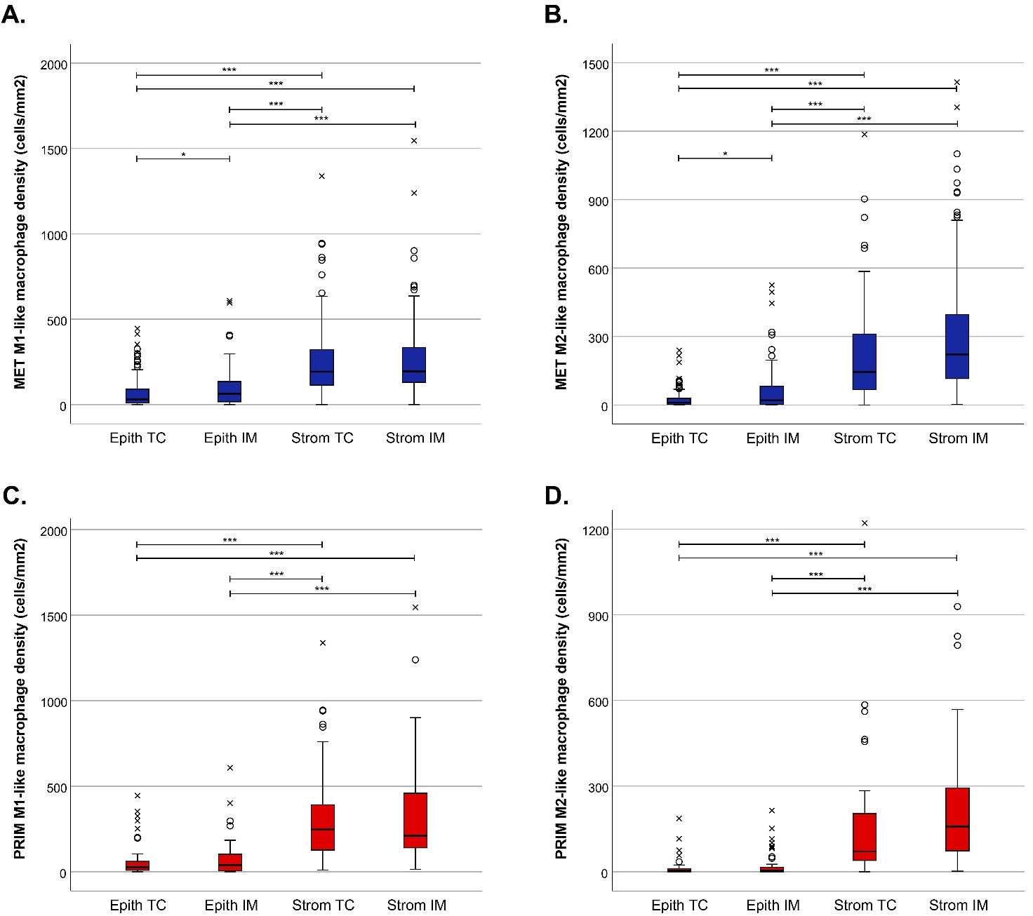
Figure S1. Comparison of M1- and M2-like macrophage densities in the different compartments of the first resected pulmonary metastases (A and B) and primary CRC tumours (C and D). Kruskal-Wallis tests were applied. Dunn’s multiple comparison tests were used for post-hoc analysis. *** Significant at the level p<0.001. * Significant at the level p<0.05. Circles indicate outliers and crosses extreme outliers.

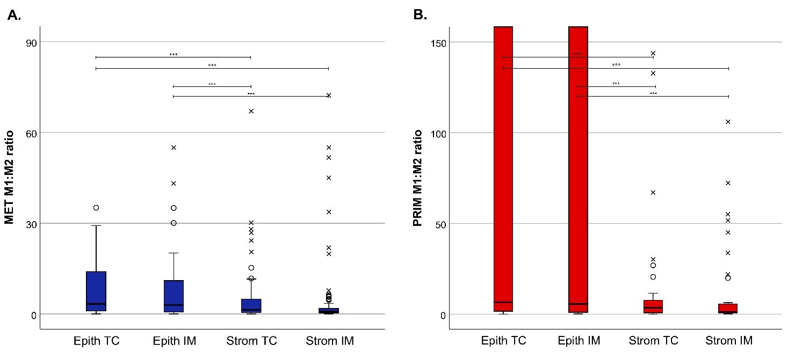
Figure S2. Comparison of M1:M2 ratios in the different areas of the first resected pulmonary metastases (A) and primary CRC tumours (B). Kruskal-Wallis tests were applied. Dunn’s multiple comparison tests were used for post-hoc analysis. *** Significant at the level p<0.001. Circles indicate outliers and crosses extreme outliers.

