Breast Pain Questionnaire

Name: Ethnicity: Birthdate:

Have you ever been diagnosed with breast cancer? Yes No

Post-menopausal? Yes No

- Have you experienced breast pain within the last six months? Yes No

If yes, please continue to fill out the rest of this survey.

- What does your breast pain feel like?
Please check one of the four categories (none, mild, moderate, or severe) for each descriptor.

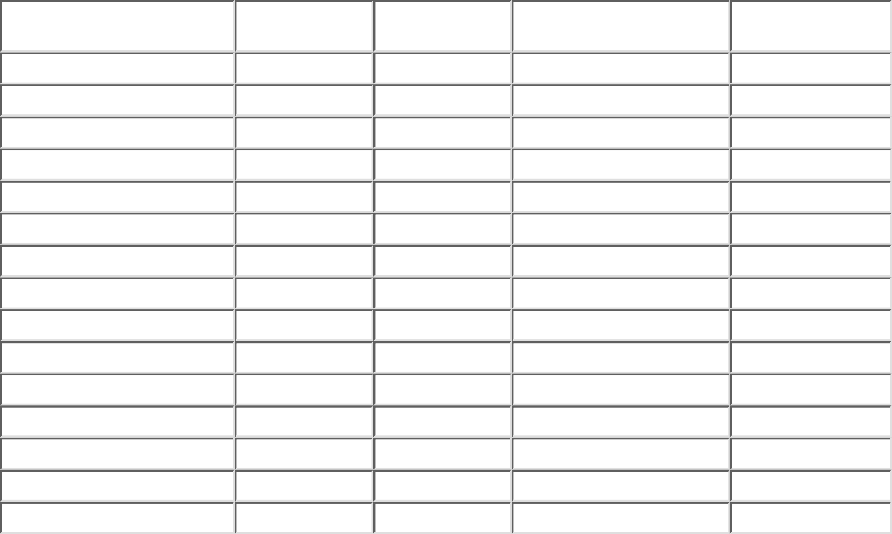
None Mild
ModerateSevere
Throbbing
Shooting Stabbing Sharp Cramping Gnawing Hot-Burning Aching Heavy Tender Splitting
Tiring-Exhausting Sickening
Fearful Punishing-Cruel

- What is the amount of your overall breast pain? Write a number between 0 and 10, where 0 means no pain and 10 is the worst possible pain ___

- Which word below best describes the amount of your overall breast pain? Check one.
Mild
Discomforting
Distressing
Horrible
Excruciating

- How does your breast pain change in time?
  - Which word or words would you use to describe the pattern of your breast pain? Please check all that apply

Continuous
Steady
Constant
Rhythmic
Periodic
Intermittent
Brief
Momentary
Transient

  - What kind of things relieve your breast pain?

  - What kind of things increase your breast pain?

- Skip if you are post-menopausal
Is your breast pain related to your menstrual cycle? Yes No If yes:
Which day is your breast pain worst? Write a number between 0 and 28 where 28 indicates menstruation.

How long does your breast pain usually last? Write a number between 0 and 28 where 28 indicates menstruation.

- How often does your breast pain occur? Check one.

Every hour
Every day
Every week
Every month

- How long have you had your breast pain?

Number of years ___Number of months ___Number of weeks

- Where, exactly, does the pain occur? Please shade painful areas.

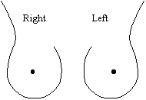

- Has your breast pain affected your work schedule? Yes No

- Has your breast pain affected your sleep pattern? Yes No

- Has your breast pain affected your sexual activity? Yes No
- Do you take medications to relieve your breast pain? Yes No If yes, write the type of medications and doses that you take.

- Do you do anything else to relieve your breast pain? Yes No If yes, write what you do to relieve your breast pain.

- Do you have other pains besides breast pain? Yes No If yes, write where?
how often?
Does it coincide with your breast pain? Yes No
Do you take any medications to relieve this pain? Yes No If yes, write the type of medications and doses that you take.

- If you have any comments regarding your breast pain that was not covered above please write them here:

