Supplementary Fig 1. Chord diagram of BRCA1/2 mutations.

Supplementary Fig 2. OncoPrinter of HRR genes regardless of by all definitions, with samples ordered by the prevalence. IHC: immunohistochemistry, m_subtype: molecular subtype.

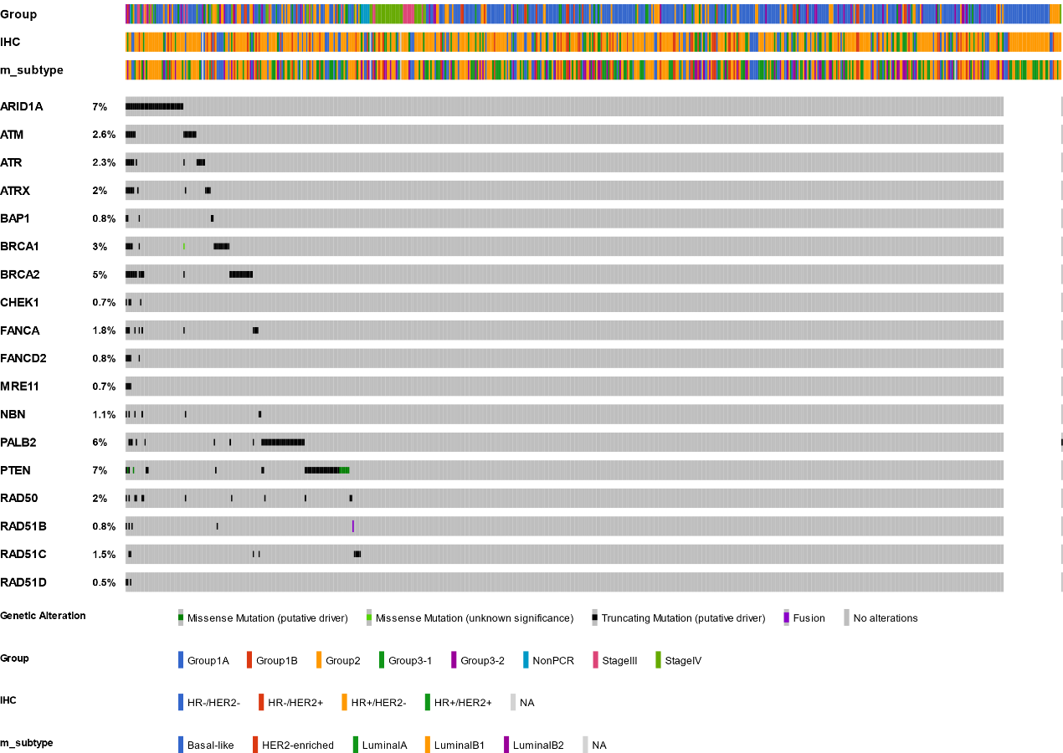

Supplementary Fig 2. Mutation maps of HRR genes other than BRCA1 and BRCA2.

