Extended Data
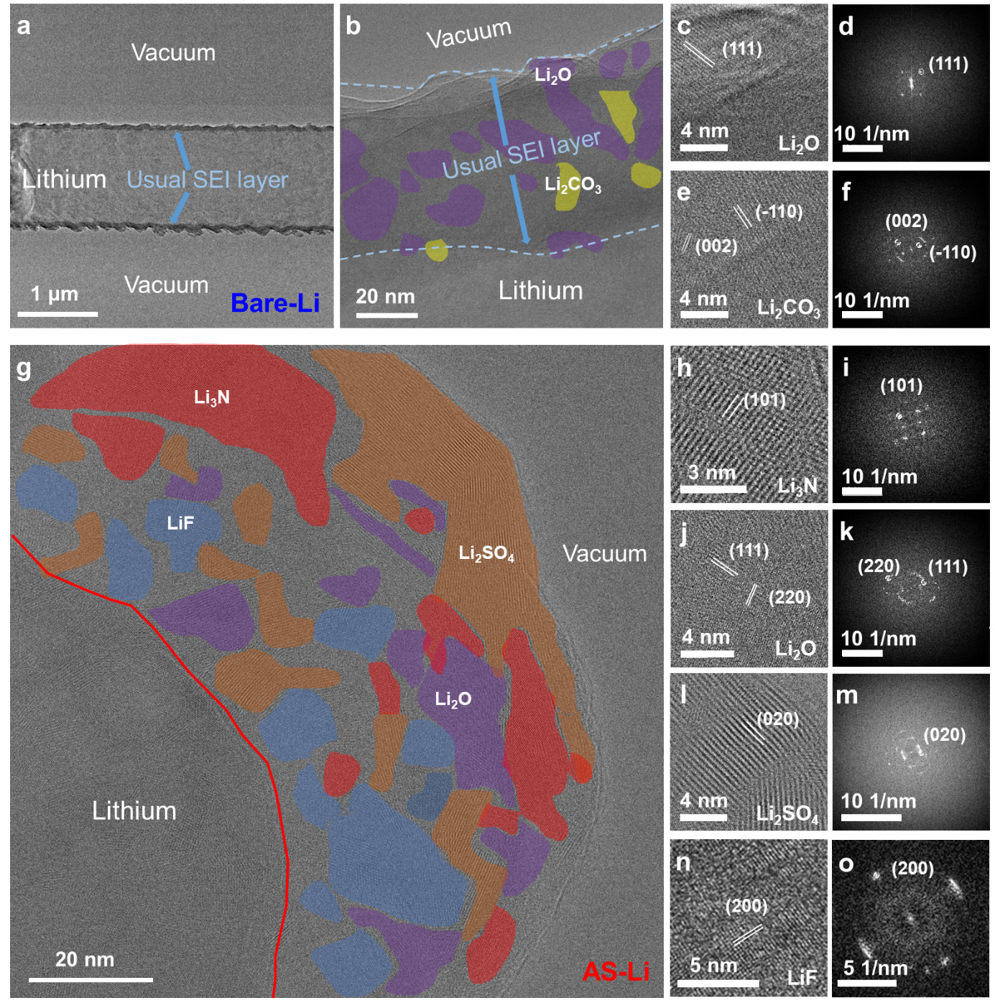
Extended Data Fig. 1 | Microstructure and composition analysis of SEIs via cryo-TEM. a, b, Cryo-TEM images showing the morphology of the cycled bare-Li a) at a low magnification and b) at a magnified view. c, d, e, f, HRTEM and fast Fourier transform (FFT) results for c, d) Li₂O and e, f) Li₂CO₃ crystals. g, Cryo-HRTEM image showing the distribution of the SEI components of the cycled AS-Li. h, i, j, k, l, m, n, o, HRTEM and FFT results for h, i) Li₃N, j, k) Li₂O, l, m) Li₂SO₄, and n, o) LiF crystals.

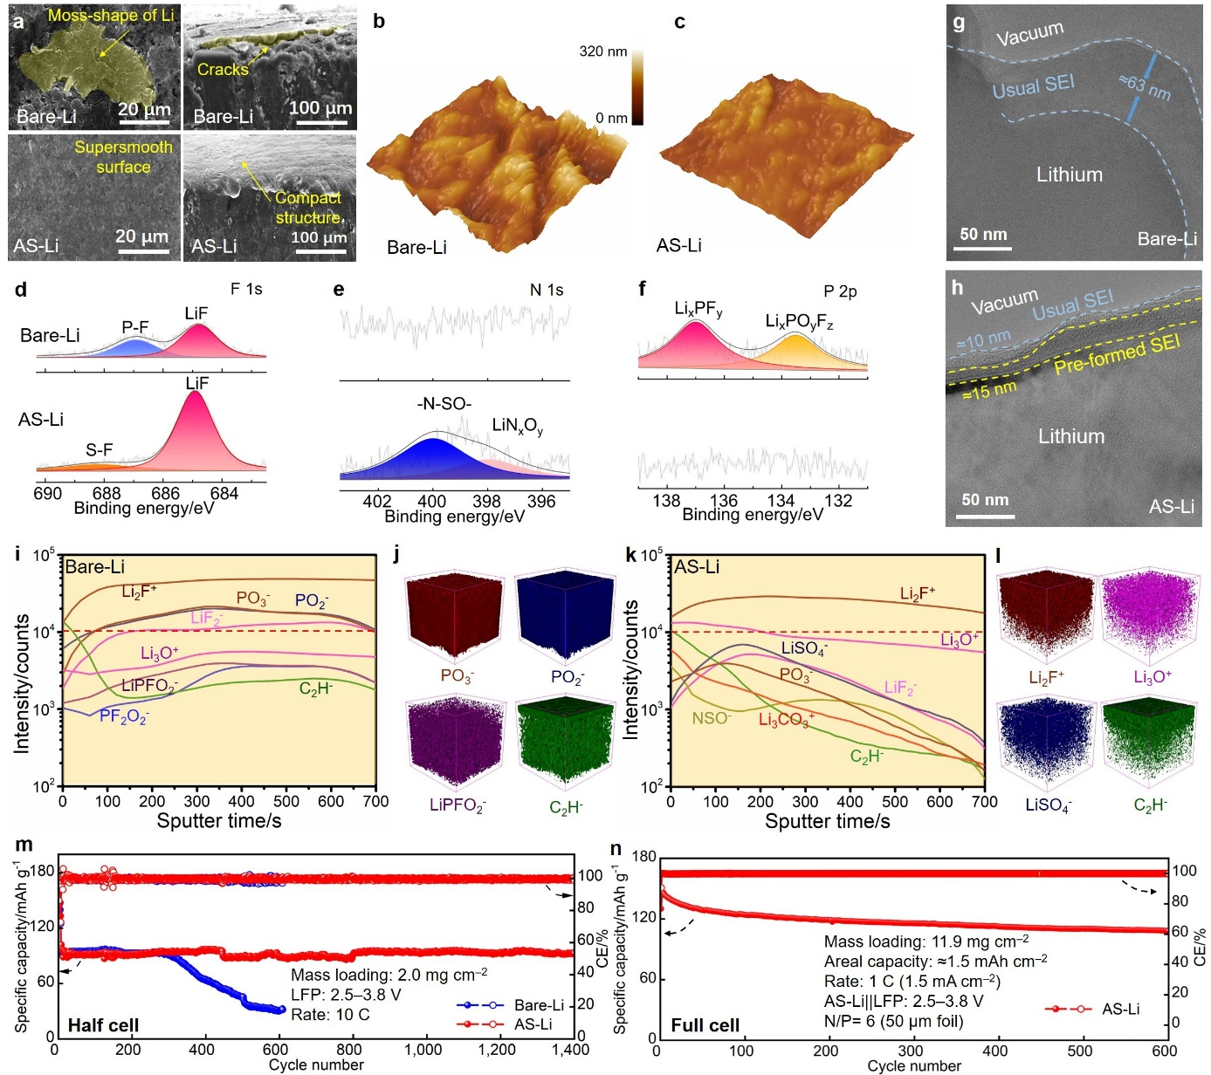
Extended Data Fig. 2 | Applicability of AS-Li in a carbonate LE. a, SEM images of bare-Li and AS-Li including both top surface and cross-sectional views after 30 cycles under 1 mA cm⁻²@3 mAh cm⁻² conditions. b, c, 3D-AFM scanning images of the surface morphologies of b) bare-Li and c) AS-Li. d, e, f, XPS spectra of d) F 1s, e) N 1s, and f) P 2p for bare-Li and AS-Li after 30 cycles. g, h, Cryo-TEM images of g) bare-Li and h) AS-Li after cycling, where both the usual and pre-formed SEI layers are highlighted. i, j, k, l, TOF-SIMS-measured i, k) depth profiles and j, l) 3D models of SEI films for bare-Li and AS-Li. m, n, Cycling performance of AS-Li||LFP m) half cell and n) full cell under carbonate LE conditions.
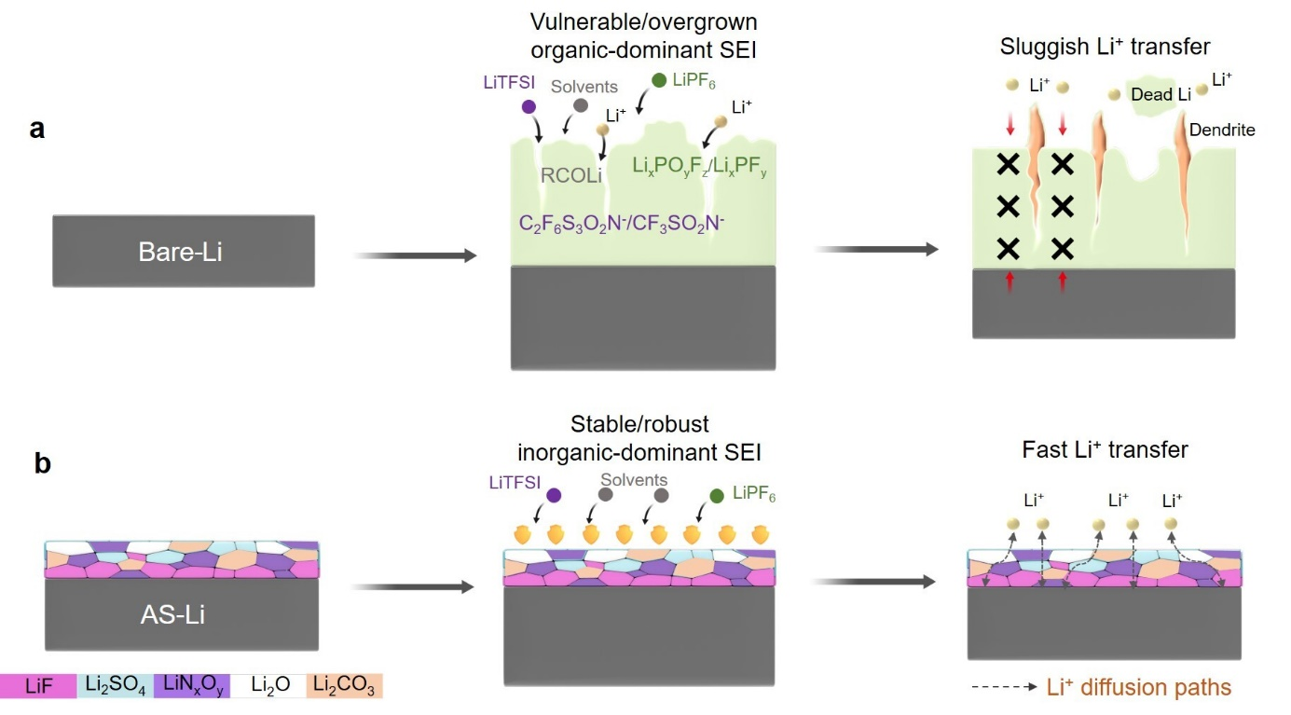
Extended Data Fig. 3 | Representation of the evolution of the interphases. a, b, Schematic of the evolution of surface behavior in both a) bare-Li and b) AS-Li during cycling.

