Supplementary Information for
Extreme fast charging of lithium metal batteries enabled by a molten-salt-derived nanocrystal interphase
Wei Wu¹*‡, Fang Niu^{1,2‡}, Chuankui Sun^{1,2‡}, Qingrong Wang^{3‡}, Man Wang³, Jun Wang³*, Yonghong Deng³, De Ning¹, Liyun Wu^{1,2}, Wenjie Li¹, Jie Zhang¹, Ming Chen¹, Hui-Ming Cheng^{4,5}*, and Chunlei Yang¹*
¹Institute of Advanced Materials Science and Engineering/Faculty of Material Science and Engineering, Shenzhen Institute of Advanced Technology, Chinese Academy of Sciences, Shenzhen 518055, P. R. China
²Nano Science and Technology Institute, University of Science and Technology of China, Suzhou 215123, P. R. China
³Department of Materials Science and Engineering, School of Innovation and Entrepreneurship, Southern University of Science and Technology, Shenzhen 518055, P. R. China
⁴Institute of Technology for Carbon Neutrality/Faculty of Material Science and Engineering, Shenzhen Institute of Advanced Technology, Chinese Academy of Sciences, Shenzhen 518055, P. R. China
⁵Shenyang National Laboratory for Materials Science, Institute of Metal Research, Chinese Academy of Sciences, Shenyang 110016, P. R. China
(A manuscript offered to “Nature Communications”)
*Corresponding authors:
Email: w.wu1@siat.ac.cn (Dr. W. Wu); wangj9@sustech.edu.cn (Prof. J. Wang); cheng@imr.ac.cn (Dr. H.-M. Cheng); cl.yang@siat.ac.cn (Dr. C. Yang).
‡These authors were equal major contributors to this work.
Supplementary Figures
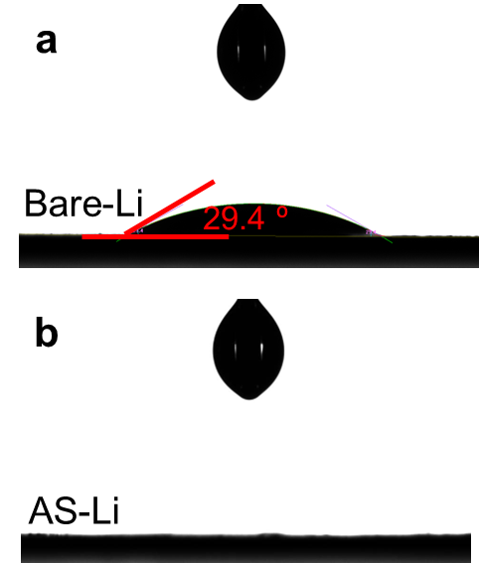
Supplementary Figure 1. Wetting angles of a) bare-Li and b) AS-Li with liquid electrolyte (LE).

Supplementary Note 1
To explore the impact of processing time on both the coverage and thickness of the resulting SEI layer, we examined times from 10 s to 30 min. Because the bare-Li sample has a rough surface with valleys and ridges (Supplementary Fig. 2), Li⁺ ions and the electric field tend to concentrate around tips to initiate the tip-growth pattern of Li dendrites¹. The entire coverage of a pre-formed SEI layer on these ridges is therefore pursued. As shown in Supplementary Fig. 3, after 1 min reaction with molten LiFSI, a flattened surface morphology is achieved. Moreover, for thickness, it is reasonable that a longer reaction time (1 to 30 min) would form a thicker SEI layer (up to 3.3 μm) on the surface of the lithium (Supplementary Fig. 4), which fits the exponential relationship in Supplementary Fig. 5. However, from the perspective of facilitating ion diffusion, a thinner layer is more desirable. Unless otherwise specified, a processing time of 1 min and a grown layer of ≈2 μm in thickness are used. This is a reasonable compromise between an entire coverage that smooths ridges and provides a short diffusion distance for the ions.

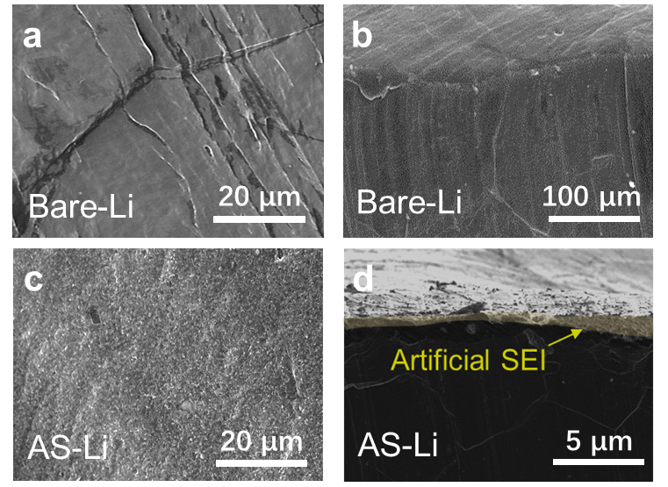
Supplementary Figure 2. a, b, SEM images of bare-Li: a) top surface and b) cross-sectional views. c, d, SEM images of AS-Li electrode: c) top surface and d) cross-sectional views.

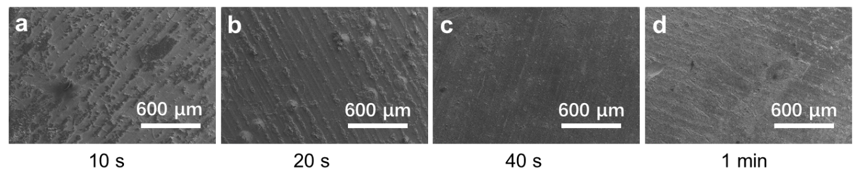
Supplementary Figure 3. Top surface SEM images of AS-Li processed for a) 10 s, b) 20 s, c) 40 s, to d) 1 min.
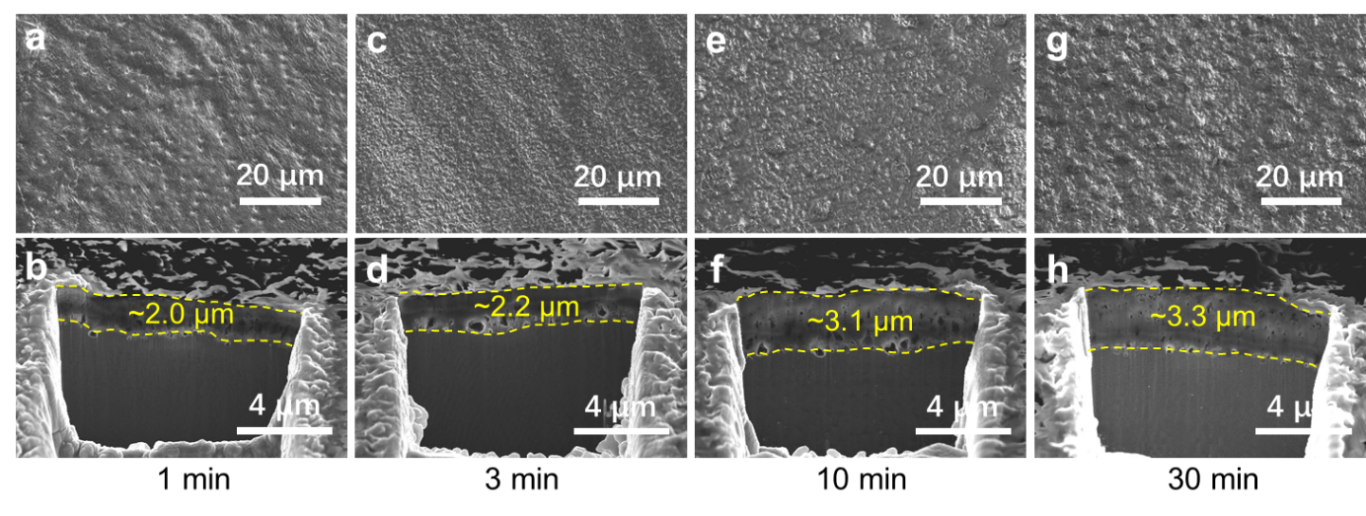
Supplementary Figure 4. a, c, e, g, Top surface, and b, d, f, h, cross-sectional FIB-SEM images of AS-Li processed for a, b) 1 min, c, d) 3 min, e, f) 10 min to g, h) 30 min.
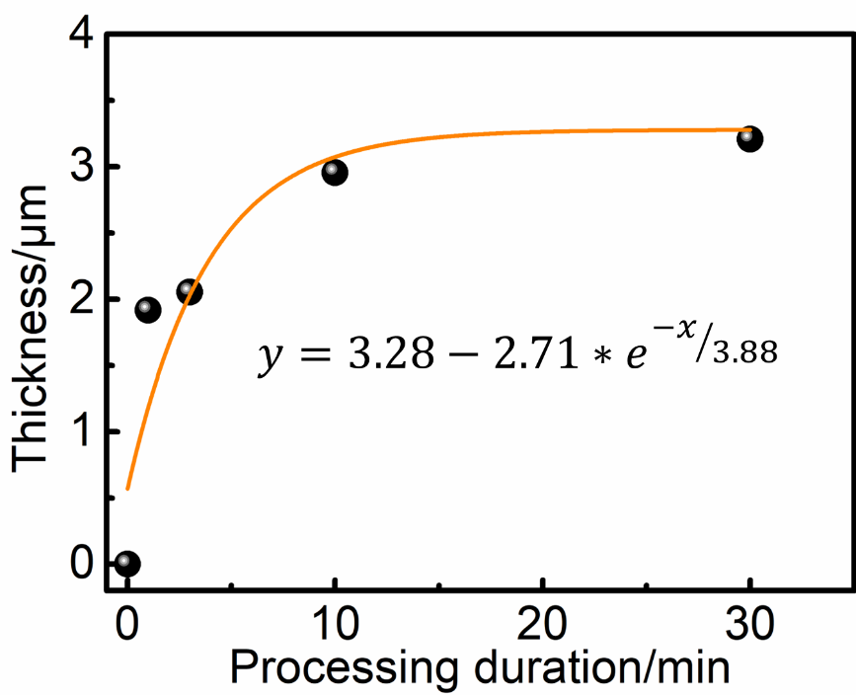
Supplementary Figure 5. Exponential fit of SEI thickness as a function of the processing time.
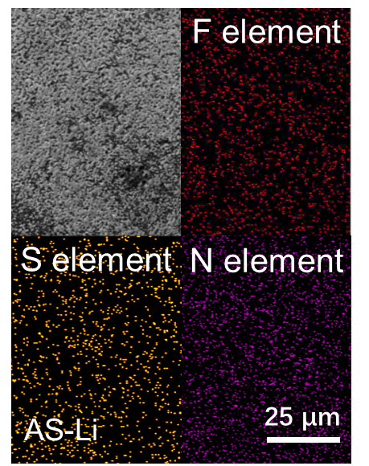
Supplementary Figure 6. Energy-dispersive X-ray spectroscopy (EDS) elemental maps of AS-Li.

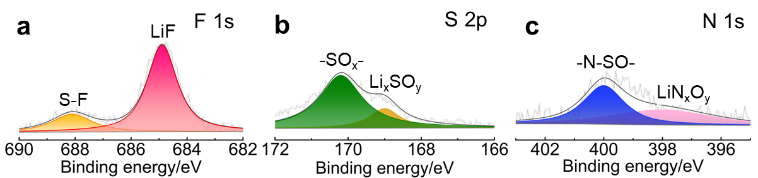
Supplementary Figure 7. XPS spectra of a) F 1s, b) S 2p, and c) N 1s for AS-Li.
In the XPS spectra, AS-Li shows pronounced peaks of F, S, and N species: The peaks at 688.5 and 685.0 eV in the F 1s spectrum are attributed to S-F and LiF, respectively^{2, 3}; The 170.2 and 169.0 eV peaks in the S 2p spectrum are assigned to overlapping -SO_{x}- and Li_{x}SO_{y} groups, respectively^{2, 4}; The 400.0 and 398.0 eV peaks in the N 1s spectrum are for -N-SO- and LiN_{x}O_{y}, respectively^{5, 6}.
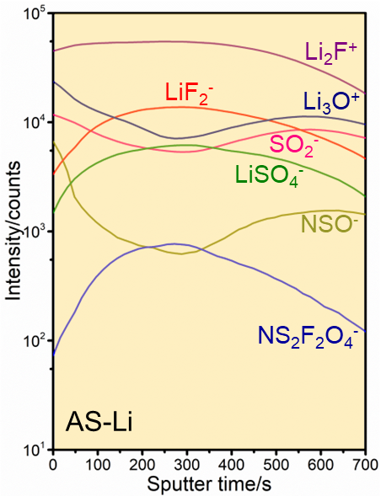
Supplementary Figure 8. TOF-SIMS-measured depth profile of the SEI film for AS-Li.

Supplementary Note 2
Li⁺ transfer kinetics are mainly affected by the morphology and composition of the SEI, whether pre-formed or not. The experimental setup for the conductive atomic force microscopy (c-AFM) measurement is shown in Supplementary Fig. 9. It consists of a c-AFM probe, a SEI layer, and a Li metal anode (Supplementary Fig. 9). The c-AFM tip is used as the working electrode (WE), while the Li metal functions as both reference electrode (RE) and counter electrode (CE)⁷. A sample table acting as the current collector applies a specific bias to drive the Li⁺ migration that passes through the SEI layer, and the c-AFM tip then detects the current response⁸. Specifically, when a reductive bias is applied to the WE, Li⁺ is drawn from the SEI layer towards the c-AFM tip and is then reduced to form Li⁰. Under the specified bias, the current response can be regarded as the major proxy that quantifies how easily Li⁺ diffusion occurs (i.e., the resistance)⁷. We monitored both the bias and the current response (Supplementary Fig. 10) to distinguish the resistance and Li⁺ diffusivity across the SEI layer on AS-Li. Over five different scan areas (10 scattered points per scan) from −6 V to 6 V, the calculated ionic conductivity fluctuates (Fig. 2f), giving an average of 6.2×10⁻³ S cm⁻¹, indicating a superior Li⁺ diffusivity of the pre-formed SEI layer.
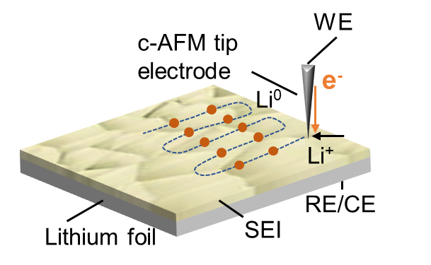
Supplementary Figure 9. Schematic of the nanoscale electrochemical measurement setup.

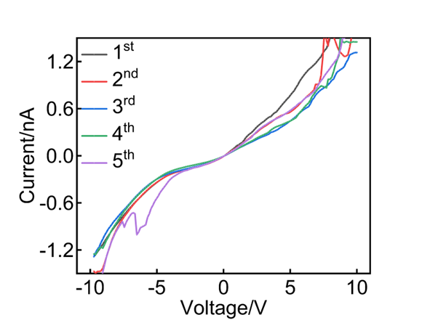
Supplementary Figure 10. Typical current response obtained by applying a varying bias on AS-Li using the c-AFM nanoelectrode during 5 scans.

Supplementary Note 3
Both the ionic conductivity and the mechanical strength of the pre-formed SEI film are important. On the one hand, fast Li⁺ transport not only causes even Li deposition and suppresses Li dendrites, but is also vital in determining the high-rate and low-temperature performance of LMBs⁹. On the other hand, the fragile nature of a SEI layer makes it prone to mechanical degradation and failure and leads to sharp capacity loss and poor durability, particularly during high-rate and high-areal-capacity usage¹⁰. In this case, a high Young's modulus for the SEI can provide sufficient fracture toughness against microcracking or defects when it is subjected to tensile stress during lithium plating¹¹. When the local stress is below the threshold for fracture propagation in the SEI, the growth and propagation of lithium dendrites is substantially suppressed, thus promoting homogeneous lithium deposition¹²⁻¹⁴.
In terms of the ionic conduction, both bulk and interface properties usually contribute to Li⁺ transport across the SEI, as jointly determined by the diffusion barrier, binding energy, and carrier concentration¹⁵. Here, the pre-formed SEI layer consists mainly of an inorganic matrix inlaid with LiF, Li₂SO₄, Li₂O, Li₂CO₃, and LiN_{x}O_{y} nano-sized domains with different crystallographic orientations. When these inorganic materials dominate the SEI, it is easier for Li⁺ to move at the SEI/Li and SEI/SEI interfaces. This SEI generally has a lower energy barrier with a higher carrier concentration that facilitates Li⁺ transport through the interfaces and grain boundaries effectively producing homogeneous Li⁺ deposition¹⁵. In working batteries the interfaces are believed to be the major Li⁺ diffusion pathways rather than the bulk. For example, it has been previously confirmed that high carrier concentrations in LiF-related interfaces (e.g., LiF/Li of 0.2 mol L⁻¹ and LiF/Li₂O of 0.14 mol L⁻¹) rather than in bulk LiF (<1.2×10⁻³ mol L⁻¹) are the chemical origin of the enhanced lithium conductivity of LiF-rich SEIs^{15, 16}. Moreover, these inorganic-rich anion-derived SEIs have also been shown to give reduced activation energies for both Li⁺ desolvation and diffusion¹⁷. A high carrier concentration combined with a low activation energy contributes to the high ionic conductivity of the AS-Li SEI.

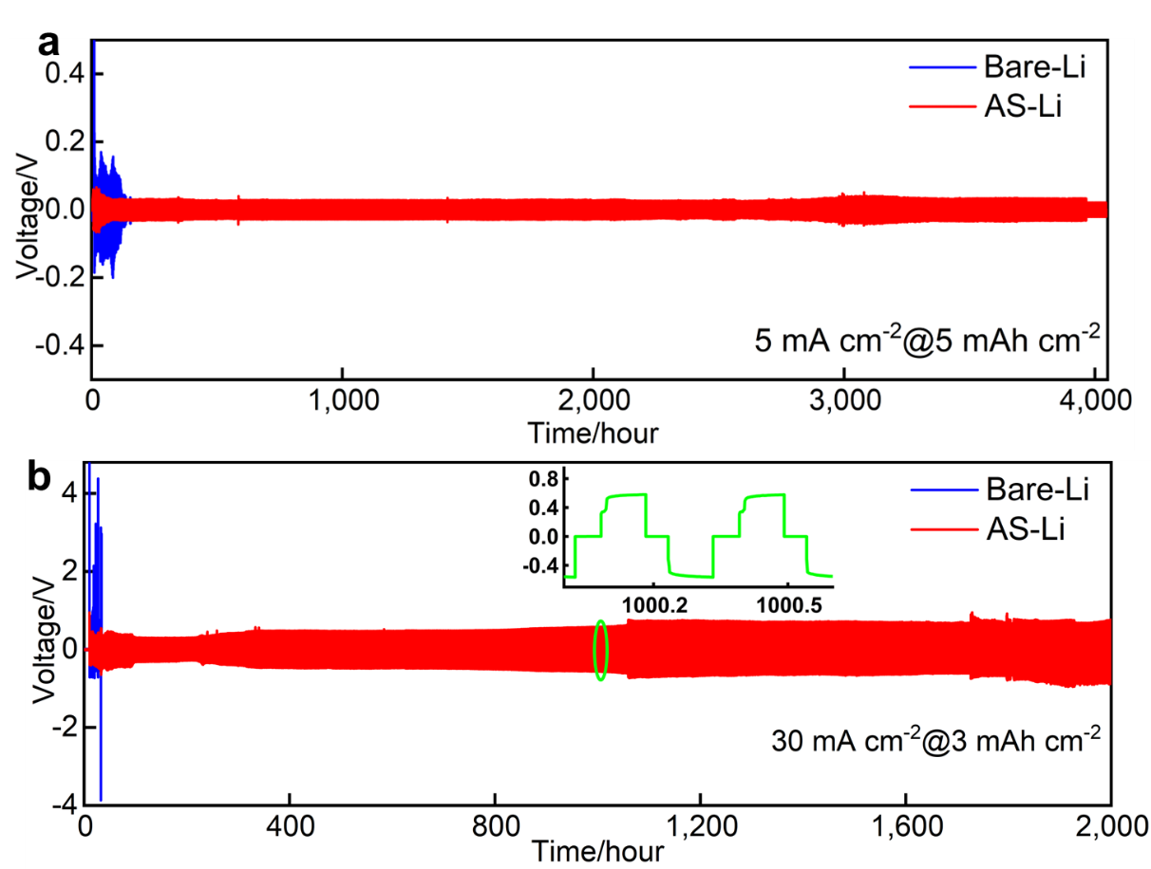
Supplementary Figure 11. Electrochemical characterization in the symmetric cell configuration. Cycling performance of bare-Li/bare-Li and AS-Li/AS-Li symmetric cells under the conditions of a) 5 mA cm⁻²@5 mAh cm⁻² and b) 30 mA cm⁻²@3 mAh cm⁻².
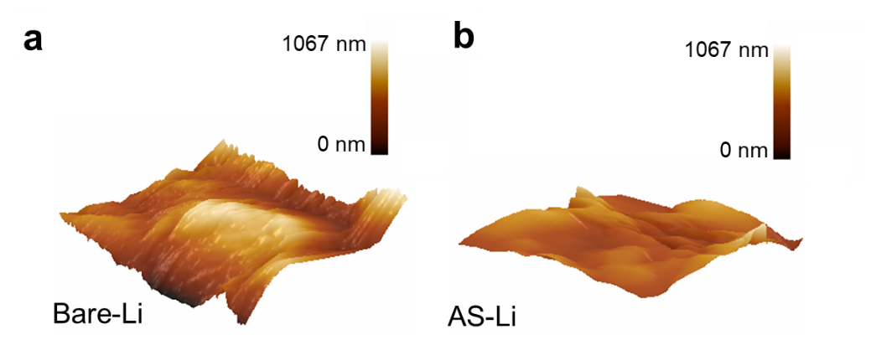
Supplementary Figure 12. 3D-AFM scanning images of a) bare-Li and b) AS-Li surfaces after 30 cycles at 1 mA cm⁻²@3 mAh cm⁻².
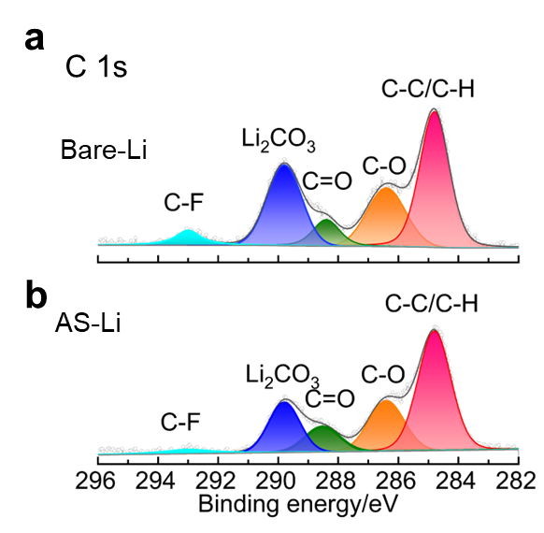
Supplementary Figure 13. XPS spectra of C 1s for a) bare-Li and b) AS-Li after 30 cycles.

Supplementary Note 4
Cryo-TEM measurements help to clarify the morphological and chemical behavior of the Li-metal electrode’s surface and give useful information. In cryo-TEM images of a lithium rod treated using molten LiFSI (Supplementary Fig. 14), a mosaic-pattern surface structure decorated with abundant inorganic nanocrystals was observed. To show the changes in the SEIs during operation, atomic- resolution cryo-TEM imaging was combined with fast Fourier transform (FFT) pattern analysis to identify the different components. After 30 cycles at 1 mA cm⁻²@3 mAh cm⁻², the bare-Li has an organic-dominated SEI with some dispersed crystalline components (Li₂O and Li₂CO₃) (Extended Data Figs. 1a–f). AS-Li shows an inorganic-dominated SEI with a mosaic-pattern structure. A high-resolution cryo-TEM (cryo-HRTEM) image (Extended Data Fig. 1g) and the corresponding FFT analysis results (Extended Data Fig. 1h–o) prove that this SEI is comprised of LiF, Li₂SO₄, Li₃N, and Li₂O, as highlighted by the different colors, which agrees well with the XPS (Supplementary Fig. 7) and TOF-SIMS (Fig. 2b–e and Supplementary Fig. 8) results for AS-Li. This pre-formed interlayer is stable, effectively inhibiting side reactions between LE and Li metal.
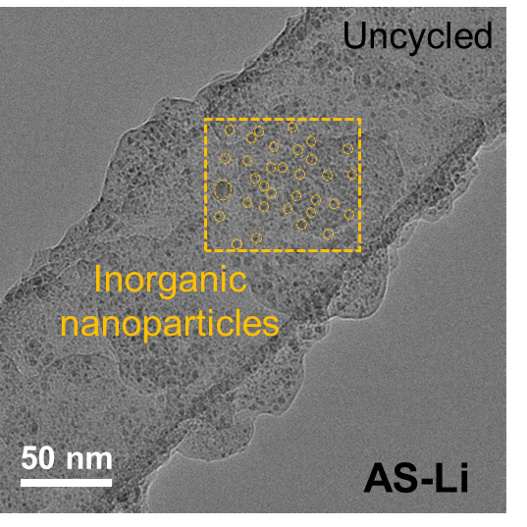
Supplementary Figure 14. Cryo-TEM image of the SEI on AS-Li showing the distribution of inorganic nanoparticles outlined in yellow.

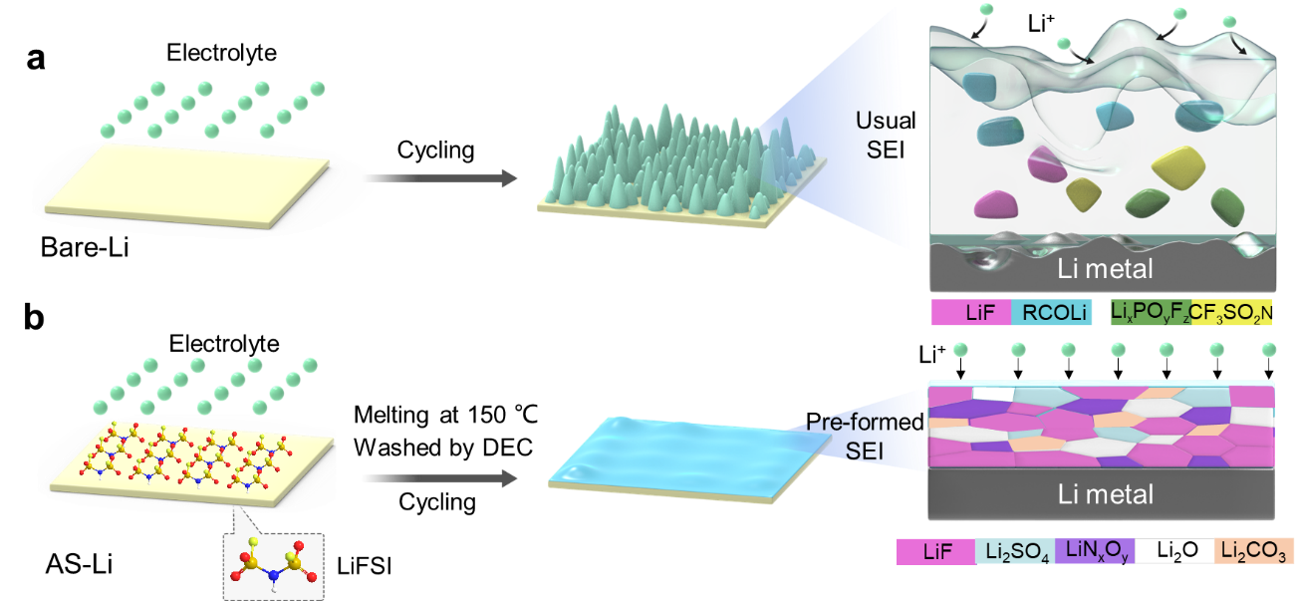
Supplementary Figure 15. Interphase changes. Schematic of the SEIs in a) bare-Li and b) AS-Li during long-term reversible deposition.
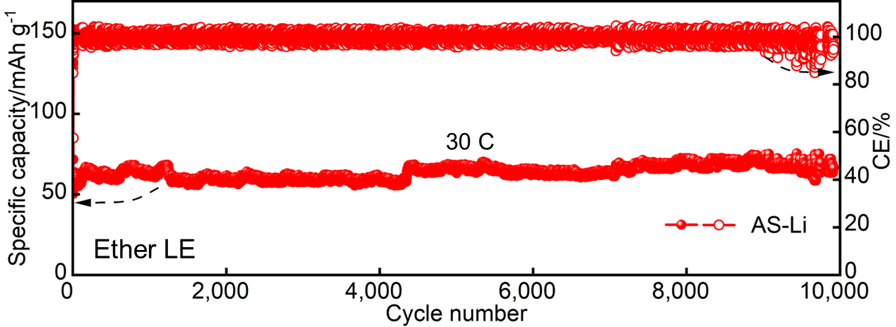
Supplementary Figure 16. Cycling performance of an AS-Li/LFP half cell at 30 C.
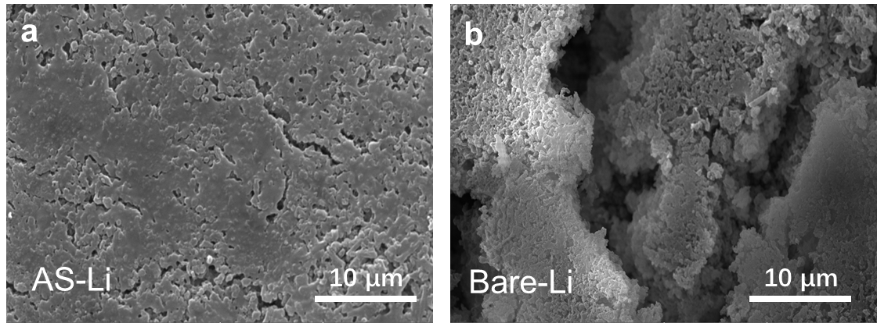
Supplementary Figure 17. Morphology of the electrode surface after cycling. SEM images of a) AS-Li and b) bare-Li after cycling at 10 C when paired with LFP.
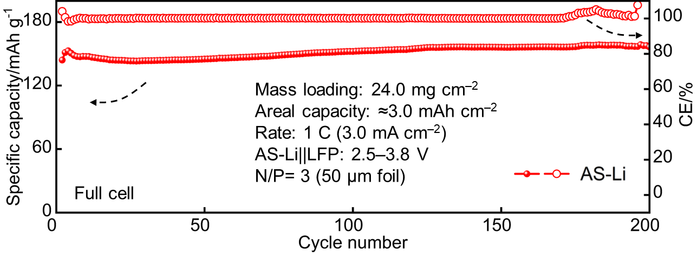
Supplementary Figure 18. Cycling performance of an AS-Li||LFP full cell at 1 C.
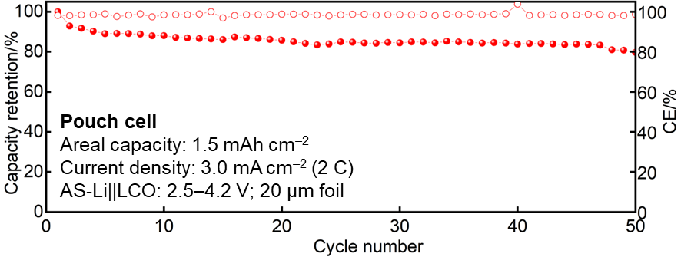
Supplementary Figure 19. Cycling performance of an AS-Li||LCO pouch cell at 2 C.
Supplementary Note 5
Ether-based LEs have been shown to favor the formation of thin, robust, and stable SEIs, thus providing higher CEs and improved dendrite suppression on Li anodes^{18, 19}. However, switching to a commercial carbonate electrolyte instead of ether LE significantly reduces the cost of LMBs. Our pre-formed SEI has also proven its effectiveness in the carbonate LE system (1.0 M LiPF₆ in EC:DEC = 1:1 vol.%). In morphology terms, after shallow cycling at 1 mA cm⁻²@3 mAh cm⁻² for 30 cycles, the bare-Li surface (Extended Data Fig. 2a) becomes rough, with cracks and mossy dendritic growths, which reduce the reversibility of the Li plating/stripping process and gradually reduce the lithium utilization ratio^{20, 21}. In contrast, both the surface and cross-section profiles of the cycled AS-Li remain flat and dense, with no Li dendrites or cracks. The 3D-AFM scanning images in Extended Data Figs. 2b and c show that the surface morphology of the cycled AS-Li is much smoother, indicating its intrinsically resilient nature during repeated Li metal stripping and plating.
In both composition and interfacial chemistry, inorganic materials including LiF and LiN_{x}O_{y} are present in larger amounts in the SEI in AS-Li (Extended Data Figs. 2d–f), indicating that it is stable and can withstand electrochemical cycling while suppressing native SEI growth. Note that distinct differences were observed in the SEI formed on bare-Li, particularly in terms of the P 2p spectra (Extended Data Fig. 2f). Li_{x}PF_{y} (136.5 eV) and Li_{x}PO_{y}F_{z} (133.5 eV)²² were obviously present on the bare-Li surface, whereas neither were found on AS-Li. This indicates that a vigorous depletion reaction occurs between bare-Li and LiPF₆ in the electrolyte, which is inhibited on the AS-Li surface^{23, 24}. The absence of the P species clearly confirms that there is no consumption of Li by the carbonate LE in AS-Li. These results show good agreement with cryo-TEM observations. In bare-Li, an approximately 63-nm-thick SEI layer was observed (Extended Data Fig. 2g), while the cycled AS-Li surface region had a much thinner (<25 nm) SEI (Extended Data Fig. 2h). The outermost layer of the SEI on AS-Li has organic components, and its thickness (≈10 nm) is only one-sixth of that of the SEI on bare-Li, indicating significant suppression of parasitic reactions between Li metal and the electrolyte.
TOF-SIMS measurements were also used to quantify the composition of the SEIs. In the spatial distribution of fragments in the usual SEI in bare-Li (Extended Data Figs. 2i and j), a large amount of C₂H⁻ supplemented by vast numbers of P species, e.g., PO₂⁻, PO₃⁻, PF₂O₂⁻, and LiPFO₂⁻ are observed. This is in line with the XPS and cryo-TEM results. In AS-Li, the SEI is principally dominated by inorganic nanocrystals, including abundant LiF and portions of Li₂SO₄, Li₂CO₃, and Li₂O (Extended Data Figs. 2k and l). Regardless of the sputtering depth, the Li₂F⁺ content remains high, while the representative organic C₂H⁻ fragment count decreases sharply as a function of sputtering depth. This signifies that the organic RCOLi that results from solvent decomposition is present only at the outermost surface, rather than in the bulk. The sharp visual contrast between the SEIs on bare-Li and AS-Li in terms of compositions confirms that more severe side reactions occurred in bare-Li.
In terms of electrochemical performance, stable cycling for over 1,400 cycles (Extended Data Fig. 2m) was shown by AS-Li||LFP at 10 C. Note that although the long-term cycling stability of AS-Li||LFP in a carbonate LE is comparable to that in an ether LE (Fig. 5a), the specific capacity of LFP in the carbonate LE is inferior (≈100 versus ≈120 mAh g⁻¹). The performance was mainly affected by the viscosity, wettability, and conductivity of the electrolyte itself, along with the grown cathode electrolyte interphase (CEI)²⁵, but this is beyond the scope of this study. We also gradually increased the test rate to 50 C using the carbonate LE, and exceptional ultrahigh-rate cycling was achieved (Supplementary Fig. 20) in combination with an apparently increased rate capability (Supplementary Fig. 21) and reduced polarizations in both half cells (Supplementary Fig. 22) and Li symmetric cells (Supplementary Fig. 23). The full cell even showed stable cycling for 600 cycles at 1 C with an ultralow fade rate of only 0.038% per cycle.
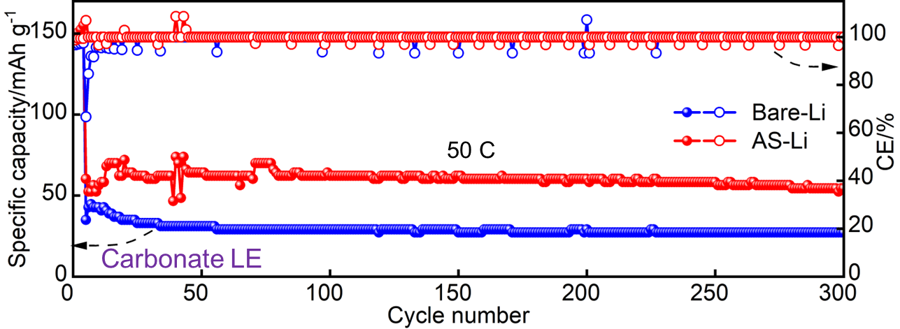
Supplementary Figure 20. Cycling performance of bare-Li||LFP and AS-Li||LFP half cells at 50 C with a carbonate LE.
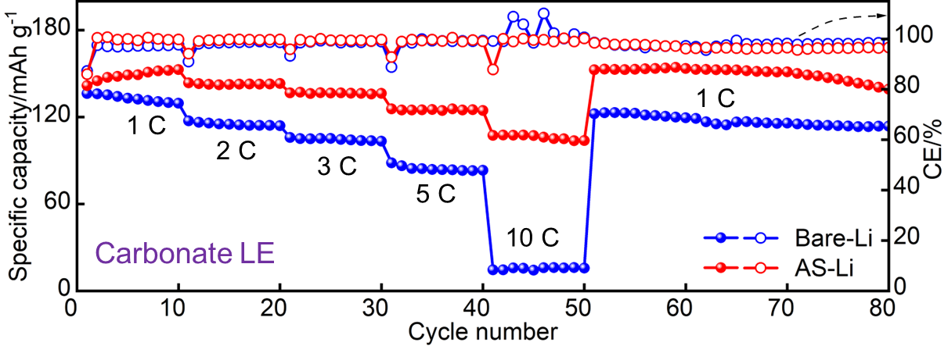
Supplementary Figure 21. Rate capability of bare-Li||LFP and AS-Li||LFP half cells with a carbonate LE.
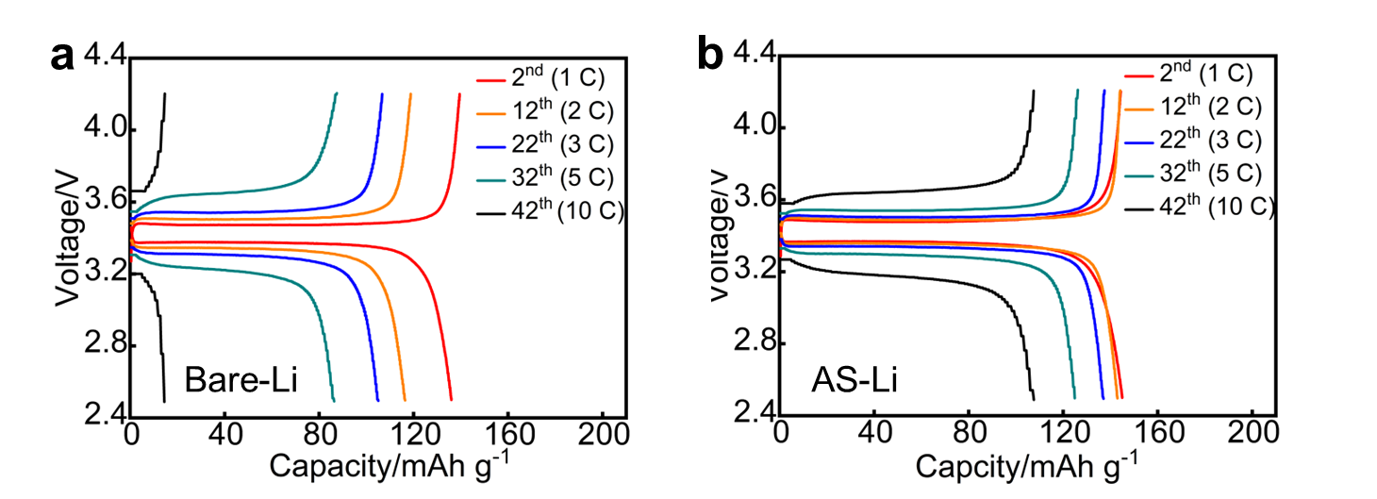
Supplementary Figure 22. Voltage profile of different electrode pairs. The charge/discharge curves of a) bare-Li||LFP and b) AS-Li||LFP cells at 1 C, 2 C, 3 C, 5 C and 10 C.
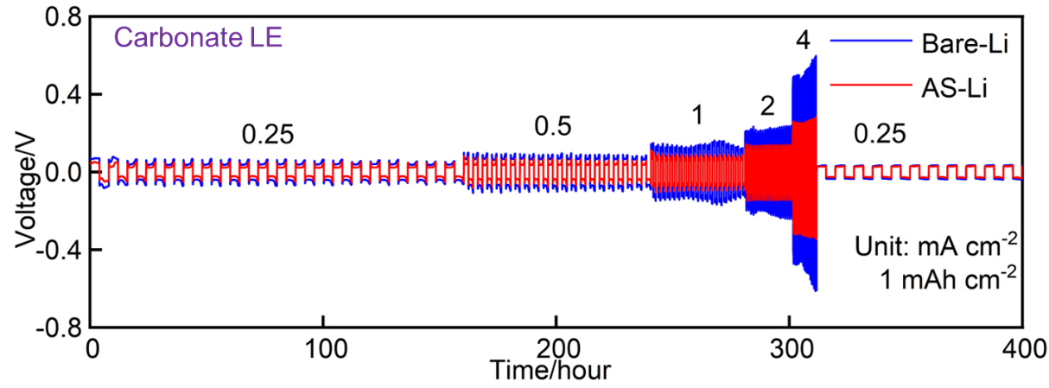
Supplementary Figure 23. Li plating/stripping overpotentials of AS-Li and bare-Li at different current densities from 0.25 to 4 mA cm⁻² for a capacity of 1 mAh cm⁻².

Supplementary Note 6
Changing electrolyte recipes affects the electrochemical performance, because it determines the reactivity, electrochemical stability, and Li⁺ transport in LMBs, as reflected by the formation of a SEI²⁶. In this study, the inorganic-rich pre-formed SEI layer on the AS-Li surface offers a strong shielding effect (Extended Data Fig. 3), which significantly improves the cycling stability as well as the rate capability of the corresponding LMBs. Such a shielding effect includes the following aspects. First, the SEI layer ensures superior Li metal wettability for LEs to enable quick electrolyte uptake and cause a uniform Li⁺ flux to arrive at the Li metal surface. Second, it prevents parasitic reactions between Li and electrolytes, thus inhibiting the continuous consumption of Li and electrolyte to form a fragile and uneven SEI. Third, rather than having a SEI composed of disordered and chemically inhomogeneous organic byproducts with a low fracture toughness, the pre-formed SEI provides good mechanical strength to suppress the growth and propagation of lithium dendrites, which ensures improved Li deposition reversibility. Fourth, the abundant inorganic interfaces in the pre-formed SEI provide a large number of channels for rapid and uniform Li⁺ transfer, which promotes regular Li deposition with a smaller local current density and a significantly improved high-rate capability^{27, 28}.
This study confirms that immersing the Li in LiFSI molten salt to pre-form an AS-Li anode is applicable to different electrolyte chemistries. However, at this stage, the real obstacles that inhibit the practical use of LMBs are performance and safety, rather than cost. To facilitate research and development in overcoming these challenges, advanced electrolyte design strategies, e.g., localized highly concentrated electrolyte (LHCE)²⁹, fluorinated solvents^{18, 30} and functional additives³¹, are also invaluable, but these are not in conflict with the modification of the lithium metal itself.

Supplementary Tables
Supplementary Table 1. Summary of the thickness, ionic conductivity and Young’s modulus of SEIs reported in the literature³².
SEIs | Thickness | Ionic conductivity (S cm⁻¹) | Young’s modulus (GPa) | Digital object identifier  (doi)
FE-Li | 640 nm | 1.0 × 10⁻⁴ | 6.2 | 10.1021/jacs.0c12051
LiPON/Au | 500 nm | 1.1 × 10⁻⁵ | 9.5 | 10.1021/acsami.0c12248
Graphene film | 5 nm | 2.0 × 10⁻⁶ | 7.7 | 10.1021/acs.nanolett.7b03071
PVDF | ≈5 µm | 2.6× 10⁻³ | 2 | 10.1002/advs.201901120
Supramolecular layer | 2.5µm | 2.6× 10⁻⁵ | 3.14 | 10.1016/j.ensm.2020.07.007
LiF/Cu layer | 2 µm | 1.8× 10⁻⁴ | 12.9 | 10.1002/adma.201804461
Nafion/LiCl | 2.5 µm | 5.0× 10⁻⁴ | 6.12 | 10.1002/adma.201804461
[LiNBH]_{n} layer | ≈150 nm | 6.6× 10⁻⁶ | 2.2 | 10.1002/adfm.202002414
ETPTA/DADMA-TFSI | ≈1 µm | 1.2 × 10⁻³ | 5.23 | 10.1002/adfm.202002414
Sb₂O₃ layer | 5±2 μm | 6.8 × 10⁻⁴ | 11 | 10.1016/j.nanoen.2019.104399
Graphite-SiO₂ bilayer | 20 nm | 2.4× 10⁻⁴ | 10.07 | 10.1002/aenm.201901486
ZrO₂ (PVDF-HFP) | 21.7 µm | 1.1×10⁻³ | 2.1 | 10.1002/aenm.201901488
Oligo (ethylene glycol) | 3.5 µm | 1.1×10⁻³ | 7 | 10.1016/j.elecom.2004.09.023
COF film | 10 nm | 1.5× 10⁻³ | 6.8 | 10.1002/adfm.201907717
Li₃Bi/LiF layer | 5 µm | 6.9 × 10⁻⁴ | 22 | 10.1038/s41467-019-11168-y
AS-Li | 2 µm | 7.1 × 10⁻³ | 18.7 | This work

Supplementary Table 2. Summary of symmetric cell performance reported since 2021 in comparison to this work.
Substrates/Materials |  | Current density  (mA cm⁻²) | Areal capacity  (mAh cm⁻²) | Cycling duration (h) | Cumulative capacity  (mAh cm⁻²) | Electrolyte | Ref. (doi, year)
Symmetric cell performance | Porous lithiophilic Li-Si alloy-type interfacial framework (Li-Si alloy) | 10 | 5 | 400 | 4,000 | 1.0 M LiTFSI in DOL: DME = 1:1 vol.% | ³³  10.1002/aenm.202101544  (2021)
Symmetric cell performance | A self-supporting carbon membrane with perpendicular micro-channels blanketed by carbon nanofiber mats (Carbon membrane with perpendicular micro-channels) | 10 | 30 | 6,480 | 64,800 | 1.0 M LiTFSI in DOL: DME = 1:1 vol.% with 3 wt.% LiNO₃ | ³⁴  10.1016/j.matt.2022.01.017  (2022)
Symmetric cell performance |  | 10 | 40 | 3,200 | 32,000 | 1.0 M LiTFSI in DOL: DME = 1:1 vol.% with 3 wt.% LiNO₃ | ³⁴  10.1016/j.matt.2022.01.017  (2022)
Symmetric cell performance | Integration of porous (poly(oligo(ethylene glycol) methylether methacrylate)-grafted, hypercross-linked poly(4‐chloromethylstyrene) nanospheres (xPCMS-g-PEGMA/LN) | 5 | 1 | 9,400 | 47,000 | 1.0 M LiTFSI in DOL: DME = 1:1 vol.% with 1 wt.% LiNO₃ | ³⁵  10.1038/s41565-022-01107-2  (2022)
Symmetric cell performance |  | 10 | 1 | 9,100 | 91,000 | 1.0 M LiTFSI in DOL: DME = 1:1 vol.% with 1 wt.% LiNO₃ | ³⁵  10.1038/s41565-022-01107-2  (2022)
Symmetric cell performance |  | 10 | 10 | 2,800 | 28,000 | 1.0 M LiTFSI in DOL: DME = 1:1 vol.% with 1 wt.% LiNO₃ | ³⁵  10.1038/s41565-022-01107-2  (2022)
Symmetric cell performance | Self-assembled monolayers (SAMs) with high-density and long-range-ordered polar carboxyl groups linked to an aluminum oxide-coated separator (SAMs-grafted separator) | 1 | 1 | 2,500 | 2,500 | 1.0 M LiTFSI in DOL: DME = 1:1 vol.% with 1 wt.% LiNO₃ | ³⁶  10.1126/science.abn1818  (2022)
Symmetric cell performance |  | 5 | 5 | 600 | 3,000 | 1.0 M LiTFSI in DOL: DME = 1:1 vol.% with 1 wt.% LiNO₃ | ³⁶  10.1126/science.abn1818  (2022)
Symmetric cell performance | An organophosphorus hybrid flexible solid electrolyte interphase (SEI) layer on Li (Li_{x}PO₄ SEI) | 5 | 5 | 2,500 | 12,500 | 1.0 M LiTFSI in DOL:DME = 1:1 vol.% with 2 wt.% LiNO₃ | ³⁷  10.1002/adfm.202107923  (2021)
Symmetric cell performance |  | 10 | 5 | 2,500 | 25,000 | 1.0 M LiTFSI in DOL:DME = 1:1 vol.% with 2 wt.% LiNO₃ | ³⁷  10.1002/adfm.202107923  (2021)
Symmetric cell performance | A thin covalent organic framework (COF) in-situ fabricated on Li | 5 | 5 | 1,200 | 6,000 | 1.0 M LiTFSI and 0.1 M LiNO₃ in DOL:DME = 1:1 vol.% | ³⁸  10.1002/anie.202116586  (2022)
Symmetric cell performance |  | 10 | 10 | 13,200 | 132,000 | 1.0 M LiTFSI and 0.1 M LiNO₃ in DOL:DME = 1:1 vol.% | ³⁸  10.1002/anie.202116586  (2022)
Symmetric cell performance | A hierarchical three-dimensional structure with CoSe₂-nanoparticle-anchored nitrogen-doped carbon nanoflake arrays (CoSe₂-NC@CFC) | 10 | 10 | 1,600 | 16,000 | 1.0 M LiTFSI in DOL:DME = 1:1 vol.% with 1 wt.% LiNO₃ | ³⁹  10.1002/advs.202104689  (2022)
Symmetric cell performance | Chemical etchant using lithium bromide (LiBr) to achieve a passivation-free naked Li metal | 10 | 1 | 10,000 | 100,000 | 1.0 M LiPF₆ in EC:DEC = 1:1 vol.% with 10 wt.% FEC | ⁴⁰  10.1038/s41467-023-36934-x  (2023)
Symmetric cell performance | Pre-formed SEI: AS-Li | 30 | 30 | 8,000 | 240,000 | 1.0 M LiTFSI in DOL: DME = 1:1 vol.% with 2 wt.% LiNO₃ | This work
Symmetric cell performance | Pre-formed SEI: AS-Li | 30 | 3 | 2,000 | 60,000 | 1.0 M LiTFSI in DOL: DME = 1:1 vol.% with 2 wt.% LiNO₃ | This work
Symmetric cell performance | Pre-formed SEI: AS-Li | 20 | 5 | 6,100 | 150,000 | 1.0 M LiTFSI in DOL: DME = 1:1 vol.% with 2 wt.% LiNO₃ | This work
Symmetric cell performance | Pre-formed SEI: AS-Li | 5 | 5 | 4,000 | 20,000 | 1.0 M LiTFSI in DOL: DME = 1:1 vol.% with 2 wt.% LiNO₃ | This work

Supplementary Table 3. Summary of LMB half cell high rate performance reported since 2021 in comparison to this work.
Technique approaches | Current rate  (C) | Specific capacity  (mAh g⁻¹) | Cycle number | Capacity retention | Fading rate per cycle | Electrolyte | Areal mass  loading  (mg cm⁻²) | Ref. (doi, year)
Electrolyte engineering: high-polarity fluoroalkyl ether electrolyte  (THE-based LE) | 10 | ≈88 (≈83) | 5,000 | 94.0% | 0.0012% | 1.0 M LiTFSI in DOL:DME = 1:1 vol.% with 60 vt.% fluoroalkyl ether 2,2,2-trifluoroethyl-1,1,2,3,3,3-hexafluoropropyl ether (THE) | ≈1.5 | ⁴¹  10.1002/advs.202104699  (2021)
Current collector modification: coaxial nano chamber heterojunction on carbon nanofibers (Li@MnZnO/CNF) | 5 | 97.7 (85) | 600 | 87.0% | 0.0217% | 1.0 M LiPF₆ in EC:DEC = 1:1 vol.% | ≈3.5 | ⁴²  10.1002/advs.202101940  (2021)
Alloying: porous lithiophilic Li-Si alloy-type interfacial framework  (Li-Si alloy) | 5 | ≈90 (≈71) | 1,000 | 79.0% | 0.0211% | 1.0 M LiPF₆ in EC:DEC = 1:1 vol.% | 1.2−1.4 | ³³  10.1002/aenm.202101544  (2021)
 | 10 | ≈75 (≈54) | 2,000 | 71.4% | 0.0143% | 1.0 M LiPF₆ in EC:DEC = 1:1 vol.% | 1.2−1.4 | ³³  10.1002/aenm.202101544  (2021)
Separator modification: Zn-ZnO@PP separator  (Zn-ZnO@PP) | 5 | 111.8 (102.3) | 2,000 | 91.5% | 0.0043% | 1.0 M LiTFSI in DOL: DME = 1:1 vol.% with 2 wt.% LiNO₃ | N/A | ⁴³  10.1021/acsnano.2c05832  (2022)
Surface modification of 3D structure: MXene layer on Li metal  (SWA-MXene-Li) | 6.4 | 102 (100) | 430 | 83.3% | 0.0388% | 1.0 M LiTFSI in DOL:DME = 1:1 vol.% with 1.0 wt.% LiNO₃ | ≈1.5 | ⁴⁴  10.1002/aenm.202201181  (2022)
Surface modification of 2D Ti₃CNT_{x} and 3D rGO-based conductive scaffold structure  (Ti₃CNT_{x}-rGO-Li) | 3 | ≈130 (≈120) | 800 | 92.3% | 0.01% | 1.0 M LiPF₆ in EC: DEC:EMC = 1:1:1 vol.% with 1 wt.% FEC | ≈4.0 | ⁴⁵  10.1016/j.ensm.2023.03.030  (2023)
 | 10 | ≈110 (≈100) | 500 | 90.9% | 0.0182% | 1.0 M LiPF₆ in EC: DEC:EMC = 1:1:1 vol.% with 1 wt.% FEC | ≈4.0 | ⁴⁵  10.1016/j.ensm.2023.03.030  (2023)
 | 30 | 72 (56) | 900 | 77.7% | 0.0248% | 1.0 M LiPF₆ in EC: DEC:EMC = 1:1:1 vol.% with 1 wt.% FEC | ≈4.0 | ⁴⁵  10.1016/j.ensm.2023.03.030  (2023)
Surface modification of 3D structure: in-situ construction of aramid nanofiber membrane on Li  (3D aramid NF) | 5 | 110 (105) | 600 | 95.0% | 0.0083% | 1.0 M LiPF₆ in EC:DMC = 1:1 vol.% | ≈6.0 | ⁴⁶  10.1002/smll.202102347  (2021)
Artificial SEI: organophosphorus hybrid solid electrolyte interphase based on Li_{x}PO₄  (Li_{x}PO₄ SEI) | 5 | ≈100 | 300 | ＞98.5% | 0.0050% | 1.0 M LiPF₆ in EC:DMC = 1:1 vol.% | ≈8.0 | ³⁷  10.1002/adfm.202107923  (2021)
Pre-formed SEI: AS-Li | 10 | 119.9 (111.2) | 1,200 | 92.6% | 0.0062% | 1.0 M LiTFSI in DOL: DME = 1:1 vol.% with 2 wt.% LiNO₃ | ≈2.0 | This work
Pre-formed SEI: AS-Li | 20 | 83.7 (78.8) | 3,000 | 94.1% | 0.0019% | 1.0 M LiTFSI in DOL: DME = 1:1 vol.% with 2 wt.% LiNO₃ | ≈2.0 | This work
Pre-formed SEI: AS-Li | 30 | 71.0 (67.0) | 10,000 | 94.4% | 0.0006% | 1.0 M LiTFSI in DOL: DME = 1:1 vol.% with 2 wt.% LiNO₃ | ≈2.0 | This work
Pre-formed SEI: AS-Li | 50 | 74.8 (51.2) | 9,000 | 68.4% | 0.0035% | 1.0 M LiTFSI in DOL: DME = 1:1 vol.% with 2 wt.% LiNO₃ | ≈2.0 | This work

Supplementary Table 4. Summary of the demonstrated power and energy densities of LFP paired with AS-Li and bare-Li using an ether LE in the half cell configuration.
Pairs of active materials |  | 1 C | 2 C | 5 C | 10 C | 20 C | 50 C
AS-Li/LFP | Energy density (Wh kg⁻¹) | 486 | 448 | 411 | 365 | 284 | 208
AS-Li/LFP | Power density (W kg⁻¹) | 486 | 896 | 2,054 | 3,650 | 5,670 | 10,416
Bare-Li/LFP | Energy density (Wh kg⁻¹) | 452 | 423 | 365 | 310 | 225 | 126
Bare-Li/LFP | Power density (W kg⁻¹) | 452 | 845 | 1,827 | 3,100 | 4,500 | 6,300

Supplementary Table 5. Summary of high loaded (> 10 mg cm⁻²) LMB full cells under high rate conditions (≥ 1 C) reported since 2021 in comparison to this work.
Technique approaches | Current rate  (C) | Specific capacity  (mAh g⁻¹) | Cycle number | N/P  ratio | Capacity retention (Fading rate per cycle) | Electrolyte | Areal mass  loading  (mg cm⁻²) | Ref. (doi, year)
Alloying: porous lithiophilic Li-Si alloy-type interfacial framework  (Li-Si alloy) | 1 | ≈126 (≈94) | 100 | 3.4 | 74.7% (0.253%) | 1.0 M LiPF₆ in EC:DEC = 1:1 vol.% | 15.0 (NCM) | ³³  10.1002/aenm.202101544  (2021)
 | 1 | ≈107 (≈81) | 100 | <3.7 | 75.6% (0.244%) | 1.0 M LiPF₆ in EC:DEC = 1:1 vol.% | 15.0  (LFP) | ³³  10.1002/aenm.202101544  (2021)
Substrate modification: lithiophobic Fe/LiF@Cu nanocomposite to deposit hexagonal Li crystals  (Fe/LiF@Cu) | 1 | ≈181 (≈142) | 130 | 2 | 80.0% (0.154%) | 2.0 M LiFSI in  DME/BTFE (Bis(2,2,2-trifluoroethyl)ether) | 16.0 (NCM) | ⁴⁷  10.1038/s41560-023-01202-1  (2023)
Substrate modification: 3D free-standing carbon nanofibers modified by lithiophilic metal  particles  (CNF/Sn-Li) | 1 | 137 (131) | 110 | 10 | 95.4% (0.042%) | 1.0 M LiTFSI in DOL: DME = 1:1 vol.% with 2 wt.% LiNO₃ | 11.0  (LFP) | ⁴⁸  10.1002/eem2.12470  (2022)
Artificial SEI: organophosphorus hybrid solid electrolyte interphase layer based on Li_{x}PO₄  (Li_{x}PO₄ SEI) | 1 | ≈128 (≈124) | 200 | 3 | 96.9% (0.016%) | 1.0 M LiPF₆ in EC:DMC = 1:1 vol.% | 16.0  (LFP) | ³⁷  10.1002/adfm.202107923  (2021)
Artificial SEI: carboxymethylcellulose lithium (CMC-Li) as an artificial SEI layer  (CMC-Li@Li) | 1 | ≈165 (≈132) | 200 | 2 | 80.0% (0.100%) | 1.0 M LiPF₆ in EC:DEC:DMC = 1:1:1 vol.% | 17.8 (NCM) | ⁴⁹  10.1016/j.ensm.2021.11.022  (2021)
 | 3 | ≈140 (≈115) | 100 | 2 | 79.3% (0.207%) | 1.0 M LiPF₆ in EC:DEC:DMC = 1:1:1 vol.% | 17.8 (NCM) | ⁴⁹  10.1016/j.ensm.2021.11.022  (2021)
Pre-formed SEI: AS-Li | 3 | 0.98 (0.77)ª | 500 | 6 | 78.6% (0.043%) | 1.0 M LiTFSI in DOL: DME = 1:1 vol.% with 2 wt.% LiNO₃ | ≈11.0 (LCO) | This work
Pre-formed SEI: AS-Li | 6 | 0.83 (0.55)ª | 500 | 6 | 66.3% (0.067%) | 1.0 M LiTFSI in DOL: DME = 1:1 vol.% with 2 wt.% LiNO₃ | ≈11.0 (LCO) | This work
Pre-formed SEI: AS-Li | 1 | 1.36 (1.32)ª | 150 | 2.5 | 97.1% (0.024%) | 1.0 M LiTFSI in DOL: DME = 1:1 vol.% with 2 wt.% LiNO₃ | ≈11.0 (LCO) | This work
Pre-formed SEI: AS-Li | 3 | 1.15 (1.09)ª | 150 | 2.5 | 94.8% (0.035%) | 1.0 M LiTFSI in DOL: DME = 1:1 vol.% with 2 wt.% LiNO₃ | ≈11.0 (LCO) | This work
Pre-formed SEI: AS-Li | 1 | 158 (154) | 200 | 3 | 97.5% (0.013%) | 1.0 M LiTFSI in DOL: DME = 1:1 vol.% with 2 wt.% LiNO₃ | 24.0  (LFP) | This work
Pre-formed SEI: AS-Li | 1 | 146 (113) | 600 | 6 | 77.4% (0.038%) | 1.0 M LiPF₆ in EC:DEC = 1:1 vol.% | 11.9  (LFP) | This work
ª The presented data are the areal capacities instead of specific capacity or mass loading.

References
1. Zou, P. et al. Polymorph evolution mechanisms and regulation strategies of lithium metal anode under multiphysical fields. Chem. Rev. 121, 5986–6056 (2021).
2. Gao, Y. et al. Polymer-inorganic solid-electrolyte interphase for stable lithium metal batteries under lean electrolyte conditions. Nat. Mater. 18, 384–389 (2019).
3. Eshetu, G.G. et al. In-depth interfacial chemistry and reactivity focused investigation of lithium-imide-and lithium-imidazole-based electrolytes. ACS Appl. Mater. Interfaces 8, 16087–16100 (2016).
4. Lee, S.H. et al. Long-lasting solid electrolyte interphase for stable Li-metal batteries. ACS Energy Lett. 6, 2153–2161 (2021).
5. Gao, Y. et al. Salt-based organic-inorganic nanocomposites: towards a stable lithium metal/Li₁₀GeP₂S₁₂ solid electrolyte interface. Angew. Chem. Int. Ed. 57, 13608–13612 (2018).
6. Zhao, Q. et al. On the crystallography and reversibility of lithium electrodeposits at ultrahigh capacity. Nat. Commun. 12, 1–10 (2021).
7. Lu, Z. et al. Modulating nanoinhomogeneity at electrode-solid electrolyte interfaces for dendrite-proof solid-state batteries and long-life memristors. Adv. Energy Mater. 11, 2003811 (2021).
8. Shen, C., Huang, Y., Yang, J., Chen, M. & Liu, Z. Unraveling the mechanism of ion and electron migration in composite solid-state electrolyte using conductive atomic force microscopy. Energy Storage Mater. 39, 271–277 (2021).
9. Wu, J. et al. A synergistic exploitation to produce high-voltage quasi-solid-state lithium metal batteries. Nat. Commun. 12, 5746 (2021).
10. Sun, J. et al. Robust transport: an artificial SEI design for anode free lithium metal battery. Adv. Mater. 2209404 (2022).
11. Liang, G. et al. Regulating inorganic and organic components to build amorphous-ZnF_{x} enriched solid-electrolyte interphase for highly reversible Zn metal chemistry. Adv. Mater. 2210051 (2023).
12. Wang, J., Zhang, Z., Ying, H., Han, G. & Han, W.Q. In-situ formation of LiF-rich composite interlayer for dendrite-free all-solid-state lithium batteries. Chem. Eng. J. 411, 128534 (2021).
13. Stadt, M.G. et al. Assessing LiF as coating material for Li metal electrodes. J. Appl. Electrochem. 52, 339–355 (2022).
14. Chen, L. et al. Novel ALD chemistry enabled low-temperature synthesis of lithium fluoride coatings for durable lithium anodes. ACS Appl. Mater. Interfaces 10, 26972–26981 (2018).
15. Ma, X.X. et al. The origin of fast lithium-ion transport in the inorganic solid electrolyte interphase on lithium metal anodes. Small Struct. 3, 2200071 (2022).
16. Shi, Y. et al. Interfacial evolution of lithium dendrites and their solid electrolyte interphase shells of quasi-solid-state lithium-metal batteries. Angew. Chem. Int. Ed. 59, 18120–18125 (2020).
17. Xiao, Y., Xu, R., Xu, L., Ding, J.F. & Huang, J.Q. Recent advances in anion-derived SEIs for fast-charging and stable lithium batteries. Energy Mater. 1, 100013 (2022).
18. Zhao, Y. et al. Fluorinated ether electrolyte with controlled solvation structure for high voltage lithium metal batteries. Nat. Commun. 13, 2575 (2022).
19. Wang, Y. et al. Ultralong cycle life organic cathode enabled by ether-based electrolytes for sodium-ion batteries. Adv. Energy Mater. 11, 2101972 (2021).
20. Yang, X. et al. Suppressed dendrite formation realized by selective Li deposition in all-solid-state lithium batteries. Energy Storage Mater. 27, 198–204 (2020).
21. Liu, T. et al. Lithiophilic Ag/Li composite anodes via a spontaneous reaction for Li nucleation with a reduced barrier. J. Mater. Chem. A 7, 20911–20918 (2019).
22. Wotango, A.S. et al. Improved interfacial properties of MCMB electrode by 1-(trimethylsilyl)imidazole as new electrolyte additive to suppress LiPF₆ decomposition. ACS Appl. Mater. Interfaces 9, 2410–2420 (2017).
23. Kim, H., Kim, Y.S. & Yoo, J. An in situ formed LiF protective layer on a Li metal anode with solvent-less cross-linking. Sustainable Energy Fuels 4, 3282–3287 (2020).
24. Parimalam, B.S. & Lucht, B.L. Reduction reactions of electrolyte salts for lithium ion batteries: LiPF₆, LiBF₄, LiDFOB, LiBOB, and LiTFSI. J. Electrochem. Soc. 165, A251 (2018).
25. Ren, X. et al. Enabling High-Voltage Lithium-Metal Batteries under Practical Conditions. Joule 3, 1662–1676 (2019).
26. Wang, H. et al. Liquid electrolyte: the nexus of practical lithium metal batteries. Joule 6, 588–616 (2022).
27. Liu, X.M. & Arnold, C.B. Effects of current density on defect-induced capacity fade through localized plating in lithium-ion batteries. J. Electrochem. Soc. 167, 130519 (2020).
28. Ramasubramanian, A. et al. Lithium diffusion mechanism through solid-electrolyte interphase in rechargeable lithium batteries. J. Phys. Chem. C 123, 10237–10245 (2019).
29. Giffin, G.A. The role of concentration in electrolyte solutions for non-aqueous lithium-based batteries. Nat. Commun. 13, 5250 (2022).
30. Zhang, G. et al. A monofluoride ether-based electrolyte solution for fast-charging and low-temperature non-aqueous lithium metal batteries. Nat. Commun. 14, 1081 (2023).
31. Kim, M.S. et al. Suspension electrolyte with modified Li⁺ solvation environment for lithium metal batteries. Nat. Mater. 21, 445–454 (2022).
32. Liu, Y. et al. Electro-chemo-mechanical modeling of artificial solid electrolyte interphase to enable uniform electrodeposition of lithium metal anodes. Adv. Energy Mater. 12, 2103589 (2022).
33. Park, J.B., Choi, C., Yu, S., Chung, K.Y. & Kim, D.W. Porous lithiophilic Li-Si alloy‐type interfacial framework via self‐discharge mechanism for stable lithium metal anode with superior rate. Adv. Energy Mater. 11, 2101544 (2021).
34. Zhang, S. et al. Spatially hierarchical carbon enables superior long-term cycling of ultrahigh areal capacity lithium metal anodes. Matter 5, 1263–1276 (2022).
35. Li, S. et al. A robust all-organic protective layer towards ultrahigh-rate and large-capacity Li metal anodes. Nat. Nanotechnol. 17, 613–621 (2022).
36. Liu, Y. et al. Self-assembled monolayers direct a LiF-rich interphase toward long-life lithium metal batteries. Science 375, 739–745 (2022).
37. Wang, Q. et al. Organophosphorus hybrid solid electrolyte interphase layer based on Li_{x}PO₄ enables uniform lithium deposition for high‐performance lithium metal batteries. Adv. Funct. Mater. 32, 2107923 (2021).
38. He, J., Bhargav, A. & Manthiram, A. Covalent organic framework as an efficient protection layer for a stable lithium-metal anode. Angew. Chem. Int. Ed. 61, 202116586 (2022).
39. Cao, J. et al. Achieving uniform Li plating/stripping at ultrahigh currents and capacities by optimizing 3D nucleation sites and Li₂Se-enriched SEI. Adv. Sci., 2104689 (2022).
40. Baek, M. et al. Naked metallic skin for homo-epitaxial deposition in lithium metal batteries. Nat. Commun. 14, 1296 (2023).
41. Dong, L. et al. High-polarity fluoroalkyl ether electrolyte enables solvation-free Li⁺ Transfer for high-rate lithium metal batteries. Adv. Sci. 9, 2104699 (2021).
42. Le, T. et al. Deeply cyclable and ultrahigh-rate lithium metal anodes enabled by coaxial nanochamber heterojunction on carbon nanofibers. Adv. Sci. 8, 2101940 (2021).
43. Lin, L. et al. Adjustable mixed conductive interphase for dendrite-free lithium metal batteries. ACS Nano 16, 13101–13110 (2022).
44. Gu, J. et al. Eliminating lightning‐rod effect of lithium anodes via sine‐wave analogous MXene layers. Adv. Energy Mater. 12, 2201181 (2022).
45. Zhang, B. et al. Ti₃CNT MXene/rGO scaffolds directing the formation of a robust, layered SEI toward high-rate and long-cycle lithium metal batteries. Energy Storage Mater. 58, 322–331 (2023).
46. Zheng, S., Zhang, H., Fan, J., Xu, Q. & Min, Y. In situ construction of aramid nanofiber membrane on Li anode as artificial SEI layer achieving ultra-high stability. Small 17, 2102347 (2021).
47. Wu, Z. et al. Growing single-crystalline seeds on lithiophobic substrates to enable fast-charging lithium-metal batteries. Nat. Energy 8, 340–350 (2023).
48. Zhuang, H. et al. 3D free‐standing carbon nanofibers modified by lithiophilic metals enabling dendrite‐free anodes for Li metal batteries. Energy Environ. Mater. 6, 12470 (2023).
49. Dong, Q. et al. A self-adapting artificial SEI layer enables superdense lithium deposition for high performance lithium anode. Energy Storage Mater. 45, 1220–1228 (2022).

