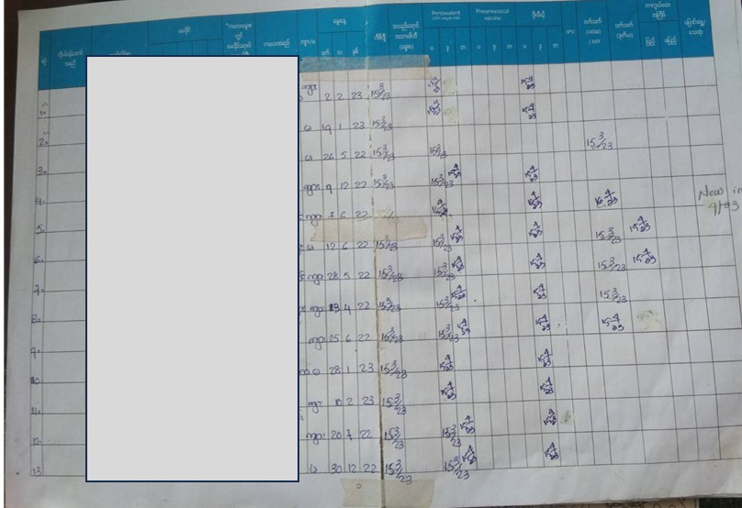
Appendix 1. Photograph of the logbook, the original source of data, recording which vaccines were administered. Data is from March and April. The grey rectangle hides identifying information. Columns to the right of the grey rectangle are sex, date of birth, date of BCG, PENTA, pneumococcal, OPV, Japanese B, MMR, and notes. The first two participants received BCG and the first dose of PENTA in March, and since OPV was out of stock, it was not received until April. The third participant received BCG, OPV, and Penta in March but appeared not to return in April.

