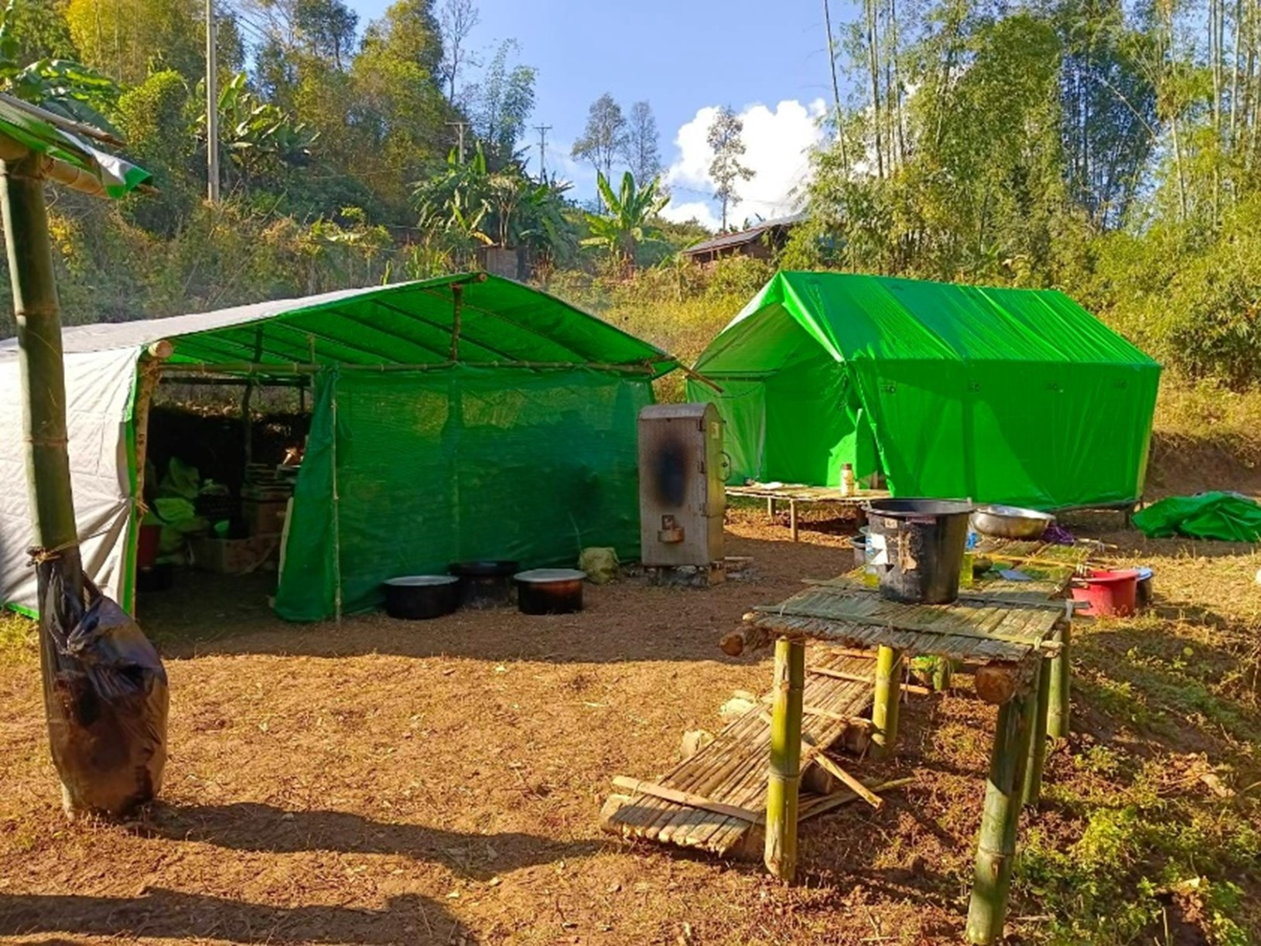
Legend. The floors are made of woven bamboo. Two or three families live in a single hut. Water supply is from nearby streams or springs, and sanitation is in an open space. There are no latrines or pit latrines built of bamboo.

