10. Appendices
10.1 Appendix A : List of tables and figures – Main manuscript
Table 1: Baseline Characteristics.
Table 2: Phosphate Administration
Table 3: Outcomes

Figure 1: Mean Daily Serum Phosphate by Severity of Hypophosphataemia
Figure 2: Daily Phosphate Administration vs Daily Low Serum Phosphate
Figure 3: Percentage of Patients That Received Phosphate Replacement by Severity of Hypophosphataemia

10.2 Appendix B : List of tables and figures – Online Supplement
Table S1. Characteristics at Diagnosis of Low Phosphate

Figure S1: ICU Day of First Low Serum Phosphate
Figure S2: Number of Patients with Low Serum Phosphate for each day during ICU Admission
Figure S3: Hypophosphataemia Severity Over Time
Figure S4: Proportion of ICU Days with Hypophosphataemia
Figure S5: Proportion of Patients Based on Type of Phosphate Replacement
Figure S6: Daily Phosphate Administration vs Daily Low Serum Phosphate by Site
Figure S7: Patient inclusion flow diagram

10.3 Appendix C : Formula for calculating NEE

10.1 Appendix A.
Hypophosphatemia in critically ill patients: Incidence, Patient Characteristics, Trajectory, Treatment and Outcomes.
Main Manuscript – Tables and Figures

List of tables and figures – Main manuscript
Table 1: Baseline Characteristics.
Table 2: Phosphate Administration
Table 3: Outcomes

Figure 1: Mean Daily Serum Phosphate by Severity of Hypophosphataemia
Figure 2: Daily Phosphate Administration vs Daily Low Serum Phosphate
Figure 3: Percentage of Patients That Received Phosphate Replacement by Severity of Hypophosphataemia

Table 1. Baseline Characteristics
 | Hypophosphataemia Severity
Variable | None, N = 50,901¹ | Mild, N = 22,870¹ | Moderate, N = 2,940¹ | Severe, N = 599¹ | p value²
Age (years) | 62.00 (48.00, 72.00) | 61.00 (47.00, 71.00) | 56.00 (40.00, 68.00) | 50.00 (38.00, 61.00) | <0.001
Female | 19,446 (38%) | 9,030 (39%) | 1,325 (45%) | 296 (49%) | <0.001
Body Mass Index | 27.76 (24.61, 32.51) | 27.48 (24.01, 31.14) | 26.81 (23.18, 29.90) | 27.34 (22.86, 29.85) | <0.001
Respiratory | 1,818 (3.6%) | 800 (3.5%) | 102 (3.5%) | 12 (2.0%) | 0.2
Cardiovascular | 1,619 (3.2%) | 544 (2.4%) | 65 (2.2%) | 9 (1.5%) | <0.001
Cirrhosis | 888 (1.7%) | 513 (2.2%) | 68 (2.3%) | 13 (2.2%) | <0.001
Hematological Malignancy | 783 (1.5%) | 407 (1.8%) | 38 (1.3%) | 5 (0.8%) | 0.019
Metastatic Cancer | 1,822 (3.6%) | 613 (2.7%) | 78 (2.7%) | 5 (0.8%) | <0.001
Immunosuppressed | 4,059 (8.0%) | 1,665 (7.3%) | 189 (6.4%) | 27 (4.5%) | <0.001
Diabetes Mellitus | 1,498 (2.9%) | 798 (3.5%) | 238 (8.1%) | 100 (17%) | <0.001
Source of Hospital Admission |  |  |  |  | <0.001
Home | 39,914 (78%) | 16,893 (74%) | 2,195 (75%) | 475 (79%)
Other Hospital | 10,698 (21%) | 5,853 (26%) | 731 (25%) | 124 (21%)
Low Acuity Facility | 85 (0.2%) | 37 (0.2%) | 2 (<0.1%) | 0 (0%)
High Care Facility | 204 (0.4%) | 87 (0.4%) | 12 (0.4%) | 0 (0%)
Source of ICU Admission |  |  |  |  | <0.001
Emergency department | 10,748 (21%) | 8,078 (35%) | 1,414 (48%) | 408 (68%)
Operating Theatre | 32,932 (65%) | 10,285 (45%) | 906 (31%) | 83 (14%)
Ward | 5,505 (11%) | 3,103 (14%) | 415 (14%) | 57 (9.5%)
Other hospital | 1,716 (3.4%) | 1,404 (6.1%) | 205 (7.0%) | 51 (8.5%)
Post Elective Surgery | 25,890 (51%) | 5,784 (25%) | 411 (14%) | 30 (5.0%) | <0.001
Post Rapid Response | 4,076 (8.1%) | 2,362 (11%) | 318 (11%) | 35 (6.0%) | <0.001
Post Cardiac Arrest | 1,415 (2.8%) | 1,325 (5.8%) | 240 (8.2%) | 72 (12%) | <0.001
Readmission | 2,282 (4.5%) | 1,024 (4.5%) | 96 (3.3%) | 5 (0.8%) | <0.001
LOS in Hospital before ICU (hours) | 15.29 (6.50, 51.40) | 9.17 (3.38, 29.71) | 5.80 (2.50, 21.19) | 4.00 (1.78, 7.86) | <0.001
APACHE 2 Score | 14.00 (10.00, 18.00) | 17.00 (13.00, 22.00) | 18.00 (14.00, 24.00) | 21.00 (16.00, 28.00) | <0.001
APACHE 3 Score | 47.00 (35.00, 61.00) | 55.00 (42.00, 70.00) | 58.00 (43.00, 76.00) | 63.00 (46.00, 90.00) | <0.001
APACHE 3 Risk of Death | 0.04 (0.02, 0.11) | 0.08 (0.03, 0.22) | 0.10 (0.03, 0.29) | 0.08 (0.02, 0.35) | <0.001
APACHE Diagnosis Group |  |  |  |  | <0.001
Cardiovascular | 17,164 (34%) | 5,965 (26%) | 523 (18%) | 98 (16%)
Gastrointestinal | 6,810 (13%) | 3,196 (14%) | 374 (13%) | 50 (8.3%)
Genitourinary | 2,137 (4.2%) | 438 (1.9%) | 40 (1.4%) | 6 (1.0%)
Haematological | 102 (0.2%) | 54 (0.2%) | 6 (0.2%) | 0 (0%)
Metabolic | 3,460 (6.8%) | 1,877 (8.2%) | 504 (17%) | 256 (43%)
Neurological | 7,526 (15%) | 2,984 (13%) | 379 (13%) | 48 (8.0%)
Other | 1,651 (3.2%) | 406 (1.8%) | 49 (1.7%) | 5 (0.8%)
Respiratory | 6,071 (12%) | 2,586 (11%) | 330 (11%) | 43 (7.2%)
Sepsis | 3,167 (6.2%) | 2,362 (10%) | 327 (11%) | 45 (7.5%)
Trauma | 2,813 (5.5%) | 3,002 (13%) | 408 (14%) | 48 (8.0%)
Treatment Goals on Admission |  |  |  |  | 0.3
Full active treatment | 48,294 (95%) | 21,616 (95%) | 2,775 (94%) | 564 (94%)
Missing | 3 (<0.1%) | 1 (<0.1%) | 0 (0%) | 0 (0%)
Treatment limitation order | 2,604 (5.1%) | 1,253 (5.5%) | 165 (5.6%) | 35 (5.8%)
ICU Level |  |  |  |  | <0.001
Tertiary | 39,859 (79%) | 16,258 (71%) | 1,899 (65%) | 386 (65%)
Outer Metropolitan | 3,805 (7.5%) | 2,459 (11%) | 453 (16%) | 107 (18%)
Regional | 7,063 (14%) | 4,029 (18%) | 570 (20%) | 98 (17%)
¹Median (IQR) or Frequency (%)
²Kruskal-Wallis rank sum test; Pearson's Chi-squared test
Abbreviations: ICU = intensive care unit; APACHE = Acute Physiology and Chronic Health Evaluation.

Table 2. Phosphate Administration
 | Hypophosphataemia Severity
Variable | None, N = 50,901¹ | Mild, N = 22,870¹ | Moderate, N = 2,940¹ | Severe, N = 599¹ | p value²
Any PO4 | 1,031 (2.0%) | 13,343 (59%) | 2,658 (91%) | 583 (97%) | <0.001
IV Dose (mmol) | 0 (0, 0) | 0 (0, 13) | 14 (10, 27) | 27 (20, 40) | <0.001
PO Dose (mmol) | 0 (0, 0) | 0 (0, 32) | 0 (0, 32) | 0 (0, 32) | <0.001
Day 0 Dose (mmol) | 0 (0, 0) | 0 (0, 14) | 20 (10, 32) | 29 (13, 56) | <0.001
Day 1 Dose (mmol) | 0 (0, 0) | 0 (0, 16) | 13 (0, 32) | 24 (0, 51) | <0.001
Day 2 Dose (mmol) | 0 (0, 0) | 0 (0, 13) | 0 (0, 20) | 0 (0, 32) | <0.001
Day 3 Dose (mmol) | 0 (0, 0) | 0 (0, 0) | 0 (0, 10) | 0 (0, 20) | <0.001
Day 4 Dose (mmol) | 0 (0, 0) | 0 (0, 0) | 0 (0, 0) | 0 (0, 2) | <0.001
IV Dose (mmol), If Any | 13 (10, 13) | 13 (13, 20) | 20 (13, 27) | 27 (20, 40) | <0.001
PO Dose (mmol), If Any | 32 (32, 32) | 32 (32, 48) | 32 (32, 64) | 64 (32, 64) | <0.001
Day 0 Dose (mmol), If Any | 26 (13, 32) | 20 (13, 32) | 26 (13, 40) | 31 (20, 59) | <0.001
Day 1 Dose (mmol), If Any | 32 (14, 32) | 27 (13, 32) | 27 (13, 45) | 32 (17, 64) | <0.001
Day 2 Dose (mmol), If Any | 32 (16, 32) | 30 (13, 32) | 32 (16, 47) | 32 (16, 64) | <0.001
Day 3 Dose (mmol), If Any | 32 (15, 32) | 32 (13, 32) | 32 (16, 54) | 32 (18, 64) | <0.001
Day 4 Dose (mmol), If Any | 32 (13, 32) | 32 (16, 32) | 32 (20, 55) | 32 (13, 64) | 0.019
¹Median (IQR) or Frequency (%)
²Pearson's Chi-squared test; Kruskal-Wallis rank sum test
Abbreviations: PO4 = phosphate; IV = intravenous; PO = enteral.

Table 3. Outcomes
 | Hypophosphataemia Severity
Variable | None, N = 50,901¹ | Mild, N = 22,870¹ | Moderate, N = 2,940¹ | Severe, N = 599¹ | p value²
Lowest PO4 during admission | 1.11 (0.95, 1.30) | 0.66 (0.57, 0.74) | 0.42 (0.36, 0.46) | 0.22 (0.19, 0.26) | <0.001
Day of Lowest PO4 | 2.00 (1.00, 2.00) | 3.00 (2.00, 3.00) | 2.00 (2.00, 3.00) | 2.00 (1.00, 2.00) | <0.001
Number of Days with Low PO4 | 0.00 (0.00, 0.00) | 1.00 (1.00, 2.00) | 2.00 (1.00, 2.00) | 2.00 (1.00, 3.00) | <0.001
Proportion of Days with Low PO4 during admission | 0.00 (0.00, 0.00) | 0.33 (0.25, 0.50) | 0.40 (0.25, 0.50) | 0.50 (0.30, 0.67) | <0.001
LOS ICU (hours) | 24 (20, 46) | 70 (42, 136) | 81 (45, 162) | 70 (42, 142) | <0.001
LOS Hospital (hours) | 195 (116, 353) | 273 (154, 504) | 264 (139, 525) | 185 (96, 357) | <0.001
ICU Mortality | 1,608 (3.2%) | 1,369 (6.0%) | 320 (11%) | 93 (16%) | <0.001
Hospital Mortality | 2,526 (5.0%) | 2,049 (9.0%) | 420 (14%) | 106 (18%) | <0.001
¹Median (IQR) or Frequency (%)
²Kruskal-Wallis rank sum test; Pearson's Chi-squared test
Abbreviations: PO4 = phosphate; LOS = length of stay; ICU = intensive care unit.

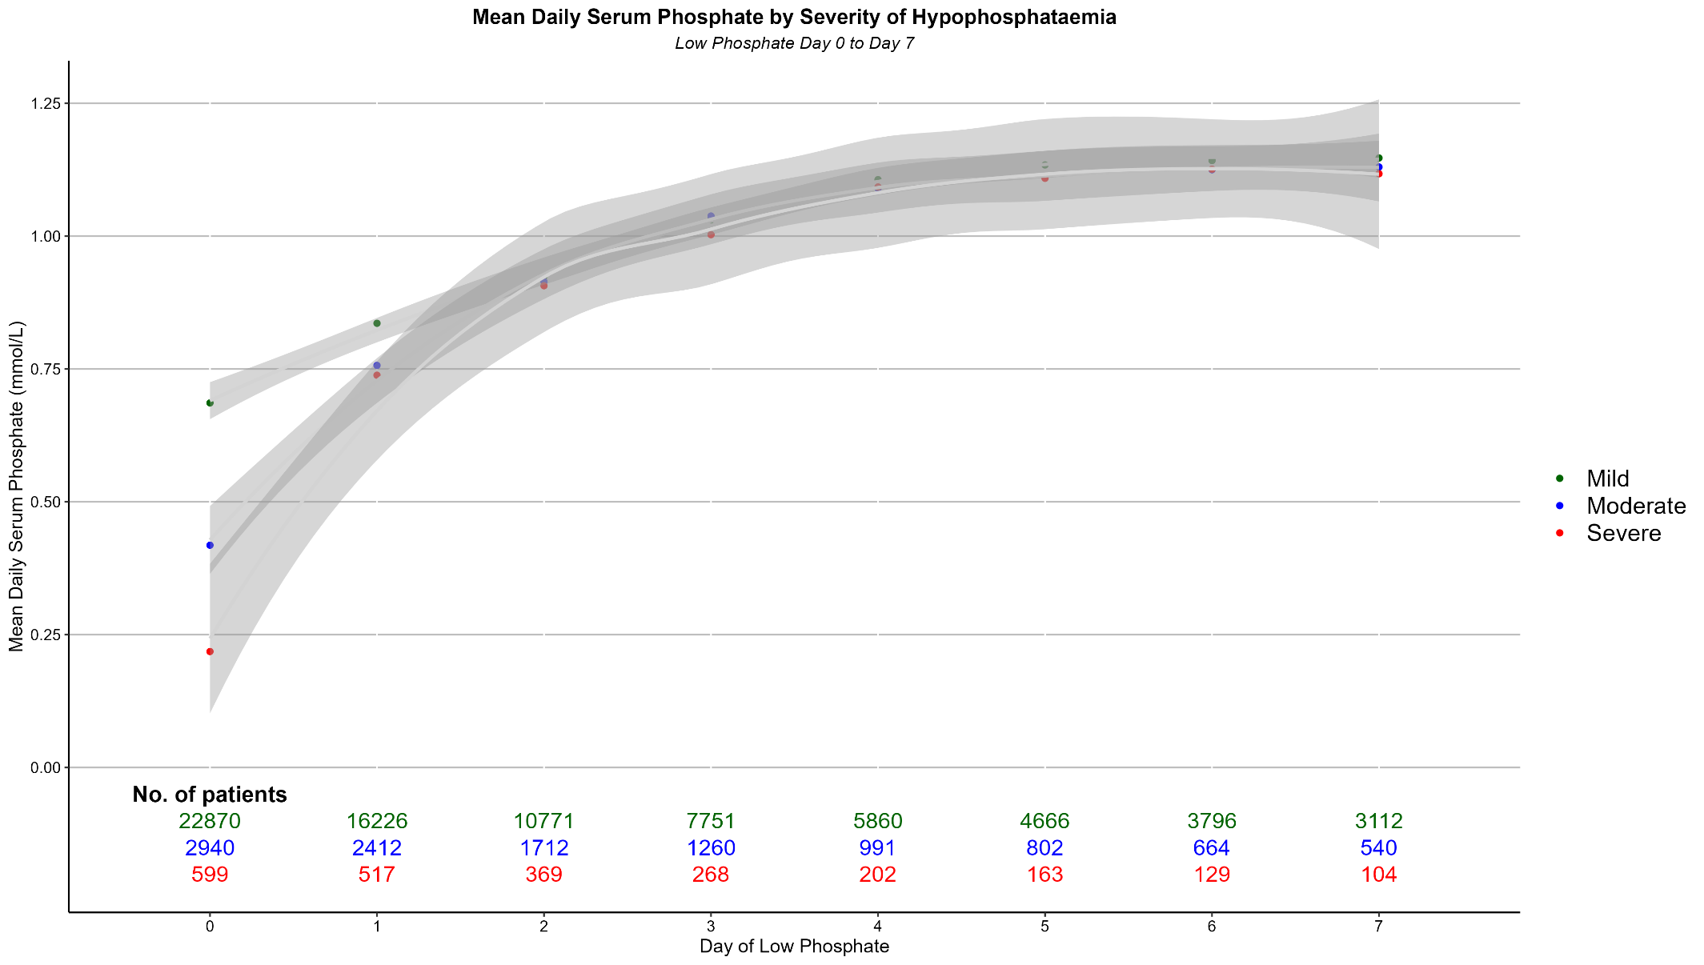
Figure 1: Mean Daily Serum Phosphate by Severity of Hypophosphataemia

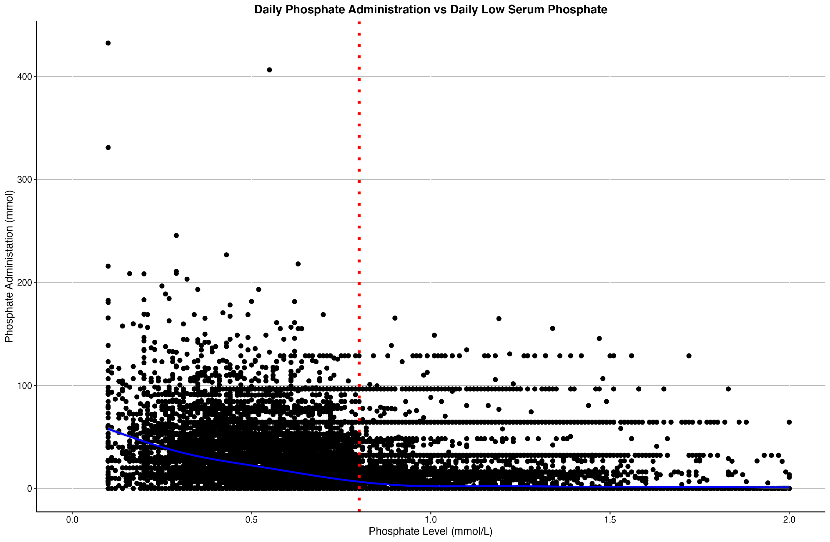
Figure 2: Daily Phosphate Administration vs Daily Low Serum Phosphate
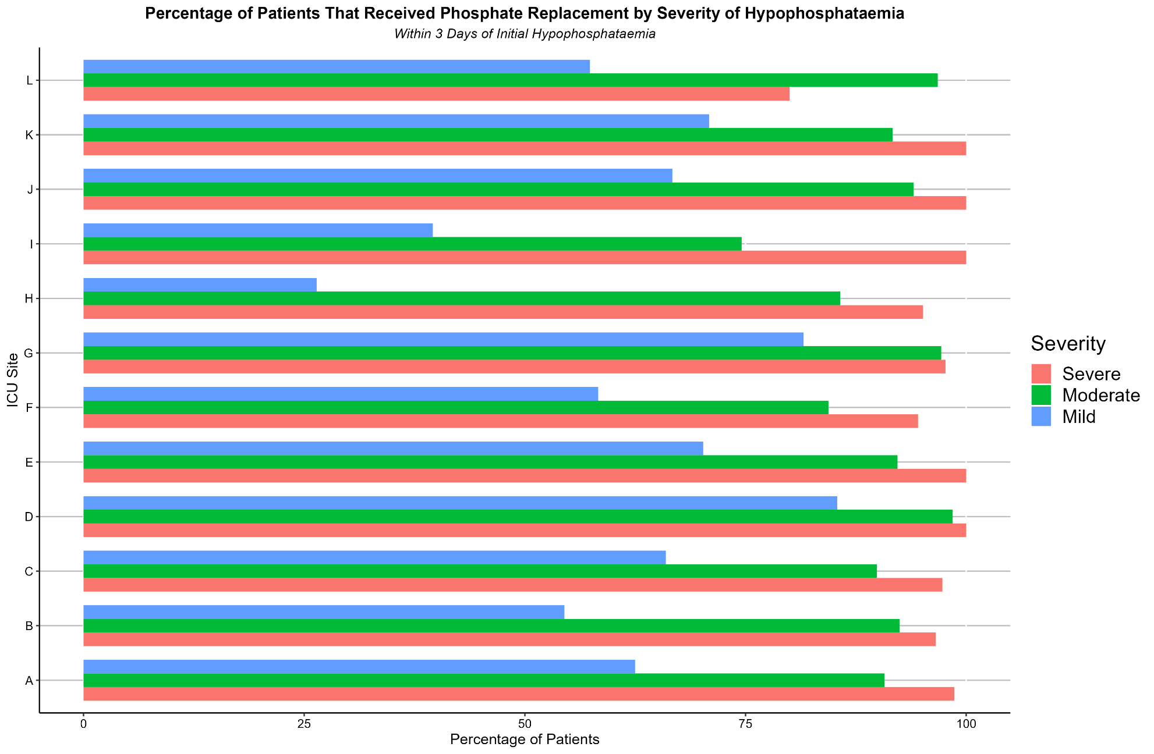
Figure 3: Percentage of Patients That Received Phosphate Replacement by Severity of Hypophosphataemia

10.2 Appendix B
Hypophosphatemia in critically ill patients: Incidence, Patient Characteristics, Trajectory, Treatment and Outcomes

Online Supplement
List of tables and figures – Online Supplement
Table S1. Characteristics at Diagnosis of Low Phosphate

Figure S1: ICU Day of First Low Serum Phosphate
Figure S2: Number of Patients with Low Serum Phosphate for each day during ICU Admission
Figure S3: Hypophosphataemia Severity Over Time
Figure S4: Proportion of ICU Days with Hypophosphataemia
Figure S5: Proportion of Patients Based on Type of Phosphate Replacement
Figure S6: Daily Phosphate Administration vs Daily Low Serum Phosphate by Site
Figure S7: Patient inclusion flow diagram

Table S1. Characteristics at Diagnosis of Low Phosphate
Variable | None, N = 50,901¹ | Mild, N = 22,870¹ | Moderate, N = 2,940¹ | Severe, N = 599¹ | p-value²
ICU Day of Low PO4 |  | 2.00 (2.00, 3.00) | 2.00 (1.00, 3.00) | 2.00 (1.00, 2.00) | <0.001
SOFA Score | 4.00 (2.00, 6.00) | 4.00 (2.00, 6.00) | 4.00 (2.00, 6.00) | 5.00 (3.00, 7.00) | <0.001
Vaso Any | 18,353 (39%) | 8,485 (44%) | 1,288 (49%) | 296 (53%) | <0.001
VIS Score, if any | 3 (1, 6) | 3 (1, 8) | 4 (2, 11) | 7 (2, 15) | <0.001
NEE Score, if any (ug/kg/min) | 0.02 (0.01, 0.06) | 0.03 (0.01, 0.08) | 0.04 (0.02, 0.12) | 0.07 (0.02, 0.17) | <0.001
MAP (mmHg) | 78 (72, 87) | 80 (73, 89) | 80 (73, 89) | 80 (73, 90) | <0.001
Ventilation | 16,377 (33%) | 11,431 (50%) | 1,769 (60%) | 357 (60%) | <0.001
PF Ratio | 263 (190, 340) | 242 (171, 320) | 240 (167, 321) | 234 (158, 328) | <0.001
Calcium (mmol/L) | 2.05 (1.95, 2.14) | 1.99 (1.90, 2.08) | 1.98 (1.89, 2.08) | 2.02 (1.90, 2.12) | <0.001
Maximum Creatinine (umol/L) | 79 (62, 106) | 72 (57, 92) | 71 (56, 93) | 81 (61, 114) | <0.001
Insulin Dose, if any (units) | 25 (11, 48) | 32 (13, 67) | 47 (21, 91) | 67 (31, 123) | <0.001
Enteral Nutrition (mL) | 0 (0, 0) | 0 (0, 287) | 0 (0, 519) | 0 (0, 301) | <0.001
¹ Median (IQR) or Frequency (%)
² Kruskal-Wallis rank sum test; Pearson's Chi-squared test
Abbreviations: PO4 = phosphate; ICU = intensive care unit; SOFA = sequential organ failure assessment; VIS = vasoactive inotrope score; NEE = norepinephrine equivalence score; MAP = mean arterial pressure; PF = PaO2/FiO2.

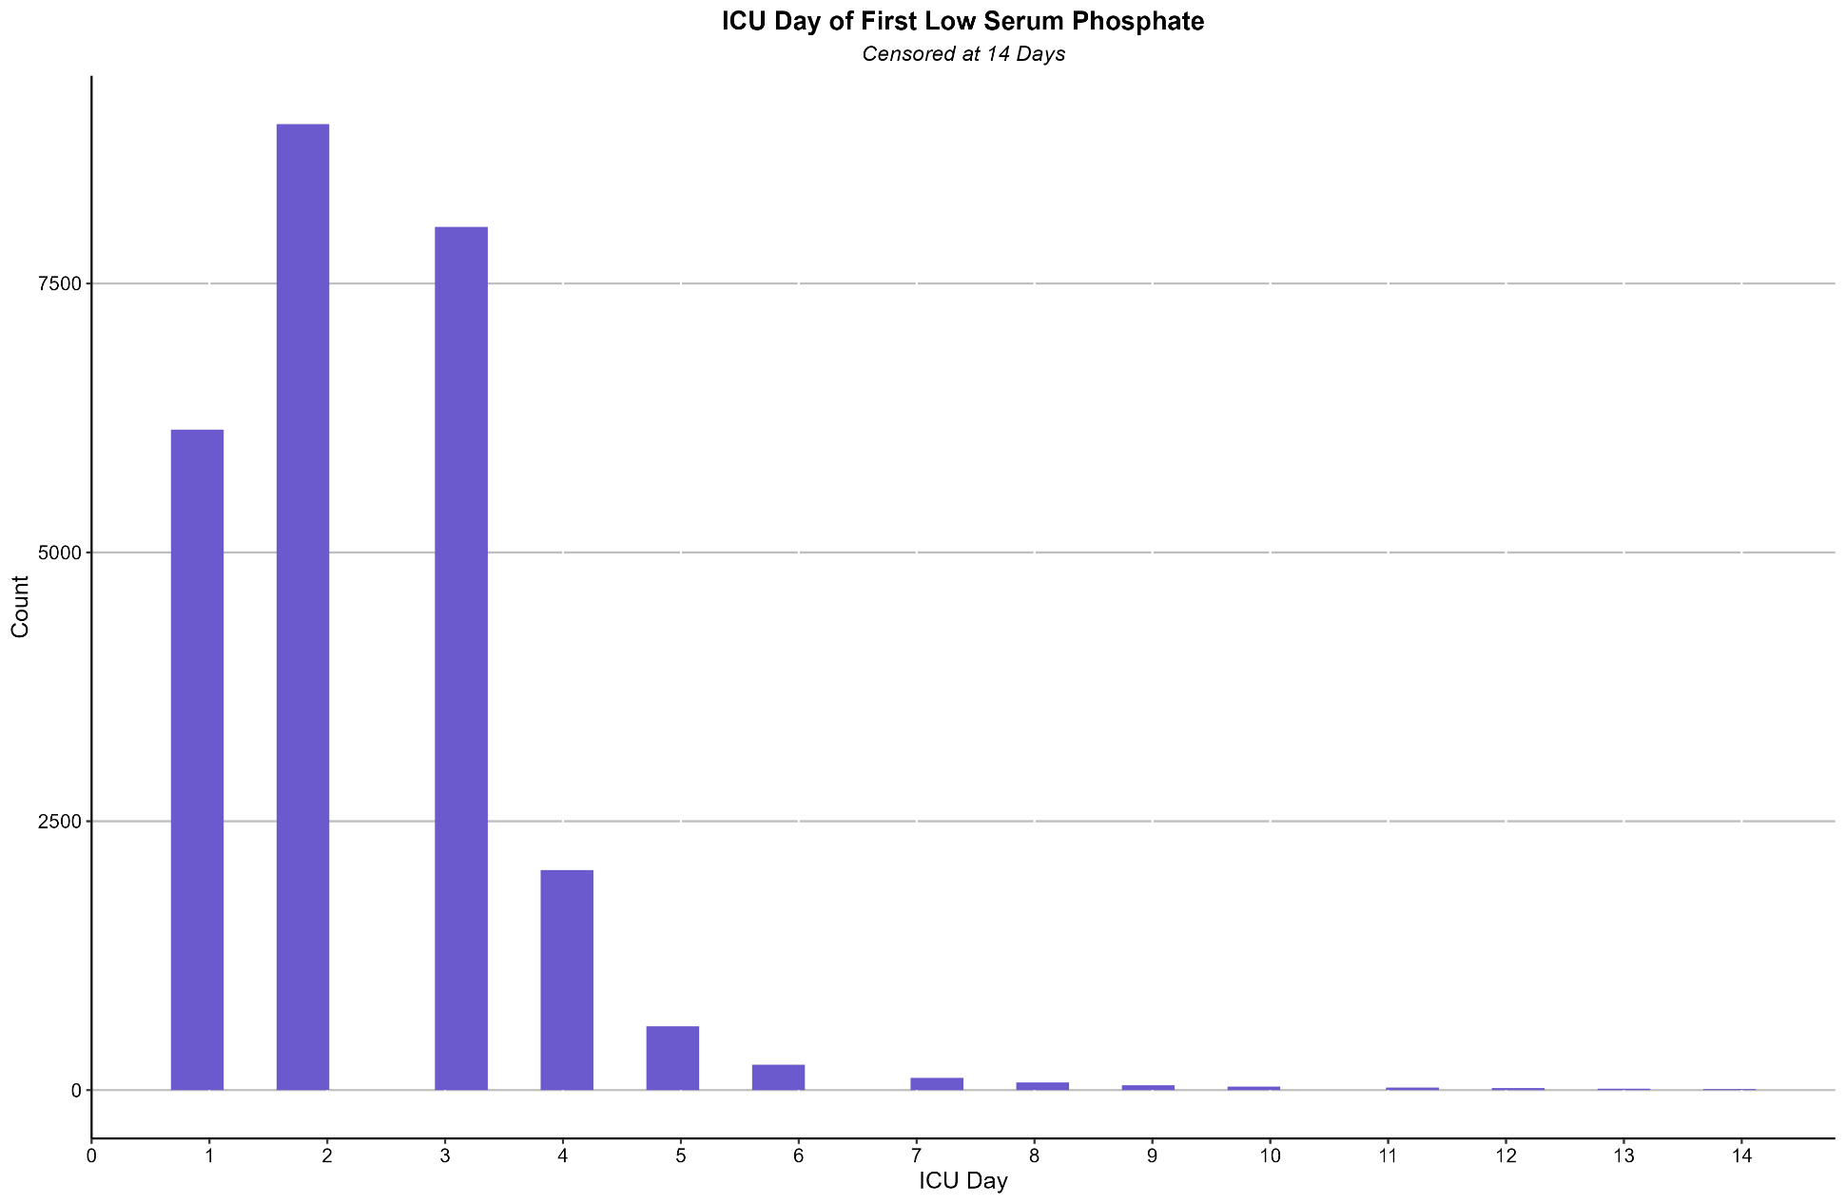
Figure S1: ICU Day of First Low Serum Phosphate
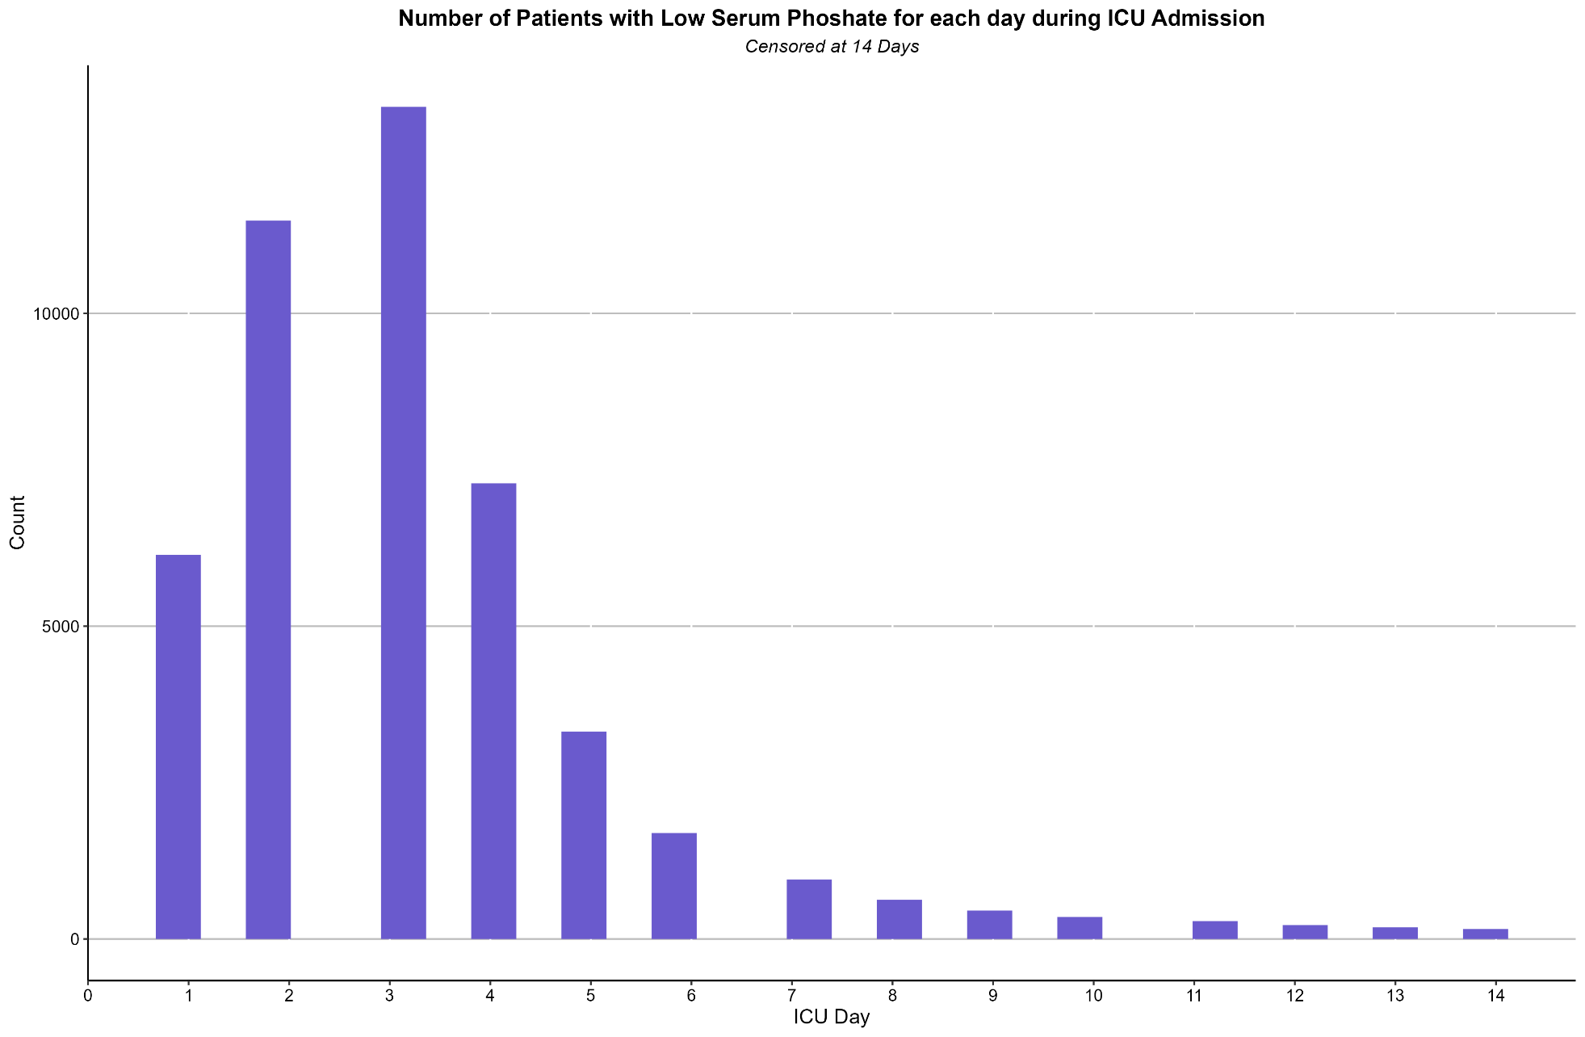
Figure S2: Number of Patients with Low Serum Phosphate for each day during ICU Admission
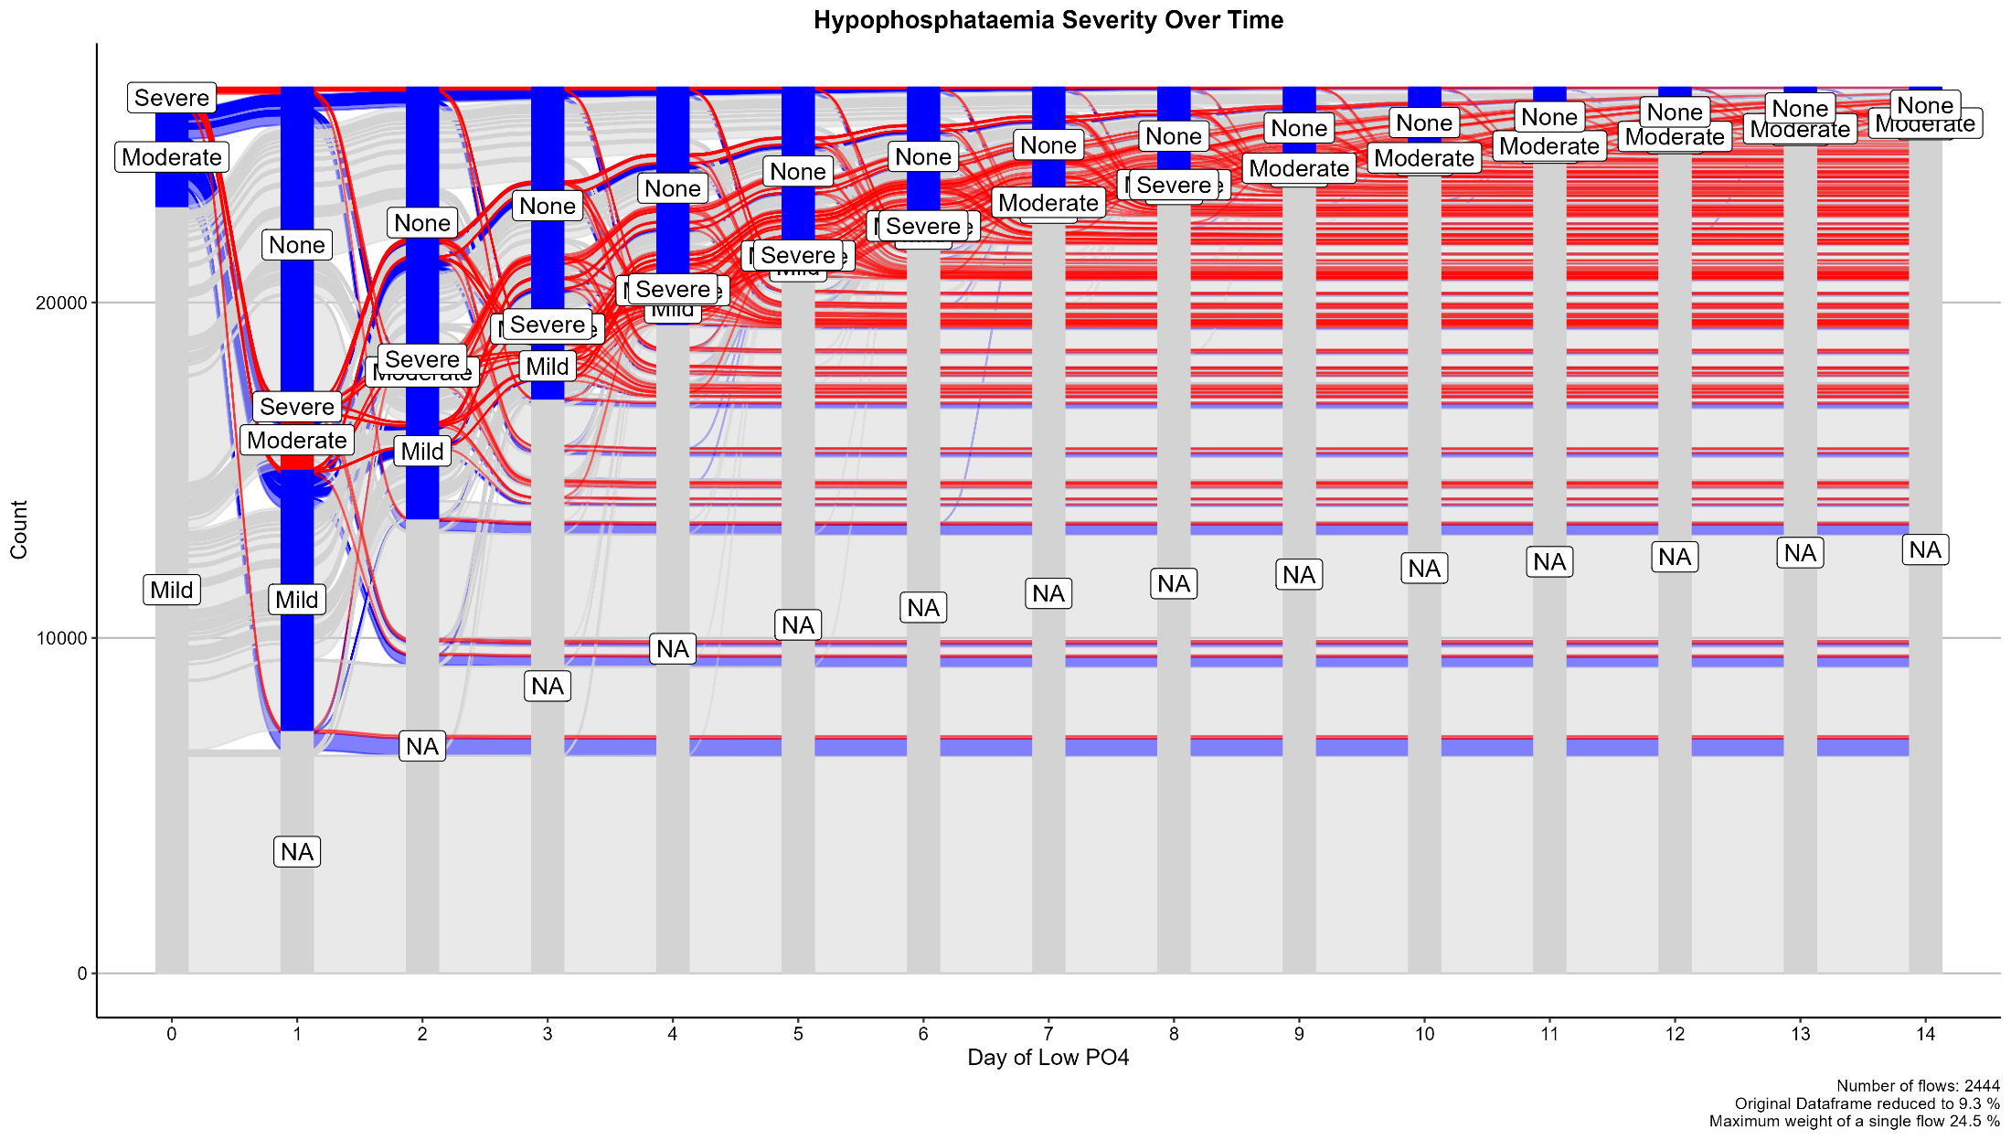
Figure S3: Hypophosphataemia Severity Over Time

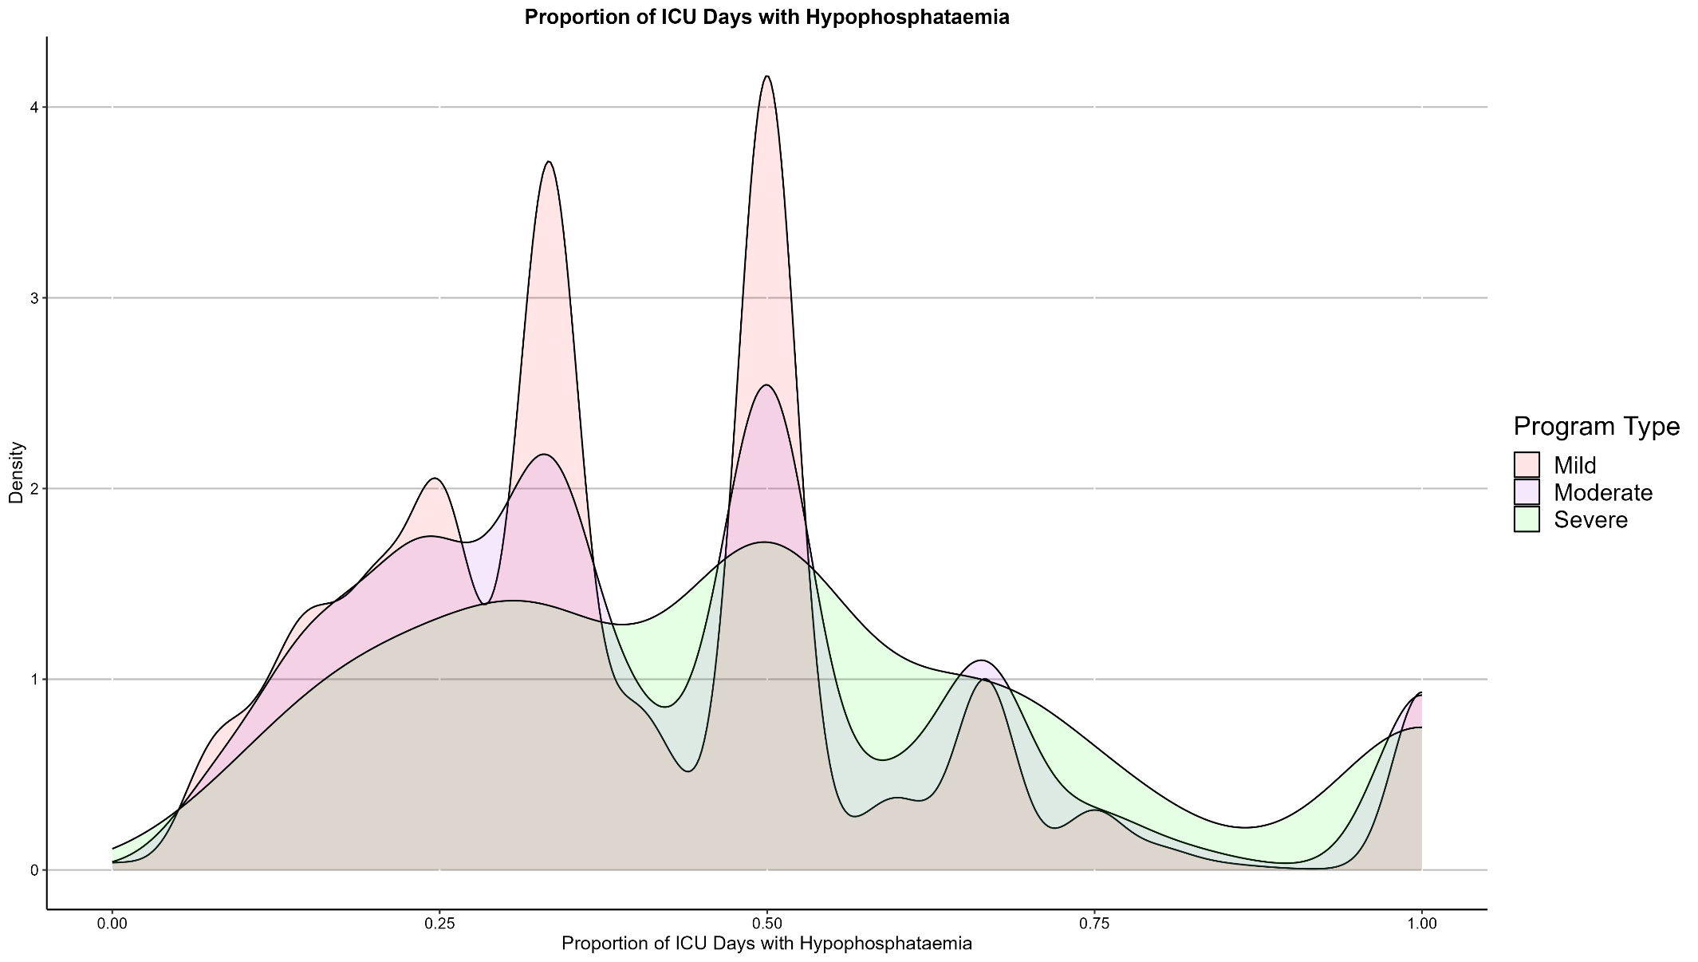
Figure S4: Proportion of ICU Days with Hypophosphataemia
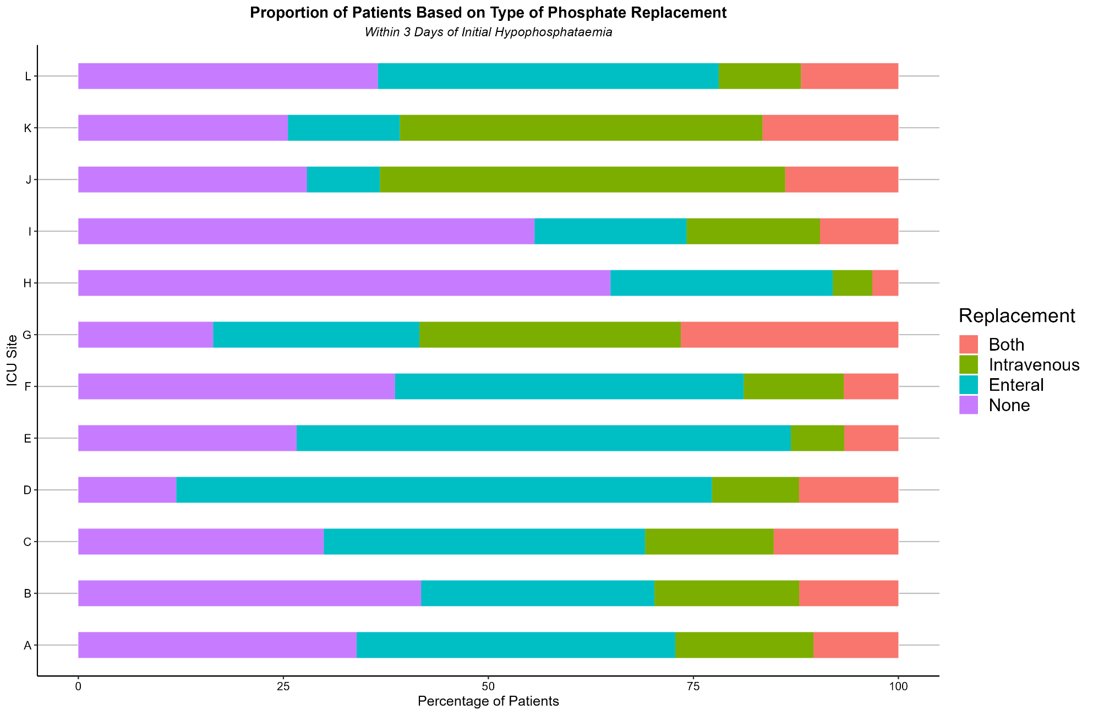
Figure S5: Proportion of Patients Based on Type of Phosphate Replacement
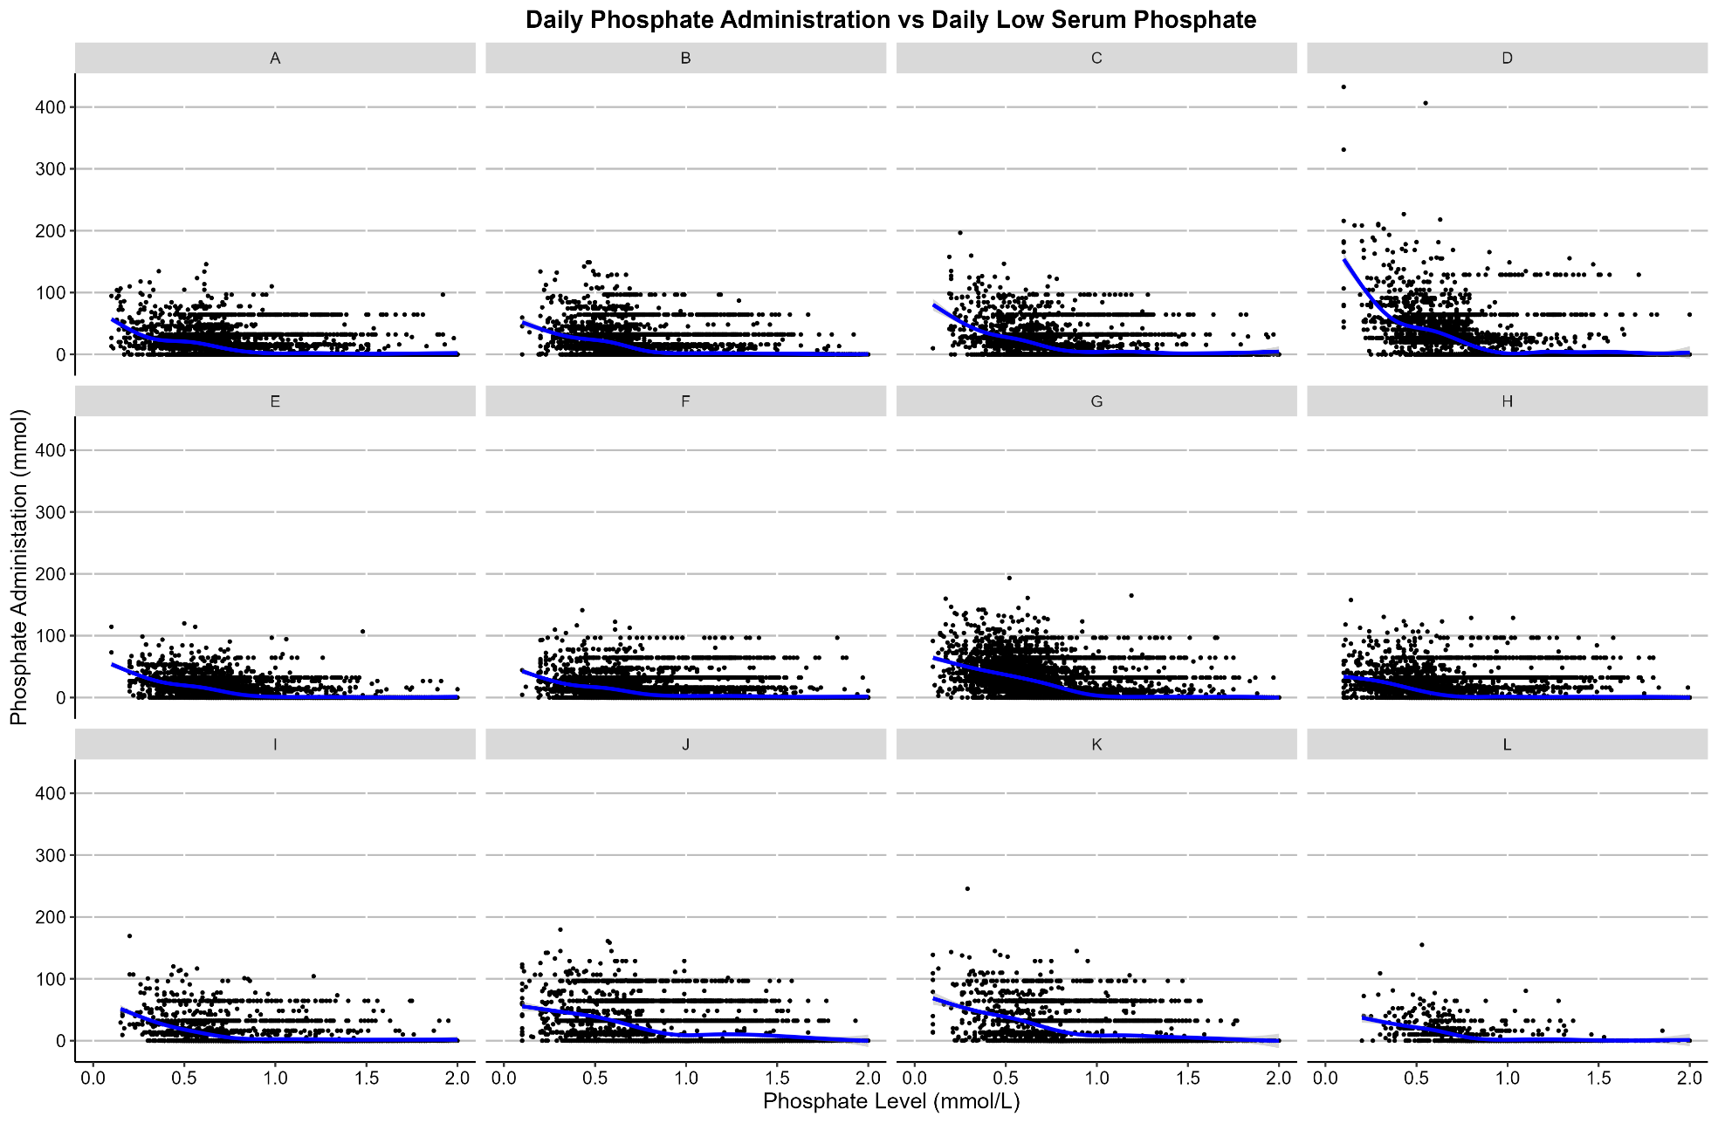
Figure S6: Daily Phosphate Administration vs Daily Low Serum Phosphate by Site

Study Flow Chart

10.3 Appendix C : Formula for calculating NEE

To standardise the reporting of vasoactive agents a norepinephrine equivalence (NEE) score for those who received any vasopressors, was calculated using the following formula.

NEE = Norepinephrine dose (µg/kg/min) +epinephrine dose (µg/kg/ min) + 1/150 × dopamine dose (µg/kg/min) +1/10×phenylephrine dose (µg/kg/min) +2.5×vasopressin dose (U/min). [11,12,13].

