Supplementary materials
Figures S1 and S2 show the results of Test 1 and Test 2 in Experiment 1. Although the data is the same as Figure 2, the pink-purple boundary, orange-pink boundary, and unique red are plotted in separate panels for the visibility of individual observers’ data.
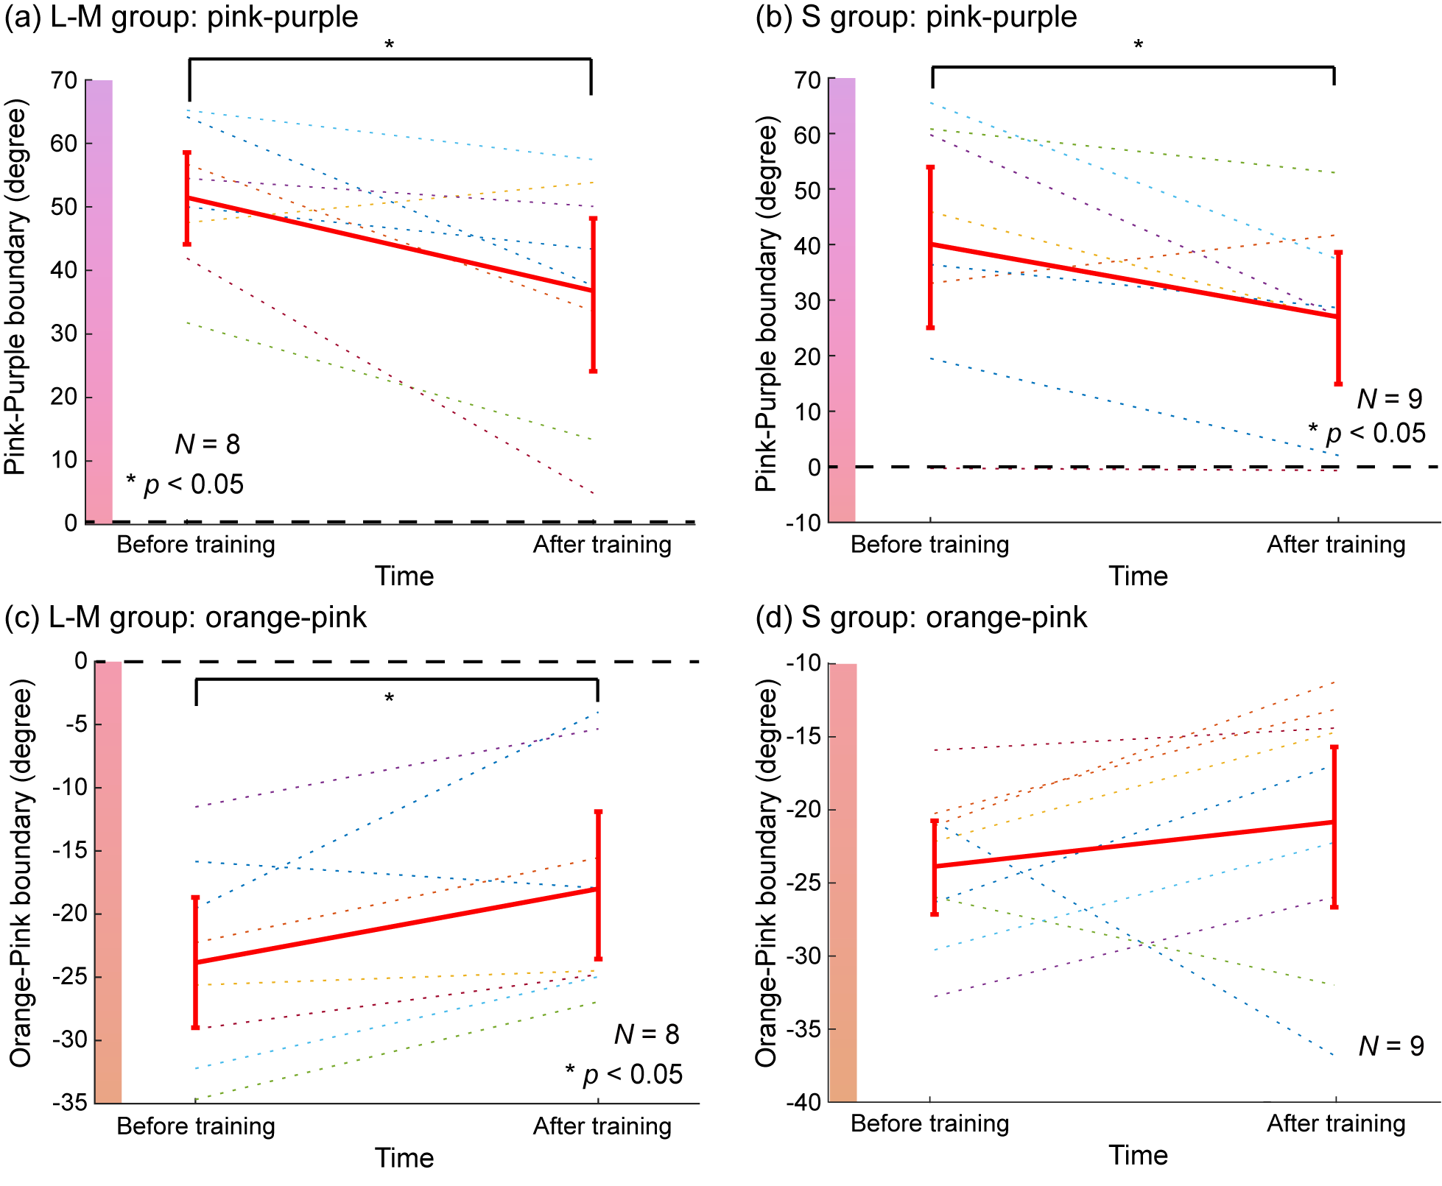
Figure S1. Color category boundaries measured in Test 1 of Experiment 1. (a) pink-purple and (c) orange-pink boundaries in the L-M group and (b) pink-purple and (d) orange-pink boundaries in the S group. The horizontal axis shows before or after training, and the vertical axis shows the hue angle. The colored dotted lines represent the results for individual observers, and the solid red line represents the mean across all observers. Black dotted line shows the trained color of 0°. Error bars indicate 95% confidence intervals obtained from the bootstrap procedure.

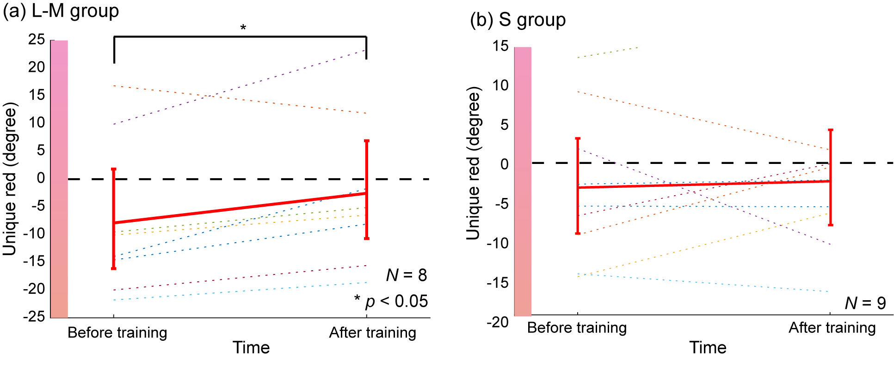
Figure S2. Unique red before and after color discrimination training measured in Test 2 of Experiment 1 for (a) L-M and (b) S groups. The format of each panel is the same as Figure S1 (a) except that the vertical axis indicates the hue angle corresponding to unique red.

Figure S3 shows the perceived color difference at different change levels measured in Test 1 of Experiment 2. In all base colors the perceived color difference monotonically increased with the change level.

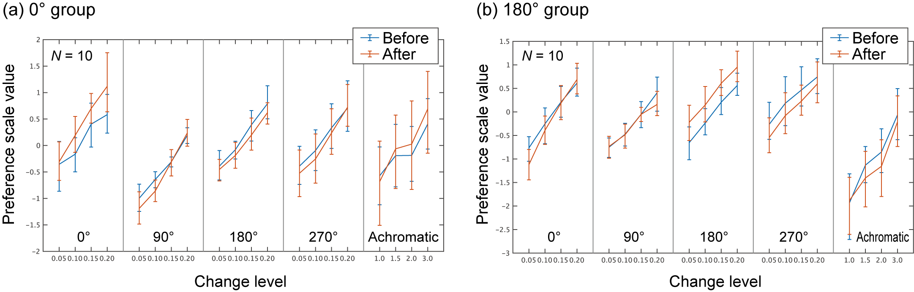
Figure S3. Perceived color difference at different change levels measured in Test 1 of Experiment 2 for (a) 0° and (b) 180° groups. The horizontal axis indicates the base color and change level. The vertical axis shows the preference scale value as an index of relative perceived color difference. The blue and red lines show the results of before- and after-training, respectively. The error bars are the 95% confidence interval obtained from the parametric bootstrap procedure with 10,000 repetitions.

