8. Supplementary Information
Online Resource 1
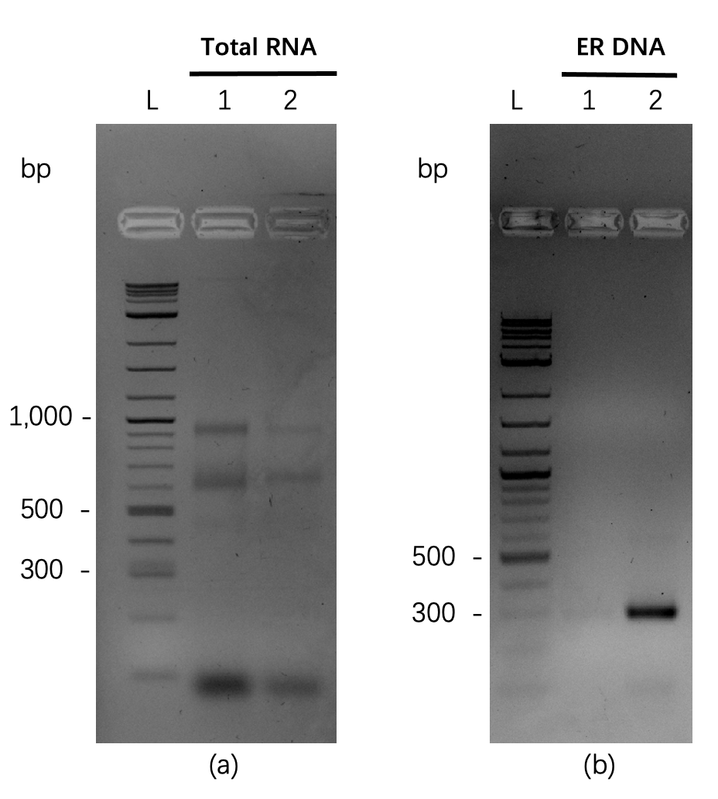
Online Resource Fig. S1 Agarose gel electrophoresis of total RNA extract from the putative blowfly embryo cell line (BFEC) and the PCR amplicon for the ER gene transcript. ER PCR amplification of 254 bp, electrophoresis for unwinding (120 V) for 40 minutes. a) Analysis of the total RNA extract: Lane 1: Total RNA from BFEC, Lane 2: Total RNA from BFEC following DNase treatment, b) Analysis of the ER transcript PCR amplicon: Lane 1: ER transcript amplicon from cDNA prepared from the BFEC total RNA extract, Lane 2: The purified and concentrated ER PCR amplicon L: 500 ng 1 kb plus ladder.

Online Resource 2
Online Resource Fig. S2 Image of a typical crystalline structure observed in the primary blowfly embryo cell line as observed using light microscopy

Online Resource 3
Online ResourceTable S3. Primers used in this study.
Gene | Primer name | Sequence (5′ – 3′)
Lucilia cuprina | BF-GART_Fwd | TAATACGACTCACTATAGGGGCCTTACAGCCTCTTATTGAGC
GART gene PCR | BF-GART_Rev | TAATACGACTCACTATAGGGTTCTCTGTCAAACCGCCACC
Lucilia cuprina | BF-SPCNC_Fwd | TAATACGACTCACTATAGGGTTGTGTTCGTCACAGCCTCA
SPCNC gene PCR | BF-SPCNC_Rev | TAATACGACTCACTATAGGGCCCACACCCGAAACATCTGA
Lucilia cuprina | BF-FL_Fwd | TAATACGACTCACTATAGGGCCGTTTGTGTGGCCAGTTG
FL gene PCR | BF-FL_Rev | TAATACGACTCACTATAGGGAAATGGTTCGCGACAGGA
Lucilia cuprina | BF-AKI_Fwd | TAATACGACTCACTATAGGGAACGCACTCTGGATTGGGAA
AKI gene PCR | BF-AKI_Rev | TAATACGACTCACTATAGGGCAACTGTTTGCGTCTGTGCA
Lucilia cuprina | BF-AlaAT1_Fwd | TAATACGACTCACTATAGGGAGGCTCGTGCTAAGACTGTT
AlaAT1 gene PCR | BF-AlaAT1_Rev | TAATACGACTCACTATAGGGGGTGGCCGAGTACAAAGGAT
Lucilia cuprina | BF-ADH3_Fwd | TAATACGACTCACTATAGGGGTTTGGGCGCTGTTGGTTTA
ADH3 gene PCR | BF-ADH3_Rev | TAATACGACTCACTATAGGGTGATTCTAAAGCTGCACGCA
Lucilia cuprina | BF-ASPM_Fwd | TAATACGACTCACTATAGGGCGAGCTCCCCGAATTCAGAT
ASPM gene PCR | BF-ASPM_Rev | TAATACGACTCACTATAGGGGCGCTCTCTGATTCTCCACT
Lucilia cuprina | BF-V-ATPase_Fwd | TAATACGACTCACTATAGGGGGTCACCAAAAATCCCGCAG
V-ATPase gene PCR | BF-V-ATPase_Rev | TAATACGACTCACTATAGGGGTCCGAAGAGGGCATTACGT
Lucilia cuprina | BF-DCO_Fwd | TAATACGACTCACTATAGGGTTAAAGGCCGCCAACAAACG
DCO gene PCR | BF-DCO_Rev | TAATACGACTCACTATAGGGCGTGGTCCACCGAACTTCA
Lucilia cuprina | BF-DALLY_Fwd | TAATACGACTCACTATAGGGGGTTATGACCGCTGGCATTG
DALLY gene PCR | BF-DALLY_Rev | TAATACGACTCACTATAGGGCCATCTCCTGAGCCTTGCAT
Lucilia cuprina | BF-TID_Fwd | TAATACGACTCACTATAGGGATGTGCTGAATGTGAGGGCA
TID gene PCR | BF-TID_Rev | TAATACGACTCACTATAGGGATGTGATGAAGTGCCCGGTT
Lucilia cuprina | BF-ER_Fwd | TAATACGACTCACTATAGGGGGTCTCGAAGAAGCCGAACT
ER gene PCR | BF-ER_Rev | TAATACGACTCACTATAGGGATGTGTGACTGCACTGAGGG
Lucilia cuprina | BF-qGART_Fwd | TAGAATCGGGTGCTGAACCG
GART gene qPCR for cell | BF-qGART_Rev | ACCCACACAATAACCAGCCA
Lucilia cuprina | BF-qSPCNC_Fwd | GAGGAGGACGATACTGGTGC
SPCNC gene qPCR for cell | BF-qSPCNC_Rev | CCTTGCCAAAGTCAGTTTCAGT
Lucilia cuprina | BF-qFL_Fwd | GCCGGCTTAGAGGTTCATCA
FL gene qPCR for cell | BF-qFL_Rev | TCTCACAAACACGAGCCGAT
Lucilia cuprina | BF-qGART_Fwd | GCCTTACAGCCTCTTATTGAGC
GART gene qPCR for larvae | BF-qGART_Rev | TTCTCTGTCAAACCGCCACC
Lucilia cuprina | BF-qSPCNC_Fwd | TTGTGTTCGTCACAGCCTCA
SPCNC gene qPCR for larvae | BF-qSPCNC_Rev | CCCACACCCGAAACATCTGA
Lucilia cuprina | BF-qFL_Fwd | CCGTTTGTGTGGCCAGTTG
FL gene qPCR for larvae | BF-qFL_Rev | GGAAATGGTTCGCGACAGGA
Lucilia cuprina | BF-qAKI_Fwd | ACGCACTCTGGATTGGGAAG
AKI gene qPCR for larvae | BF-qAKI_Rev | AACGGACTGGGTTGAGGTTC
Lucilia cuprina | BF-qASPM_Fwd | TGCAATCGGAAGAGAGTGCC
ASPM gene qPCR for larvae | BF-qASPM_Rev | CCGTTACTGCCAGCACTTTG
Lucilia cuprina | BF-qV-ATPase_Fwd | GTTTTGGAAGATGCCCGTCG
V-ATPase gene qPCR for larvae | BF-qV-ATPase_Rev | ATCAACTTGACGGCAGCGTA
GFP Expression | LC-exCas-GFP_Fwd | GTAAAACACAATCAAGAAATGATGTC
Cassette | LC-exCas-GFP_Rev | GATCTAAACGAGTTTTTAAGCAAAC
dsRED Expression | LC-exCas-dsRED_Fwd | GGATCTAATTCAATTAGAGAC
Cassette | LC-exCas-dsRED_Rev | TTAAGATACATTGATGAGTTTGG
Lucilia cuprina | BF-ER_Fwd | TAATACGACTCACTATAGGGACGGCTGATGGTAAACGTTT
ER gene for sequencing | BF-ER_Rev | TAATACGACTCACTATAGGGTCTGGCGGCGAGGTATTTAC
Bacterial 16S | 27_Fwd | AGAGTTTGATC(A/C)TGGCTCA
RNA | 1525_Fwd | AGGAGGTGATCCAGCC

Online Resource 4
Online Resource Table S4. Experimental design of optimized culture conditions, with multiple doses of antibiotic combinations, FBS, yeast extract, and HEPES.
antibiotics |  | Anti-Anti 0 x  +  10 µg/mL Gentamicin | Anti-Anti 0 x  +  20 µg/mL Gentamicin | Anti-Anti 0 x  +  50 µg/mL Gentamicin | Anti-Anti 0 x  +  100 µg/mL Gentamicin | Anti-Anti 0 x  +  200 µg/mL Gentamicin | Anti-Anti 0 x  +  500 µg/mL Gentamicin
antibiotics | control * | Anti-Anti 1 x  +  10 µg/mL Gentamicin | Anti-Anti 1 x  +  20 µg/mL Gentamicin | Anti-Anti 1 x  +  50 µg/mL Gentamicin | Anti-Anti 1 x  +  100 µg/mL Gentamicin | Anti-Anti 1 x  +  200 µg/mL Gentamicin | Anti-Anti 1 x  +  500 µg/mL Gentamicin
antibiotics | Anti-Anti 2 x  +  0 µg/mL Gentamicin | Anti-Anti 2 x  +  10 µg/mL Gentamicin | Anti-Anti 2 x  +  20 µg/mL Gentamicin | Anti-Anti 2 x  +  50 µg/mL Gentamicin | Anti-Anti 2 x  +  100 µg/mL Gentamicin | Anti-Anti 2 x  +  200 µg/mL Gentamicin | Anti-Anti 2 x  +  500 µg/mL Gentamicin
antibiotics | 5 µg/mL Doxycycline | Anti-Anti 1 x  +  5 µg/mL Doxycycline | 5 µg/mL Doxycycline  +  50 µg/mL Gentamicin
antibiotics | 10 µg/mL Doxycycline | Anti-Anti 2 x  +  10 µg/mL Doxycycline | 10 µg/mL Doxycycline  +  50 µg/mL Gentamicin
culture  medium reagents | 0% yeast extract  +  5% FBS | 0% yeast extract  +  10% FBS | 0% yeast extract  +  20% FBS
culture  medium reagents | 3% yeast extract  +  5% FBS | 3% yeast extract  +  10% FBS | 3% yeast extract  +  20% FBS
supplement | 10 µM HEPES | 20 µM  HEPES | 30 µM  HEPES

Online Resource 5
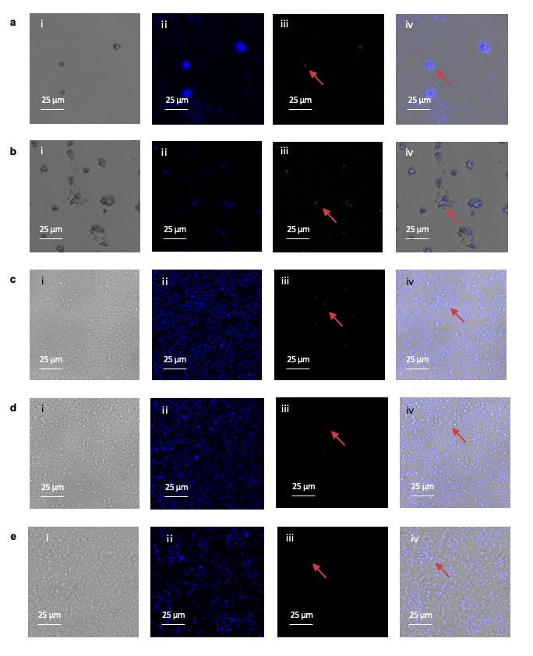
Online Resource Fig. S5 Confocal microscope images of blowfly embryo cell line (BFEC) cell transfection in original BFEC culture medium by Cellfectin® II with insect-specific expression plasmid for green fluorescent protein (GFP)
a, 200 ng pLC-exCas-GFP without Plus Reagent at 24 hours; b, 200 ng pLC-exCas-GFP with Plus Reagent at 24 hours; c, 200 ng pLC-exCas-GFP) with Plus Reagent at 48 hours; d, 600 ng pLC-exCas-GFP with Plus Reagent at 48 hours; e, 200 ng pLC-exCas-GFP without Plus Reagent at 72 hours. (i) Brightfield microscopy. (ii) BFECs have self-blue fluorescence and can confirm the cell location. (iii) GFP view was used to detect the cellular uptake of the green fluorescent plasmid. (iv) Brightfield microscopy + GFP view + self-fluorescence was used to image whole cells with nucleus and cellular uptake of plasmid expressing GFP. Images were analysed using a Leica TCS SP8 confocal fluorescence microscope. Glycerinum (99.5%) was applied for glass slip sealing.

Online Resource 6
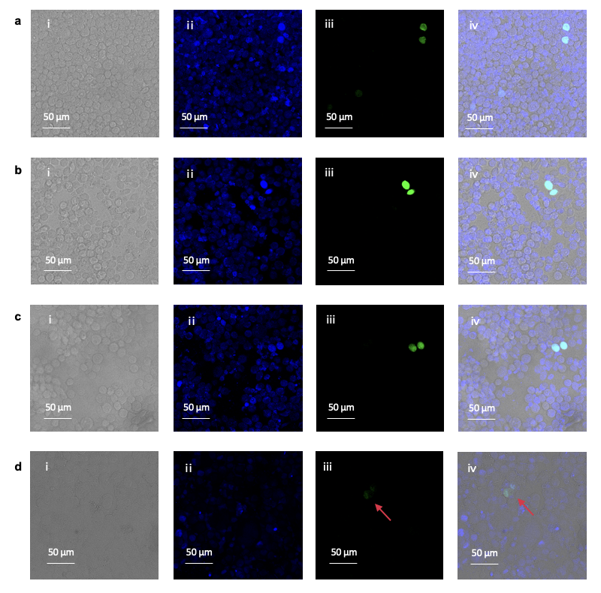
Online Resource Fig. S6 Confocal microscope images of transfection in ESF 921 +10% FBS culture medium by Cellfectin® II with insect-specific expression plasmid for green fluorescent protein (GFP). a, 200 ng pLC-exCas-GFP with Plus Reagent at 72 hours; b, 600 ng pLC-exCas-GFP without Plus Reagent at 72 hours; c, 600 ng pLC-exCas-GFP) with Plus Reagent at 72 hours; d, 200 ng pLC-exCas-GFP with Plus Reagent at 24 hours;
(i) brightfield, (ii) Sf9 has self-blue fluorescence and can confirm the cell location, (iii) GFP view was used to detect the cellular uptake of the green fluorescent plasmid, and (iv) brightfield + GFP view + self-fluorescence was used to image whole cells with nucleus and cellular uptake of plasmid expressing GFP. Images were analysed using a Leica TCS SP8 confocal fluorescence microscope. Glycerinum (99.5%) was applied for glass slip sealing.

Online Resource 7
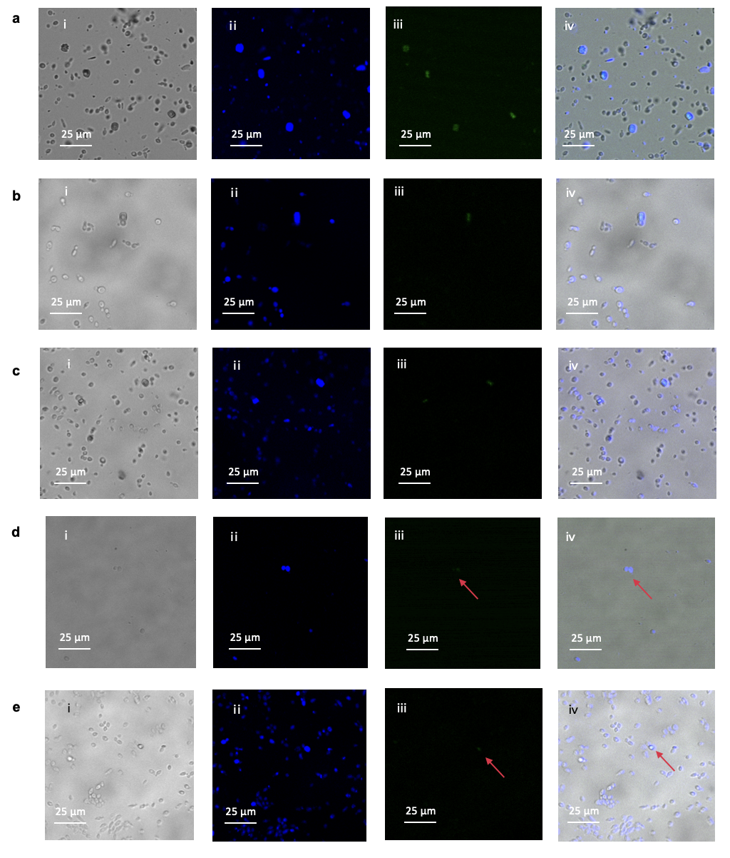
Online Resource Fig. S7 Confocal microscope images of blowfly embryo cell line (BFEC) cell transfection of fluorescent RNA (GFP) in original BFEC culture medium by Cellfectin® II with Plus Reagent. a, 500 ng eGFP mRNA at 24 hours; b, 500 ng eGFP mRNA at 48 hours; c, 500 ng eGFP mRNA at 72 hours; d, 500 ng L. cuprina-specific fluorescent dsRNA (FL) at 24 hours; e, 500 ng L. cuprina-specific fluorescent dsRNA (FL) at 48 hours
(i) Brightfield microscopy. (ii) BFECs have self-blue fluorescence and can confirm the cell location. (iii) GFP view was used to detect the cellular uptake of the green fluorescent plasmid. (iv) Brightfield microscopy + GFP view + self-fluorescence was used to image whole cells with nucleus and cellular uptake of plasmid expressing GFP. Images were analysed using a Leica TCS SP8 confocal fluorescence microscope. Glycerinum (99.5%) was applied for glass slip sealing.

Online Resource 8
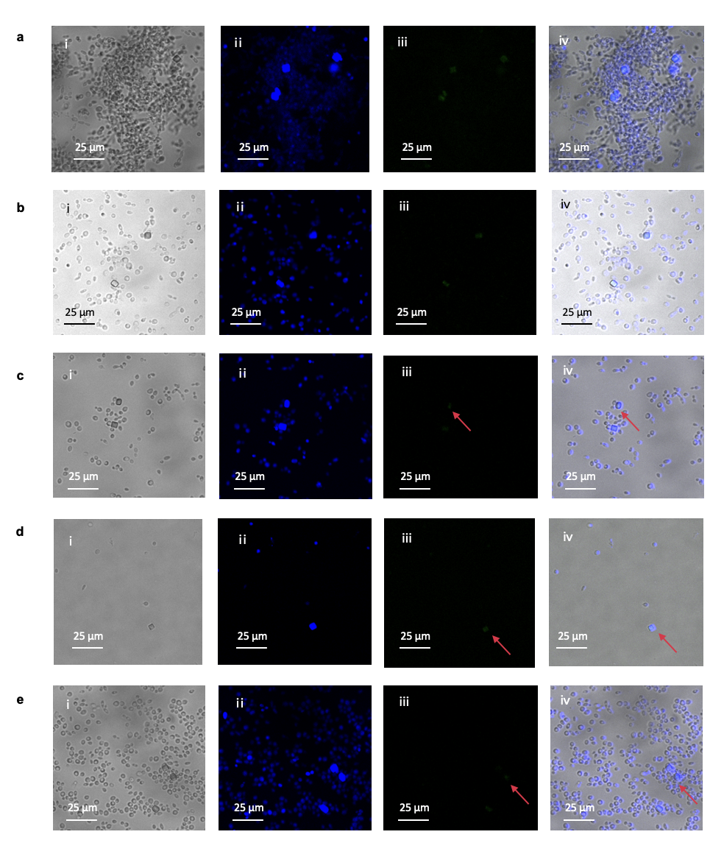
Online Resource Fig. S8 Confocal microscopy images of blowfly embryo cell line (BFEC) cells transfected with fluorescent RNA (GFP) in original BFEC culture medium by Lipofectamine™ MessengerMAX™. a, 500 ng eGFP mRNA at 24 hours; b, 500 ng eGFP mRNA at 48 hours; c, 500 ng eGFP mRNA at 72 hours; d, 500 ng L. cuprina-specific fluorescent dsRNA (FL) at 24 hours; e, 500 ng L. cuprina-specific fluorescent dsRNA (FL) at 72 hours
(i) Brightfield microscopy. (ii) BFECs have self-blue fluorescence and can confirm the cell location. (iii) GFP view was used to detect the cellular uptake of the green fluorescent plasmid. (iv) Brightfield microscopy + GFP view + self-fluorescence was used to image whole cells with nucleus and cellular uptake of plasmid expressing GFP. Images were analysed using a Leica TCS SP8 confocal fluorescence microscope. Glycerinum (99.5%) was applied for glass slip sealing.

Online Resource 9
Online Resource Fig. S9 Mortality of naked dsRNA oral treatment in L. cuprina larvae dsRNA feeding assay
Twelve candidate dsRNAs (a: GART; b: SPCNC; c: FL; d: AKI; e: AT1; f: ADH3; g: ASPM; h: V-ATPase; i: DCO; j: DALLY; k: TID; l: ER) were tested in 3 (i-iii) independent bioassays (n = 5 soda glass tubes with 20 larvae each). Twenty larvae in every biological replicate were provided 500 μg of naked individual candidate dsRNA mixed with 1 mL of 100% heat-inactivated sheep serum for dsRNA treatment, nutrition and moisture. The best candidate dsRNA (ci) showed 27% increased corrected mortality.

Online Resource 10
Online Resource Fig. S10 pupation rates (%) of naked dsRNA oral treatment in L. cuprina larvae dsRNA feeding assay
Twelve candidate dsRNAs (a: GART; b: SPCNC; c: FL; d: AKI; e: AT1; f: ADH3; g: ASPM; h: V-ATPase; i: DCO; j: DALLY; k: TID; l: ER) were tested in 3 (i-iii) independent bioassays (n = 5 soda glass tubes with 20 larvae each). Twenty larvae in every biological replicate were provided 500 μg of naked individual candidate dsRNA mixed with 1 mL of 100% heat-inactivated sheep serum for dsRNA treatment, nutrition and moisture. In this experimental design, larvae that become pupa were considered one health feature, which is against this project's aim. Pupa only appeared from day 7 under our artificial larval growth environment; hence, only two days (day 7 and day 10) of data were available for the pupa rate. The best candidate dsRNA (ai) showed a 34% decreased pupa rate.

Online Resource 11
Online Resource Fig. S11 Growth performance (%) of naked dsRNA oral treatment in L. cuprina larvae dsRNA feeding assay
Twelve candidate dsRNAs (a: GART; b: SPCNC; c: FL; d: AKI; e: AT1; f: ADH3; g: ASPM; h: V-ATPase; i: DCO; j: DALLY; k: TID; l: ER) were tested in 3 (i-iii) independent bioassays (n = 5 soda glass tubes with 20 larvae each). Twenty larvae in every biological replicate were provided 500 μg of naked individual candidate dsRNA mixed with 1 mL of 100% heat-inactivated sheep serum for dsRNA treatment, nutrition and moisture. The growth performance score is one feature used to evaluate larval growth performance in general, including mortality, pupa rate and larval body size.

