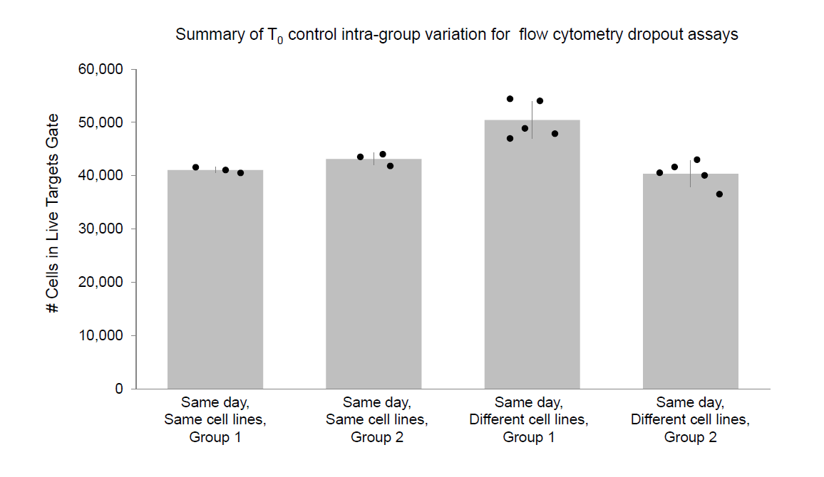

Supplementary Figure 1. Intra-experiment variance of T₀ controls is consistent. A summary of cell counts obtained in live targets gate of YT-rCTL/KFRET T₀ controls illustrates variance between absolute counts in individual samples. While statistically significant differences were apparent between groups prepared for different experimental runs (e.g., on different days), samples prepared in the same experimental run (e.g. on the same day) are found to be highly consistent, even when comparing T₀ controls composed of differing cell lines. By Levene’s test, the variance between groups of samples prepared in different batches is found to be homogenous, indicating that the use of relative cell counting as a measure of cell dropout over co-culture duration is reliable when matched experimental and T₀ samples are prepared in parallel.

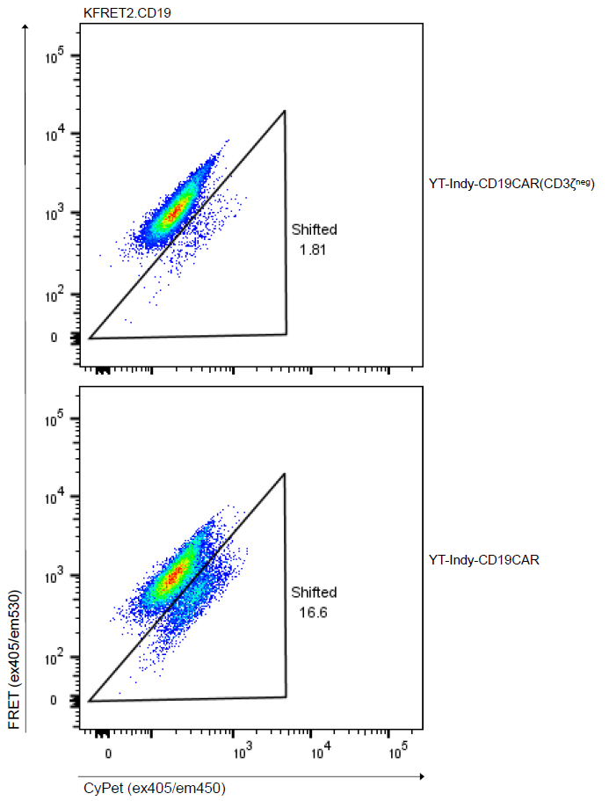

Supplementary Figure 2. CAR-mediated cytotoxicity is primarily triggered through the CD3ζ signaling domain. K562 cells modified to express FRET2 reporter and CD19 protein coding sequence were co-incubated with YT-Indy modified with either an FMC63-41BB-CD3ζ anti-CD19 CAR or a prematurely truncated FMC63-41BB anti-CD19 CAR (CD3ζ^{neg}) at 1:1 effector:target ratios for 4 hours.

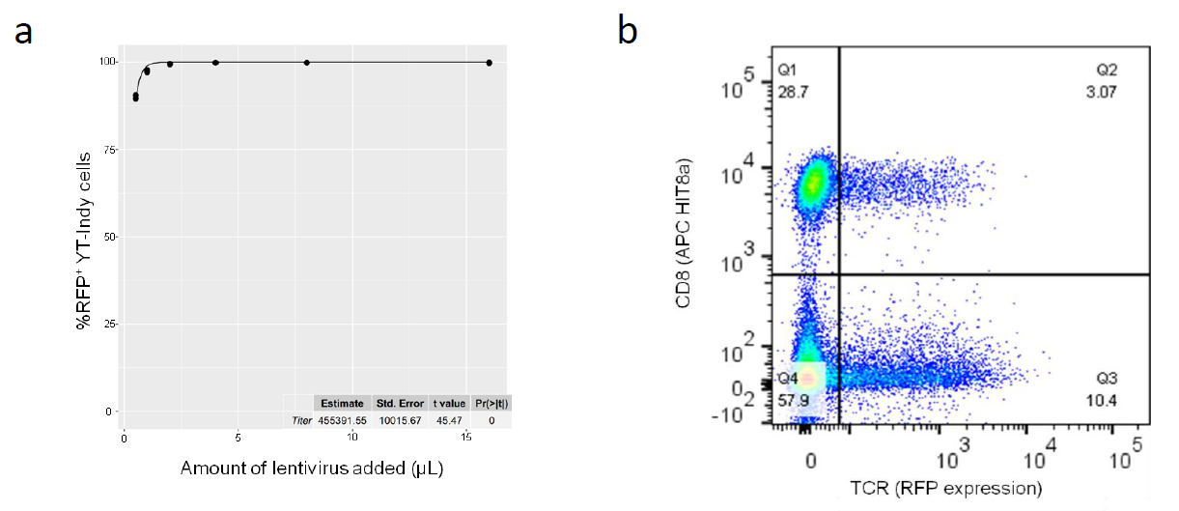

Supplementary Figure 3. Lentiviral vector uptake is three orders of magnitude more efficient in YT-Indy cells than primary T cells. TCR-2A-RFP encoding lentiviral vector was functionally titered over YT-Indy cells by adding increasing amounts of virus to a fixed number of cells in a fixed volume. The resulting fluorescence was measured by flow cytometry 72 hours later. The proportions of positive cells in each condition were fit to a Poisson probability mass function by nonlinear least squares regression to determine a functional titer of 4.55 x 10⁵ infectious units/μL against YT-Indy (a). The same virus was also applied to an activated and proliferating culture of human T cells. In this experiment 150 μL of viral vector was added to 5x10⁵ T cells to yield a transduction efficiency of 13.47% (b). Applying Poisson probability to this result and accounting for input cell and virus quantities, the same product had an effective functional titer of 483 infectious units/μL against T cells.

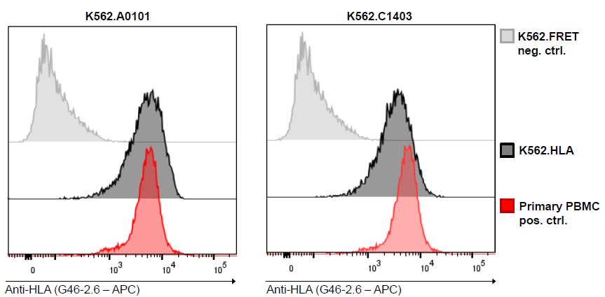

Supplementary Figure 4. Robust recombinant expression of MHC molecules on K562 cells following transduction of HLA allele coding sequences. K562 cells transduced with lentivirus at an MOI of 1 KIU/cell encoding either HLA-A*01:01 or HLA-C*14:03 allele coding sequences were purity-sorted by FACS to isolate RFP and surface MHC-expressing cells. Recovered cell lines were characterized with respect to surface expression level, as measured by MFI from staining and flow cytometry using pan-MHC antibody, relative to primary human PBMC positive control.

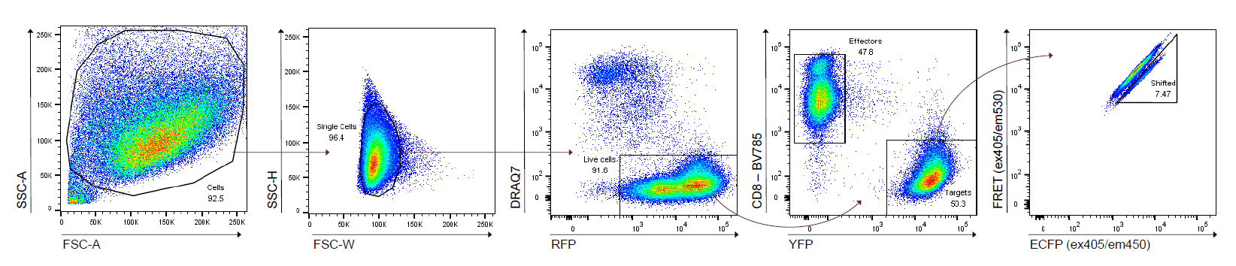

Supplementary Figure 5. Representative gating strategy for FRET-shift flow cytometry in YT-rCTL/KFRET experiments. A common flow cytometry template was employed to facilitate endpoint measurements of all YT-rCTL/KFRET format TCR/pMHC functional assays shown in Main Figures 3, 4, and 5, and Supplementary Figures 5, 6, 7, 8, and 9. Intact, single cells are first selected using sequential forward- and side-scatter gates. Viable cells are then selected by gating on cells negative for DRAQ7 vital staining dye and positive for RFP living color. Effector and target cells are separated by CD8-BV785 and EYFP expression. Unshifted and Shifted gates are drawn by adjusting gate boundaries to keep background FRET-shift in T₀ or targets-only control samples to <1%.

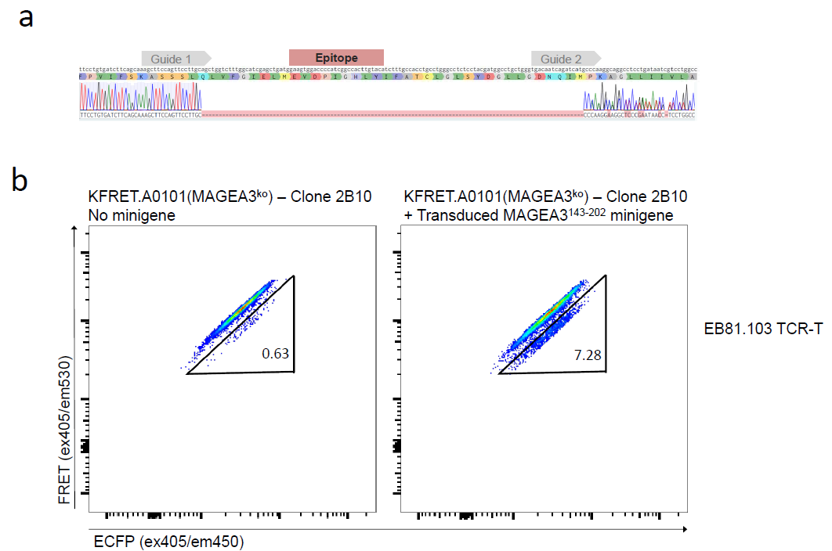

Supplementary Figure 6. Successful excision of endogenous MAGEA3 epitope of EB81.103 TCR from KFRET.A0101 cells. Upon electroporation with epitope-flanking sgRNAs in complex with Cas9 protein, KFRET.A0101 cells were single-cell sorted to yield 384 founder clones for selection. Colonies with successful outgrowth were individually checked for sustained RFP and FRET expression by flow cytometry. Phenotypically selected cell lines were then genotyped by PCR amplification and Sanger sequencing of the genomic region around the edited locus. (a) The clone ultimately selected for further study (2B10) showed an unambiguous deletion of the desired site in Sanger trace. The presence of multiple traces downstream of the edited site indicates that multiple distinct successful edits were made. Since K562 has maintained X-chromosome ploidy of 2, ablation of the MAGEA3 epitope was assumed to be complete. (b) The selected 2B10 clone was transduced with MAGEA3¹⁴³⁻²⁰² minigene to restore the deleted epitope. A rescue experiment in which primary EB81.103 TCR-T cells were co-cultured with either KFRET.A0101(2B10) or KFRET.A0101(2B10).MAGEA3¹⁴³⁻²⁰² at 1.5:1 effector:target ratio (to account for ~60% TCR transduction efficiency in T cells) for 12 hours demonstrates deletion of endogenous MAGEA3 epitope and maintained function of the HLA-A*01:01 and GZMB FRET-reporter transgenes in the 2B10 clone.

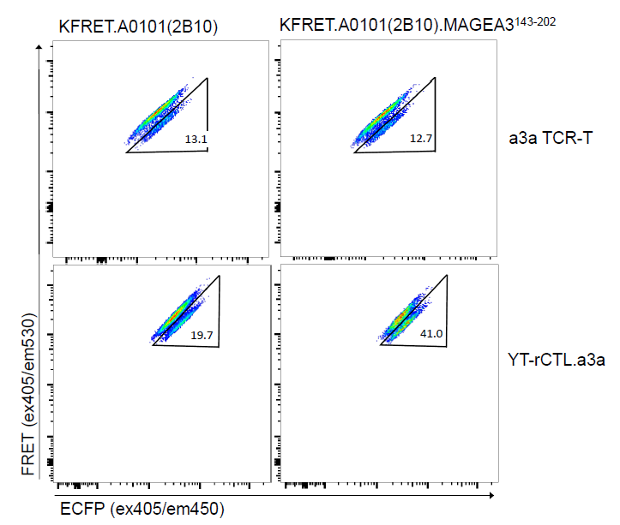

Supplementary Figure 7. The a3a variant of EB81.103 results in a larger percent FRET-shift signal than wild-type. KFRET.A0101(2B10) and KFRET.A0101(2B10).MAGEA3¹⁴³⁻²⁰² target cells were co-cultured with either YT-rCTL.a3a or primary cytotoxic T cells freshly isolated by FACS purification CD8⁺ CD4⁻ CD56⁻ T cells from healthy donor PBMC, activated by plate-bound anti-CD3/28 stimulation, and transduced with a3a TCR lentivirus. YT-rCTL.a3a were co-cultured with targets at a 1:1 effector:target ratio for 12 hours. Primary a3a TCR-T cells were co-cultured at a 1.5:1 ratio (to compensate for 68% TCR transduction efficiency) for 12 hours.

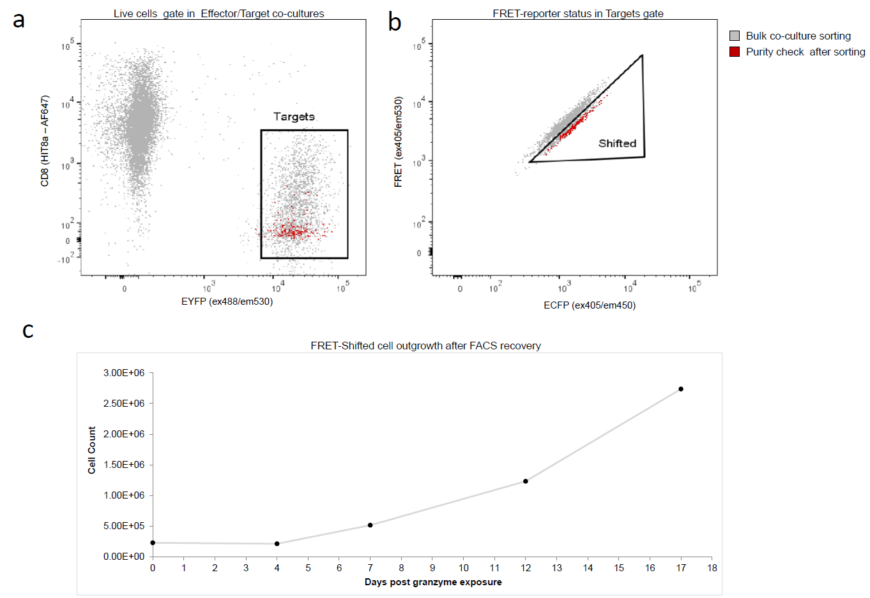

Supplementary Figure 8. Outgrowth of FRET-shifted cells after their recovery by FACS. YT-rCTL.a3a and KFRET.A0101.MAGEA3¹⁶⁴⁻¹⁷⁹ peptide were co-cultured at a 1:1 effector:target ratio for 12 hours. Target sAPC cells undergoing FRET-shift were isolated by FACS. Recovered cells were immediately assessed for purity by flow cytometry and were determined to be 100% free of any contaminating effector cells (a) or contaminating non-FRET-shifted target cells (b). Recovered FRET-shifted cells (3.25 x 10⁵ total) were placed into fresh culture media and counted at regular intervals using an automated trypan based cell counter. Cell counts initially declined and reached a minimum total cell count of 2.14 x 10⁵ by day 4, but subsequently reversed their decline and followed an exponential growth curve post-day 4 (c).

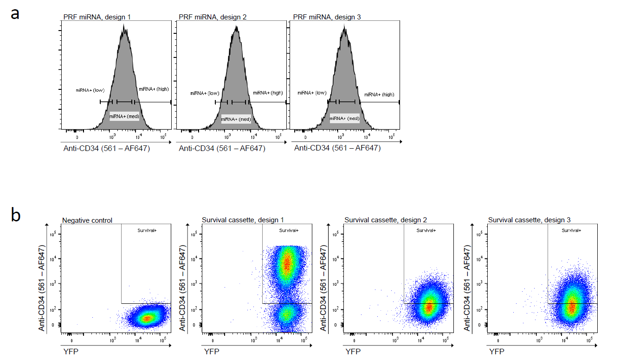

Supplementary Figure 9. FACS purity-sorting schema for KFRET Survival cassette lines and YT-rCTL PRF miRNA lines. (a) KFRET.A0101.MAGEA3¹⁶⁰⁻¹⁸³ cells were transduced at an MOI of 1 KIU/cell with each of three Survival cassette designs or an empty vector control. Purity-sorting was conducted 72 hours after transduction by staining cells with anti-CD34 antibody to detect inert truncated recombinant CD34 transduction marker, and gating on live target cells with AF647 MFI using a threshold of >5 standard deviation above the mean of the negative control. (b) YT-rCTL.a3a cells transduced at an MOI of 0.05 KIU/cell with each of three PRF miRNA designs or a scrambled miRNA control. Purity-sorting was conducted 72 hours after transduction by staining cells with anti-CD34 antibody to detect inert truncated recombinant CD34 transduction marker. Gating on AF647 signal was done by arbitrarily selecting low, medium, and high expression gates for each. The minimum threshold of the low expresser population was set at 5 standard deviations above the mean of the scrambled control.

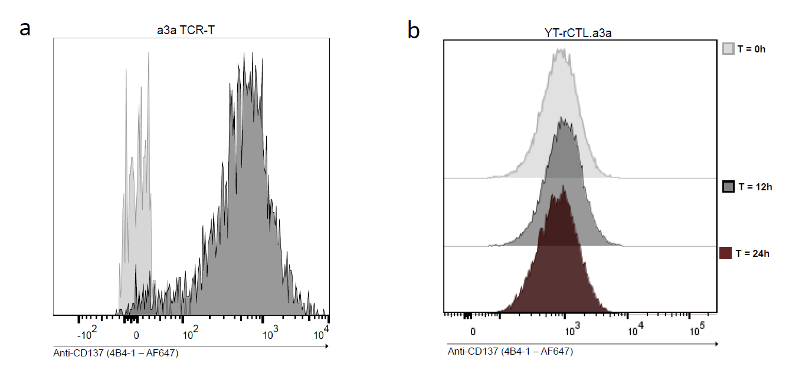

Supplementary Figure 10. Assessing CD137 upregulation in YT-rCTL cells. (a) Primary CD8⁺ a3a TCR-T cells co-cultured with KFRET.A0101.MAGEA3¹⁶⁰⁻¹⁸³ sAPC were stained with anti-CD137 antibody (AF647-conjugated clone 4B4-1, Biolegend) and analyzed by flow cytometry. Clear resolution between T₀ control and 12-hour co-culture experiment was observed. (b) YT-rCTL.a3a effectors co-cultured with KFRET.A0101.MAGEA3¹⁶⁰⁻¹⁸³ sAPC for either 12 or 24 hours were stained with anti-CD137 antibody and analyzed by flow cytometry. No resolution between T₀ control and either the 12-hour or 24-hour co-culture experiments was observable.

