Hydrogeochemical appraisal, groundwater quality, and health risks through potential toxic elements around municipal solid waste dumpsite Peshawar, Pakistan
Nabeel Afzal Butt ª, Muhammad Younis Khanª, Seema Anjum Khattakª, Abdur Rashid^{a, b,} Liaqat Aliª, Shah Jehanª
ª National Centre of Excellence in Geology, University of Peshawar, 25130, Pakistan
^{b} State Key Laboratory of Biogeology and Environmental Geology, School of Environmental Studies, China University of Geosciences, Wuhan, 430074, P.R. China
Corresponding Authors Email: abdur.rashid@bs.qau.edu.pk (A. Rashid), and nabeel.qau1@gmail.com (B. A., Nabeel).

Table S1
Chronic daily consumption of PTEs and major elements through intake of drinking water
Parameter | Adults |  |  | Children
 | Min | Max | Average | Min | Max | Average
Cr | 6.01E-02 | 3.58E-01 | 2.17E-01 | 8.65E-02 | 5.15E-01 | 3.12E-01
Cd | 1.32E-04 | 6.60E-04 | 3.08E-04 | 1.90E-04 | 9.50E-04 | 4.43E-04
Pb | 1.22E-03 | 7.99E-02 | 2.59E-02 | 1.76E-03 | 1.15E-01 | 3.73E-02
Ni | 7.43E-04 | 2.23E-01 | 4.10E-02 | 1.04E-03 | 2.91E-01 | 5.91E-02
Cu | 1.94E-02 | 2.41E+00 | 2.62E-01 | 2.80E-02 | 3.47E+00 | 3.77E-01
Major elements
Zn | 1.05E-02 | 2.66E+01 | 3.28E+00 | 1.51E-02 | 3.83E+01 | 4.72E+00
Co | 2.96E-03 | 4.18E-02 | 1.22E-02 | 4.26E-03 | 6.01E-02 | 1.76E-02
Fe | 6.89E+00 | 3.09E+01 | 1.49E+01 | 9.93E+00 | 4.45E+01 | 2.15E+01
Mn | 1.20E-02 | 1.50E+01 | 3.82E+00 | 1.72E-02 | 2.16E+01 | 5.51E+00
Mg | 3.61E+01 | 3.89E+03 | 1.93E+03 | 5.20E+01 | 5.60E+03 | 2.78E+03
Na | 1.57E+03 | 4.08E+03 | 2.67E+03 | 2.26E+03 | 5.88E+03 | 3.85E+03
Ca | 2.90E+02 | 3.07E+03 | 1.43E+03 | 4.17E+02 | 4.42E+03 | 2.05E+03
K | 1.16E+02 | 2.43E+03 | 8.11E+02 | 1.67E+02 | 3.50E+03 | 1.17E+03

Table S2
Assessment of the quality of groundwater and associated risk in the vicinity of solid waste dumpsite dumpsite.

Parameters | GTV (μg L−1) | Min. GWQI | Max. GWQI | Average GWQI | GWQI
Cr | 5.00E+01 | 4.33E-02 | 2.58E-01 | 1.56E-01 | 1.09E+00
Cd | 5.00E+00 | 9.50E-04 | 4.75E-03 | 5.12E-04 | 1.33E-02
Pb | 1.00E+01 | 4.39E-03 | 2.88E-01 | 9.33E-02 | 1.21E+00
Ni | 2.00E+01 | 1.30E-03 | 3.64E-01 | 7.39E-02 | 1.70E+00
Cu | 2.00E+02 | 3.50E-03 | 4.33E-01 | 4.71E-02 | 1.23E+00
Zn | 1.00E+03 | 3.76E-04 | 9.58E-01 | 1.18E-01 | 2.60E+00
Co | 5.00E+03 | 2.13E-05 | 3.01E-04 | 8.80E-05 | 2.29E-03
Fe | 3.00E+02 | 8.27E-01 | 3.71E+00 | 1.79E+00 | 4.65E+01
Mn | 1.00E+02 | 4.31E-03 | 5.41E+00 | 1.38E+00 | 2.75E+01
Mg | 1.00E+05 | 1.30E-02 | 1.40E+00 | 6.96E-01 | 1.81E+01
Na | 2.00E+05 | 2.82E-01 | 7.35E-01 | 4.81E-01 | 1.25E+01
Ca | 2.00E+05 | 5.21E-02 | 5.52E-01 | 2.57E-01 | 6.67E+00
K | 1.50E+04 | 2.78E-01 | 5.83E+00 | 1.95E+00 | 5.06E+01

Table S3
Principal component analysis results in groundwater around the dump site, Peshawar
 | F1 | F2 | F3
pH | -0.32 | -0.58 | 0.37
EC | 0.47 | -0.05 | 0.86
TDS | 0.47 | -0.05 | 0.82
Resistivity | 0.05 | -0.51 | -0.01
SO₄ | 0.89 | -0.07 | 0.00
Cl | 0.91 | -0.07 | -0.01
HCO₃ | -0.09 | 0.89 | 0.14
Ca | 0.02 | 0.46 | -0.20
Mg | -0.10 | 0.72 | 0.20
Na | 0.88 | -0.19 | -0.17
K | 0.93 | -0.11 | -0.13
Cr | 0.12 | -0.60 | -0.01
Cu | 0.86 | 0.08 | -0.02
Co | 0.96 | 0.03 | -0.10
Zn | 0.92 | 0.10 | -0.06
Fe | 0.93 | 0.17 | 0.08
Mn | 0.95 | 0.07 | -0.09
Cd | -0.13 | -0.21 | -0.23
Pb | 0.95 | 0.02 | -0.10
Ni | 0.96 | 0.05 | -0.02
Eigenvalue | 10.85 | 3.14 | 1.86
Variability (%) | 51.69 | 14.94 | 8.86
Cumulative % | 51.69 | 66.63 | 75.48

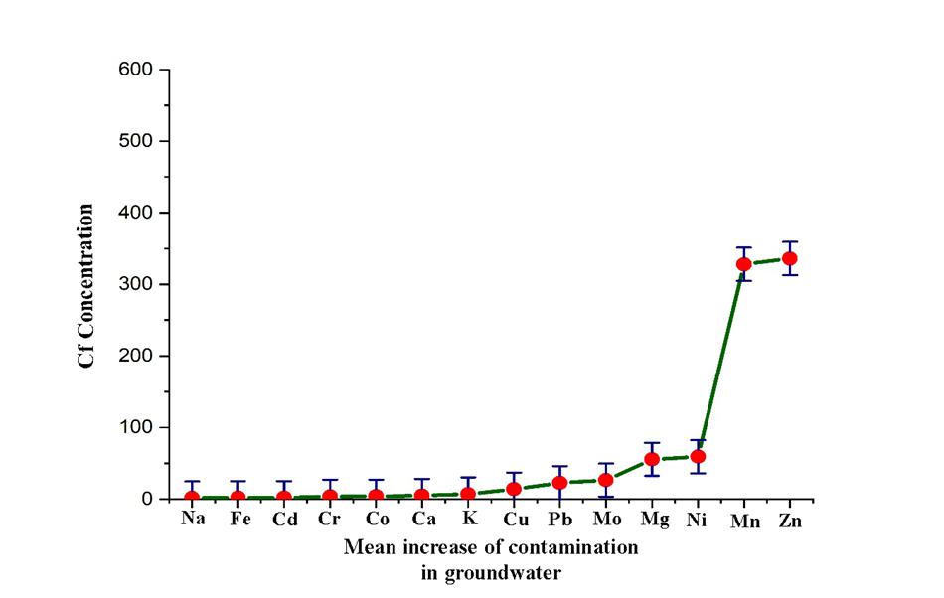
Fig. S1 Quantification and trends of contamination in groundwater surrounding the dumpsite

Fig. S2 Chronic daily intake of elements in children and adults

Fig. S3 Shows a dendrogram classifying groundwater into three clusters

