CD9
CD63
TSG101
GM130

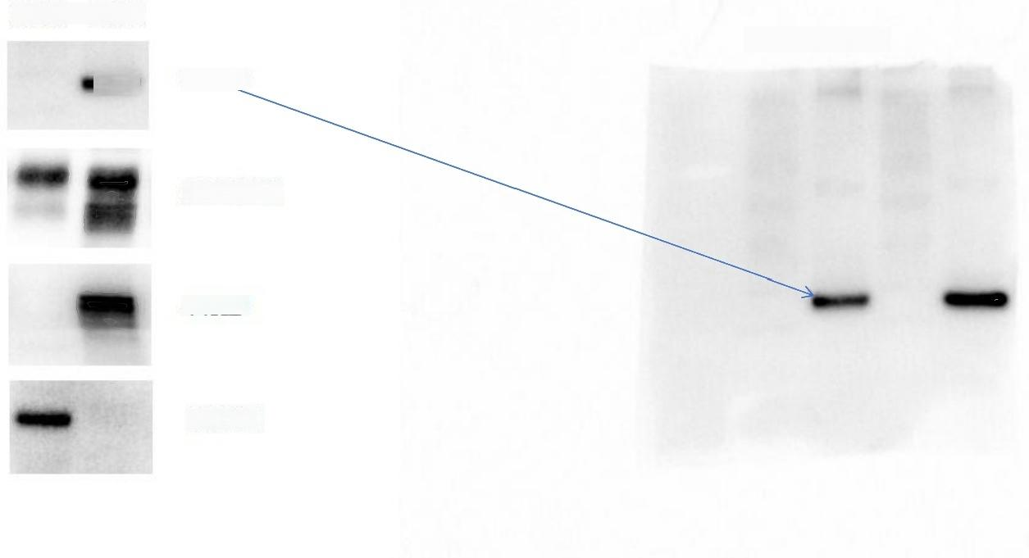
MSC EXO
MSC EXO
24KD

25/43KD

44KD

130KD

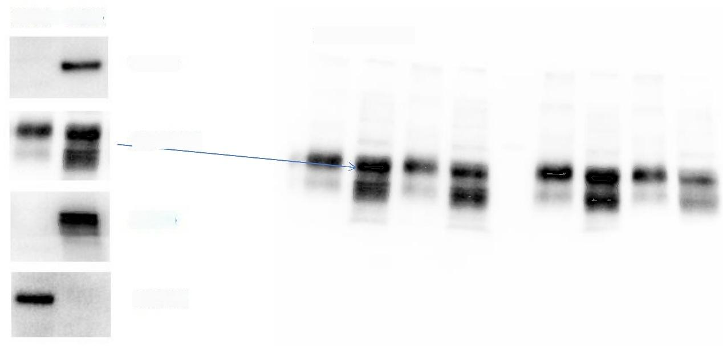
MSC EXO

CD9

MSC EXO
24KD

CD63

25/43KD

TSG101

44KD

GM130

130KD

CD9
CD63
TSG101
GM130

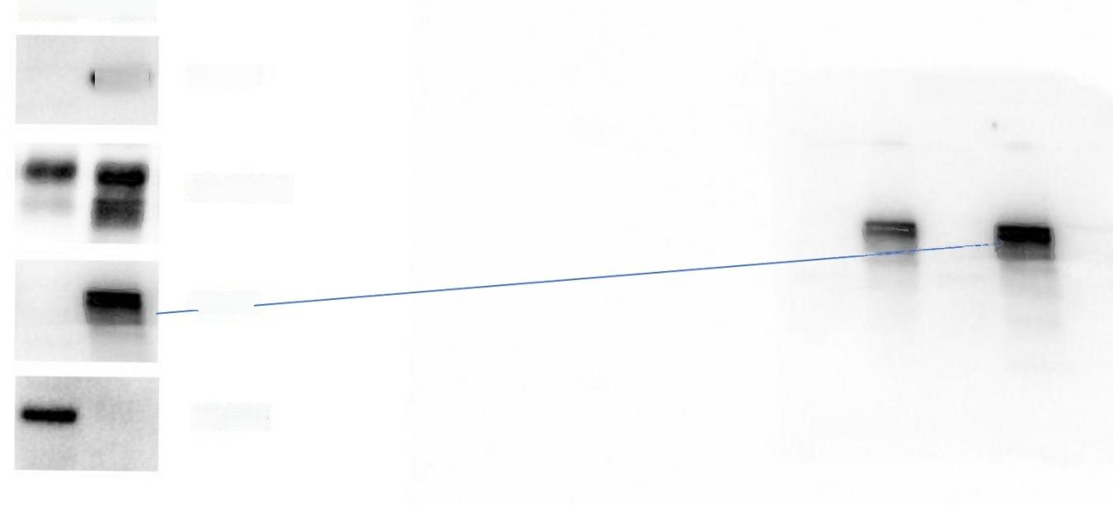
MSC EXO

24KD
MSC EXO

25/43KD

44KD -

130KD

CD9
CD63
TSG101
GM130

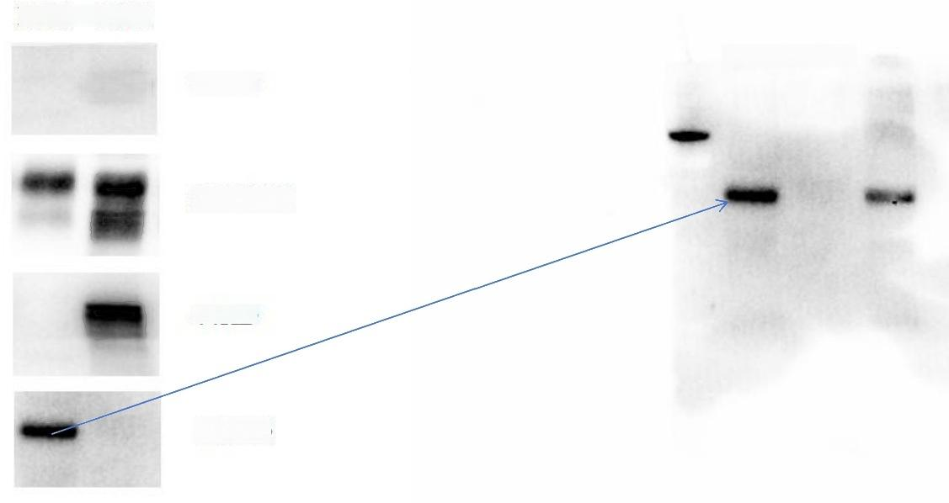

MSC EXO | MSC EXO  24KD

25/43KD

44KD

130KD

