Supplemental data
Figure S1: Leukocyte kinetics in patients who did and did not develop pneumonia during the hospital stay

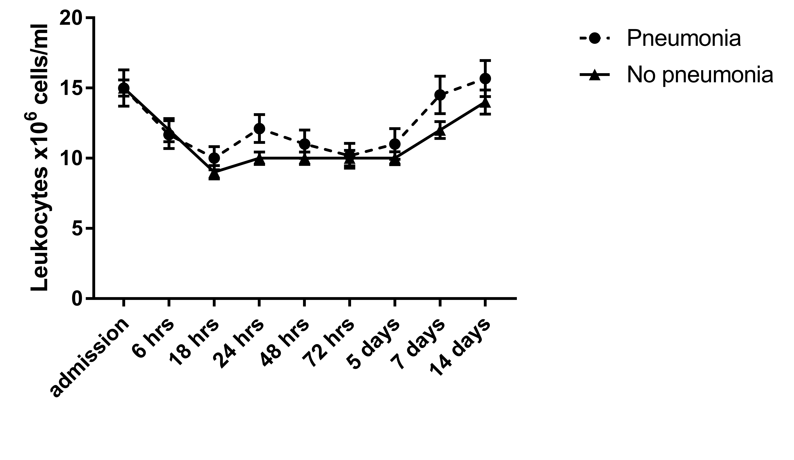

Figure S1: Absolute leukocyte numbers in patients diagnosed with pneumonia and regular patients. Data are expressed as mean +/- SEM (*p<0.05).

).

