THE ROLE OF KDM5D IN THE DEVELOPMENT OF CHEMORESISTANCE TO CISPLATIN THROUGH CUL4A IN NEUROBLASTOMA

Natalia Podhorska, Jan Hrabeta, Marie Belhajova, Tomas Eckschlager*
Department of Pediatric Hematology and Oncology, 2nd Faculty of Medicine, Charles University and Motol University Hospital, 150 06 Prague 5, Czech Republic
* Correspondence: Tomas.Eckschlager@lfmotol.cuni.cz, T.E. V Úvalu 84, 150 06 Prague 5, Czech Republic

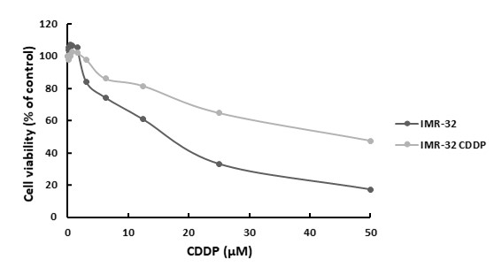
Figure S1. Viability of IMR-32 and IMR-32^{CDDP} cells after 72 h treatment with CDDP. IMR-32 has IC₅₀ 25.29 µM and CDDP resistant IMR-32^{CDDP} has IC₅₀ 43.61 µM. Data shown is representative from one measurement from two independent experiments.

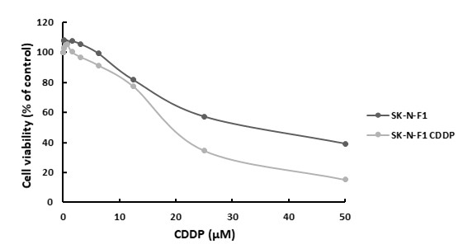
Figure S2. Viability of SK-N-F1 and SK-N-F1^{CDDP} cells after 72 h treatment with CDDP. SK-N-F1 has 27.02 µM and CDDP resistant SK-N-F1^{CDDP} has IC₅₀ 38.02 µM. Data shown is representative from one measurement from two independent experiments.
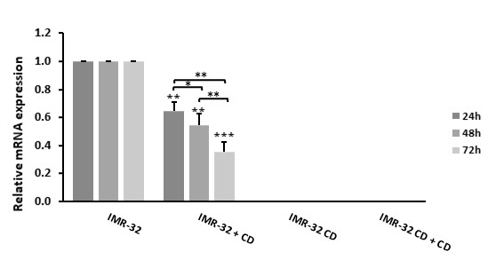
Figure S3. KDM5D expression of mRNA in the CDDP-sensitive IMR-32 and the CDDP-resistant IMR-32^{CDDP}. KDM5D expression was lost in CDDP-resistant IMR-32^{CDDP} cell line. Treatment with 20 µM CDDP significantly decreased KDM5D level in IMR-32 depending on the incubation time (p < 0.01; p < 0.001). Shown are means and standard deviations (SD) from two independent experiments. * p < 0.05; ** p < 0.01; *** p < 0.001 (ANOVA with post-hoc Tukey HSD Test). IMR-32 CD - CDDP resistant cell line IMR-32^{CDDP}; IMR-32 + CD - IMR-32 cells treated with 20 µM CDDP; IMR-32 CD + CD - CDDP resistant cells IMR-32^{CDDP} treated with 20 µM CDDP.
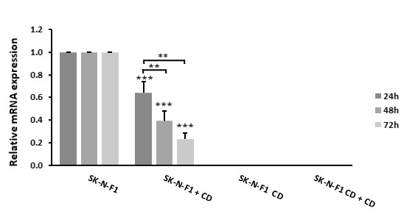
*
Figure S4. KDM5D expression of mRNA in the CDDP-sensitive SK-N-F1 and the CDDP-resistant SK-N-F1^{CDDP}. KDM5D expression was lost in CDDP-resistant SK-N-F1^{CDDP} cell line. Treatment with 20 µM CDDP significantly decreased KDM5D level in SK-N-F1depending on the incubation time (p < 0.001). Shown are means and standard deviations (SD) from two independent experiments. * p < 0.05; ** p < 0.01; *** p < 0.001 (ANOVA with post-hoc Tukey HSD Test). SK-N-F1 CD - CDDP resistant cell line SK-N-F1^{CDDP}; SK-N-F1 + CD - SK-N-F1 cells treated with 20 µM CDDP; SK-N-F1 CD + CD - CDDP resistant cells SK-N-F1^{CDDP} treated with 20 µM CDDP.

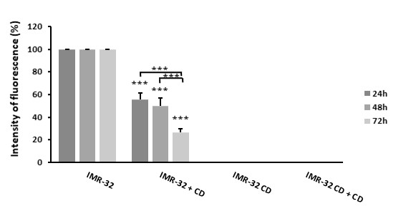
Figure S5. Protein level of KDM5D in the CDDP-sensitive IMR-32 and CDDP-resistant IMR-32^{CDDP}. KDM5D expression was lost in CDDP resistant IMR-32^{CDDP} cell line. Treatment with 20 µM CDDP significantly decreased KDM5D protein level in IMR-32 depending on the incubation time (p < 0.01; p < 0.001). Shown are means and standard deviations (SD) from three independent experiments. * p < 0.05; ** p < 0.01; *** p < 0.001 (ANOVA with post-hoc Tukey HSD Test). IMR-32 CD - CDDP resistant cell line IMR-32^{CDDP}; IMR-32 + CD - IMR-32 cells treated with 20 µM CDDP; IMR-32 CD + CD - CDDP resistant cells IMR-32^{CDDP} treated with 20 µM CDDP.

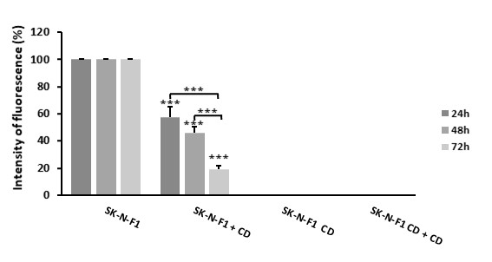
Figure S6. Protein level of KDM5D in the CDDP-sensitive SK-N-F1 and the CDDP-resistant SK-N-F1^{CDDP}. KDM5D expression was lost in CDDP-resistant SK-N-F1^{CDDP} cell line. Treatment with 20 µM CDDP significantly decreased KDM5D protein level in SK-N-F1depending on the incubation time (p < 0.001). Shown are means and standard deviations (SD) from three independent experiments. * p < 0.05; ** p < 0.01; *** p < 0.001 (ANOVA with post-hoc Tukey HSD Test). SK-N-F1 CD - CDDP resistant cell line SK-N-F1^{CDDP}; SK-N-F1 + CD - SK-N-F1 cells treated with 20 µM CDDP; SK-N-F1 CD + CD - CDDP resistant cells SK-N-F1^{CDDP} treated with 20 µM CDDP.
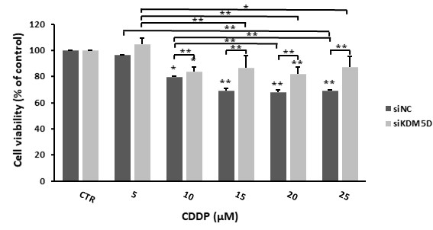
Figure S7. Viability after incubation with CDDP (24 h) and KDM5D silencing in UKF-NB-3 decrease depending on the concentration (p < 0.05; p < 0.01), decrease was smaller compared with NC (p < 0.05; p < 0.01). Shown are means and standard deviations (SD) from three independent experiments are. * p < 0.05; ** p < 0.01; *** p < 0.001 (ANOVA with post-hoc Tukey HSD Test). NC - negative control; si - short interfering RNA.

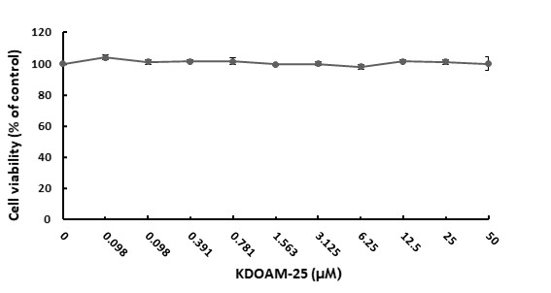
Figure S8. Cytotoxicity of KDOAM-25 after 72h in UKF-NB-3, concentration up to 50 μM does not affect a viability of cells. Shown are means and standard deviations (SD) from three independent experiments.
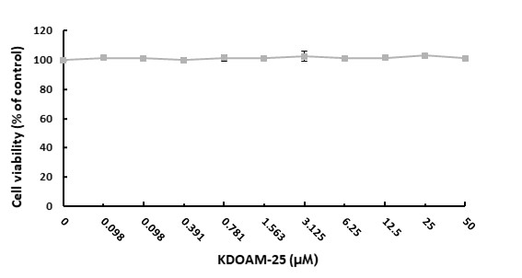
Figure S9. Cytotoxicity of KDOAM-25 after 72h in UKF-NB-3^{CDDP}, concentration up to 50 μM does not affect a viability of cells. Shown are means and standard deviations (SD) from three independent experiments.

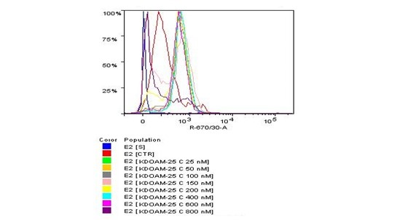
Figure S10. Level of H3K4me3 in UKF-NB-3 after 24 h of incubation with KDOAM-25 with different concentration. Data shown is representative from three independent experiments. S - control only with secondary antibody; CTR - control; c - concentration.
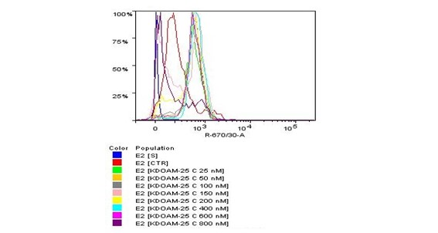
Figure S11. Level of H3K4me3 in UKF-NB-3 after 48 h of incubation with KDOAM-25 with different concentration. Data shown is representative from three independent experiments. S - control only with secondary antibody; CTR - control; c - concentration.

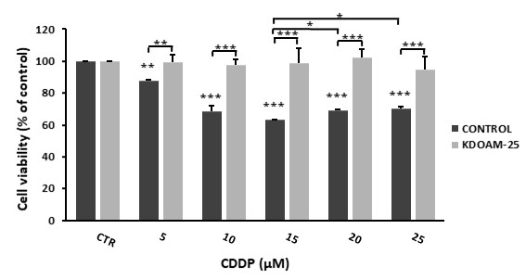
Figure S12. Cell viability after incubation with CDDP (24 h) and inhibition of KDM5s with KDOAM-25 (48 h) in UKF-NB-3 is not affected even after treatment with increasing concentrations of CDDP compared to controls without KDOAM-25, in which cell viability decreased (p < 0.001). Shown are means and standard deviations (SD) from three independent experiments. * p < 0.05; ** p < 0.01; *** p < 0.001 (ANOVA with post-hoc Tukey HSD Test). CTR - control.

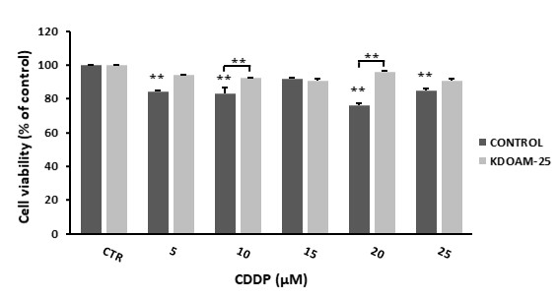
Figure S13. Cell viability after incubation with CDDP (24 h) and inhibition of KDM5s with KDOAM-25 (48 h) in UKF-NB-3^{CDDP} is not affected even after treatment with increasing concentrations of CDDP compared to controls without KDOAM-25, in which cell viability decreased (p < 0.01). Shown are means and standard deviations (SD) from three independent experiments. * p < 0.05; ** p < 0.01; *** p < 0.001 (ANOVA with post-hoc Tukey HSD Test). CTR - control.

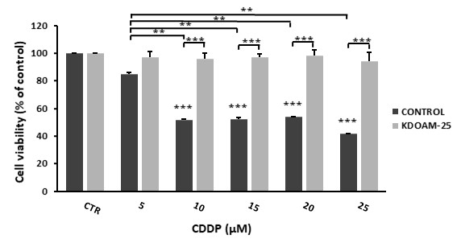
Figure S14. Cell viability after incubation with CDDP (48 h) and inhibition of KDM5s with KDOAM-25 (48 h) in UKF-NB-3 is not affected even after treatment with increasing concentrations of CDDP compared to controls without KDOAM-25, in which cell viability decreased (p < 0.001). Shown are means and standard deviations (SD) from three independent experiments. * p < 0.05; ** p < 0.01; *** p < 0.001 (ANOVA with post-hoc Tukey HSD Test). CTR - control.

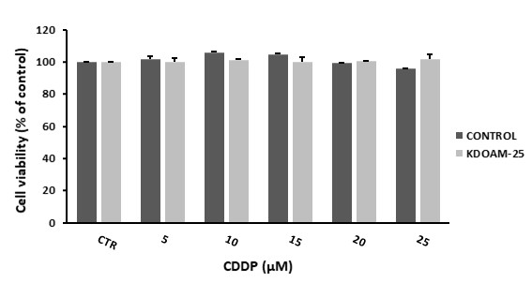
Figure S15. Cell viability after incubation with CDDP (48 h) and inhibition of KDM5s with KDOAM-25 (48 h) in UKF-NB-3^{CDDP}. CDDP treatment does not affect cell viability in control or inhibited cells. Shown are means and standard deviations (SD) from three independent experiments. CTR - control.

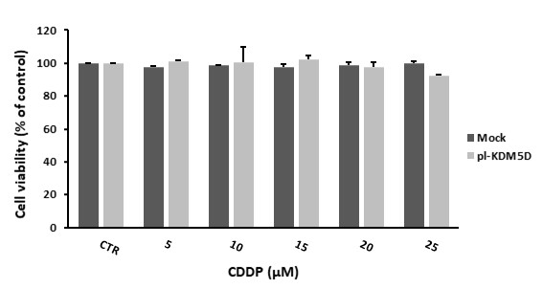
Figure S16. Cell viability after incubation with CDDP (24 h) and transfection with plasmid carrying gene KDM5D (48 h) in UKF-NB-3^{CDDP} does not affect cell viability in control or transfected cells. Shown are means and standard deviations (SD) from three independent experiments. CTR - control; pl - ORF-clone plasmid.

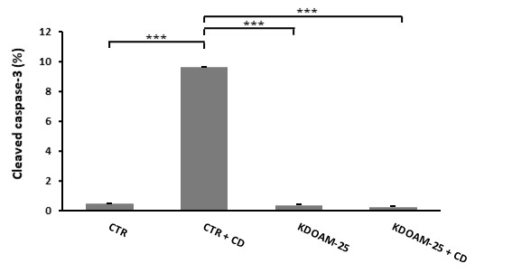
Figure S17. Cleaved caspase-3 in CDDP sensitive cell line UKF-NB-3. The KDM5s pan-inhibitor did not significantly changed the level of cleaved caspase-3 even after CDDP treatment, but significantly decreased the amount of cleaved caspase-3 compared to control after CDDP treatment (p < 0.001). Shown are means and standard deviations (SD) from three independent experiments. CTR - control; CTR + CD - control cells treated with 20 µM CDDP; KDOAM-25 - control cells treated with 400 nM KDOAM-25; KDOAM-25 + CD - control cells treated with 400 nM KDOAM-25 and 20 µM CDDP.
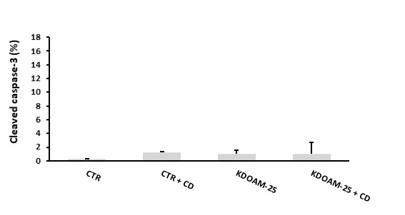
Figure S18. Cleaved caspase-3 in CDDP resistant cell line UKF-NB-3^{CDDP}. The KDM5s pan-inhibitor did not significantly changed the level of cleaved caspase-3 even after CDDP treatment. Shown are means and standard deviations (SD) from three independent experiments. CTR - control; CTR + CD - control cells treated with 20 µM CDDP; KDOAM-25 - control cells treated with 400 nM KDOAM-25; KDOAM-25 + CD - control cells treated with 400 nM KDOAM-25 and 20 µM CDDP.

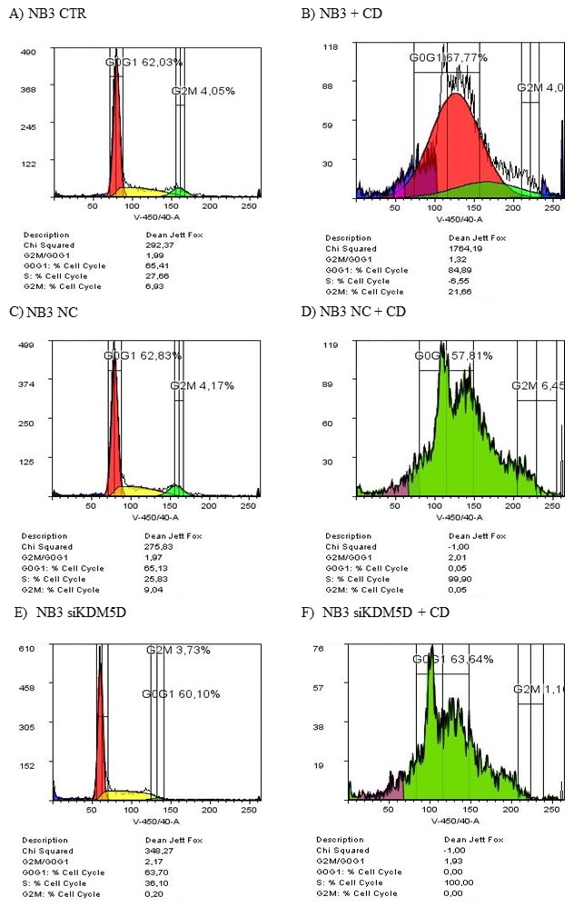
Figure S19. Flow cytometry histograms showed cell cycle of UKF-NB-3 in (A) control, (B) cells after CDDP treatment (48 h), (C) cells transfected with noncoding RNA (NC) (48 h), (D) NC after CDDP treatment (48 h), (E) cells transfected with siKDM5D (si) (48 h), (F) si after CDDP treatment (48 h). Histograms are representative from one measurement from three independent experiments. CD - CDDP; CTR - control; NC - non-coding RNA; si - short interfering RNA; pl - ORF-clone plasmid; NB3 - UKF-NB-3.

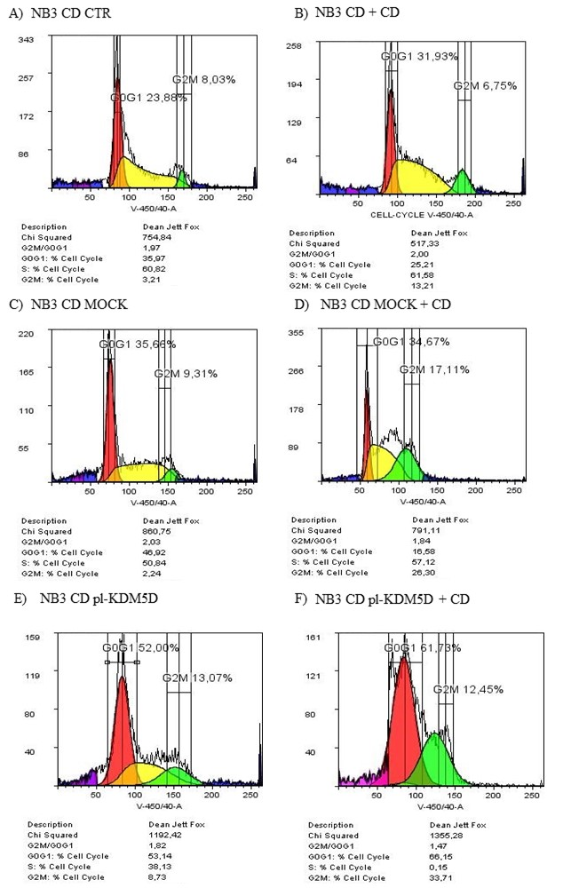
Figure S20. Flow cytometry histograms showed cell cycle of UKF-NB-3^{CDDP} in (A) control, (B) cells after CDDP treatment (48 h), (C) cells transfected with control plasmid (mock) (48 h), (D) mock after CDDP treatment (48 h), (E) cells transfected with plasmid with KDM5D (pl-KDM5D) (48 h), (F) pl-KDM5D after CDDP treatment (48 h). Histograms are representative from one measurement from three independent experiments. CD, CDDP; CTR - control; NC - non-coding RNA; si - short interfering RNA; pl - ORF-clone plasmid; NB3 CD - UKF-NB-3^{CDDP}.
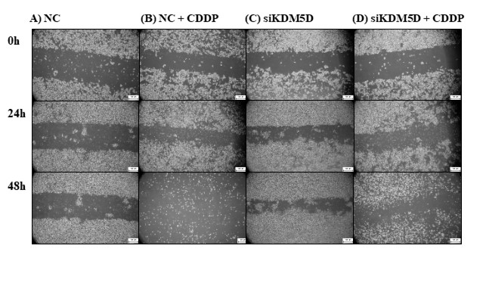
Figure S21. Wound-healing assay of UKF-NB-3 showed cell migration after 0 h, 24 h and 48 h in (A) cells transfected with noncoding RNA (NC), (B) NC after CDDP treatment, (C) cells transfected with siKDM5D, (D) siKDM5D after CDDP treatment. Photos are representative from one measurement from three independent experiments. Scale – 500 µm. si - short interfering RNA; NC – control cells with non-coding RNA; NC + CD – control cells treated with 20 µM CDDP; siKDM5D – control cells transfected with siKDM5D; siKDM5D + CD – control cells transfected with siKDM5D and treated with 20 µM CDDP.
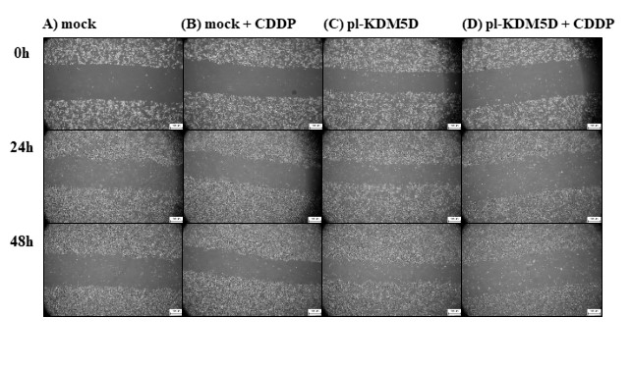
Figure S22. Wound-healing assay of UKF-NB-3^{CDDP} showed cell migration after 0 h, 24 h and 48 h in (A) cells transfected with control plasmid (mock), (B) mock after CDDP treatment, (C) cells transfected with plasmid with KDM5D (pl-KDM5D), (D) pl-KDM5D after CDDP treatment. Photos are representative from one measurement from three independent experiments. Scale – 500 µm. NC - non-coding RNA; pl - ORF-clone plasmid; Mock + CD – control cells treated with 20 µM CDDP; pl-KDM5D – control cells transfected with pl-KDM5D; pl-KDM5D + CD – control cells transfected with pl-KDM5D and treated with 20 µM CDDP.

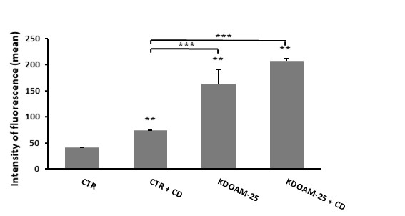
Figure S23. Protein level of CUL4A in UKF-NB-3 after treatment with KDM5s pan-inhibitor KDOAM-25 and after CDDP treatment. Shown are means and standard deviations (SD) from three independent experiments. * p < 0.5; ** p < 0.01; *** p < 0.001 (ANOVA with post-hoc Tukey HSD Test). CTR - control; CTR + CD - control cells treated with 20 µM CDDP; KDOAM-25 - control cells treated with 400 nM KDOAM-25; KDOAM-25 + CD - control cells treated with 400 nM KDOAM-25 and 20 µM CDDP.

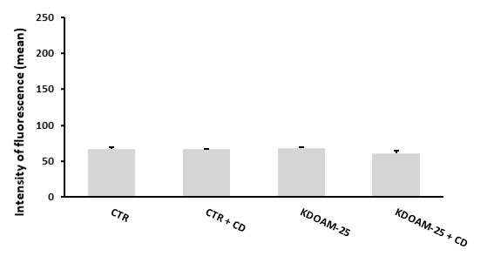
Figure S24. Protein level of CUL4A in UKF-NB-3^{CDDP} after treatment with KDM5s pan-inhibitor KDOAM-25 and after CDDP treatment. Shown are means and standard deviations (SD) from three independent experiments. CTR - control; CTR + CD - control cells treated with 20 µM CDDP; KDOAM-25 - control cells treated with 400 nM KDOAM-25; KDOAM-25 + CD - control cells treated with 400 nM KDOAM-25 and 20 µM CDDP.

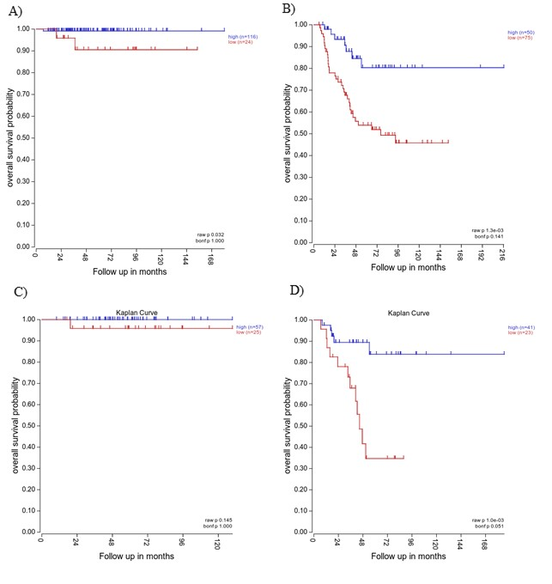

Figure S25. Kaplan-Meier curves analyzing KDM5D expression data and overall survival of patients in two different neuroblastoma datasets: Tumor Neuroblastoma by Kocak (649; custom; ag44kcwolf) - in male patients with stages 1, 2 and 4S (A); in male patients with stages 3 and 4 (B); Tumor Neuroblastoma by Oberthuer (251; custom; amexp255) – in male patients with stages 1, 2 and 4S (C) and in male patients with stages 3 and 4 (D) via the R2: Genomics Analysis and Visualization Platform revealed that low relative expression of KDM5D is associated with poorer survival.

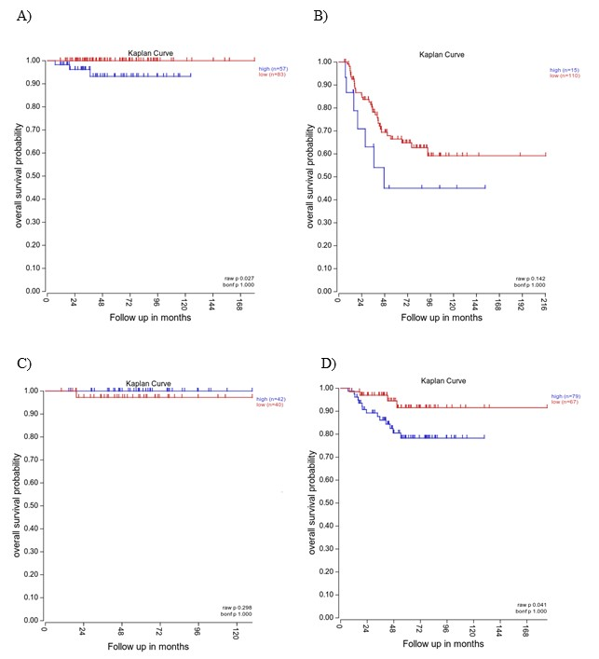
Figure S26. Kaplan-Meier curves analyzing CUL4A expression data and overall survival of patients in two different neuroblastoma datasets: Tumor Neuroblastoma by Kocak (649; custom; ag44kcwolf) - in male patients with stages 1, 2 and 4S (A); in male patients with stages 3 and 4 (B); Tumor Neuroblastoma by Oberthuer (251; custom; amexp255) – in male patients with stages 1, 2 and 4S (C) and in male patients with stages 3 and 4 (D) via the R2: Genomics Analysis and Visualization Platform revealed that high relative expression of CUL4Ais associated with poorer survival rates in male patients with stages 3 and 4.

Table S1. Characteristics of datasets analyzed in R2 Genomics Platform (https://r2.amc.nl)
