Supplementary Table 1. Definition and scoring approach for Life’s Essential 8 score(1).
Domain | CVH Metric | Quantification and Scoring of CVH Metric
Health Behaviors | Diet score | Metric: Quantiles of DASH-style diet adherence(Healthy Eating Index-2015 diet score percentile)  Scoring (Population):  Points Quantile  100 ≥95th percentile (top/ideal diet)  80 75th – 94th percentile  50 50th – 74th percentile  25 25th – 49th percentile  0 1st – 24th percentile (bottom/least ideal quartile)
Health Behaviors | Physical activity score | Metric: Minutes of moderate (or greater) intensity activity per week  Scoring:  Points Minutes  100 ≥150  90 120 – 149  80 90 – 119  60 60 – 89  40 30 – 59  20 1 – 29  0 0
Health Behaviors | Nicotine exposure  score | Metric: Combustible tobacco use and/or inhaled NDS use; or secondhand smoke exposure  Scoring:  Points Status  100 Never smoker  75 Former smoker, quit ≥5 yrs  50 Former smoker, quit 1 - <5 yrs  25 Former smoker, quit <1 year, or currently using inhaled NDS  0 Current smoker  Subtract 20 points (unless score is 0) for living with active indoor smoker in home
Health Behaviors | Sleep health  score | Metric: Average hours of sleep per night  Scoring:  Points Level  100 7 – <9  90 9 – <10  70 6 – <7  40 5 – <6 or ≥10  20 4 – <5  0 <4
Health Factors | Body mass index score | Metric: Body mass index (kg/m²)  Scoring: Points Level 100 <25  70 25.0 – 29.9  30 30.0 – 34.9  15 35.0 – 39.9  0 ≥40.0
Health Factors | Blood lipids score | Metric: Non-HDL-cholesterol (mg/dL)  Scoring:  Points Level  100 <130  60 130 – 159  40 160 – 189  20 190 – 219  0 ≥220  If the drug-treated level, subtract 20 points
Health Factors | Blood glucose score | Metric: Fasting blood glucose (mg/dL) or Hemoglobin A1c (%)  Scoring:  Points Level  100 No history of diabetes and FBG <100 (or HbA1c < 5.7)  60 No diabetes and FBG 100 – 125 (or HbA1c 5.7-6.4) (Pre-diabetes)  40 Diabetes with HbA1c <7.0  30 Diabetes with HbA1c 7.0 – 7.9  20 Diabetes with HbA1c 8.0 – 8.9  10 Diabetes with Hb A1c 9.0 – 9.9  0 Diabetes with HbA1c ≥10.0
Health Factors | Blood pressure score | Metric: Systolic and diastolic blood pressure (mm Hg)  Scoring:  Points Level  100 <120/<80 (Optimal)  75 120-129/<80 (Elevated)  50 130-139 or 80-89 (Stage I HTN)  25 140-159 or 90-99  0 ≥160 or ≥100  Subtract 20 points if treated level

Supplementary table 2 Characteristics of the matched study population.
 | Male |  |  | Female
Characteristic | non-depression | depression | P value | non-depression | depression | P value
N(%) | N=800 | N=800 |  | N=1385 | N=1385
Age(year) | 49.0 (17.6) | 49.1 (16.1) | 0.901 | 49.0 (16.9) | 48.9 (15.7) | 0.824
Race, n(%)
Non-Hispanic White | 379 (47.4%) | 380 (47.5%) | 0.949 | 556 (40.1%) | 572 (41.3%) | 0.801
Non-Hispanic Black | 177 (22.1%) | 167 (20.9%) |  | 330 (23.8%) | 308 (22.2%)
Mexican American | 101 (12.6%) | 102 (12.8%) |  | 223 (16.1%) | 215 (15.5%)
Other Hispanic | 55 (6.9%) | 62 (7.8%) |  | 86 (6.2%) | 95 (6.9%)
Other race | 88 (11.0%) | 89 (11.1%) |  | 190 (13.7%) | 195 (14.1%)
Poverty, n (%)
<1.3 | 406 (50.8%) | 403 (50.4%) | 0.904 | 714 (51.6%) | 705 (50.9%) | 0.919
1.3–3.5 | 294 (36.8%) | 291 (36.4%) |  | 456 (32.9%) | 466 (33.6%)
>3.5 | 100 (12.5%) | 106 (13.3%) |  | 215 (15.5%) | 214 (15.5%)
Education , n(%)
Less than high school | 391 (48.9%) | 389 (48.6%) | 0.96 | 675 (48.7%) | 648 (46.8%) | 0.323
High school or above | 409 (51.1%) | 411 (51.4%) |  | 710 (51.3%) | 737 (53.2%)
Marital status, n(%)
Other | 383 (47.9%) | 386 (48.3%) | 0.92 | 794 (57.3%) | 780 (56.3%) | 0.618
Married or living with partner | 417 (52.1%) | 414 (51.8%) |  | 591 (42.7%) | 605 (43.7%)
Drinking status, n(%)
Former | 179 (22.4%) | 175 (21.9%) | 0.98 | 293 (21.2%) | 285 (20.6%) | 0.96
Never or mild | 299 (37.4%) | 300 (37.5%) |  | 547 (39.5%) | 543 (39.2%)
Moderate | 93 (11.6%) | 98 (12.3%) |  | 246 (17.8%) | 248 (17.9%)
Heavy | 229 (28.6%) | 227 (28.4%) |  | 299 (21.6%) | 309 (22.3%)
Antidepressants use, n (%)
No | 605 (75.6%) | 605 (75.6%) | 1 | 895 (64.6%) | 885 (63.9%) | 0.721
Yes | 195 (24.4%) | 195 (24.4%) |  | 490 (35.4%) | 500 (36.1%)
CCI
0 | 355 (44.4%) | 336 (42.0%) | 0.258 | 475 (34.3%) | 478 (34.5%) | 0.627
1~3 | 122 (15.3%) | 146 (18.3%) |  | 358 (25.8%) | 337 (24.3%)
>3 | 323 (40.4%) | 318 (39.8%) |  | 552 (39.9%) | 570 (41.2%)
%, weighted proportion. Abbreviations: CVH, Cardiovascular Health; LE8, Life’s Essential 8; CCI, Charlson comorbidity index.

Supplementary Figure 1 Flowchart of the population included in our final analysis.
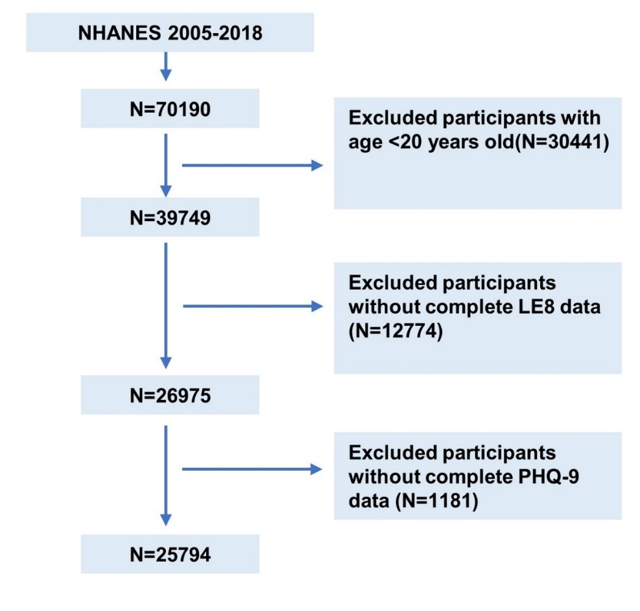
Supplementary Figure 2 Age-adjusted prevalence of depression in different levels of LE8 scores.
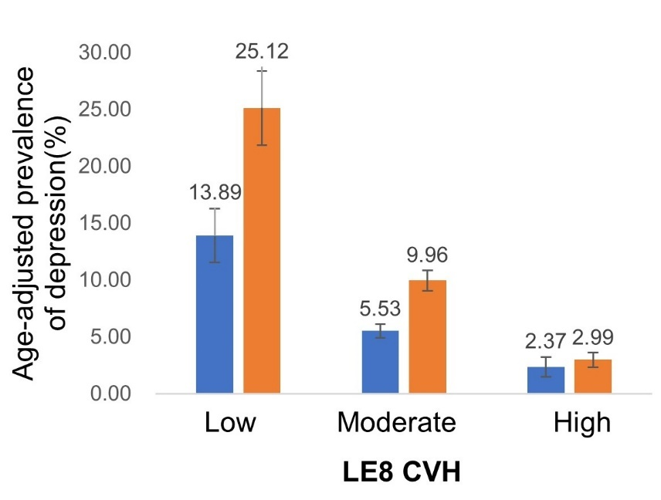

The numbers above the bars represent the weighted percentage. Whiskers on the bars represent the 95% confidence level. Abbreviations: CVH, Cardiovascular Health; LE8, Life’s Essential 8.

Supplementary Figure 3 Distribution of variables standardized mean difference before and after matching.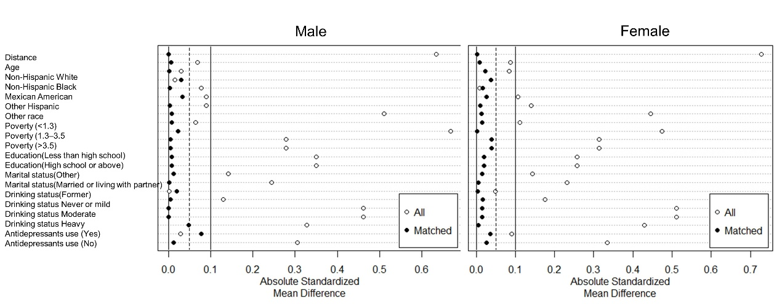

Supplementary Figure 4 Distribution of propensity score before and after matching.
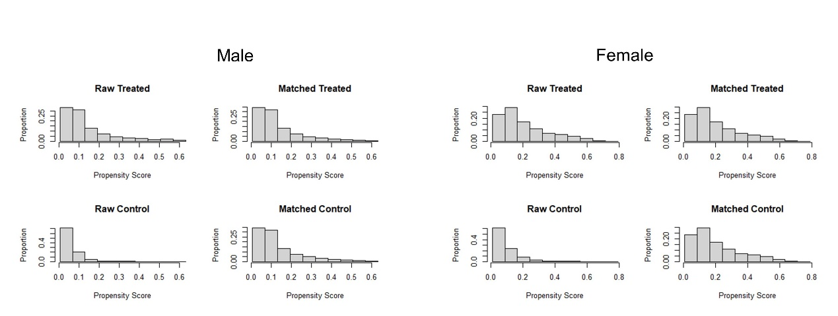
1. Lloyd-Jones DM, Allen NB, Anderson CAM, Black T, Brewer LC, Foraker RE, et al. Life's Essential 8: Updating and Enhancing the American Heart Association's Construct of Cardiovascular Health: A Presidential Advisory From the American Heart Association. Circulation. 2022;146(5):e18-e43.

