
Sample_01
Sample_02
Sample_03
Sample_04
Sample_05
Sample_06
Sample_07
Sample_08
Sample_01
Sample_02
Sample_03
Sample_04
Sample_05
Sample_06
Sample_07
Sample_08

Sup. 1. The relative abundance of the most prevalent bacterial groups associated with each microenvironment depicted for all the subjects investigated. Superscripts indicate phylum.


Sup. 2. The relative abundance of the most prevalent bacterial groups in each group.

Sup. 3. The relative abundance of the main genera of bacteria in post-treatment groups (post-ND and post-NF)
Phylum | Genus | Group |  | Abundance (%) |  | P value |  | Phylum | Genus | Group | Abundance (%) | P value
Firmicutes | Staphylococcus | Post-ND |  | 26.32 ± 12.06 |  | 0.027 |  | Proteobacteria | Burkholderia | Post-ND | 7.10 ± 3.01 | 0.462
 |  | Post-NF |  | 13.18 ± 8.85 |  |  |  |  |  | Post-NF | 8.42 ± 5.56
 | Streptococcus | Post-ND |  | 1.63 ± 1.08 |  | 0.208 |  |  | Sphingomonas | Post-ND | 3.29 ± 1.01 | 0.462
 |  | Post-NF |  | 4.25 ± 4.29 |  |  |  |  |  | Post-NF | 3.83 ± 2.02
 | Thermoanaerobacterium | Post-ND |  | 3.74 ± 2.05 |  | 0.074 |  |  | Enterobacteriaceae_g | Post-ND | 4.11 ± 2.61 | 0.753
 |  | Post-NF |  | 6.67 ± 4.27 |  |  |  |  |  | Post-NF | 1.06 ± 1.02
 | Anaerococcus | Post-ND |  | 2.53 ± 2.07 |  | 0.916 |  | Actinobacteria | Cutibacterium | Post-ND | 13.69 ± 12.27 | 0.916
 |  | Post-NF |  | 2.33 ± 2.57 |  |  |  |  |  | Post-NF | 11.44 ± 8.17
Bacteroidetes | Prevotella | Post-ND |  | 1.60 ± 1.17 |  | 1.00 |  |  | Corynebacterium | Post-ND | 1.54 ± 0.79 | 0.674
 |  | Post-NF |  | 1.72 ± 2.24 |  |  |  |  |  | Post-NF | 0.93 ± 0.51
 |  |  |  |  |  |  |  |  | Lawsonella | Post-ND | 1.77 ± 2.76 | 0.600
 |  |  |  |  |  |  |  |  |  | Post-NF | 3.08 ± 2.05

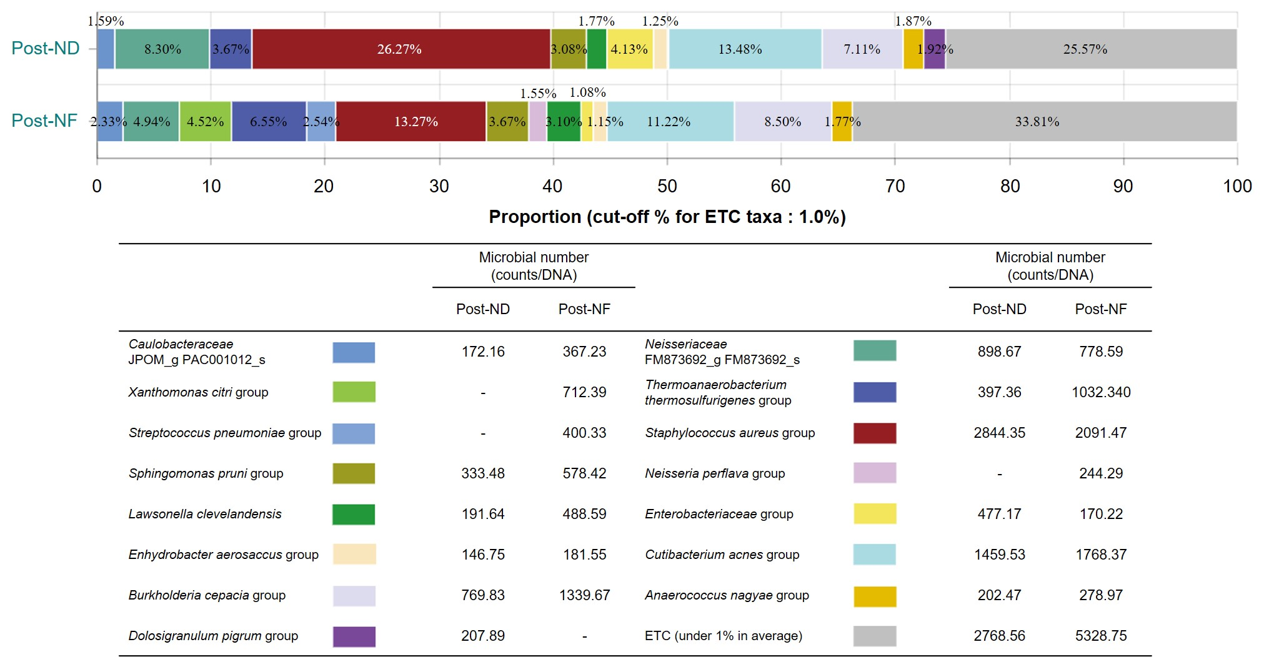
Sup. 4. The relative abundance of the main species of bacteria in post-treatment groups (post-ND and post-NF)

