Edge states in 2D A₂BX₄ lead halide perovskites enabled by local structural reorganization
Zhi-Gang Li¹, Xiang Li^{2,3}, Xiao-Hui Dong¹, Wei Li^{1*}, Hai-Peng Song⁴, Zi-Ying Li¹, Xiang Wu⁴, Ilya Kupenko^{2,3}, Michael Hanfland³, Konstantin Glazyrin⁵, Jacky Even⁶ and Xian-He Bu^{1*}
- School of Materials Science and Engineering, Tianjin Key Laboratory of Metal and Molecule-Based Material Chemistry, Nankai University, Tianjin 300350, China.
- Institut für Mineralogie, University of Münster, Corrensstr.24,48149 Münster, Germany.
- ESRF—The European Synchrotron, CS40220, 38043 Grenoble Cedex 9, France.
- State Key Laboratory of Geological Processes and Mineral Resources, China University of Geosciences, Wuhan 430074, China.
- Deutsches Elektronen-Synchrotron DESY, Notkestr. 85, 22607 Hamburg, Germany.
- Univ Rennes, INSA Rennes, CNRS, Institut FOTON, UMR 6082, Rennes F-35000, France.

Figure S1. DSC curves of 2D LHPs. The temperature dependence of heat flows on heating (red) and cooling (blue) of the (BA)₂PbBr₄ (a), (OPEA)₂PbBr₄ (b) and (PEA)₂PbBr₄ (c) single crystals from 90 to 360 K, indicating the no phase transitions occurs in this temperature range.

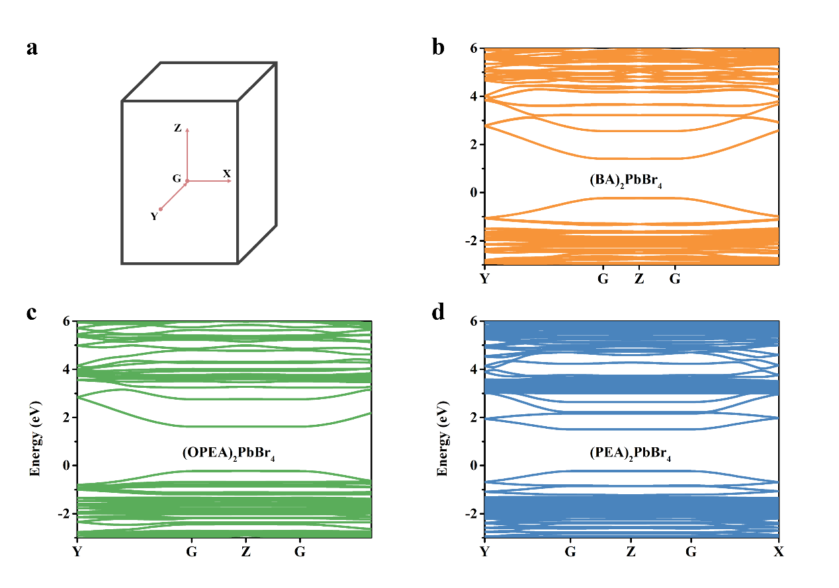
Figure S2. Electronic band structures of 2D LHPs. (a) The corresponding Brillouin zone in the reciprocal space used for band structure calculations. (b-d) DFT-PBE+SOC band structures of 2D LHPs. For consistent comparison, we have aligned the crystal axes for the three LHPs so that the layer-stacking direction points along the c-axis whereas the a- and b-axes define the two in-plane directions of the inorganic layer.

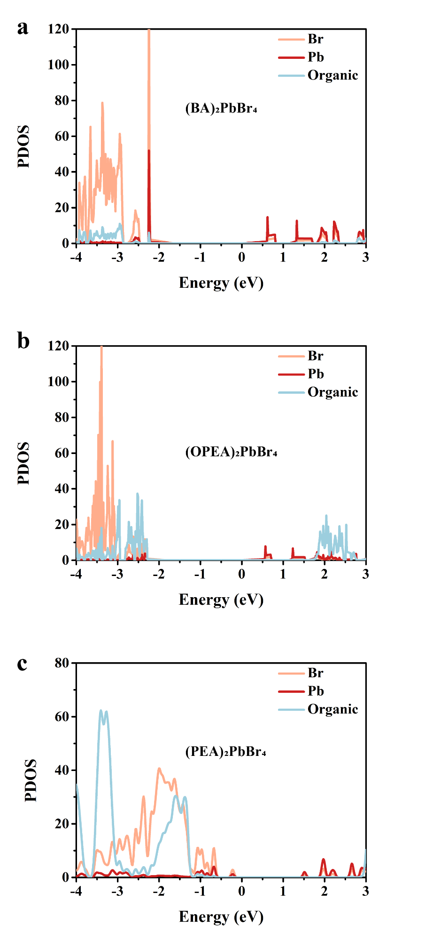
Figure S3. Projected density of states (PDOS) of 2D LHPs.

Figure S4. Time-resolved PL measurements of IS and ES.
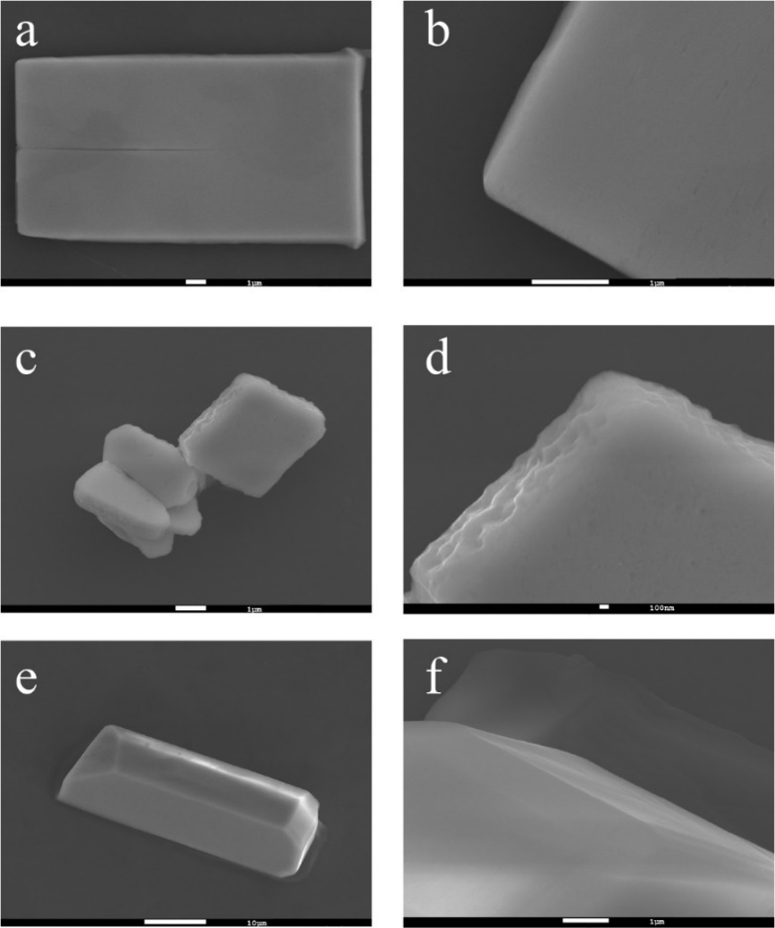
Figure S5. SEM image of (BA)₂PbBr₄ (a-b), (OPEA)₂PbBr₄ (c-d) and (PEA)₂PbBr₄ (e-f).

Figure S6. Le-Bail fitting of PXRD patterns of LHPs measured at ambient conditions. Symbols correspond to the observed (gray dots), calculated (blue line), difference (green line) XRD patterns and Bragg peaks (red vertical lines).

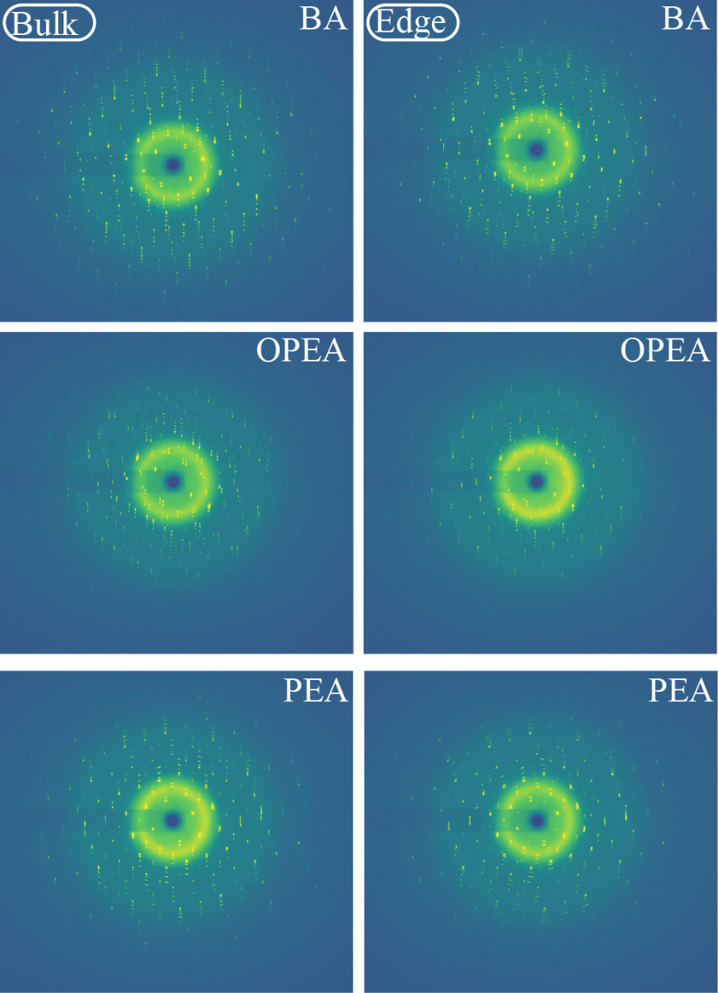
Figure S7. Synchrotron diffraction patterns of different regions of (BA)₂PbBr₄, (OPEA)₂PbBr₄ and (PEA)₂PbBr

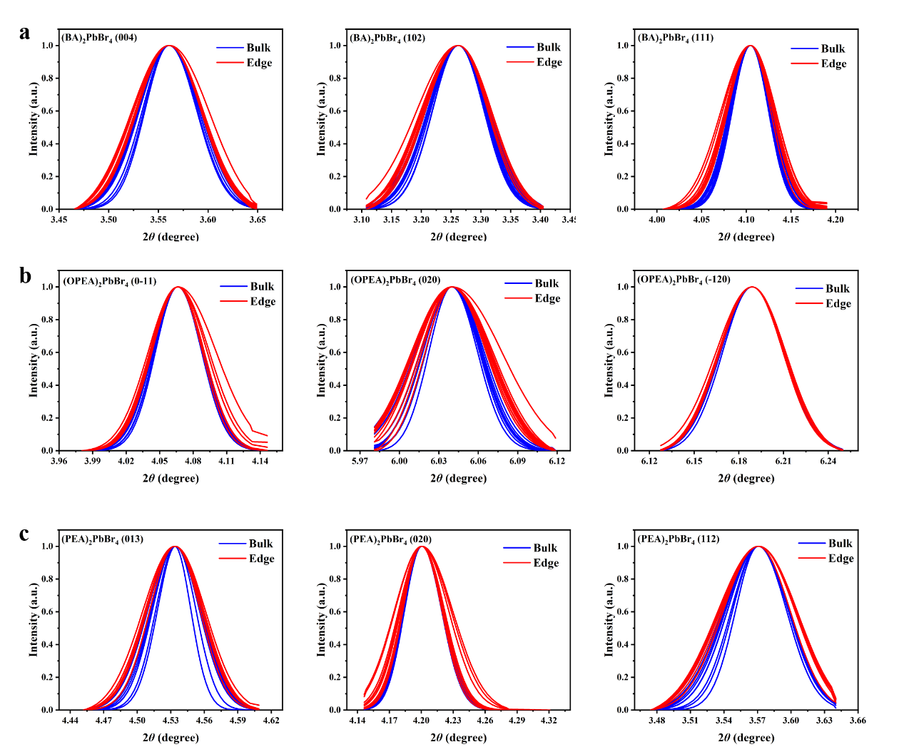
Figure S8. Powder XRD spectra of several specific lattice planes for (BA)₂PbBr₄ (a), (OPEA)₂PbBr₄ (b) and (PEA)₂PbBr₄ (c).

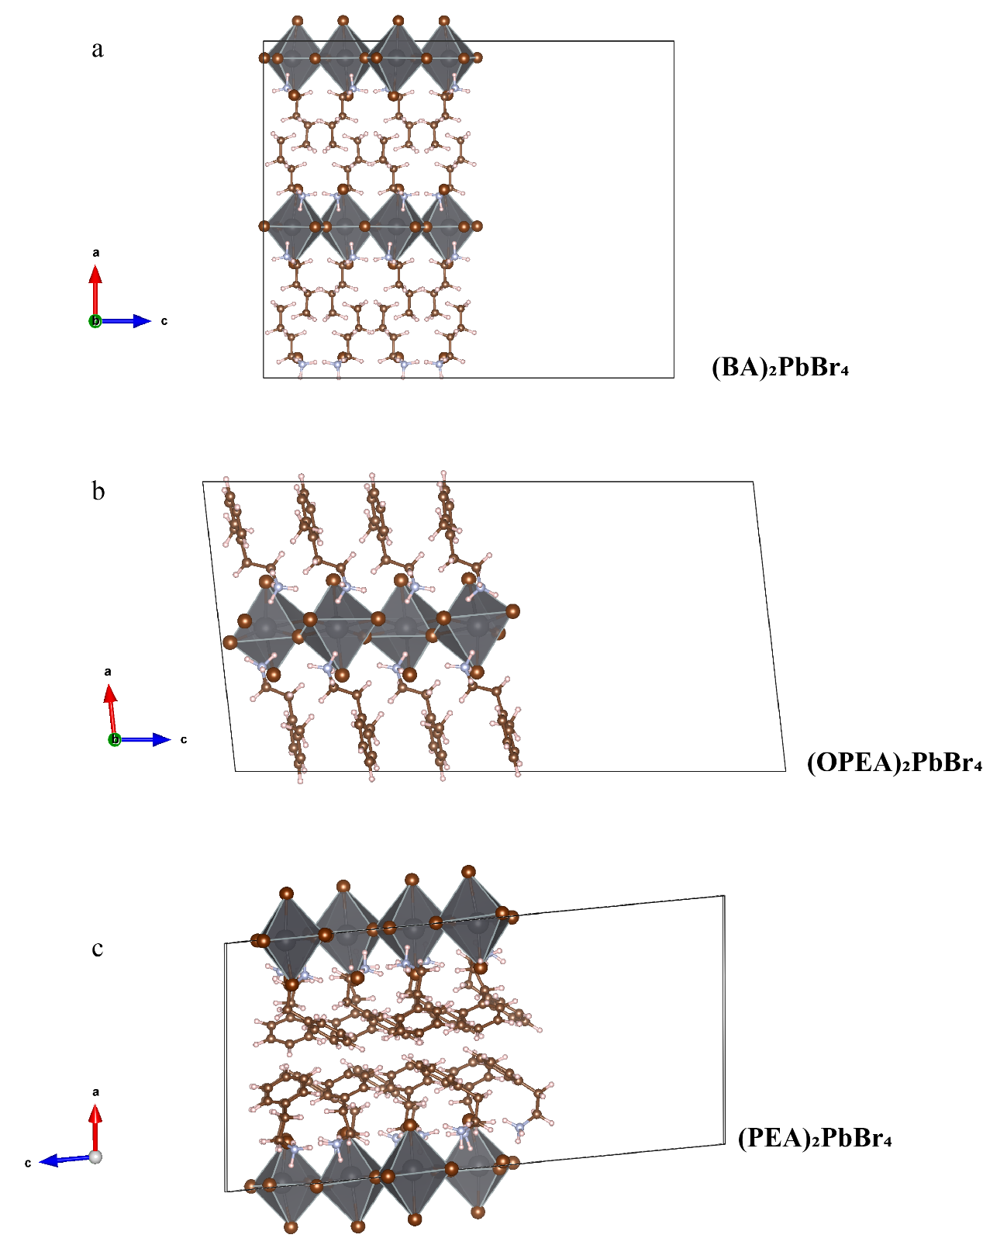
Figure S9. Relaxation of edge models of (BA)₂PbBr₄, (OPEA)₂PbBr₄ and (PEA)₂PbBr₄.

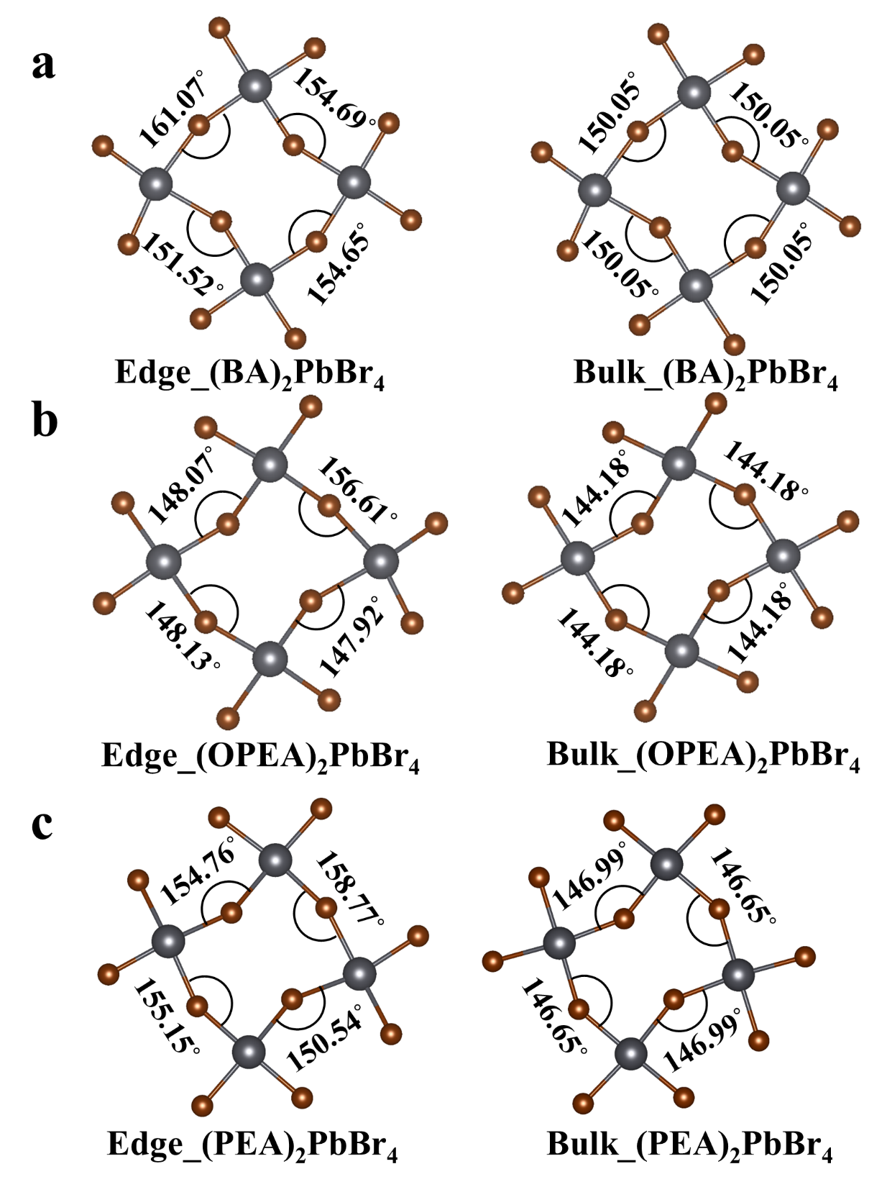
Figure S10. Asymmetric (left) and symmetric (right) tilting of inorganic octahedra in bulk state and edge state, respectively.

Figure S11. The temperature-dependent PL spectra of three 2D LHPs. The (OPEA)₂PbBr₄ (b) crystal show a more prominent low-energy tail with STE character when the temperature is above 320 K, indicating the soft nature of lattice.

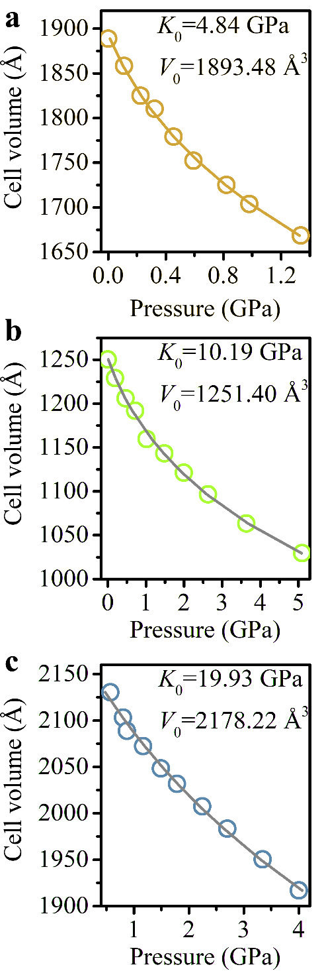
Figure S12. Bulk mechanical responses of 2D LHPs. Cell volume evolutions of crystals upon compression. The bulk modulus K₀ and zero-pressure unit-cell volume V₀ can be obtained by fitting the third-order Birch–Murnaghan equations of state.

Figure S13. Phonon modes extracted from lattice dynamics calculations. The fractional contribution of the A-site (orange), Br (blue), and Pb (red) to the total phonon density of states for (BA)₂PbBr₄, (OPEA)₂PbBr₄ and (PEA)₂PbBr within the corresponding frequency range, respectively
Figure S14. Radial distribution functions (RDF) extracted from AIMD simulations for the pairs Pb–Br (upper panel) and Pb–Pb (lower panel).

Figure S15. DFT-calculated Young’s moduli for three 2D LHPs. 3D surface of Young’s moduli for (BA)₂PbBr₄ (a), (OPEA)₂PbBr₄ (c) and (PEA)₂PbBr₄ (e), respectively. 2D polar plots of Young’s moduli projected normal to the inorganic-layer plane for (BA)₂PbBr₄ (b), (OPEA)₂PbBr₄ (d) and (PEA)₂PbBr₄ (f), respectively.
Figure S16. Pressure-dependent PL emissions for (BA)₂PbBr₄ (a) and (PEA)₂PbBr₄ (b).
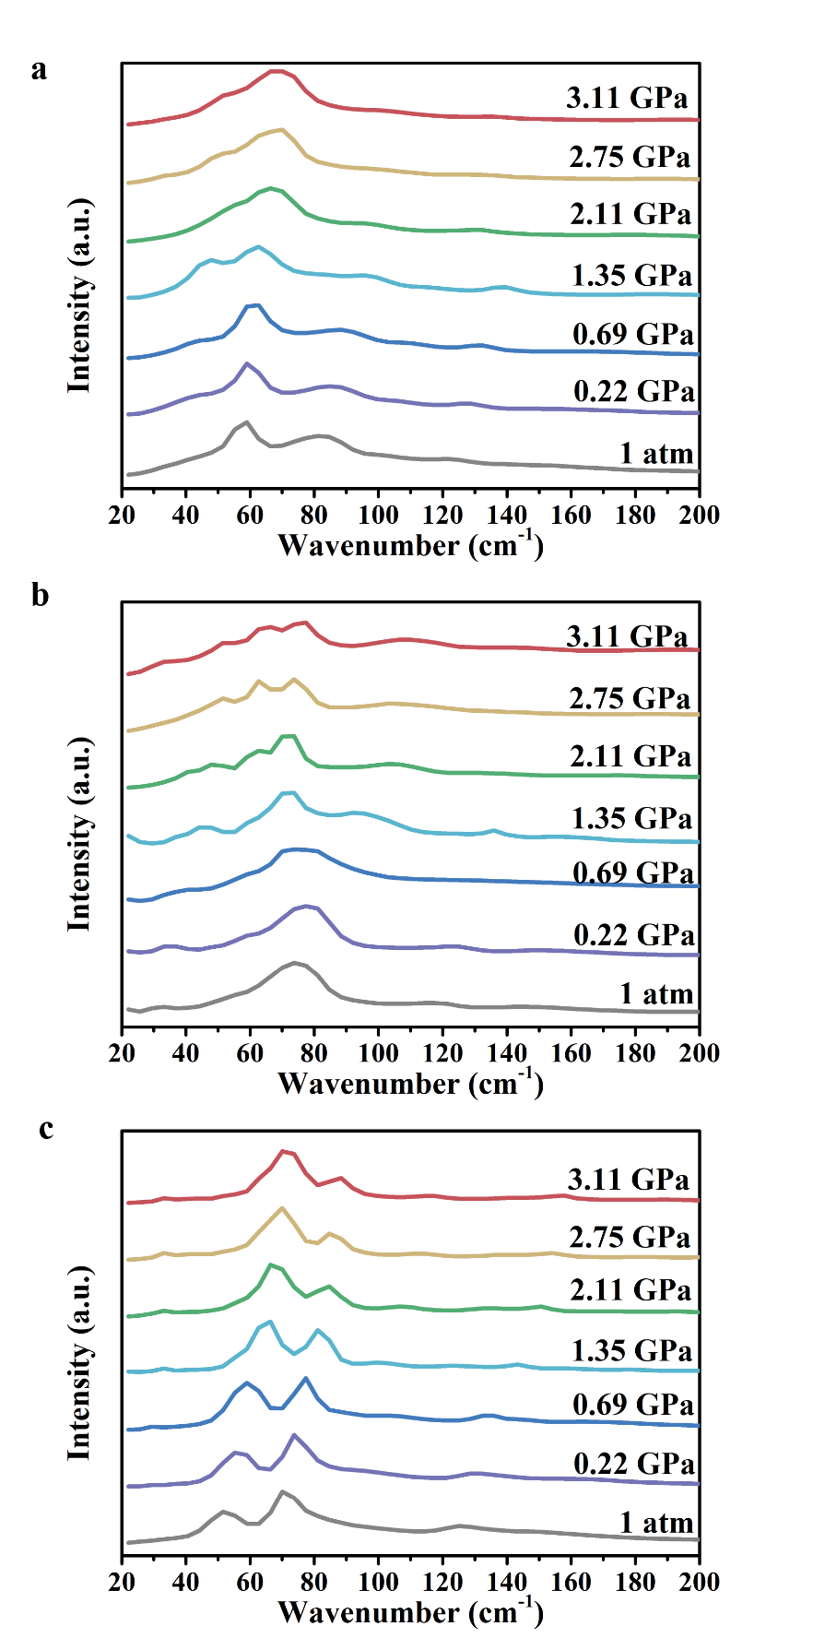
Figure S17. Pressure-dependent Raman spectra for (BA)₂PbBr₄ (a), (OPEA)₂PbBr₄ (b) and (PEA)₂PbBr₄ (c).

Figure S18. HP XRD patterns of 2D LHPs powder. For (BA)₂PbBr₄ crystal, a doublet peak splitting was found around 3° at 2.05 GPa, indicating the appearance of the second phase.
Table S1 The summary of the calculated elastic constants of three LHPs.

Properties | quantities | (BA)₂PbBr₄ | (OPEA)₂PbBr₄ | (PEA)₂PbBr₄
 | C₁₁ | 25.25 | 23.20 | 27.11
 | C₂₂ | 26.38 | 26.41 | 24.52
 | C₃₃ | 17.22 | 18.57 | 18.48
 | C₄₄ | 3.71 | 0.74 | 7.11
 | C₅₅ | 5.15 | 5.54 | 6.29
 | C₆₆ | 7.31 | 4.41 | 6.54
 | C₁₂ | 12.52 | 10.35 | 10.26
Stiffness cccoefficient Ci | C₁₃ | 9.60 | 9.33 | 8.32
Coefficient | C₁₄ | / | / | 0.12
C_{ij} (GPa) | C₁₅ | / | 0 | 0.96
 | C₁₆ | / | / | 0.01
 | C₂₃ | 8.57 | 11.99 | 9.43
 | C₂₄ | / | / | 0.10
 | C₂₅ | / | 0 | -1.09
 | C₂₆ | / | / | -0.14
 | C₃₄ | / | / | 0.17
 | C₃₅ | / | 0 | -0.21
 | C₃₆ | / | / | -0.18
 | C₄₅ | / | / | -0.19
 | C₄₆ | / | 0 | -0.57
 | C₅₆ | / | / | 0.04

