Supplementary Figure 1. Rarefaction curves of the number of OTUs versus the sequencing effort per sample in the full cohort.
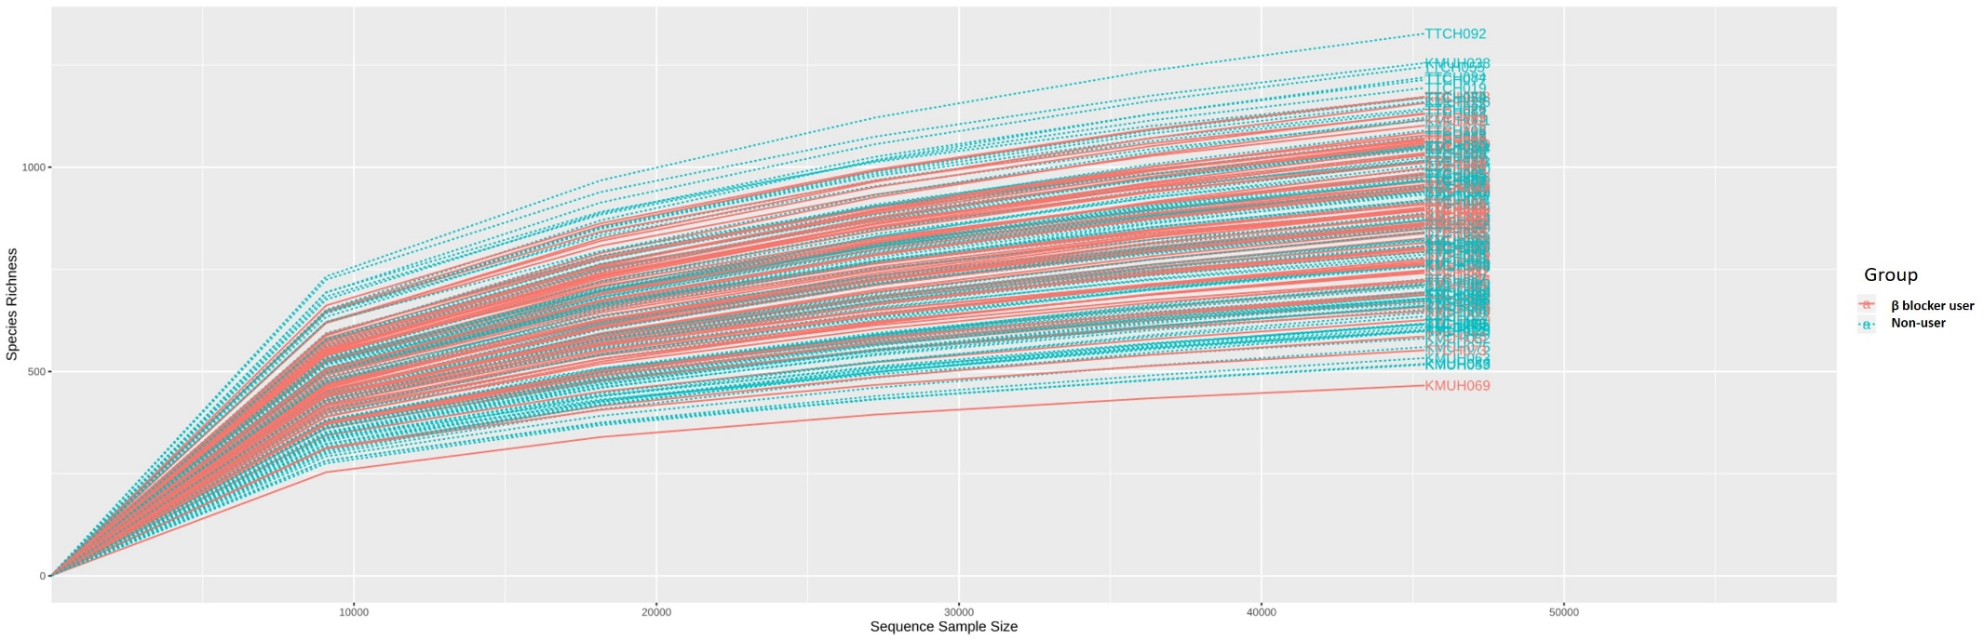

Supplementary Figure 2. The relative abundance percentage of intestinal microbiota between β blocker users and non-users in the full cohort and propensity score matching cohort. (A) Phylum level (B) Class level (C) Order level.
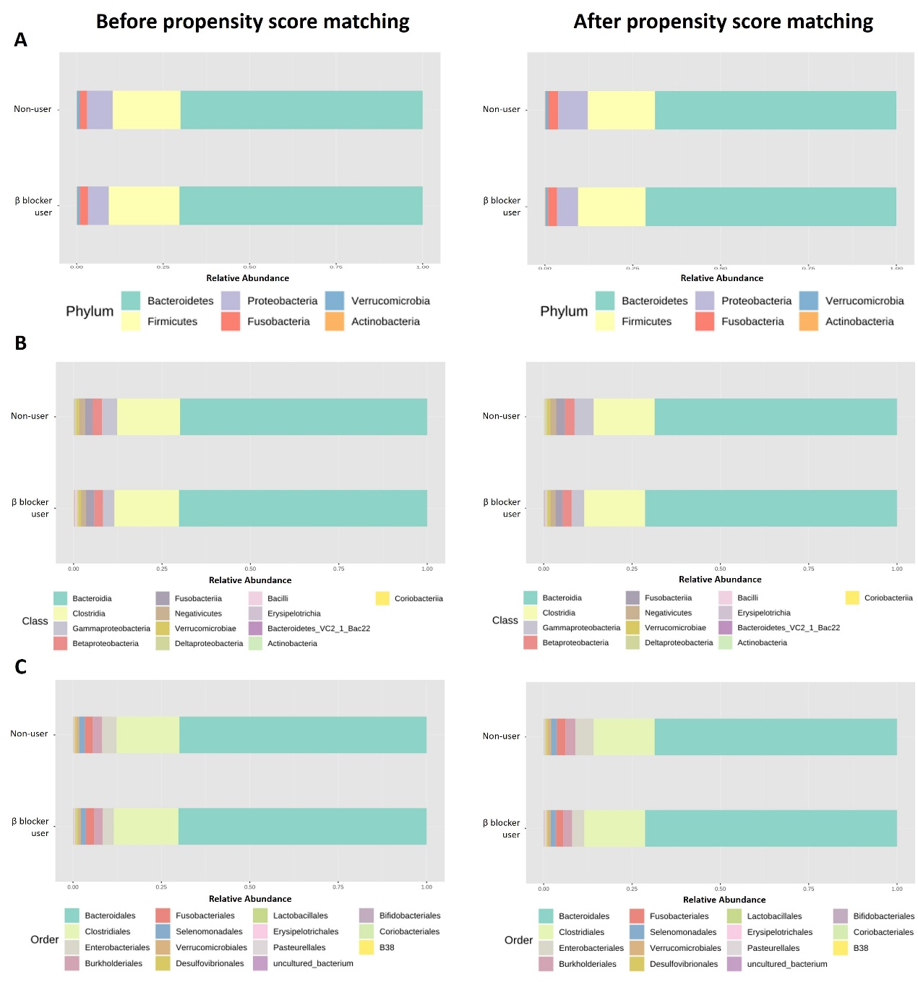

Supplementary Figure 3. Core microbiome analysis in hemodialysis patients with and without β blocker used. (A) SparCC correlation analysis (genus level using 100 SparCC permutations, 0.35 correlation threshold, and 0.05 P-value threshold) in all hemodialysis patients with and without β blocker used (B) Relative abundance and sample prevalence of bacterial genus in β blocker users and non- users.
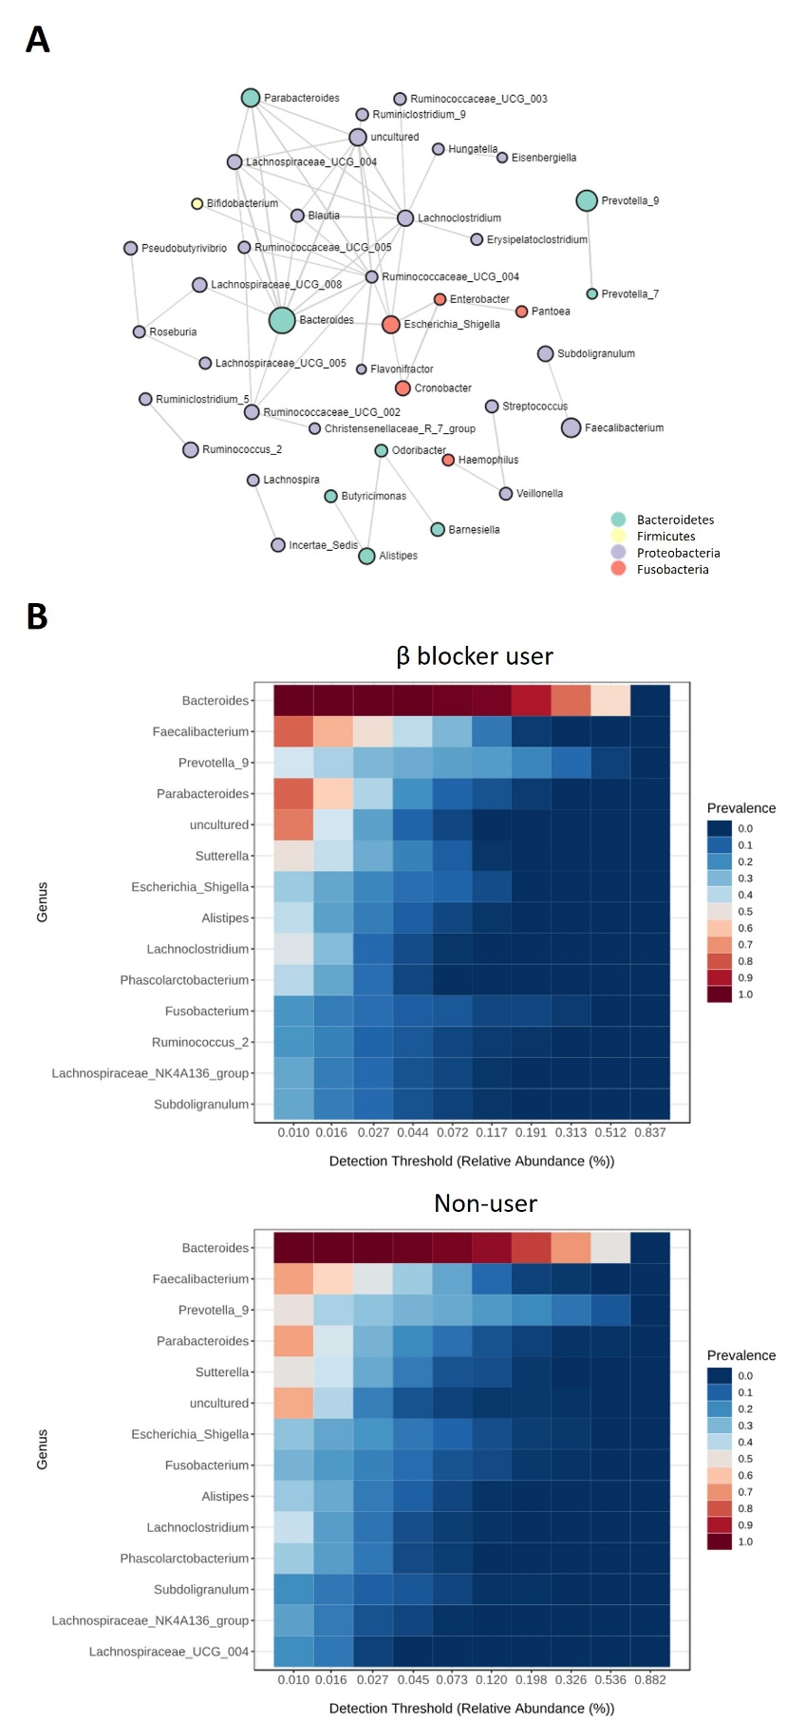

Supplementary Table 1. Summary table of significant genus difference in hemodialysis patients with and without β-blocker treatment in zero-inflated Gaussian fit model
Genus | Zero-inflated Gaussian fit method
 | Before propensity score matching | After propensity score matching
 | P value | P value
Prevotella_2 | 0.192 | 0.004
Prevotellaceae NK3B31 group | 0.030 | 0.005
Subdoligranulum | 0.400 | 0.011
Flavonifractor | 0.044 | 0.015
Tyzzerella | 0.049 | 0.024
Streptococcus | 0.073 | 0.037
Ruminococcaceae UCG-005 | 0.283 | 0.039
Faecalibacterium | 0.501 | 0.044
Christensenellaceae R7 group | 0.473 | 0.063
Ruminococcaceae UCG-003 | 0.791 | 0.069
Enterobacter | 0.599 | 0.070
Lachnospiraceae UCG-004 | 0.641 | 0.091
Ruminiclostridium 9 | 0.044 | 0.093
Ruminococcaceae UCG-004 | 0.016 | 0.100
Lachnospiraceae UCG-005 | 0.236 | 0.115
Pantoea | 0.711 | 0.140
Anaerotruncus | 0.031 | 0.144
Intestinibacter | 0.496 | 0.148
Eubacterium ventriosum group | 0.488 | 0.187
Erysipelatoclostridium | 0.271 | 0.200
Ruminiclostridium 6 | 0.204 | 0.210
Collinsella | 0.748 | 0.210
Lachnoclostridium | 0.850 | 0.232
Bacteroides | 0.282 | 0.232
Prevotella 9 | 0.796 | 0.244
uncultured | 0.117 | 0.252
Eubacterium coprostanoligenes group | 0.765 | 0.252
Cronobacter | 0.810 | 0.254
Roseburia | 0.303 | 0.274
Lachnospiraceae NC2004 group | 0.573 | 0.311
Ruminiclostridium | 0.314 | 0.312
Eubacterium hallii group | 0.111 | 0.316
Butyricimonas | 0.448 | 0.344
Eisenbergiella | 0.080 | 0.351
Barnesiella | 0.554 | 0.358
Clostridium sensu stricto 1 | 0.778 | 0.375
Lachnospiraceae UCG-010 | 0.778 | 0.382
Phascolarctobacterium | 0.926 | 0.385
Ruminiclostridium 5 | 0.043 | 0.397
Akkermansia | 0.169 | 0.399
Bifidobacterium | 0.651 | 0.422
Haemophilus | 0.534 | 0.444
Lachnospira | 0.613 | 0.446
Fusicatenibacter | 0.887 | 0.460
Sutterella | 0.991 | 0.460
Megamonas | 0.957 | 0.483
Lactonifactor | 0.385 | 0.488
Dorea | 0.897 | 0.551
Desulfovibrio | 0.087 | 0.555
Parabacteroides | 0.194 | 0.573
Pseudobutyrivibrio | 0.910 | 0.577
Odoribacter | 0.761 | 0.577
Intestinimonas | 0.096 | 0.581
Lachnospiraceae NK4A136 group | 0.819 | 0.644
Hungatella | 0.288 | 0.644
Eubacterium ruminantium group | 0.457 | 0.645
Eubacterium oxidoreducens group | 0.651 | 0.658
Bilophila | 0.750 | 0.682
Lachnospiraceae UCG-008 | 0.618 | 0.694
Prevotella 7 | 0.804 | 0.694
Paraprevotella | 0.869 | 0.709
uncultured bacterium | 0.849 | 0.723
Erysipelotrichaceae UCG-003 | 0.739 | 0.822
Escherichia Shigella | 0.915 | 0.838
Parasutterella | 0.326 | 0.858
Fusobacterium | 0.990 | 0.872
Incertae Sedis | 0.959 | 0.874
Veillonella | 0.522 | 0.888
Blautia | 0.829 | 0.894
Ruminococcus 2 | 0.145 | 0.896
Oscillospira | 0.523 | 0.913
Alistipes | 0.650 | 0.921
Ruminococcaceae UCG-013 | 0.745 | 0.925
Ruminococcaceae UCG-002 | 0.388 | 0.928
Anaerostipes | 0.581 | 0.938
Ruminococcus 1 | 0.876 | 0.958
Ruminococcaceae NK4A214 group | 0.498 | 0.979
Family XIII AD3011 group | 0.018 | -
Lachnospiraceae ND3007 group | 0.464 | -

