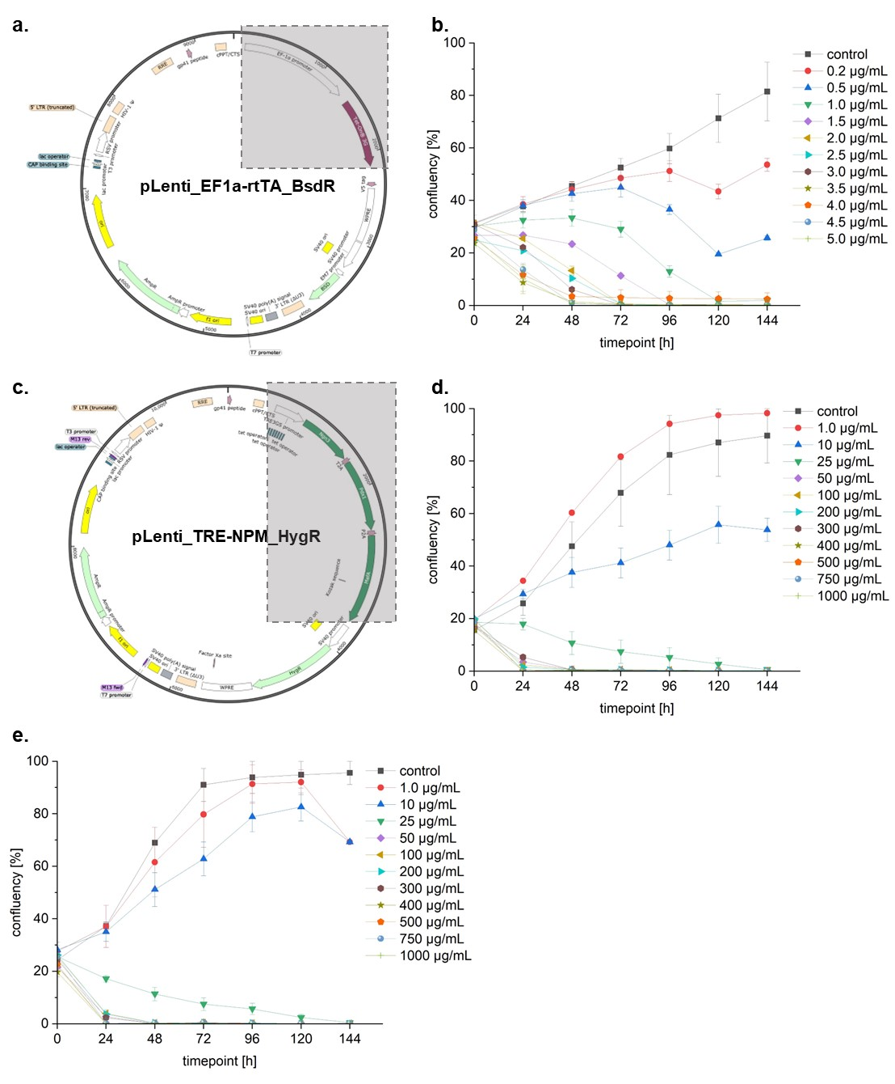
Supplementary Figure 1: Final lentiviral plasmid design and antibiotic kill curves. a. Lentiviral plasmid design of pLenti_EF1a-rtTA_BsdR with the regions of interest in the gray box. b. Un-transduced hiPSCs were used to determine the optimal concentration of Blasticidin needed to select for successfully transduced cells and 1.0 µg/mL of Blasticidin S HCl for five days was chosen. c. Lentiviral plasmid design of pLenti_TRE-NPM_HygR with the regions of interest in the gray box. d. Un-transduced hiPSCs and e. hiPSCs with pLenti_EF1a-rtTA_BsdR were used to determine the optimal concentration of HygromycinB needed to select for successfully transduced cells and 25.0 µg/mL of HygromycinB for six days was chosen.

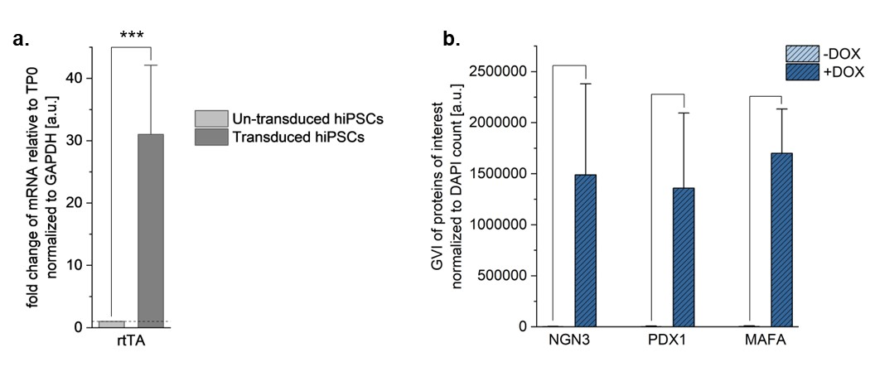
Supplementary Figure 2: Gene expression analysis of rtTA and semi-quantification of marker expression of the markers of interest in cells cultured for five days. a. Gene expression analysis of un-transduced and transduced hiPSCs for rtTA relative to un-transduced hiPSCs (dashed line at 1), normalized to GAPDH levels. b. Semi-quantification analysis using GVI of the protein expression of the markers of interest in cells cultured with and without DOX for five days, normalized to DAPI counts. Error bars represent standard deviation. Unpaired t-test, *** p ≤ 0.001, **** p ≤ 0.0001.

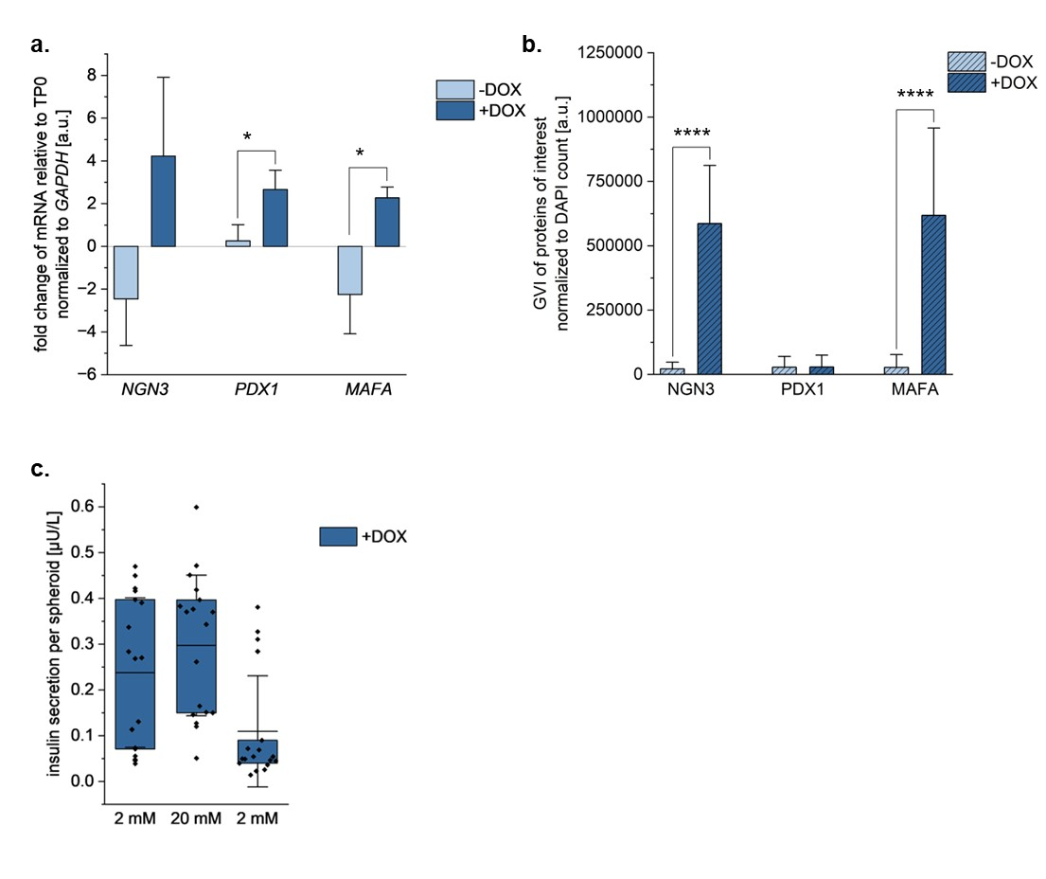
Supplementary Figure 3: Gene expression and semi-quantification of marker expression of cells cultured for ten days. a. Gene expression of the markers of interest after ten days of culture with and without DOX. All values relative to day 0 at the stem cell stage and normalized to GAPDH. b. Semi-quantification analysis using GVI of the protein expression of the markers of interest in cells cultured with and without DOX for ten days, normalized to DAPI counts. c. Serial GSIS results: amount of insulin secreted upon consecutive stimulation with 2 mM, 20 mM, and again 2 mM glucose normalized to cell count. Error bars represent standard deviation. Unpaired t-test, * p ≤ 0.05, **** p ≤ 0.0001.

Target | ThermoFisher Gene Expression Assay ID or Sequence | Dye | Quencher | Notes
Oct4 | Hs00999634_gH | FAM | MGB-NFQ
Sox2 | Hs01053049_s1 | FAM | MGB-NFQ
Nanog | Hs02387400_g1 | FAM | MGB-NFQ
Klf4 | Hs00358836_m1 | FAM | MGB-NFQ
Ngn3 | Hs00360700_g1 | FAM | MGB-NFQ | Marker of interest
Pdx1 | Hs00236830_m1 | FAM | MGB-NFQ | Marker of interest
MafA | Hs04419852_s1 | FAM | MGB-NFQ | Marker of interest
Nkx6.1 | Hs00232355_m1 | FAM | MGB-NFQ
MafB | Hs00534343_s1 | FAM | MGB-NFQ
β-actin | Hs01060665 | FAM | MGB-NFQ
GAPDH | Hs99999905_m1 | FAM | MGB-NFQ
Fwd_rtTA | TGC CCT GCC AAT CGA GAT | - | - | designed by Primer Express 3.0 of 7500 Fast Real Time PCR System from Applied Biosystems
Rev_rtTA | GCC ATG ACT CGC CTT CCA | - | -
rtTA Probe | ACAGGCATCATACCCACTCCTGCCC | FAM | TAMRA

Supplementary Table 1: List of qPCR primers used.

Target | Company, Catalog Number | Notes
OCT4 | Santa Cruz, sc8629
NANOG | Cell Signaling Technology, 4903
GATA4 | Santa Cruz, sc788
SOX2 | New England Biolabs, 3579S
NGN3 | Sigma Aldrich, AB5684 | Marker of interest
PDX1 | Thermo Fisher, PA5-84405 | Marker of interest
MAFA | Abcam, ab26405 | Marker of interest
NKX6.1 | Developmental Studies Hybridoma Bank, F55A12-S
Insulin | Dako, A0564
C-peptide | Cell Signaling Technology, 4593S

Supplementary Table 2: List of primary antibodies used.

Reagent | Concentration | Company, Catalog Number
NaCl | 115.0 mM | Carl Roth, 3957.3
KCl | 5.0 mM | Carl Roth, 6781.3
CaCl₂ | 1.0 mM | Sigma Aldrich, 12095
MgCl₂ | 1.0 mM | Serva, 28305
NaHCO₃ | 24.0 mM | Sigma Aldrich, S5761
HEPES | 10.0 mM | Sigma Aldrich, H4034
BSA | 1% | Sigma, A9576
Glucose | 0.5 mM | Sigma, G7528

Supplementary Table 3: Recipe for β-Krebs buffer.

