Extended Data
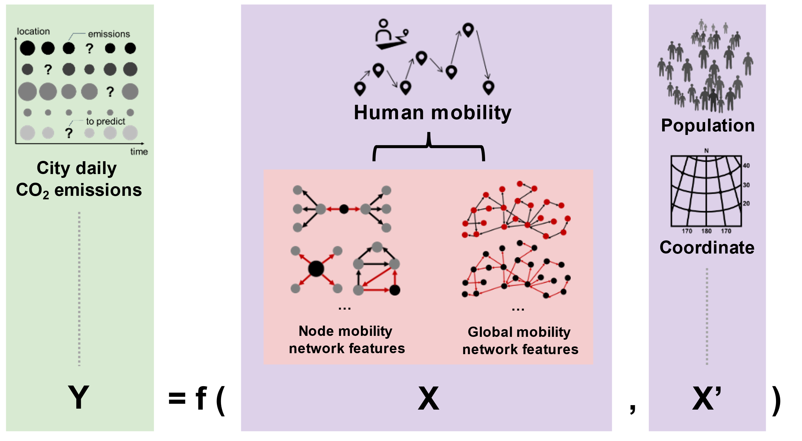

Extended Data Fig. 1 | Computational framework.

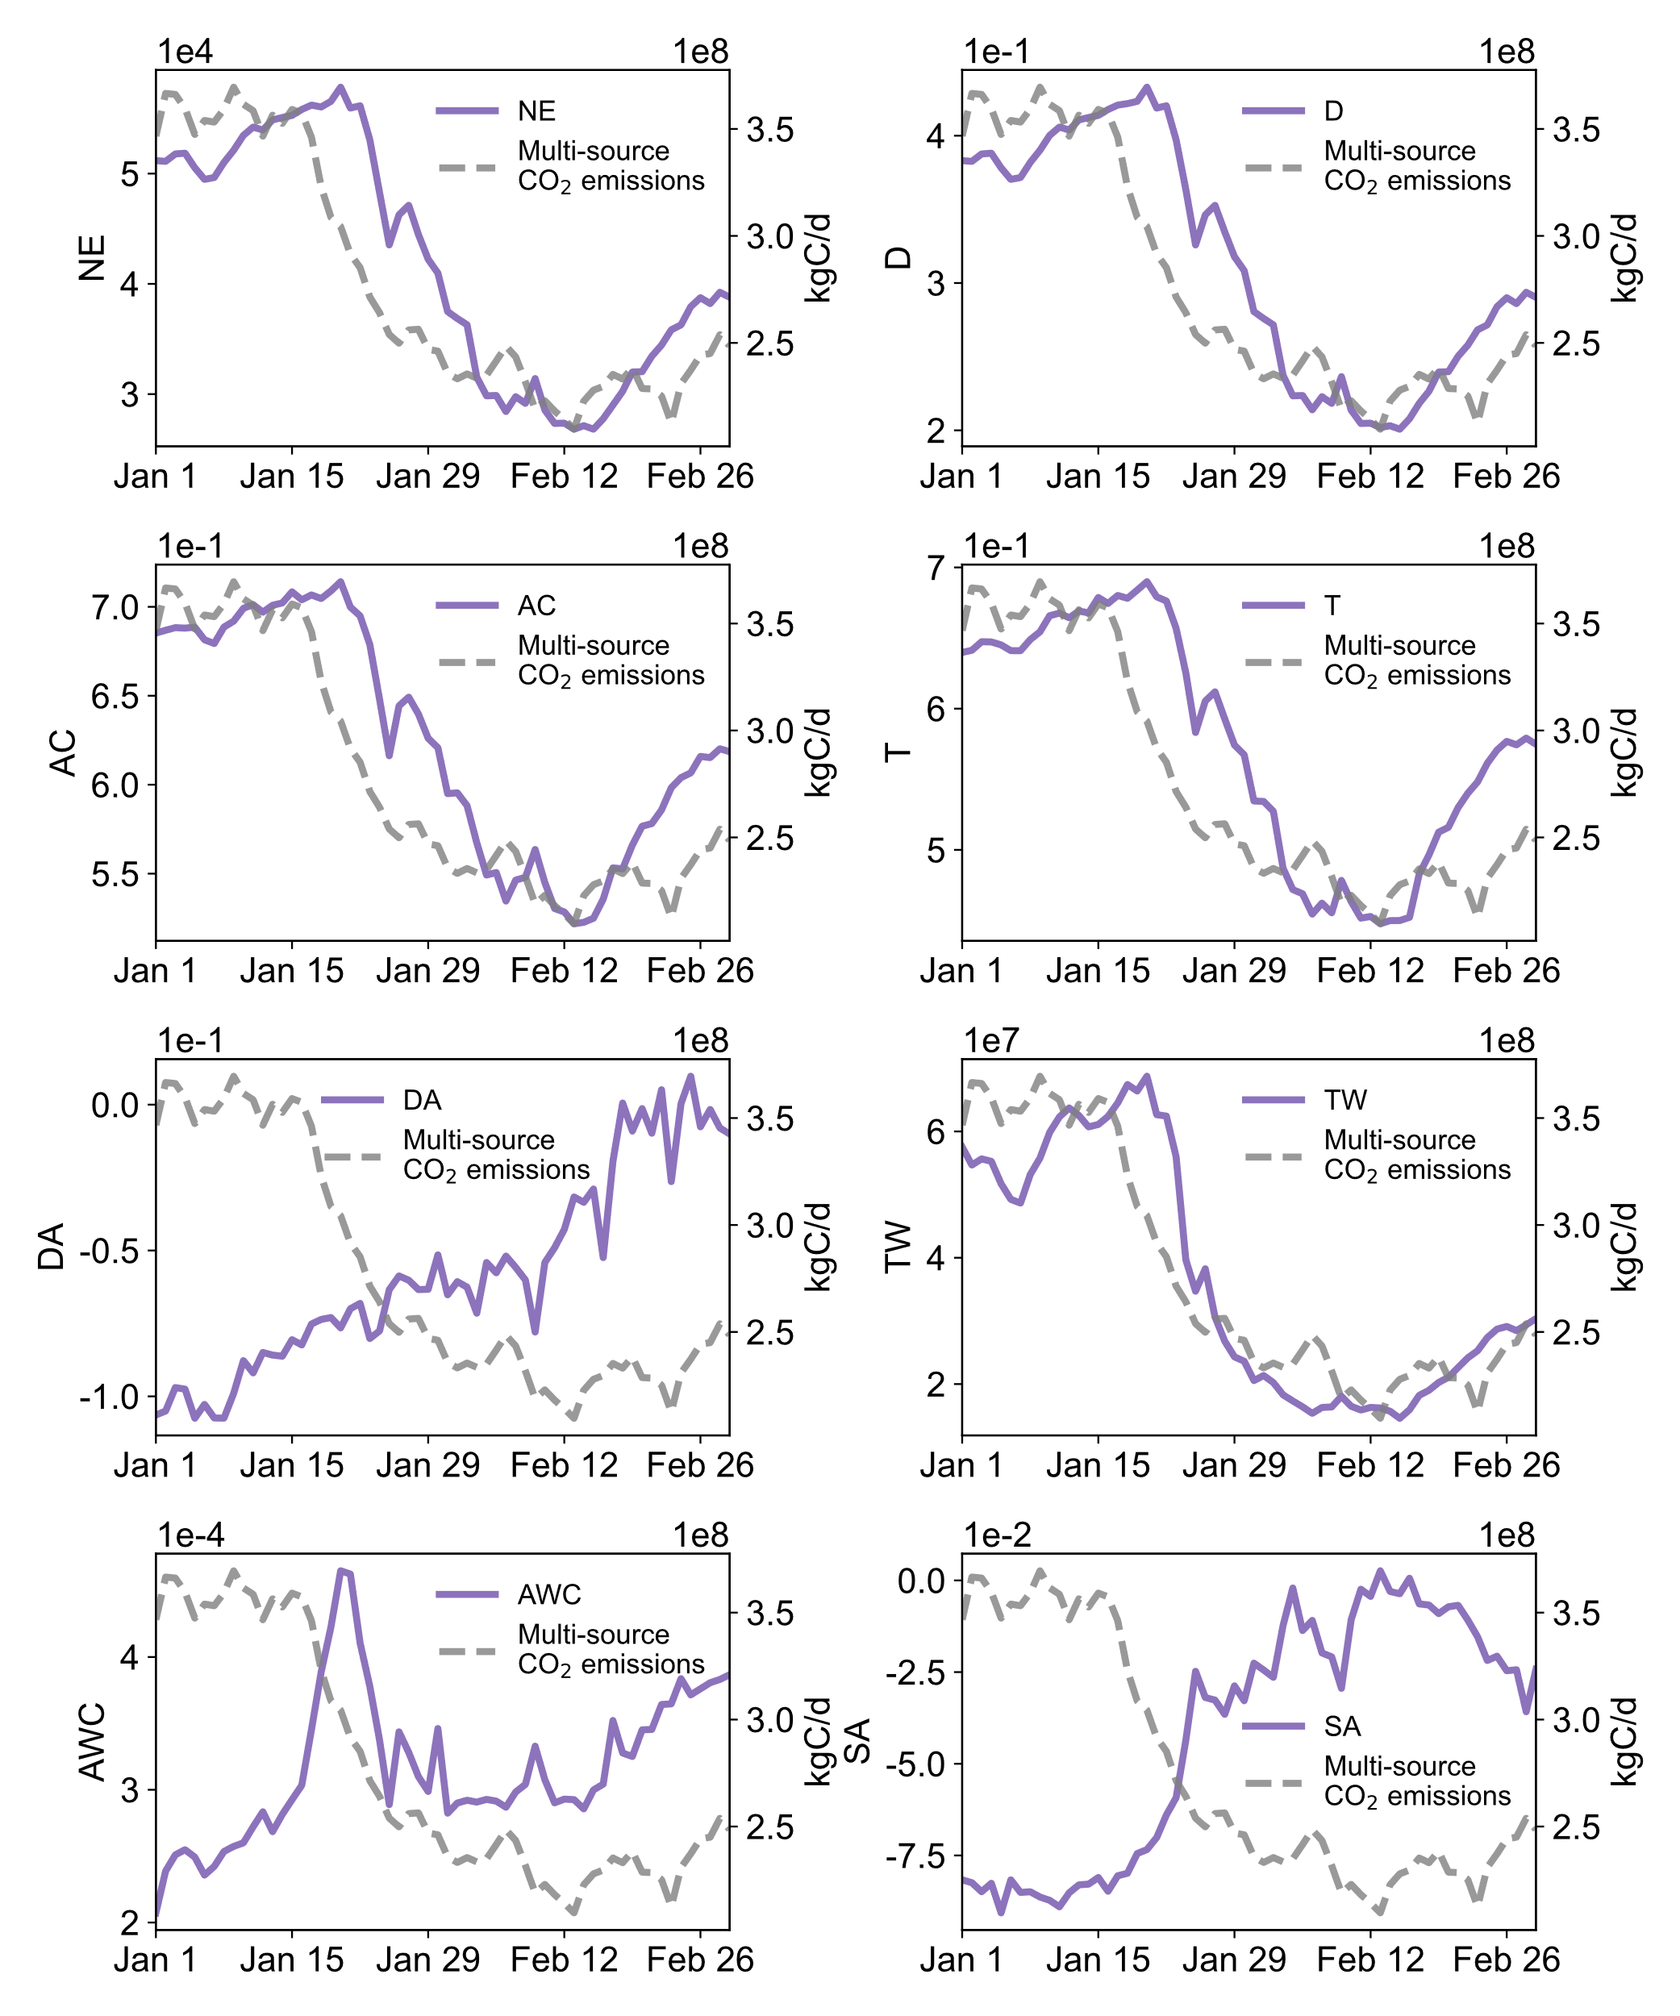
Extended Data Fig. 2 | Correlation between the global features and multi-source CO₂ emissions.

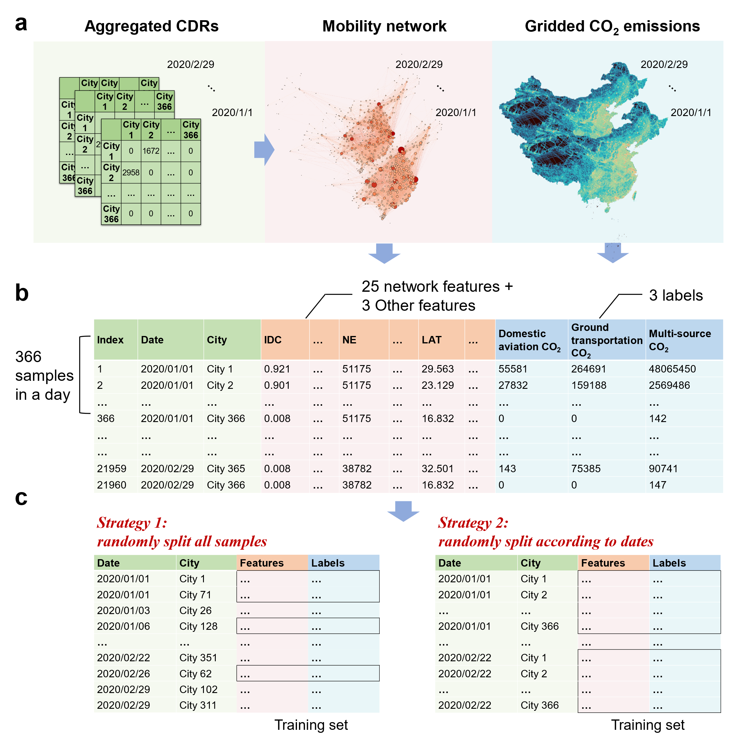

Extended Data Fig. 3 | Data set combination split.
a, b. Combine the daily city-level CO₂ emissions and intercity mobility datasets. Construct a temporal mobility network comprising 60 snapshots, with each snapshot consisting 366 nodes, based on aggregated CDRs (a). Then extracted 25 network features and combined them with their corresponding longitude, latitude, population to form a complete feature set, and the gridded CO₂ emissions were aggregated to the city level as labels. The dataset generated (b) had a sample size of 60×366=21,960. c. Two strategies to divide the dataset into training and test sets. Strategy 1, randomly split all the 21,960 samples; Strategy 2, randomly divide by date (60 days), with samples of the same date grouped together. Both strategies kept the proportion of training and test sets at 80% and 20% respectively.

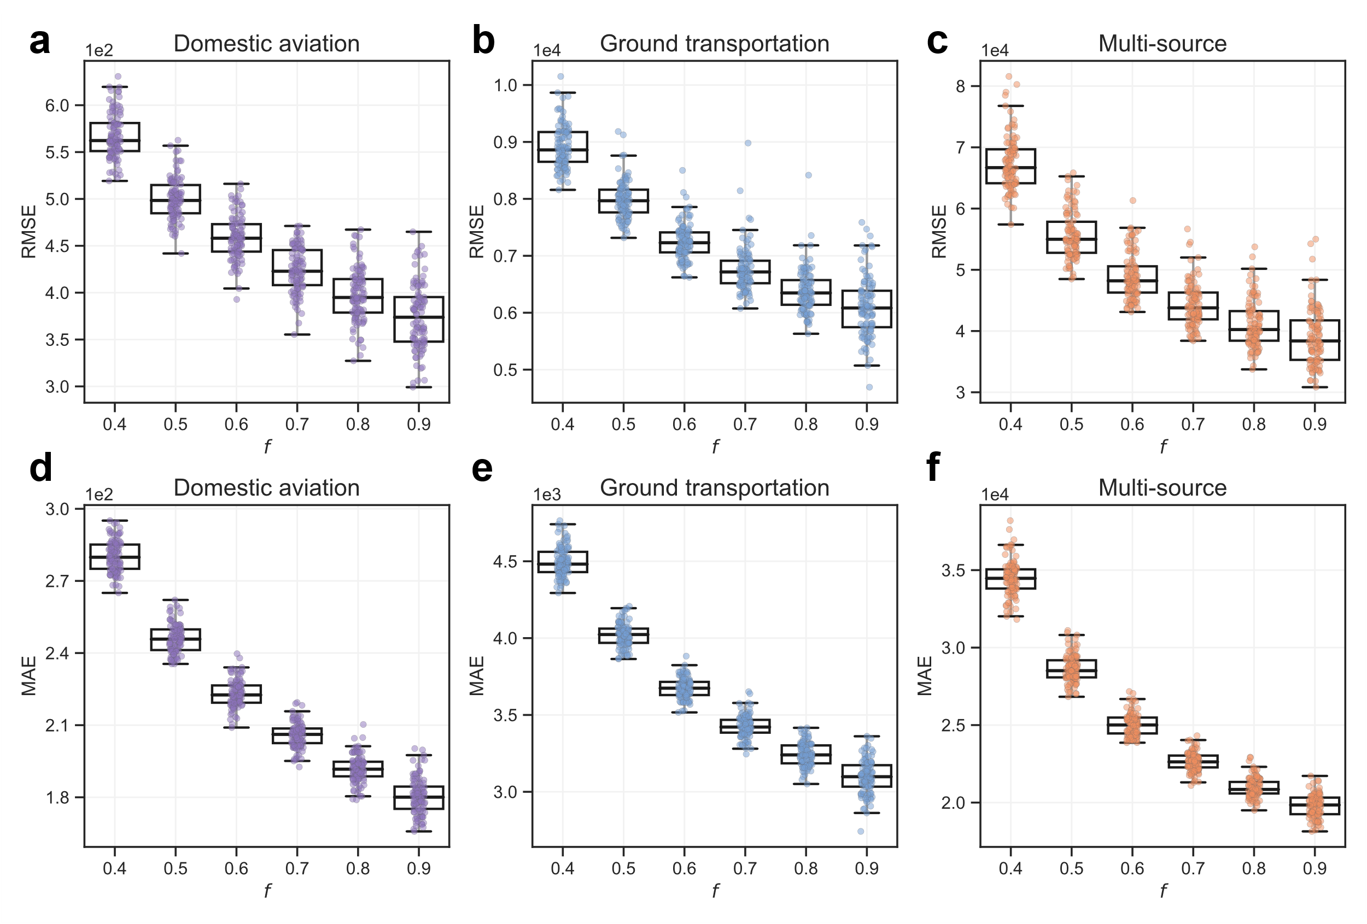

Extended Data Fig. 4 | Performance of CO₂ emissions prediction based on Strategy 1 with different sizes of training sets.
a-f. The RMSE and MAE of LGBM use tenfold cross-validation to predict CO₂ emissions of domestic aviation, ground transportation, and multi-source, respectively. Each box in the boxplot illustrates the predicting accuracy obtained by 200 implementations with the independent random split of training and testing sets on a certain proportion. Different boxes display the predicting accuracy based on different sizes of the training sets, ranging from 0.4 to 0.9, and f symbolizes the fraction of training set. The testing set is always the complementary part of the entire data set to the training set.

Extended Data Table 1 | The Pearson correlation coefficient of network features and CO₂ emissions.
Features | Domestic  aviation | Ground transportation | Multi-source
Unweighted node features
IDC | 0.67 | 0.48 | 0.51
ODC | 0.63 | 0.45 | 0.52
ICC | 0.71 | 0.51 | 0.50
OCC | 0.65 | 0.48 | 0.52
EC | 0.47 | 0.31 | 0.46
BC | 0.49 | 0.38 | 0.38
PR | 0.46 | 0.41 | 0.38
C | -0.10 | -0.12 | -0.14
Weighted node features
IS | 0.61 | 0.50 | 0.46
OS | 0.63 | 0.51 | 0.46
WICC | 0.45 | 0.40 | 0.31
WOCC | 0.44 | 0.39 | 0.29
WEC | 0.15 | 0.15 | 0.07
WBC | 0.29 | 0.20 | 0.27
WC | 0.00 | -0.09 | -0.04
AR | 0.46 | 0.40 | 0.35
TR | 0.42 | 0.37 | 0.37
Unweighted global features
NE | 0.97 | 0.80 | 0.86
D | 0.97 | 0.80 | 0.85
AC | 0.95 | 0.82 | 0.87
T | 0.93 | 0.79 | 0.83
DA | -0.79 | -0.60 | -0.76
Weighted global features
TW | 0.93 | 0.89 | 0.89
AWC | -0.10 | -0.17 | -0.37
SA | -0.93 | -0.91 | -0.96

Extended Data Table 2 | Cross-validation statistics based on a random 20% test subset of all samples.

Model | Domestic aviation |  |  | Ground transportation |  |  | Multi-source
Model | R² | RMSE | MAE | R² | RMSE | MAE | R² | RMSE | MAE
Strategy 1: randomly split all samples
MLR | 0.66 | 2,956 | 1,932 | 0.54 | 32,471 | 21,417 | 0.44 | 616,788 | 381,987
Lasso | 0.87 | 1,833 | 1,169 | 0.86 | 18,064 | 11,679 | 0.77 | 396,977 | 269,450
KNN | 0.94 | 1,258 | 647 | 0.91 | 14,130 | 8,036 | 0.91 | 252,208 | 125,944
SVR | 0.59 | 3,251 | 1,900 | 0.27 | 40,822 | 26,017 | 0.03 | 813,624 | 491,544
ANN | 0.97 | 807 | 512 | 0.94 | 11,314 | 7,170 | 0.97 | 142,397 | 97,086
RF | 0.98 | 689 | 341 | 0.96 | 10,025 | 5,344 | 0.99 | 60,895 | 30,618
XGB | 0.99 | 457 | 221 | 0.97 | 7,802 | 3,757 | 1.00 | 44,850 | 24,184
LGBM | 0.99 | 392 | 187 | 0.98 | 6,806 | 3,289 | 1.00 | 41,837 | 21,085
Strategy 2: randomly split according to dates
MLR | 0.64 | 2,510 | 1,681 | 0.50 | 25,820 | 17,708 | 0.45 | 546,422 | 353,572
Lasso | 0.80 | 1,871 | 1,108 | 0.77 | 17,557 | 12,020 | 0.73 | 379,462 | 262,343
KNN | 0.94 | 1,029 | 516 | 0.92 | 10,467 | 6,632 | 0.93 | 194,973 | 95,442
SVR | 0.57 | 2,723 | 1,622 | 0.28 | 31,072 | 21,125 | 0.07 | 710,943 | 445,864
ANN | 0.95 | 888 | 547 | 0.93 | 9,887 | 6,974 | 0.96 | 144,201 | 98,217
RF | 0.95 | 901 | 515 | 0.94 | 9,267 | 5,140 | 0.99 | 54,122 | 29,224
XGB | 0.97 | 774 | 374 | 0.93 | 9,367 | 5,763 | 1.00 | 48,141 | 28,195
LGBM | 0.97 | 662 | 333 | 0.94 | 9,142 | 5,622 | 1.00 | 46,495 | 26,909
Abbreviations: MLR, Multiple Linear Regressor; LASSO, Least Absolute Shrinkage and Selection Operator; KNN, K-Nearest Neighbors regressor; SVR, Support Vector Regressor; ANN, Artificial Neural Network; RF, Random Forest regressor; XGB, eXtreme Gradient Boosting regressor; LGBM, Light Gradient Boosting Machine.

Extended Data Table 3 | Cross-validation statistics based on 20% test subset with 200 random splits of null model.

CO₂ emissions | R² | RMSE | MAE
Strategy 1: randomly split all samples
Domestic aviation | 0.63 (57.15%) | 3,175 (87.55%) | 1,931 (90.09%)
Ground transportation | 0.57 (72.34%) | 30,589 (79.16%) | 20,369 (84.08%)
Multi-source | 0.93 (7.61%) | 222,662 (81.54%) | 138,106 (84.79%)
Strategy 2: randomly split according to dates
Domestic aviation | 0.61 (61.93%) | 3,190 (82.70%) | 1,942 (85.45%)
Ground transportation | 0.56 (69.02%) | 30,497 (64.22%) | 20,356 (68.55%)
Multi-source | 0.93 (7.26%) | 222,139 (71.74%) | 138,142 (75.10%)

