SUPPLEMENTARY FIGURES AND FIGURE LEGENDS
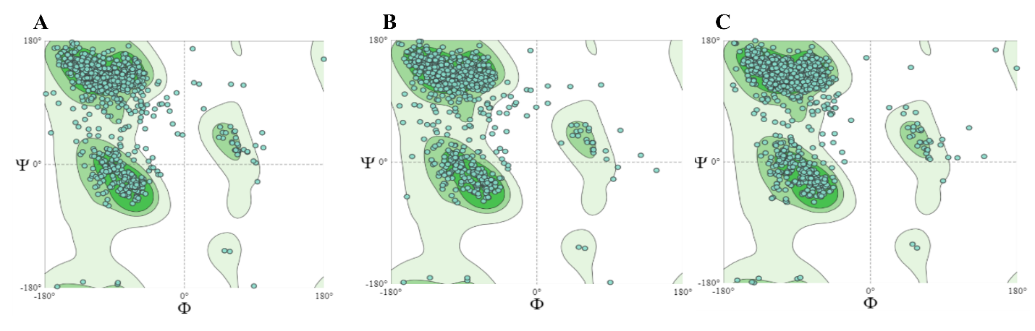
Supplementary Fig. 1. Ramachandran plots were constructed for all residues in VIDO4296 (A), VIDO4304 (B), and VIDO4372 (C). The Ramachandran plot is a two-dimensional graphical representation of dihedral angles, ϕ and ψ of backbone atoms plotted on the graph and defined allowed regions of conformational space. The ϕ (phi) and ψ (psi) torsions represent the rotation around the N-Cα and Cα-C bonds, respectively. Using the R plot, we assessed the geometrical quality of protein structures, particularly the backbone dihedral angles of amino acids.

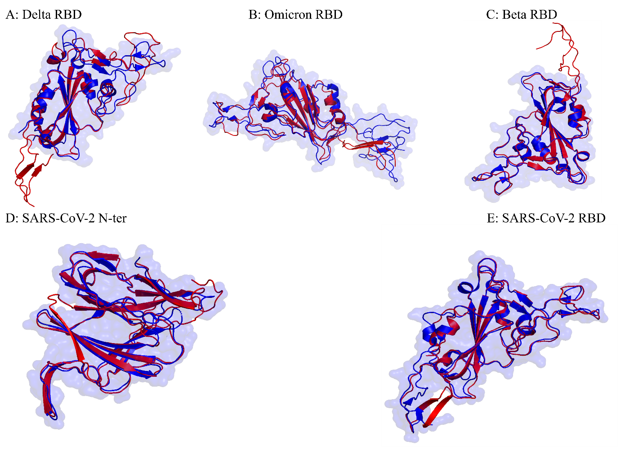
Supplementary Fig. 2. Alignment of the modeled RBDs and S1 N-terminus was performed separately against the X-ray and Cryo-EM conformations. (A) Alignment of the Delta RBD to the X-ray conformation of the Delta RBD, PDB: 7WBQ. (B) Alignment of the Omicron RBD (VIDO 4304) to the Cryo-EM derived RBD of Omicron, PDB: 8HC6. (C) Superimposing the Beta RBD onto the crystal structure of the Beta RBD, PDB: 7S5P. (D) N-terminus of SARS-CoV-2 (VIDO 4372) superimposed on the N-terminus of the crystal conformation, PDB: 7LY3. (E) RBD of SARS-CoV-2 (VIDO 4372) aligned to its crystal structure, PDB: 6M0J. In all the figures, the predicted domain is depicted in red, while blue has been used to represent the X-ray or cryo-EM conformations.

