Appendix A

The information sheet used for the discussion in the second study

Instruction
A murder case was reported in Shimonoseki City, Yamaguchi Prefecture, Japan. The victims included both men and women. The room was ransacked, but nothing was stolen. Defendant F, a resident of Hioki-cho, Yamaguchi Prefecture, has emerged as a suspect. Defendant F should be sentenced according to whether he is guilty by discussion. Please note the following three points
① All testimony is true, except for defendant F.
② There is no accomplice.
③ Trains follow the schedule perfectly unless otherwise noted.

Common information for four members
１． The victim is defendant F's ex-wife and her unfaithful partner, who betrays defendant F and flees.
Defendant F told everyone around him that he would kill both male and female victims. He also identified the victims' current whereabouts as Shimonoseki’s.
２． Around the time of the crime, a neighbor (Witness A) hears a yell of "You betrayed me!" He heard a yelling voice saying,’ You betrayed me!
３． The time of crime was near Shimonoseki station. One minute walk.
The time of the crime was approximately 17:00. The margin of error was within ± 5 min.
Information Card A

Information sheet for A

4 . (Shared alibi with C) Testimony of a friend who played with Defendant F during the day. “We met up at 11 a.m. and stayed together until 2p.m. after that. We ate, went to a CD store and a jeans store. We parted almost exactly at 2 p.m. in front of the Nagato Station.”
5 . (Shared alibi with D) Defendant F kept receipts from a bookstore and a coffee shop. The time of receipt at the bookstore is 14:13, and the time of receipt at the coffee shop is 15:00.
6 . (Shared dummy with B) Defendant F's assertion “ During the day, I played with a local friend in Nagato City. After that, I did not leave the station and stayed in the car at a bookstore. I bought a paperback book to read at the coffee shop, and since it was hot, I killed time at the coffee shop until the last minute. After that, I took the San-in Line to Shimonoseki a little after 3:00 PM. I stayed at a friend's house in Shimonoseki on that day. I stayed at a friend's house in Shimonoseki that day”.
7. (Nonshared alibi) It was raining on the day of the incident, and there was an announcement in the car saying,’ Watch your step. The caller who received the call from the defendant heard the broadcast.
8. (Share alibi with B) It was confirmed that the murder weapon was a kitchen knife with a 16 cm blade, purchased at a hardware store in the Nagato City shopping district on the day of the incident.
9 . (Nonshared dummy) Defendant F was a passenger in a friend's car in Shimonoseki at around 18:00 on the same day. This is a fact that the friend testified.

Information sheet for B
４． (Shared alibi with A) The murder weapon was a kitchen knife with a 16 cm blade, and was confirmed to have been purchased at a hardware store in the Nagato City shopping district on the day of the incident.
５． (Nonshared alibi) Call records confirm that Defendant F made cell phone calls from the train between 15:20 and 16:00.
６． (Share dummy with A) Defendant F's allegations (unsupported).
During the day, I was playing with a local friend in Nagato City. After that, I stayed in the station area and bought a paperback book to read in the car at a bookstore, and since it was hot, I killed time at a coffee shop until the last minute. I then took the San-in Line to Shimonoseki a little after three o'clock. I stayed in a friend's house in Shimonoseki that night. The San-in Line runs at a slow speed, and passenger cars can overtake it if they want to. If you are a passenger car, you can get from Nagato City to Shimonoseki in about one and a half hours if you drive sufficiently fast.
７． (Shared dummy with C) The operating speed of the Yin Line is low and can be overtaken by passenger cars if it chooses. For passenger cars, it takes only one and a half hours to fly between Nagato City and Shimonoseki.
８． (Shared dummy with D) Even if you take the San-in Line train departing from Nagato City at 15:04, you can still reach the crime scene before 17:00 by getting off the train at Kogushi Station and changing to a passenger car that you prepared in advance. Conversely, you can catch up with a train that has already gone by a passenger car, catch up with it, and board the train.
９． (Nonshared dummy) A station attendant at Nagato City Station saw Defendant F buy a ticket to Shimonoseki and go through the ticket gate. However, they do not know whether he has boarded the 14:01 or 15:04 trains. Defendant F himself claimed that he boarded the 15:04 train, but this has not been corroborated.

Information sheet for C
(Nonshared alibi) The hardware store where the murderer purchased the murder weapon is located in the only shopping street in the city, which takes five minutes one way from Nagato Station no matter how you drive. The time required by a car was not significantly different. The hardware store keeper was quite old, and his testimony was not very convincing; therefore, the purchaser could not be identified.
I only remember the time of sale, which was in the afternoon.
5.(Shared alibi with a A) Testimony of a friend who played with Defendant F during the daytime. “We met up at 11 a.m. and stayed together until 2 p.m. after that. We ate, went to a CD store and a jeans store. We parted almost exactly at 2 p.m. in front of Nagato Station”.
6.(Noshared alibi) Nagato City → Shimonoseki on the day of the event
14:07 → 15:58
15:04 → 17:13
16:22 → 18:25
The nearest station to Defendant F's home was not Nagato City Station. The interval between Nagato City Station and Shimonoseki Station is one station every seven minutes.
7.(Nonshared alibi) Testimony of a bookstore assistant in which Defendant F stopped.
“I recognize defendant F. Indeed, he came to the store at the time. He ordered a book, so I looked for it and found a paperback. He was in the store for 10 minutes at least to buy two books." After book shopping, the defendant was seen went into the coffee shop across the street by the bookstore assistant.
8. (Shared dummy with B) The Sanin Main Line's operating speed is slow, and passenger cars can overtake the train if they so desire. Passenger cars can reach Nagato City to Shimonoseki in approximately an hour and a half if they are willing to fly.
9.(Nonshrad alibi) Testimony of a water at a coffee shop in which Defendant F stopped by. “I do not remember the details, but indeed, this person came to the store. He had been reading a book ever since he came to the store, and nothing was particularly unnatural about him. He was constantly concerned about the time of the train, but because the coffee shop is located inside a train station, it is not unusual to see customers with such an appearance”.

Information sheet for D
4.(Shared alibi with A) Defendant F kept receipts from the bookstore and coffee shops. The time of bookstore receipt was 14:13, and the time of coffee shop receipt was 15:00.
5.(Nonshared dummy) Testimony of a newspaper delivery person in the vicinity of Kogushi station.“ I recognize defendant F." I vaguely remember the time of day, but he was on the platform and standing tall. The train passes an express train. There must have been a long stop because of express train overtaking. Because of being passing by a cab I didn't even look to see if he got on the train because I was in such a hurry."
Note: It takes approximately 40 minutes from Kogushi Station to Shimonoseki on the San-in Line. It takes 30 min for a passenger car to fly or 25 min if you fly.
6.(Nonshared dummy) Defendant F is a large man (180 cm tall) with a history of injury.
7. (Nonshared dummy) A friend of defendant F testified that "defendant F used to verbally abuse male and female victims whenever he drank alcohol, saying things like, 'You betrayed me.
8.(Nonshared dummy) Witness A is an 81-year-old woman who usually uses a hearing aid and often has difficulty hearing the judge's questions.
9. (Shared dummy with B) Even if you take the San-in Line train departing from Nagato City at 15:04, you can get off the train at Kogushi Station and change to a passenger car that you have prepared in advance and arrive at the crime scene before 17:00. Conversely, one can catch up with a train that has already departed from a passenger car and board the train.

Appendix B
Results of Topic Models

Fig.1 Word cloud in Ex. 1

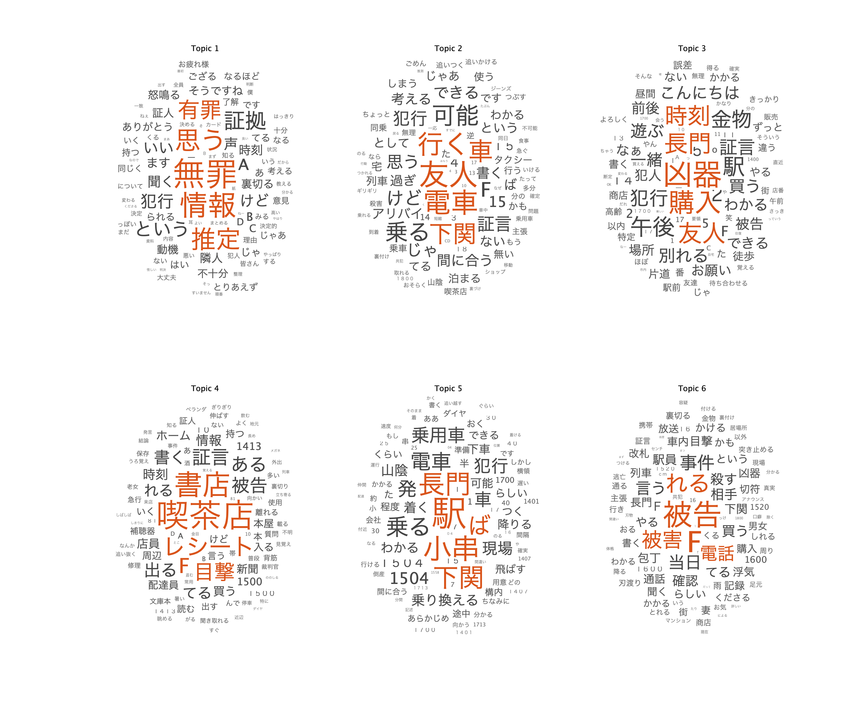

Fig.2 Perplexity and computation time for the result of Fig.1

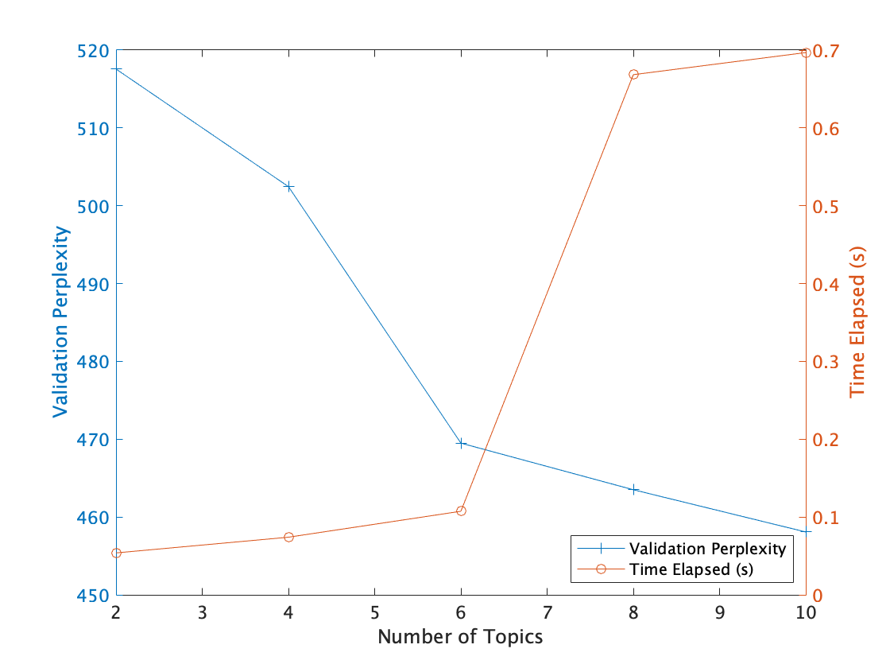
Note: Perplexity = 226.79, Negative Log Likelihood =184764.06

Fig.3 Example of topic ratios for 20 chat lines

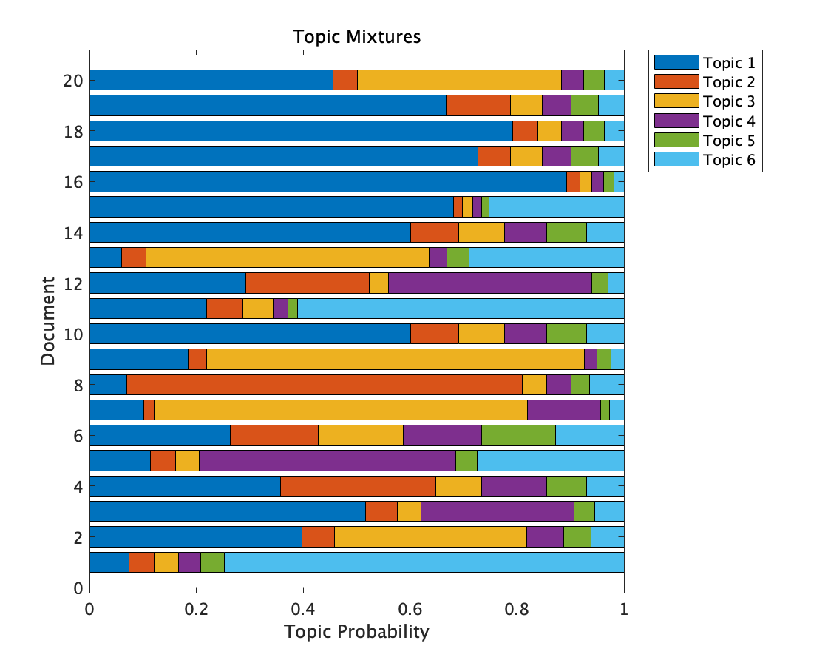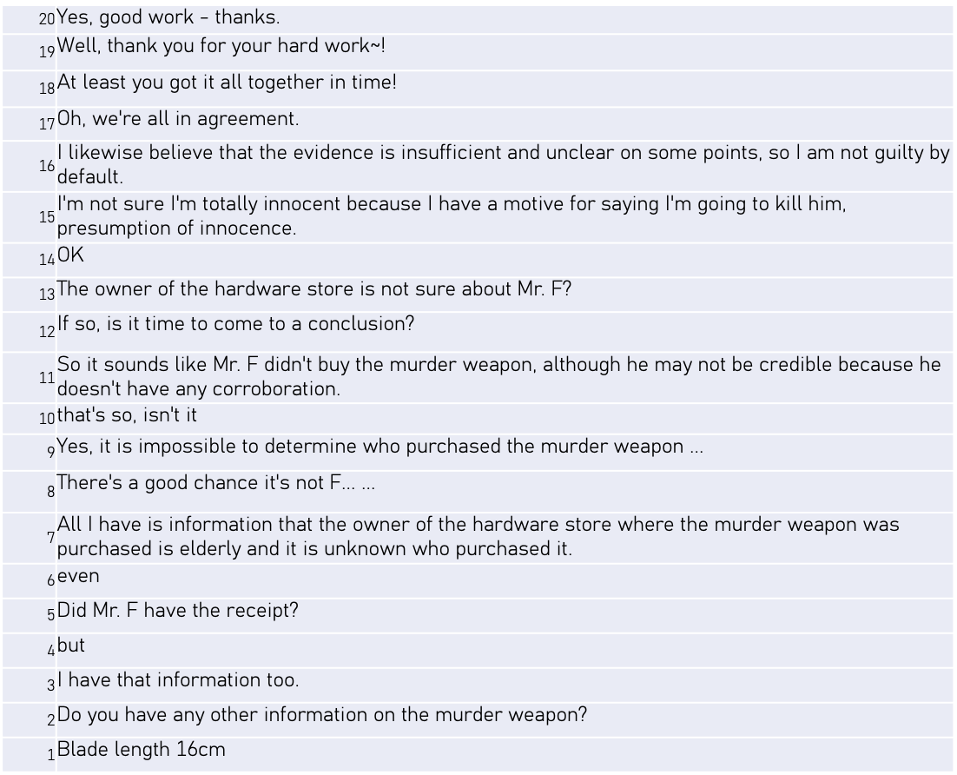
Note: Chat lines are arranged from bottom to top.

Experiment 2 Topic Ratio by Chat Log

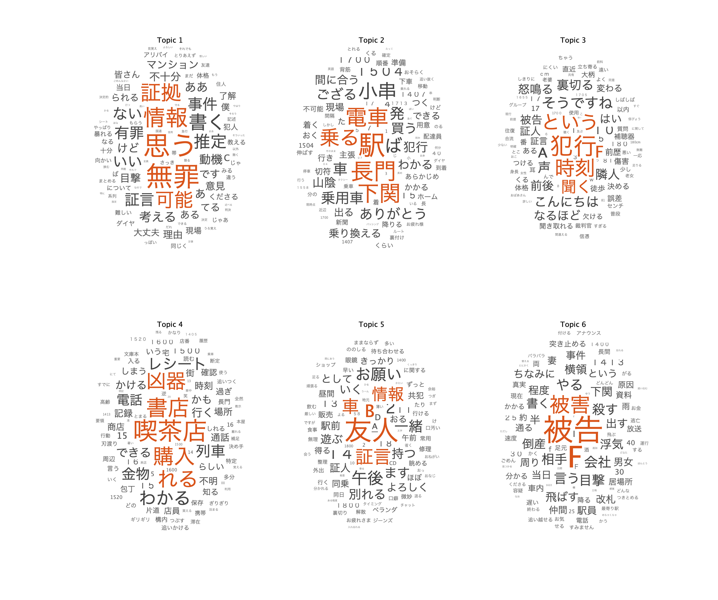

Appendix C
Effect of Information Distribution Conditions on Topic Ratios

Experiment 1 examined the effect of the information distribution conditions on each of the six topics. Since the validity of using topic ratio as a dependent variable was not established, the analysis for Experiment 1 is presented as side-by-side graphs of the conditional effects on the data of Experiments 1 and 2 to examine reproducibility. When a linear mixed model with the discussion group was used as a random variable to perform a multilevel analysis, a warning was issued by JASP that the p-value was too large because the number of people in a group was too small. Therefore, in addition to the results of the linear mixed model, the results of the analysis of variance were also reported, in which the group mean was subtracted from each score as a group-centering score.

Topic 1 Verdicts. The results of the multilevel analysis showed a significant interaction effect between sharing and information conditions (F [1,98] = 4.12, p = .045) and no difference between Experiments 1 and 2 (model fit Log Likelihood = 310.18, df = 15, Akaike information criterion [AIC] = - 590.36). The interaction effect of ANOVA was not significant (F [1,196] = 2.89, p = .09, partialη2 = .02). The results of the posterior test showed no differences between the cells. All conditions mentioned adjudication to the same extent.

Topic 2 Crime. The results of the multilevel analysis showed that the main effect of the shared condition (F [1,49] = 8.533, p = .006) was not significantly different between Experiments 1 and 2 (Log Likelihood = 297.43, df = 15, AIC = - 564.886). Analysis of variance showed a main effect of the shared condition (F [1,196] = 11.64, p < .001, partialη2 = .06). Shared conditions are more likely to indicate the likelihood of committing a crime. Fig. 1 shows the results for Topic 2.

Fig. 1 (Figure 3 in main document)
Condition effects on Crime topic ratio.

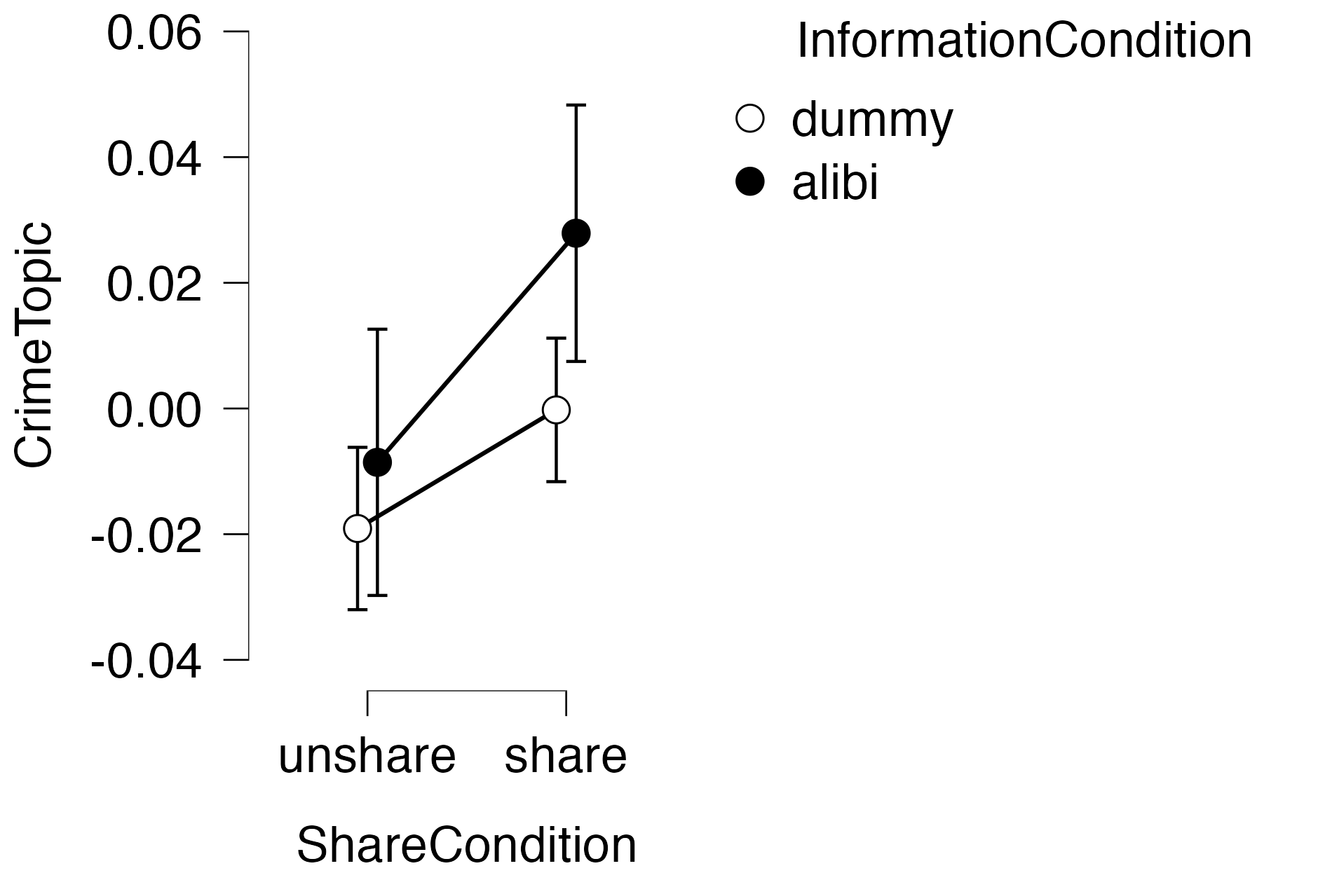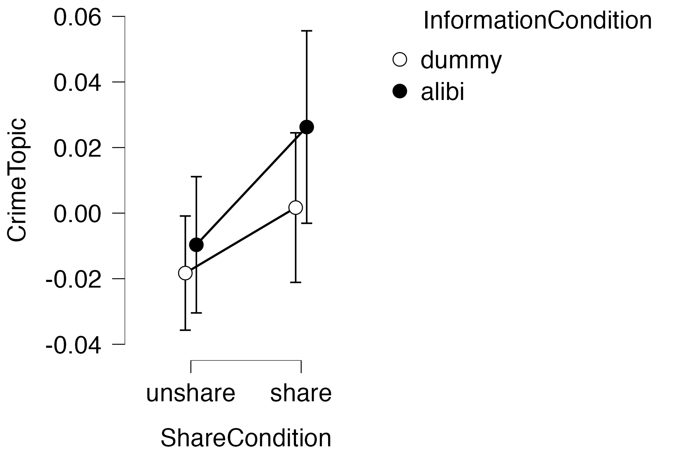
Note: The left: Experiment 1 (156 participants); The right: Experiment 2 (48 participants).

Topic 3 Weapon. Multilevel analysis revealed a significant main effect of the shared condition (F [1,49] = 7.05, p = .011), main effect of the information condition (F [1,49] = 63.69, p < .001), and an interaction effect (F [1,98] = 19.53, p < .001); there was no difference between Experiments 1 and 2 (Log Likelihood = 336.15, df = 15, AIC = - 642.302). Analysis of variance revealed a main effect of the shared condition (F [1,196] = 6.68, p = .011, partialη2 = .03), a main effect of the information condition (F [1,196] = 95.65, p < .001, partialη2 = .33), and an interaction effect (F [1,196] = 15.15, p < .001, partialη2 = .07);post-test results showed no difference between B and D, as shown in Table 3. The alibi condition was more likely to elicit mention of murder weapons, particularly C, in the shared alibi condition. Fig. 2 shows the results for Topic 3.

Fig. 2
Condition effects on Weapon topic ratio.
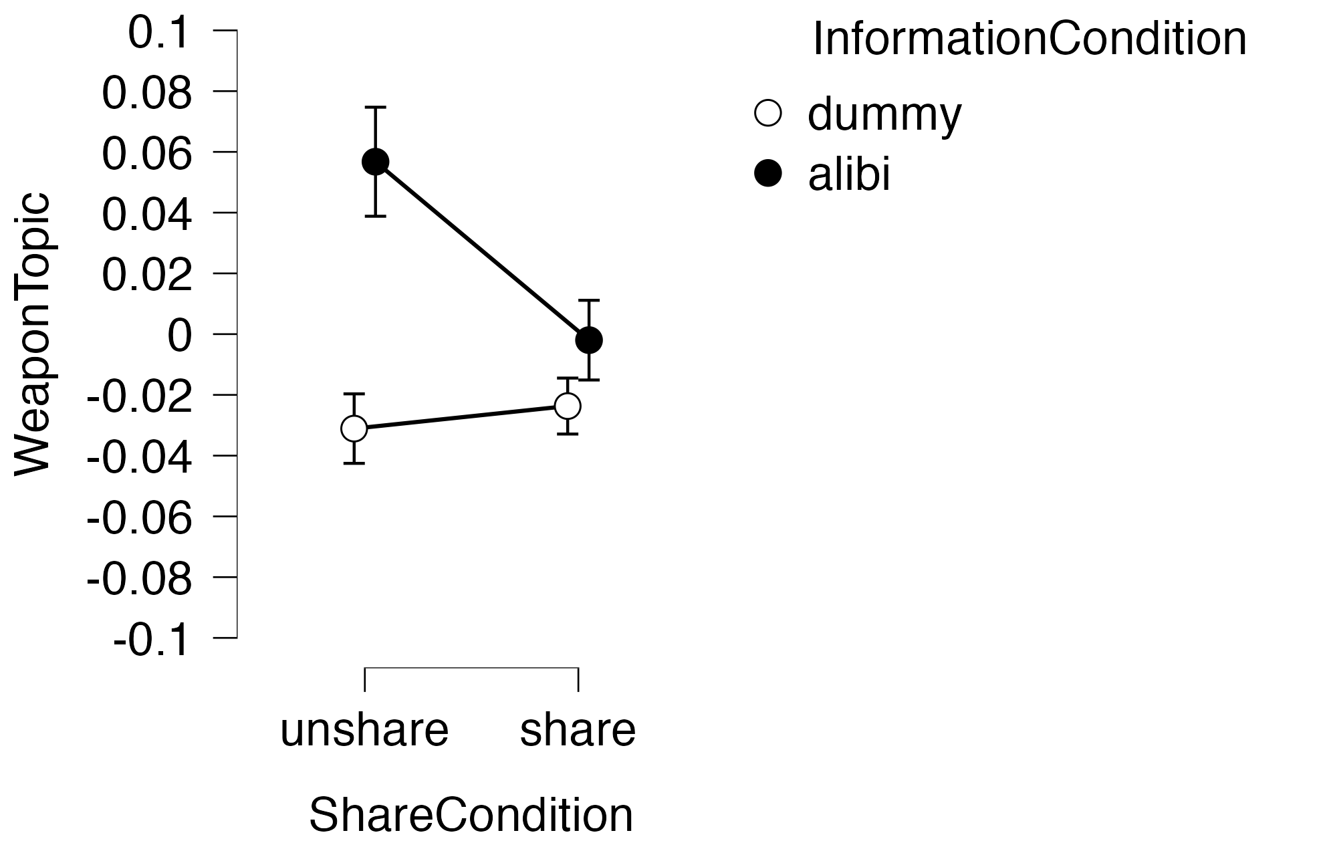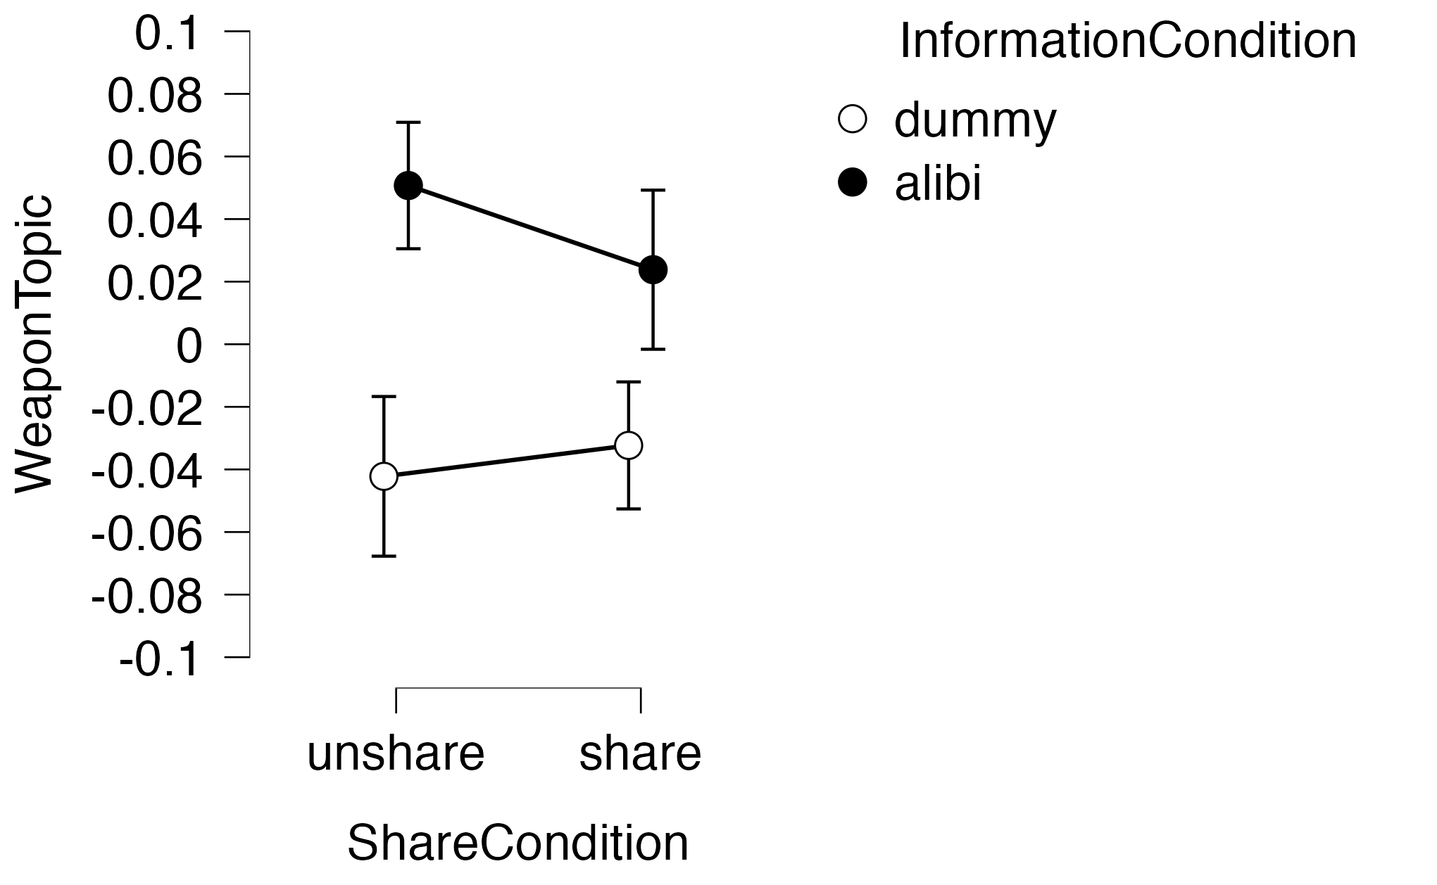
Note: The left: Experiment 1 (156 participants); The right: Experiment 2 (48 participants).

Table 3.
Post Hoc Comparisons for Weapon Topic

Topic 4 Evidence. The results of the multilevel analysis showed a significant main effect of the shared condition (F [1,51.07] = 44.21, p < .001), main effect of the information condition (F [1,61.46] = 14.23, p < .001), and an interaction effect (F [1,147] = 35.32, p < .001). There was no difference between Experiments 1 and 2 (Log Likelihood = 347.75, df = 15, AIC = - 665.51). From analysis of variance, main effect of the shared condition (F [1,196] = 62.95, p < .001, partialη2 = .24), main effect of the information condition (F [1,196] = 15.06, p < .001, partialη2 = .07), and interaction effects (F [1,196] = 26.78, p < .001, partialη2 = .12) were observed. Table 4 displays the results of the post hoc tests, showing differences in all cases other than between A, and B or C. The non-shared condition was more likely to mention the topic, “evidence”, especially D, in the non-shared dummy condition. Fig. 3 shows the results for Topic 4.

Fig.3
Condition effects on Evidence topic ratio.

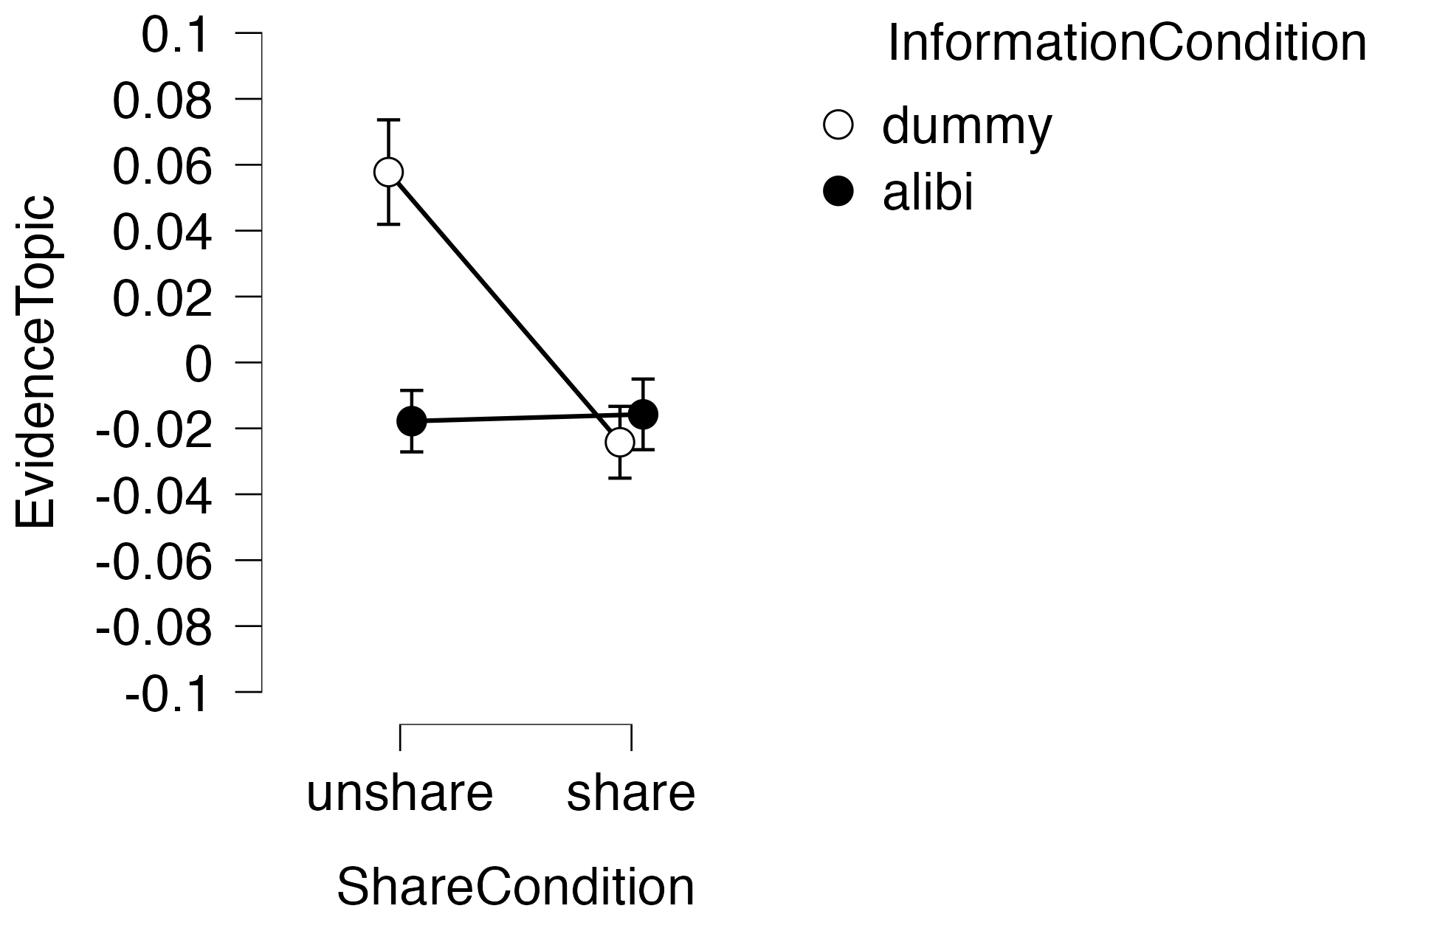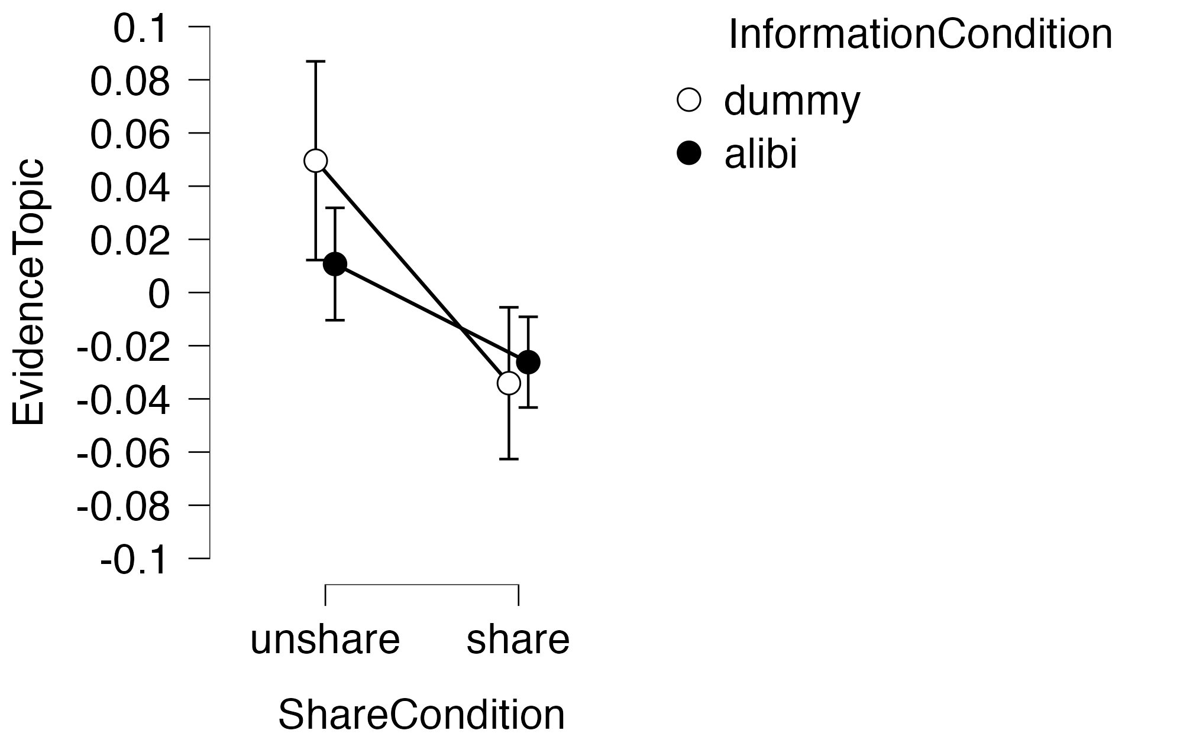
Note: The left: Experiment 1 (156 participants); The right: Experiment 2 (48 participants).

Table 4.
Multi Comparison Test for the Evidence Topic
Topic 5 Time. The results of the multilevel analysis showed that the main effects of the shared condition (F [1,49] = 11.49, p = .001), the information condition (F [1,49] = 28.86, p < .001), and the interaction effect (F [1,98] = 30.08, p < .001) were significant. An experimental influence in the form of a three-factor interaction effect was observed (F [1,98] = 5.76, p < .018; Log Likelihood = 353.48, df = 15, AIC = - 676.97). Analysis of variance revealed main effects of the shared condition (F [1,196] = 18.16, p <.001, partialη2 = .09), the information condition (F [1,196] = 34.85, p < .001, partialη2 = .15), and the interaction effects (F [1,196] = 18.24, p < .001, partialη2 = .09). No differences were observed between the experiments. The results of the post hoc test showed differences between A and B, and C and D. The dummy condition was more likely to mention the topic of time, whereas A in the shared alibi condition did not mention transportation. Fig.4 shows the results for Topic 5.
Fig. 4 Condition effect on Time topic ratio.
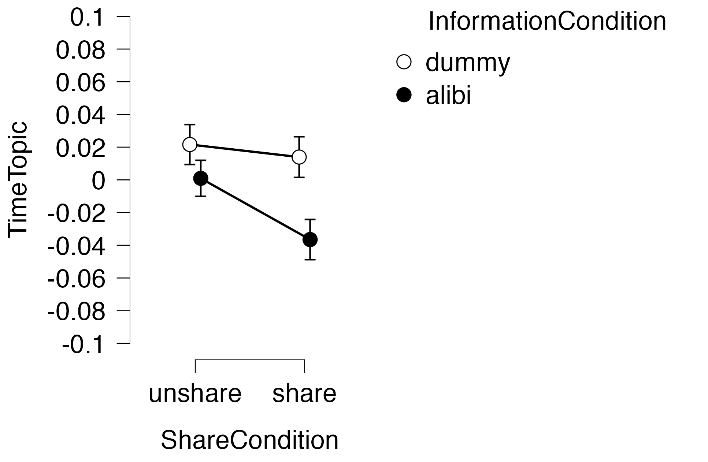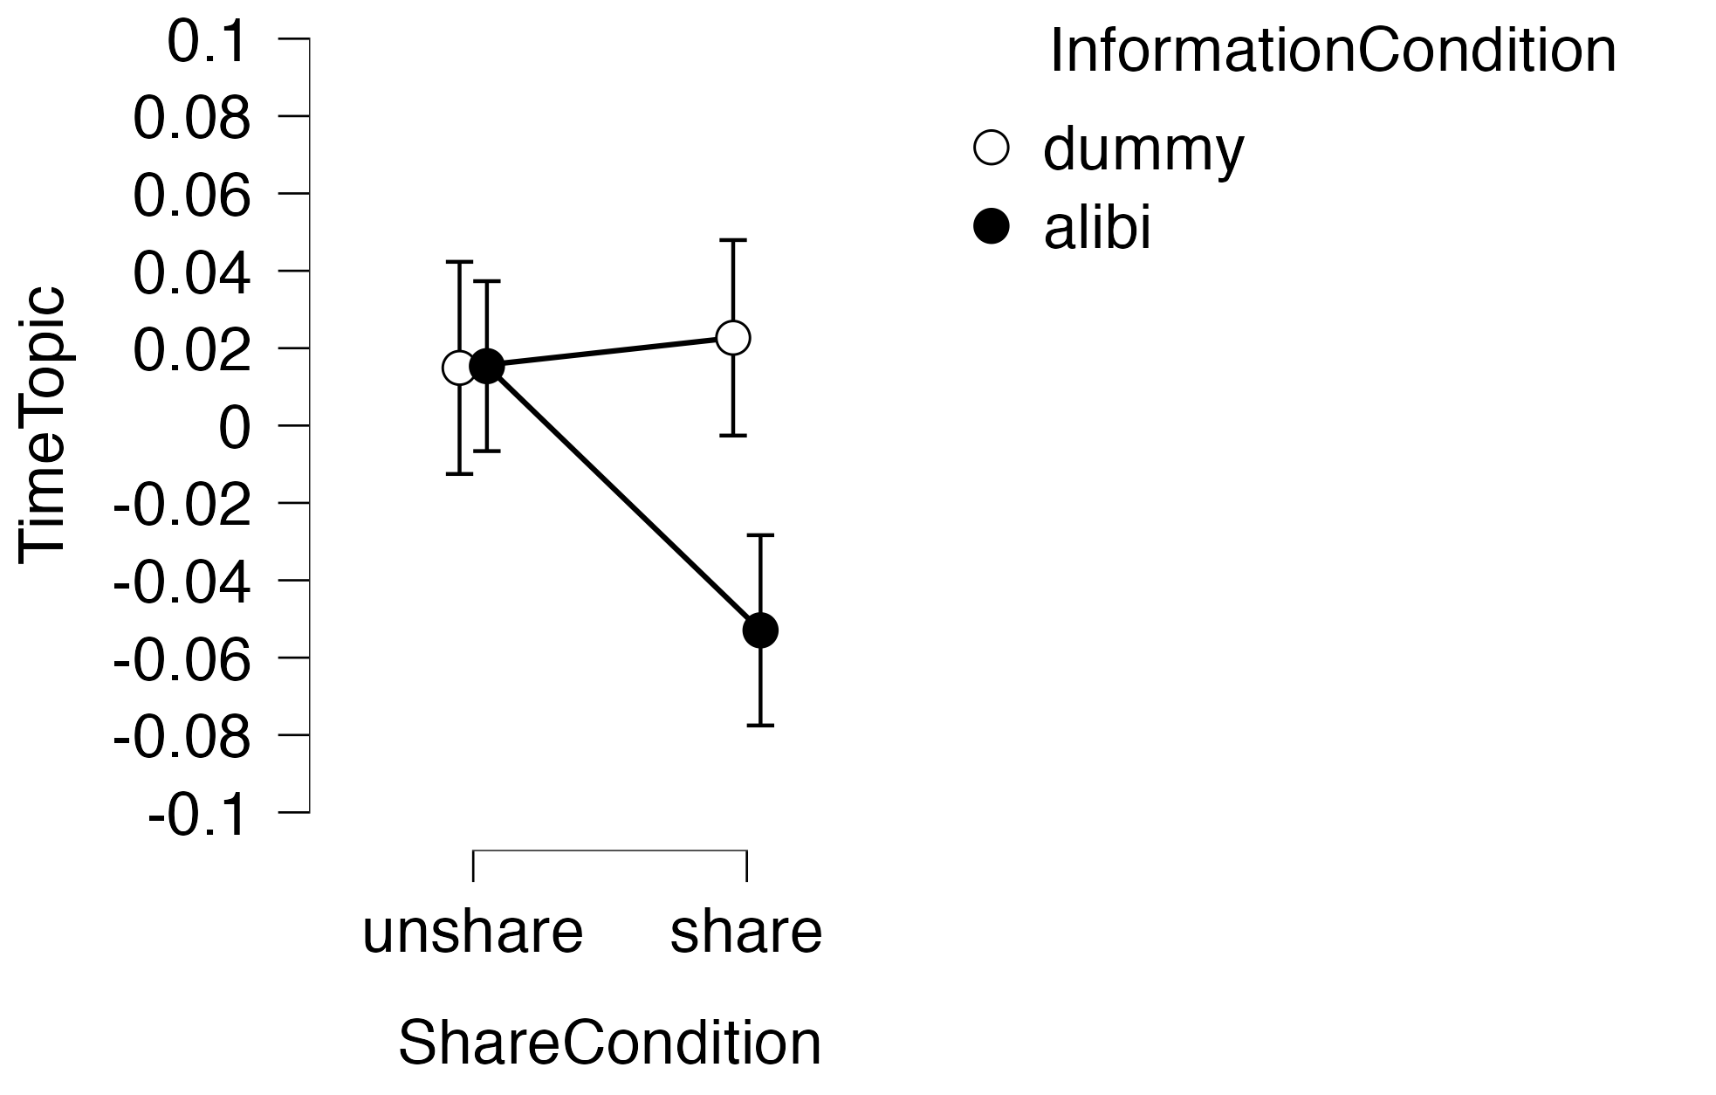
Note: The left: Experiment 1 (156 participants); The right: Experiment 2 (48 participants).

Topic 6 Motive. The results of the multilevel analysis showed that the main effects of the shared (F [1,49] = 70.19, p < .001) and information conditions (F [1,49] = 13.31, p < .001) were significant. We found an experimental influence in the form of a three-factor interaction effect (F [1,98] = 8.34, p < .004; Log Likelihood = 341.44, df = 15, AIC = - 652.88). Analysis of variance revealed main effects of the shared (F [1,196] = 106.74, p <.001, partialη2 = .35), and information conditions (F [1,196] = 18.03, p < .001, partialη2 = .08), and a three-factor interaction effect (F [1,196] = 4.98, p <=.027, partialη2 = .03). The results of the post hoc tests showed differences across all cells. Shared and dummy conditions referred to the defendants’ behavior and motivation. Fig. 5 shows the results for Topic 6.

Fig.5
Condition effects on Motive topic ratio.

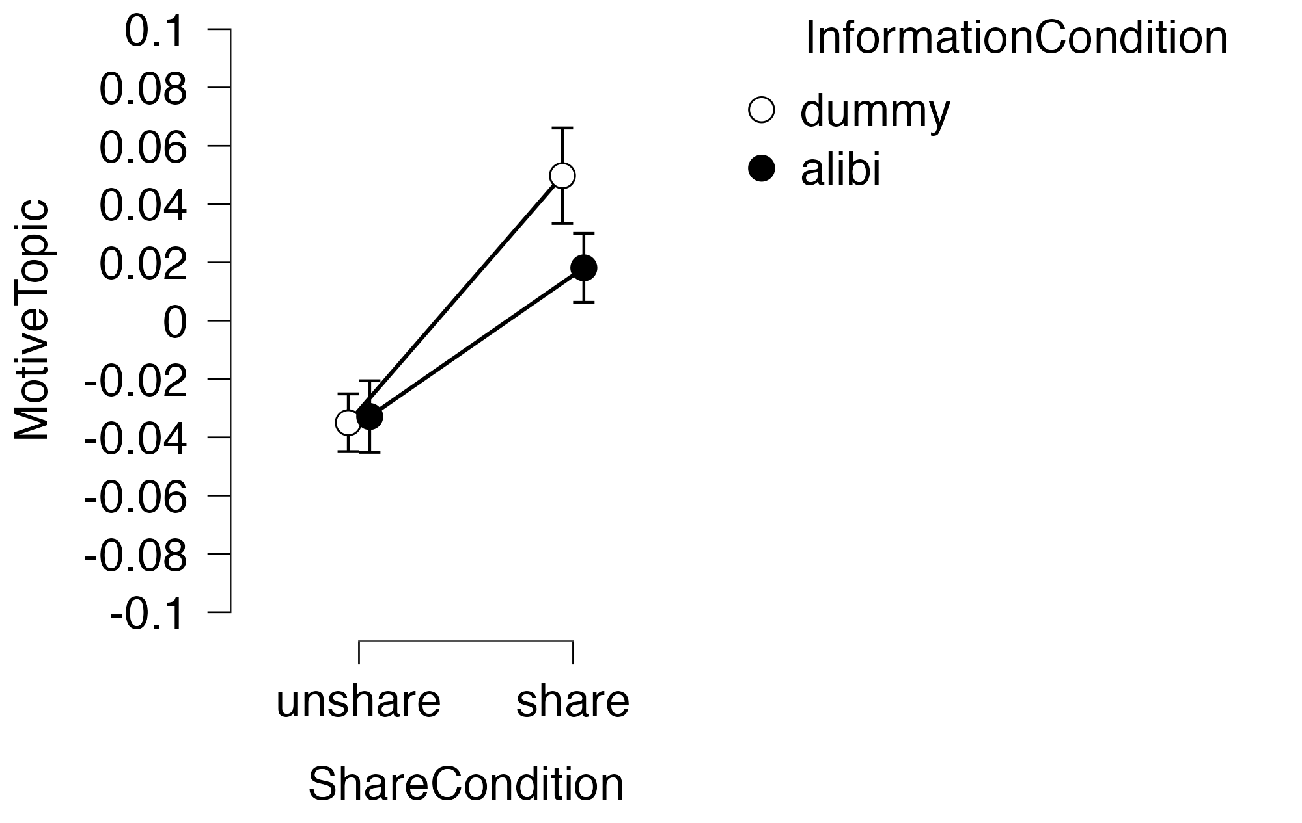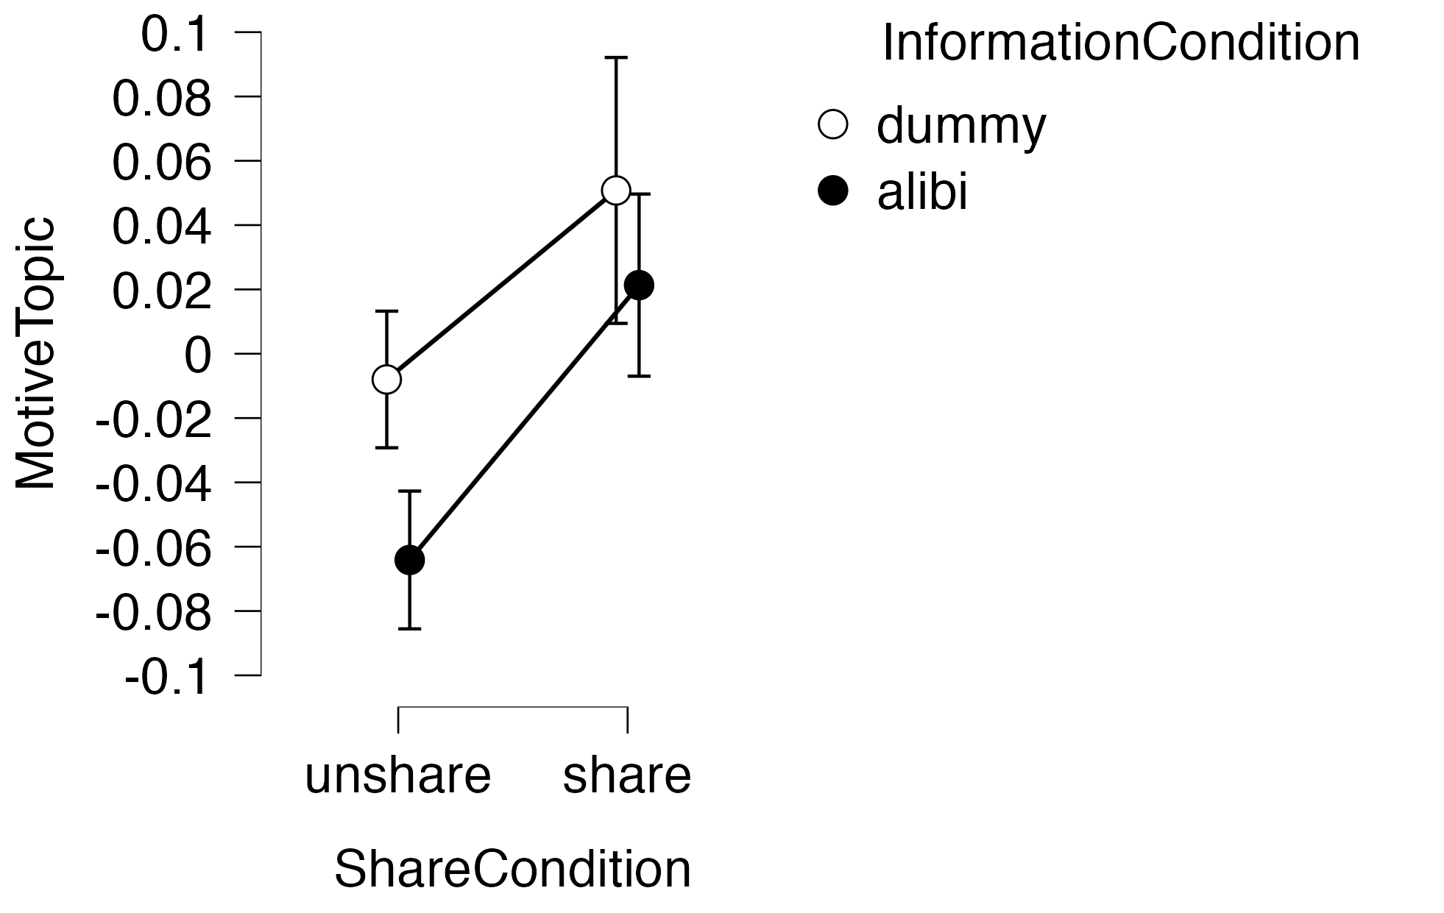
Note: The left: Experiment 1 (156 participants); The right: Experiment 2 (48 participants).
Appendix D
Results of mediation analysis for all chat logs from Experiments 1 and 2

The table 1 and 2 indicates that the “evidence topics → correct answer → innocence” path was significant (p = .049) in Figure 1; however, there was no impact on false memory from the evidence topic ratio. Regarding the explanation rate of the mediation analysis, the group decision was .304 and false memory was .111 when all chat logs were used.

Table 1. Total Effects of Mediation Analysis

Table 2 Indirect Effects of Mediation Analysis

Figure 1.
Mediation analysis for all chat logs(Experiment 1 and 2) model
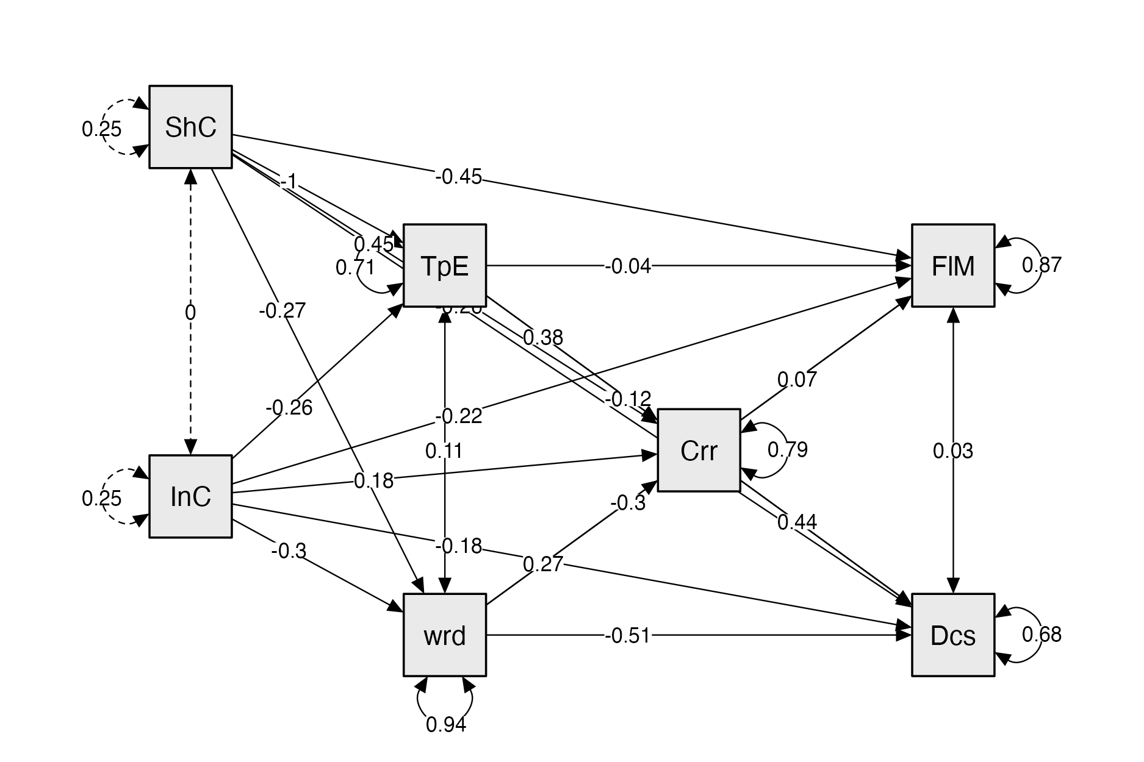

Appendix E

Word list for DRM experiment

Lure 1: "Not guilty".
List of words for inscription "decision," "choice," "presumption," "jury," "accomplice," "truth," "victim," "guilty," "debate," "trial," "witness," "sentence."
Lure 2 "Testimony"
Words for recognition: “friend”, “glasses”, “meal”, “local”, “paperback”, “bookstore”, “clerk”, bookstore, witness, coffee shop, elderly, neighbor, and station attendant
Lure 3 "Time"
"ticket" "ticket gate" "train" "car" "ride" "interval" "speed" "in car" "one way" "in front of station" "on the way" "afternoon"
Lure 4 = "Criminal"
Words for inscription "murder" "alleged" "defendant" "suspect" "injury" "height" "scene" "incident" "large" "drinking" "prior history" "build"
Lure 5, "Evidence."
"receipt" "weapon" "walk" "purchase" "record" "insufficient" "call" "phone call" "confirm" "identify" = "information" "corroborate"
Lure 6 "Motive"
"cheating," "bankruptcy," "betrayal," "whereabouts," "company," "associates," "escape," "embezzlement," "mouthpiece," "partner," "gender," "cause."

Words for errors in the recognition task
"weather" "jacket" "library" "stairs" "river" "summer vacation" "zoo" "park" "fireplace" "vase" "magazine" "hall"

