Supplementary information 2

Mast cells ImageJ quantification protocol

1.0 Mast cell counting
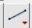
  - Open an HPF
  - Open the corresponding scale bar, then select the tool
  - Trace a line over the scale bar, then click on Analyze → Set a scale, enter the corresponding length in µm, check Global, then click on OK
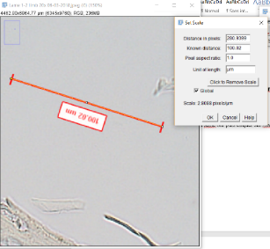
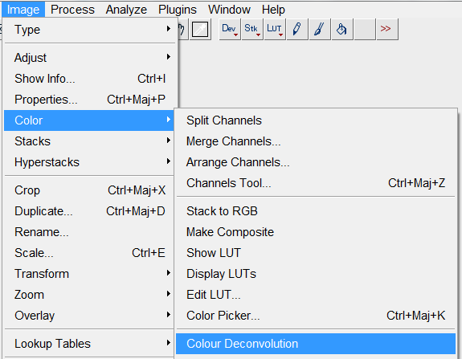
  - Dissociate the HPF in 3 colours by clicking on Image → Color → Colour Deconvolution

  - Select H DAB → OK
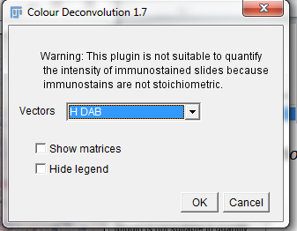

Obtaining 3 images: Color 1 = H&E, Color 2 = DAB

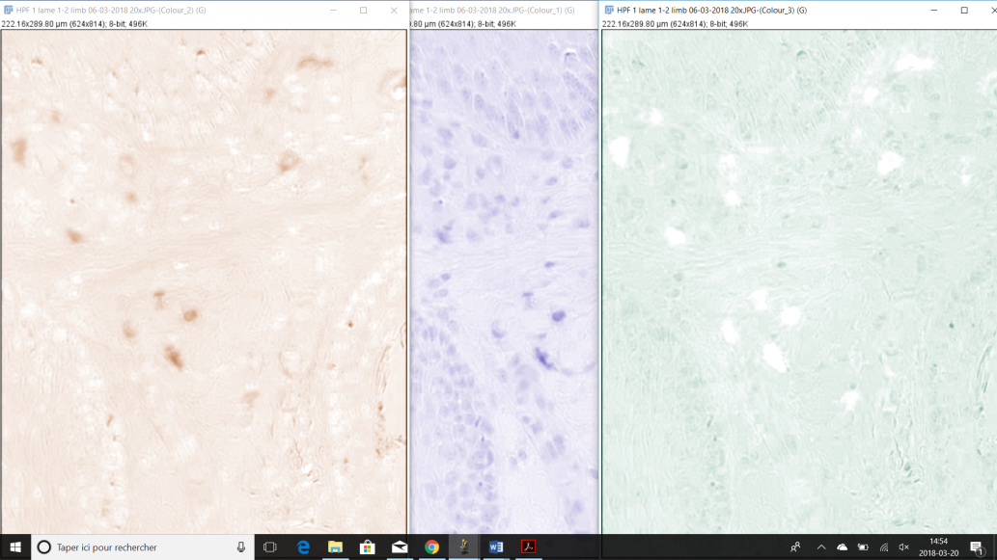

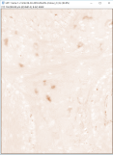
  - Choose the DAB image →

  - o in Process → Binary the click on Make binary

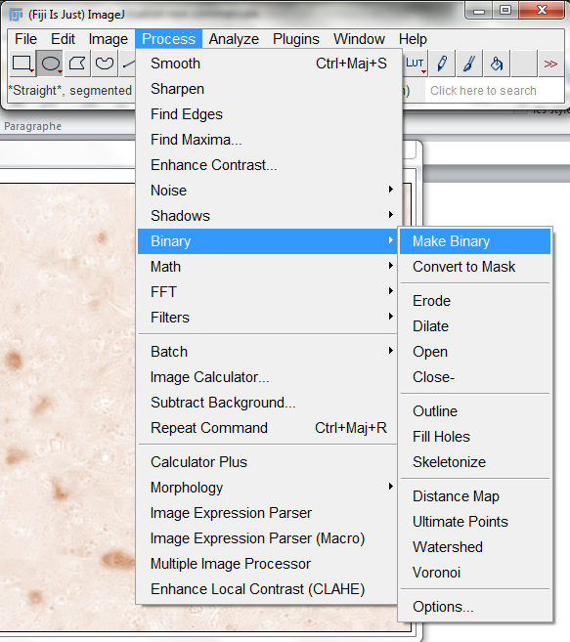

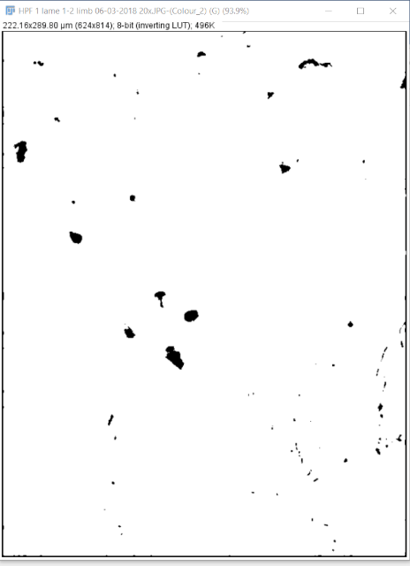
Result →

  - If epidermis, blood vessels, sweat/sebaceous glands and/or hair follicles are present, select 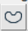 and draw around undesirable zones to delete, then click on Erode until zones are completely disappeareRemove selection and click on Erode until background had completely disappeared (only stained cells are remaining)

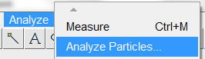
  - Go to Analyze and click on Analyze particles

  - Write the minimal and maximal cell area to consider (Between 8 et 300 µm²), go to Show, select Overlay Masks and check Display results, Summarize and Record stats → click on OK
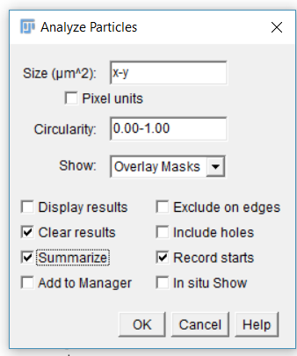

  - Result → number of counted cells, % staine surface and others
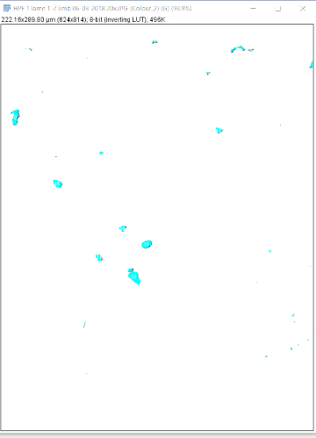

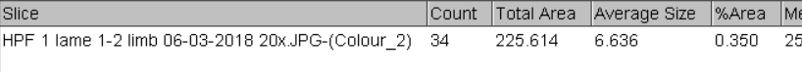

- Mast cell expression in number of mast cells/mm²:
  - Select 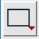 or then draw around HPF borders that just has been quantified, then push on Ctrl + m to measure the HPF area
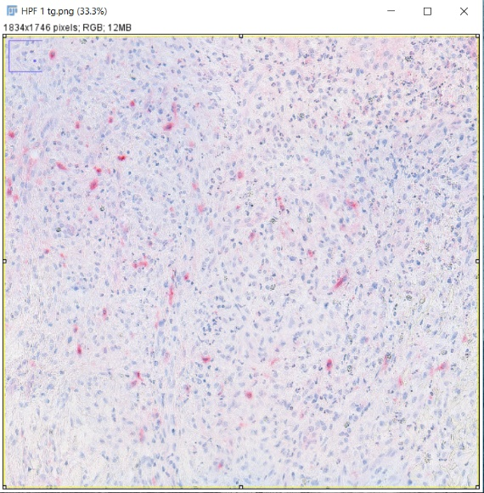
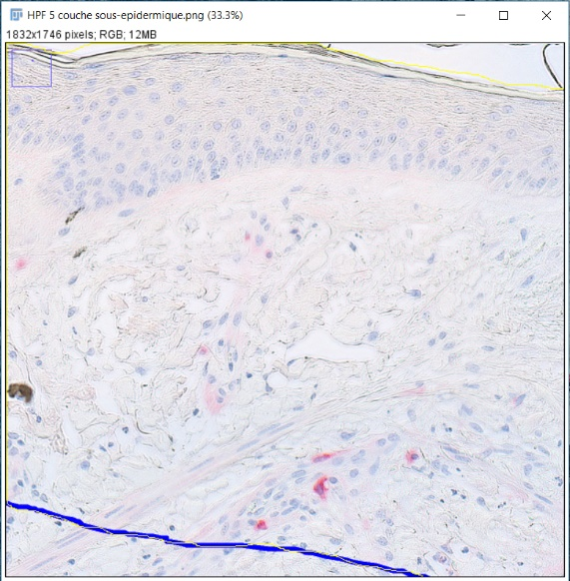
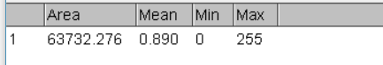

  - Transform the area measured in mm² (divide the area by 1 000² = 1 000 000)
  - Divide the mast cell number by the area calculated in mm²

