Supplementary Figures
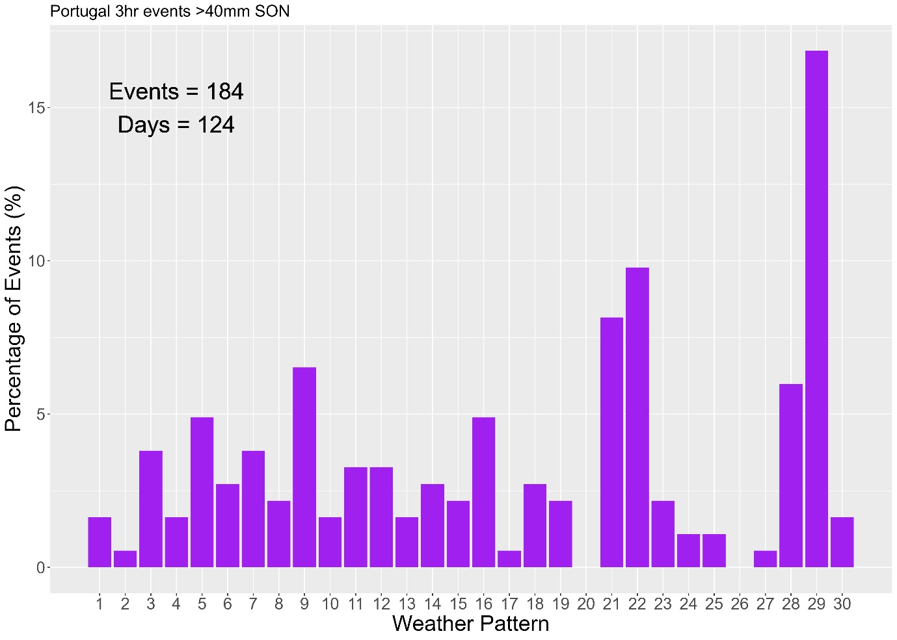
Figure S1: MO30 WPs associated with 3hr 40mm events in Portugal in Autumn. Proportion of all events which occur under each WP given as %. The number of events and the number of days with events over the threshold are given in the top right corner of each panel.

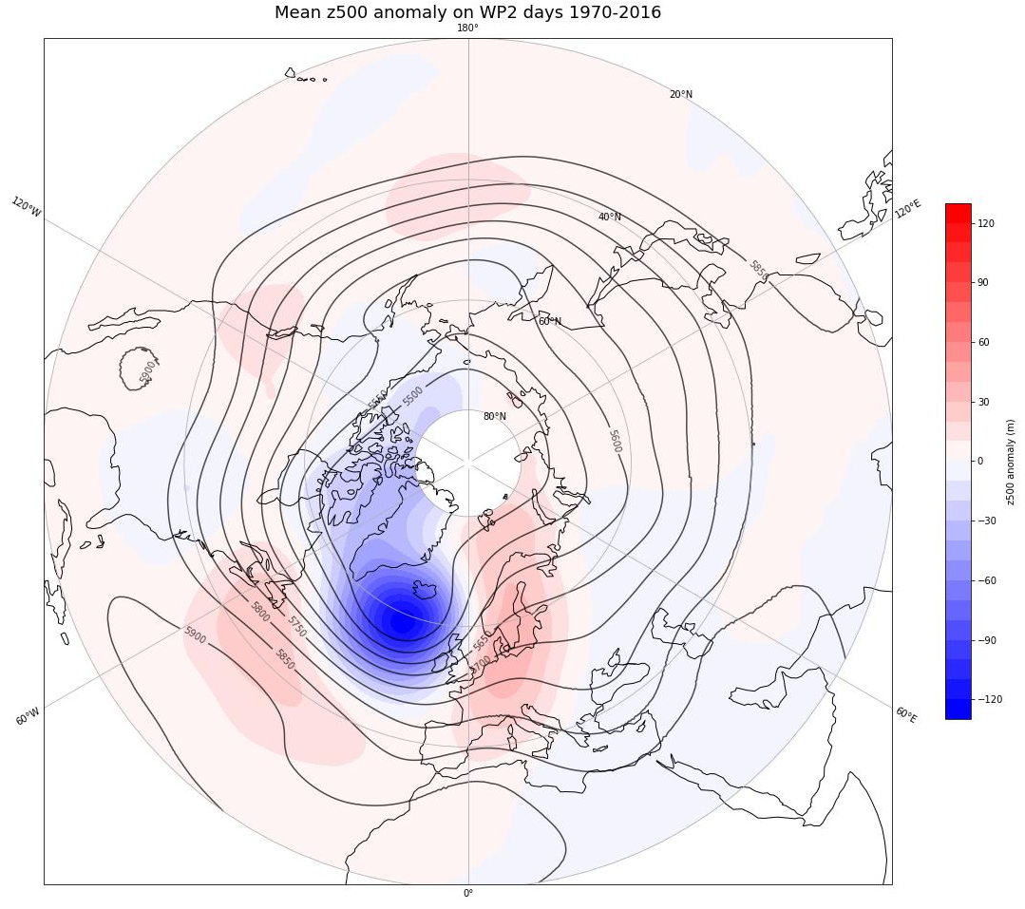
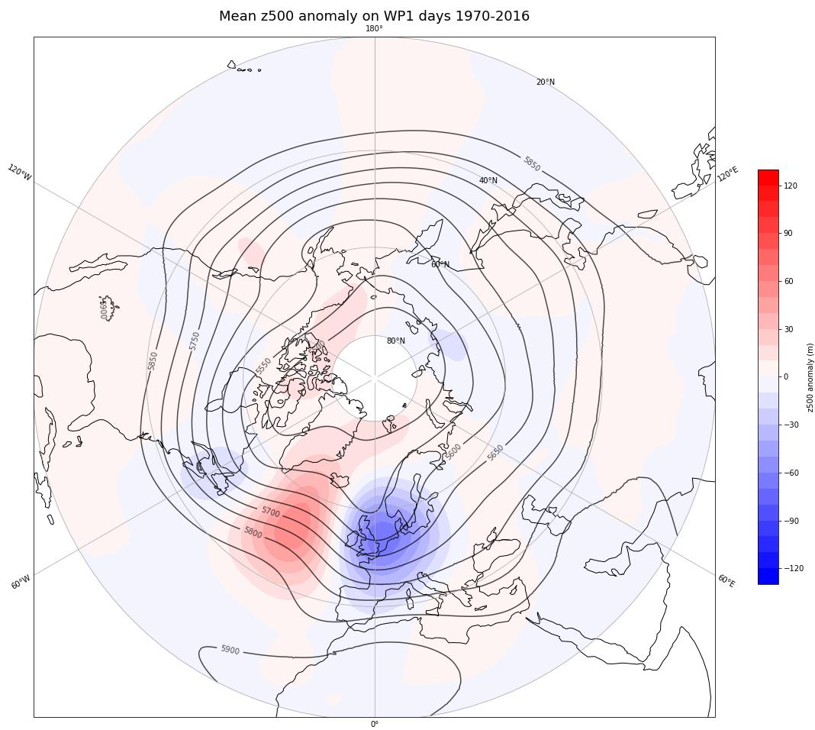
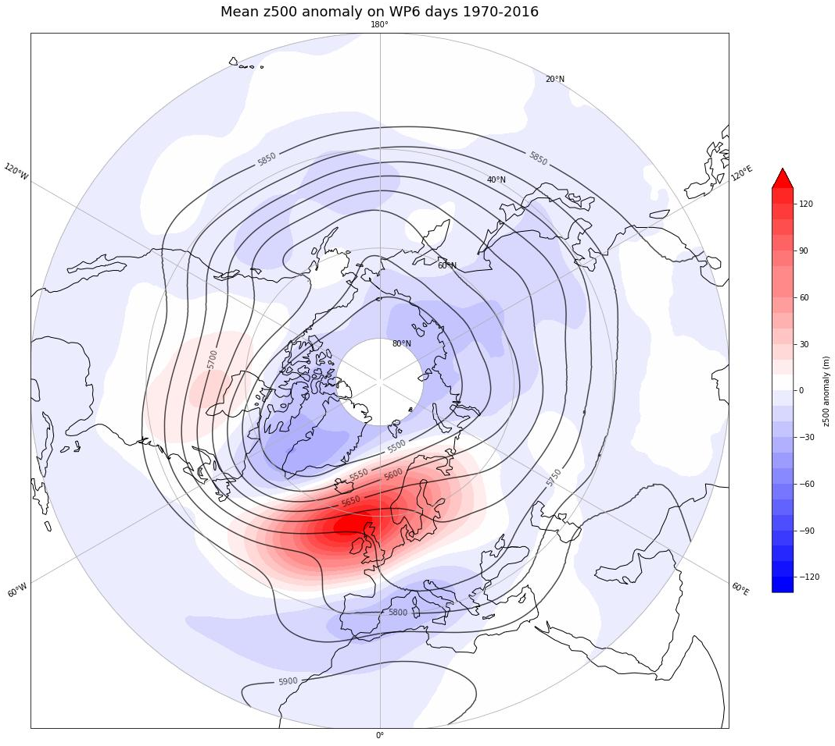
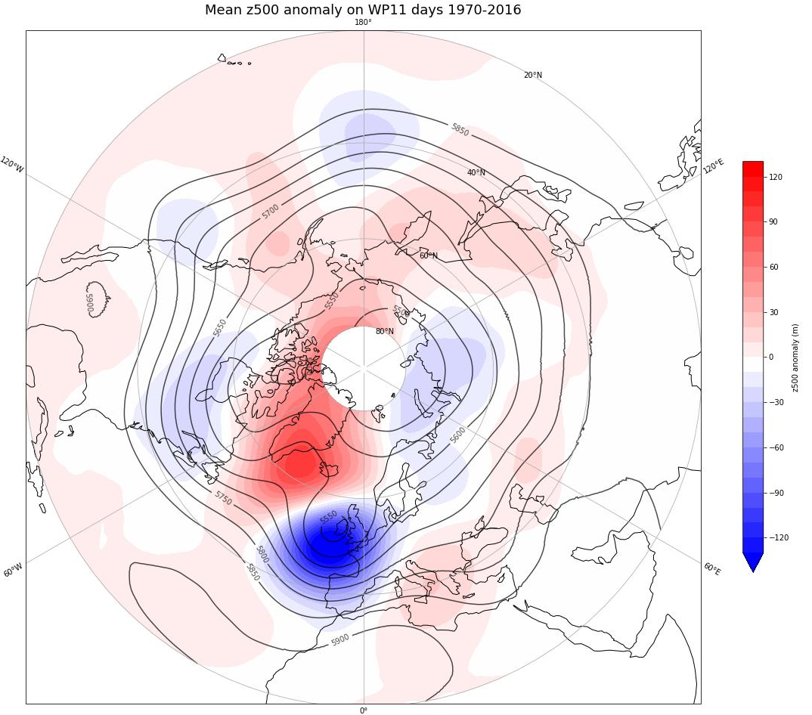
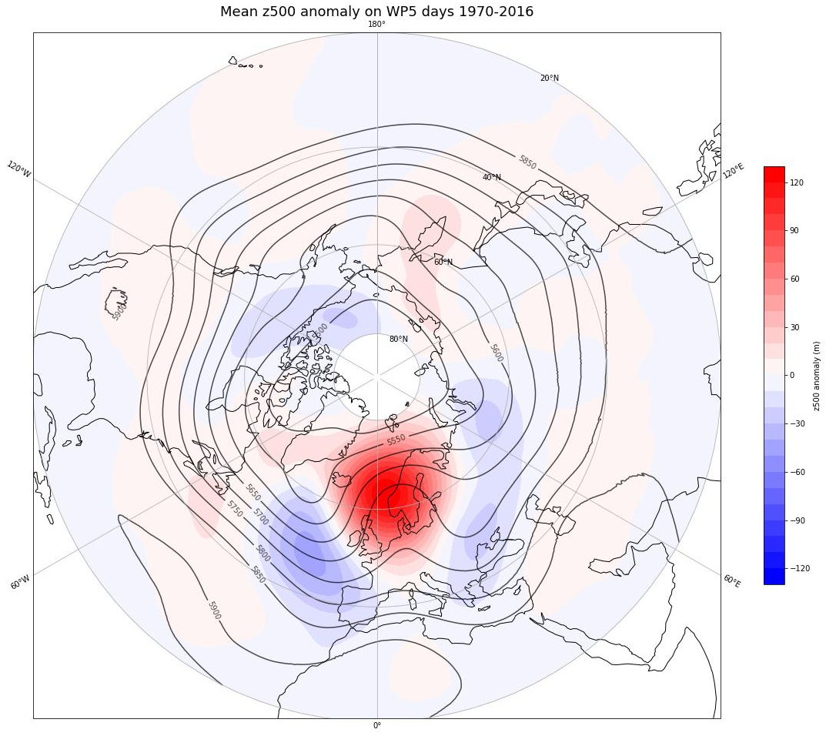
Figure S2: Mean z500 anomaly composite of all summer days with WP1, 2, 5, 6 and 11.

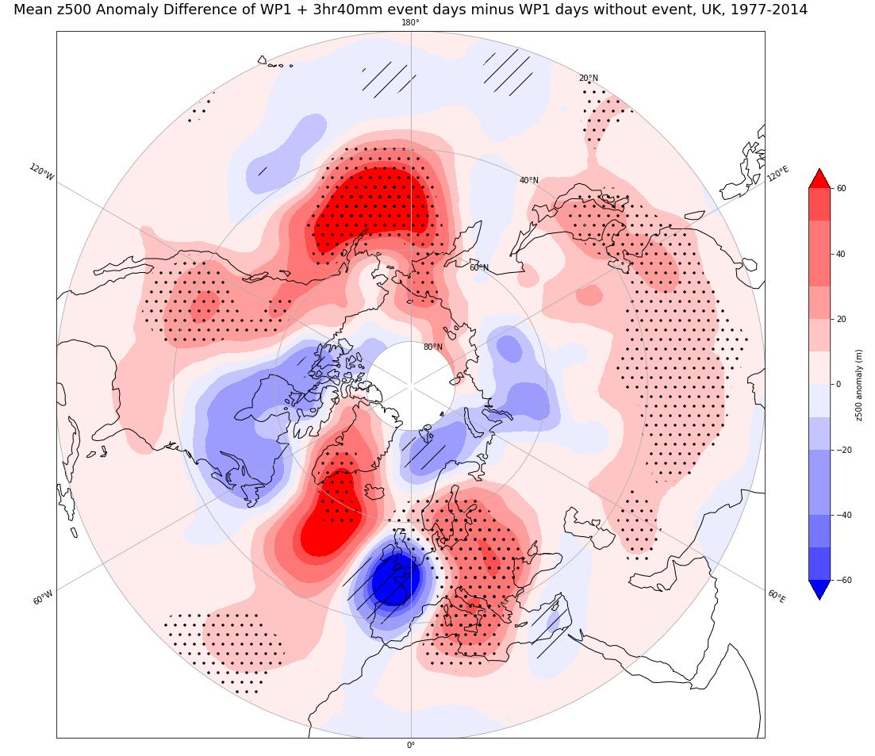
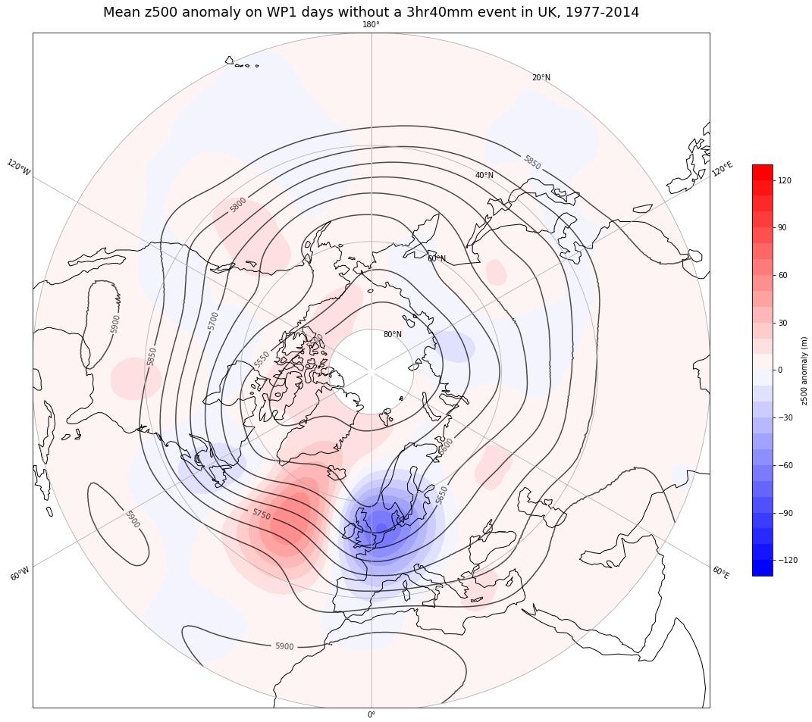
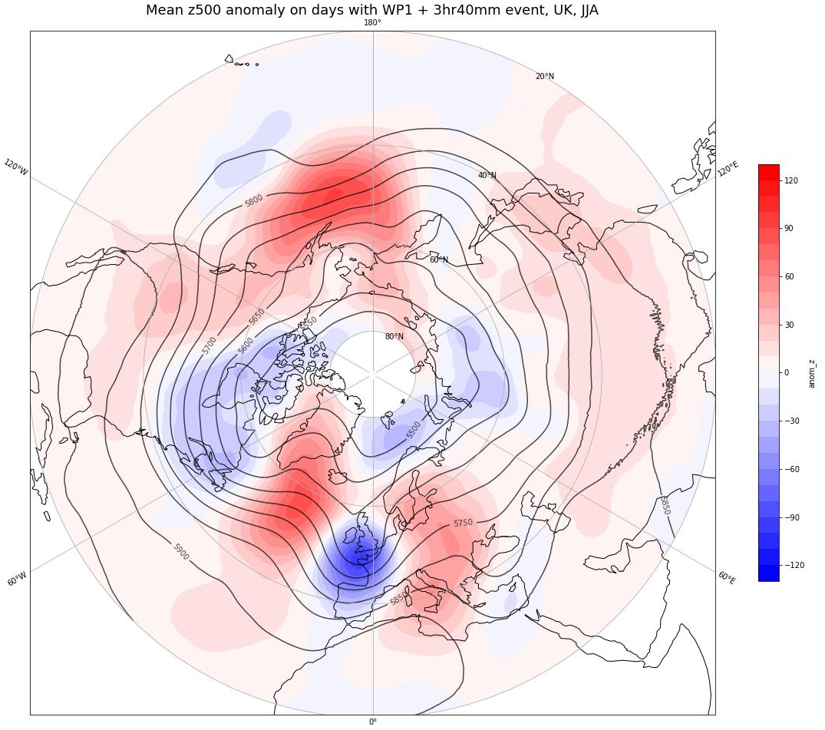

Figure S3: Results of significance testing of the z500 anomalies on WP1 + 3hr 40mm event days in the UK. a) the mean z500 anomalies on days with WP1 + 3hr40mm event in the UK. b) mean z500 anomalies on days with WP1 and no extreme event in the UK. The colours are z500 anomaly (m) and black contours mean z500 (m). c) The difference between a) and b). Colours are showing the mean z500 anomaly difference between S3a and S3b and the stippling shows areas where the mean z500 anomaly on event days (from S3a) are above/below the 95/5% limit from 500 bootstrap resample of all WP6 days without an event (S3b).

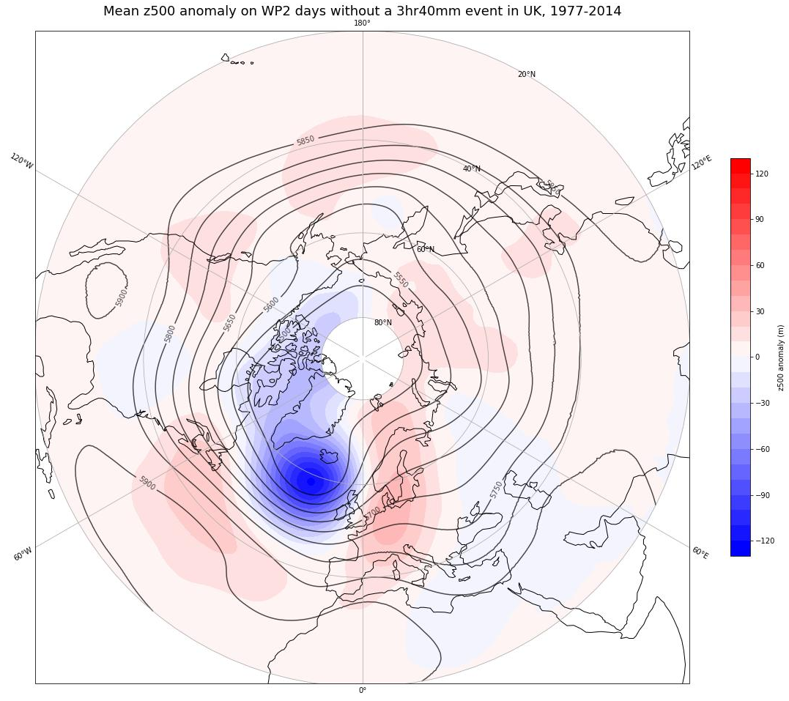
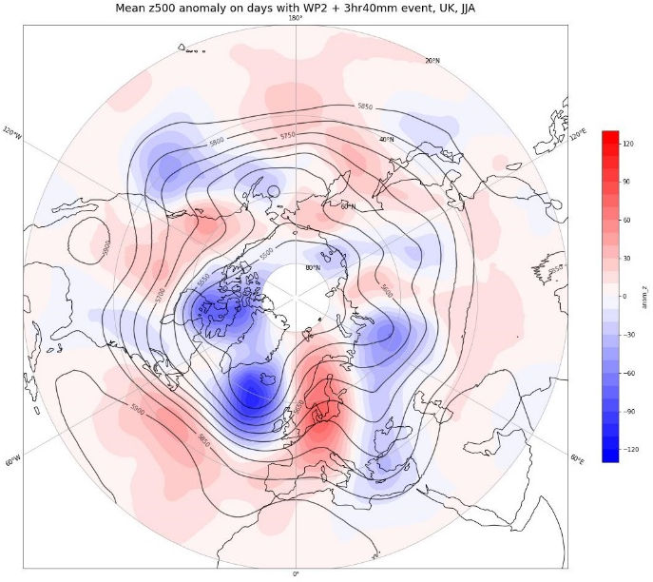

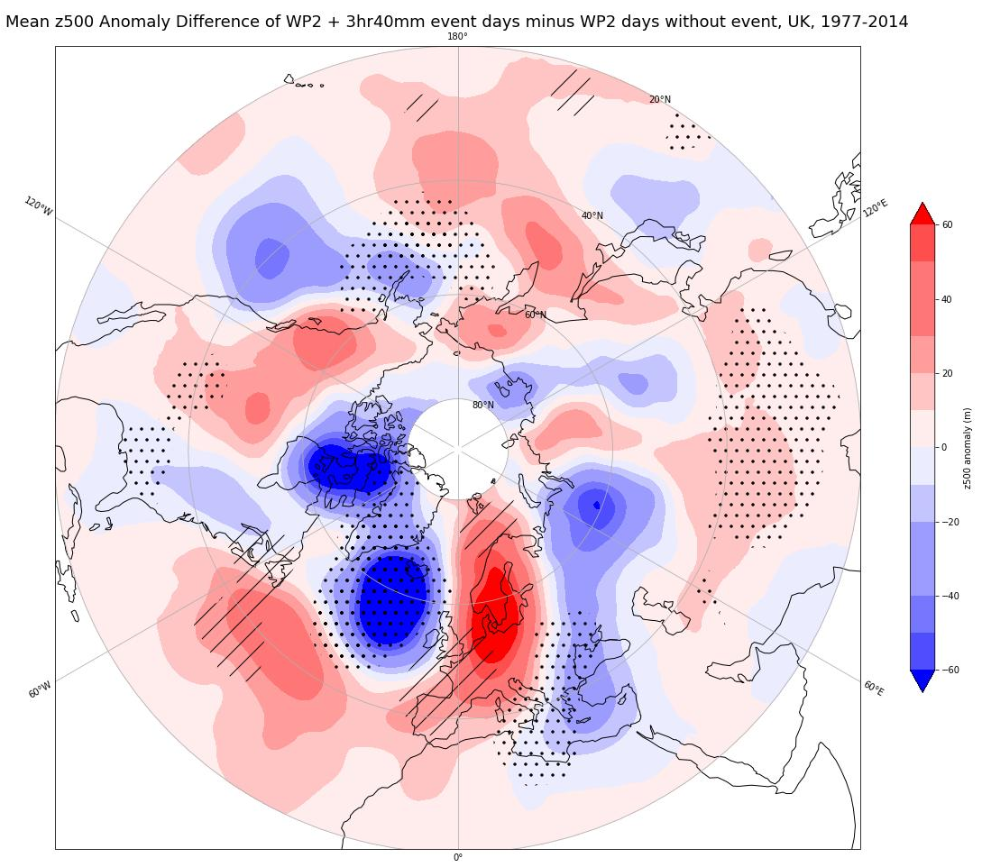

Figure S4: Results of significance testing of the z500 anomalies on WP2 + 3hr 40mm event days in the UK. a) the mean z500 anomalies on days with WP2 + 3hr40mm event in the UK. b) mean z500 anomalies on days with WP2 and no extreme event in the UK. The colours are z500 anomaly (m) and black contours mean z500 (m). c) The difference between a) and b). Colours are showing the mean z500 anomaly difference between S4a and S4b and the stippling shows areas where the mean z500 anomaly on event days (from S4a) are above/below the 95/5% limit from 500 bootstrap resample of all WP6 days without an event (S4b).

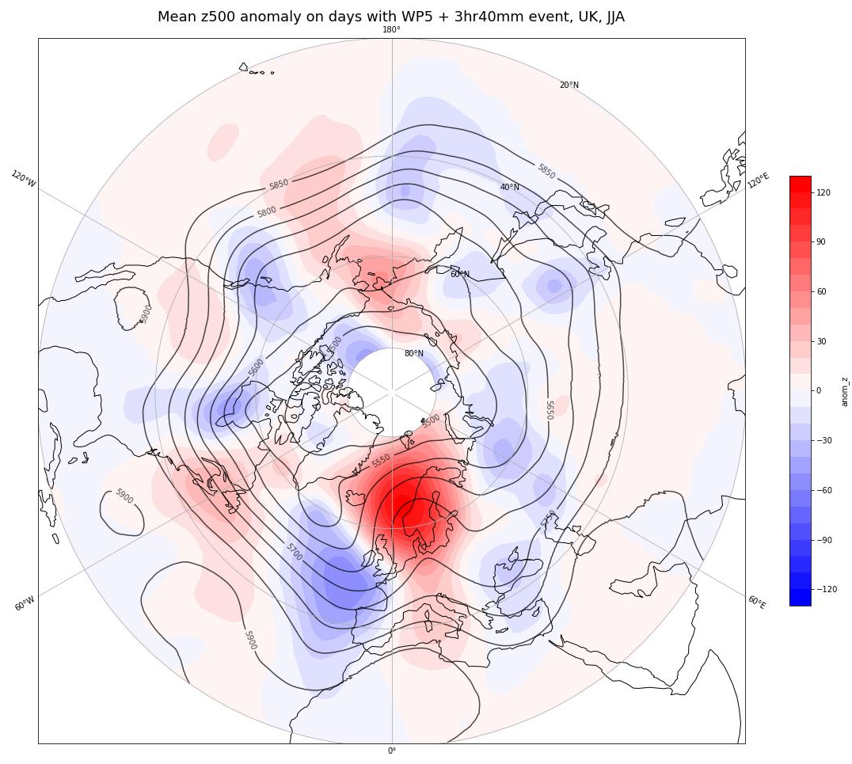
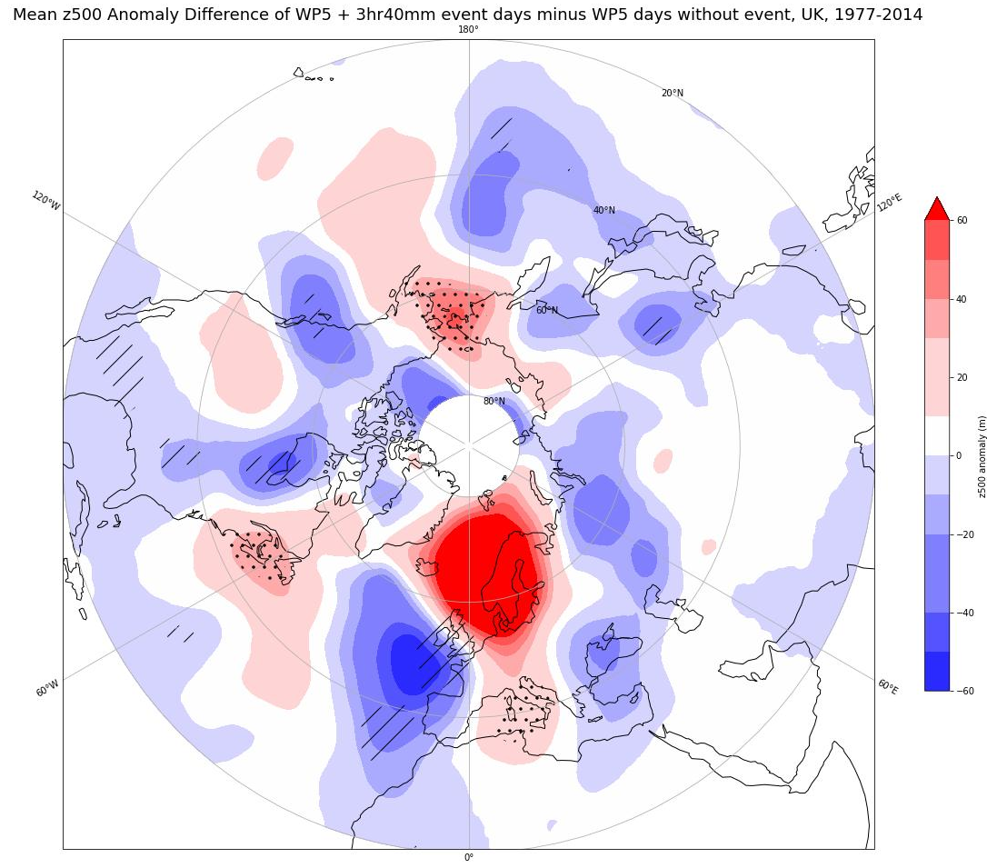
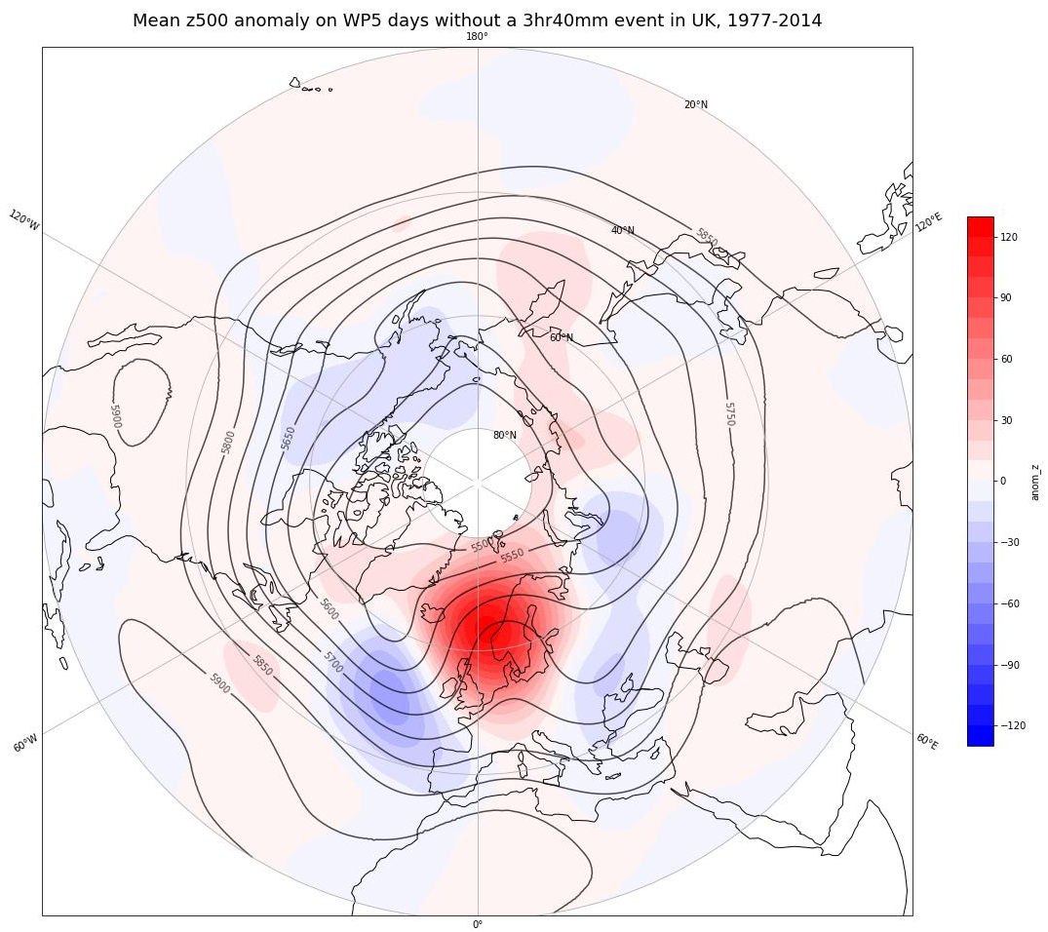

Figure S5: Results of significance testing of the z500 anomalies on WP5 + 3hr 40mm event days in the UK. a) the mean z500 anomalies on days with WP5 + 3hr40mm event in the UK. b) mean z500 anomalies on days with WP5 and no extreme event in the UK. The colours are z500 anomaly (m) and black contours mean z500 (m). c) The difference between a) and b). Colours are showing the mean z500 anomaly difference between S5a and S5b and the stippling shows areas where the mean z500 anomaly on event days (from S5a) are above/below the 95/5% limit from 500 bootstrap resample of all WP6 days without an event (S5b).

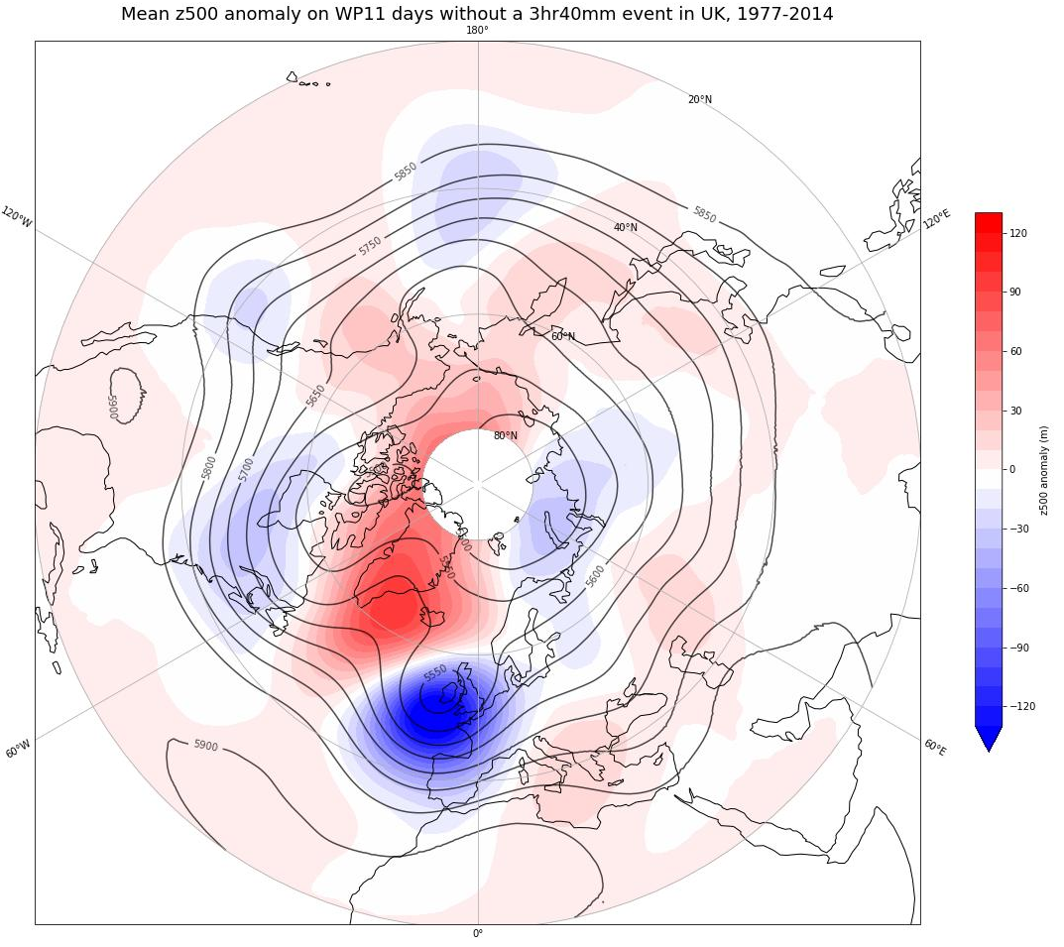
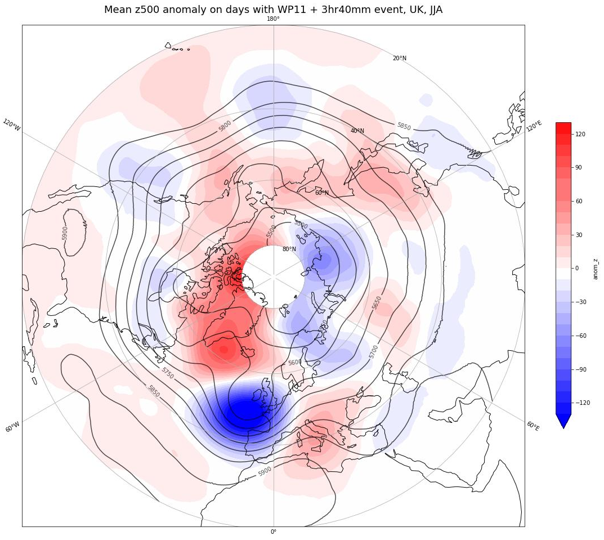
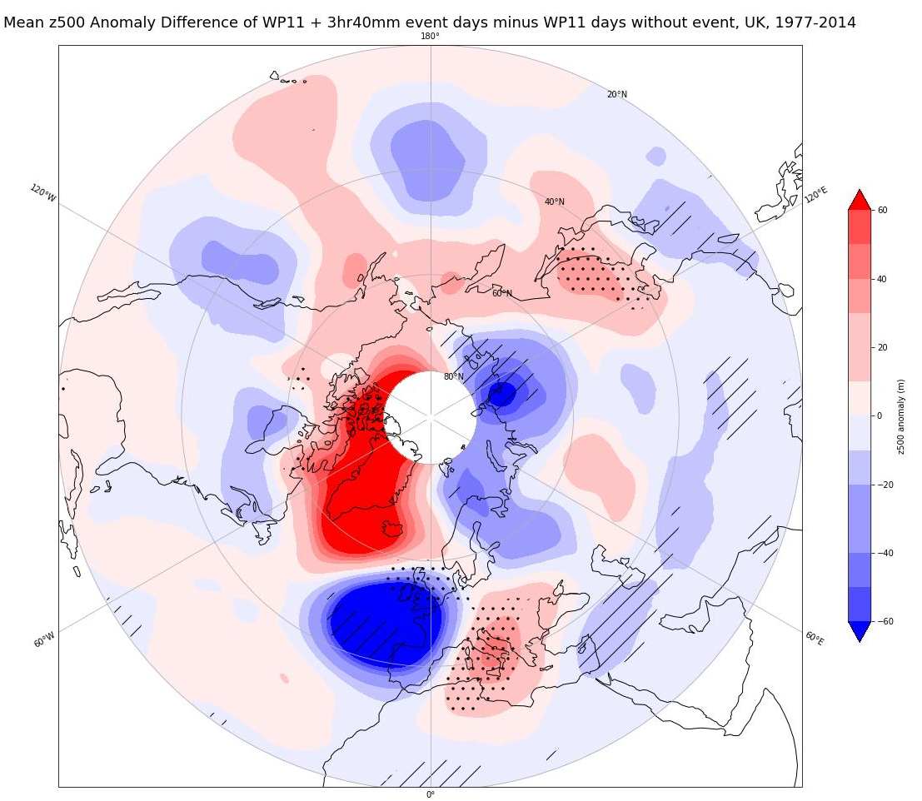
Figure S6: Results of significance testing of the z500 anomalies on WP11 + 3hr 40mm event days in the UK. a) the mean z500 anomalies on days with WP11 + 3hr40mm event in the UK. b) mean z500 anomalies on days with WP11 and no extreme event in the UK. The colours are z500 anomaly (m) and black contours mean z500 (m). c) The difference between a) and b). Colours are showing the mean z500 anomaly difference between S6a and S6b and the stippling shows areas where the mean z500 anomaly on event days (from S6a) are above/below the 95/5% limit from 500 bootstrap resample of all WP6 days without an event (S6b).

